XenonStack

**Name**: Abhishek Yadav   
**Roll** **No**.: 201210003

**Branch**: Computer Science and Engineering

**(Task 1: Create a custom linux command via bash script)**

$ cd/mnt/c/Users/Messi/Desktop

$ sudo chmod +x internsctl.sh

**Section A**

$ ./internsctl.sh --help: helps the end user to understand the use cases

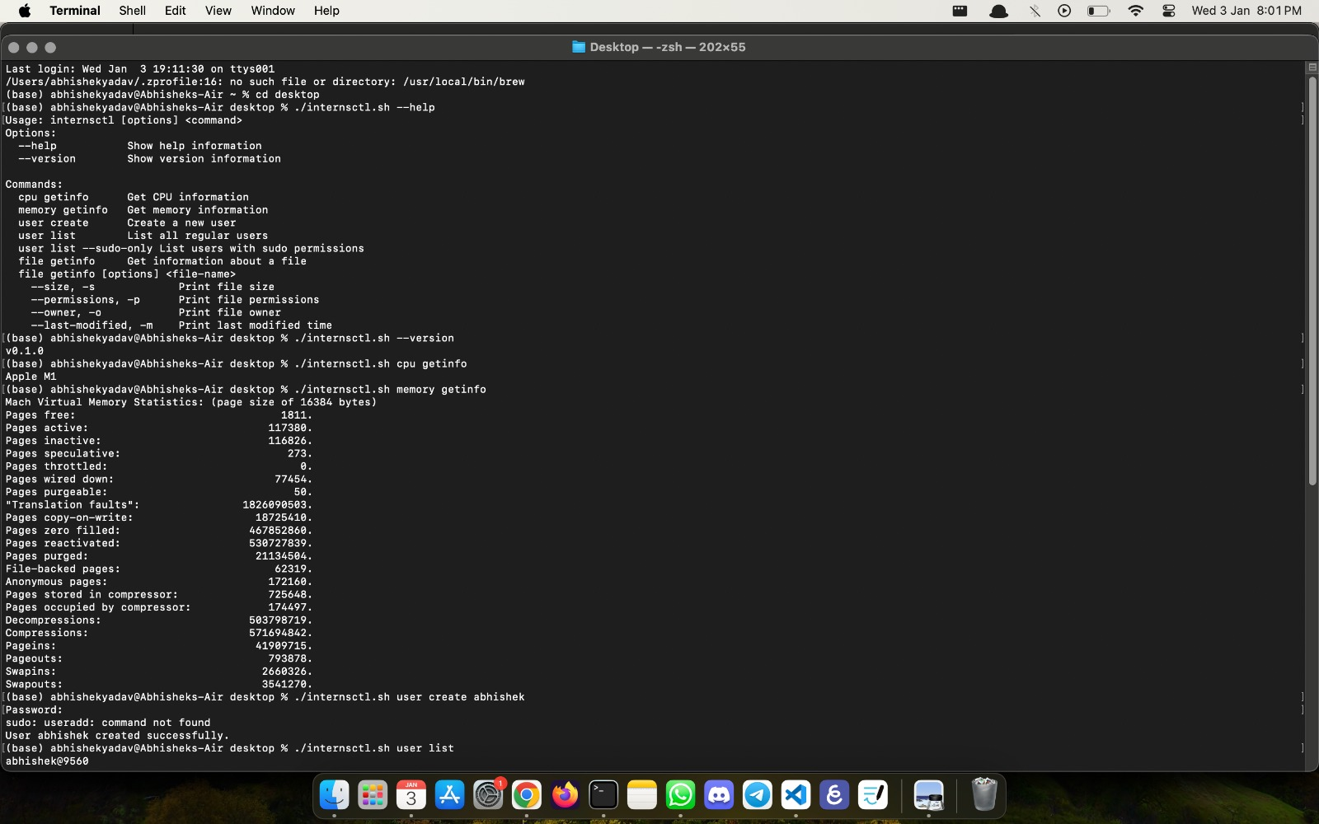

$ ./internsctl.sh --version: for showing version of the command



**Section B**

**Part1 | Level Easy**

$ ./internsctl.sh cpu getinfo



$ ./internsctl.sh memory getinfo



**Part2 | Level Intermediate**

$ ./internsctl.sh user create <username>



$ ./internsctl.sh user list

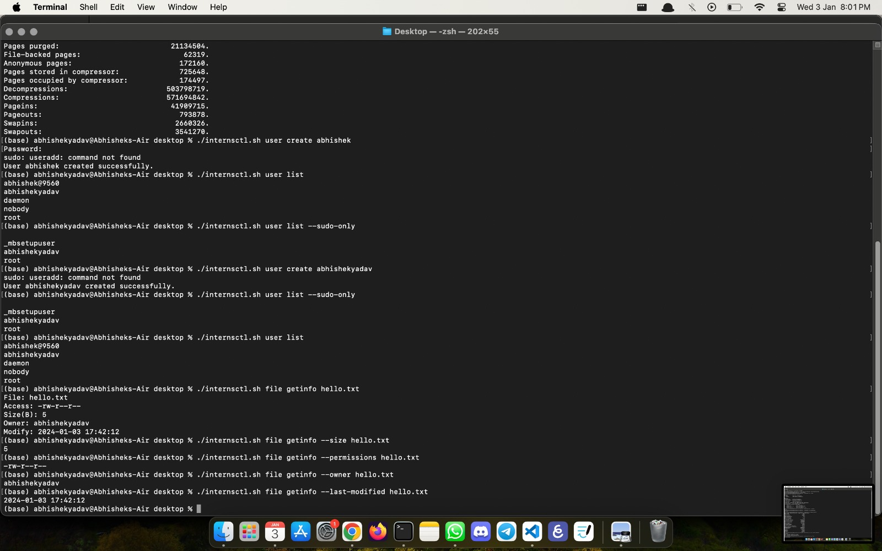

$ ./internsctl.sh user list --sudo-only



**Part3 | Advanced Level**

$ ./internsctl.sh file getinfo <file-name>



$ ./internsctl.sh file getinfo [option] <file-name>

--size, -s to print size

--permissions, -p print file permissions

--owner, O print file owner

--last-modified, m



Workflow Diagram:

Displaying the flow of the application

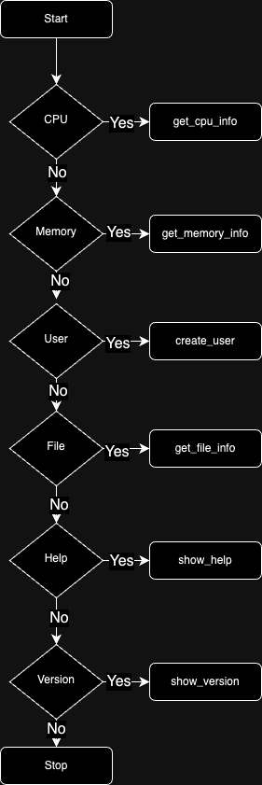

Architecture Diagram:

Basic structure of the application

