#Importing libraries

import numpy as np

import pandas as pd

import matplotlib.pyplot as plt

import seaborn as sns

import sklearn

from sklearn.model_selection import train_test_split, GridSearchCV

from sklearn.linear_model import LogisticRegression

from sklearn.neighbors import KNeighborsClassifier

from sklearn.svm import SVC

from sklearn.tree import DecisionTreeClassifier

from sklearn.ensemble import RandomForestClassifier

import xgboost

from xgboost import XGBClassifier

from imblearn.over_sampling import SMOTE

from collections import Counter

from sklearn.metrics import accuracy_score

from sklearn.preprocessing import StandardScaler

from sklearn.metrics import accuracy_score, confusion_matrix, classification_report

import warnings

warnings.filterwarnings('ignore')

#Loading the data set

df = pd.read_csv(r"C:\Users\abhis\Downloads\loan_detection.csv")

print(df.head())

print(df.shape)

#EDA

#Finding missing or duplicate values

print(df.info())

print(df.describe())

print(df.nunique())

print(df.isnull().sum())

print(df.duplicated().sum())

print(df.columns)

print(df['Loan_Status_label'])

print(df['Loan_Status_label'].value_counts())

# Imbalance Data ratio and reprensentation

print(round(len(df[df['Loan_Status_label']==0])/len(df)*100, 2))

print(round(len(df[df['Loan_Status_label']==1])/len(df)*100, 2))

# Analyze categorical variables

categorical_columns = [col for col in df.columns if 'job_' in col or 'education_' in col or 'marital_' in col]

for col in categorical_columns:

    sns.countplot(x=col, data=df)

    plt.title(f'Distribution of {col}')

    plt.xticks(rotation=90)

    plt.show()

plt.pie(df['Loan_Status_label'].value_counts(), autopct='%1.0f%%',labels=['Not Eligible','Eligible'],

            startangle=60,shadow=True,explode=[0,0.2])

plt.title('Imbalanced Data Visulaization')

plt.show()

#Outlier or Anomalies

def remove_outliers_iqr(df, columns):

    for col in columns:

        Q1 = df[col].quantile(0.25)

        Q3 = df[col].quantile(0.75)

        IQR = Q3 - Q1  # Interquartile Range

        lower_bound = Q1 - 1.5 * IQR

        upper_bound = Q3 + 1.5 * IQR

        df = df[(df[col] >= lower_bound) & (df[col] <= upper_bound)]

    return df

numerical_columns = ['age', 'campaign', 'pdays', 'previous']

df_cleaned = remove_outliers_iqr(df, numerical_columns)

print("Original dataset shape:", df.shape)

print("Cleaned dataset shape (after removing outliers):", df_cleaned.shape)



# Pairplot to analyze relationships after cleaning

sns.pairplot(df_cleaned[['age', 'campaign', 'previous', 'Loan_Status_label']], hue='Loan_Status_label')

plt.title('Pairplot after cleaning')

plt.show()

# Visualizing distribution of age and other numeric columns

numeric_columns = ['age', 'campaign', 'pdays', 'previous']

for col in numeric_columns:

    sns.histplot(df_cleaned[col], bins=30, kde=True)

    plt.title(f'Distribution of {col}')

    plt.show()

#Split the dataset into features and target variable

X = df_cleaned.drop(columns=['Loan_Status_label'])  # Features

y = df_cleaned['Loan_Status_label']  # Target (Loan Approved or Not)

#Check class distribution before resampling

print("Class distribution before SMOTE:", Counter(y))

#Apply SMOTE to balance the data

smote = SMOTE(random_state=42)

X_resampled, y_resampled = smote.fit_resample(X, y)

#Check class distribution after resampling

print("Class distribution after SMOTE:", Counter(y_resampled))



#Splitting your data

X_train, X_test, y_train, y_test = train_test_split(X_resampled, y_resampled, test_size=0.2, random_state=42)

print(X_train.shape)

print(X_test.shape)



#Feature scaling

scaler = StandardScaler()

X_train_scaled = scaler.fit_transform(X_train)

X_test_scaled = scaler.transform(X_test)

#Model Building

#Initialize Logistic Regression, Random Forest, and Decision Tree models

log_reg = LogisticRegression(max_iter=1000, random_state=42)

rf_model = RandomForestClassifier(random_state=42)

dt_model = DecisionTreeClassifier(random_state=42)

# Train Logistic Regression

log_reg.fit(X_train_scaled, y_train)

# Train Random Forest

rf_model.fit(X_train, y_train)

# Train Decision Tree

dt_model.fit(X_train, y_train)

# Model Evaluation

# Logistic Regression Evaluation

y_pred_log_reg = log_reg.predict(X_test_scaled)

log_reg_accuracy = accuracy_score(y_test, y_pred_log_reg)

print(f'Logistic Regression Accuracy: {log_reg_accuracy:.2f}')

# Random Forest Evaluation

y_pred_rf = rf_model.predict(X_test)

rf_accuracy = accuracy_score(y_test, y_pred_rf)

print(f'Random Forest Accuracy: {rf_accuracy:.2f}')

# Decision Tree Evaluation

y_pred_dt = dt_model.predict(X_test)

dt_accuracy = accuracy_score(y_test, y_pred_dt)

print(f'Decision Tree Accuracy: {dt_accuracy:.2f}')

# Confusion Matrix and Classification Report for Random Forest

print("\nConfusion Matrix for Random Forest:")

conf_matrix = confusion_matrix(y_test, y_pred_rf)

sns.heatmap(conf_matrix, annot=True, fmt='d', cmap='Blues')

plt.title('Confusion Matrix for Random Forest')

plt.show()

print("\nClassification Report for Random Forest:")

print(classification_report(y_test, y_pred_rf))

# Hyperparameter Tuning using GridSearchCV for Random Forest

param_grid = {

    'n_estimators': [100, 200],

    'max_depth': [10, 20, None],

    'min_samples_split': [2, 5]

}

grid_search = GridSearchCV(rf_model, param_grid, cv=3, scoring='accuracy', n_jobs=-1)

grid_search.fit(X_train, y_train)

# Best Model from GridSearchCV

best_rf_model = grid_search.best_estimator_

print(f'Best Parameters: {grid_search.best_params_}')

# Evaluate the tuned model

y_pred_best_rf = best_rf_model.predict(X_test)

best_rf_accuracy = accuracy_score(y_test, y_pred_best_rf)

print(f'Best Random Forest Accuracy (after tuning): {best_rf_accuracy:.2f}')



# Confusion Matrix and Heatmap (After Tuning)

print("\nConfusion Matrix for Random Forest (After Tuning):")

conf_matrix_after = confusion_matrix(y_test, y_pred_best_rf)

sns.heatmap(conf_matrix_after, annot=True, fmt='d', cmap='Blues')

plt.title('Confusion Matrix (After Tuning)')

plt.show()

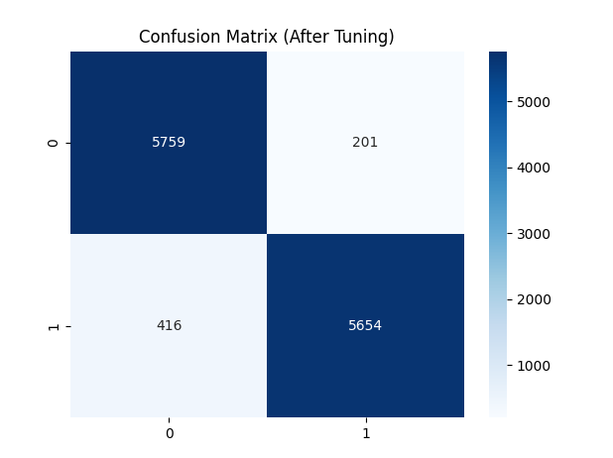

#Classification Report (Optional for After Tuning)

print("\nClassification Report for Random Forest (After Tuning):")

print(classification_report(y_test, y_pred_best_rf))

