Assignment 2

Clocks, Multicast and COMMIT

**Implementation of Part 1:**

**Berkley Algorithm:**

Logic Used:

I have created 2 C Plus Plus programs named server3 and client3. The program server3.cpp has the following functionalities:

1. Generate a local time of server using random function
2. Create a socket file descriptor
3. Attach socket to a port (predefined to 8080)
4. Bind socket to port 8080
5. Listen for connections
6. Accept connection from clients
7. Create a thread for each connection from client
8. Convert timestamp sent by client to int value
9. Store all client timestamps in an array
10. Find the time difference between client time and server time
11. Find the average value and add it to the server time
12. Send the updated server time to all the clients for updating.

The program client3.cpp has the following functionalities:

1. Generate a local time using random function
2. Create a socket
3. Connect to server
4. Send local time of client
5. Receive Berkley time from server
6. Calculate the difference between new time and old time and display

Activity Diagram:

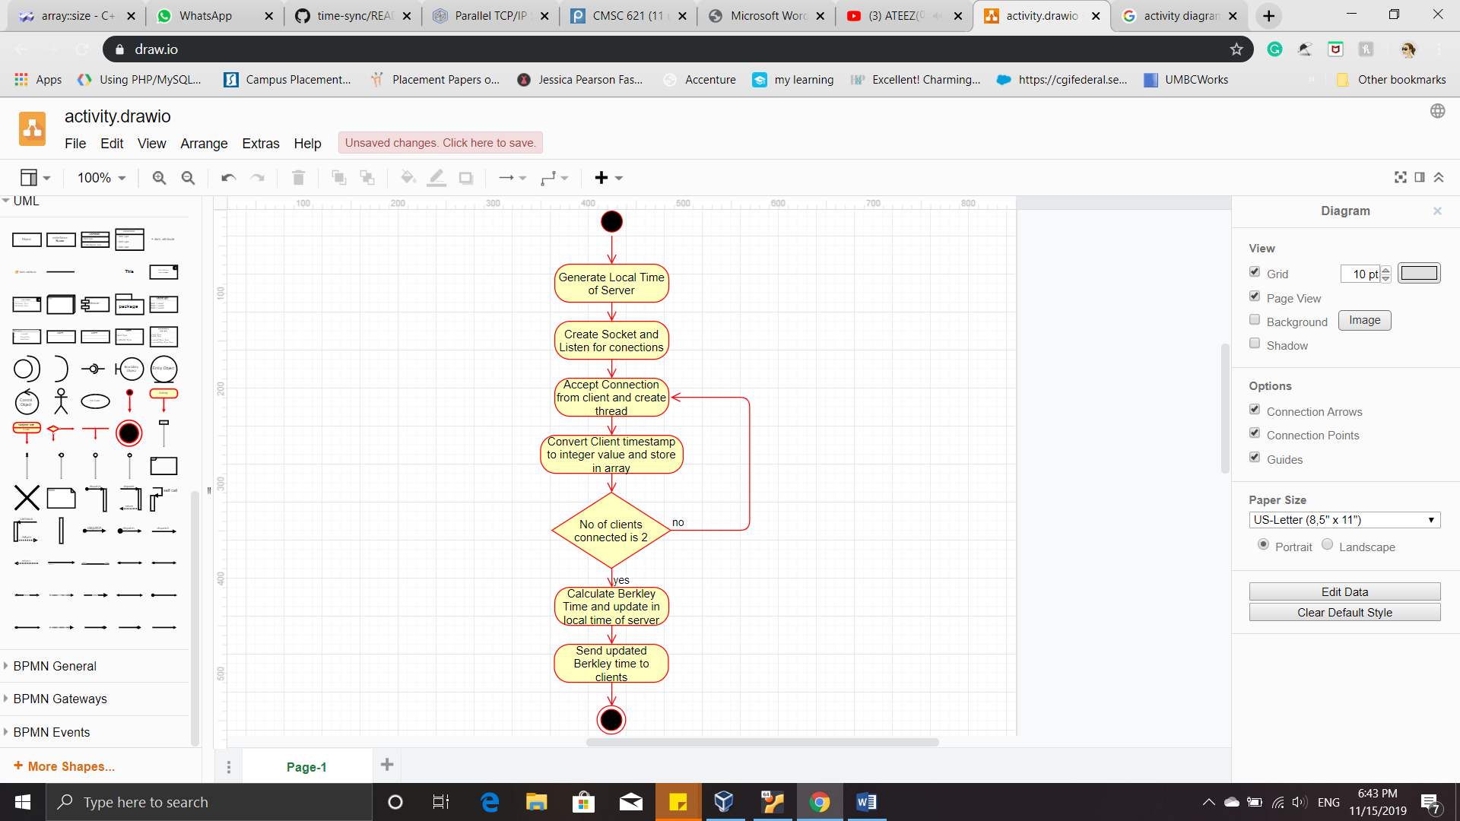 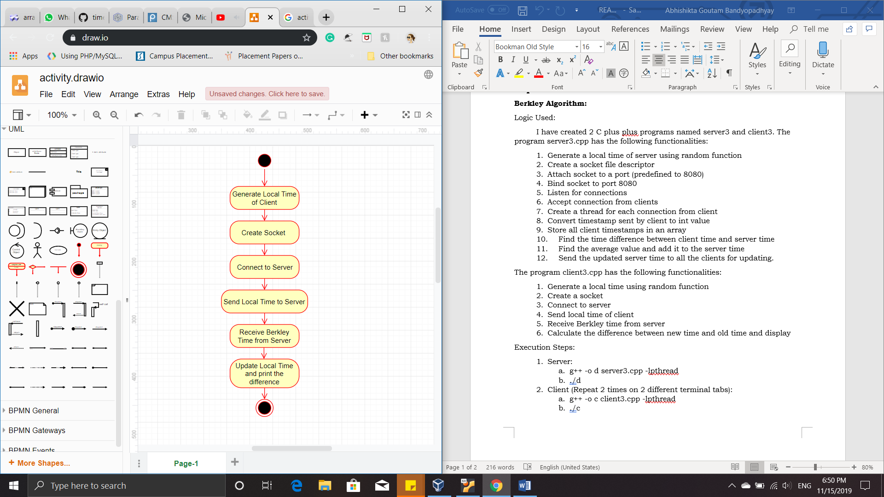

*Fig1: Activity Diagram of Server Fig2: Activity Diagram of Client*

Output:

