**SPRING NOTES**

**What Is Inversion of Control?**

Inversion of Control is a principle in software engineering by which the control of objects or portions of a program is transferred to a container or framework. It's most often used in the context of object-oriented programming.

**Dependency Injection:**

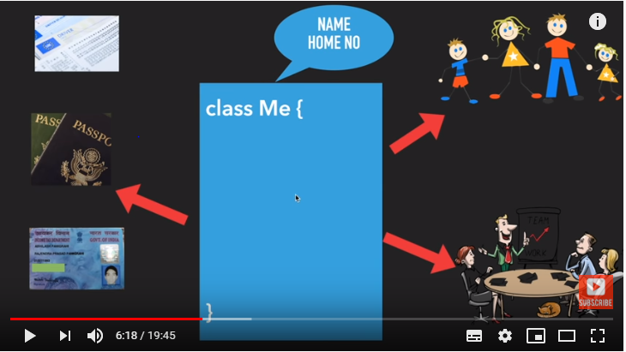

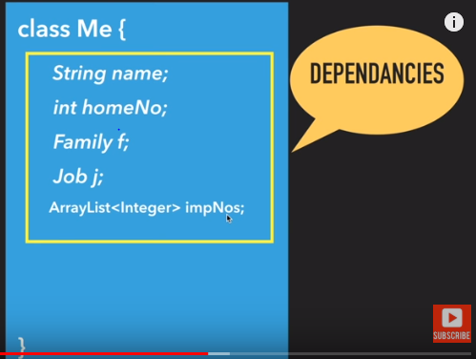

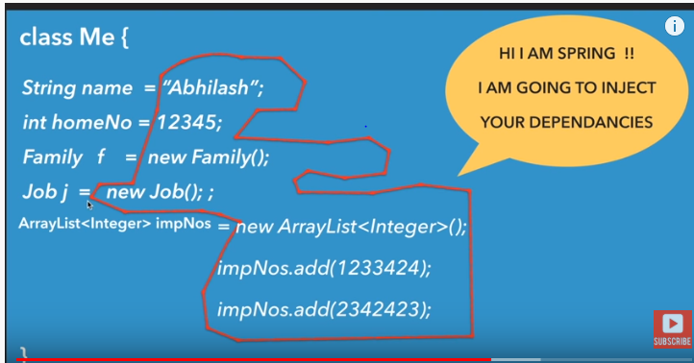

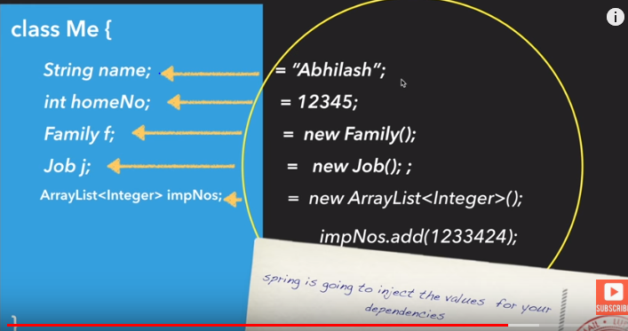



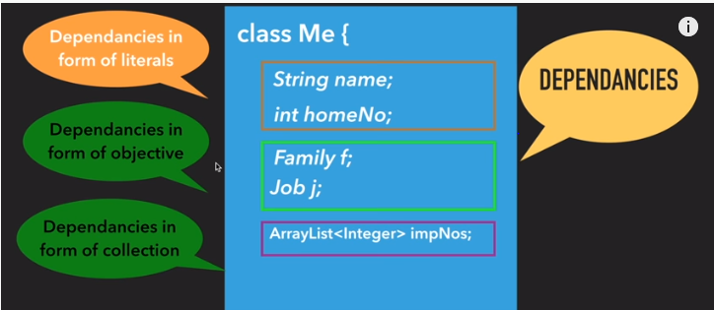

**@PostConstruct** -> **Spring calls methods annotated with**@PostConstruct**only once, just after the initialization of bean properties**. Keep in mind that these methods will run even if there is nothing to initialize.

The method annotated with @PostConstruct can have any access level but it can't be static.

One example usage of @PostConstruct is populating a database. During development, for instance, we might want to create some default users

**@PreDestroy** ->A method annotated with @PreDestroy runs only once, just before Spring removes our bean from the application context.

Same as with @PostConstruct, the methods annotated with @PreDestroy can have any access level but can't be static.

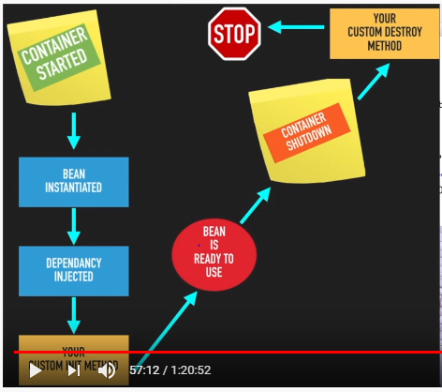

|  |
| --- |
| *package* com.fda.restaurant.Restaurant.config;  *import* com.fda.restaurant.Restaurant.dao.Dishes; *import* com.fda.restaurant.Restaurant.dao.Restaurant; *import* com.fda.restaurant.Restaurant.repository.*RestaurantRepository*; *import* lombok.extern.slf4j.Slf4j; *import* org.springframework.beans.factory.annotation.Autowired; *import* org.springframework.boot.*CommandLineRunner*; *import* org.springframework.context.annotation.Bean; *import* org.springframework.context.annotation.Configuration;  *import* javax.annotation.PostConstruct; *import* javax.annotation.PreDestroy;  *import static* com.fda.restaurant.Restaurant.dao.Cuisines.*CHINESE*; *import static* com.fda.restaurant.Restaurant.dao.Cuisines.*INDIAN*; *import static* com.fda.restaurant.Restaurant.dao.VegOrNonVeg.*NON_VEG*; *import static* com.fda.restaurant.Restaurant.dao.VegOrNonVeg.*VEG*;  @Configuration @Slf4j *class* LoadDatabase {   @Autowired  *private RestaurantRepository* repository1;   @Bean  *CommandLineRunner* initDatabase(*RestaurantRepository* repository) {  *return* args -> {  *log*.info("PreLoading " + repository.save(*new* Restaurant("Delhi Pub", *VEG*, *INDIAN*,400,*new* Dishes("COFFEE",100))));  *log*.info("PreLoading " + repository.save(*new* Restaurant("Delhi Continental", *NON_VEG*, *CHINESE*,600,*new* Dishes("SWEETS",600))));  };  }   @PostConstruct  *public void* addDefaultRestaurant()  {  *log*.info("PreLoading " + repository1.save(*new* Restaurant("PostDestroyExample", *VEG*, *INDIAN*,400,*new* Dishes("COFFEE",100))));  }   @PreDestroy  *public void* removeDefaultRestaurant()  {  System.*out*.println("Remove Default Restaurant");  } } |