AFTERHOURS
Demo Video Scripts & Architecture
The risk desk for tokenized stocks on Solana — two scripts, one system diagram, one narration to explain it.

Video 1 — Main product demo · target 2:50
General Stocklana track. One continuous screen recording. Pre-load every URL below in separate tabs before recording so there's no typing or RPC waiting on camera.
Pre-load
• https://afterhours-v0dr.onrender.com/
• https://afterhours-v0dr.onrender.com/dashboard/?address=<the $21M xStocks wallet> ("A real xStocks wallet")
• Phantom unlocked, on devnet, holding a little devnet SOL — needed only for the final beat.
TIME | ON SCREEN | SAY
0:00–0:15 | Landing page. Hover the New York day ring, let the tape of xStock moves scroll. | An xStock trades every hour of every week. The share it tracks trades six and a half hours a day, five days a week. Afterhours is the risk desk for everything that happens in between.
0:15–0:30 | Click Open the desk. Sample book loads with live prices, ten panels down the left. | Paste any wallet, or start here. Thirty-five xStocks, priced live, scored from thirty days of hourly data — nothing on a server, all of it in this tab.
0:30–0:50 | Score, VaR, Beta panels, in order. | Score: volatility plus concentration, zero to a hundred. Value at risk: the ninety-five percent one-day loss, parametric and historical side by side. Beta: this book, and every position in it, against the S&P 500.
0:50–1:10 | Click into Holdings, click MSTRx, its 30-day chart opens with closed-hours shaded. | Click a holding. Thirty days, and every hour the New York exchange was shut, shaded — this stock kept moving the whole time, with no market open behind it.
1:10–1:30 | Scroll to Stocks / crypto / cash panel. | Sector labels lie a little. COIN, MSTR, HOOD, CRCL are equity on paper — the desk says what share of this book is actually riding crypto.
1:30–1:55 | What-if panel: drag half of one position into another, watch score, VaR, beta update live. | Move half of one position into another and every number on the page updates instantly — still nothing leaving the browser.
1:55–2:15 | If-the-market-gaps panel: S&P shock to −5%, then the custom two-slider shock. | Shock the S&P five percent, or set your own — every position moves by its own beta, and you see the book that results before Monday opens.
2:15–2:35 | Target and drift panel: set a target, show the sell/buy orders with live Jupiter quotes. | State the allocation you meant to hold. The drift becomes real orders, quoted live on Jupiter — size, price impact, route, right now.
2:35–2:50 | Switch to the xStocks-wallet link. Connect Phantom. Save Policy, record a Snapshot; explorer flashes the new account. | Connect the wallet that owns the book, and it's not just a reading — target and snapshot get written on Solana, signed by you. That policy and that snapshot are what a lending protocol could watch instead of a price feed.
Do not show on camera: an actual mainnet Sign-and-swap send (real funds move) — quote it live, don't execute it, unless you've decided in advance to spend real SOL. Total 2:50; cut the 1:30–2:15 block first if over.

Video 2 — PreStocks bounty demo · target 2:15
Covers "Best Use of PreStocks" only — a separate recording so a judge scoring this bounty doesn't sit through the full desk tour first.
Pre-load
• https://afterhours-v0dr.onrender.com/dashboard/?address=6GJbPKBtovsrMEEMcic5KMi5tswh9qSyT5ZYLMqEwNgt ("A real PreStocks wallet")
TIME | ON SCREEN | SAY
0:00–0:15 | Landing page or PreStocks site for a hook shot, or skip straight to the wallet. | PreStocks tokenizes pre-IPO equity — OpenAI, SpaceX, Anthropic — on Solana, before any of it is public. Afterhours reads it.
0:15–0:35 | Load the linked wallet. Point at the five PreStocks tokens sitting next to SOL and USDC. | This is a real mainnet wallet: five PreStocks tokens, found through the largest holders of the SpaceX token, read live — same as any other wallet, no key, no custody.
0:35–1:05 | Open "What you hold." Hover a PreStocks token to show its live price ticking from PreStocks' own API. | Priced live from PreStocks' own API, sitting right beside the risk-scored xStocks book — not folded into it.
1:05–1:35 | Point at the label / tooltip explaining why they're excluded from VaR / score. | A private company has no public listing, so there's no thirty-day series to score it against. The honest move is to say that, not to dress up a number that doesn't know it — so PreStocks tokens are priced and shown, never scored into the book's VaR.
1:35–1:55 | Quick cut to a plain xStocks wallet, then back, to show the same read path. | Same pipeline as every xStock: token accounts, both token programs, verified mints — PreStocks just adds eight more rows to a list the desk already knew how to read.
1:55–2:15 | End card: the wallet link on screen. | Only PreStocks tokens are used here — no other pre-IPO token is integrated. This is Afterhours' best use of PreStocks.
If you need more runtime, extend 0:35–1:05 with a second PreStocks token rather than adding new claims. Total 2:15.

Architecture diagram
A classic four-tier map — User, Client, Server/Services, Chain — of the same product. No tier is a server Afterhours operates; Tier 3 is labelled that way on purpose, because these external services are what stands in for a backend.
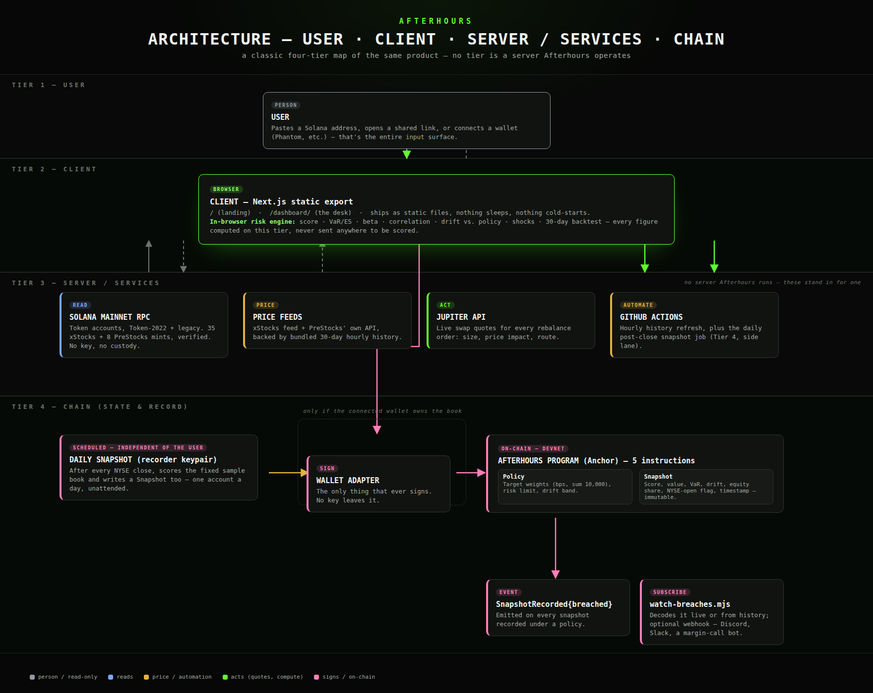

Narration — explaining the architecture out loud (~1:40)
TIME | SAY (reading pace, ~2 words/sec)
0:00–0:15 | Four tiers, top to bottom. Tier one is the user — pasting an address, opening a shared link, or connecting a wallet. That's the entire input surface.
0:15–0:35 | Tier two is the client: a static browser export, no server behind it, and inside it the in-browser risk engine — score, VaR, beta, correlation, drift, shocks — every figure computed right there in the tab.
0:35–1:00 | Tier three stands in for a server, because there isn't one Afterhours runs: Solana's own mainnet RPC for reads, live price feeds, Jupiter for swap quotes, and GitHub Actions for the scheduled jobs. Four external services doing the job a backend usually would.
1:00–1:25 | Tier four is the chain — where state actually persists. A wallet adapter signs; the Afterhours program on devnet holds two account types, Policy and Snapshot; and every snapshot recorded under a policy emits one event, SnapshotRecorded, that a script can subscribe to.
1:25–1:40 | Two paths write to that same program: the user's own wallet, only when it owns the book on screen — that's the dashed box — and, completely independently, a scheduled job that writes a snapshot after every NYSE close whether or not anyone's watching.

Technical flow diagram
The same system, drawn as a sequence: six lifelines (User, Client, Data sources, Jupiter, Wallet, Solana Program) and eleven numbered calls between them, in the order they actually happen. The dashed box marks the one stretch that's conditional on a connected wallet owning the book.
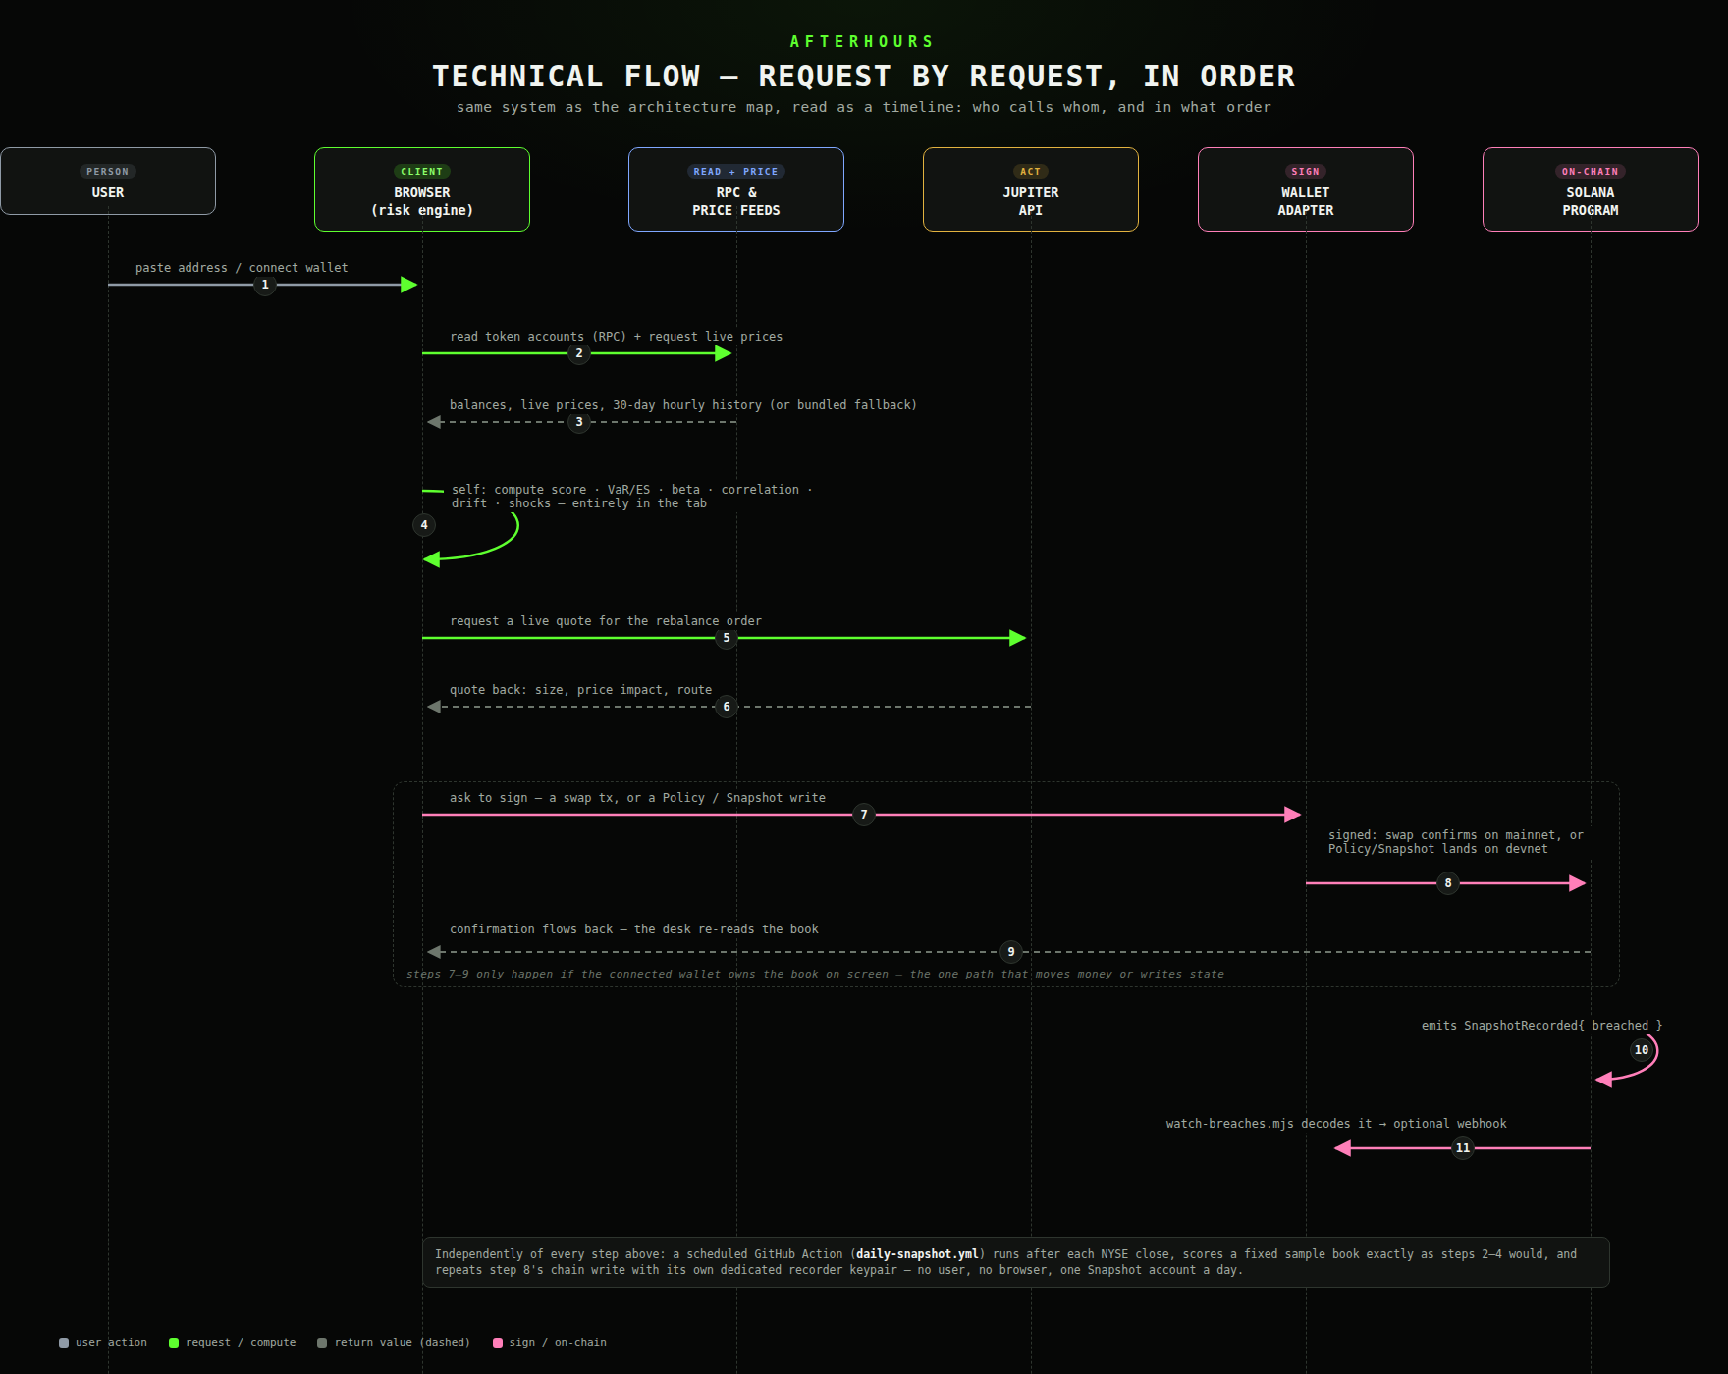

Narration — explaining the flow out loud (~2:10)
TIME | SAY (reading pace, ~2 words/sec)
0:00–0:10 | Same system, now read as a timeline. Six lifelines: the user, the client, the data sources, Jupiter, the wallet, and the on-chain program.
0:10–0:30 | Steps one through three: the user hands the client an address, the client reads token accounts over RPC and requests live prices, and the data comes back — balances, prices, thirty days of hourly history.
0:30–0:45 | Step four is a self-loop — the client doesn't call out anywhere to score the book. Score, VaR, beta, correlation, drift, shocks, all computed against what it already has.
0:45–1:05 | Steps five and six: a live quote request to Jupiter, and a quote back — size, price impact, route — for whatever rebalance the drift implies.
1:05–1:35 | Steps seven through nine only happen inside one condition, marked by the dashed box: the connected wallet has to own the book on screen. The client asks the wallet to sign — a swap, or a Policy and Snapshot write — the wallet sends it, and confirmation flows back so the desk can re-read the book.
1:35–1:55 | Steps ten and eleven happen on-chain, after the fact: the program emits SnapshotRecorded with a breached flag, and watch-breaches.mjs — a completely separate process — decodes that event and can forward it to a webhook.
1:55–2:10 | None of steps two through four, or step eight's write, need step one to come from a live user at all — that's exactly what the daily snapshot job proves, running the same sequence on a schedule, signed by its own keypair, with no one at the keyboard.

