**1. Total Bookings in the given timeline.**

*SELECT COUNT(Trip_id) AS Total_bookings*

*FROM uber_trip_details;*

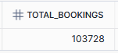

**2. Total revenue generated BY Uber in the given timeline.**

SELECT ROUND(SUM(fare_amnt) + SUM(Surge_Fee), 0) AS Total_revenue

FROM uber_trip_details;



**3. Find Average Revenue Value per ride.**

SELECT ROUND((SUM(fare_amnt) + SUM(Surge_Fee))/COUNT(Trip_id), 0) AS Average_Revenue_Per_Ride

FROM uber_trip_details;

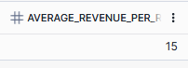

**4. Find Total Trips Distance**

SELECT CONCAT(ROUND(SUM(TRIPDIST), 0), ' Km') AS Total_Trip_Distance

FROM uber_trip_details;



**5. Find Average Trips Distance and also add 'Km' in output.**

SELECT

CONCAT(ROUND(SUM(TRIPDIST)/COUNT(Trip_id), 1), ' Km') AS Average_Trip_Distance

FROM uber_trip_details;



**6. Find Average Trip Time Per Ride in seconds.**

SELECT

ROUND(SUM(TOTIMESTAMPDIFF(SECOND, TO_TIMESTAMP(pickupdate || ' ' || pickuptime) , TO_TIMESTAMP(dropday || ' ' || droptime)))/

(SELECT COUNT(*) FROM uber_trip_details)/60, 1) Avg_Trip_Time

FROM uber_trip_details

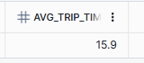

**7. Find Total Rev generated BY Transaction Type**

SELECT payment_type,

CONCAT('$ ', ROUND(SUM(fare_amnt) + SUM(surge_fee), 0)) AS Total_TransactiON_BY _Payment_Type

FROM uber_trip_details

GROUP BY payment_type

ORDER BY ROUND(SUM(fare_amnt) + SUM(surge_fee), 0) DESC

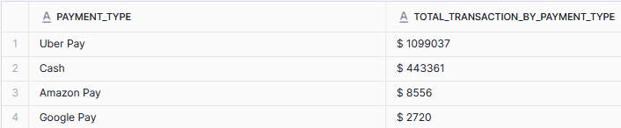

**8. Find Total no of bookings, total distance covered, and revenue based ON day and Night.**

SELECT

CASE WHEN pickuptime> = '20:00:00' or pickuptime< = '05:00:00' then 'Night' ELSE 'Day' END AS DayorNight,

COUNT(*) AS Total_bookings,

ROUND(SUM(tripdist), 1) Total_Distance_in_Km,

ROUND(SUM(fare_amnt) + SUM(Surge_Fee), 0) AS Total_revenue_$

FROM uber_trip_details

GROUP BY 1

ORDER BY CASE DayorNight

WHEN ‘Day' then 1

ELSE 2 END

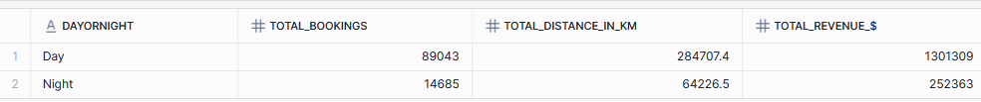

**9. Find key performance indicators like Total Bookings, Total Booking Value, Avg Booking Value, Total Trip Distance across different Vehicle Types in Uber trips.**

SELECT

Vehicle,

COUNT(*) AS Total_Bookings,

ROUND(SUM(fare_amnt) + SUM(Surge_Fee), 0) AS Total_Booking_val_$,

ROUND((SUM(fare_amnt) + SUM(Surge_Fee))/COUNT(*), 1) Avg_Booking_Value,

ROUND(SUM(tripdist), 1) Total_Trip_Distance_KM

FROM uber_trip_details

GROUP BY 1

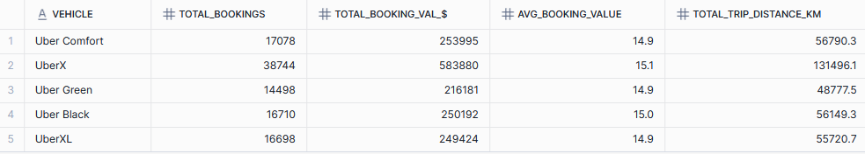

**10. Find Total No of Bookings BY Day_of_Week, BY Total Percent Value and Total Distance coverage.**

SELECT

dayname(pickupdate) Day_of_Week,

COUNT(Trip_id) AS Total_Bookings,

ROUND(COUNT(Trip_id)*100.0/(SELECT COUNT(trip_id) FROM uber_trip_details), 1) Percent_of_Total,

ROUND(SUM(tripdist), 1) Total_Trip_Distance_KM

FROM uber_trip_details

GROUP BY Day_of_Week

ORDER BY CASE Day_of_week

WHEN 'Sun' then 1

WHEN 'MON' then 2

WHEN 'Tue' then 3

WHEN 'Wed' then 4

WHEN 'Thu' then 5

WHEN 'Fri' then 6

ELSE 7 END

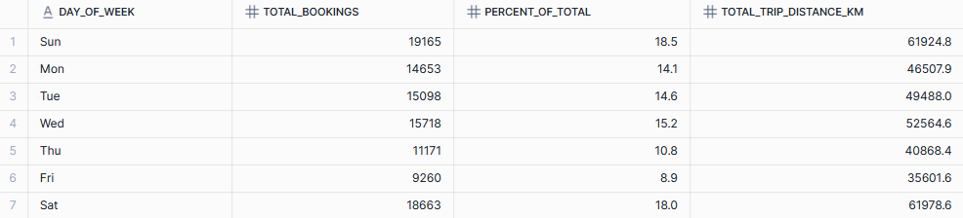

**11. Find most Pickup Location and observe locations which contributes 80% of Total COUNT (PARETO ANALYSIS)**

WITH cte AS

(SELECT

location AS Pickup_Location ,

COUNT(location ) AS Total_COUNT,

ROUND((COUNT(location )*100.0)/(SELECT COUNT(*) FROM uber_trip_details), 1) AS Percent_of_total,

SUM(ROUND((COUNT(location )*100.0)/(SELECT COUNT(*) FROM uber_trip_details), 1))

OVER(ORDER BY COUNT(location ) DESC) Cum_SUM_percentage

FROM uber_trip_details u

INNER JOIN loc_info l ON l.location _id = u.pickup_locid

GROUP BY 1

ORDER BY 2 DESC)

SELECT * FROM cte

WHERE Cum_SUM_percentage< = 80

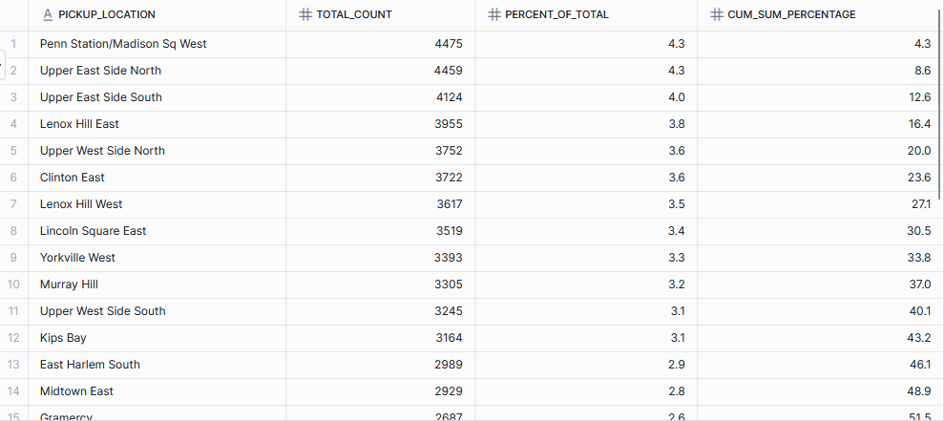

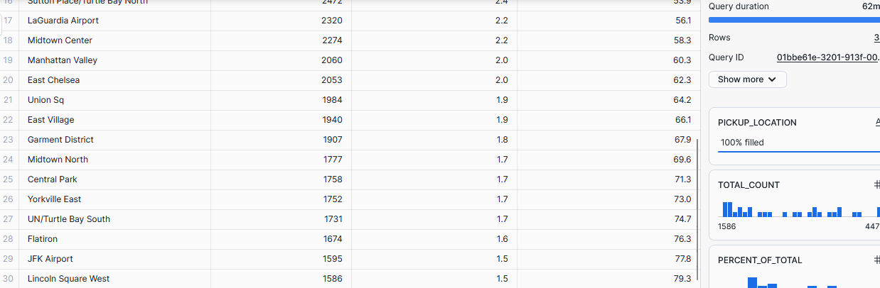

**12. Find most Drop-off Location and observe locations which contributes 80% of Total COUNT (PARETO ANALYSIS)**

WITH cte AS

(SELECT location AS Drop_Location , COUNT(location ) AS Total_COUNT,

ROUND((COUNT(location )*100.0)/(SELECT COUNT(*) FROM uber_trip_details), 1) AS Percent_of_total,

SUM(ROUND((COUNT(location )*100.0)/(SELECT COUNT(*) FROM uber_trip_details), 1)) OVER(ORDER BY COUNT(location ) DESC) Cum_SUM_percentage

FROM uber_trip_details u

INNER JOIN loc_info l ON l.location _id = u.drop_locid

GROUP BY 1)

SELECT * FROM cte

WHERE Cum_SUM_percentage<80

ORDER BY Cum_SUM_percentage

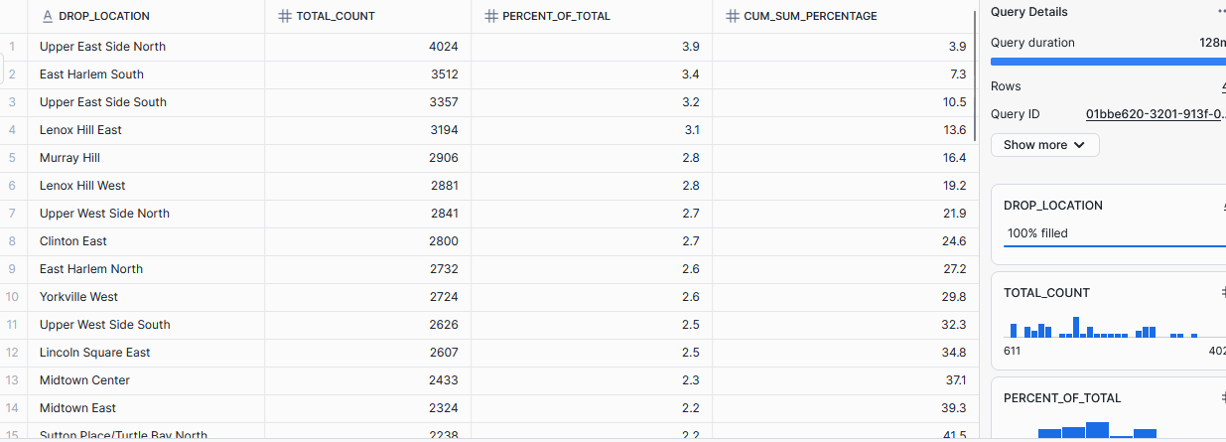

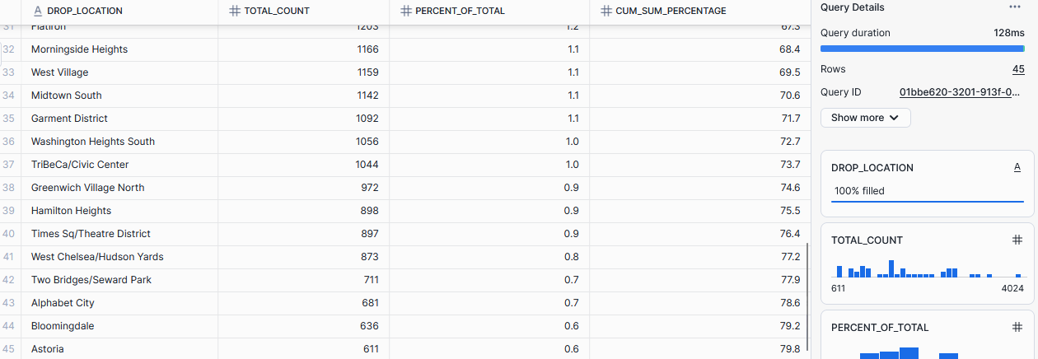

**13. We are working ON Vehicle Distribution. Find vehicles Distribution for top 20 Pickup locations**

WITH cte AS

(SELECT

location , vehicle ,

COUNT(vehicle) cnt, dense_rank() OVER(partition BY location ORDER BY COUNT(vehicle)DESC) rn

FROM uber_trip_details u

INNER JOIN loc_info l ON l.location _id = u.pickup_locid

GROUP BY Location , Vehicle

ORDER BY location ASC, cnt DESC)

SELECT location , vehicle, CASE WHEN rn = 1 then cnt END AS No_of_time

FROM cte

WHERE rn = 1

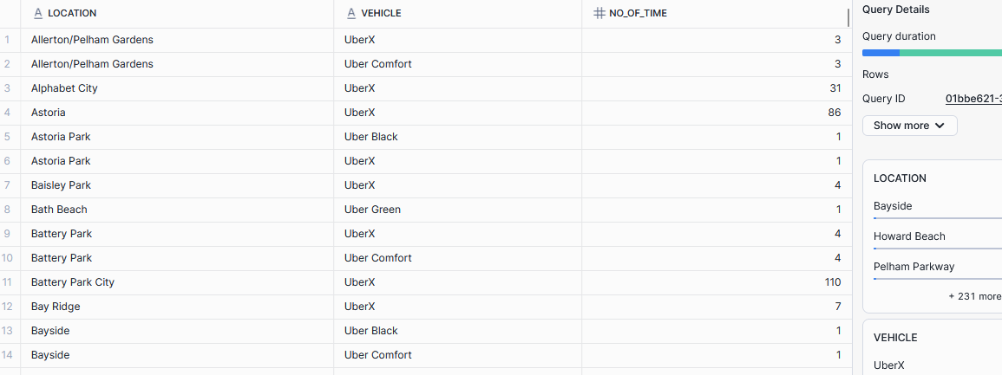

**14. Cluster trip times into dayparts (Morning, Afternoon, Evening, Night) and analyze trip frequency & revenue share per part.**

SELECT

CASE

WHEN (pickuptime) > = '04:30:00' AND (pickuptime) < '11:30:00' THEN 'Morning'

WHEN (pickuptime) > = '11:30:00' AND (pickuptime) < '16:30:00' THEN 'Afternoon'

WHEN (pickuptime) > = '16:30:00' AND (pickuptime) < '20:30:00' THEN 'Evening'

ELSE 'Night'

END AS time_of_day, COUNT(*) AS No_of_bookings,

ROUND(COUNT(CASE

WHEN (pickuptime) > = '04:30:00' AND (pickuptime) < '11:30:00' THEN 'Morning'

WHEN (pickuptime) > = '11:30:00' AND (pickuptime) < '16:30:00' THEN 'Afternoon'

WHEN (pickuptime) > = '16:30:00' AND (pickuptime) < '20:30:00' THEN 'Evening'

ELSE 'Night'

END)*100.0/(SELECT COUNT(*) FROM uber_trip_details), 1) AS Perc_of_Booking,

ROUND((SUM(fare_amnt) + SUM(Surge_Fee))/(SELECT SUM(fare_amnt) + SUM(Surge_Fee) FROM uber_trip_details)*100.0, 1) AS Revenue_percent_of_Total

FROM uber_trip_details GROUP BY 1

ORDER BY CASE Time_of_Day

WHEN 'Morning' then 1

WHEN 'Afternoon' then 2

WHEN 'Evening' then 3

WHEN 'Night' then 4 END

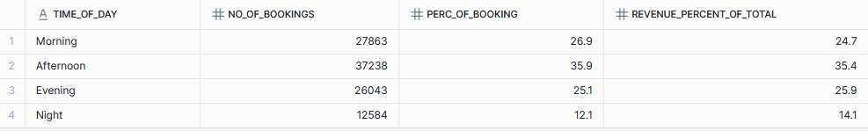

**15. Total Revenue Generated BY Vehicles**

SELECT

vehicle,

ROUND(SUM(fare_amnt) + SUM(Surge_Fee), 0) AS Total_revenue,

ROUND((SUM(fare_amnt) + SUM(Surge_Fee))/(SELECT SUM(fare_amnt) + SUM(Surge_Fee) FROM uber_trip_details)*100, 1) Perc_of_total

FROM uber_trip_details

GROUP BY Vehicle

ORDER BY Total_revenue DESC

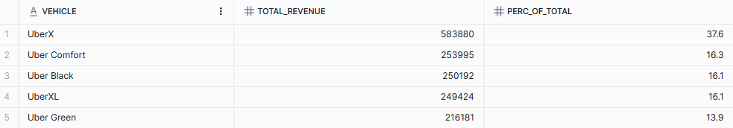

**16. Which hours of the day generate the most revenue per passengers ON average?**

SELECT

hour(pickuptime) hour_of_the_day,

COUNT(*) AS Total_Bookings,

ROUND(SUM(fare_amnt) + SUM(Surge_Fee)) AS Total_Rev

FROM uber_trip_details

GROUP BY hour_of_the_day

ORDER BY hour_of_the_day

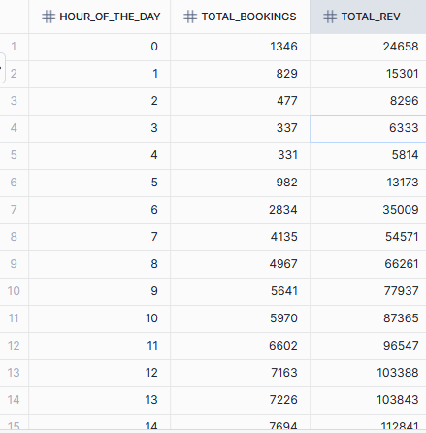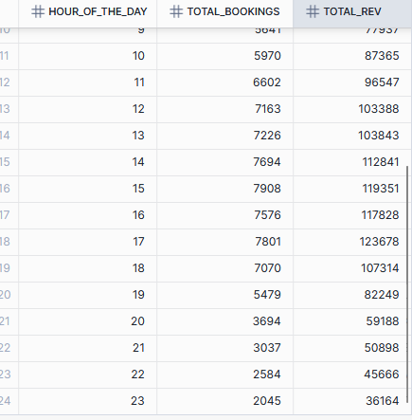

**17. What is the average fare per km across different vehicle types?**

SELECT

vehicle,

ROUND((SUM(fare_amnt) + SUM(Surge_Fee))/SUM(TRIPDIST), 2) AS Avg_fare_per_km

FROM uber_trip_details

GROUP BY vehicle

ORDER BY Avg_fare_per_km DESC

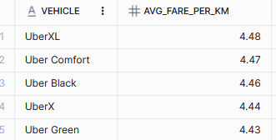

**18. What pickup location s have the highest surge fee ratios compared to base fare?**

SELECT

location ,

SUM(surge_fee) Surge_Fee,

SUM(fare_amnt) FARE_AMNT,

ROUND((SUM(surge_fee)/SUM(fare_amnt))*100, 1) Ratio

FROM uber_trip_details u

INNER JOIN loc_info l ON l.location _id = u.pickup_locid

GROUP BY location

ORDER BY ratio DESC

limit 10

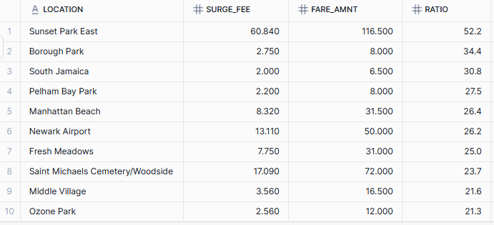

**19. Do longer trips (distance-wise) always correspond to higher fare? (Correlation analysis between distance and fare)**

SELECT

corr(tripdist, (fare_amnt + surge_fee)) AS CorrelatiON_val

FROM uber_trip_details

WHERE surge_fee>0



**20. Create Pivot Table for Weekday vs Hour ON No of Bookings**

SELECT

dayname(PickupDate) AS Weekday,

COUNT(CASE WHEN hour(PickupTime) = 0 THEN 1 END) AS "00",

COUNT(CASE WHEN hour(PickupTime) = 1 THEN 1 END) AS "01",

COUNT(CASE WHEN hour(PickupTime) = 2 THEN 1 END) AS "02",

COUNT(CASE WHEN hour(PickupTime) = 3 THEN 1 END) AS "03",

COUNT(CASE WHEN hour(PickupTime) = 4 THEN 1 END) AS "04",

COUNT(CASE WHEN hour(PickupTime) = 5 THEN 1 END) AS "05",

COUNT(CASE WHEN hour(PickupTime) = 6 THEN 1 END) AS "06",

COUNT(CASE WHEN hour(PickupTime) = 7 THEN 1 END) AS "07",

COUNT(CASE WHEN hour(PickupTime) = 8 THEN 1 END) AS "08",

COUNT(CASE WHEN hour(PickupTime) = 9 THEN 1 END) AS "09",

COUNT(CASE WHEN hour(PickupTime) = 10 THEN 1 END) AS "10",

COUNT(CASE WHEN hour(PickupTime) = 11 THEN 1 END) AS "11",

COUNT(CASE WHEN hour(PickupTime) = 12 THEN 1 END) AS "12",

COUNT(CASE WHEN hour(PickupTime) = 13 THEN 1 END) AS "13",

COUNT(CASE WHEN hour(PickupTime) = 14 THEN 1 END) AS "14",

COUNT(CASE WHEN hour(PickupTime) = 15 THEN 1 END) AS "15",

COUNT(CASE WHEN hour(PickupTime) = 16 THEN 1 END) AS "16",

COUNT(CASE WHEN hour(PickupTime) = 17 THEN 1 END) AS "17",

COUNT(CASE WHEN hour(PickupTime) = 18 THEN 1 END) AS "18",

COUNT(CASE WHEN hour(PickupTime) = 19 THEN 1 END) AS "19",

COUNT(CASE WHEN hour(PickupTime) = 20 THEN 1 END) AS "20",

COUNT(CASE WHEN hour(PickupTime) = 21 THEN 1 END) AS "21",

COUNT(CASE WHEN hour(PickupTime) = 22 THEN 1 END) AS "22",

COUNT(CASE WHEN hour(PickupTime) = 23 THEN 1 END) AS "23"

FROM

uber_trip_details

GROUP BY

Weekday

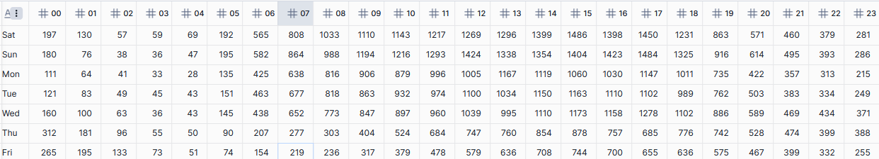

**21. What is the average number of passengers per trip across different payment types?**

SELECT

payment_type,

avg(passemger_COUNT) AS avg_passenger_per_trip , SUM(passemger_COUNT)/(SELECT COUNT(*) FROM uber_trip_details)

FROM uber_trip_details

GROUP BY payment_type

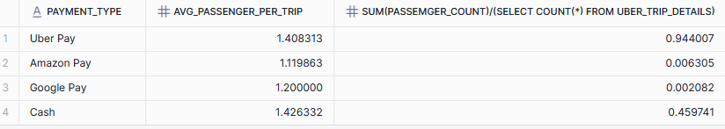

**22. What is the average number of passengers per trip across different vehicle types?**

SELECT

vehicle,

avg(passemger_COUNT) AS Avg_passenger_per_trip

FROM uber_trip_details

GROUP BY vehicle

ORDER BY Avg_passenger_per_trip DESC

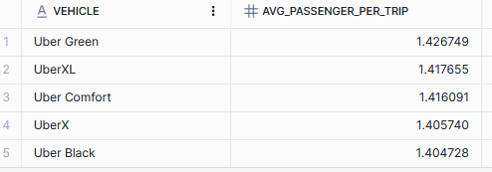

**23. Analyze fare Distribution for each vehicle type and see which has the most consistent pricing throughout week.**

SELECT vehicle,

SUM(CASE WHEN dayname(pickupdate) = 'Sun' then ROUND((FARE_AMNT + surge_fee), 1) END) AS "Sunday",

SUM(CASE WHEN dayname(pickupdate) = 'MON' then ROUND((FARE_AMNT + surge_fee), 1) END) AS "Monday",

SUM(CASE WHEN dayname(pickupdate) = 'Tue' then ROUND((FARE_AMNT + surge_fee), 1) END) AS "Tuesday",

SUM(CASE WHEN dayname(pickupdate) = 'Wed' then ROUND((FARE_AMNT + surge_fee), 1) END) AS "Wednesday",

SUM(CASE WHEN dayname(pickupdate) = 'Thu' then ROUND((FARE_AMNT + surge_fee), 1) END) AS "Thursday",

SUM(CASE WHEN dayname(pickupdate) = 'Fri' then ROUND((FARE_AMNT + surge_fee), 1) END) AS "Friday",

SUM(CASE WHEN dayname(pickupdate) = 'Sat' then ROUND((FARE_AMNT + surge_fee), 1) END) AS "Saturday"

FROM uber_trip_details

GROUP BY vehicle;

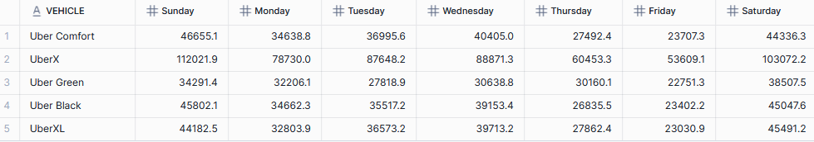

**24. Which pickup locations have the highest average surge fee and how often do they appear?**

SELECT

location ,

ROUND(avg(surge_fee), 2) surge_fee,

COUNT(*) frequency

FROM uber_trip_details u

INNER JOIN loc_info l ON l.location _id = u.pickup_locid

GROUP BY location

ORDER BY surge_fee DESC

limit 25;

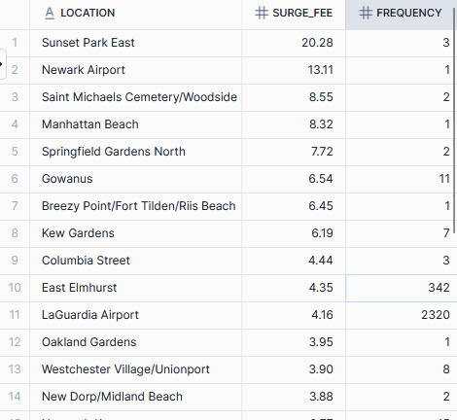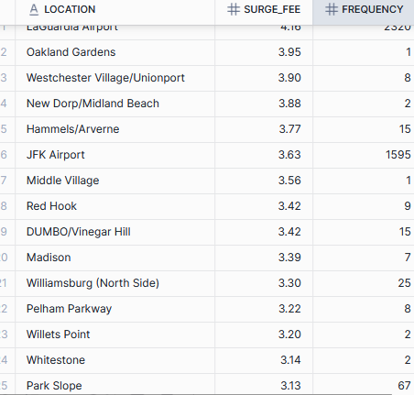

**25. Create Distance bins and find total bookings and revenue BY percentage**.

SELECT

CASE WHEN ROUND(tripdist, 0)< = 4 then '<4 KM'

WHEN ROUND(tripdist, 0)>4 and ROUND(tripdist, 0)< = 10 then '4-10 KM'

WHEN ROUND(tripdist, 0)>10 and ROUND(tripdist, 0)< = 25 then '10-25 KM'

WHEN ROUND(tripdist, 0)>25 and ROUND(tripdist, 0)< = 60 then '25-60 KM'

WHEN ROUND(tripdist, 0)>60 then '>60 KM'

END AS Distance_bins

, COUNT(*) no_of_bookings,

ROUND((SUM(fare_amnt) + SUM(surge_fee))/(SELECT (SUM(fare_amnt) + SUM(surge_fee)) FROM uber_trip_details)*100.0, 1) AS Rev_Perc_of_total

FROM uber_trip_details

GROUP BY Distance_bins

ORDER BY CASE Distance_bins

WHEN '<4 KM' THEN 1

WHEN '4-10 KM' THEN 2

WHEN '10-25 KM' THEN 3

WHEN '25-60 KM' THEN 4

ELSE 5 END

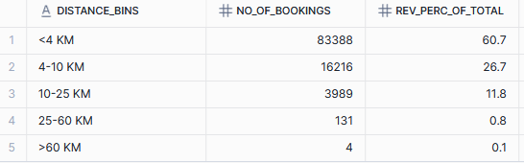

**26. Cluster trips BY pickup time(3 hour slab), trip distance, fare, and passengers COUNT**

SELECT

CASE WHEN hour(pickuptime)< = 2 then '0-3'

WHEN hour(pickuptime)>2 and hour(pickuptime)< = 5 then '3-6'

WHEN hour(pickuptime)>5 and hour(pickuptime)< = 8 then '6-9'

WHEN hour(pickuptime)>8 and hour(pickuptime)< = 11 then '9-12'

WHEN hour(pickuptime)>11 and hour(pickuptime)< = 14 then '12-15'

WHEN hour(pickuptime)>14 and hour(pickuptime)< = 17 then '15-18'

WHEN hour(pickuptime)>17 and hour(pickuptime)< = 20 then '18-21'

WHEN hour(pickuptime)>20 then '21-24' END AS Time_slab

, SUM(tripdist) Trip_Dist,

ROUND(SUM(fare_amnt) + SUM(surge_fee), 1) Total_Fare

, COUNT(*) No_of_booikngs,

SUM(passenger_COUNT) Total_Passengers

FROM uber_trip_details

GROUP BY Time_Slab

ORDER BY CASE Time_Slab

WHEN '0-3' then 1

WHEN '3-6' then 2

WHEN '6-9' then 3

WHEN '9-12' then 4

WHEN '12-15' then 5

WHEN '15-18' then 6

WHEN '18-21' then 7

WHEN '21-24' then 8 END

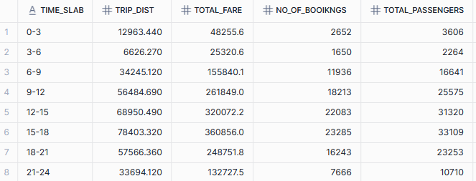

**27. Cluster trips BY pickup time (3 hour slab), trip distance, fare, and passengers COUNT but in %_of total**

SELECT

CASE WHEN hour(pickuptime)< = 2 then '0-3'

WHEN hour(pickuptime)>2 and hour(pickuptime)< = 5 then '3-6'

WHEN hour(pickuptime)>5 and hour(pickuptime)< = 8 then '6-9'

WHEN hour(pickuptime)>8 and hour(pickuptime)< = 11 then '9-12'

WHEN hour(pickuptime)>11 and hour(pickuptime)< = 14 then '12-15'

WHEN hour(pickuptime)>14 and hour(pickuptime)< = 17 then '15-18'

WHEN hour(pickuptime)>17 and hour(pickuptime)< = 20 then '18-21'

WHEN hour(pickuptime)>20 then '21-24' END AS Time_slab

, ROUND(SUM(tripdist)/(SELECT SUM(tripdist) FROM uber_trip_details)*100.0, 1) AS Trip_Dist_of_perc_in_total

, ROUND((SUM(fare_amnt) + SUM(surge_fee))/(SELECT SUM(fare_amnt) + SUM(surge_fee) FROM uber_trip_details)*100.0, 1) AS Total_Fare_perc_of_total

, ROUND(COUNT(*)/(SELECT COUNT(*) FROM uber_trip_details)*100.0, 1) No_of_booikngs_perc_of_total

, ROUND(SUM(passemger_COUNT)/(SELECT SUM(passemger_COUNT) FROM uber_trip_details)*100.0, 1) Total_Passengers_perc_of_total

FROM uber_trip_details

GROUP BY Time_Slab

ORDER BY CASE Time_Slab

WHEN '0-3' then 1

WHEN '3-6' then 2

WHEN '6-9' then 3

WHEN '9-12' then 4

WHEN '12-15' then 5

WHEN '15-18' then 6

WHEN '18-21' then 7

WHEN '21-24' then 8 END

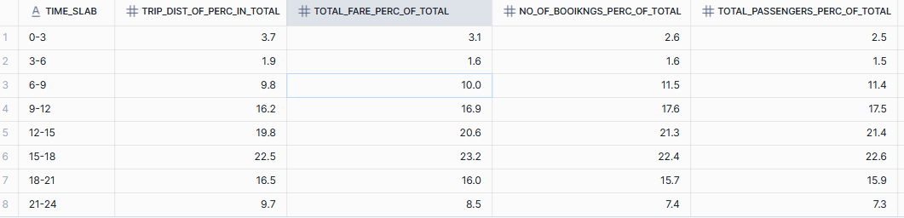

**28. which Drop-offs locations contributes most to the Surge Fee**

SELECT

location AS DropOFF_Loc,

SUM(surge_fee) AS Surge_Amount,

ROUND((SUM(surge_fee)/(SUM(fare_amnt) + SUM(surge_fee)))*100.0, 1) location _wise_perc_of_total_rev

FROM uber_trip_details u

INNER JOIN loc_info l ON l.location _id = u.drop_locid

GROUP BY DropOFF_Loc

having Surge_Amount >350

ORDER BY location _wise_perc_of_total_rev DESC

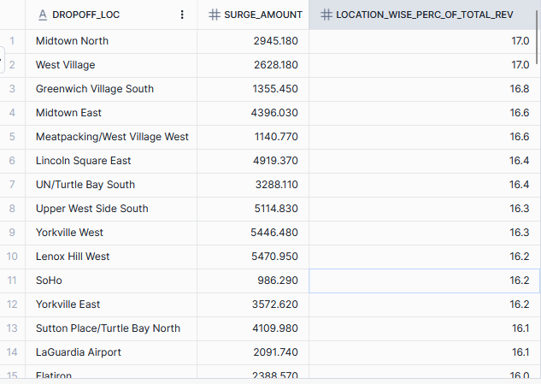

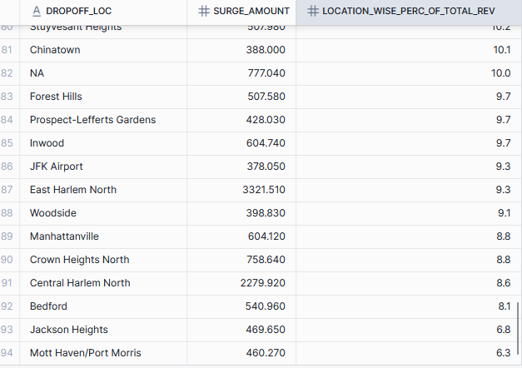

**29. Find Total Bookings ON the basis of Vehicles and Daytime**

SELECT vehicle,

SUM(CASE WHEN hour(pickuptime) > = 5 and hour(pickuptime) < 12 THEN 1 END) AS Morning,

SUM(CASE WHEN hour(pickuptime) > = 12 AND hour(pickuptime) < 16 THEN 1 END) AS Afternoon,

SUM(CASE WHEN hour(pickuptime) > = 16 AND hour(pickuptime) < 20 THEN 1 END) AS Evening,

SUM(CASE WHEN hour(pickuptime) > = 20 or hour(pickuptime) < 5 THEN 1 END) AS Night

FROM uber_trip_details

GROUP BY vehicle

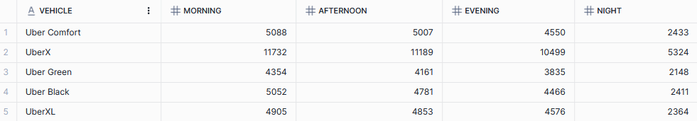

**30. Find Total Surge Amount ON the basis of Vehicles and Daytime**

SELECT vehicle,

SUM(CASE WHEN hour(pickuptime) > = 5 and hour(pickuptime) < 12 THEN surge_fee END) AS Morning,

SUM(CASE WHEN hour(pickuptime) > = 12 AND hour(pickuptime) < 16 THEN surge_fee END) AS Afternoon,

SUM(CASE WHEN hour(pickuptime) > = 16 AND hour(pickuptime) < 20 THEN surge_fee END) AS Evening,

SUM(CASE WHEN hour(pickuptime) > = 20 or hour(pickuptime) < 5 THEN surge_fee END) AS Night

FROM uber_trip_details

GROUP BY vehicle

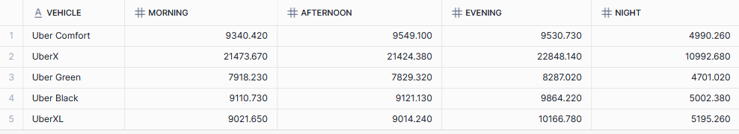

**31.Find No of Trips ON the basis of time of this format : 0-5 minutes, 5-15 minutes, 15 minutes to 1 hour, 1 hour to 3 hour, 3-8 hour, 8-24 hour, 24 hour +**

WITH cte AS(

SELECT

trip_id,

TOTIMESTAMPDIFF(minute, TO_TIMESTAMP(pickupdate || ' ' || pickuptime), TO_TIMESTAMP(dropday || ' ' || droptime)) time_intrvl

FROM uber_trip_details),

cte2 AS(

SELECT

CASE WHEN time_intrvl<5 then 'Very_Short 0-5min'

WHEN time_intrvl> = 5 and time_intrvl<16 then 'Short_Ride 5-15min'

WHEN time_intrvl> = 16 and time_intrvl<61 then 'Medium_Ride 15min - 1Hour'

WHEN time_intrvl> = 61 and time_intrvl<181 then 'Long_Ride 1Hour-3Hour'

WHEN time_intrvl> = 181 and time_intrvl<481 then 'Extra_long_ride 3-8Hour'

WHEN time_intrvl> = 481 and time_intrvl<1441 then 'OVER_Haul_Ride 8-24Hour'

ELSE 'Outlier' END AS Time_period

FROM cte)

SELECT Time_period, COUNT(Time_period) No_of_Rides

FROM cte2

GROUP BY 1

ORDER BY CASE Time_period

WHEN 'Very_Short 0-5min' then 1

WHEN 'Short_Ride 5-15min' then 2

WHEN 'Medium_Ride 15min - 1Hour' then 3

WHEN 'Long_Ride 1Hour-3Hour' then 4

WHEN 'Extra_long_ride 3-8Hour' then 5

WHEN 'OVER_Haul_Ride 8-24Hour' then 6

WHEN 'Outlier' then 7 END

