**iPhone Sales Analysis Report**

Date: September 10, 2025

Analysis Prepared By: [Abhiudai Shahi / bt22csd040]

1. Executive Summary

This report provides a comprehensive analysis of the provided iPhone sales data, focusing on product performance, sales trends, and customer purchasing behaviour. The data reveals that the Apple iPhone 15 Plus (Blue, 128 GB) has emerged as the single highest-selling model by volume and revenue, closely followed by the popular iPhone 13 (128GB) models. Sales are highly seasonal, with a significant spike in September, indicating a critical period for marketing and inventory management.

Furthermore, an analysis of product categories shows a clear market preference for "Standard" iPhone models over "Pro" models. This suggests a powerful synergy where the accessibility of standard and plus-sized models captures the broader market. The key recommendation is to optimize inventory for the top-performing iPhone 15 Plus and iPhone 13 models ahead of the September peak.

2. **Data Preparation & Cleaning**

To ensure the accuracy of the findings, the raw data was processed and cleaned. Key steps included:

* **Removing Irrelevant Data:** The 'country' column was deleted as it was not needed for the analysis.
* **Handling Missing Values:** All blank cells within the dataset were populated with "N/A" to ensure data completeness.
* **Removing Duplicates:** The dataset was checked for any duplicate transaction entries, which were removed to ensure each sale was counted only once.

3. Sales Performance Dashboard

The dashboard below visualizes the core findings of this analysis, highlighting the top products, key sales periods, and dominant market categories.

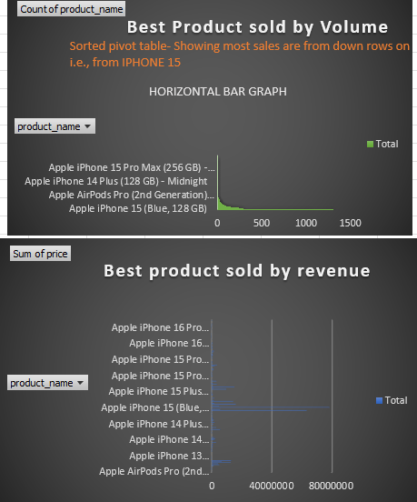

|  |
| --- |
| 1. Bar Chart: iPhone Sales Volume by Model |
|  |
| *This chart clearly illustrates that the Apple iPhone 15 Plus (Blue, 128 GB) is the definitive top-seller by volume as well as by value, followed closely by two variations of the Apple iPhone 13 (128GB). These three products represent the most critical models in the portfolio.* |

|  |
| --- |
| 2. Line Chart: Monthly Sales Trend |
|  |
| *The sales trendline demonstrates a massive and sharp increase in sales during September, confirming the highly seasonal nature of the business and pinpointing the most important month for strategic planning.* |

|  |
| --- |
| 3. Pie Chart: VLookup Categories |
|  |
| *This chart reveals two key insights: firstly, a large portion of product sales are uncategorized (#N/A) as we took short demo vlookup data, and secondly, within the categorized data, "Standard" models make up the vast majority of sales compared to "Pro" models.* |

4. Key Findings & Insights

Insight 1: Top-Selling Models by Sales Volume After data cleaning and consolidation, the analysis reveals a new top performer. The top-selling models show a consumer preference for both newer "Plus" models and the enduring value of the iPhone 13 series.

* 1st Place: Apple iPhone 15 Plus (Blue, 128 GB) - 1305 units
* 2nd Place: Apple iPhone 15 Plus (Black, 128 GB) - 1055 units
* 3rd Place: Apple iPhone 13 (128GB) – Starlight – 298 units
* 4th Place: Apple iPhone 13 (128GB) - Midnight - 294 units
* 5th Place: Apple iPhone 15 (128GB) - Green - 269 units

Insight 2: Sales Trends are Highly Seasonal The timeline analysis reveals a distinct and predictable pattern in sales.

* September Surge: There is a dramatic spike in sales volume during the month of September, which accounted for a majority of the year's transactions. This is almost certainly linked to Apple's annual new product launch event.
* Strategic Importance: This seasonality underscores the need for strategic planning, with inventory levels and marketing campaigns needing to be at their peak in late August and September to capture this predictable demand.

Insight 3: Clear Preference for Standard and Plus Models The categorization of sales using VLOOKUP shows a definitive trend in consumer choice.

* Market Dominance: "Standard" iPhone models vastly outsell "Pro" models in terms of the number of units sold. This suggests that the larger consumer base prioritizes cost-effectiveness and screen size over the high-end features exclusive to the Pro lineup.
* Data Note: While a significant portion of products were not categorized (#N/A), the trend among the categorized items is overwhelmingly clear and provides a strong directional insight into market preferences.

5. Recommendations

1. Optimize Inventory for Key Models: Prior to the peak sales season, significantly increase stock levels for the Apple iPhone 15 Plus (Blue, 128 GB) and the top iPhone 13 (128GB) models to prevent stockouts and maximize revenue.
2. Targeted Marketing Campaigns: Develop marketing campaigns that focus on the value and popular features of the iPhone 15 Plus and iPhone 13. Highlight the benefits of the larger "Plus" screen for the broader market.
3. Enhance Data Categorization: To gain even deeper insights, a project should be undertaken to clean the dataset and assign a category ("Pro", "Standard", "Plus") to all products. This will allow for a more precise analysis of the revenue and margin contribution of each category.