**Seamlessly Integrating a Person into a Scene**

**Role:** AI Engineer  
**Name:** Abhiudai Shahi (BT22CSD040)  
Email: [bt22csd040@iiitn.ac.in](mailto:bt22csd040@iiitn.ac.in)

Phone: 9696333760  
**Tools Used:** Pixelcut.ai, Photopea, Let's Enhance, Watermark Remover.



## भारतीय सूचना प्रौद्योगिकी संस्थान, नागपुर

## INDIAN INSTITUTE OF INFORMATION TECHNOLOGY, NAGPUR

### (An Institution of National Importance by Act of Parliament) Survey No.140,141/1 behind Br.Sheshrao Wankhede Shetkari Sahkari Soot **Girni,Nagpur, 441108**

**Objective**

The objective of this assignment was to integrate a person into a background scene in a photorealistic way, ensuring proper alignment of lighting, shadows, color tones, and spatial blending — using any available tools and manual processing. The focus was on visual realism without coding.

**Task Breakdown & Execution**

**Task 1: Capturing and Preparing the Person’s Image**

**Step 1: Capture a High-Quality Image**  
A front-facing image of the subject (my mother) was captured while sitting on a sofa in a well-lit indoor environment.

**Step 2: Remove the Background**  
The background was removed using the online tool [Pixelcut.ai](https://www.pixelcut.ai/ai-image-editor?tool=removeBackground), which isolated the subject with a transparent background. This provided a clean foreground image ready for insertion into a different scene.

**Task 2: Analyzing Shadows and Lighting of the Background Image**

**Step 1: Detect and Classify Shadows**  
Upon analyzing the selected background (a room with a window on the right side), the lighting was identified as **diffused daylight**, with **soft shadows** visible beneath furniture. Based on this:

* Shadow type was classified as: **Soft Shadow**
* A soft shadow mask was planned

**Task 3: Determining Light Direction**

* Light was observed to be entering from the **right side** of the background scene (through the window).
* To match this, the subject image was **flipped horizontally in Photopea** so that her brighter side faced the incoming light.
* Contrast was enhanced slightly between her right and left side to better align with the environment’s lighting.

**Task 4: Coloring and Blending the Subject into the Scene**

This section required several **missing steps not mentioned in the assignment**, which were crucial for realism:

**🔹 Missing Step 1: Resizing and Positioning**

The subject’s image was rescaled using Free Transform in Photopea and placed appropriately on the background to ensure correct proportions with objects in the room (e.g., floor, wall, window).

**🔹 Missing Step 2: Shadow Creation**

* A **new layer** was created below the subject
* A soft black oval was drawn slightly **to the left-bottom**, to match the light direction
* Gaussian Blur was applied, and opacity was lowered to 30–40% for natural blending

**🔹 Missing Step 3: Color Harmonization**

* Minor brightness and contrast adjustments were done to make the subject match the overall tone of the background scene.

**🔹 Missing Step 4: Edge Feathering**

* The Eraser tool and soft blur were used at the edges of the subject’s image to remove sharp cutout lines and make her blend naturally into the background.

**Task 5: Generating the Final Output**

The composite was polished and finalized in the following way:

1. **Final image exported** from Photopea
2. **Upscaled using** [**Let's Enhance**](https://letsenhance.io) for improved clarity and sharpness
3. **Watermark (shutterstock.com) removed using** [**Watermark Remover**](https://www.watermarkremover.io/)

**✅ Final Deliverables**

* **Final Composite Image**: A photorealistic output with natural lighting, soft shadows, and seamless integration of the subject into the background.
* **Algorithm Documentation**: This document outlines each step (including those missing in the original assignment), tools used, and reasoning for each design choice.

**Tools and Resources Used**

| **Tool** | **Purpose** |
| --- | --- |
| Remove.bg | Background removal |
| Photopea | Layer editing, flipping, shadow drawing, blending |
| Let's Enhance | AI-based upscaling and clarity enhancement |
| Watermark Remover | Clean-up of final output image |

FINAL RESULT :

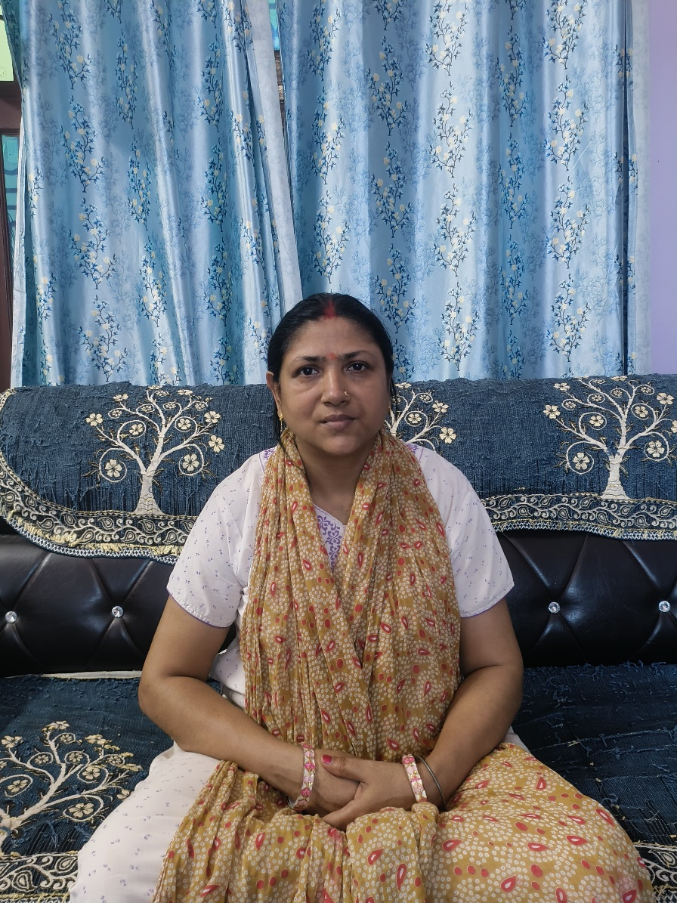

Clicked image

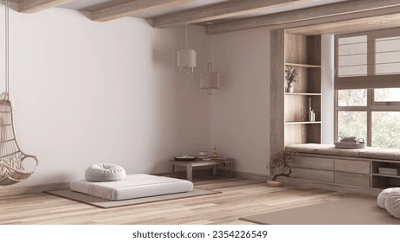

Background Image(Source : Internet)

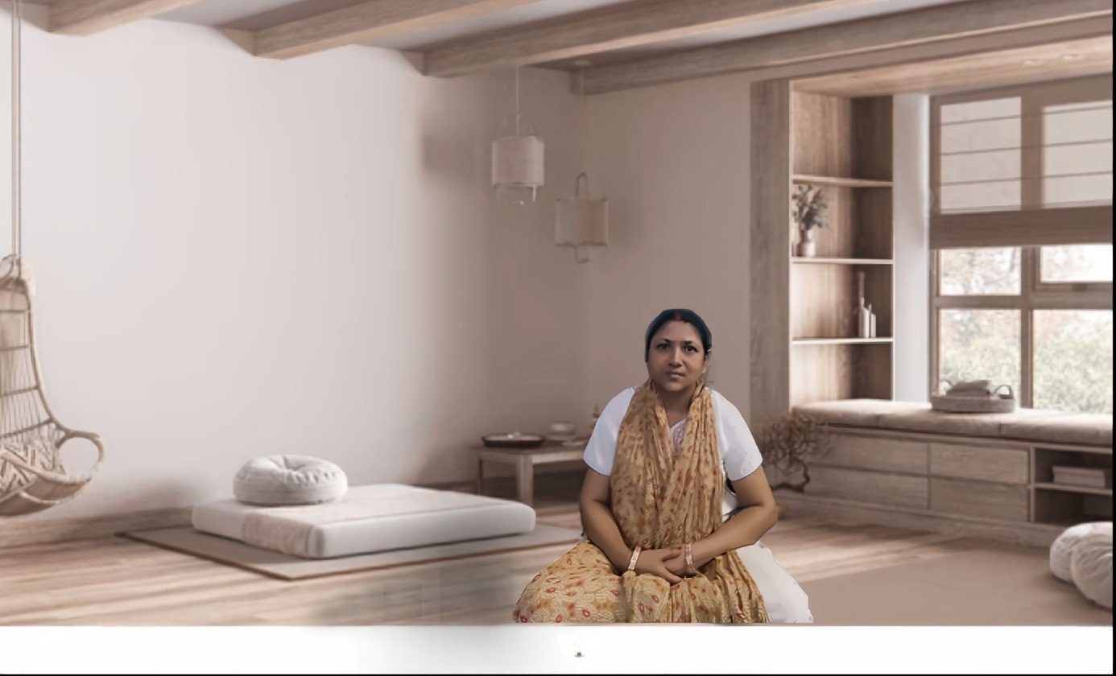

FLAM_Final_Image.jpg