**MethanODE: A Unified Neural ODE Approach for Chemical Kinetics Modeling**

***Assignment report submitted to - Siemens***

By - Abhiudai Shahi (BT22CSD040)

**June -2025**



## 

## भारतीय सूचना प्रौद्योगिकी संस्थान, नागपुर

## INDIAN INSTITUTE OF INFORMATION TECHNOLOGY,NAGPUR

**1. Introduction:**  
Modeling the time evolution of chemical species during combustion is essential for simulating reactive systems, engine design, and pollutant formation. Traditional detailed chemical kinetic solvers (e.g., Cantera with GRI-Mech 3.0) are accurate but computationally expensive, especially when modeling mechanisms with tens of species and reactions.

Recent approaches such as ChemNODE have introduced neural ordinary differential equations (Neural ODEs) for modeling species evolution in reactive systems. However, ChemNODE's sequential training strategy, while stable, introduces limitations in capturing species interactions and propagates errors across species. In this project, we present **MethanODE**, a unified training approach using Neural ODEs to learn the joint dynamics of 53 chemical species and temperature in methane oxidation.

**2. Objectives:**

* Improve prediction accuracy and physical consistency over ChemNODE
* Capture coupled species dynamics and temporal evolution using a unified model
* Handle high-concentration spikes and maintain stability

**3. Methodology:**

**3.1 Dataset and Preprocessing:**



Sample image of testing_data.csv provided

* Species concentration and temperature data was provided by the Siemens team.
* The dataset contains 53 species labeled form y1 to y53 and a temperature column.
* Standard scaling was applied to normalize inputs since temperature had very high values compared to other columns hence for better training , making their mean=0 and std=1 was necessary.
* Both training and testing data was provided hence train_test_ split was not required.

**3.2 Model Architecture - MethanODE:**

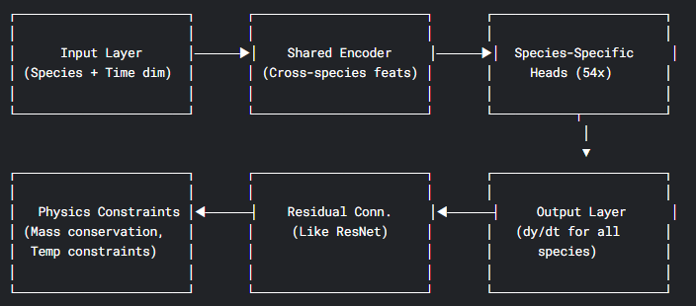

ASCII Architecture Diagram

* A shared encoder-decoder model built using Neural ODEs
* 53 species + temperature modeled as a coupled ODE system
* Each output channel corresponds to a species or temperature prediction

**3.3 Training Strategies:**

**A. Sequential Training (ChemNODE-style)**

* Each species trained independently
* Later species depend on predictions of earlier species, others use ground truth
* Drawbacks: error propagation, loss of coupled dynamics, longer training time

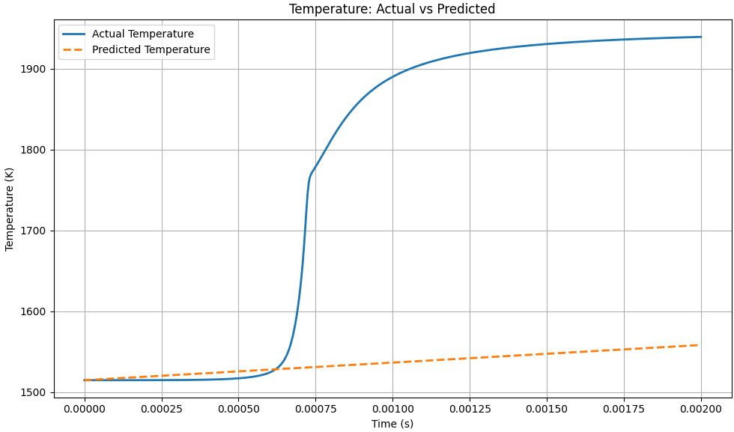

PLOT 1: SHOWING POOR LEARNING DURING SEQUENTIAL TRAINING

(as each specie ignored others)

**B. Unified Training (Proposed)**

* All species and temperature trained jointly
* Allows shared representation learning for coupled dynamics
* Used Cosine annealing schedulers, adjust the learning rate following a cosine curve
* Loss components:
  + Weighted MSE loss to focus on high-concentration spikes
  + Gradient loss to enforce temporal consistency
  + Physics-informed constraints (e.g., mass conservation)

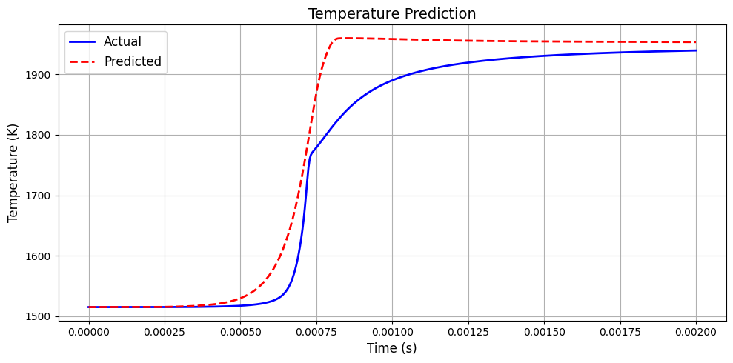

PLOT 2: SHOWING BETTER LEARNING WITH UNIFIED TRAINING

**3.4 Optimizers and Schedulers:**

* MethanODE: AdamW with OneCycle or ReduceLROnPlateau scheduler
* ChemNODE: Used Levenberg-Marquardt (LM) optimizer (not implemented here)

**4. Evaluation Metrics:**

* **MAE (Mean Absolute Error)** and **RMSE (Root Mean Squared Error)** for all species and temperature
* **Correlation Coefficient (R) per specie** to validate pattern agreement
* **Spike and Flat MAE (for better capturing spikes in chemical species)**

**5. Results:**

**5.1 MethanODE (Unified Training) Results:**

* Temperature:
  + MAE: 34.85 K
  + RMSE: 49.46 K
* Species:
  + Avg MAE: 2.37e-04
  + Avg RMSE: 1.13e-03
  + R(Correlation b/w actual & predicted concentration ): >0.8 for most species
  + Spikes captured with higher fidelity

**5.2 Comparison with ChemNODE:**

| **Quantity** | **Species** | **ChemNODE AMAE** | **MethanODE MAE** | **Remarks** |
| --- | --- | --- | --- | --- |
| **Temperature** | T | 7.14×10⁻⁴ (≈3%) | 34.85 K (≈2.0%) | Comparable or better relative error (normalized) |
| Concentration | H₂ (y1) | 4.72×10⁻³ | 2.57×10⁻⁴ | Significantly lower error |
| Concentration | O₂ (y2) | 2.18×10⁻³ | 1.85×10⁻⁴ | Better than ChemNODE |
| Concentration | O (y4) | 9.14×10⁻³ | 4.36×10⁻³ | Slightly higher |
| Concentration | OH (y14) | 8.51×10⁻³ | 1.69×10⁻³ | Much better than ChemNODE |
| Concentration | H₂O (y26) | 1.17×10⁻² | 1.02×10⁻⁶ | Drastically lower error |

Table 1: Concentration Prediction – ChemNODE vs MethanODE(randomly assumed y1 as H2 or y2 as O2… for species comparision)

* ChemNODE reported normalized MAEs (~1e-3 to 1e-2) for species at various Φ values
* MethanODE achieves lower unnormalized MAEs and better shape consistency
* ChemNODE's sequential training caused compounding errors; MethanODE mitigates this

--------------------------------------------------------------------------------------------------------

|  |  |  |
| --- | --- | --- |
|  |  |  |
|  |  |  | **Aspect** | **ChemNODE Paper (Hydrogen)** | **My Model (Methane – MethanODE)** |
|  |  |  | **System** | H₂/Air combustion | CH₄/Air combustion (GRI-Mech 3.0) |
|  |  |  | **Num. Species** | 6–7 | 53 |
|  |  |  | **Temperature Range (K)** | 950–1200 | ~1500 |
|  |  |  | **Architecture** | 1-layer, 10 neurons per species | Shared 2-layer encoder + 1-layer per-species head + ResNet-like skip + physics constraints |
|  |  |  | **Optimizer** | Levenberg–Marquardt (2nd-order) | Adam (1st-order) |
|  |  |  | **Loss Function** | MSE over all time (species-wise) | MAE (Spike + Flat) joint across all species |
|  |  |  | **Log-scaling** | Sometimes used | Not used |
|  |  |  | **Model Type** | Per-species ODE models | Single joint model for all species + temperature |
|  |  |  | **Global RMSE** | Not directly reported | 0.00113 (species), 49.46 (temperature) |
|  |  |  | **Global MAE** | ~7×10⁻⁴ to 1×10⁻² (normalized) | 2.37×10⁻⁴ (species), 34.85 (temperature) |
|  |  |  | **Training Epochs** | Not specified (few hundred estimated) | 130 |
|  |  |  | **Total Parameters** | ~1,000–2,000 per species model | 971,884 total |

**Table 2: Comparison Between ChemNODE (Hydrogen) and My Model MethanODE (Methane)**

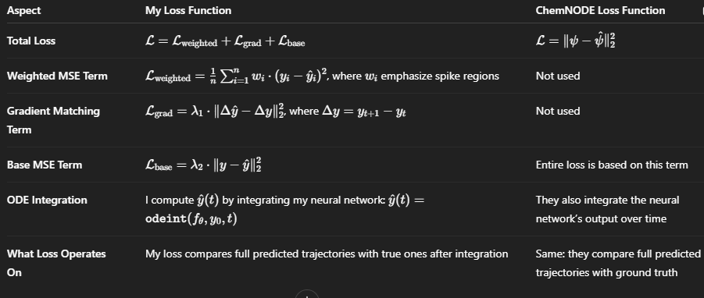

TABLE 3: COMPARISION OF LOSS FUNCTIONS

* wi ​ are adaptive weights giving more importance to spike values in your implementation.
* λ1=0.2, λ2=0.3 are the weighting coefficients for gradient and base MSE terms in your code.
* In ChemNODE, the loss is computed **only** based on the integrated trajectory difference, without weighting or gradient penalties.

**---------------------------------------------------------------------**

**6. Visual Analysis:**

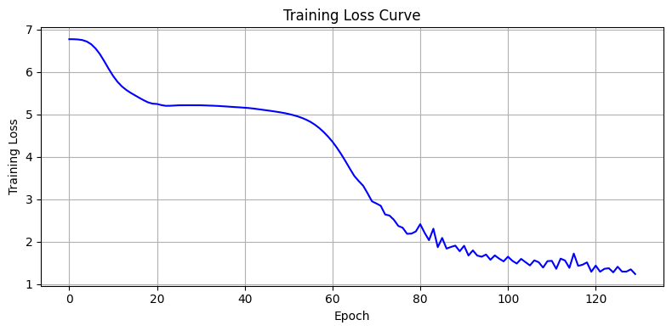

PLOT 3: TRAINING CURVE

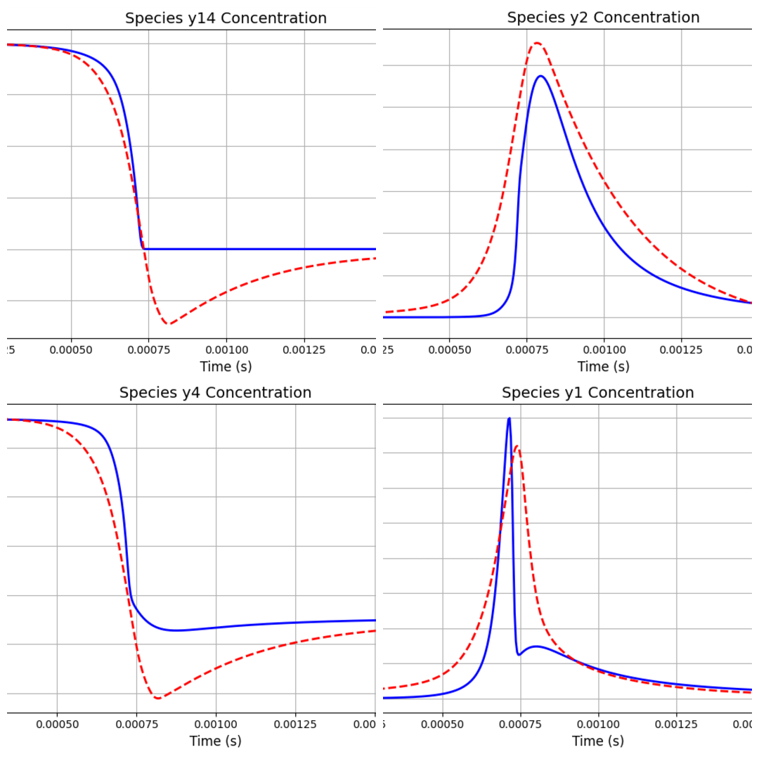

PLOT 4: ACTUAL VS PREDICTED CONCENTRATION OF SOME SPECIES WITH TIME (red=predicted, blue= actual)

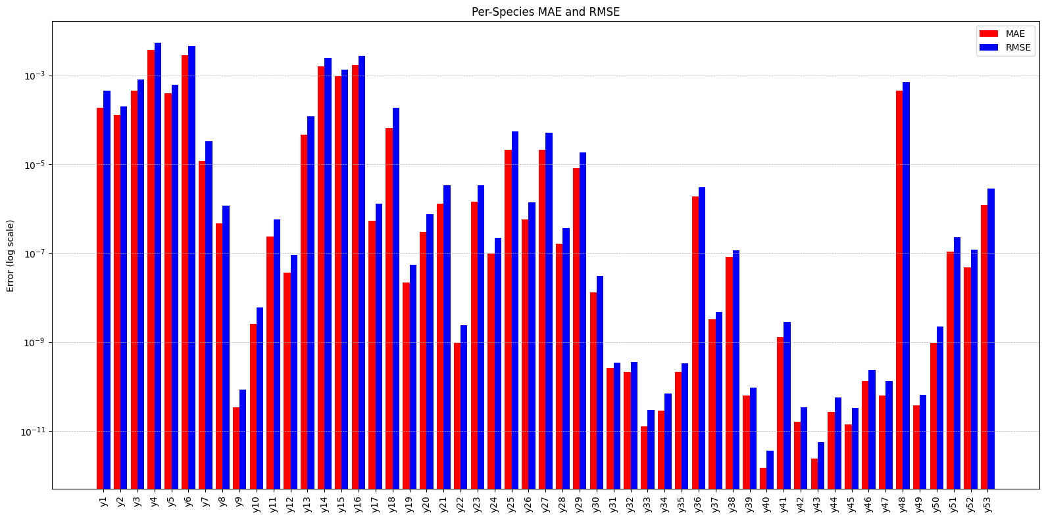

PLOT 5: Computing per-species(log scaled) MAE and RMSE VALUES

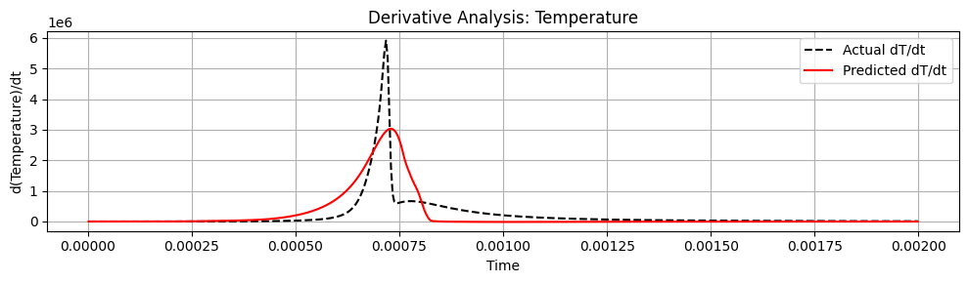



PLOT 6: DERIVATIVE PLOT

Each neuaral network for each speicies predicts it's rate of change with time. Its Overall concentration is calculated by :

[Original conc + dy/dt * time]

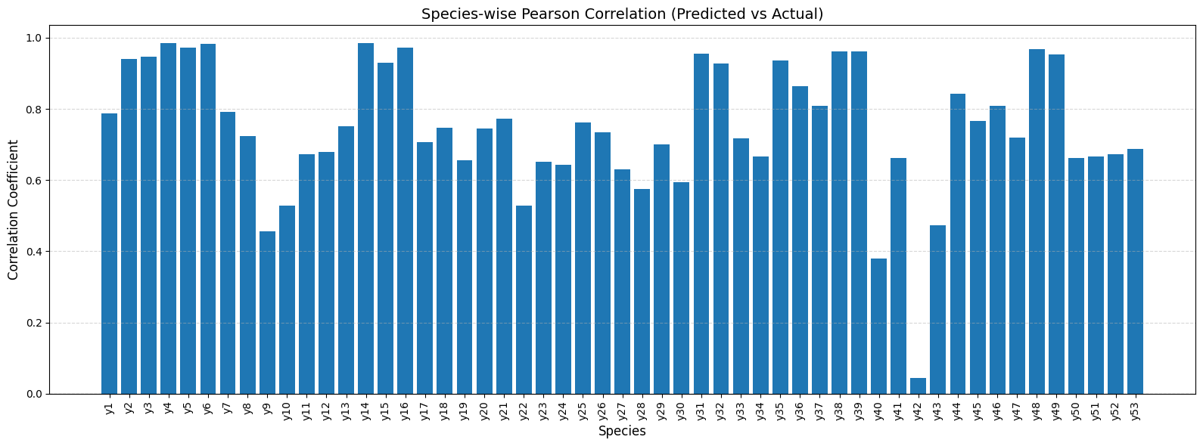

PLOT 7 : Correlation Plot: Actual vs Predicted Species

This plot shows the **Pearson correlation coefficient (R)** between the actual and predicted concentration profiles for each species.

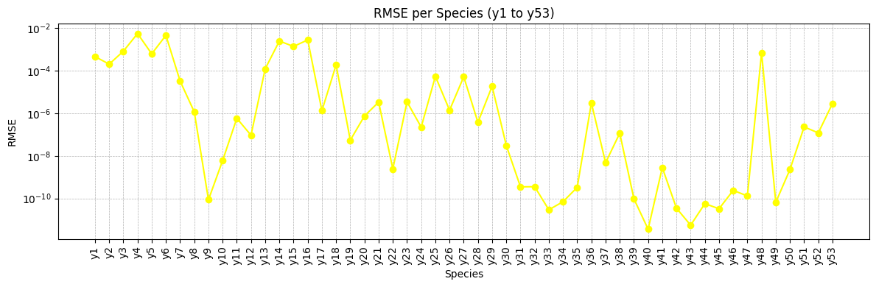 PLOT 8: SHOWING RMSE VALUES OF ALL SPECIES THROUGH A LINE CHART

High correlation indicates that the model successfully learns the **shape and dynamics** of the species over time, not just the average values.

Note: Even a low-concentration species can have high correlation if the model learns its pattern correctly.

**7. Conclusions:**

* MethanODE significantly improves prediction accuracy and stability in kinetic modeling
* Unified training strategy captures species interactions and reduces error propagation
* Sequential training as per chemNODE was taking a lot time to train each species individually . Moreover species while training ignored other species values resulting in much poor learning. These drawbacks were overcomed by methanODE.
* Model better captures dynamics and spikes than sequential variant of chemNODE
* Can be extended with physics constraints and hyperparameter tuning for further gains

**8. Future Work:**

* Implement LM optimizer for direct ChemNODE comparison
* Introduce uncertainty quantification
* Explore hybrid symbolic-ML approaches for explainability

THANK YOU !!!