App Dev Project Report

1. Student Details
Name:Abhinav R. Tiwari
Roll Number:24f3003222 Email:24f3003222@ds.study.iitm.ac.in
About Me: I am an engineering student with a deep interest in full-stack web application development, specifically backend and integrating solutions using different technologies like data science, geospatial apis, etc. to create data-driven software.

2. Project Details
Project Title: Hospital Management System V2
Problem Statement: To design and build a multi-role, web-based application that streamlines hospital operations. The system must allow patients to book appointments, doctors to manage availability and treatment records, and administrators to oversee hospital statistics, all while automating administrative tasks like email reminders and reporting.
Approach:The backend is powered by Flask with a modular Blueprint structure, handling RESTful APIs, JWT authentication, and background task queuing with Celery and Redis. The frontend is a Single Page Application (SPA) built with Vue 3 and styled with Bootstrap 5.

3. AI/LLM Declaration
I used ChatGPT/Gemini to assist in converting the frontend UI from a utility-first framework to standard Bootstrap 5, formatting Chart.js boilerplate, and structuring basic API scaffolding.
The extent of AI/LLM usage is approximately 15-20%, limited primarily to frontend styling, UI migration and repetitive templating. All core architectural logic, database schema design, Redis caching implementation, secure JWT blacklisting, and Celery background task integration were done manually.

4. Technologies and Frameworks Used
- Flask: Core backend web framework for developing RESTful APIs.
- SQLAlchemy & SQLite: Object Relational Mapper (ORM) and lightweight local database for storing user and hospital data.
- Flask-JWT-Extended: User authentication, role-based access, and session management.
- Vue 3 & Bootstrap 5: Frontend JavaScript framework and UI styling for a responsive SPA.
- Celery & Redis: Task queue and message broker for asynchronous background jobs (emails, CSV exports) and API caching.
- Google GenAI (Gemini): Used to generate automated clinical summaries from patient history.
- Chart.js: To visualize trends such as appointment statuses on the admin dashboard.

5. Database Schema / ER Diagram
Tables:
- Department: Stores clinical specialties (dep_id, dep_name, dep_des, no_docs_registered).
- Doctor :Practitioner profiles (doctor_id, username, password, type, experience, qualification).
- Patient: Patient profiles (patient_id, username, password, email, phone, age, gender, is_blacklisted).
- DoctorAvailability: Time slots configured by doctors (availability_id, doctor_id, date, start_time, end_time, slot_name).
- Appointment: Transactional record of a booking (app_id, patient_id, doctor_id, status, date, time).
- Treatment: Medical records linked to a visit (treatment_id, app_id, diagnosis, prescription, medication).
- ChatMessage: Follow-up messages (id, appointment_id, sender_role, message).
Relationships:
- One-to-Many → Department → Doctor
- One-to-Many → Doctor → DoctorAvailability
- One-to-Many → Doctor → Appointment
- One-to-Many → Patient → Appointment
- One-to-One → Appointment → Treatment
- One-to-Many → Appointment → ChatMessage
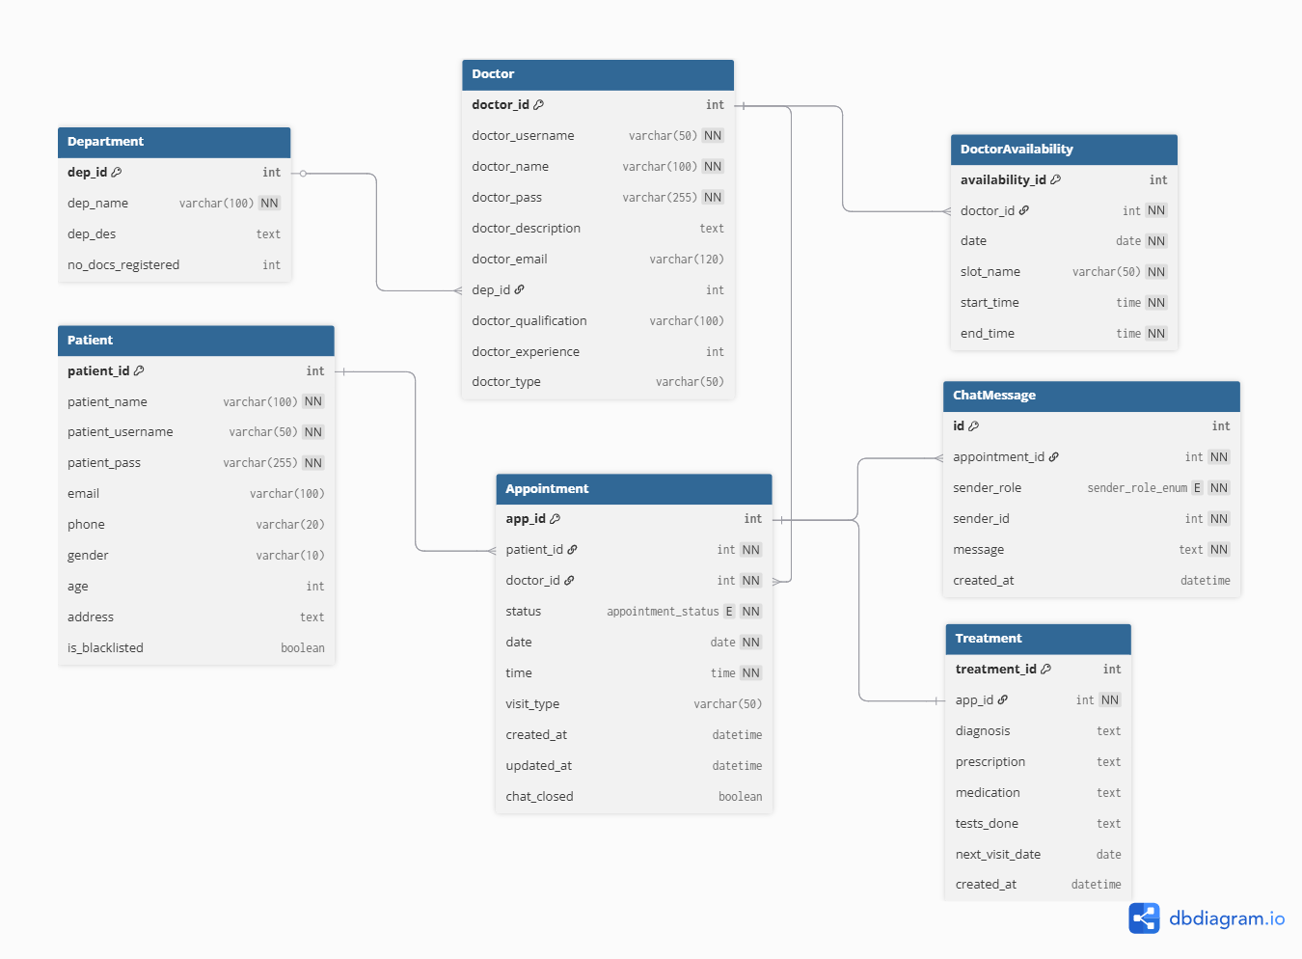

6. API Resource Endpoints
A few endpoints(the rest are in api.yaml):
Endpoint | Method | Description
/api/auth/login/<role> | POST | Authenticate Admin/Doctor/Patient and generate JWT session
/api/admin/dashboard | GET | Fetch aggregated statistics and caching via Redis
/api/patient/book/<id> | POST | Add a new appointment entry checking slot capacity limits
/api/doctor/appointments/<id>/treatment | POST | Log diagnosis and prescription for a completed appointment
/api/appointments/<id>/messages | POST | Send a chat message within the 48-hour post-visit window
/api/doctor/patients/<id>/summary | POST | Return an AI-generated clinical summary of the patient's history
YAML API Definition File: Included separately in the submission ZIP as api.yaml.

7. Architecture and Features
Architecture Overview:
- main.py: Main Flask application entry point, JWT config, and Blueprint registration.
- /models.py: Database models and relationships using SQLAlchemy.
- /routes: Flask Blueprints separating logic by domain (admin.py, doctor.py, patient.py, chat_service.py, ai_summary.py).
- tasks.py & celery_app.py: Celery workers, schedules (Beat) and SMTP email logic.
- cache.py: Redis configuration for API response caching and JWT blacklisting.
Implemented Features:
- Independent User registration and login for Doctors and Patients using JWT auth.
- Daily activity tracking, appointment lifecycle management and doctor availability toggling.
- Visualization dashboard for Admins using Chart.js.
- Redis caching for frequent GET requests (e.g., department lists) to reduce DB load.
- Secure password handling and JWT token blacklisting upon logout.
- Daily appointment reminder emails and Monthly doctor activity reports dispatched via Celery Beat schedules.
- Patients can request their history as a CSV, which is processed by Celery and emailed as an attachment without blocking the UI.
Additional Features:
- AI Clinical Insights: Integration with Google Gemini (gemini-2.5-flash) to generate clinical summaries based on past treatment data to help doctors with recall.
- Time-locked (48-hour) post-consultation chat system between doctor and patient.

8. Video Presentation
Drive Link: [ https://drive.google.com/file/d/your-video-link-here ] (Accessible to all with “View” permission.)

