# LUMBINI ICT CAMPUS

**Affiliated to TU** Gaindakot-4, Nawalpur

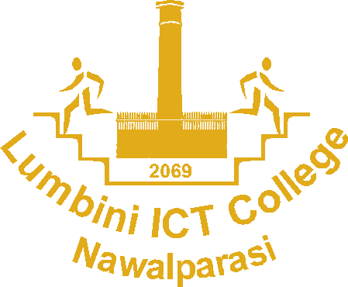

## Title: Mini-project report

**Submitted by Submitted to**

* Abhiyan lamsal Campus Lab Department
* Diwas Sharma
* Sagun Sapkota

**Date: 2076-08-09**

Table of Contents

Introduction 2

Objectives 3

Background 3

Body 3

Tools & Technology 3

Functions 3

Expected Outcomes 4

# Introduction

Namaste Nepal is specially designed for purpose of serving tourism industry in Nepal. Coming to Nepal is coming to an experience that is only yours. From the remotest corners to the urban landscape, Nepal embodies a sensory experience of colors, sounds, sights and tastes. Namaste Nepal welcomes you to Nepal for life’s amazing moments.

# Objectives

* The site is built to serve international or domestic individual or group travels.
* The site provides link to external database, GIS mapping information, online utility payments, and engagement tools and social networking.
* There is so much that the Nepal has to offer and we feel, through superior design, that we can convey the dynamic energy and diversity to all who visit the site.

# Background

Technology and expectations have change to enable us to build a better site to serve the community. We are looking to build a distinctive modern site to reflect the diversity, character and uniqueness of Nepal. It needs to be responsive for mobile devices, intuitive to easily find information and accessible to the entire community and visitors.

# Body

## Tools & Technology

CMS (content management software) like Microsoft Visual Code Studio and Github.

## Functions

## Header: It has functions and user login to make it easier to navigate the site.

Home: It is landing page of the site.

Book: It will allow clients to fill up details of their visit.

Packages: The site offers visiting packages at cheap rate. It comes with all necessary like hotel room, foods, travel fee and guides.

Features: It contains full overview of what above packages will offer at the given rate.

Gallery: It reflects the beauty of Nepal through image.

Contact: User can report any problems through this or send us feedback.

Footer: Footer contains socials links, about us and user can contact us through mail or phone no..

# Expected Outcomes

* Researcher interface that provides easy access to information and easy to navigate visiting places.
* The site provides the link to external database, GIS mapping information, online utility payments, and engagement tools and social networking.
* The home page will highlight blogs and social media posts to engage the public.