 | 

PROJECT REPORT
SUPPLY CHAIN ANALYSIS
A Power BI Dashboard Project — Data-Driven Insights across Inventory, Logistics, Suppliers & Profitability
Submitted by
Abhiyuday Sharma
Registration No.: 12508368
Bhaveen Kumar
Registration No.: 12506979
Submitted to
Mr Robin Tyagi Sir

Mittal School of Business
Lovely Professional University

Table of Contents
1. Introduction 3
2. Objectives of the Project 3
3. About the Dataset 3
4. Tools & Methodology 4
5. Dashboard Architecture Overview 4
6. Executive Overview Dashboard 5
7. Inventory & Supplier Analysis Dashboard 5
8. Logistics & Profitability Analysis Dashboard 6
9. Business Insights & Recommendations Dashboard 7
10. Consolidated Key Findings 8
11. Strategic Recommendations 8
12. Challenges & Limitations 8
13. Conclusion 9
14. Future Scope 9

1. Introduction
Modern supply chains generate large volumes of data across procurement, production, inventory, logistics, and sales. This data is often scattered across spreadsheets and disconnected systems, making it difficult for decision-makers to see the complete picture of business performance.
This project consolidates a supply-chain dataset into an interactive Power BI dashboard, enabling stakeholders to monitor product, supplier, inventory, and logistics performance from a single, unified view. The dashboard is designed to support faster and better-informed operational decisions.
The core business problem addressed by this project is: how can a company track product performance, supplier reliability, logistics cost, and profitability together, in one place, in order to make faster and more effective decisions?

2. Objectives of the Project
The project was undertaken with the following objectives:
- Consolidate Data: Bring product, supplier, inventory, and logistics data into a single unified data model.
- Track Performance: Monitor revenue, sales volume, and profitability across all product categories.
- Evaluate Suppliers: Compare suppliers on the basis of production volume, defect rate, and lead time.
- Optimise Logistics: Identify the most cost-efficient transportation modes and shipping routes.
- Improve Quality: Highlight defect and inspection patterns to strengthen quality control processes.
- Enable Decisions: Convert raw data and analysis into clear, actionable business recommendations.

3. About the Dataset
The analysis is based on a supply chain dataset covering 100 product-level records (SKUs) across 27 attributes. The dataset spans three product categories, five suppliers, and four transportation modes, providing a rounded view of the end-to-end supply chain.
Metric | Value
Total Records (SKUs) | 100
Attributes per Record | 27
Product Categories | 3 — Skincare, Haircare, Cosmetics
Suppliers Tracked | 5 — Supplier 1 to Supplier 5
Transportation Modes | 4 — Road, Rail, Air, Sea
Inspection Result Categories | 3 — Pass, Fail, Pending

3.1 Key Fields Captured
- Product: Product type, SKU, price, availability, and revenue generated.
- Supplier & Production: Supplier name, location, production volume, manufacturing cost and lead time.
- Inventory & Quality: Stock levels, order quantities, inspection results, and defect rates.
- Logistics: Shipping times, shipping costs, shipping carriers, transportation mode, and routes.

3.2 Derived Fields
To support deeper analysis, three calculated fields were engineered during data preparation: Profit Margin, Revenue Category, and Shipping Efficiency. These derived metrics power several of the KPIs shown on the dashboard.

4. Tools & Methodology
The project followed a structured Business Intelligence workflow, moving from raw data to a fully interactive dashboard:
- Step 1 — Raw Data (CSV): Sourced the supply chain dataset containing 100 SKU-level records.
- Step 2 — Power Query: Cleaned, renamed, and validated columns; handled data types and inconsistent entries.
- Step 3 — Data Modeling: Structured fields into product, supplier, and logistics dimensions within the Power BI data model.
- Step 4 — DAX Measures: Built key KPIs, including Profit Margin, Revenue Category, and Shipping Efficiency, using DAX.
- Step 5 — Power BI Visuals: Designed a four-page interactive dashboard with cross-filtering slicers.

4.1 Tools Used
Microsoft Power BI Desktop • Power Query Editor • DAX (Data Analysis Expressions) • Excel/CSV as the data source.

4.2 Data Cleaning Steps
Data preparation involved removing inconsistent entries, standardising column names, and verifying numeric ranges for costs and rates. New calculated columns (Profit Margin, Revenue Category, and Shipping Efficiency) were engineered to support deeper analysis beyond the raw fields.

5. Dashboard Architecture Overview
The final Power BI report is organised into four interconnected pages, each focusing on a distinct area of the supply chain:
- Page 1 — Executive Overview: Company-wide KPIs covering revenue, units sold, shipping cost, and defect rate.
- Page 2 — Inventory & Supplier Analysis: Stock levels, production volumes, and defect/inspection breakdowns by supplier.
- Page 3 — Logistics & Profitability Analysis: Shipping cost and time by transportation mode, profit margin, and supplier lead times.
- Page 4 — Business Insights & Recommendations: Consolidated takeaways and recommended actions for each area.
Every page shares synchronised slicers — Product Type, Supplier Name, Transportation Mode, and Inspection Result — allowing users to filter the entire report from any single page.

6. Executive Overview Dashboard
The Executive Overview page presents company-wide performance at a glance, giving leadership a fast read on overall health before drilling into specific areas.
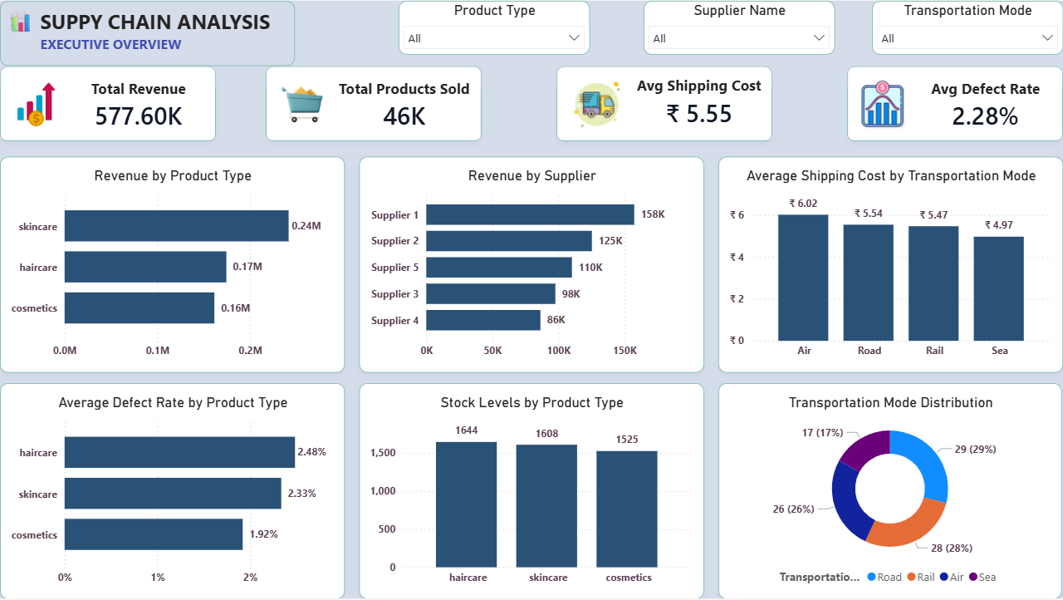
Figure 1: Executive Overview dashboard
KPI | Value
Total Revenue | ₹577.60K
Total Products Sold | 46K
Average Shipping Cost | ₹5.55
Average Defect Rate | 2.28%

6.1 Key Insights
- Skincare is the top-performing category, generating ₹0.24M — nearly 42% of total revenue.
- Air transport has the highest average shipping cost (₹6.02) versus Sea, the cheapest at ₹4.97.
- Haircare products show the highest average defect rate (2.48%), warranting a closer quality review.
- The business sold 46K units across all categories, with only a 2.28% average defect rate overall.

7. Inventory & Supplier Analysis Dashboard
This page evaluates the reliability of individual suppliers and how stock is distributed across product categories, helping identify quality risks and inventory imbalances.
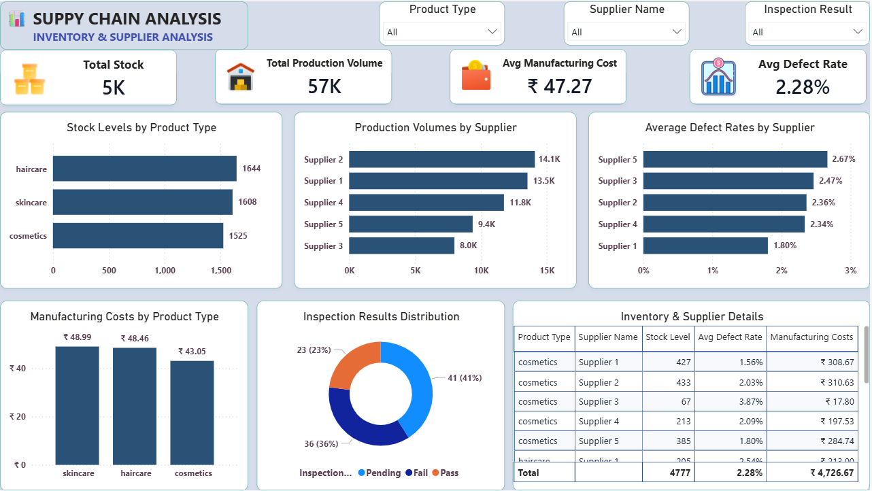
Figure 2: Inventory & Supplier Analysis dashboard

7.1 Key Insights
- Supplier 2 leads production volume (14.1K units), followed closely by Supplier 1 (13.5K units).
- Supplier 5 has the highest defect rate (2.67%) despite moderate output — a clear quality risk.
- Supplier 1 combines strong output with the lowest defect rate (1.80%), making it the most reliable partner.
- Haircare holds the highest stock level (1,644 units), requiring careful inventory planning.
- Skincare carries the highest manufacturing cost per unit (₹48.99), directly impacting margins.
- Total inventory stands at 4,777 units, built from 57K units of total production volume.

8. Logistics & Profitability Analysis Dashboard
This page connects logistics efficiency to financial outcomes, comparing transportation modes and suppliers on cost, time, and profitability.
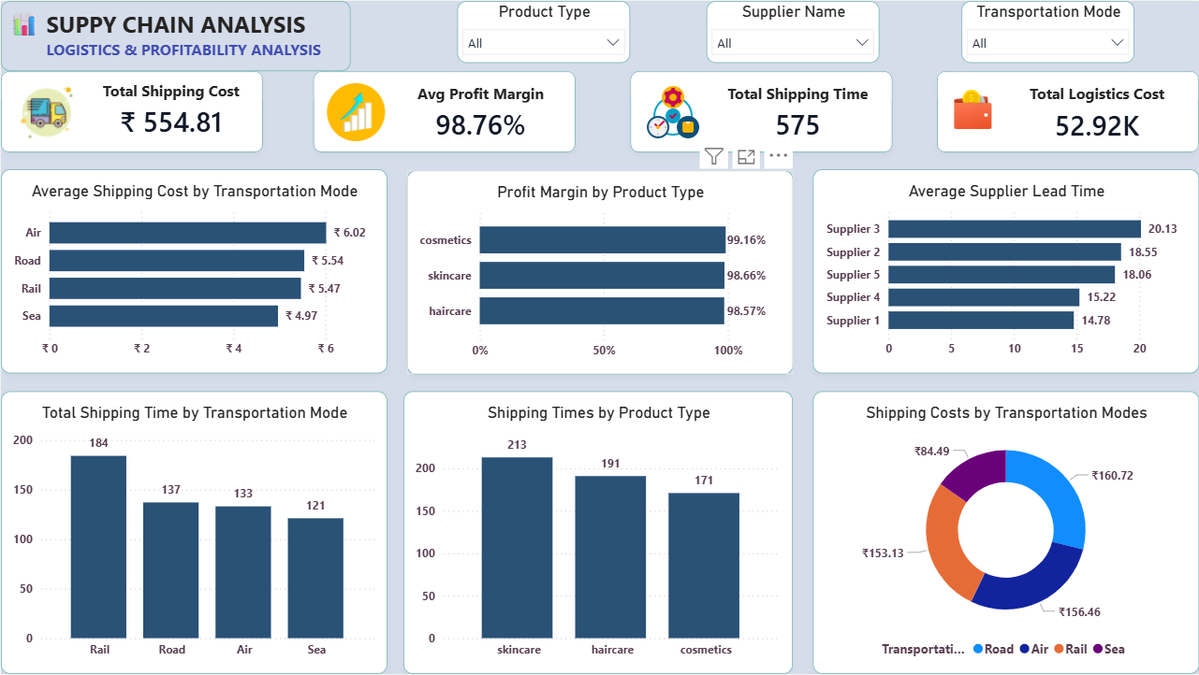
Figure 3: Logistics & Profitability Analysis dashboard

8.1 Key Insights
- Air freight is the costliest mode (₹6.02/unit); Sea is the most economical (₹4.97/unit).
- Cosmetics delivers the highest profit margin (99.16%), just ahead of skincare and haircare.
- Supplier 3 has the longest average lead time (20.13 days) — a potential bottleneck in replenishment.
- Supplier 1 offers the shortest lead time (14.78 days), supporting faster restocking.
- Skincare products have the longest average shipping time among the three categories.
- Total logistics cost across the business is ₹52.92K, with an overall profit margin of 98.76%.

9. Business Insights & Recommendations Dashboard
The final dashboard page consolidates the headline finding from each area of the business into a single, decision-ready summary, alongside a first set of recommended actions.
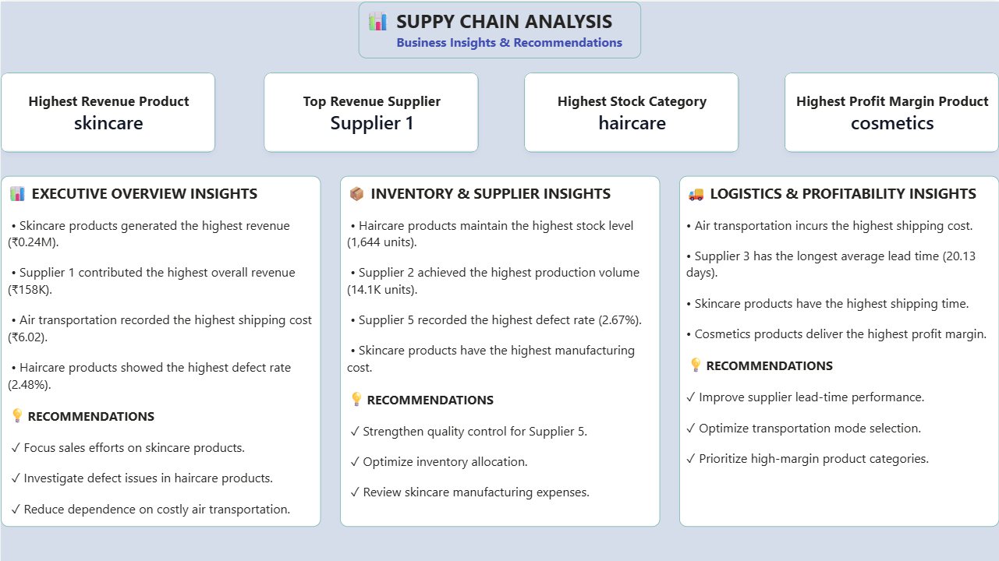
Figure 4: Business Insights & Recommendations dashboard

10. Consolidated Key Findings
Bringing together the results from all four dashboard pages, the following headline findings summarise overall business performance:
Area | Finding
Highest Revenue Product | Skincare
Top Revenue Supplier | Supplier 1
Highest Stock Category | Haircare
Highest Profit Margin Product | Cosmetics
Costliest Transport Mode | Air (₹6.02/unit)
Longest Supplier Lead Time | Supplier 3 (20.13 days)

Bottom line: skincare and Supplier 1 drive the business, but haircare quality, Air freight cost, and Supplier 3's lead time are the clearest areas for improvement.

11. Strategic Recommendations

11.1 Sales & Marketing
- Focus promotional spend on skincare — the strongest revenue driver.
- Investigate the demand drivers behind Supplier 1's revenue leadership.

11.2 Quality Control
- Strengthen inspection and QC protocols for Supplier 5, which has the highest defect rate.
- Investigate root causes of defects in haircare production specifically.

11.3 Inventory Management
- Review haircare stock allocation to avoid overstocking relative to demand.
- Re-evaluate skincare manufacturing costs to protect margins.

11.4 Logistics & Profitability
- Shift more shipping volume to Sea/Rail where transit time allows, to reduce cost.
- Work with Supplier 3 to shorten lead time, or diversify sourcing to reduce dependency.
- Prioritise and promote high-margin categories such as cosmetics.

12. Challenges & Limitations
- Small sample size: The dataset contains 100 SKU-level records, which limits statistical depth.
- No time dimension: The data represents a single snapshot, so seasonality and trends could not be analysed.
- Simulated figures: Cost, margin, and defect values appear synthetic rather than audited financials.
- No customer-level detail: Beyond broad demographics, individual customer behaviour is not captured.
- Limited geographic depth: Supplier locations are recorded, but regional cost drivers are not broken out.
- Static Power BI file: The dashboard is not connected to a live or automatically refreshing data source.

13. Conclusion
This Power BI dashboard turns raw supply chain data into a clear, interactive story. It shows that skincare and Supplier 1 lead overall performance, while haircare quality and Air freight costs stand out as the key levers for improvement.
By combining revenue, inventory, supplier, and logistics metrics on a single screen, the project demonstrates how business intelligence tools can shorten the path from raw data to actionable business decisions.

14. Future Scope
- Connect the dashboard to a live or automatically refreshing data source for real-time monitoring.
- Apply predictive analytics — for example, demand or defect forecasting — using Power BI combined with AI visuals.
- Expand the dataset to cover a longer time period, enabling analysis of seasonal trends.
- Add drill-through pages for SKU-level and route-level deep dives.
- Incorporate customer feedback data to link satisfaction directly with supply chain performance.

