**Chapter-1**

# Introduction

**1.1 Background**

RFM (Recency, Frequency, Monetary) Analysis is a widely used concept in the marketing domain. It enables businesses to understand and segment customers based on their buying behavior. By analyzing customers' recency (the date of their last purchase), frequency (how often they make purchases), and monetary value (the amount spent on purchases), businesses can gain insights into customer engagement, loyalty, and value.

**1.2 Objectives**

The objective of this project is to perform RFM Analysis using Python to analyze customer behavior and provide actionable insights for marketing strategies. By calculating RFM values for each customer, this project aims to segment customers, identify patterns, and develop targeted marketing campaigns.

**1.3 Scope and Limitations**

This project focuses on using a dataset that includes customer IDs, purchase dates, and transaction amounts. The analysis includes calculating RFM values for each customer, visualizing customer segments, and deriving insights. Limitations may include the availability and quality of the dataset, as well as the scope restricted to RFM analysis without additional predictive modeling.

**Chapter-2**

**Rationale**

**2.1 Importance of RFM Analysis**

RFM Analysis is essential for understanding customer behavior and optimizing marketing strategies. By evaluating customers' recency, frequency, and monetary value, businesses can identify their most valuable and engaged customers, target marketing campaigns effectively, and tailor personalized experiences. RFM Analysis enables businesses to maximize customer retention, increase customer lifetime value, and improve overall business performance.

**2.2 Customer Segmentation and Targeted Marketing**

RFM Analysis enables businesses to segment customers based on their buying behavior patterns. This segmentation approach helps identify high-value customers, potential churn risks, and opportunities for cross-selling or upselling. By understanding customer segments, businesses can develop targeted marketing campaigns, personalized offers, and customized experiences that resonate with specific customer needs and preferences.

**2.3 Enhanced Decision Making and Resource Allocation**

By applying RFM Analysis, businesses gain insights that aid in making informed decisions and optimizing resource allocation. Identifying loyal and high-value customers allows for prioritizing marketing efforts and allocating resources effectively. RFM metrics provide a quantitative basis for measuring customer engagement, enabling businesses to optimize marketing strategies, customer retention initiatives, and budget allocation for maximum return on investment.

**2.4 Maximizing Customer Lifetime Value**

RFM Analysis plays a pivotal role in maximizing customer lifetime value. By understanding customer segments and behavior patterns, businesses can tailor retention strategies, such as personalized loyalty programs or proactive customer service. RFM Analysis helps identify opportunities to increase customer loyalty, drive repeat purchases, and foster long-term customer relationships, ultimately resulting in increased customer lifetime value.

**2.5 Data-Driven Decision Making and Competitive Advantage**

RFM Analysis provides a data-driven approach to marketing, enabling businesses to leverage insights derived from customer data. By utilizing Python and RFM Analysis techniques, businesses gain a competitive advantage by understanding customer preferences, predicting future behavior, and making data-driven marketing decisions. This empowers organizations to adapt swiftly to changing market dynamics, stay ahead of competitors, and drive sustainable growth.

**Chapter-3**

**Methodology**

**3.1 Data Collection**

For RFM Analysis, a dataset was collected containing customer IDs, purchase dates, and transaction amounts. The data collection process involved accessing internal sales databases, extracting relevant information, and ensuring data integrity and privacy.

**3.2 Data Preprocessing**

To prepare the dataset for analysis, various data preprocessing techniques were applied. This included handling missing values, removing duplicates, and addressing outliers. Data consistency checks were performed to ensure accurate RFM calculations.

**3.3 RFM Analysis Calculation**

RFM values were calculated for each customer based on their purchase history. Recency was measured by calculating the number of days since the last purchase. Frequency was determined by counting the number of purchases made by each customer. Monetary value was calculated by summing the transaction amounts for each customer.

**3.4 Segmentation and Analysis**

Customers were segmented based on their RFM scores. The RFM scores were categorized into segments, such as "high-value," "loyal," "at risk," or "inactive." The segments were visualized using charts and graphs to identify patterns and trends. Insights were derived from the analysis, such as the identification of high-value customer segments or the detection of customers at risk of churn.

**Chapter-4**

**Implementation**

**4.1 Code:**

import pandas as pd

import plotly.express as px

import plotly.io as pio

import plotly.graph_objects as go

pio.templates.default = "plotly_white"

data = pd.read_csv("rfm_data.csv")

print(data.head())

from datetime import datetime

# Convert 'PurchaseDate' to datetime

data['PurchaseDate'] = pd.to_datetime(data['PurchaseDate'])

# Calculate Recency

data['Recency'] = (datetime.now().date() - data['PurchaseDate'].dt.date).dt.days

# Calculate Frequency

frequency_data = data.groupby('CustomerID')['OrderID'].count().reset_index()

frequency_data.rename(columns={'OrderID': 'Frequency'}, inplace=True)

data = data.merge(frequency_data, on='CustomerID', how='left')

# Calculate Monetary Value

monetary_data = data.groupby('CustomerID')['TransactionAmount'].sum().reset_index()

monetary_data.rename(columns={'TransactionAmount': 'MonetaryValue'}, inplace=True)

data = data.merge(monetary_data, on='CustomerID', how='left')

print(data.head())

# Define scoring criteria for each RFM value

recency_scores = [5, 4, 3, 2, 1] # Higher score for lower recency (more recent)

frequency_scores = [1, 2, 3, 4, 5] # Higher score for higher frequency

monetary_scores = [1, 2, 3, 4, 5] # Higher score for higher monetary value

# Calculate RFM scores

data['RecencyScore'] = pd.cut(data['Recency'], bins=5, labels=recency_scores)

data['FrequencyScore'] = pd.cut(data['Frequency'], bins=5, labels=frequency_scores)

data['MonetaryScore'] = pd.cut(data['MonetaryValue'], bins=5, labels=monetary_scores)

# Convert RFM scores to numeric type

data['RecencyScore'] = data['RecencyScore'].astype(int)

data['FrequencyScore'] = data['FrequencyScore'].astype(int)

data['MonetaryScore'] = data['MonetaryScore'].astype(int)

# Calculate RFM score by combining the individual scores

data['RFM_Score'] = data['RecencyScore'] + data['FrequencyScore'] + data['MonetaryScore']

# Create RFM segments based on the RFM score

segment_labels = ['Low-Value', 'Mid-Value', 'High-Value']

data['Value Segment'] = pd.qcut(data['RFM_Score'], q=3, labels=segment_labels)

print(data.head())

# RFM Segment Distribution

segment_counts = data['Value Segment'].value_counts().reset_index()

segment_counts.columns = ['Value Segment', 'Count']

pastel_colors = px.colors.qualitative.Pastel

# Create the bar chart

fig_segment_dist = px.bar(segment_counts, x='Value Segment', y='Count',

color='Value Segment', color_discrete_sequence=pastel_colors,

title='RFM Value Segment Distribution')

# Update the layout

fig_segment_dist.update_layout(xaxis_title='RFM Value Segment',

yaxis_title='Count',

showlegend=False)

# Show the figure

fig_segment_dist.show()

# Create a new column for RFM Customer Segments

data['RFM Customer Segments'] = ''

# Assign RFM segments based on the RFM score

data.loc[data['RFM_Score'] >= 9, 'RFM Customer Segments'] = 'Champions'

data.loc[(data['RFM_Score'] >= 6) & (data['RFM_Score'] < 9), 'RFM Customer Segments'] = 'Potential Loyalists'

data.loc[(data['RFM_Score'] >= 5) & (data['RFM_Score'] < 6), 'RFM Customer Segments'] = 'At Risk Customers'

data.loc[(data['RFM_Score'] >= 4) & (data['RFM_Score'] < 5), 'RFM Customer Segments'] = "Can't Lose"

data.loc[(data['RFM_Score'] >= 3) & (data['RFM_Score'] < 4), 'RFM Customer Segments'] = "Lost"

# Print the updated data with RFM segments

print(data[['CustomerID', 'RFM Customer Segments']])

segment_product_counts = data.groupby(['Value Segment', 'RFM Customer Segments']).size().reset_index(name='Count')

segment_product_counts = segment_product_counts.sort_values('Count', ascending=False)

fig_treemap_segment_product = px.treemap(segment_product_counts,

path=['Value Segment', 'RFM Customer Segments'],

values='Count',

color='Value Segment', color_discrete_sequence=px.colors.qualitative.Pastel,

title='RFM Customer Segments by Value')

fig_treemap_segment_product.show()

# Filter the data to include only the customers in the Champions segment

champions_segment = data[data['RFM Customer Segments'] == 'Champions']

fig = go.Figure()

fig.add_trace(go.Box(y=champions_segment['RecencyScore'], name='Recency'))

fig.add_trace(go.Box(y=champions_segment['FrequencyScore'], name='Frequency'))

fig.add_trace(go.Box(y=champions_segment['MonetaryScore'], name='Monetary'))

fig.update_layout(title='Distribution of RFM Values within Champions Segment',

yaxis_title='RFM Value',

showlegend=True)

fig.show()

correlation_matrix = champions_segment[['RecencyScore', 'FrequencyScore', 'MonetaryScore']].corr()

# Visualize the correlation matrix using a heatmap

fig_heatmap = go.Figure(data=go.Heatmap(

z=correlation_matrix.values,

x=correlation_matrix.columns,

y=correlation_matrix.columns,

colorscale='RdBu',

colorbar=dict(title='Correlation')))

fig_heatmap.update_layout(title='Correlation Matrix of RFM Values within Champions Segment')

fig_heatmap.show()

import plotly.colors

pastel_colors = plotly.colors.qualitative.Pastel

segment_counts = data['RFM Customer Segments'].value_counts()

# Create a bar chart to compare segment counts

fig = go.Figure(data=[go.Bar(x=segment_counts.index, y=segment_counts.values,

marker=dict(color=pastel_colors))])

# Set the color of the Champions segment as a different color

champions_color = 'rgb(158, 202, 225)'

fig.update_traces(marker_color=[champions_color if segment == 'Champions' else pastel_colors[i]

for i, segment in enumerate(segment_counts.index)],

marker_line_color='rgb(8, 48, 107)',

marker_line_width=1.5, opacity=0.6)

# Update the layout

fig.update_layout(title='Comparison of RFM Segments',

xaxis_title='RFM Segments',

yaxis_title='Number of Customers',

showlegend=False)

fig.show()

# Calculate the average Recency, Frequency, and Monetary scores for each segment

segment_scores = data.groupby('RFM Customer Segments')['RecencyScore', 'FrequencyScore', 'MonetaryScore'].mean().reset_index()

# Create a grouped bar chart to compare segment scores

fig = go.Figure()

# Add bars for Recency score

fig.add_trace(go.Bar(

x=segment_scores['RFM Customer Segments'],

y=segment_scores['RecencyScore'],

name='Recency Score',

marker_color='rgb(158,202,225)'

))

# Add bars for Frequency score

fig.add_trace(go.Bar(

x=segment_scores['RFM Customer Segments'],

y=segment_scores['FrequencyScore'],

name='Frequency Score',

marker_color='rgb(94,158,217)'

))

# Add bars for Monetary score

fig.add_trace(go.Bar(

x=segment_scores['RFM Customer Segments'],

y=segment_scores['MonetaryScore'],

name='Monetary Score',

marker_color='rgb(32,102,148)'

))

# Update the layout

fig.update_layout(

title='Comparison of RFM Segments based on Recency, Frequency, and Monetary Scores',

xaxis_title='RFM Segments',

yaxis_title='Score',

barmode='group',

showlegend=True

)

fig.show()

**4.2 Screenshots**

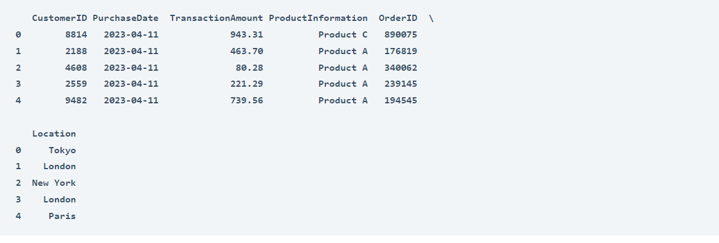

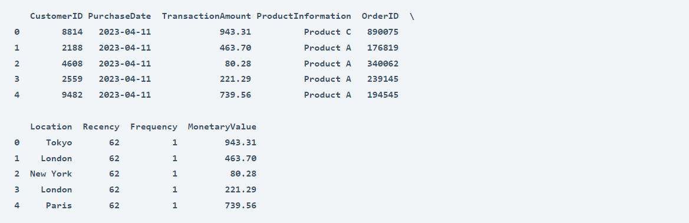

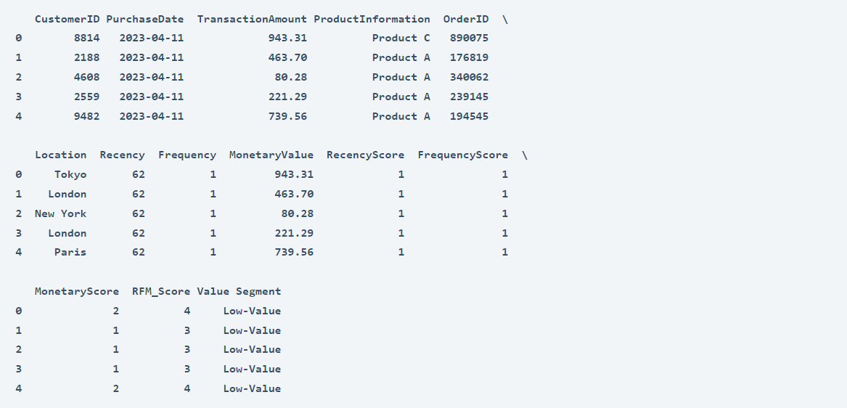

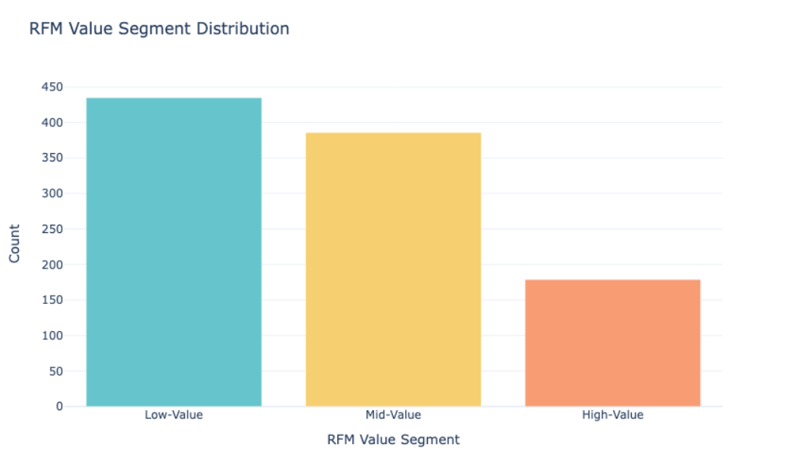

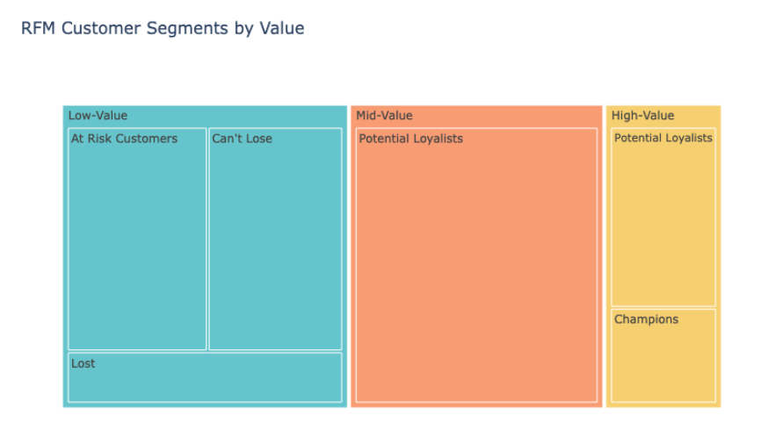

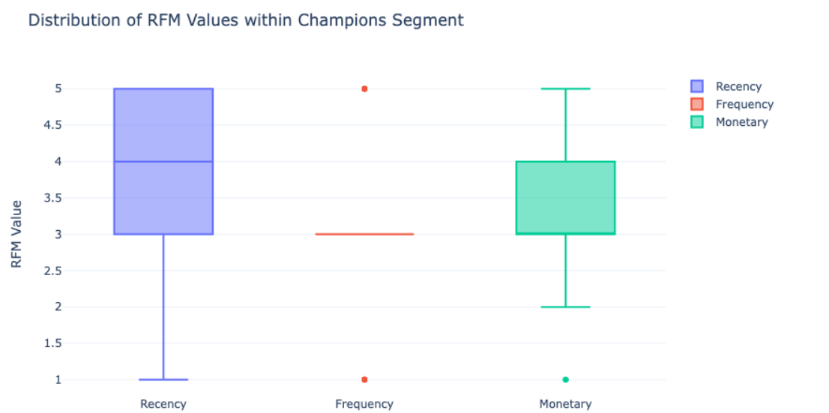

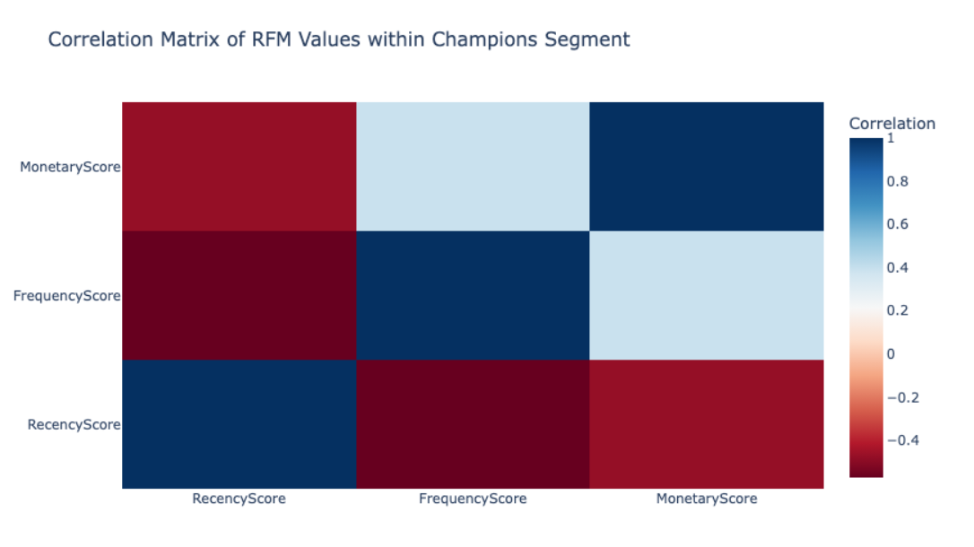

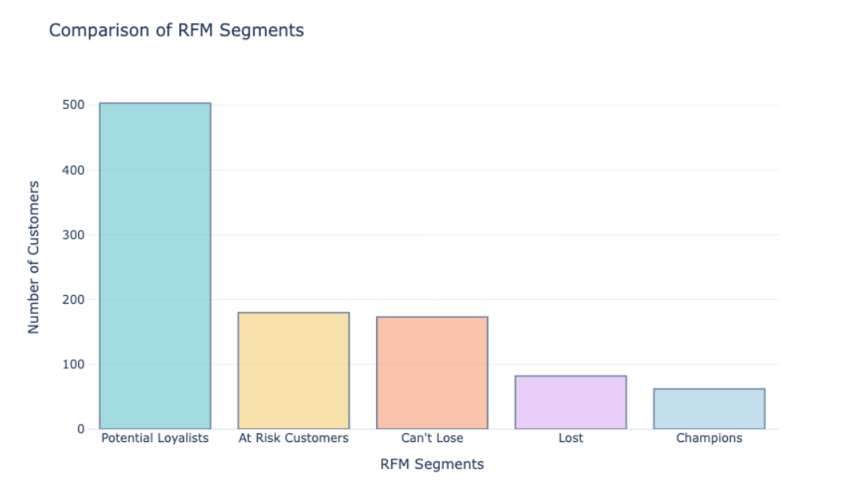

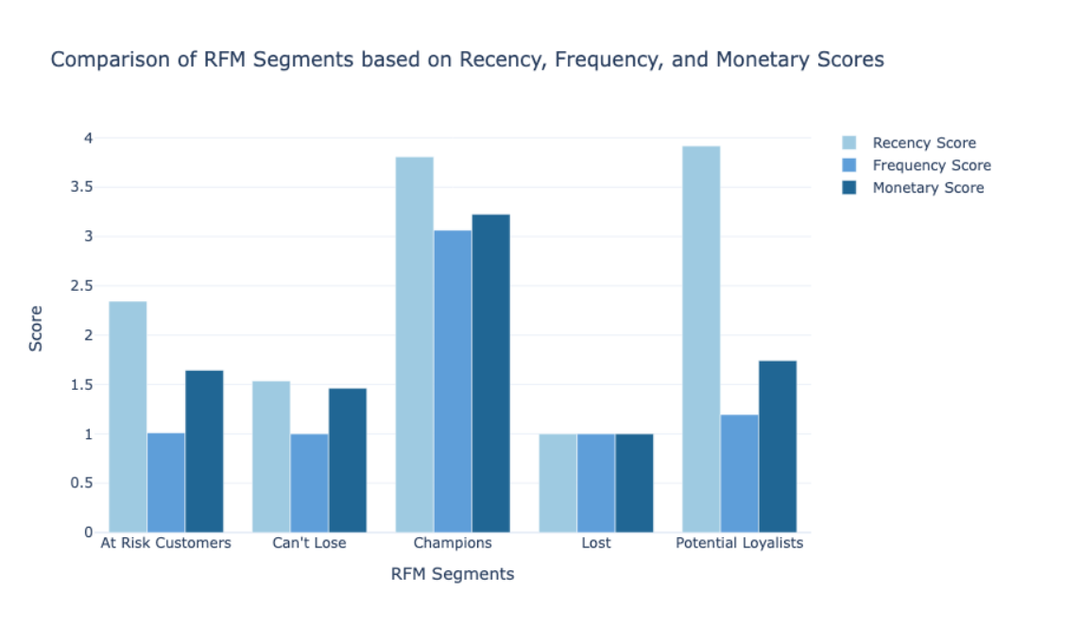

**Chapter-5**

**Future Enhancements and Recommendations**

**5.1 Integration with Predictive Modeling**

To enhance RFM Analysis, integration with predictive modeling techniques can be explored. Machine learning algorithms, such as clustering or classification models, can be applied to refine customer segmentation and enable targeted marketing strategies. This integration can further improve the accuracy and effectiveness of marketing campaigns.

**5.2 Personalization and Automation**

Implementing personalization and automation based on RFM Analysis can enhance marketing effectiveness. By leveraging RFM insights, personalized messaging, promotions, and recommendations can be tailored to individual customer segments. Automation of marketing campaigns can be implemented to deliver targeted communications, ensuring timely engagement with customers.

**Chapter-6**

**Conclusion**

**6.1 Summary of Findings**

The RFM Analysis project successfully analyzed customer behavior based on recency, frequency, and monetary value. Insights were derived by segmenting customers and visualizing their RFM scores. The project identified valuable customer segments, patterns, and trends, enabling data-driven marketing strategies.

**6.2 Key Takeaways**

The project demonstrated the importance of RFM Analysis in understanding customer behavior and optimizing marketing efforts. By segmenting customers based on RFM scores, businesses can identify their most valuable customers, tailor marketing campaigns, and enhance customer engagement and loyalty. Python proved to be a powerful tool for RFM Analysis, providing efficient data manipulation, calculation, and visualization capabilities.

**6.3 Significance of RFM Analysis**

RFM Analysis plays a crucial role in customer relationship management and marketing strategy development. It enables businesses to make informed decisions, maximize customer value, and drive business growth. By utilizing RFM Analysis techniques, businesses can enhance customer satisfaction, retention, and overall performance.