PROJECT STATEMENT:

HOTEL MANAGEMENT SYSTEM was developed following system development stages for smooth running and management of Hotel SPECTRA.

The objective of the Hotel management system is to enable the user to do general activities of a hotel like booking a room, ordering food and etc.

The Project was developed using Python version 3.8

The modules used in this project are :

* pandas
* numpy
* matplotlib
* datetime
* Smtplib

This Project has 3 interfaces (Users).

All the tables used in this project are CSV Files.

Types of Users and Tasks performed by each user:

1. Customer :

* Login into existing account or create new account
* Booking of Rooms
* Ordering Food
* Checking your bill
* Check out
* Cancel booking

1. Receptionist :

* Login into Receptionist Account
* Book rooms for customer
* Room Service for Customer
* View Room Details (Access Database)
* Customer Checkout
* Cancel a customer’s booking

1. Manager :

* Login into Manager Account
* View Room Details (Access Database)
* View Staff Details (Access Database)
* View Statistics

BACKEND TABLES:

## TABLE 1

Table Name: ALL

Used to store details of customers currently using the rooms.

Table ALL gets modified after every booking,Check out or Room cancelation

Table Structure:

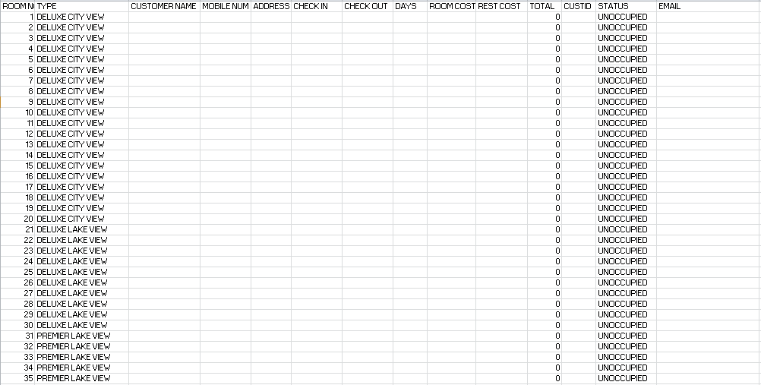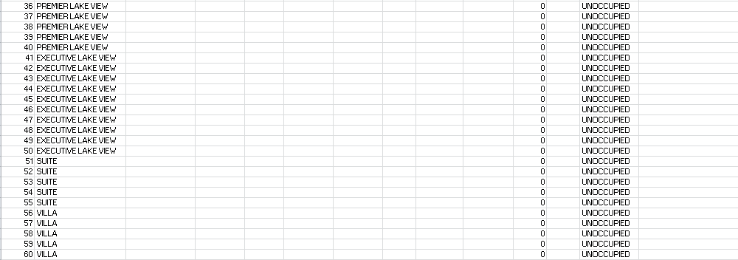

## TABLE 2

Table Name: DET

Used to plot graphs which can be viewed by the manager

Table DET gets modified after every booking,Check out or Room cancelation

Table Structure:

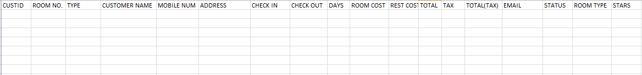

## TABLE 3

Table Name: CUSTID

Used to store Customer Login Details

Table CUSTID gets modified for every new customer

Table Structure:

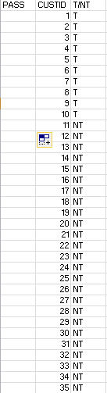

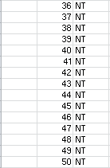

## TABLE 4

Table Name: Rooms

Used to show type of rooms to the user and to access price of each room.

Table Rooms will not get modified.

Table Structure:

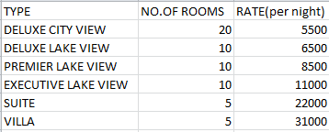

## TABLE 5

Table Name: restaurant

Used to access price of item

Table restaurant does not get modified

Table Structure:

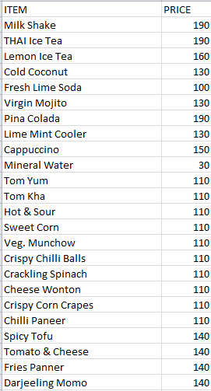

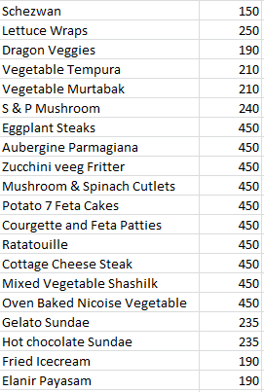

CODING

main.py

description:

main.py is the first page of the program from which the user can choose their user interface in order to perform desired actions.

modules imported:

import manager

import reception

import customer

import numpy as np

import pandas as pd

CODE:

def main():

print("\n\n------------WELCOME TO HOTEL SPECTRA------------\n")

print('1.CUSTOMER')

print('2.RECPTION')

print('3.MANAGER')

a = input('ENTER YOUR CHOICE')

if a== '1' or a== 'CUSTOMER' or a == 'customer':

customer.cust_log()

elif a == '2' or a== 'RECEPTION' or a== 'reception':

reception.recep_log()

elif a == '3' or a== 'MANAGER' or a=='manager':

manager.mana_log()

main()

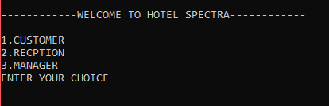

customer.py

description:

customer.py is the user interface for customers and here they can perform their desired actions.

modules imported:

import random as rd

import pandas as pd

import datetime as dt

import numpy as np

import smtplib

from email.message import EmailMessage

Login/New customer:

CODE:

def cust_log():

ALL=pd.read_csv('ALL.csv')

CUSTID=pd.read_csv('CUSTID.csv')

print('')

print('1.LOGIN')

print('2.NEW')

a=input('ENTER YOUR CHOICE:')

print('')

global cid

if a== '1' or a== 'login':

print('----CUSTOMER LOGIN----')

cid = float(input('ENTER CUSTOMER ID:'))

list_val = CUSTID['CUSTID'].tolist()

if cid in list_val:

cid=cid-1

loca=CUSTID.PASS[cid]

cid=cid+1

c=input('enter password')

if c == loca:

print('')

print('LOGIN SUCCESSFUL')

cust()

else:

print('')

print('WRONG PASSWORD')

else:

print('')

print('kindly give a valid id')

elif a== '2':

global passw

for L in range(1,51):

if CUSTID.loc[L-1,'T/NT'] == 'NT':

cid=L

print('your customer id is:',cid)

passw=input('enter password')

CUSTID.loc[L-1,'T/NT']='T'

CUSTID.loc[L-1,'PASS']=passw

CUSTID.loc[L-1,'CUSTID']=cid

CUSTID.to_csv('CUSTID.csv',index=False)

cust()

else:

print('enter a valid option')

cust_log()

Output:

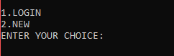

* If u choose NEW, user will be assigned a customer id and then will be asked to give a password to his id.

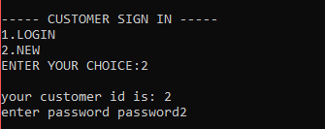

* If u choose LOGIN, user will be asked to enter customer id and its password if correct will be let into the customer page if not will not be let in.

Correct password:

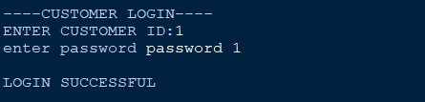

Wrong password:

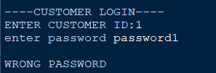

CODE :

def cust():

print('')

print("\t\t\t 1 Booking\n")

print("\t\t\t 2 Restaurant\n")

print("\t\t\t 3 Payment\n")

print("\t\t\t 4 Cancel Booking\n")

print("\t\t\t 5 Exit\n")

choice =int(input('enter your choice'))

if choice == 1:

book()

#Booking

def book():

roomt= pd.read_csv('Rooms.csv')

DET=pd.read_csv('DET.csv')

ALL=pd.read_csv('ALL.csv')

print(" BOOKING ROOMS")

name = str(input("Name: "))

pn = str(input("Phone No.: "))

add = str(input("Address: "))

global ema

ema = input('EMAIL : ')

if name!="" and pn!="" and add!="":

pass

else:

print("\tName, Phone no. & Address cannot be empty..!!")

print('ROOM TYPES')

print(roomt)

a = int(input('enter your choice'))

price = roomt.loc[a,'RATE(per night)']

b=1

while b==1:

global ci

global co

global dif

ci = str(input('CHECK IN(y/m/d):'))

co = str(input('CHECK OUT(y/m/d):'))

c=1

while c == 1:

cil=ci.split('/')

col=co.split('/')

alpha = dt.date(int(cil[0]),int(cil[1]),int(cil[2]))

beta = dt.date(int(col[0]),int(col[1]),int(col[2]))

if alpha > beta :

print('error check out date must be after check in date')

b=2

c=2

exit()

elif alpha == beta :

print('error check out date must be after check in date')

b=2

c=2

exit()

elif alpha < beta:

dif = (beta - alpha).days

c=2

print('no.of days:',dif)

b=2

if(a == 0):

for i in range(0,20):

if ALL.loc[i,'STATUS'] == 'UNOCCUPIED':

print('your room number is',i+1)

typ=ALL.loc[i,'TYPE']

ALL.loc[i,'STATUS']='OCCUPIED'

ALL.loc[i,'CUSTOMER NAME']=name

ALL.loc[i,'MOBILE NUM']=pn

ALL.loc[i,'ADDRESS']=add

ALL.loc[i,'CHECK IN']=ci

ALL.loc[i,'CHECK OUT']=co

ALL.loc[i,'ROOM COST']=price*dif

ALL.loc[i,'CUSTID']=cid

ALL.loc[i,'DAYS']=dif

ALL.loc[i,'EMAIL']=ema

msg = EmailMessage()

msg['Subject']='Reservation at Hotel SPECTRA'

msg['From']='reservations.spectra@gmail.com'

msg['To']=ema

msg.set_content('Your '+typ+' has been reserved at Hotel Spectra \n from: '+ci+'\n to: '+co+'\n in the name of: '+name)

with smtplib.SMTP_SSL('smtp.gmail.com',465) as smtp:

smtp.login('reservations.spectra@gmail.com','spectracular')

smtp.send_message(msg)

row=DET.shape[0]

count=row

DET.loc[count,'CUSTOMER NAME']=name

DET.loc[count,'MOBILE NUM']=pn

DET.loc[count,'ADDRESS']=add

DET.loc[count,'CHECK IN']=ci

DET.loc[count,'CHECK OUT']=co

DET.loc[count,'ROOM COST']=price*dif

DET.loc[count,'CUSTID']=cid

DET.loc[count,'DAYS']=dif

DET.loc[count,'ROOM NO.']=i+1

DET.loc[count,'EMAIL']=ema

DET.loc[count,'STATUS']='in'

DET.loc[count,'ROOM TYPE']=roomt.loc[a,'TYPE']

DET.to_csv('DET.csv',index=False)

ALL.to_csv('ALL.csv',index=False)

cust()

break

elif a== 1:

for i in range(20,30):

if ALL.loc[i,'STATUS'] == 'UNOCCUPIED':

print('your room number is',i+1)

typ=ALL.loc[i,'TYPE']

ALL.loc[i,'STATUS']='OCCUPIED'

ALL.loc[i,'CUSTOMER NAME']=name

ALL.loc[i,'MOBILE NUM']=pn

ALL.loc[i,'ADDRESS']=add

ALL.loc[i,'CHECK IN']=ci

ALL.loc[i,'CHECK OUT']=co

ALL.loc[i,'ROOM COST']=price*dif

ALL.loc[i,'CUSTID']=cid

ALL.loc[i,'DAYS']=dif

ALL.loc[i,'EMAIL']=ema

msg = EmailMessage()

msg['Subject']='Reservation at Hotel SPECTRA'

msg['From']='reservations.spectra@gmail.com'

msg['To']=ema

msg.set_content('Your '+typ+' has been reserved at Hotel Spectra \n from: '+ci+'\n to: '+co+'\n in the name of: '+name)

with smtplib.SMTP_SSL('smtp.gmail.com',465) as smtp:

smtp.login('reservations.spectra@gmail.com','spectracular')

smtp.send_message(msg)

row=DET.shape[0]

count=row

DET.loc[count,'CUSTOMER NAME']=name

DET.loc[count,'MOBILE NUM']=pn

DET.loc[count,'ADDRESS']=add

DET.loc[count,'CHECK IN']=ci

DET.loc[count,'CHECK OUT']=co

DET.loc[count,'ROOM COST']=price*dif

DET.loc[count,'CUSTID']=cid

DET.loc[count,'DAYS']=dif

DET.loc[count,'ROOM NO.']=i+1

DET.loc[count,'EMAIL']=ema

DET.loc[count,'STATUS']='in'

DET.loc[count,'ROOM TYPE']=roomt.loc[a,'TYPE']

DET.to_csv('DET.csv',index=False)

ALL.to_csv('ALL.csv',index=False)

cust()

break

elif a== 2:

for i in range(30,40):

if ALL.loc[i,'STATUS'] == 'UNOCCUPIED':

print('your room number is',i+1)

typ=ALL.loc[i,'TYPE']

ALL.loc[i,'STATUS']='OCCUPIED'

ALL.loc[i,'CUSTOMER NAME']=name

ALL.loc[i,'MOBILE NUM']=pn

ALL.loc[i,'ADDRESS']=add

ALL.loc[i,'CHECK IN']=ci

ALL.loc[i,'CHECK OUT']=co

ALL.loc[i,'ROOM COST']=price*dif

ALL.loc[i,'CUSTID']=cid

ALL.loc[i,'DAYS']=dif

ALL.loc[i,'EMAIL']=ema

msg = EmailMessage()

msg['Subject']='Reservation at Hotel SPECTRA'

msg['From']='reservations.spectra@gmail.com'

msg['To']=ema

msg.set_content('Your '+typ+' has been reserved at Hotel Spectra \n from: '+ci+'\n to: '+co+'\n in the name of: '+name)

with smtplib.SMTP_SSL('smtp.gmail.com',465) as smtp:

smtp.login('reservations.spectra@gmail.com','spectracular')

smtp.send_message(msg)

row=DET.shape[0]

count=row

DET.loc[count,'CUSTOMER NAME']=name

DET.loc[count,'MOBILE NUM']=pn

DET.loc[count,'ADDRESS']=add

DET.loc[count,'CHECK IN']=ci

DET.loc[count,'CHECK OUT']=co

DET.loc[count,'ROOM COST']=price*dif

DET.loc[count,'CUSTID']=cid

DET.loc[count,'DAYS']=dif

DET.loc[count,'ROOM NO.']=i+1

DET.loc[count,'EMAIL']=ema

DET.loc[count,'STATUS']='in'

DET.loc[count,'ROOM TYPE']=roomt.loc[a,'TYPE']

DET.to_csv('DET.csv',index=False)

ALL.to_csv('ALL.csv',index=False)

cust()

break

elif a== 3:

for i in range(40,50):

if ALL.loc[i,'STATUS'] == 'UNOCCUPIED':

print('your room number is',i+1)

typ=ALL.loc[i,'TYPE']

ALL.loc[i,'STATUS']='OCCUPIED'

ALL.loc[i,'CUSTOMER NAME']=name

ALL.loc[i,'MOBILE NUM']=pn

ALL.loc[i,'ADDRESS']=add

ALL.loc[i,'CHECK IN']=ci

ALL.loc[i,'CHECK OUT']=co

ALL.loc[i,'ROOM COST']=price*dif

ALL.loc[i,'CUSTID']=cid

ALL.loc[i,'DAYS']=dif

ALL.loc[i,'EMAIL']=ema

msg = EmailMessage()

msg['Subject']='Reservation at Hotel SPECTRA'

msg['From']='reservations.spectra@gmail.com'

msg['To']=ema

msg.set_content('Your '+typ+' has been reserved at Hotel Spectra \n from: '+ci+'\n to: '+co+'\n in the name of: '+name)

with smtplib.SMTP_SSL('smtp.gmail.com',465) as smtp:

smtp.login('reservations.spectra@gmail.com','spectracular')

smtp.send_message(msg)

row=DET.shape[0]

count=row

DET.loc[count,'CUSTOMER NAME']=name

DET.loc[count,'MOBILE NUM']=pn

DET.loc[count,'ADDRESS']=add

DET.loc[count,'CHECK IN']=ci

DET.loc[count,'CHECK OUT']=co

DET.loc[count,'ROOM COST']=price*dif

DET.loc[count,'CUSTID']=cid

DET.loc[count,'DAYS']=dif

DET.loc[count,'ROOM NO.']=i+1

DET.loc[count,'EMAIL']=ema

DET.loc[count,'STATUS']='in'

DET.loc[count,'ROOM TYPE']=roomt.loc[a,'TYPE']

DET.to_csv('DET.csv',index=False)

ALL.to_csv('ALL.csv',index=False)

cust()

break

elif a== 4:

for i in range(50,55):

if ALL.loc[i,'STATUS'] == 'UNOCCUPIED':

print('your room number is',i+1)

typ=ALL.loc[i,'TYPE']

ALL.loc[i,'STATUS']='OCCUPIED'

ALL.loc[i,'CUSTOMER NAME']=name

ALL.loc[i,'MOBILE NUM']=pn

ALL.loc[i,'ADDRESS']=add

ALL.loc[i,'CHECK IN']=ci

ALL.loc[i,'CHECK OUT']=co

ALL.loc[i,'ROOM COST']=price*dif

ALL.loc[i,'CUSTID']=cid

ALL.loc[i,'DAYS']=dif

ALL.loc[i,'EMAIL']=ema

msg = EmailMessage()

msg['Subject']='Reservation at Hotel SPECTRA'

msg['From']='reservations.spectra@gmail.com'

msg['To']=ema

msg.set_content('Your '+typ+' has been reserved at Hotel Spectra \n from: '+ci+'\n to: '+co+'\n in the name of: '+name)

with smtplib.SMTP_SSL('smtp.gmail.com',465) as smtp:

smtp.login('reservations.spectra@gmail.com','spectracular')

smtp.send_message(msg)

row=DET.shape[0]

count=row

DET.loc[count,'CUSTOMER NAME']=name

DET.loc[count,'MOBILE NUM']=pn

DET.loc[count,'ADDRESS']=add

DET.loc[count,'CHECK IN']=ci

DET.loc[count,'CHECK OUT']=co

DET.loc[count,'ROOM COST']=price*dif

DET.loc[count,'CUSTID']=cid

DET.loc[count,'DAYS']=dif

DET.loc[count,'ROOM NO.']=i+1

DET.loc[count,'EMAIL']=ema

DET.loc[count,'STATUS']='in'

DET.loc[count,'ROOM TYPE']=roomt.loc[a,'TYPE']

DET.to_csv('DET.csv',index=False)

ALL.to_csv('ALL.csv',index=False)

cust()

break

elif a== 5:

for i in range(55,60):

if ALL.loc[i,'STATUS'] == 'UNOCCUPIED':

print('your room number is',i+1)

typ=ALL.loc[i,'TYPE']

ALL.loc[i,'STATUS']='OCCUPIED'

ALL.loc[i,'CUSTOMER NAME']=name

ALL.loc[i,'MOBILE NUM']=pn

ALL.loc[i,'ADDRESS']=add

ALL.loc[i,'CHECK IN']=ci

ALL.loc[i,'CHECK OUT']=co

ALL.loc[i,'ROOM COST']=price*dif

ALL.loc[i,'CUSTID']=cid

ALL.loc[i,'DAYS']=dif

ALL.loc[i,'EMAIL']=ema

msg = EmailMessage()

msg['Subject']='Reservation at Hotel SPECTRA'

msg['From']='reservations.spectra@gmail.com'

msg['To']=ema

msg.set_content('Your '+typ+' has been reserved at Hotel Spectra \n from: '+ci+'\n to: '+co+'\n in the name of: '+name)

with smtplib.SMTP_SSL('smtp.gmail.com',465) as smtp:

smtp.login('reservations.spectra@gmail.com','spectracular')

smtp.send_message(msg)

row=DET.shape[0]

count=row

DET.loc[count,'CUSTOMER NAME']=name

DET.loc[count,'MOBILE NUM']=pn

DET.loc[count,'ADDRESS']=add

DET.loc[count,'CHECK IN']=ci

DET.loc[count,'CHECK OUT']=co

DET.loc[count,'ROOM COST']=price*dif

DET.loc[count,'CUSTID']=cid

DET.loc[count,'DAYS']=dif

DET.loc[count,'ROOM NO.']=i+1

DET.loc[count,'EMAIL']=ema

DET.loc[count,'STATUS']='in'

DET.loc[count,'ROOM TYPE']=roomt.loc[a,'TYPE']

DET.to_csv('DET.csv',index=False)

ALL.to_csv('ALL.csv',index=False)

cust()

break

#Restaurant

elif choice == 2:

food=pd.read_csv('restaurant.csv')

roomno=int(input('enter your room number'))

ALL=pd.read_csv('ALL.csv')

print("-------------------------------------------------------------------------------------")

print(" Hotel SPECTRA")

print("-------------------------------------------------------------------------------------")

print(" Menu Card")

print("-------------------------------------------------------------------------------------")

print("\n BEVARAGES 23 Darjeeling momo........... 140.00")

print("--------------------------------------- 24 Schezwan.................. 150.00")

print(" 0 Milk Shake.................. 190.00 ")

print(" 1 THAI Ice Tea................ 190.00 STARTERS")

print(" 2 Lemon Ice Tea............... 160.00 ------------------------------------")

print(" 3 Cold Coconut................ 130.00 25 Lettuce Wraps............. 250.00")

print(" 4 Fresh Lime Soda............. 100.00 26 Dragon Veggies............ 190.00")

print(" 5 Virgin Mojito............... 130.00 27 Vegetable Tempura......... 210.00")

print(" 6 Pina Colada................. 190.00 28 Vegetable Murtabak........ 210.00")

print(" 7 Lime Mint Cooler............ 130.00 29 S & P Mushroom............ 240.00")

print(" 8 Cappuccino.................. 150.00")

print(" 9 Mineral Water............... 30.00 MAIN COURSE")

print(" ------------------------------------")

print(" SOUPS 30 Eggplant Steaks........... 450.00")

print("--------------------------------------- 31 Aubergine Parmagiana...... 450.00")

print(" 10 Tom Yum..................... 110.00 32 Zucchini veeg Fritte...... 450.00")

print(" 11 Tom Kha..................... 110.00 33 Mushroom & Spinach ")

print(" Cutlets................... 450.00")

print(" 12 Hot & Sour.................. 110.00 34 Potato 7 Feta Cakes....... 450.00")

print(" 13 Sweet Corn.................. 110.00 35 Courgette and Feta")

print(" 14 Veg. Munchow................ 110.00 Patties................... 450.00")

print(" 36 Ratatouille............... 450.00")

print(" STARTERS 37 Cottage Cheese Steak...... 450.00")

print("--------------------------------------- 38 Mixed Vegetable ")

print(" 15 Crispy Chilli Balls......... 110.00 Shashlik.................. 450.00")

print(" 16 Crackling Spinach........... 110.00 39 Oven Baked Nicoise")

print(" 17 Cheese Wonton............... 120.00 Vegetable................. 450.00")

print(" 18 crispy corn crapes.......... 120.00")

print(" 19 Chilli Paneer............... 140.00 ")

print(' DESERTS')

print(" MOMOS (4 pcs) ------------------------------------")

print(" -------------------------------------- 40 Gelato Sundae............. 235.00")

print(" 20 Spicy Tofu.................. 140.00 41 Hot chocolate Sundae...... 235.00")

print(" 21 Tomato & Cheese............. 140.00 42 Fried Icecream............ 190.00")

print(" 22 Fried paneer................ 140.00 43 Elanir Payasam............ 190.00")

TP=0

x=1

while x==1:

choice = int(input('enter the dish number'))

amt= int(input('enter amount'))

price = food.loc[choice,'PRICE']

tp = price*amt

b=input('enter y if u want to order more')

if b == 'y':

x=1

TP=TP+tp

else:

TP=TP+tp

break

RT=ALL.loc[roomno-1,'ROOM COST']

print(‘order placed’)

ALL.loc[roomno-1,'REST COST']=TP

TL=RT+TP

ALL.loc[roomno-1,'TOTAL']=TL

ALL.to_csv('ALL.csv',index=False)

cust()

#Payment

DET= pd.read_csv('DET.csv')

ALL = pd.read_csv('ALL.csv')

a = input('DO YOU WANT TO CHECK OUT or JUST WANT TO SEE THE BILL')

if a in ('bill','BILL'):

roomno = int(input('ENTER YOUR ROOM NUMBER'))

if ALL.loc[roomno-1,'STATUS'] == 'UNOCCUPIED':

print('PLEASE ENTER THE CORRECT ROOM NUMBER')

elif ALL.loc[roomno-1,'STATUS'] == 'OCCUPIED':

ROOM_COST=ALL.loc[roomno-1,'ROOM COST']

REST_COST=ALL.loc[roomno-1,'REST COST']

TOTAL=ROOM_COST+REST_COST

t_18=TOTAL*(0.18)

TT=TOTAL+t_18

CUSTID = ALL.loc[roomno-1,'CUSTID']

print('------------------------ HOTEL SPECTRA ------------------------')

print()

print('CUSTOMER ID :',str(ALL.loc[roomno-1,'CUSTID']))

print('CUSTOMER NAME :',ALL.loc[roomno-1,'CUSTOMER NAME'])

print('MOBILE NUMBER :',str(ALL.loc[roomno-1,'MOBILE NUM']))

print('ADDRESS :',ALL.loc[roomno-1,'ADDRESS'])

print('CHECK IN DATE :',ALL.loc[roomno-1,'CHECK IN'])

print('CHECK OUT DATE :',ALL.loc[roomno-1,'CHECK OUT'])

print('TOTAL NUMBER OF DAYS :',str(ALL.loc[roomno-1,'DAYS']))

print()

print('---------------------------------------------------------------')

print('ROOM :',ALL.loc[roomno-1,'TYPE'])

print('ROOM COST :','\t₹',ROOM_COST)

print('RESTAURANT COST :','\t₹',REST_COST)

print('TOTAL(without tax) :','\t₹',TOTAL)

print('TAX: 18% :','\t₹',t_18)

print('TOTAL(with tax) :','\t₹',TT)

print()

print('---------------------------------------------------------------')

print('------------------------- THANK YOU ---------------------------')

print('---------------- HOPE WE CURATED YOUR MEMORIES ----------------')

print('---------- VISIT US AGAIN FOR MORE WONDERFUL EXPERIENCE -------')

cust()

elif a in ('CHECK OUT','check out'):

roomno = int(input('ENTER YOUR ROOM NUMBER'))

if ALL.loc[roomno-1,'STATUS'] == 'UNOCCUPIED':

print('PLEASE ENTER THE CORRECT ROOM NUMBER')

elif ALL.loc[roomno-1,'STATUS'] == 'OCCUPIED':

ROOM_COST=ALL.loc[roomno-1,'ROOM COST']

REST_COST=ALL.loc[roomno-1,'REST COST']

TOTAL=ROOM_COST+REST_REST

t_18=TOTAL*(0.18)

TT=TOTAL+t_18

pay=input('ENTER PAYMENT METHOD')

CUSTID = ALL.loc[roomno-1,'CUSTID']

print('------------------------ HOTEL SPECTRA ------------------------')

print()

print('CUSTOMER ID :',str(ALL.loc[roomno-1,'CUSTID']))

print('CUSTOMER NAME :',ALL.loc[roomno-1,'CUSTOMER NAME'])

print('MOBILE NUMBER :',str(ALL.loc[roomno-1,'MOBILE NUM']))

print('ADDRESS :',ALL.loc[roomno-1,'ADDRESS'])

print('CHECK IN DATE :',ALL.loc[roomno-1,'CHECK IN'])

print('CHECK OUT DATE :',ALL.loc[roomno-1,'CHECK OUT'])

print('TOTAL NUMBER OF DAYS :',str(ALL.loc[roomno-1,'DAYS']))

print()

print('---------------------------------------------------------------')

print('ROOM :',ALL.loc[roomno-1,'TYPE'])

print('ROOM COST :','\t₹',ROOM_COST)

print('RESTAURANT COST :','\t₹',REST_COST)

print('TOTAL(without tax) :','\t₹',TOTAL)

print('TAX: 18% :','\t₹',t_18)

print('TOTAL(with tax) :','\t₹',TT)

print('PAYMENT METHOD :',pay)

print()

print('---------------------------------------------------------------')

print('------------------------- THANK YOU ---------------------------')

print('---------------- HOPE WE CURATED YOUR MEMORIES ----------------')

print('---------- VISIT US AGAIN FOR MORE WONDERFUL EXPERIENCE -------')

typ=ALL.loc[roomno-1,'TYPE']

ci=ALL.loc[roomno-1,'CHECK IN']

co=ALL.loc[roomno-1,'CHECK OUT']

name=ALL.loc[roomno-1,'CUSTOMER NAME']

ema = ALL.loc[roomno-1,'EMAIL']

msg = EmailMessage()

msg['Subject']='Booking Cancelled at Hotel SPECTRA'

msg['From']='reservations.spectra@gmail.com'

msg['To']=ema

msg.set_content('You have checked out from your '+typ+' which you had booked \n from: '+ci+'\n to: '+co+'\n in the name of: '+name)

with smtplib.SMTP_SSL('smtp.gmail.com',465) as smtp:

smtp.login('reservations.spectra@gmail.com','spectracular')

smtp.send_message(msg)

r=DET[DET['CUSTID']==CUSTID].index.values

DET.loc[r[0],'STATUS']='out'

ALL.loc[roomno-1,'STATUS']='UNOCCUPIED'

ALL.loc[roomno-1,'CUSTOMER NAME']=np.NaN

ALL.loc[roomno-1,'MOBILE NUM']=np.NaN

ALL.loc[roomno-1,'ADDRESS']=np.NaN

ALL.loc[roomno-1,'CHECK IN']=np.NaN

ALL.loc[roomno-1,'CHECK OUT']=np.NaN

ALL.loc[roomno-1,'CUSTID']=np.NaN

ALL.loc[roomno-1,'DAYS']=np.NaN

ALL.loc[roomno-1,'EMAIL']=np.NaN

ALL.loc[roomno-1,'ROOM COST']=0

ALL.loc[roomno-1,'REST COST']=0

ALL.loc[roomno-1,'TOTAL']=0

ALL.loc[roomno-1,'TAX(18%)']=0

ALL.loc[roomno-1,'TOTAL(tax)']=0

pimpos=1

while pimpos ==1:

numoro=int(input('HOW MANY STARS (out of 5) WOULD YOU LIKE TO GIVE TO OUR HOTEL AND OTHER SERVICES'))

if numoro == 1:

DET.loc[r[0],'STARS'] = 1

pimpos =2

if numoro == 2:

DET.loc[r[0],'STARS'] = 2

pimpos = 2

if numoro == 3:

DET.loc[r[0],'STARS'] = 3

pimpos = 2

if numoro == 4:

DET.loc[r[0],'STARS'] = 4

pimpos = 2

if numoro == 5:

DET.loc[r[0],'STARS'] = 5

pimpos = 2

if numoro not in (1,2,3,4,5):

print('PLEASE GIVE A VALID RATING')

DET.to_csv('DET.csv',index=False)

ALL.to_csv('ALL.csv',index=False)

exit()

else:

print('ENJOY YOUR EXPERIENCE IN SPECTRA')

cust()

elif choice ==4:

ALL=pd.read_csv('ALL.csv')

custid=int(input('enter customer id'))

roomno=int(input('enter room number'))

if custid == ALL.loc[roomno-1,'CUSTID']:

can=input('do you want to cancel your booking')

if ALL.loc[roomno-1,'REST COST']==0:

if can in('y','yes','YES','Y'):

typ=ALL.loc[roomno-1,'TYPE']

ci=ALL.loc[roomno-1,'CHECK IN']

co=ALL.loc[roomno-1,'CHECK OUT']

name=ALL.loc[roomno-1,'CUSTOMER NAME']

ema = ALL.loc[roomno-1,'EMAIL']

msg = EmailMessage()

msg['Subject']='Booking Cancelled at Hotel SPECTRA'

msg['From']='reservations.spectra@gmail.com'

msg['To']=ema

msg.set_content('Your '+typ+' booking \n from: '+ci+'\n to: '+co+'\n in the name of: '+name+'\n has been cancelled at Hotel Spectra')

with smtplib.SMTP_SSL('smtp.gmail.com',465) as smtp:

smtp.login('reservations.spectra@gmail.com','spectracular')

smtp.send_message(msg)

print('CANCELLING YOUR BOOKING')

r=DET[DET['CUSTID']==custid].index.values

DET.loc[r[0],'STATUS']='cancel'

ALL.loc[roomno-1,'STATUS']='UNOCCUPIED'

ALL.loc[roomno-1,'CUSTOMER NAME']=np.NaN

ALL.loc[roomno-1,'MOBILE NUM']=np.NaN

ALL.loc[roomno-1,'ADDRESS']=np.NaN

ALL.loc[roomno-1,'CHECK IN']=np.NaN

ALL.loc[roomno-1,'CHECK OUT']=np.NaN

ALL.loc[roomno-1,'CUSTID']=np.NaN

ALL.loc[roomno-1,'DAYS']=np.NaN

ALL.loc[roomno-1,'EMAIL']=np.NaN

ALL.loc[roomno-1,'ROOM COST']=0

ALL.loc[roomno-1,'REST COST']=0

ALL.loc[roomno-1,'TOTAL']=0

ALL.loc[roomno-1,'TAX(18%)']=0

ALL.loc[roomno-1,'TOTAL(tax)']=0

DET.to_csv('DET.csv',index=False)

ALL.to_csv('ALL.csv',index=False)

print('BOOKING CANCELLED')

cust_log()

else:

print('enjoy your stay in SPECTRA')

cust()

else:

print('YOU CANT CANCEL YOUR BOOKING')

cust()

elif custid != ALL.loc[roomno-1,'CUSTID']:

print('enter valid Customer ID')

cust()

elif choice ==5:

exit()

OUTPUT:

MAINSCREEN FOR CUSTOMERS :

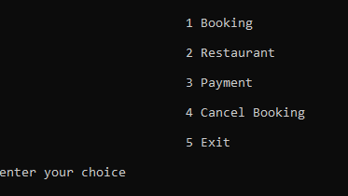

The user is redirected to this part after every task i.e booking, room service,

Bill checking.

Booking output:

Takes u back to the main screen after successful booking 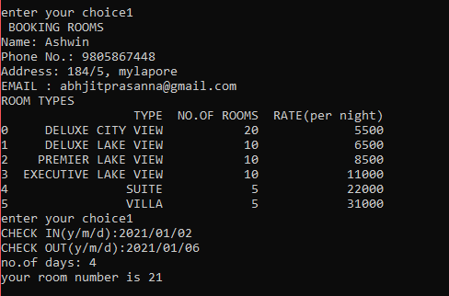

A mail is recieved by the user at the given EMail ID confirming your booking.

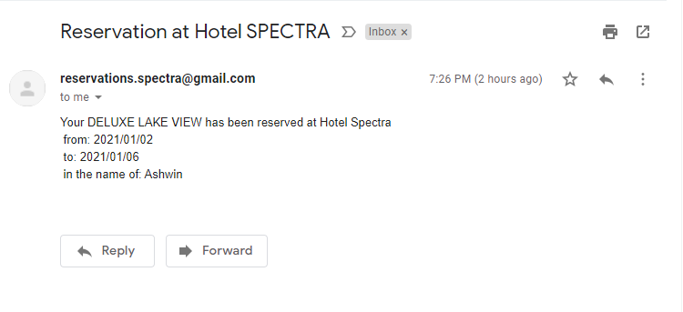

Restaurant OUTPUT :

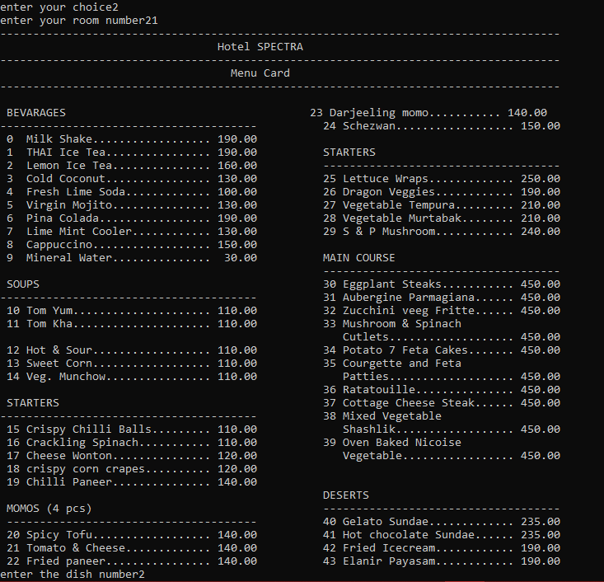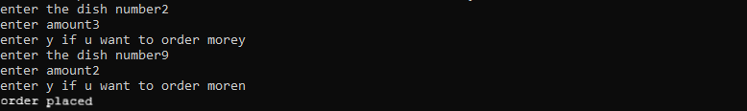

Payment (viewing bill) OUTPUT :

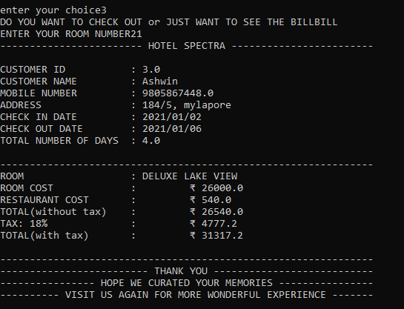

Payment (check out) OUTPUT :

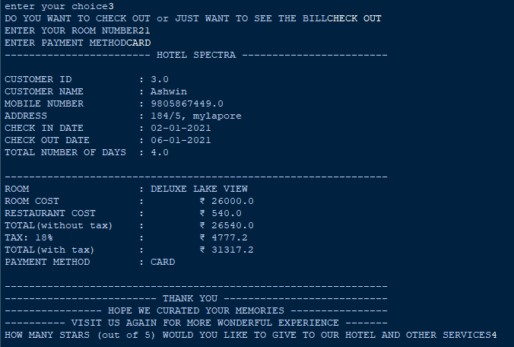

A mail is recieved by the user at the given EMail ID regarding Checking Out of your room.

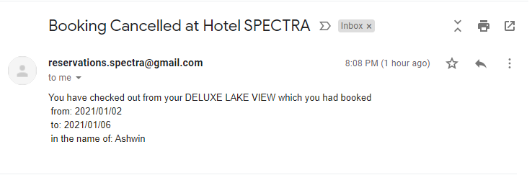

Cancel Booking OUTPUT :

You can only cancel the booking if you have not ordered food at room service.

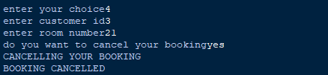

A mail is recieved by the user at the given EMail ID regarding the cancellation of your booking.

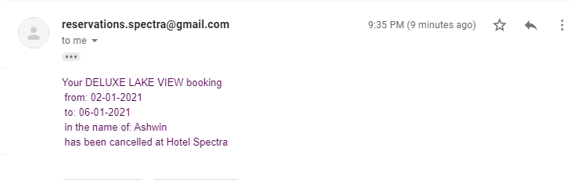

reception.py:

description:

reception.py is the user interface for receptionis and here they can perform their desired actions.

modules imported:

import random as rd

import pandas as pd

import datetime as dt

import numpy as np

import smtplib

from email.message import EmailMessage

DataFrame created:

rec_log_data = {'USERID':['RECEP_1','RECEP_2','RECEP_3','RECEP_4','RECEP_5','RECEP_6'],'PASSWORD':['SPECT_REC1','SPECT_REC2','SPECT_REC3','SPECT_REC4','SPECT_REC5','SPECT_REC6'],'NAME':['RAHUL SUBRAMANIAM','PRITA ANAND','SHEENA K','TANMAY BHAT','SUSHANT S','RHEA C'], 'MOBILENUM':['9884840103','9876453811','8394628390','93647525347','7778394912','9385769400']}

LOGIN :

def recep_log():

rec_log_data = pd.DataFrame(rec_log_data)

print()

print('-----RECEPTION LOGIN------')

a=input('Enter your UserID:')

li = rec_log_data['USERID'].tolist()

if a in li:

b=input('Enter your Password:')

print('Checking...')

che = int(a[-1])

if b == rec_log_data.loc[che-1,'PASSWORD']:

print('login successful')

recep()

else:

print('WRONG PASSWORD')

else:

print('enter a valid USERID')

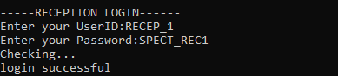

CODE :

def recep():

print("\t\t\t 1 Booking\n")

print("\t\t\t 2 Restaurant\n")

print("\t\t\t 3 Details\n")

print('\t\t\t 4 Payment\n')

print("\t\t\t 5 Cancel Booking\n")

print('\t\t\t 6 Exit\n')

choice =int(input('enter your choice'))

if choice == 1:

book()

#Booking

def book():

roomt= pd.read_csv('Rooms.csv')

DET=pd.read_csv('DET.csv')

ALL=pd.read_csv('ALL.csv')

print(" BOOKING ROOMS")

name = str(input("Name: "))

pn = str(input("Phone No.: "))

add = str(input("Address: "))

global cid

cid = str(input('Customer ID'))

global ema

ema = input('EMAIL : ')

if name!="" and pn!="" and add!="":

pass

else:

print("\tName, Phone no. & Address cannot be empty..!!")

print('ROOM TYPES')

print(roomt)

a = int(input('enter choice'))

price = roomt.loc[a,'RATE(per night)']

b=1

while b==1:

global ci

global co

global dif

ci = str(input('CHECK IN(y/m/d):'))

co = str(input('CHECK OUT(y/m/d):'))

c=1

while c == 1:

cil=ci.split('/')

col=co.split('/')

alpha = dt.date(int(cil[0]),int(cil[1]),int(cil[2]))

beta = dt.date(int(col[0]),int(col[1]),int(col[2]))

if alpha > beta :

print('error check out date must be after check in date')

b=2

c=2

exit()

elif alpha == beta :

print('error check out date must be after check in date')

b=2

c=2

exit()

elif alpha < beta:

dif = (beta - alpha).days

c=2

print('no.of days:',dif)

b=2

if(a == 0):

for i in range(0,20):

if ALL.loc[i,'STATUS'] == 'UNOCCUPIED':

print("customer's room number is",i+1)

typ=ALL.loc[i,'TYPE']

ALL.loc[i,'STATUS']='OCCUPIED'

ALL.loc[i,'CUSTOMER NAME']=name

ALL.loc[i,'MOBILE NUM']=pn

ALL.loc[i,'ADDRESS']=add

ALL.loc[i,'CHECK IN']=ci

ALL.loc[i,'CHECK OUT']=co

ALL.loc[i,'ROOM COST']=price

ALL.loc[i,'CUSTID']=cid

ALL.loc[i,'DAYS']=dif

ALL.loc[i,'EMAIL']=ema

msg = EmailMessage()

msg['Subject']='Reservation at Hotel SPECTRA'

msg['From']='reservations.spectra@gmail.com'

msg['To']=ema

msg.set_content('Your '+typ+' has been reserved at Hotel Spectra \n from: '+ci+'\n to: '+co+'\n in the name of: '+name)

with smtplib.SMTP_SSL('smtp.gmail.com',465) as smtp:

smtp.login('reservations.spectra@gmail.com','spectracular')

smtp.send_message(msg)

row=DET.shape[0]

count=row

DET.loc[count,'CUSTOMER NAME']=name

DET.loc[count,'MOBILE NUM']=pn

DET.loc[count,'ADDRESS']=add

DET.loc[count,'CHECK IN']=ci

DET.loc[count,'CHECK OUT']=co

DET.loc[count,'ROOM COST']=price

DET.loc[count,'CUSTID']=cid

DET.loc[count,'DAYS']=dif

DET.loc[count,'ROOM NO.']=i+1

DET.loc[count,'EMAIL']=ema

DET.loc[count,'STATUS']='in'

DET.loc[count,'ROOM TYPE']=roomt.loc[a,'TYPE']

DET.to_csv('DET.csv',index=False)

ALL.to_csv('ALL.csv',index=False)

recep()

break

elif a== 1:

for i in range(20,30):

if ALL.loc[i,'STATUS'] == 'UNOCCUPIED':

print("customer's room number is",i+1)

typ=ALL.loc[i,'TYPE']

ALL.loc[i,'STATUS']='OCCUPIED'

ALL.loc[i,'CUSTOMER NAME']=name

ALL.loc[i,'MOBILE NUM']=pn

ALL.loc[i,'ADDRESS']=add

ALL.loc[i,'CHECK IN']=ci

ALL.loc[i,'CHECK OUT']=co

ALL.loc[i,'ROOM COST']=price

ALL.loc[i,'CUSTID']=cid

ALL.loc[i,'DAYS']=dif

ALL.loc[i,'EMAIL']=ema

msg = EmailMessage()

msg['Subject']='Reservation at Hotel SPECTRA'

msg['From']='reservations.spectra@gmail.com'

msg['To']=ema

msg.set_content('Your '+typ+' has been reserved at Hotel Spectra \n from: '+ci+'\n to: '+co+'\n in the name of: '+name)

with smtplib.SMTP_SSL('smtp.gmail.com',465) as smtp:

smtp.login('reservations.spectra@gmail.com','spectracular')

smtp.send_message(msg)

row=DET.shape[0]

count=row

DET.loc[count,'CUSTOMER NAME']=name

DET.loc[count,'MOBILE NUM']=pn

DET.loc[count,'ADDRESS']=add

DET.loc[count,'CHECK IN']=ci

DET.loc[count,'CHECK OUT']=co

DET.loc[count,'ROOM COST']=price

DET.loc[count,'CUSTID']=cid

DET.loc[count,'DAYS']=dif

DET.loc[count,'ROOM NO.']=i+1

DET.loc[count,'EMAIL']=ema

DET.loc[count,'STATUS']='in'

DET.loc[count,'ROOM TYPE']=roomt.loc[a,'TYPE']

DET.to_csv('DET.csv',index=False)

ALL.to_csv('ALL.csv',index=False)

recep()

break

elif a== 2:

for i in range(30,40):

if ALL.loc[i,'STATUS'] == 'UNOCCUPIED':

print("customer's room number is",i+1)

typ=ALL.loc[i,'TYPE']

ALL.loc[i,'STATUS']='OCCUPIED'

ALL.loc[i,'CUSTOMER NAME']=name

ALL.loc[i,'MOBILE NUM']=pn

ALL.loc[i,'ADDRESS']=add

ALL.loc[i,'CHECK IN']=ci

ALL.loc[i,'CHECK OUT']=co

ALL.loc[i,'ROOM COST']=price

ALL.loc[i,'CUSTID']=cid

ALL.loc[i,'DAYS']=dif

ALL.loc[i,'EMAIL']=ema

msg = EmailMessage()

msg['Subject']='Reservation at Hotel SPECTRA'

msg['From']='reservations.spectra@gmail.com'

msg['To']=ema

msg.set_content('Your '+typ+' has been reserved at Hotel Spectra \n from: '+ci+'\n to: '+co+'\n in the name of: '+name)

with smtplib.SMTP_SSL('smtp.gmail.com',465) as smtp:

smtp.login('reservations.spectra@gmail.com','spectracular')

smtp.send_message(msg)

row=DET.shape[0]

count=row

DET.loc[count,'CUSTOMER NAME']=name

DET.loc[count,'MOBILE NUM']=pn

DET.loc[count,'ADDRESS']=add

DET.loc[count,'CHECK IN']=ci

DET.loc[count,'CHECK OUT']=co

DET.loc[count,'ROOM COST']=price

DET.loc[count,'CUSTID']=cid

DET.loc[count,'DAYS']=dif

DET.loc[count,'ROOM NO.']=i+1

DET.loc[count,'EMAIL']=ema

DET.loc[count,'STATUS']='in'

DET.loc[count,'ROOM TYPE']=roomt.loc[a,'TYPE']

DET.to_csv('DET.csv',index=False)

ALL.to_csv('ALL.csv',index=False)

recep()

break

elif a== 3:

for i in range(40,50):

if ALL.loc[i,'STATUS'] == 'UNOCCUPIED':

print("customer's room number is",i+1)

typ=ALL.loc[i,'TYPE']

ALL.loc[i,'STATUS']='OCCUPIED'

ALL.loc[i,'CUSTOMER NAME']=name

ALL.loc[i,'MOBILE NUM']=pn

ALL.loc[i,'ADDRESS']=add

ALL.loc[i,'CHECK IN']=ci

ALL.loc[i,'CHECK OUT']=co

ALL.loc[i,'ROOM COST']=price

ALL.loc[i,'CUSTID']=cid

ALL.loc[i,'DAYS']=dif

ALL.loc[i,'EMAIL']=ema

msg = EmailMessage()

msg['Subject']='Reservation at Hotel SPECTRA'

msg['From']='reservations.spectra@gmail.com'

msg['To']=ema

msg.set_content('Your '+typ+' has been reserved at Hotel Spectra \n from: '+ci+'\n to: '+co+'\n in the name of: '+name)

with smtplib.SMTP_SSL('smtp.gmail.com',465) as smtp:

smtp.login('reservations.spectra@gmail.com','spectracular')

smtp.send_message(msg)

row=DET.shape[0]

count=row

DET.loc[count,'CUSTOMER NAME']=name

DET.loc[count,'MOBILE NUM']=pn

DET.loc[count,'ADDRESS']=add

DET.loc[count,'CHECK IN']=ci

DET.loc[count,'CHECK OUT']=co

DET.loc[count,'ROOM COST']=price

DET.loc[count,'CUSTID']=cid

DET.loc[count,'DAYS']=dif

DET.loc[count,'ROOM NO.']=i+1

DET.loc[count,'EMAIL']=ema

DET.loc[count,'STATUS']='in'

DET.loc[count,'ROOM TYPE']=roomt.loc[a,'TYPE']

DET.to_csv('DET.csv',index=False)

ALL.to_csv('ALL.csv',index=False)

recep()

break

elif a== 4:

for i in range(50,55):

if ALL.loc[i,'STATUS'] == 'UNOCCUPIED':

print('customers room number is',i+1)

typ=ALL.loc[i,'TYPE']

ALL.loc[i,'STATUS']='OCCUPIED'

ALL.loc[i,'CUSTOMER NAME']=name

ALL.loc[i,'MOBILE NUM']=pn

ALL.loc[i,'ADDRESS']=add

ALL.loc[i,'CHECK IN']=ci

ALL.loc[i,'CHECK OUT']=co

ALL.loc[i,'ROOM COST']=price

ALL.loc[i,'CUSTID']=cid

ALL.loc[i,'DAYS']=dif

ALL.loc[i,'EMAIL']=ema

msg = EmailMessage()

msg['Subject']='Reservation at Hotel SPECTRA'

msg['From']='reservations.spectra@gmail.com'

msg['To']=ema

msg.set_content('Your '+typ+' has been reserved at Hotel Spectra \n from: '+ci+'\n to: '+co+'\n in the name of: '+name)

with smtplib.SMTP_SSL('smtp.gmail.com',465) as smtp:

smtp.login('reservations.spectra@gmail.com','spectracular')

smtp.send_message(msg)

row=DET.shape[0]

count=row

DET.loc[count,'CUSTOMER NAME']=name

DET.loc[count,'MOBILE NUM']=pn

DET.loc[count,'ADDRESS']=add

DET.loc[count,'CHECK IN']=ci

DET.loc[count,'CHECK OUT']=co

DET.loc[count,'ROOM COST']=price

DET.loc[count,'CUSTID']=cid

DET.loc[count,'DAYS']=dif

DET.loc[count,'ROOM NO.']=i+1

DET.loc[count,'EMAIL']=ema

DET.loc[count,'STATUS']='in'

DET.loc[count,'ROOM TYPE']=roomt.loc[a,'TYPE']

DET.to_csv('DET.csv',index=False)

ALL.to_csv('ALL.csv',index=False)

recep()

break

elif a== 5:

for i in range(55,60):

if ALL.loc[i,'STATUS'] == 'UNOCCUPIED':

print("customer's room number is",i+1)

typ=ALL.loc[i,'TYPE']

ALL.loc[i,'STATUS']='OCCUPIED'

ALL.loc[i,'CUSTOMER NAME']=name

ALL.loc[i,'MOBILE NUM']=pn

ALL.loc[i,'ADDRESS']=add

ALL.loc[i,'CHECK IN']=ci

ALL.loc[i,'CHECK OUT']=co

ALL.loc[i,'ROOM COST']=price

ALL.loc[i,'CUSTID']=cid

ALL.loc[i,'DAYS']=dif

ALL.loc[i,'EMAIL']=ema

msg = EmailMessage()

msg['Subject']='Reservation at Hotel SPECTRA'

msg['From']='reservations.spectra@gmail.com'

msg['To']=ema

msg.set_content('Your '+typ+' has been reserved at Hotel Spectra \n from: '+ci+'\n to: '+co+'\n in the name of: '+name)

with smtplib.SMTP_SSL('smtp.gmail.com',465) as smtp:

smtp.login('reservations.spectra@gmail.com','spectracular')

smtp.send_message(msg)

row=DET.shape[0]

count=row

DET.loc[count,'CUSTOMER NAME']=name

DET.loc[count,'MOBILE NUM']=pn

DET.loc[count,'ADDRESS']=add

DET.loc[count,'CHECK IN']=ci

DET.loc[count,'CHECK OUT']=co

DET.loc[count,'ROOM COST']=price

DET.loc[count,'CUSTID']=cid

DET.loc[count,'DAYS']=dif

DET.loc[count,'ROOM NO.']=i+1

DET.loc[count,'EMAIL']=ema

DET.loc[count,'STATUS']='in'

DET.loc[count,'ROOM TYPE']=roomt.loc[a,'TYPE']

DET.to_csv('DET.csv',index=False)

ALL.to_csv('ALL.csv',index=False)

recep()

break

#Restaurant

elif choice == 2:

food=pd.read_csv('restaurant.csv')

roomno=int(input('enter customers room number'))

ALL=pd.read_csv('ALL.csv')

print("-------------------------------------------------------------------------------------")

print(" Hotel SPECTRA")

print("-------------------------------------------------------------------------------------")

print(" Menu Card")

print("-------------------------------------------------------------------------------------")

print("\n BEVARAGES 23 Darjeeling momo........... 140.00")

print("--------------------------------------- 24 Schezwan.................. 150.00")

print(" 0 Milk Shake.................. 190.00 ")

print(" 1 THAI Ice Tea................ 190.00 STARTERS")

print(" 2 Lemon Ice Tea............... 160.00 ------------------------------------")

print(" 3 Cold Coconut................ 130.00 25 Lettuce Wraps............. 250.00")

print(" 4 Fresh Lime Soda............. 100.00 26 Dragon Veggies............ 190.00")

print(" 5 Virgin Mojito............... 130.00 27 Vegetable Tempura......... 210.00")

print(" 6 Pina Colada................. 190.00 28 Vegetable Murtabak........ 210.00")

print(" 7 Lime Mint Cooler............ 130.00 29 S & P Mushroom............ 240.00")

print(" 8 Cappuccino.................. 150.00")

print(" 9 Mineral Water............... 30.00 MAIN COURSE")

print(" ------------------------------------")

print(" SOUPS 30 Eggplant Steaks........... 450.00")

print("--------------------------------------- 31 Aubergine Parmagiana...... 450.00")

print(" 10 Tom Yum..................... 110.00 32 Zucchini veeg Fritte...... 450.00")

print(" 11 Tom Kha..................... 110.00 33 Mushroom & Spinach ")

print(" Cutlets................... 450.00")

print(" 12 Hot & Sour.................. 110.00 34 Potato 7 Feta Cakes....... 450.00")

print(" 13 Sweet Corn.................. 110.00 35 Courgette and Feta")

print(" 14 Veg. Munchow................ 110.00 Patties................... 450.00")

print(" 36 Ratatouille............... 450.00")

print(" STARTERS 37 Cottage Cheese Steak...... 450.00")

print("--------------------------------------- 38 Mixed Vegetable ")

print(" 15 Crispy Chilli Balls......... 110.00 Shashlik.................. 450.00")

print(" 16 Crackling Spinach........... 110.00 39 Oven Baked Nicoise")

print(" 17 Cheese Wonton............... 120.00 Vegetable................. 450.00")

print(" 18 crispy corn crapes.......... 120.00")

print(" 19 Chilli Paneer............... 140.00 ")

print(' DESERTS')

print(" MOMOS (4 pcs) ------------------------------------")

print(" -------------------------------------- 40 Gelato Sundae............. 235.00")

print(" 20 Spicy Tofu.................. 140.00 41 Hot chocolate Sundae...... 235.00")

print(" 21 Tomato & Cheese............. 140.00 42 Fried Icecream............ 190.00")

print(" 22 Fried paneer................ 140.00 43 Elanir Payasam............ 190.00")

TP=0

x=1

while x==1:

choice = int(input('enter the dish number'))

amt= int(input('enter amount'))

price = food.loc[choice,'PRICE']

tp = price*amt

b=input('enter y if u want to add more to the customers order')

if b == 'y':

x=1

TP=TP+tp

else:

TP=TP+tp

break

RT=ALL.loc[roomno-1,'ROOM COST']

ALL.loc[roomno-1,'REST COST']=TP

TL=RT+TP

ALL.loc[roomno-1,'TOTAL']=TL

ALL.to_csv('ALL.csv',index=False)

recep()

#Accessing Details

elif choice == 3:

ALL=pd.read_csv('ALL.csv')

print('\t 1 PARTICULAR ROOM\n')

print('\t 2 ALL OCCUPIED ROOMS\n')

print('\t 3 ALL UNOCCUPIED ROOMS\n')

print('\t 4 ALL ROOMS\n')

print('\t 5 TYPES OF ROOMS\n')

choice = input('ENTER YOUR CHOICE')

if choice == '1':

roomno = int(input('ENTER THE CUSTOMERS ROOM NUMBER'))

print(ALL.loc[roomno-1,['ROOM NO.','TYPE','CUSTOMER NAME','MOBILE NUM','ADDRESS','CHECK IN','CHECK OUT','DAYS']])

recep()

elif choice == '2':

pd.set_option("display.max_rows", None, "display.max_columns", None)

data=[]

for i in range(0,60):

if ALL.loc[i,'STATUS']=='OCCUPIED':

a=ALL.loc[i,'ROOM NO.':'DAYS'].tolist()

data.append(a)

d1=pd.DataFrame(data,columns=['ROOM NO.','TYPE','CUSTOMER NAME','MOBILE NUM','ADDRESS','CHECK IN','CHECK OUT','DAYS'])

print(d1)

recep()

elif choice == '3':

pd.set_option("display.max_rows", None, "display.max_columns", None)

data=[]

for i in range(0,60):

if ALL.loc[i,'STATUS']=='UNOCCUPIED':

a=ALL.loc[i,'ROOM NO.':'TYPE'].tolist()

data.append(a)

d1=pd.DataFrame(data,columns=['ROOM NO.','TYPE'])

print(d1)

recep()

elif choice == '4':

print(ALL.loc[0:60,'ROOM NO.':'DAYS'])

recep()

elif choice == '5':

Type=pd.read_csv('Rooms.csv')

print(Type)

recep()

#Checking customers out

elif choice == 4:

DET= pd.read_csv('DET.csv')

ALL = pd.read_csv('ALL.csv')

roomno = int(input('ENTER YOUR ROOM NUMBER'))

if ALL.loc[roomno-1,'STATUS'] == 'UNOCCUPIED':

print('PLEASE ENTER THE CORRECT ROOM NUMBER')

elif ALL.loc[roomno-1,'STATUS'] == 'OCCUPIED':

ROOM_COST=ALL.loc[roomno-1,'ROOM COST']

REST_COST=ALL.loc[roomno-1,'REST COST']

TOTAL=ROOM_COST+REST_COST

t_18=TOTAL*(0.18)

TT=TOTAL+t_18

pay=input('ENTER PAYMENT METHOD')

CUSTID = ALL.loc[roomno-1,'CUSTID']

print('------------------------ HOTEL SPECTRA ------------------------')

print()

print('CUSTOMER ID :',str(ALL.loc[roomno-1,'CUSTID']))

print('CUSTOMER NAME :',ALL.loc[roomno-1,'CUSTOMER NAME'])

print('MOBILE NUMBER :',str(ALL.loc[roomno-1,'MOBILE NUM']))

print('ADDRESS :',ALL.loc[roomno-1,'ADDRESS'])

print('CHECK IN DATE :',ALL.loc[roomno-1,'CHECK IN'])

print('CHECK OUT DATE :',ALL.loc[roomno-1,'CHECK OUT'])

print('TOTAL NUMBER OF DAYS :',str(ALL.loc[roomno-1,'DAYS']))

print()

print('---------------------------------------------------------------')

print('ROOM :',ALL.loc[roomno-1,'TYPE'])

print('ROOM COST :','\t₹',ROOM_COST)

print('RESTAURANT COST :','\t₹',REST_COST)

print('TOTAL(without tax) :','\t₹',TOTAL)

print('TAX: 18% :','\t₹',t_18)

print('TOTAL(with tax) :','\t₹',TT)

print('PAYMENT METHOD :',pay)

print()

print('---------------------------------------------------------------')

print('------------------------- THANK YOU ---------------------------')

print('---------------- HOPE WE CURATED YOUR MEMORIES ----------------')

print('---------- VISIT US AGAIN FOR MORE WONDERFUL EXPERIENCE -------')

typ=ALL.loc[roomno-1,'TYPE']

ci=ALL.loc[roomno-1,'CHECK IN']

co=ALL.loc[roomno-1,'CHECK OUT']

name=ALL.loc[roomno-1,'CUSTOMER NAME']

ema = ALL.loc[roomno-1,'EMAIL']

msg = EmailMessage()

msg['Subject']='Checked out from Hotel SPECTRA'

msg['From']='reservations.spectra@gmail.com'

msg['To']=ema

msg.set_content('You have checked out from your '+typ+' which you had booked \n from: '+ci+'\n to: '+co+'\n in the name of: '+name)

with smtplib.SMTP_SSL('smtp.gmail.com',465) as smtp:

smtp.login('reservations.spectra@gmail.com','spectracular')

smtp.send_message(msg)

r=DET[DET['CUSTID']==CUSTID].index.values

DET.loc[r[0],'STATUS']='out'

ALL.loc[roomno-1,'STATUS']='UNOCCUPIED'

ALL.loc[roomno-1,'CUSTOMER NAME']=np.NaN

ALL.loc[roomno-1,'MOBILE NUM']=np.NaN

ALL.loc[roomno-1,'ADDRESS']=np.NaN

ALL.loc[roomno-1,'CHECK IN']=np.NaN

ALL.loc[roomno-1,'CHECK OUT']=np.NaN

ALL.loc[roomno-1,'CUSTID']=np.NaN

ALL.loc[roomno-1,'DAYS']=np.NaN

ALL.loc[roomno-1,'EMAIL']=np.NaN

ALL.loc[roomno-1,'ROOM COST']=0

ALL.loc[roomno-1,'REST COST']=0

ALL.loc[roomno-1,'TOTAL']=0

ALL.loc[roomno-1,'TAX(18%)']=0

ALL.loc[roomno-1,'TOTAL(tax)']=0

pimpos=1

while pimpos ==1:

numoro=int(input('HOW MANY STARS (out of 5) WOULD YOU LIKE TO GIVE TO OUR HOTEL AND OTHER SERVICES'))

if numoro == 1:

DET.loc[r[0],'STARS'] = 1

pimpos =2

if numoro == 2:

DET.loc[r[0],'STARS'] = 2

pimpos = 2

if numoro == 3:

DET.loc[r[0],'STARS'] = 3

pimpos = 2

if numoro == 4:

DET.loc[r[0],'STARS'] = 4

pimpos = 2

if numoro == 5:

DET.loc[r[0],'STARS'] = 5

pimpos = 2

if numoro not in (1,2,3,4,5):

print('PLEASE GIVE A VALID RATING')

DET.to_csv('DET.csv',index=False)

ALL.to_csv('ALL.csv',index=False)

recep()

#Cancel booking for customer

elif choice == 5:

DET= pd.read_csv('DET.csv')

ALL=pd.read_csv('ALL.csv')

custid=int(input('enter customer id'))

roomno=int(input('enter room number'))

if custid == ALL.loc[roomno-1,'CUSTID']:

can=input('do you want to cancel your booking')

if ALL.loc[roomno-1,'REST COST']==0:

if can in('y','yes','YES','Y'):

typ=ALL.loc[roomno-1,'TYPE']

ci=ALL.loc[roomno-1,'CHECK IN']

co=ALL.loc[roomno-1,'CHECK OUT']

name=ALL.loc[roomno-1,'CUSTOMER NAME']

ema = ALL.loc[roomno-1,'EMAIL']

msg = EmailMessage()

msg['Subject']='Booking Cancelled at Hotel SPECTRA'

msg['From']='reservations.spectra@gmail.com'

msg['To']=ema

msg.set_content('Your '+typ+' booking \n from: '+ci+'\n to: '+co+'\n in the name of: '+name+'\n has been cancelled at Hotel Spectra')

with smtplib.SMTP_SSL('smtp.gmail.com',465) as smtp:

smtp.login('reservations.spectra@gmail.com','spectracular')

smtp.send_message(msg)

print('CANCELLING YOUR BOOKING')

r=DET[DET['CUSTID']==custid].index.values

DET.loc[r[0],'STATUS']='cancel'

ALL.loc[roomno-1,'STATUS']='UNOCCUPIED'

ALL.loc[roomno-1,'CUSTOMER NAME']=np.NaN

ALL.loc[roomno-1,'MOBILE NUM']=np.NaN

ALL.loc[roomno-1,'ADDRESS']=np.NaN

ALL.loc[roomno-1,'CHECK IN']=np.NaN

ALL.loc[roomno-1,'CHECK OUT']=np.NaN

ALL.loc[roomno-1,'CUSTID']=np.NaN

ALL.loc[roomno-1,'DAYS']=np.NaN

ALL.loc[roomno-1,'EMAIL']=np.NaN

ALL.loc[roomno-1,'ROOM COST']=0

ALL.loc[roomno-1,'REST COST']=0

ALL.loc[roomno-1,'TOTAL']=0

ALL.loc[roomno-1,'TAX(18%)']=0

ALL.loc[roomno-1,'TOTAL(tax)']=0

DET.to_csv('DET.csv',index=False)

ALL.to_csv('ALL.csv',index=False)

print('BOOKING CANCELLED')

recep()

else:

print('enjoy your stay in SPECTRA')

recep()

else:

print('YOU CANT CANCEL THE BOOKING')

recep()

elif custid != ALL.loc[roomno-1,'CUSTID']:

print('enter valid Customer ID')

recep()

elif choice ==5:

exit()

OUTPUT:

MAINSCREEN FOR RECEPTIONISTS :

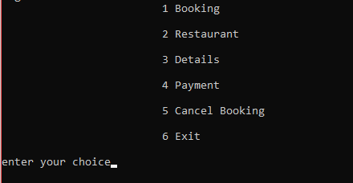

The user is redirected to this part after every task i.e booking, room service,

Checking Details, checkout.

Booking output:

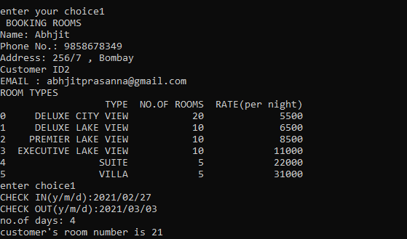

Takes u back to the main screen after successful booking

A mail is recieved by the customer at the given EMail ID confirming their booking.

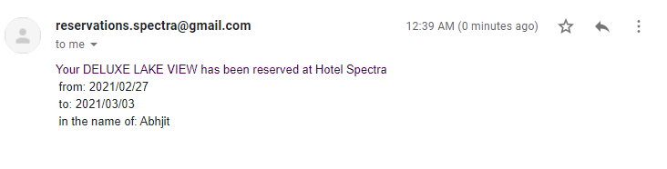

Restaurant OUTPUT :



Details :

* PARTICULAR ROOM

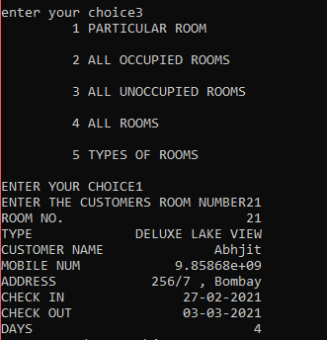

9858678349

sfsds

sfsds

* ALL OCCUPIED ROOMS

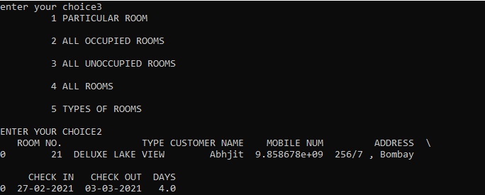

9858678349

sfsds

sfsds

* ALL UNOCCUPIED ROOMS

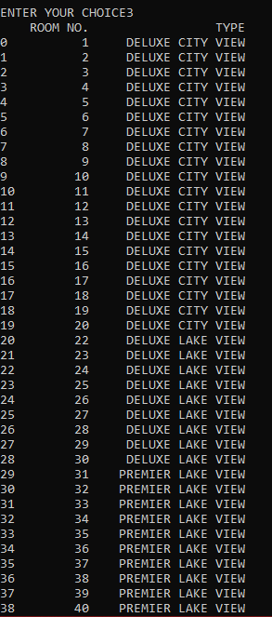

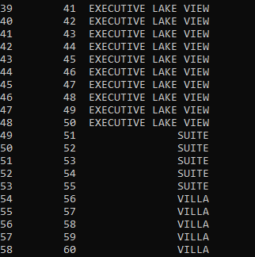

* ALL ROOMS

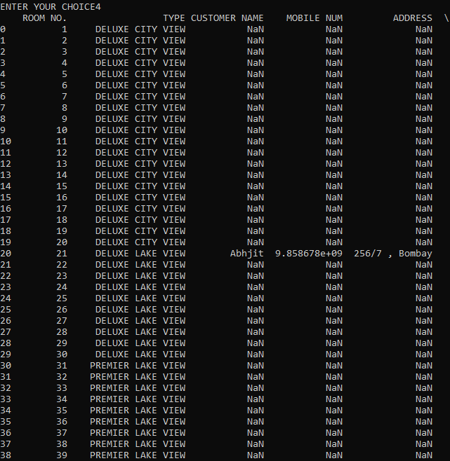

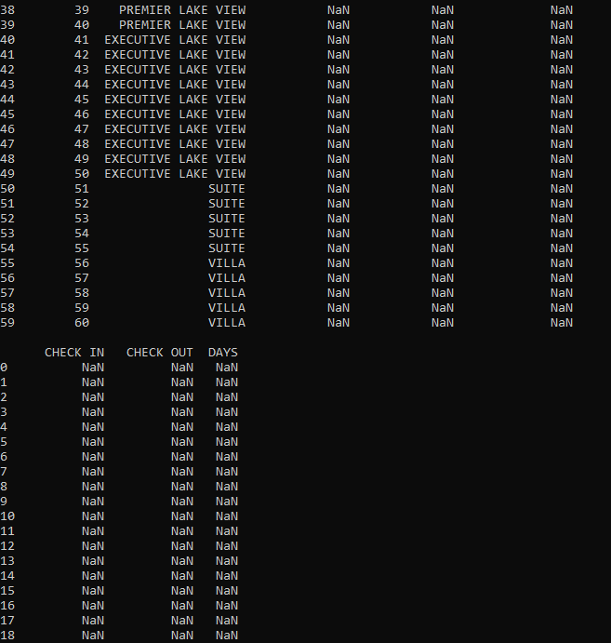

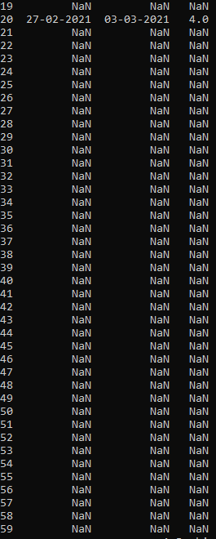

* TYPES OF ROOMS

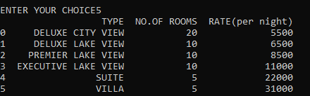

Payment (check out) OUTPUT :



A mail is recieved by the user at the given EMail ID regarding Checking Out of your room.



Cancel Booking OUTPUT :

You can only cancel the booking if you have not ordered food at room service.



A mail is recieved by the user at the given EMail ID regarding the cancellation of your booking.

