- Problem Statement:
The task is to estimate an aircraft's true height above ground level (AGL), using data from two downward-facing laser altimeters and a GPS sensor. At low altitudes (below ~15m), precise ground-following is critical for crop spraying and landing, while at higher altitudes a smooth flight trajectory is more important than exactly tracking terrain contours. The challenge is that altimeter readings are frequently corrupted producing physically impossible values that must be detected and rejected before they can corrupt the height estimate.

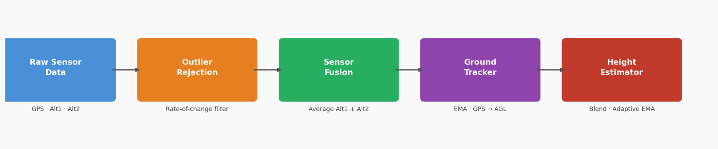
- Solution:

  - Outlier Rejection:
Each altimeter reading is checked before being used. A reading is rejected if it is at or below zero (sensor dropout or hardware fault) or if it changed too fast since the last reading. The rate-of-change check works by computing how quickly the altitude changed between two consecutive readings (10ms apart) and rejecting it if that speed exceeds 30 m/s. Using only an absolute upper bound (e.g. reject anything above 200m) is not enough because a spike to 50m looks valid in isolation but is physically impossible when the previous reading was 5m. When a reading is rejected, the previous reference is slowly decayed toward the current estimate rather than held frozen, this prevents the reference from going stale during a long outage, which would cause legitimate readings to be incorrectly rejected when the sensor recovers.
  - Sensor Fusion
Both altimeters are checked independently and then combined. If both pass the validity check, their average is used, this reduces random noise since the two sensors are independent. If only one passes, that reading is used directly. If neither passes, no altimeter data is available for that timestep and the estimate holds its last value. This fallback hierarchy means the system degrades gracefully, it never blindly trusts a single bad sensor, but it also never discards good data just because the other sensor is misbehaving.
  - Ground Elevation Tracking
The GPS reports altitude above mean sea level (ASL), not above the ground. To get a GPS-based height above ground level (AGL), we need to know the ground elevation at the current location. This is estimated by computing ground elevation = GPS ASL − altimeter AGL at each timestep and tracking it with an exponential moving average (EMA). The EMA uses a faster learning rate for the first 100 samples to initialize quickly, then switches to a slower rate so the estimate is not thrown off by individual noisy readings. This gives a running estimate of what the ground is doing beneath the aircraft, which is then used to convert GPS altitude into a usable AGL value.
  - Height Estimation and Blending
The final height estimate blends the fused altimeter reading and the GPS-derived AGL based on the current altitude. Below 15m the estimate relies entirely on the altimeters, at crop spraying height, precise ground-following matters most and the altimeters are more accurate than GPS. Above 40m the estimate relies entirely on GPS-derived AGL. Between 10m and 40m the two sources are linearly mixed. On top of the blending, an EMA smoothing filter is applied — with a stronger smoothing factor at higher altitudes and a lighter one near the ground. This ensures the estimate is responsive at low altitude where precision matters, and smooth at high altitude where sudden jumps in the output would affect flight quality.
- Results:
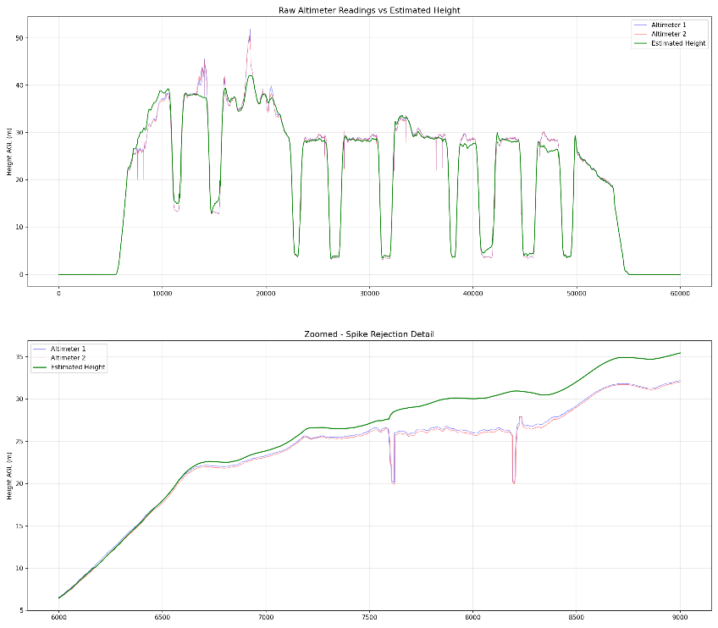
Log1 Analysis
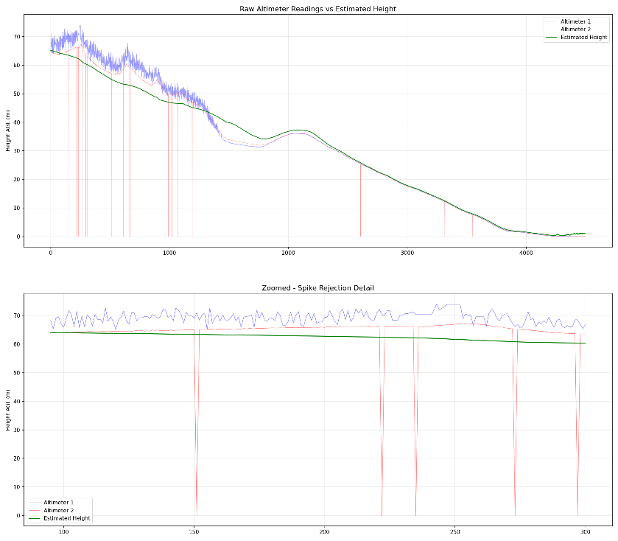
Log2 Analysis
The pipeline was tested on two flight logs with very different characteristics. Log 1 captures a low-altitude mission with the aircraft flying between 0–40m. The estimated height tracks the flight profile cleanly, and the occasional spikes visible in the raw altimeter readings — clearly seen around timestamps are successfully rejected with no visible impact on the estimate.
Log 2 captures a high-altitude descent from ~65m down to ground level, where altimeter 2 shows frequent large spikes dropping to zero throughout the flight. The zoomed plot confirms these are completely filtered out, and the estimated height follows a smooth, physically plausible descent trajectory.
In both cases the estimated height is noticeably smoother than the raw sensor data while still accurately reflecting the true flight profile.
- Tunable Parameters:
Parameter | Value | Effect
MAX_CHANGE_RATE | 30 m/s | Controls outlier sensitivity
LOW_ALT | 20 m | Below this, altimeters fully trusted
HIGH_ALT | 40 m | Above this, GPS fully trusted
alphaHigh | 0.15 | Smoothing at high altitude
Ground tracker alpha | 0.008 | Terrain adaptation speed

- Limitations
- Constants need tuning per flight profile (log1 vs log2 fly very differently)
- Ground tracker lags on rapidly changing terrain
- A Kalman filter would be more principled, it would handle sensor uncertainty explicitly rather than through tuned constants
- No handling for GPS dropouts

- Realizations and Future Improvements
The exponential moving average used in this solution is fundamentally a low-pass filter — it smooths out high-frequency noise but introduces lag, meaning the estimate always trails slightly behind sudden real changes in height. This lag is manageable at cruise altitude where smooth trajectories matter more, but at low altitude where the aircraft needs to react quickly to terrain, it is a genuine limitation.
A Kalman filter would be a more principled solution. It explicitly models sensor uncertainty and predicts the next state based on a motion model, which means it adapts its smoothing automatically based on how confident it is in the sensors at any given moment — removing the need to manually tune constants like ALPHA, LOW_ALT, and HIGH_ALT. I have a limited understanding of Kalman filters at this point, so the EMA-based approach was chosen as a practical alternative, but this would be the natural next step.

- References:
- https://heyeduardo.com/posts/exponential-moving-average/
- https://towardsdatascience.com/intuitive-explanation-of-exponential-moving-average-2eb9693ea4dc/
- https://github.com/hridaybavle/altitude_filtering ( Future for Kalman Filtering)
- https://www.researchgate.net/publication/264291862_A_Sensor_Fusion_Method_for_Tracking_Vertical_Velocity_and_Height_Based_on_Inertial_and_Barometric_Altimeter_Measurements

