PROJECT SCHEDULE, CRITICAL PATH ANALYSIS
AND BUDGET ESTIMATION
ShopEase Online Store: Development of an
E-commerce Web Application
Name : Abhay Maurya
PRN : 202301040187
Subject : Project Management ( Assignment 2 )
Project Domain : E-commerce Application
Document Version : 1.0, 16 Sep 2026
Schedule and budget model : ShopEase_Schedule_Budget_Model.xlsx

ABSTRACT
This document is the schedule and cost plan for the ShopEase online store project, whose charter, WBS and WBS dictionary were prepared in Assignment 1. The 25 work packages of the WBS were converted into 26 schedule activities. Durations were estimated with three-point (PERT) estimates, and the activities were sequenced with finish-to-start, start-to-start and finish-to-finish dependencies, including leads and lags.
An activity-on-node network diagram was drawn and the Critical Path Method (forward and backward pass) was applied. The project takes 108 working days. The critical path is A - C - D - I - K - L - P - S - T - V - W - X - Y - Z, giving go-live on 27 Jan 2027 and closure on 16 Feb 2027, which matches the charter. Total float and free float were calculated for every activity, resource loading was checked and levelled within float, and crashing and fast-tracking options were compared.
The budget was estimated bottom-up from effort and daily rates for each activity and rolled up to the WBS control accounts. The work package total is Rs 10,17,800; a contingency reserve of Rs 1,02,000, based on the expected monetary value of the project risks, gives a cost baseline of Rs 11,19,800, and a management reserve of Rs 51,000 gives a total budget of Rs 11,70,800. The cost baseline was time-phased by week and plotted as an S-curve for both early and late start schedules. All calculations are also built as formulas in an Excel workbook, so the critical path, dates, floats, budget and S-curve recalculate when a duration, dependency, rate or date is changed.
Keywords: Project Schedule, Network Diagram, Precedence Diagramming Method, Critical Path Method, Float, PERT, Crashing, Fast Tracking, Cost Baseline, Contingency Reserve, Management Reserve, S-Curve.

1. INTRODUCTION

1.1 Background
ShopEase is a clothing and lifestyle store in Pune that is building its own online store to replace ordering through WhatsApp messages. Assignment 1 authorised the project through a project charter and defined the scope with a WBS of 8 control accounts and 25 work packages. This assignment takes the scope baseline and produces the next two baselines of the project management plan: the schedule baseline and the cost baseline.

1.2 Objectives
- To define the schedule activities from the WBS work packages and estimate their durations.
- To sequence the activities with the correct dependency types, leads and lags.
- To draw the network diagram and find the critical path and float with the Critical Path Method.
- To build the project schedule (Gantt chart and milestones) and check resource loading.
- To analyse schedule compression options (crashing and fast tracking).
- To estimate the budget bottom-up, aggregate it into a cost baseline with reserves and plot the S-curve.
- To build a dynamic model that recalculates the schedule and budget when inputs change.

1.3 Planning Basis and Assumptions
- Calendar: 5 working days per week (Monday to Friday). Project day 0 is Tuesday 01 Sep 2026; week 1 is the week starting Monday 31 Aug 2026. Holidays: Ganesh Chaturthi (14 Sep), Gandhi Jayanti (2 Oct), Dussehra (20 Oct), Diwali (9 to 11 Nov), Christmas (25 Dec), office closure from 28 Dec 2026 to 1 Jan 2027 and Republic Day (26 Jan 2027), 13 working days in total.
- Units: all durations, leads, lags and floats are in working days. ES and EF are day numbers counted from day 0; an activity with ES = 5 and duration 5 occupies days 5 to 9 and has EF = 10.
- Team: Project Manager, Business Analyst, UI/UX Designer, 2 Full-stack Developers, QA Engineer and DevOps Engineer, as in the charter. Developer 1 builds the customer storefront chain and Developer 2 builds the admin chain; these resource sequences are included as dependencies.
- Monitoring and status reporting (WBS 1.1.3) is a level-of-effort activity that runs from the start of planning until the end of hypercare. It has no logic of its own and is not drawn in the network, but its cost is included in the budget and S-curve.
- Rates and non-labour costs are the same as in the WBS dictionary, so the budget in this document traces directly to Assignment 1.

2. ACTIVITY DEFINITION AND DURATION ESTIMATES

2.1 From Work Packages to Activities
Each work package of the WBS became one activity, except work package 1.8.3 (Go-Live and Hypercare), which was split into X (go-live preparation and deployment) and Y (hypercare) because they have different logic and the go-live date is the start of Y. Activity IDs A to Z are used in the network diagram; the WBS code links every activity back to the WBS dictionary.

2.2 Three-Point Estimates
The team gave an optimistic (O), most likely (M) and pessimistic (P) duration for each activity. The expected duration uses the PERT (beta) formula and is rounded to whole working days:
t_{e} = (O + 4M + P) / 6 standard deviation σ = (P - O) / 6
Example, activity I (Product catalogue and search): O = 12, M = 14, P = 18, so t_{e} = (12 + 56 + 18) / 6 = 14.33, rounded to 14 days, and σ = (18 - 12) / 6 = 1.00 day. Hypercare (Y) is fixed at 10 days by the charter, so O = M = P.
ID | Activity | WBS | O | M | P | t_{e} | σ | Dur
A | Project initiation and charter | 1.1.1 | 4 | 5 | 6 | 5.00 | 0.33 | 5
B | Project planning (baselines) | 1.1.2 | 4 | 5 | 9 | 5.50 | 0.83 | 6
C | Requirements specification | 1.2.1 | 8 | 10 | 12 | 10.00 | 0.67 | 10
D | UI/UX design and prototype test | 1.2.2 | 12 | 15 | 18 | 15.00 | 1.00 | 15
E | Architecture and database design | 1.2.3 | 8 | 10 | 12 | 10.00 | 0.67 | 10
F | Cloud hosting and environments | 1.6.1 | 5 | 7 | 9 | 7.00 | 0.67 | 7
G | CI/CD pipeline | 1.6.2 | 4 | 5 | 6 | 5.00 | 0.33 | 5
H | User accounts and OTP login | 1.3.2 | 6 | 8 | 10 | 8.00 | 0.67 | 8
I | Product catalogue and search | 1.3.1 | 12 | 14 | 18 | 14.33 | 1.00 | 14
J | Product and inventory admin | 1.5.1 | 8 | 10 | 12 | 10.00 | 0.67 | 10
K | Shopping cart and checkout | 1.3.3 | 12 | 14 | 17 | 14.17 | 0.83 | 14
L | Payment gateway integration | 1.4.1 | 8 | 10 | 14 | 10.33 | 1.00 | 10
M | Order management and returns | 1.5.2 | 8 | 10 | 14 | 10.33 | 1.00 | 10
N | Shipping and courier integration | 1.4.2 | 5 | 6 | 8 | 6.17 | 0.50 | 6
O | GST invoice generation | 1.4.3 | 4 | 5 | 7 | 5.17 | 0.50 | 5
P | Order tracking and notifications | 1.3.4 | 6 | 8 | 10 | 8.00 | 0.67 | 8
Q | Sales reports dashboard | 1.5.3 | 5 | 6 | 7 | 6.00 | 0.33 | 6
R | Security hardening and backups | 1.6.3 | 8 | 10 | 12 | 10.00 | 0.67 | 10
S | Functional and integration testing | 1.7.1 | 16 | 20 | 24 | 20.00 | 1.33 | 20
T | Performance and security testing (VAPT) | 1.7.2 | 6 | 8 | 12 | 8.33 | 1.00 | 8
U | Product data migration | 1.8.1 | 10 | 12 | 16 | 12.33 | 1.00 | 12
V | User acceptance testing | 1.7.3 | 4 | 6 | 8 | 6.00 | 0.67 | 6
W | Staff training and user manual | 1.8.2 | 6 | 8 | 10 | 8.00 | 0.67 | 8
X | Go-live preparation and deployment | 1.8.3 | 3 | 4 | 5 | 4.00 | 0.33 | 4
Y | Hypercare (2 weeks) | 1.8.3 | 10 | 10 | 10 | 10.00 | 0.00 | 10
Z | Project closure | 1.1.4 | 4 | 5 | 6 | 5.00 | 0.33 | 5
Table 1: Activity list with three-point estimates (durations in working days)

3. ACTIVITY SEQUENCING

3.1 Dependency Types Used
The schedule uses the Precedence Diagramming Method (PDM), where activities are nodes and dependencies are arrows. Three of the four PDM relationship types are used:
Type | Meaning | Example in this project
FS (finish-to-start) | Successor cannot start until predecessor finishes | K Cart and checkout -> L Payment gateway
SS (start-to-start) | Successor cannot start until predecessor has started (plus lag) | F Hosting SS+3 -> G CI/CD: pipeline starts 3 days after hosting setup starts
FF (finish-to-finish) | Successor cannot finish until predecessor has finished (plus lag) | P Tracking FF+4 -> S Testing: testing ends 4 days after the last feature is finished
SF (start-to-finish) | Successor cannot finish until predecessor starts | Not needed in this project
Table 2: PDM relationship types
A lag is a waiting time added to a relationship (for example J FS+15 -> U, because suppliers need three weeks to send product data after the bulk upload is ready). A lead is a negative lag that lets the successor start early (C FS-2 -> E: architecture starts 2 days before the SRS is formally finished, using the final draft).
Dependencies were also classified as mandatory (hard logic, for example payment needs checkout), discretionary (preferred logic that can be changed for fast tracking), external (depends on suppliers or vendors) and resource (the same developer cannot do two activities at once).

3.2 Dependency Register
No | Pred. | Succ. | Type | Lag | Category | Reason
1 | A | B | FS | 0 | Mandatory | Baselines need the approved charter
2 | A | C | FS | 0 | Mandatory | Requirements work is authorised by the charter
3 | C | D | FS | 0 | Mandatory | Screens are designed from approved user stories
4 | B | D | FS | 0 | Discretionary | Design starts only after the plan is baselined
5 | C | E | FS | -2 | Discretionary | Lead of 2 days: architecture starts on the final SRS draft
6 | E | F | FS | -3 | Discretionary | Lead of 3 days: hosting set up once the stack is chosen
7 | F | G | SS | +3 | Mandatory | SS + 3: pipeline needs the staging server, not all environments
8 | E | H | FS | 0 | Mandatory | Needs database schema and API design
9 | D | H | SS | +10 | Discretionary | SS + 10: login screens are designed first, so coding starts early
10 | D | I | FS | 0 | Mandatory | Catalogue pages need the signed-off design
11 | E | I | FS | 0 | Mandatory | Needs database schema
12 | H | J | FS | 0 | Resource | Developer 2 moves from accounts to admin
13 | I | K | FS | 0 | Mandatory | Cart needs products; also Developer 1 sequence
14 | H | K | FS | 0 | Mandatory | Checkout needs logged-in customers and addresses
15 | K | L | FS | 0 | Mandatory | Payment is the last step of checkout; Developer 1 sequence
16 | K | M | SS | +4 | Discretionary | SS + 4: order screens start once the order model in checkout is fixed
17 | J | M | FS | 0 | Resource | Developer 2 sequence
18 | M | N | FS | 0 | Mandatory | Shipments are created from processed orders
19 | N | O | FS | 0 | Resource | Developer 2 sequence
20 | L | P | FS | 0 | Mandatory | Notifications are triggered by payment status
21 | N | P | FS | 0 | Mandatory | Tracking status comes from the courier API
22 | O | Q | FS | 0 | Resource | Developer 2 sequence; reports use invoice data
23 | G | R | FS | +15 | Discretionary | FS + 15: hardening done once the main features are deployed
24 | I | S | SS | +5 | Discretionary | SS + 5: testing starts with the first finished feature
25 | P | S | FF | +4 | Mandatory | FF + 4: testing ends 4 days after the last feature
26 | Q | S | FF | +4 | Mandatory | FF + 4: same as above for the admin side
27 | R | T | FS | 0 | Mandatory | Audit is done on the hardened system
28 | S | T | FF | +2 | Mandatory | FF + 2: load and security tests finish after functional testing
29 | J | U | FS | +15 | External | FS + 15: bulk upload ready, then 3 weeks for supplier data and photos
30 | S | V | FS | 0 | Mandatory | UAT on a tested build
31 | T | V | FS | 0 | Mandatory | No open critical VAPT findings before UAT
32 | U | V | FS | 0 | Mandatory | UAT uses real product data
33 | V | W | SS | +3 | Discretionary | SS + 3: training uses the UAT environment
34 | V | X | FS | 0 | Mandatory | Go-live needs UAT sign-off
35 | W | X | FF | 0 | Mandatory | FF: staff must be trained before the site goes live
36 | X | Y | FS | 0 | Mandatory | Hypercare starts at go-live
37 | Y | Z | FS | 0 | Mandatory | Closure after hypercare
Table 3: Dependency register (37 relationships)
There are no circular dependencies: the activities are listed in an order where every predecessor appears before its successor (a topological order), which is also what allows the forward pass to be calculated row by row in the Excel model.

4. PROJECT NETWORK DIAGRAM
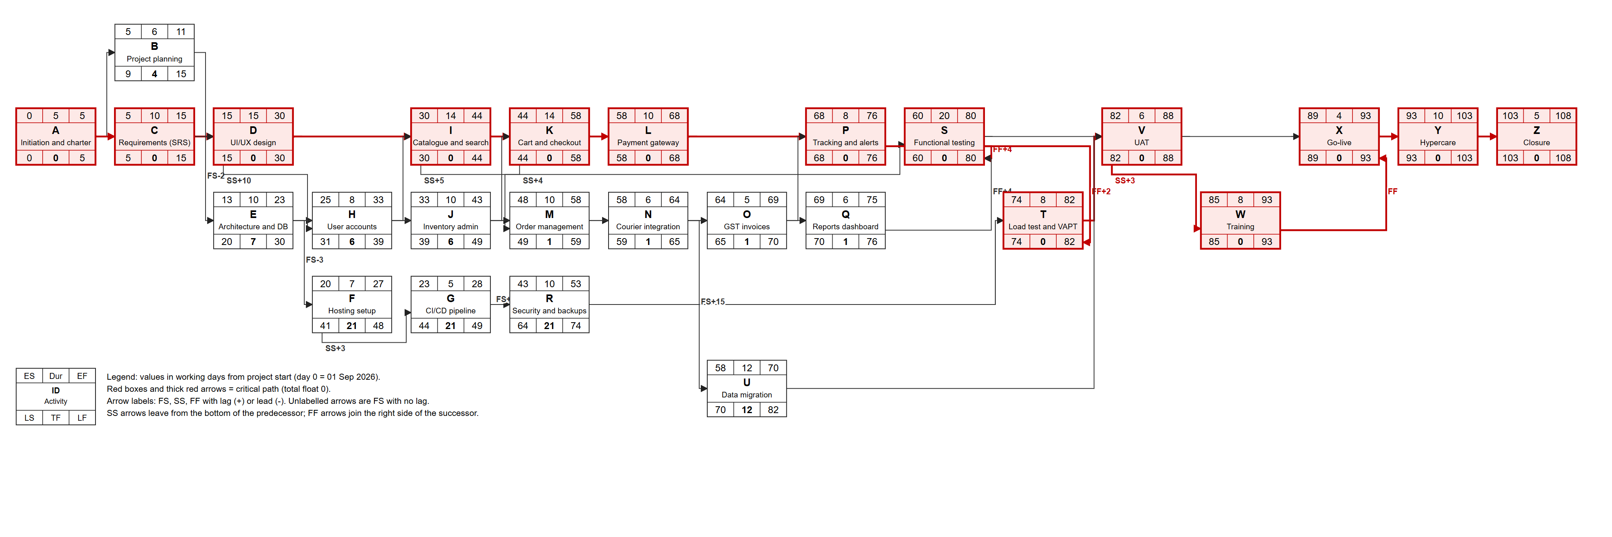
Figure 1: Activity-on-node network diagram with ES, duration, EF, LS, total float and LF for every activity

5. CRITICAL PATH METHOD

5.1 Forward Pass
The forward pass calculates the early start (ES) and early finish (EF) of each activity, starting with ES = 0 for activity A. For each activity, ES is the largest value given by its predecessors:
- FS: ES = EF(pred) + lag
- SS: ES = ES(pred) + lag
- FF: ES = EF(pred) + lag - duration (the successor must not finish before the predecessor finishes + lag)
- EF = ES + duration
Worked examples:
- E (FS-2 from C): ES = EF(C) - 2 = 15 - 2 = 13; EF = 13 + 10 = 23.
- H (FS from E, SS+10 from D): ES = max(EF(E) = 23, ES(D) + 10 = 15 + 10 = 25) = 25; EF = 33.
- S (SS+5 from I, FF+4 from P, FF+4 from Q): ES = max(30 + 5 = 35, EF(P) + 4 - 20 = 76 + 4 - 20 = 60, EF(Q) + 4 - 20 = 75 + 4 - 20 = 59) = 60; EF = 80. The FF link from P controls S, so testing is pushed to finish 4 days after the last storefront feature.
- V (FS from S, T, U): ES = max(80, 82, 70) = 82.
The largest EF is 108 (activity Z), so the project duration is 108 working days.

5.2 Backward Pass
The backward pass starts with LF = 108 for the last activity and calculates the late finish (LF) and late start (LS). For each activity, LF is the smallest value given by its successors:
- FS: LF = LS(succ) - lag
- SS: LF = LS(succ) - lag + duration
- FF: LF = LF(succ) - lag
- LS = LF - duration; Total float TF = LS - ES; Free float FF = time the activity can slip without delaying the early start of any successor.
Worked examples:
- Q (FF+4 to S): LF = LF(S) - 4 = 80 - 4 = 76; LS = 70; TF = 70 - 69 = 1.
- F (SS+3 to G): LF = LS(G) - 3 + 7 = 44 - 3 + 7 = 48; LS = 41; TF = 41 - 20 = 21.
- E (FS-3 to F, FS to H, FS to I): LF = min(LS(F) + 3 = 44, LS(H) = 31, LS(I) = 30) = 30; LS = 20; TF = 7.
- U (FS to V): LF = LS(V) = 82, LS = 70, TF = 70 - 58 = 12. Its free float is also 12 because V's early start (82) is set by T.

5.3 CPM Results
ID | Activity | Dur | ES | EF | LS | LF | TF | FF | Crit. | Start | Finish
A | Project initiation and charter | 5 | 0 | 5 | 0 | 5 | 0 | 0 | Yes | 01 Sep | 07 Sep
B | Project planning (baselines) | 6 | 5 | 11 | 9 | 15 | 4 | 4 |  | 08 Sep | 16 Sep
C | Requirements specification | 10 | 5 | 15 | 5 | 15 | 0 | 0 | Yes | 08 Sep | 22 Sep
D | UI/UX design and prototype test | 15 | 15 | 30 | 15 | 30 | 0 | 0 | Yes | 23 Sep | 14 Oct
E | Architecture and database design | 10 | 13 | 23 | 20 | 30 | 7 | 0 |  | 21 Sep | 05 Oct
F | Cloud hosting and environments | 7 | 20 | 27 | 41 | 48 | 21 | 0 |  | 30 Sep | 09 Oct
G | CI/CD pipeline | 5 | 23 | 28 | 44 | 49 | 21 | 0 |  | 06 Oct | 12 Oct
H | User accounts and OTP login | 8 | 25 | 33 | 31 | 39 | 6 | 0 |  | 08 Oct | 19 Oct
I | Product catalogue and search | 14 | 30 | 44 | 30 | 44 | 0 | 0 | Yes | 15 Oct | 04 Nov
J | Product and inventory admin | 10 | 33 | 43 | 39 | 49 | 6 | 0 |  | 21 Oct | 03 Nov
K | Shopping cart and checkout | 14 | 44 | 58 | 44 | 58 | 0 | 0 | Yes | 05 Nov | 27 Nov
L | Payment gateway integration | 10 | 58 | 68 | 58 | 68 | 0 | 0 | Yes | 30 Nov | 11 Dec
M | Order management and returns | 10 | 48 | 58 | 49 | 59 | 1 | 0 |  | 16 Nov | 27 Nov
N | Shipping and courier integration | 6 | 58 | 64 | 59 | 65 | 1 | 0 |  | 30 Nov | 07 Dec
O | GST invoice generation | 5 | 64 | 69 | 65 | 70 | 1 | 0 |  | 08 Dec | 14 Dec
P | Order tracking and notifications | 8 | 68 | 76 | 68 | 76 | 0 | 0 | Yes | 14 Dec | 23 Dec
Q | Sales reports dashboard | 6 | 69 | 75 | 70 | 76 | 1 | 1 |  | 15 Dec | 22 Dec
R | Security hardening and backups | 10 | 43 | 53 | 64 | 74 | 21 | 21 |  | 04 Nov | 20 Nov
S | Functional and integration testing | 20 | 60 | 80 | 60 | 80 | 0 | 0 | Yes | 02 Dec | 06 Jan
T | Performance and security testing (VAPT) | 8 | 74 | 82 | 74 | 82 | 0 | 0 | Yes | 22 Dec | 08 Jan
U | Product data migration | 12 | 58 | 70 | 70 | 82 | 12 | 12 |  | 30 Nov | 15 Dec
V | User acceptance testing | 6 | 82 | 88 | 82 | 88 | 0 | 0 | Yes | 11 Jan | 18 Jan
W | Staff training and user manual | 8 | 85 | 93 | 85 | 93 | 0 | 0 | Yes | 14 Jan | 25 Jan
X | Go-live preparation and deployment | 4 | 89 | 93 | 89 | 93 | 0 | 0 | Yes | 20 Jan | 25 Jan
Y | Hypercare (2 weeks) | 10 | 93 | 103 | 93 | 103 | 0 | 0 | Yes | 27 Jan | 09 Feb
Z | Project closure | 5 | 103 | 108 | 103 | 108 | 0 | 0 | Yes | 10 Feb | 16 Feb
Table 4: Forward pass, backward pass and float (working days); dates are early start and early finish

5.4 Critical Path and Near-Critical Paths
The critical path is A - C - D - I - K - L - P - S - T - V - W - X - Y - Z with zero total float. It runs through requirements and design, the storefront development chain of Developer 1 (catalogue, checkout, payment, tracking), testing, UAT, training, go-live, hypercare and closure. Any delay on these activities delays go-live day for day.
Path (through) | Total float | Comment
A-C-D-I-K-L-P-S-T-V-W-X-Y-Z | 0 | Critical path (storefront chain, Developer 1)
...-K-M-N-O-Q-S-... | 1 | Admin and integration chain, Developer 2 (near-critical)
...-D-H-K-... | 6 | Accounts before checkout
...-H-J-M-... | 6 | Inventory admin chain
...-E-I-... | 7 | Architecture to catalogue
...-J-U-V-... | 12 | Product data migration
...-E-F-G-R-T-... | 21 | Infrastructure and security
A-B-D-... | 4 | Planning before design
Table 5: Main paths and their float
The admin chain M - N - O - Q has only 1 day of float, so it is near-critical and is tracked as closely as the critical path. Activities B, E, H, J have 4 to 7 days of float, U has 12 days and the infrastructure chain F - G - R has 21 days, which is where the project manager can borrow time or move resources without affecting go-live.

5.5 Schedule Risk (PERT)
The standard deviation of the critical path is the square root of the sum of the variances of the critical activities: σ_{CP} = √(Σσ²) = 2.93 days. The planned dates are the expected (50%) dates. The probability of finishing within 5 working days of the plan is P(Z ≤ 5 / 2.93) = 96%. The near-critical admin chain is not included in this simple PERT calculation, so the real risk is slightly higher, which is one reason for keeping the contingency reserve.

6. PROJECT SCHEDULE
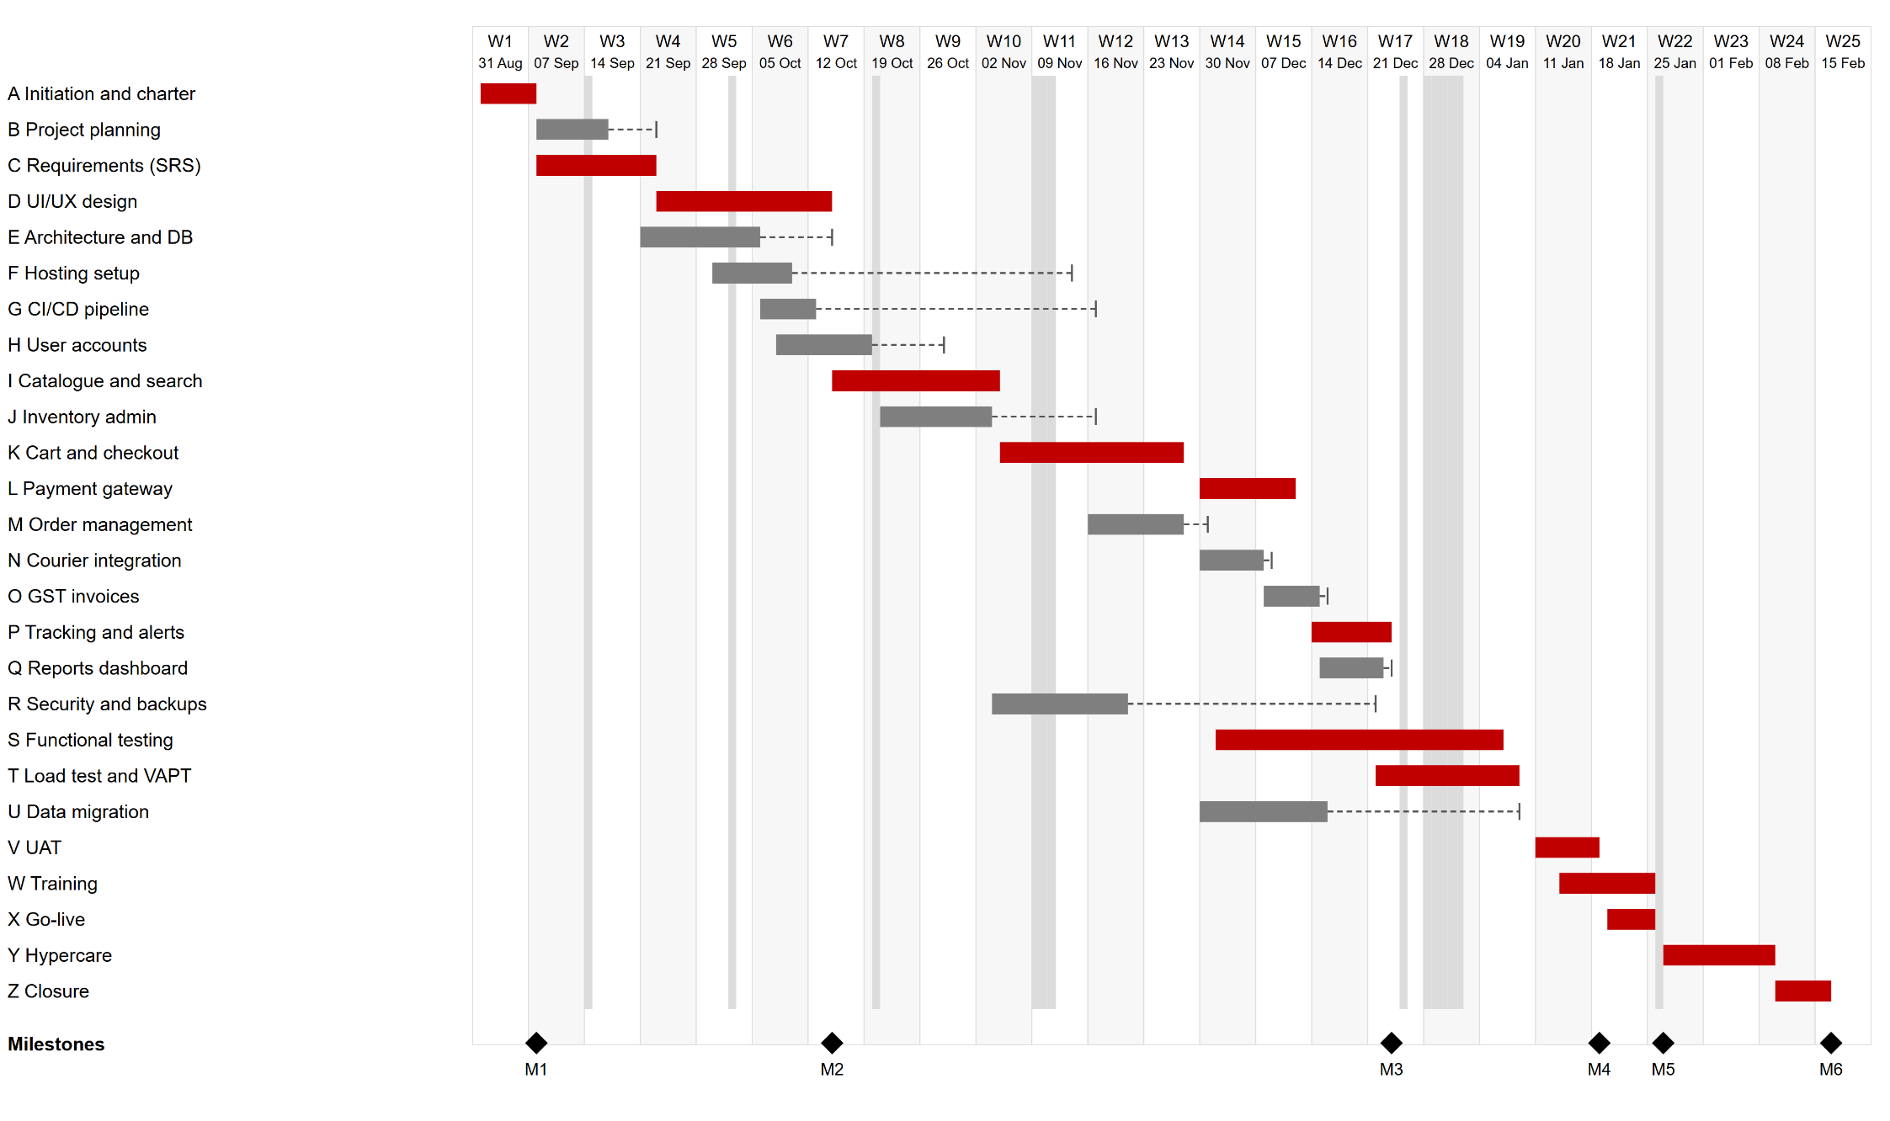
Figure 2: Gantt chart (early start schedule). Red = critical, grey = non-critical, dashed line = total float

6.1 Milestone Schedule
ID | Milestone | Scheduled date | Week | Approved by
M1 | Charter approved | 07 Sep 2026 | W2 | Sponsor
M2 | Design signed off | 14 Oct 2026 | W7 | Sponsor, Operations Head
M3 | Feature complete | 23 Dec 2026 | W17 | Project Manager
M4 | UAT signed off | 18 Jan 2027 | W21 | Sponsor
M5 | Go-live | 27 Jan 2027 | W22 | Sponsor (go/no-go)
M6 | Project closed | 16 Feb 2027 | W25 | Sponsor
Table 6: Milestone schedule
These milestone dates are the ones recorded in the charter (Assignment 1). Go-live is on Wednesday 27 Jan 2027, the day after Republic Day, so the go/no-go meeting is held on 25 Jan 2027. Milestone M3 (feature complete) is reached when the last development activity (P, tracking and notifications) finishes. A change of up to 5 working days in a milestone that does not affect go-live is within the project manager's authority; anything larger goes to the sponsor.

7. RESOURCE ALLOCATION AND LEVELLING
CPM assumes unlimited resources, so the schedule was checked against the team capacity. The developer demand per week was calculated by spreading each activity's developer effort evenly over its duration.
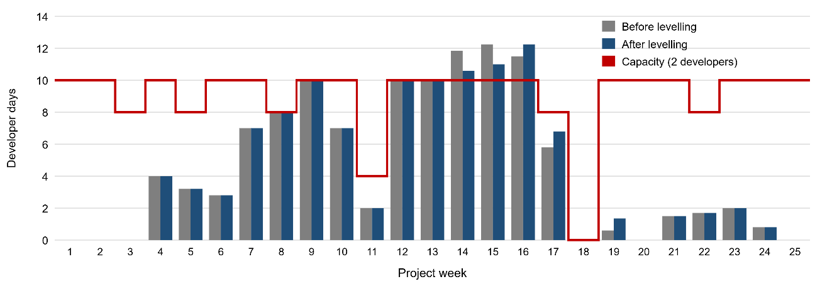
Figure 3: Developer loading per week before and after levelling (capacity = 2 developers x working days)
Before levelling, the developers are over-allocated in weeks 14, 15 and 16 (up to 12.2 developer-days against a capacity of 10), because developer support for data migration (U) and defect fixing during testing (S) overlap with the last feature work. Activity U has 12 days of total float, so it was delayed by 10 days within its float, which moves its developer work out of the busiest weeks. The remaining excess of about 4 developer-days in weeks 14, 15 and 16 is defect fixing inside testing; it is covered by planned Saturday work (about 2 days per developer, about Rs 13,475 from the contingency reserve) instead of delaying the critical path. Week 11 has only 2 working days because of Diwali, so its capacity is lower. The DevOps engineer is over-allocated in week 6 (hosting F and CI/CD G overlap); G has 21 days of float and is delayed by 4 days. Neither change affects the critical path or the go-live date.
Role | Effort (person-days) | Main weeks of work | Peak load
Project Manager | 52 | All weeks (about 1.5 days a week for monitoring); other work in W1-W4, W20-W25 | W2
Business Analyst | 32 | W1-W7, W14-W16, W20-W22, W24-W25 | W2
UI/UX Designer | 15 | W4-W7 | W6
Developers (2) | 112 | W4-W17, W19, W21-W24 | W16
QA Engineer | 30 | W14-W17, W19-W24 | W19
DevOps Engineer | 26 | W4-W7, W10-W12, W17, W19, W21-W24 | W7 (after levelling)
Table 7: Resource allocation summary

8. SCHEDULE COMPRESSION
If the sponsor asks for an earlier go-live (for example to have the store live well before the Valentine's Day sale), the schedule can be compressed without changing the scope. Only activities on the critical path shorten the project.

8.1 Crashing
Crashing adds resources to critical activities. The cost slope = extra cost / days saved shows which activity is cheapest to crash.
ID | Activity | Normal | Crash | Extra cost | Slope (Rs/day) | How
C | Requirements specification | 10 | 8 | Rs 9,000 | Rs 4,500 | Business analyst works 2 Saturdays; PM joins interviews
D | UI/UX design and prototype test | 15 | 12 | Rs 18,000 | Rs 6,000 | Freelance designer for 6 days at Rs 3,000
I | Product catalogue and search | 14 | 11 | Rs 31,500 | Rs 10,500 | Contract developer for 7 days at Rs 4,500
K | Shopping cart and checkout | 14 | 11 | Rs 31,500 | Rs 10,500 | Contract developer for 7 days at Rs 4,500
L | Payment gateway integration | 10 | 8 | Rs 18,000 | Rs 9,000 | Paid integration support package from the payment gateway
P | Order tracking and notifications | 8 | 6 | Rs 14,000 | Rs 7,000 | Developer overtime (2 developers, 2 days)
S | Functional and integration testing | 20 | 16 | Rs 33,600 | Rs 8,400 | Second QA engineer for 12 days at Rs 2,800
V | User acceptance testing | 6 | 5 | Rs 6,000 | Rs 6,000 | Extra UAT session on a Saturday
Table 8: Crashing options
The activities were crashed one day at a time, always choosing the cheapest critical activity that actually shortens the project, and the CPM was recalculated after each step:
Step | Crashed | Cost | Cumulative cost | New go-live | Critical activities after step
1 | C | Rs 4,500 | Rs 4,500 | 25 Jan 2027 | A C D I K L P S T V W X Y Z
2 | C | Rs 4,500 | Rs 9,000 | 22 Jan 2027 | A C D I K L P S T V W X Y Z
3 | D | Rs 6,000 | Rs 15,000 | 21 Jan 2027 | A C D I K L P S T V W X Y Z
4 | D | Rs 6,000 | Rs 21,000 | 20 Jan 2027 | A C D I K L P S T V W X Y Z
5 | D | Rs 6,000 | Rs 27,000 | 19 Jan 2027 | A C D I K L P S T V W X Y Z
6 | P | Rs 7,000 | Rs 34,000 | 18 Jan 2027 | A C D I K L M N O P Q S T V W X Y Z
7 | I | Rs 10,500 | Rs 44,500 | 15 Jan 2027 | A C D I K L M N O P Q S T V W X Y Z
8 | I | Rs 10,500 | Rs 55,000 | 14 Jan 2027 | A C D H I J K L M N O P Q S T V W X Y Z
Table 9: Crashing steps (each step saves 1 working day)
The first 5 days are cheap (Rs 27,000, from requirements and design). From step 6 the admin chain M - N - O - Q, which had only 1 day of float, also becomes critical, and from step 8 the chain H - J becomes critical too, so every further day needs more activities to be shortened at the same time. After 8 days no single or paired crash can shorten the project any more. The total crash cost of Rs 55,000 would come from the contingency reserve, which needs sponsor approval above Rs 50,000 per event.

8.2 Fast Tracking
Fast tracking overlaps activities that were planned in sequence, without extra cost but with a risk of rework. The best candidate is the discretionary part of K -> L: payment integration can start when the checkout screens are ready, before the coupon and delivery-charge rules are finished. Changing K FS -> L to K SS+9 -> L lets L start 5 days earlier, but go-live only moves to 25 Jan 2027 (1 working day earlier). The reason is the near-critical admin chain: tracking (P) also waits for courier integration (N), and testing (S) also waits for the reports dashboard (Q), so after 1 day the chain M - N - O - Q becomes critical. Fast tracking K and L alone is therefore not worth the rework risk and the extra load on Developer 1; it only helps if the admin chain is also shortened.

8.3 Recommendation
The baseline keeps the original durations because the go-live date already meets the charter. If compression is required, crash C and D first (5 days for Rs 27,000) because these are planning-phase activities where extra people do not add technical risk. Fast tracking K and L is not recommended on its own, and crashing beyond 5 days is not recommended because the near-critical paths make it expensive and leave no float anywhere in the development phase.

9. BUDGET ESTIMATION

9.1 Estimating Method
A bottom-up estimate was used because the WBS dictionary already gives effort per role for every work package. For each activity:
Activity cost = Σ (person-days of role x daily rate of role) + non-labour cost
The cost elements are direct labour (internal team and contractors at daily rates that include their overheads) and direct non-labour costs (design tool licence, cloud hosting during the project, backup storage, external security audit, product photo shoot and printed manuals). Costs after go-live, such as gateway fees, SMS charges and hosting from April, are operating costs paid by ShopEase and are not part of the project budget. Example, activity I: 14 developer-days x Rs 3,500 = Rs 49,000.

9.2 Activity Cost Estimates
ID | Activity | WBS | Effort (person-days) | Labour | Non-labour | Total
A | Project initiation and charter | 1.1.1 | PM 5, BA 1 | Rs 20,500 | - | Rs 20,500
B | Project planning (baselines) | 1.1.2 | PM 6, BA 2 | Rs 27,000 | - | Rs 27,000
C | Requirements specification | 1.2.1 | BA 10, PM 2 | Rs 37,000 | - | Rs 37,000
D | UI/UX design and prototype test | 1.2.2 | UX 15, BA 2 | Rs 51,000 | Rs 6,000 | Rs 57,000
E | Architecture and database design | 1.2.3 | DEV 8, OPS 2 | Rs 35,600 | - | Rs 35,600
F | Cloud hosting and environments | 1.6.1 | OPS 6 | Rs 22,800 | Rs 36,000 | Rs 58,800
G | CI/CD pipeline | 1.6.2 | OPS 5 | Rs 19,000 | - | Rs 19,000
H | User accounts and OTP login | 1.3.2 | DEV 8 | Rs 28,000 | - | Rs 28,000
I | Product catalogue and search | 1.3.1 | DEV 14 | Rs 49,000 | - | Rs 49,000
J | Product and inventory admin | 1.5.1 | DEV 10 | Rs 35,000 | - | Rs 35,000
K | Shopping cart and checkout | 1.3.3 | DEV 14 | Rs 49,000 | - | Rs 49,000
L | Payment gateway integration | 1.4.1 | DEV 10 | Rs 35,000 | - | Rs 35,000
M | Order management and returns | 1.5.2 | DEV 10 | Rs 35,000 | - | Rs 35,000
N | Shipping and courier integration | 1.4.2 | DEV 6 | Rs 21,000 | - | Rs 21,000
O | GST invoice generation | 1.4.3 | DEV 5, BA 1 | Rs 20,500 | - | Rs 20,500
P | Order tracking and notifications | 1.3.4 | DEV 8 | Rs 28,000 | - | Rs 28,000
Q | Sales reports dashboard | 1.5.3 | DEV 6 | Rs 21,000 | - | Rs 21,000
R | Security hardening and backups | 1.6.3 | OPS 6 | Rs 22,800 | Rs 8,000 | Rs 30,800
S | Functional and integration testing | 1.7.1 | QA 18, DEV 4 | Rs 64,400 | - | Rs 64,400
T | Performance and security testing (VAPT) | 1.7.2 | QA 6, OPS 3 | Rs 28,200 | Rs 35,000 | Rs 63,200
U | Product data migration | 1.8.1 | BA 6, DEV 3 | Rs 28,500 | Rs 30,000 | Rs 58,500
V | User acceptance testing | 1.7.3 | QA 4, BA 4, PM 2 | Rs 30,200 | - | Rs 30,200
W | Staff training and user manual | 1.8.2 | BA 5 | Rs 15,000 | Rs 5,000 | Rs 20,000
X | Go-live preparation and deployment | 1.8.3 | DEV 2, OPS 2, QA 1, PM 1 | Rs 20,900 | - | Rs 20,900
Y | Hypercare (2 weeks) | 1.8.3 | DEV 4, OPS 2, QA 1, PM 2 | Rs 31,400 | - | Rs 31,400
Z | Project closure | 1.1.4 | PM 4, BA 1 | Rs 17,000 | - | Rs 17,000
LOE | Monitoring and status reporting | 1.1.3 | PM 30 | Rs 1,05,000 | - | Rs 1,05,000
 | Total (work packages) |  | 267 person-days | Rs 8,97,800 | Rs 1,20,000 | Rs 10,17,800
Table 10: Bottom-up cost estimate per activity

9.3 Cost by Resource and Element
Role / element | Rate (Rs/day) | Person-days | Cost
Project Manager | 3500 | 52 | Rs 1,82,000
Business Analyst | 3000 | 32 | Rs 96,000
UI/UX Designer | 3000 | 15 | Rs 45,000
Developers | 3500 | 112 | Rs 3,92,000
QA Engineer | 2800 | 30 | Rs 84,000
DevOps Engineer | 3800 | 26 | Rs 98,800
Non-labour (licence, hosting, backup storage, VAPT, photo shoot, manuals) |  |  | Rs 1,20,000
Total |  |  | Rs 10,17,800
Table 11: Cost by role

9.4 Reserves
Two different reserves are added on top of the work package costs:
- Contingency reserve is for identified risks ("known unknowns") from the risk register. It is part of the cost baseline, is controlled by the project manager within the limits in the charter and is used when a listed risk happens.
- Management reserve is for unidentified risks ("unknown unknowns"). It is not part of the cost baseline, is held by the sponsor and needs a change to the baseline when it is used.
The contingency reserve was checked against the expected monetary value (EMV = probability x cost impact) of the risks in the charter:
ID | Risk | Probability | Cost impact | EMV
R1 | Payment gateway KYC delayed | 30% | Rs 60,000 | Rs 18,000
R2 | Product data and photos incomplete or late | 50% | Rs 40,000 | Rs 20,000
R3 | Store staff resist the new process (extra training) | 30% | Rs 30,000 | Rs 9,000
R4 | Approved scope changes during development | 40% | Rs 80,000 | Rs 32,000
R5 | A developer leaves (replacement and handover) | 10% | Rs 1,20,000 | Rs 12,000
R6 | Site slows down at launch (extra servers) | 10% | Rs 50,000 | Rs 5,000
R7 | Security incident (audit and fixes) | 5% | Rs 1,20,000 | Rs 6,000
 | Total EMV |  |  | Rs 1,02,000
Table 12: Expected monetary value of the identified risks
The total EMV is Rs 1,02,000, which is the same as 10% of the work package cost (Rs 1,02,000), so 10% is used as the contingency reserve. The management reserve is set at 5% (Rs 51,000), as agreed with the sponsor in the charter.

9.5 Budget Aggregation
Level | Item | Amount
Control account | 1.1 Project Management | Rs 1,69,500
Control account | 1.2 Requirements and Design | Rs 1,29,600
Control account | 1.3 Customer Storefront | Rs 1,54,000
Control account | 1.4 Payments and Integrations | Rs 76,500
Control account | 1.5 Admin and Back Office | Rs 91,000
Control account | 1.6 Infrastructure and Deployment | Rs 1,08,600
Control account | 1.7 Testing and Quality | Rs 1,57,800
Control account | 1.8 Launch and Transition | Rs 1,30,800
 | Work package total = performance measurement baseline (PMB) | Rs 10,17,800
+ | Contingency reserve (10%) | Rs 1,02,000
= | Cost baseline | Rs 11,19,800
+ | Management reserve (5%) | Rs 51,000
= | Total project budget | Rs 11,70,800
Table 13: Cost aggregation from control accounts to total budget
The totals are the same as in the charter of Assignment 1, which confirms that the budget is built from the WBS work packages and not set top-down.

10. TIME-PHASED COST BASELINE AND S-CURVE

10.1 Method
The cost of each activity was spread evenly over its working days and then added up per calendar week (week 1 starts on Monday 31 Aug 2026; work starts on Tuesday 01 Sep 2026). This was done twice: once with the early start dates and once with the late start dates from the CPM. The monitoring activity (level of effort) is spread evenly from week 2 to week 24. The contingency reserve is distributed in proportion to the planned work, so the cost baseline curve is the planned value curve x 1.10.
Week | Starts | Weekly PV (early) | Cumulative PV (early) | Weekly PV (late) | Cumulative PV (late) | Cumulative cost baseline | % complete
1 | 31 Aug | Rs 16,400 | Rs 16,400 | Rs 16,400 | Rs 16,400 | Rs 18,044 | 2%
2 | 07 Sep | Rs 41,186 | Rs 57,586 | Rs 23,186 | Rs 39,586 | Rs 63,357 | 6%
3 | 14 Sep | Rs 28,086 | Rs 85,671 | Rs 37,086 | Rs 76,671 | Rs 94,257 | 8%
4 | 21 Sep | Rs 41,957 | Rs 1,27,629 | Rs 33,157 | Rs 1,09,829 | Rs 1,40,419 | 13%
5 | 28 Sep | Rs 50,526 | Rs 1,78,154 | Rs 26,606 | Rs 1,36,434 | Rs 1,96,008 | 18%
6 | 05 Oct | Rs 92,117 | Rs 2,70,271 | Rs 42,157 | Rs 1,78,591 | Rs 2,97,357 | 27%
7 | 12 Oct | Rs 45,057 | Rs 3,15,329 | Rs 37,937 | Rs 2,16,529 | Rs 3,46,930 | 31%
8 | 19 Oct | Rs 32,286 | Rs 3,47,614 | Rs 32,286 | Rs 2,48,814 | Rs 3,82,451 | 34%
9 | 26 Oct | Rs 40,357 | Rs 3,87,971 | Rs 40,357 | Rs 2,89,171 | Rs 4,26,852 | 38%
10 | 02 Nov | Rs 39,097 | Rs 4,27,069 | Rs 89,957 | Rs 3,79,129 | Rs 4,69,868 | 42%
11 | 09 Nov | Rs 15,303 | Rs 4,42,371 | Rs 40,543 | Rs 4,19,671 | Rs 4,86,704 | 43%
12 | 16 Nov | Rs 55,757 | Rs 4,98,129 | Rs 44,157 | Rs 4,63,829 | Rs 5,48,049 | 49%
13 | 23 Nov | Rs 40,357 | Rs 5,38,486 | Rs 40,357 | Rs 5,04,186 | Rs 5,92,451 | 53%
14 | 30 Nov | Rs 74,392 | Rs 6,12,878 | Rs 50,017 | Rs 5,54,203 | Rs 6,74,298 | 60%
15 | 07 Dec | Rs 83,232 | Rs 6,96,110 | Rs 70,577 | Rs 6,24,780 | Rs 7,65,871 | 68%
16 | 14 Dec | Rs 66,807 | Rs 7,62,917 | Rs 87,682 | Rs 7,12,462 | Rs 8,39,374 | 75%
17 | 21 Dec | Rs 58,366 | Rs 8,21,283 | Rs 84,446 | Rs 7,96,908 | Rs 9,03,589 | 81%
18 | 28 Dec | Rs 0 | Rs 8,21,283 | Rs 0 | Rs 7,96,908 | Rs 9,03,589 | 81%
19 | 04 Jan | Rs 54,517 | Rs 8,75,800 | Rs 78,892 | Rs 8,75,800 | Rs 9,63,569 | 86%
20 | 11 Jan | Rs 35,524 | Rs 9,11,324 | Rs 35,524 | Rs 9,11,324 | Rs 10,02,653 | 90%
21 | 18 Jan | Rs 38,565 | Rs 9,49,889 | Rs 38,565 | Rs 9,49,889 | Rs 10,45,084 | 93%
22 | 25 Jan | Rs 21,431 | Rs 9,71,320 | Rs 21,431 | Rs 9,71,320 | Rs 10,68,662 | 95%
23 | 01 Feb | Rs 21,057 | Rs 9,92,377 | Rs 21,057 | Rs 9,92,377 | Rs 10,91,829 | 98%
24 | 08 Feb | Rs 18,623 | Rs 10,11,000 | Rs 18,623 | Rs 10,11,000 | Rs 11,12,319 | 99%
25 | 15 Feb | Rs 6,800 | Rs 10,17,800 | Rs 6,800 | Rs 10,17,800 | Rs 11,19,800 | 100%
Table 14: Time-phased planned value and cost baseline by week
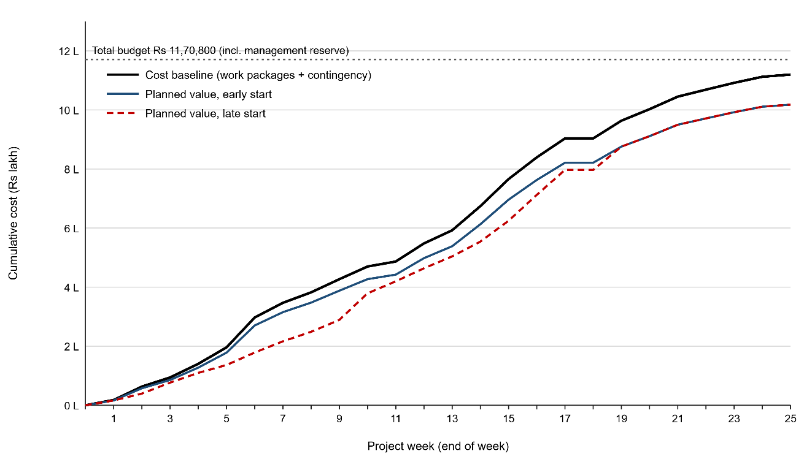
Figure 4: S-curve of the cost baseline with early and late start planned value and the total budget

10.2 Reading the S-Curve
- The curve is flat in the first weeks (planning and requirements need few people), steep in weeks 7 to 19 (two developers, QA and DevOps working together) and flat again during hypercare and closure. It also flattens in the holiday weeks: Diwali in week 11 and the year-end closure in week 18.
- The area between the early start and late start curves is the cost effect of float. Spending that stays between the two curves is still on schedule; spending below the late start curve means the project is behind schedule.
- The cost baseline ends at Rs 11,19,800. The gap between the end of the cost baseline and the total budget line (Rs 11,70,800) is the management reserve, which is not part of the baseline.
- The cumulative planned value is the PV used later in earned value management, where it will be compared with earned value (EV) and actual cost (AC) to calculate SPI and CPI.

10.3 Funding Requirement by Month
Month | Planned spend (cost baseline) | Cumulative
Sep 2026 | Rs 1,96,008 | Rs 1,96,008
Oct 2026 | Rs 2,30,844 | Rs 4,26,852
Nov 2026 | Rs 1,65,598 | Rs 5,92,451
Dec 2026 | Rs 3,11,138 | Rs 9,03,589
Jan 2027 | Rs 1,65,073 | Rs 10,68,662
Feb 2027 | Rs 51,138 | Rs 11,19,800
Table 15: Monthly funding requirement
The owner releases funds monthly in line with this table. The management reserve is kept aside by the owner and released only through change control.

11. DYNAMIC SCHEDULE AND BUDGET MODEL
All calculations in this document are also built as formulas in the workbook ShopEase_Schedule_Budget_Model.xlsx, so the model is not a static picture. The workbook has these sheets:
Sheet | Contents
Inputs | Project start date, holidays, daily rates, contingency % and management reserve % (yellow input cells)
Links | All 37 dependencies with type (FS, SS, FF) and lag; type and lag can be edited
CPM | O, M, P estimates, PERT duration, forward pass, backward pass, total and free float, critical flag, dates, project finish, go-live date, critical path text and probability
Costs | Effort per role and non-labour cost per activity, labour cost, total cost and cost per day
Budget | Roll-up to control accounts, PMB, contingency, cost baseline, management reserve and total budget, with a check against the Costs sheet
S-Curve | Weekly time-phased cost for early and late start, cumulative curves and the S-curve chart
Compression | Crash durations, extra costs and cost slopes
Table 16: Workbook structure
Each ES cell is a MAX formula over its predecessors that reads the dependency type and lag from the Links sheet, for example for activity H:
=MAX(0, IF(type="FS", EF_{E}+lag, IF(type="SS", ES_{E}+lag, EF_{E}+lag-D_{H})), IF(type="SS", ES_{D}+lag, ...))
The LF cells use MIN formulas over successors in the same way, dates use WORKDAY with the holiday list, and the weekly cost uses NETWORKDAYS between the activity dates and the week dates. Changing any input recalculates the floats, critical path, dates, budget and S-curve. The workbook was opened in Microsoft Excel and its results match every table in this report. The following what-if tests show how the model reacts:
What-if change | Duration (days) | Go-live | Critical path | Explanation
Baseline | 108 | 27 Jan 2027 | A C D I K L P S T V W X Y Z | -
Payment gateway (L) takes 14 days instead of 10 (KYC delay, risk R1) | 112 | 02 Feb 2027 | Same | L is critical, so go-live moves by 4 days
Data migration (U) takes 17 days instead of 12 | 108 | 27 Jan 2027 | Same | U has 12 days of float, so nothing moves
Reports dashboard (Q) takes 8 days instead of 6 | 109 | 28 Jan 2027 | A C D I K M N O Q S T V W X Y Z | Q had only 1 day of float; the extra day delays go-live and the admin chain becomes critical
Security work (R) takes 32 days instead of 10 | 109 | 28 Jan 2027 | A C E F G R T V W X Y Z | R had 21 days of float; a slip of 22 days uses it all and delays go-live by 1 day through T
Table 17: What-if tests on the dynamic model
When an activity moves, its cost moves to other weeks, so the S-curve changes shape while the total budget stays the same. A change in a rate or in the contingency percentage changes the budget totals and the height of the curve.

12. CONCLUSION
The 25 work packages from Assignment 1 were turned into 26 activities with PERT durations and 37 dependencies, using FS, SS and FF relationships with leads and lags. The CPM gives a project duration of 108 working days with the critical path A - C - D - I - K - L - P - S - T - V - W - X - Y - Z, go-live on 27 Jan 2027 and closure on 16 Feb 2027, which confirms the charter. The calculation also showed a near-critical admin chain with only 1 day of float, resource over-allocations that were levelled within float, and that the cheapest way to gain one week is to crash requirements and design for Rs 27,000.
The bottom-up budget rolls up from activities to control accounts and gives a work package total of Rs 10,17,800. A contingency reserve supported by an EMV analysis gives a cost baseline of Rs 11,19,800, and a management reserve gives a total budget of Rs 11,70,800. The cost baseline was time-phased and plotted as an S-curve for early and late start schedules. The Excel model makes the schedule and the budget dynamic, so the plan can be updated quickly when estimates or dependencies change during the project.

REFERENCES
- Project Management Institute. A Guide to the Project Management Body of Knowledge (PMBOK Guide), 7th Edition, 2021.
- Project Management Institute. Practice Standard for Scheduling, 3rd Edition, 2019.
- Project Management Institute. Practice Standard for Project Estimating, 2nd Edition, 2019.
- Kerzner, H. Project Management: A Systems Approach to Planning, Scheduling, and Controlling, 13th Edition, Wiley, 2022.
- Schwalbe, K. Information Technology Project Management, 9th Edition, Cengage, 2019.
- Malcolm, D. G., Roseboom, J. H., Clark, C. E., Fazar, W. Application of a Technique for Research and Development Program Evaluation (PERT). Operations Research, 7(5), 1959.
- Kelley, J. E., Walker, M. R. Critical-Path Planning and Scheduling. Proceedings of the Eastern Joint Computer Conference, 1959.
- Microsoft Support. WORKDAY and NETWORKDAYS functions. Available at: https://support.microsoft.com

