PROJECT KANBAN BOARD AND
EXECUTION CONTROL PLAN
ShopEase Online Store: Development of an
E-commerce Web Application
Name : Abhay Maurya
PRN : 202301040187
Subject : Project Management ( Assignment 3 )
Project Domain : E-commerce Application
Document Version : 1.0, 03 Oct 2026
Kanban board (live) : https://abhxym.github.io/project-management/assignment-3-kanban-execution/ShopEase_Kanban_Board.html
GitHub Repository : https://github.com/Abhxym/project-management

ABSTRACT
The ShopEase online store project started on 1 September 2026 with the scope, schedule and cost baselines prepared in Assignments 1 and 2. This document covers the execution phase: how the work is visualised and pulled through a Kanban board, who is responsible and accountable for each activity, and how progress is controlled against the baselines with earned value management.
The 26 schedule activities were broken into 87 task cards of one to six days. A web-based Kanban board was built with five columns, explicit work-in-progress (WIP) limits and entry and exit policies. Every move of a card is dated, and the board calculates flow metrics (lead time, cycle time, throughput, velocity, WIP, queue size and a cumulative flow diagram) and earned value metrics (PV, EV, AC, SV, CV, SPI, CPI, EAC, ETC, VAC and TCPI) directly from the card history, with an S-curve and an SPI/CPI trend chart. Moving a card immediately recalculates all indicators, including the estimate at completion. A RACI matrix assigns exactly one accountable person and at least one responsible role to every activity and is checked automatically for structural errors.
At the status date of 3 October 2026, 14 of 87 tasks are done, the average cycle time is 2.9 working days, SPI is 0.95 and CPI is 0.98. The project is slightly behind schedule because requirements finished one day late on the critical path, and the estimate at completion is Rs 10,38,927 against a budget of Rs 10,17,800, which is within the contingency reserve.
Keywords: Kanban, WIP Limit, Lead Time, Cycle Time, Throughput, Velocity, Cumulative Flow Diagram, RACI Matrix, Earned Value Management, SPI, CPI, EAC, Execution Control.

1. INTRODUCTION

1.1 Background
Assignment 1 authorised the ShopEase project and defined its scope (charter, WBS and WBS dictionary). Assignment 2 produced the schedule baseline (26 activities, critical path A-C-D-I-K-L-P-S-T-V-W-X-Y-Z, go-live on 27 January 2027) and the cost baseline (work package budget Rs 10,17,800, contingency Rs 1,02,000, cost baseline Rs 11,19,800). The project started on Tuesday 1 September 2026. This assignment sets up the tools and rules used to run and control the project during execution.

1.2 Objectives
- To design a Kanban board for the project with clear columns, policies and WIP limits.
- To build the board as a working web application that tracks card moves and shows live flow metrics.
- To define responsibility and accountability for every activity with a RACI matrix.
- To define the execution control plan: control baselines, earned value method, thresholds, reporting and change control.
- To report the project status at 3 October 2026 with earned value analysis and corrective actions.

1.3 Status Date
All figures in this document are as of Saturday 3 October 2026. The last working day before the status date is Thursday 1 October, because 2 October (Gandhi Jayanti) is a holiday. Progress up to that day has been recorded on the board.

2. KANBAN BOARD DESIGN

2.1 Why Kanban for Execution
The team is small (7 people with different skills) and the work is a continuous stream of design, development, testing and launch tasks. Kanban fits this situation because it makes all work visible in one place, limits the amount of work started at the same time so that tasks finish faster, and produces flow data (cycle time and throughput) that can be used for forecasting. The baselines from Assignment 2 are still used to measure performance; Kanban is the way the team pulls the work, and earned value is the way the project manager controls it against the plan.

2.2 From Activities to Cards
Each of the 26 activities was split into 2 to 5 tasks, giving 87 cards. A task has one responsible role, a planned effort of 1 to 6 person-days and a budget equal to effort x daily rate, plus any purchase (for example the hosting plan in F1 or the security audit in T2). The task budgets add up exactly to the work package budgets in the cost baseline, so the board and the baseline use the same numbers. Monitoring and status reporting (WBS 1.1.3) is a level-of-effort activity and is not shown as cards.
Each card shows the activity and task ID, the task title, the responsible role, the budget and either the planned effort, the days worked against the plan (In progress) or the cycle time (Done). Cards of activities on the critical path have a red left border, and the age turns amber or red when a task has taken longer than planned or more than 1.5 times its plan.

2.3 Columns, Policies and WIP Limits
Column | Meaning and entry policy (Definition of Ready) | Exit policy | WIP limit
Backlog | All planned tasks not yet ready to start | Predecessor activity done or started as per the schedule logic; inputs available | None
Ready | Next tasks the team commits to. Inputs, acceptance criteria and owner are known | A person with the right role is free | 6
In progress | Work has started. The card is pulled by the person doing it, never pushed | Work finished and self-checked | 5
Review / Test | Work is being reviewed (PM, sponsor sign-off) or tested (QA) | Accepted against the acceptance criteria in the WBS dictionary (Definition of Done) | 3
Done | Task accepted. Its full budget is earned | - | None
Table 1: Board columns and policies
Why these WIP limits: six team members do the delivery work (BA, UX, two developers, QA, DevOps). A limit of 5 in progress means at least one person is normally free to review or unblock others instead of starting new work. Review/Test is limited to 3 because the project manager and the QA engineer review most cards, and a long review queue hides finished but unaccepted work. Ready is limited to 6, a little more than two weeks of current throughput, so that the queue in front of the team stays short and priorities can still change. When a column is full the board refuses the move and shows a message; the team must finish or review existing work first ("stop starting, start finishing").

2.4 The Web-Based Board
The board is a single HTML file (ShopEase_Kanban_Board.html) that runs in any browser without installation or internet connection. It is published with GitHub Pages and can be opened directly at https://abhxym.github.io/project-management/assignment-3-kanban-execution/ShopEase_Kanban_Board.html; the source is in the assignment-3-kanban-execution folder of the GitHub repository. Its features are:
- Board: drag and drop or arrow buttons to move cards; WIP limits enforced; filters by activity, role and critical path; card details with history, budget, earned value, actual cost and the accountable person from the RACI matrix.
- Status date: every move is stamped with the status date. "Next working day" moves the date forward, skipping weekends and holidays, so the board can be used day by day.
- Live indicators: WIP, queue, throughput, velocity, average cycle and lead time, SPI, CPI, EAC and percent complete are shown above every tab and recalculate after each move.
- Flow metrics: cumulative flow diagram, cycle time chart with average and 85th percentile, weekly throughput and velocity, and a flow summary.
- Earned value: S-curve with PV, EV and AC, SPI/CPI trend, a full EVM table and EVM by activity.
- RACI matrix: editable matrix with an automatic check for structural errors.
- The board state is saved in the browser and can be exported to a JSON file; "Reset to baseline data" restores the recorded history.
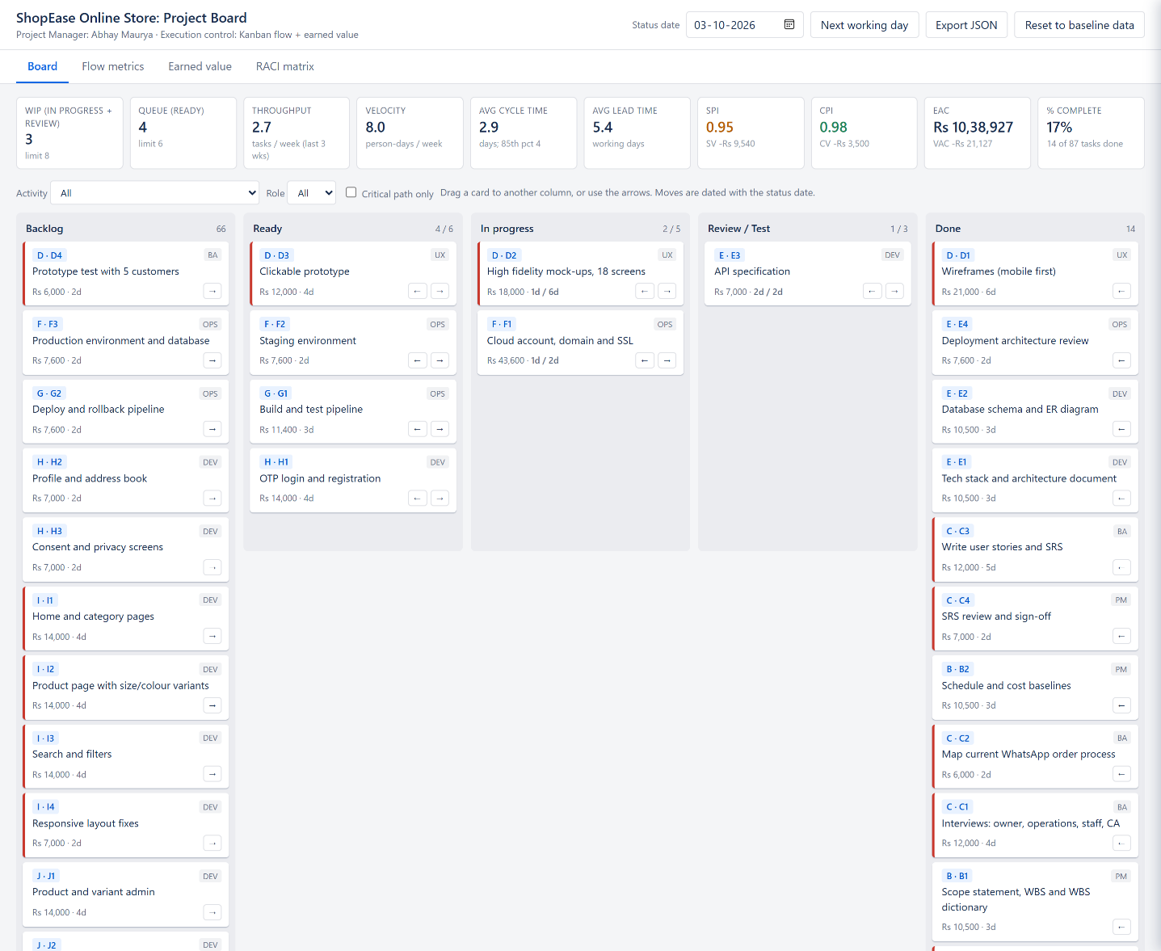
Figure 1: Kanban board at the status date (3 October 2026) with the live indicator strip

3. FLOW METRICS

3.1 Definitions
Metric | Definition | How the board measures it
Lead time | Time from commitment to delivery | Working days from first entry into Ready to Done
Cycle time | Time the work is actually in process | Working days from first entry into In progress to Done (review included)
Throughput | Number of tasks finished per period | Tasks moved to Done per calendar week; average of the last 3 weeks
Velocity | Amount of work finished per period | Planned effort (person-days) of the tasks finished per week
Work in progress (WIP) | Tasks started but not finished | Cards in In progress and Review / Test
Queue size | Work waiting to be started | Cards in Ready
Cumulative flow diagram | Count of cards in each column over time | Rebuilt from the card history for every working day
Little's law | Average WIP = throughput x average cycle time | WIP / throughput per day, compared with the measured cycle time
Table 2: Flow metric definitions

3.2 Values at the Status Date
Metric | Value
Tasks done / total | 14 / 87
WIP (In progress + Review) | 3 (limit 8)
Queue (Ready) | 4 (limit 6)
Average cycle time | 2.9 working days
85th percentile cycle time | 4 working days
Average lead time | 5.4 working days
Throughput (last 3 weeks) | 2.7 tasks per week
Velocity (last 3 weeks) | 8.0 person-days per week
Little's law cycle time (WIP / throughput) | 4.7 working days
Remaining planned effort | 198 person-days
Table 3: Flow metrics on 3 October 2026
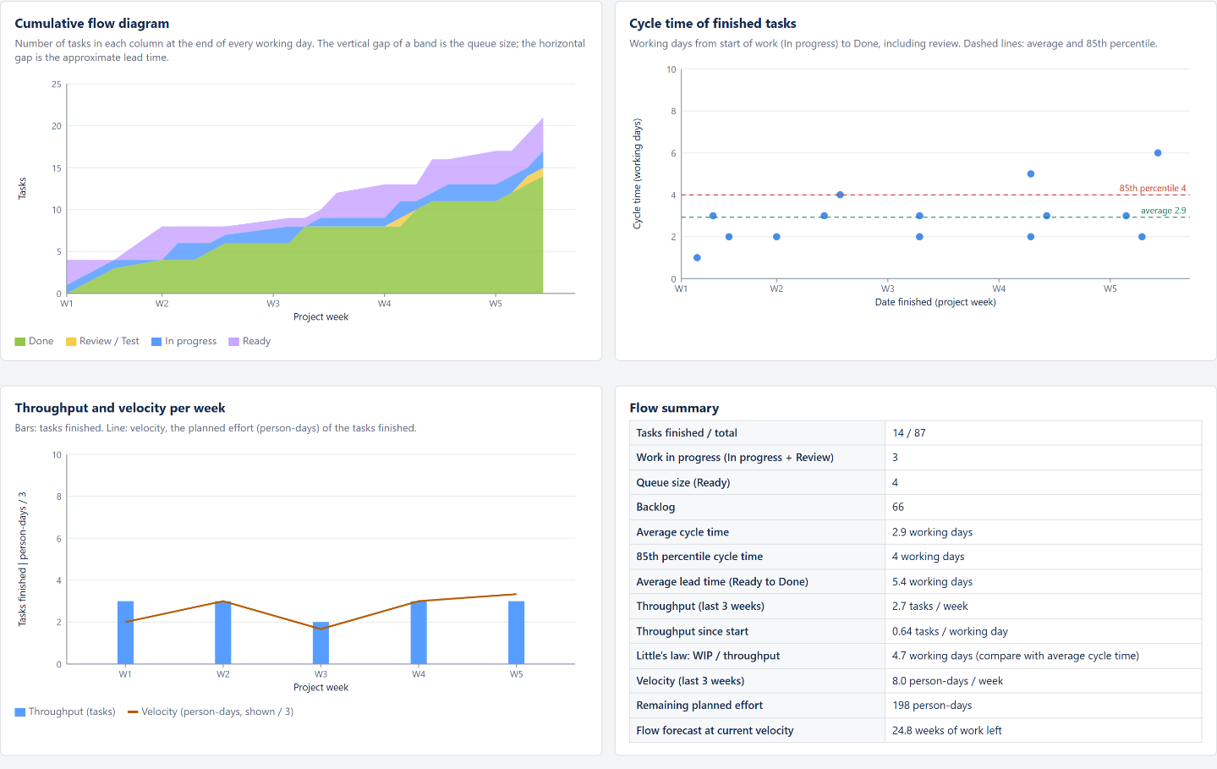
Figure 2: Flow metrics tab: cumulative flow diagram, cycle time chart, throughput and velocity

3.3 Interpretation
- Service level: 85% of the finished tasks took 4 working days or less. This is used as the team's service level expectation: a card that has been in progress for more than 4 days is discussed at the daily stand-up.
- Lead time vs cycle time: the average lead time (5.4 days) is about 2.5 days longer than the cycle time, which is the time a task waits in Ready. Keeping the Ready limit at 6 stops this waiting time from growing.
- Little's law: current WIP divided by throughput gives 4.7 days, higher than the measured cycle time of 2.9 days. The difference comes from the first weeks, when planning tasks were finished quickly one after another; as more development tasks run in parallel the two values are expected to come closer.
- Velocity: the team finished 8.0 person-days of planned work per week over the last three weeks. In weeks 1 to 5 only part of the team was working (planning and design), so velocity will rise when both developers start in week 6; it is not used alone to forecast the end date.

4. RESPONSIBILITY ALLOCATION (RACI MATRIX)
The RACI matrix assigns each activity to the roles of the project. R (Responsible) does the work, A (Accountable) owns the result and approves it, C (Consulted) gives input before the work is done and I (Informed) is told about the result. The following rules were applied and are checked automatically by the board:
- Every activity has exactly one A, so there is never confusion about who approves the result.
- Every activity has at least one R. A role may be both the only R and the A is not allowed to be empty.
- The sponsor is accountable only where the charter gives him the decision: charter approval, UAT sign-off, go-live (go/no-go) and closure. The project manager is accountable for all delivery activities.
- The accountant (CA firm) is consulted on requirements and GST invoices and informed about payments, go-live and closure.
Activity | SP | OH | PM | BA | UX | DEV | QA | OPS | CA
A Project initiation and charter | A | C | R | C | I | I | I | I
B Project planning (baselines) | I | C | A | R | I | C | C | C
C Requirements specification | C | C | A | R | C | C | I | I | C
D UI/UX design and prototype test | I | C | A | C | R | C | I
E Architecture and database design | I |  | A | C |  | R | C | C
F Cloud hosting and environments | I |  | A |  |  | C |  | R
G CI/CD pipeline |  |  | A |  |  | C | C | R
H User accounts and OTP login |  |  | A | C | C | R | C | I
I Product catalogue and search | I | C | A | C | C | R | C | I
J Product and inventory admin | I | C | A | C | C | R | C | I
K Shopping cart and checkout | I | C | A | C | C | R | C | I
L Payment gateway integration | C | I | A | C |  | R | C | C | I
M Order management and returns | I | C | A | C | C | R | C | I
N Shipping and courier integration | I | C | A | C |  | R | C | I
O GST invoice generation | I | I | A | C |  | R | C |  | C
P Order tracking and notifications | I | C | A | C | C | R | C | I
Q Sales reports dashboard | C | C | A | C | C | R | C
R Security hardening and backups | I |  | A |  |  | C | C | R
S Functional and integration testing | I | I | A | C |  | R | R | C
T Performance and security testing (VAPT) | I |  | A |  |  | C | R | R
U Product data migration | I | C | A | R |  | R | C
V User acceptance testing | A | R | R | R |  | C | R | I
W Staff training and user manual | I | C | A | R | C
X Go-live preparation and deployment | A | C | R | I |  | R | R | R | C
Y Hypercare (2 weeks) | I | C | A | C |  | R | R | R
Z Project closure | A | C | R | R | I | I | I | I | I
Table 4: RACI matrix (A = Accountable, R = Responsible, C = Consulted, I = Informed)
SP = Sponsor (R. Kulkarni) · OH = Operations Head (M. Kulkarni) · PM = Project Manager (Abhay Maurya) · BA = Business Analyst · UX = UI/UX Designer · DEV = Developers (2) · QA = QA Engineer · OPS = DevOps Engineer · CA = Accountant (CA firm)
Structural check: 26 activities, 26 accountabilities (one per activity), no activity without a responsible role, so the matrix has zero structural errors. The project manager is accountable for 22 activities and the sponsor for 4. The developers are responsible for 15 activities, which matches the resource loading in Assignment 2. If a cell is changed on the board so that an activity has two A's or no R, the row turns red and the error count is shown.

5. EXECUTION CONTROL PLAN

5.1 Control Baselines
Baseline | Content | Source
Scope baseline | Scope statement, WBS (25 work packages) and WBS dictionary | Assignment 1
Schedule baseline | 26 activities, 108 working days, critical path A-C-D-I-K-L-P-S-T-V-W-X-Y-Z, go-live 27 Jan 2027, closure 16 Feb 2027 | Assignment 2
Cost baseline | Work package budget (BAC) Rs 10,17,800 + contingency Rs 1,02,000 = Rs 11,19,800; management reserve Rs 51,000 | Assignment 2
Performance measurement baseline | Time-phased planned value (PV) by day, used for SV and SPI | Assignment 2 S-curve
Table 5: Control baselines

5.2 Earned Value Measurement Rules
- Planned value (PV): the budget of each activity spread evenly over the working days of its baseline dates, summed up to the status date.
- Earned value (EV): the 50/50 rule on task cards: 50% of a task's labour budget is earned when it enters In progress and the rest when it reaches Done. This rule is suitable because every task is at most 6 days long. Purchases (non-labour) are earned when the task is done.
- Actual cost (AC): working days the card has spent in In progress or Review x the daily rate of the responsible role, plus purchases when they are paid (task done). Rates are the same as in the budget.
- Level of effort: monitoring (WBS 1.1.3) earns exactly its planned value; its actual cost is taken as planned.
- The 50/50 rule gives credit for starting work, which could be misused by starting many tasks. The WIP limits prevent this, and SPI is always read together with the critical path and the number of tasks done.

5.3 Formulas
Measure | Formula | Meaning
Schedule variance | SV = EV - PV | Negative = behind schedule (in money terms)
Cost variance | CV = EV - AC | Negative = over cost
Schedule performance index | SPI = EV / PV | Below 1 = less work done than planned
Cost performance index | CPI = EV / AC | Below 1 = work costs more than budgeted
Estimate at completion | EAC = BAC / CPI | Forecast final cost if the current cost efficiency continues
EAC (atypical) | EAC = AC + (BAC - EV) | If the variance so far was a one-off
EAC (cost and schedule) | EAC = AC + (BAC - EV) / (CPI x SPI) | If both cost and schedule performance continue
Estimate to complete | ETC = EAC - AC | Money still needed
Variance at completion | VAC = BAC - EAC | Forecast overrun (negative) or saving
To-complete performance index | TCPI = (BAC - EV) / (BAC - AC) | Efficiency needed on the remaining work to finish on budget
Table 6: Earned value formulas

5.4 Thresholds and Actions
Indicator | Green | Amber | Red | Action and owner
SPI | 0.95 or more | 0.90 to 0.95 | below 0.90 | Amber: check critical path cards at stand-up. Red: recovery plan within 2 days (re-sequence, crash or fast-track); PM, sponsor informed
CPI | 0.95 or more | 0.90 to 0.95 | below 0.90 | Amber: find the cause per activity. Red: use contingency only with a cause analysis; above Rs 50,000 needs sponsor approval
Card age (In progress) | within plan | over plan | over 1.5 x plan | Discussed at stand-up; PM removes blockers or splits the task
WIP limit | within limit | - | limit reached | Board blocks the move; team helps finish or review existing cards
Critical path card blocked | - | 1 day | 2 days or more | Escalate to PM the same day; sponsor if a milestone may move by more than 5 working days
VAC | within contingency | uses more than 50% of contingency | above contingency | Red: change request to the Change Control Board (CCB)
Table 7: Control thresholds

5.5 Reporting and Meetings
Event | When | Who | Input / output
Daily stand-up at the board | Every working day, 15 min | Team, PM | Board, card ages, blocked cards / updated board
Board replenishment | Monday | PM, BA | Backlog, schedule logic / Ready column filled up to the limit
Weekly status report | Friday | PM to sponsor and operations head | EVM table, S-curve, SPI/CPI trend, flow metrics, risks, decisions needed
Milestone review | At M1 to M6 | Sponsor, operations head, PM | Milestone deliverables, EVM, stakeholder register update / approval
Change Control Board | When a change request is raised | Sponsor, operations head, PM | Change request with impact on scope, schedule, cost / decision logged
Table 8: Reporting cadence

5.6 Change Control
- Any request that changes scope, a baseline date or the budget is written as a change request (description, reason, requester).
- The PM analyses the impact on the WBS, critical path (using the Assignment 2 model) and cost, and checks it against the PM's authority limits from the charter.
- Small changes (up to 2 person-days, no milestone or cost impact) are approved by the PM; all others go to the CCB.
- Approved changes are added to the board as new cards, the baselines and RACI matrix are updated and the change log is versioned.

6. PROJECT STATUS ON 3 OCTOBER 2026

6.1 Earned Value Analysis
Measure | Value | Measure | Value
BAC | Rs 10,17,800 | SPI | 0.95 (amber)
PV | Rs 1,78,154 | CPI | 0.98 (green)
EV | Rs 1,68,614 | EAC = BAC / CPI | Rs 10,38,927
AC | Rs 1,72,114 | EAC = AC + (BAC - EV) | Rs 10,21,300
SV = EV - PV | -Rs 9,540 | EAC = AC + (BAC - EV) / (CPI x SPI) | Rs 10,87,970
CV = EV - AC | -Rs 3,500 | ETC = EAC - AC | Rs 8,66,813
% complete (EV / BAC) | 17% | VAC = BAC - EAC | -Rs 21,127
 |  | TCPI | 1.00
Table 9: Earned value at the status date
Activity | PV | EV | AC | SV | CV
A Project initiation and charter | Rs 20,500 | Rs 20,500 | Rs 20,500 | Rs 0 | Rs 0
B Project planning (baselines) | Rs 27,000 | Rs 27,000 | Rs 27,000 | Rs 0 | Rs 0
C Requirements specification | Rs 37,000 | Rs 37,000 | Rs 40,000 | Rs 0 | -Rs 3,000
D UI/UX design and prototype test | Rs 26,600 | Rs 30,000 | Rs 27,000 | Rs 3,400 | Rs 3,000
E Architecture and database design | Rs 32,040 | Rs 32,100 | Rs 35,600 | Rs 60 | -Rs 3,500
F Cloud hosting and environments | Rs 16,800 | Rs 3,800 | Rs 3,800 | -Rs 13,000 | Rs 0
Monitoring (level of effort) | Rs 18,214 | Rs 18,214 | Rs 18,214 | Rs 0 | Rs 0
Total | Rs 1,78,154 | Rs 1,68,614 | Rs 1,72,114 | -Rs 9,540 | -Rs 3,500
Table 10: Earned value by activity
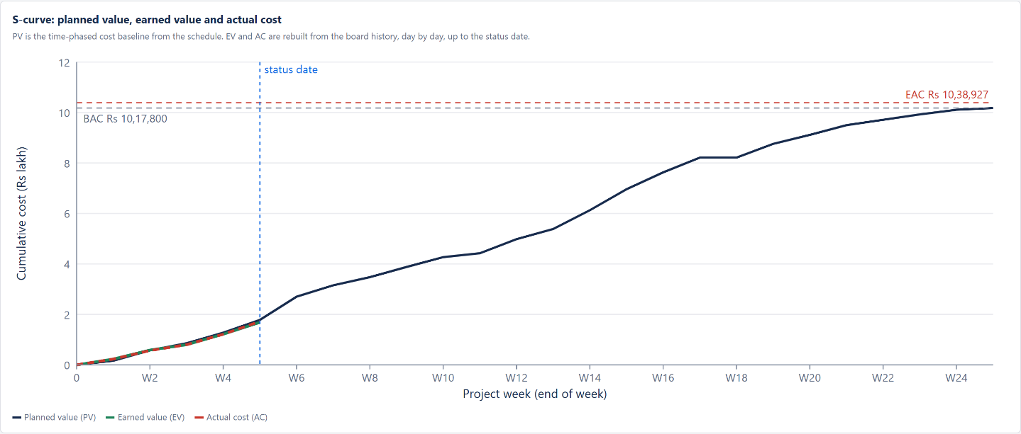
Figure 3: S-curve on the board: PV for the whole project, EV and AC up to the status date
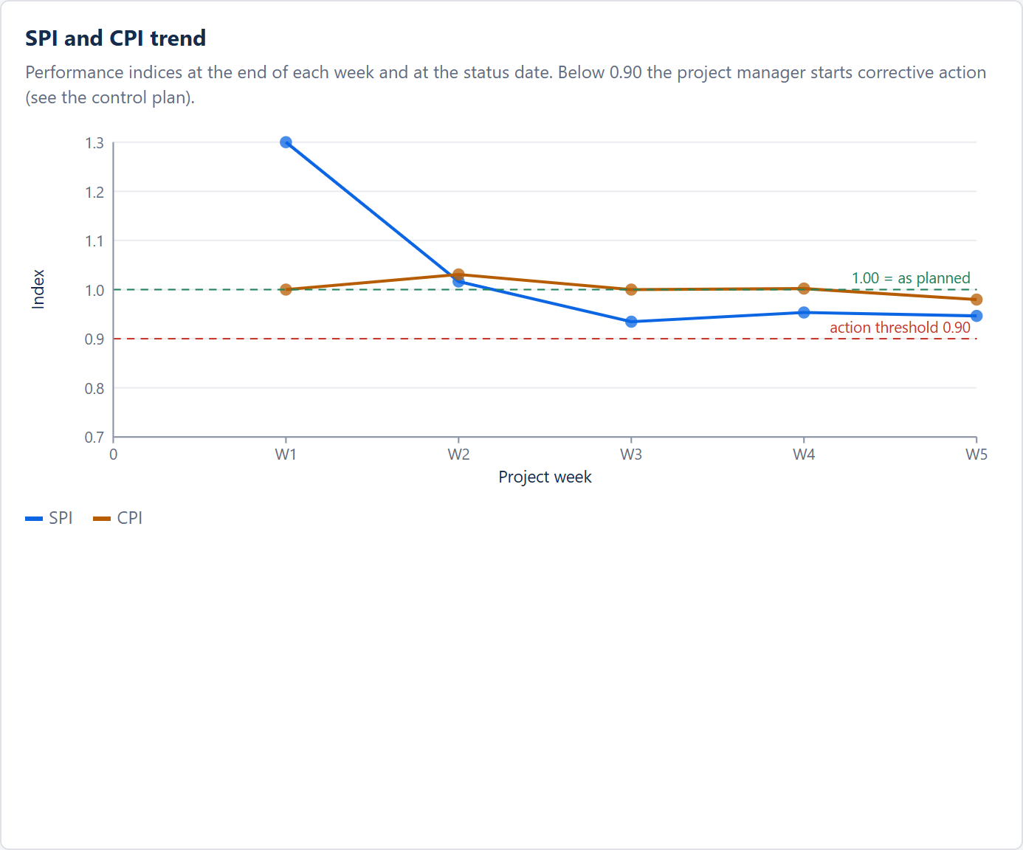
Figure 4: SPI and CPI trend by week

6.2 Variance Analysis
- Schedule (SV -Rs 9,540, SPI 0.95): requirements (C) needed one extra interview round, so the SRS was signed off on 23 September instead of 22 September. Because C is on the critical path, UI/UX design (D) started one day late, and hosting setup (F1) also started one day after its baseline date. Non-critical work is on plan (the risk register B3 was even finished before planning started). The forecast impact on go-live is one working day.
- Cost (CV -Rs 3,500, CPI 0.98): requirements (C) cost Rs 3,000 more because of the extra business analyst day on C3. Architecture (E) shows -Rs 3,500 because the API specification E3 has used its 2 planned days but earns only 50% until its review is accepted; this reverses when the card reaches Done. UI/UX design (D) shows +Rs 3,000 because the mock-ups (D2) received their 50% credit on the first day. Only the C variance is a real overrun; it is small and one-off.
- Forecast: the typical EAC (Rs 10,38,927) assumes the current CPI continues; the atypical EAC (Rs 10,21,300) treats the overrun as a one-off. Both are well inside the contingency reserve of Rs 1,02,000. TCPI of 1.00 shows that the remaining work must be done at about the planned efficiency to finish on budget.

6.3 Corrective and Preventive Actions
Issue | Action | Owner | Due
Critical path 1 day late (C to D) | Recover the day in D: prototype test with customers (D4) is prepared by the BA in parallel with the mock-ups | PM, BA | 14 Oct 2026
E3 waiting in review | Developers and PM review the API specification together on the next working day; review cards older than 2 days are raised at stand-up | PM | 05 Oct 2026
Hosting purchase (F1, Rs 36,000) | Pay on delivery of the account and SSL so that the cost is recorded when the work is complete | DevOps | 06 Oct 2026
Payment gateway KYC (risk R1) | Submit KYC documents now so that approval is ready before L starts in week 14 | PM | 09 Oct 2026
Table 11: Actions from the status review

7. DYNAMIC BEHAVIOUR OF THE BOARD
The following sequence was run on the board to show how moving cards changes the indicators. All numbers are calculated by the board itself.
Step | WIP | Done | PV | EV | AC | SPI | CPI | EAC
Baseline state on the status date (Saturday 03 Oct) | 3 | 14 | Rs 1,78,154 | Rs 1,68,614 | Rs 1,72,114 | 0.95 | 0.98 | Rs 10,38,927
Status date moved to Monday 05 Oct, no card moved | 3 | 14 | Rs 1,94,986 | Rs 1,69,686 | Rs 1,83,486 | 0.87 | 0.92 | Rs 11,00,574
E3 API specification and F1 hosting moved to Done | 1 | 16 | Rs 1,94,986 | Rs 2,12,986 | Rs 2,19,486 | 1.09 | 0.97 | Rs 10,48,862
H1, G1, D3 and F2 pulled from Ready to In progress | 5 | 16 | Rs 1,94,986 | Rs 2,35,486 | Rs 2,33,586 | 1.21 | 1.01 | Rs 10,09,588
Two more working days pass (07 Oct) with no card finished | 5 | 16 | Rs 2,29,129 | Rs 2,37,629 | Rs 2,69,929 | 1.04 | 0.88 | Rs 11,56,146
Table 12: Effect of card moves on the indicators
- Moving the status date forward without moving any card increases PV and AC (people keep working on open cards) but not EV, so SPI and CPI fall and EAC rises. This is how a stalled card shows up in the numbers.
- Finishing E3 earns its remaining 50%. Finishing F1 earns and pays the hosting purchase of Rs 36,000 at the same time, so EV and AC rise together and CPI is not distorted by the purchase.
- Pulling four cards into In progress earns 50% of their labour budget immediately (50/50 rule), so SPI jumps. In progress then holds 5 cards, and the next attempt to start a card was refused with the message: "WIP limit reached in "In progress" (5). Finish work before starting more." This is why WIP limits are needed when the 50/50 rule is used.
- When two more working days pass without any card being finished, AC and PV keep growing while EV stays the same, so both indices fall and the EAC rises again. A stalled board is visible in the numbers within days.

8. CONCLUSION
A Kanban board was designed and built as a working web application for the execution of the ShopEase project. The 87 task cards come from the WBS and the schedule, the columns have explicit policies and WIP limits, and the board measures lead time, cycle time, throughput, velocity and WIP from the dated card history. The RACI matrix gives every activity exactly one accountable person and at least one responsible role, and the board checks it automatically.
The execution control plan links the board to the baselines from Assignments 1 and 2. Earned value is calculated with clear measurement rules, compared against thresholds, reported weekly and acted on through defined escalation and change control. On 3 October 2026 the project is 17% complete, one day behind on the critical path (SPI 0.95) and close to budget (CPI 0.98, EAC Rs 10,38,927), and corrective actions have been assigned. Because every indicator is recalculated whenever a card moves, the same board is used for the daily stand-up, the weekly status report and the milestone reviews.

❖ GitHub Repository
All four Project Management assignments of the ShopEase project (reports, Excel model, Kanban board and risk register) are available on GitHub:
GitHub Repository Link:
https://github.com/Abhxym/project-management
Kanban board (opens in the browser):
https://abhxym.github.io/project-management/assignment-3-kanban-execution/ShopEase_Kanban_Board.html
Files for this assignment (assignment-3-kanban-execution):
- ShopEase_Kanban_Board.html - the web-based Kanban board with flow and earned value metrics.
- PM_Assignment3_Kanban_Execution_Control.pdf and .docx - this report.

REFERENCES
- Project Management Institute. A Guide to the Project Management Body of Knowledge (PMBOK Guide), 7th Edition, 2021.
- Project Management Institute. The Standard for Earned Value Management, 2019.
- Anderson, D. J. Kanban: Successful Evolutionary Change for Your Technology Business. Blue Hole Press, 2010.
- Vacanti, D. S. Actionable Agile Metrics for Predictability. ActionableAgile Press, 2015.
- Little, J. D. C. A Proof for the Queuing Formula: L = λW. Operations Research, 9(3), 1961.
- Fleming, Q. W., Koppelman, J. M. Earned Value Project Management, 4th Edition. Project Management Institute, 2010.
- Schwalbe, K. Information Technology Project Management, 9th Edition, Cengage, 2019.

