RISK MANAGEMENT PLAN
AND RISK REGISTER
ShopEase Online Store: Development of an
E-commerce Web Application
Name : Abhay Maurya
PRN : 202301040187
Subject : Project Management ( Assignment 4 )
Project Domain : E-commerce Application
Document Version : 1.0, 10 Oct 2026
Risk register (live) : https://abhxym.github.io/project-management/assignment-4-risk-management/ShopEase_Risk_Register.html
GitHub Repository : https://github.com/Abhxym/project-management

ABSTRACT
This document is the risk management plan and risk register of the ShopEase online store project, which started on 1 September 2026 and is planned to go live on 27 January 2027. The plan defines how risks are identified, analysed, responded to and monitored: roles, budget, timing, risk categories, probability and impact scales, the probability-impact (P-I) matrix, risk thresholds and reporting.
20 project-specific risks were identified: 15 threats and 5 opportunities. Each risk is written as cause, event and effect, has an owner, a probability in percent, a cost and schedule impact, a P x I severity score from 1 to 25, an expected monetary value (EMV), a response strategy with a justification, a trigger, a fallback plan and a residual rating after the response. The register is built as an interactive web application in which the risks are plotted on separate P-I matrices for threats and opportunities; changing any value, or dragging a risk to another cell, recalculates the score, EMV, contingency cover and matrix at once.
Quantitative analysis shows a net EMV of Rs 97,250 before responses, which is covered by the contingency reserve of Rs 1,02,000. A decision tree justifies a backup payment gateway, and a Monte Carlo simulation of 10,000 runs over the project network shows that the planned responses raise the probability of going live on time from 13% to 57%.
Keywords: Risk Management Plan, Risk Register, Threat, Opportunity, Probability-Impact Matrix, Risk Score, Expected Monetary Value, Decision Tree, Monte Carlo Simulation, Contingency Reserve, Risk Response.

1. INTRODUCTION

1.1 Background
The charter (Assignment 1) listed seven high-level risks and the budget (Assignment 2) set a contingency reserve of Rs 1,02,000 from their EMV. Execution started on 1 September and the Kanban board and earned value control (Assignment 3) are in use. This document turns the early risk list into a full risk management process for the rest of the project.

1.2 Objectives
- To define the risk management approach, roles, scales and thresholds.
- To identify project-specific threats and opportunities and record them in a risk register with owners.
- To rate each risk on a probability-impact matrix with a quantitative score and EMV.
- To choose and justify a response for each risk and measure the residual risk.
- To check the contingency reserve and the go-live date with quantitative analysis.

1.3 Threats and Opportunities
A risk is an uncertain event that, if it happens, affects at least one project objective. A threat has a negative effect (higher cost, delay, lower quality), for example the payment gateway approving the KYC late. An opportunity has a positive effect (lower cost, time saved, better quality), for example the cloud provider giving start-up credits. Both are managed in the same register with the same scales, but the response strategies are different: threats are avoided, transferred, mitigated or accepted, while opportunities are exploited, shared, enhanced or accepted.

2. RISK MANAGEMENT PLAN

2.1 Methodology
Step | What is done | Tools and data
1. Plan | This plan: approach, roles, scales, thresholds | Charter, baselines (Assignments 1 and 2)
2. Identify | Find threats and opportunities and write them as cause, event, effect | Workshops, assumption analysis, WBS and schedule review, board data
3. Qualitative analysis | Rate probability and impact; score P x I; plot on the P-I matrix | Scales in 2.6, P-I matrix in 2.7
4. Quantitative analysis | EMV, contingency check, decision tree, Monte Carlo on the network | Interactive register, schedule model from Assignment 2
5. Plan responses | Choose a strategy, actions, owner, trigger, fallback; rate the residual risk | Response playbook (Section 5)
6. Implement responses | Owners carry out the actions as Kanban cards | Kanban board (Assignment 3)
7. Monitor | Review triggers, re-rate risks, close or add risks, report | Weekly status meeting, milestone reviews
Table 1: Risk management process

2.2 Roles and Responsibilities
Role | Responsibilities in risk management
Sponsor (R. Kulkarni) | Approves this plan; owns escalated risks; controls the management reserve; decides on risks above the PM authority
Project Manager (Abhay Maurya) | Owns the risk process and the register; runs risk reviews; controls the contingency reserve within the charter limits; reports top risks weekly
Risk owner | Named for each risk; watches the trigger; carries out the response; reports status and re-rates the risk
Team members | Raise new risks at any time (stand-up, sprint demos); carry out response actions as task cards
Operations Head | Owns business-side risks (staff adoption, UAT availability); member of the Change Control Board
Table 2: Roles and responsibilities

2.3 Budget
- Contingency reserve Rs 1,02,000 (part of the cost baseline): for identified risks in this register. Used by the PM up to Rs 50,000 per risk event; above that with sponsor approval.
- Management reserve Rs 51,000 (outside the cost baseline): for unidentified risks; released only by the sponsor through change control.
- Response costs (Rs 16,000 in total) are paid from the contingency reserve because they reduce identified risks.

2.4 Timing
Activity | When
Full risk identification workshop | At the start of execution and at each milestone (M1 to M6)
Risk review of top risks and triggers | Weekly status meeting (Friday)
Review of all medium and low risks | Every two weeks and at milestone reviews
New risk raised | Any time; rated by the PM within 2 working days
Quantitative analysis (EMV, Monte Carlo) | At each milestone and after any change to a high risk
Lessons learned on risks | At project closure (Z)
Table 3: Risk management timing

2.5 Risk Categories
Category | Typical sources in this project | Risks
Technical | Requirements, architecture, performance, security, hosting | T06, T07, T08, T12, O01
External | Payment gateway, courier, suppliers, regulators, cloud provider | T01, T02, T09, T10, T13, T15, O02, O03, O05
Organisational | Staff, owner, funding, availability of business users | T03, T05, T11, T14
Project management | Scope control, planning, estimating | T04, O04
Table 4: Risk breakdown structure (RBS)

2.6 Probability and Impact Scales
Rating | Probability | Cost impact | Schedule impact (on the activity)
5 Very high | 70% or more | Rs 1,00,000 or more | 20 working days or more
4 High | 50% to 69% | Rs 50,000 to 99,999 | 10 to 19 days
3 Medium | 30% to 49% | Rs 25,000 to 49,999 | 5 to 9 days
2 Low | 10% to 29% | Rs 10,000 to 24,999 | 2 to 4 days
1 Very low | below 10% | below Rs 10,000 | 0 to 1 day
Table 5: Probability and impact scales
The impact rating is the higher of the cost and schedule ratings. The same scales are used for opportunities, where the impact is a saving or time gained. The scales are anchored to this project: Rs 1,00,000 is about 10% of the work package budget and 20 days is more than the whole schedule float on most paths.

2.7 Probability-Impact Matrix and Thresholds
The severity score is P x I (1 to 25). The matrix is divided into three zones, which set the required action:
Zone | Score | Threat | Opportunity
High | 12 to 25 | Response plan with owner within 2 days, reviewed weekly, reported to the sponsor | Exploit or share actively
Medium | 6 to 11 | Response plan, reviewed every two weeks | Enhance where it costs little
Low | 1 to 5 | Watch list, reviewed at milestones | Accept
Table 6: Score zones
Risk appetite and thresholds agreed with the sponsor: the go-live date may slip by at most 5 working days (charter authority limit), the total of identified risks must stay within the contingency reserve, and no high threat may remain on the critical path without an active response. A breach of a threshold is escalated to the sponsor.

2.8 Response Strategies
Threat strategy | Meaning | Opportunity strategy | Meaning
Avoid | Remove the cause or change the plan | Exploit | Make sure the opportunity happens
Transfer | Move the impact to a third party (contract, insurance) | Share | Work with a partner who can capture it
Mitigate | Reduce probability or impact | Enhance | Increase probability or impact
Accept | Active (fallback, contingency) or passive | Accept | Take it if it happens
Escalate | Outside the PM authority; owned by the sponsor | Escalate | Benefit is at business level; owned by the sponsor
Table 7: Response strategies

2.9 Reporting and Tracking
- The register records for each risk: ID, type, category, cause-event-effect, activity affected, owner, probability, cost and schedule impact, P, I, score, EMV, strategy, actions, justification, trigger, fallback, response cost, residual rating and status (Active, Watch, Escalated, Occurred, Closed).
- The weekly status report contains the top risks by score, risks whose trigger has fired, contingency used and the net EMV against the remaining contingency.
- When a risk occurs it becomes an issue: its status is set to Occurred, the fallback plan is started and the contingency used is recorded.
- The register is exported to CSV after each review and kept with the project files.

3. RISK IDENTIFICATION
Technique | Input | Risks found
Team workshop (1 Oct) | WBS, schedule, Kanban board | T04, T05, T06, T07, T08, T12, O01, O04
Assumption and constraint analysis | Charter assumptions (KYC by week 11, data on time, staff available) | T01, T02, T11
Interviews with sponsor, operations head and CA | Business calendar, cash flow, GST rules | T03, T13, T14
Vendor and partner review | Gateway, courier, WhatsApp, cloud, suppliers | T09, T10, O02, O03, O05
Regulatory review | DPDP Act 2023, Consumer Protection (E-Commerce) Rules | T15
Project data | Requirements finished 1 day late (Assignment 3 board) | T08 probability raised
Table 8: Identification techniques
Every risk is written in the form "Because of (cause), (event) may happen, leading to (effect)". This keeps the cause, which the response works on, separate from the effect, which is used for the impact rating.

4. RISK REGISTER
Status date: 10 October 2026. T = threat, O = opportunity. Activity = schedule activity affected (Assignment 2). Owner codes: SP = Sponsor (R. Kulkarni), OH = Operations Head (M. Kulkarni), PM = Project Manager (Abhay Maurya), BA = Business Analyst, DEV = Developers, OPS = DevOps Engineer. EMV is positive for threats (expected cost) and negative for opportunities (expected saving).
ID | T/O | Risk (cause, event, effect) | Act. | Owner | Prob. | Cost impact | Days | P | I | Score | EMV
T01 | T | Payment gateway KYC approval delayed  Because the gateway needs a full set of KYC documents (GST, PAN, bank proof, website policy pages) and its review queue is long, approval may come after payment integration (L) is due to start on 30 Nov, leading to L, a critical path activity, cannot be tested with real transactions and go-live slips. | L | PM | 30% | Rs 60,000 | 8 | 3 | 4 | 12  High | Rs 18,000
T02 | T | Product data and photos from suppliers late or incomplete  Because 8 suppliers send data in different formats and some products have no photos, the product master file may not be complete when data migration (U) starts, leading to UAT runs on partial data and extra photo shoot days are needed. | U | BA | 50% | Rs 40,000 | 5 | 4 | 3 | 12  High | Rs 20,000
T03 | T | Store staff resist the new order process  Because staff are used to WhatsApp and worry about extra work and job security, staff may avoid the admin panel or make errors after go-live, leading to order errors stay high (G7 not met) and extra training is needed. | W | OH | 30% | Rs 30,000 | 0 | 3 | 3 | 9  Medium | Rs 9,000
T04 | T | Scope creep from new feature requests  Because the owner sees competitor features during development, new features may be requested after the SRS sign-off, leading to development effort grows and the critical path moves. | K | PM | 40% | Rs 80,000 | 10 | 3 | 4 | 12  High | Rs 32,000
T05 | T | A developer leaves or is unavailable for long  Because the job market for developers is active and the team has only two developers, one developer may leave during development, leading to storefront or admin chain stops while a replacement is found and handed over. | K | PM | 10% | Rs 1,20,000 | 15 | 2 | 5 | 10  Medium | Rs 12,000
T06 | T | Site slows down or fails under launch traffic  Because the launch campaign brings a traffic peak on the first days, response times may exceed 3 seconds or the site may go down, leading to lost sales, bad reviews and emergency fixes during hypercare. | X | OPS | 10% | Rs 50,000 | 3 | 2 | 4 | 8  Medium | Rs 5,000
T07 | T | Security breach or customer data leak  Because an online store is a target for attacks and stores personal data, a vulnerability may be exploited, leading to DPDP Act penalties, loss of trust and emergency fixes. | Y | OPS | 5% | Rs 1,20,000 | 5 | 1 | 5 | 5  Low | Rs 6,000
T08 | T | Requirements misunderstood, causing rework  Because user stories were written quickly and the requirements phase already slipped by one day, developers may build features differently from what the business expects, leading to rework in checkout and admin, delaying the critical path. | K | BA | 30% | Rs 35,000 | 4 | 3 | 3 | 9  Medium | Rs 10,500
T09 | T | Courier aggregator API change or account delay  Because the aggregator updates its API and account approval needs documents, the courier integration (N) may need extra work, leading to shipping labels and tracking are delayed. | N | DEV | 20% | Rs 20,000 | 3 | 2 | 2 | 4  Low | Rs 4,000
T10 | T | WhatsApp Business API approval delayed  Because message templates need approval from the provider, WhatsApp notifications (P3) may not be ready for go-live, leading to customers get SMS and e-mail only at launch. | P | DEV | 30% | Rs 10,000 | 2 | 3 | 2 | 6  Medium | Rs 3,000
T11 | T | Business users not available for UAT  Because January is the start of the wedding season and the shop is busy, the owner and staff may not attend UAT sessions on time, leading to UAT sign-off (M4) and go-live slip. | V | OH | 30% | Rs 15,000 | 3 | 3 | 2 | 6  Medium | Rs 4,500
T12 | T | Cloud hosting cost above plan  Because test environments and storage grow during development, monthly hosting bills may exceed the planned Rs 6,000, leading to overrun on the hosting work package. | F | OPS | 20% | Rs 15,000 | 0 | 2 | 2 | 4  Low | Rs 3,000
T13 | T | GST invoice errors found late by the CA  Because GST rules differ by product type and delivery state, the CA may reject the invoice format during review (O3), leading to rework of invoices close to testing. | O | BA | 20% | Rs 15,000 | 2 | 2 | 2 | 4  Low | Rs 3,000
T14 | T | Owner delays vendor payments in the slow season  Because shop cash flow is low in December before the wedding season, payments to the audit firm or contractors may be delayed, leading to vendors pause work, delaying the security audit. | T | SP | 15% | Rs 20,000 | 5 | 2 | 3 | 6  Medium | Rs 3,000
T15 | T | New data protection rules need consent changes  Because rules under the DPDP Act 2023 are still being notified, new consent or notice requirements may apply before go-live, leading to changes to registration and privacy screens. | H | PM | 15% | Rs 25,000 | 3 | 2 | 3 | 6  Medium | Rs 3,750
O01 | O | Reuse an open-source UI component library  Because a mature component library matches the approved design, the storefront can be built from ready components, leading to catalogue and checkout pages are built faster. | I | DEV | 50% | Rs 30,000 | 4 | 4 | 3 | 12  High | -Rs 15,000
O02 | O | Cloud provider start-up credits  Because the cloud provider has a programme for small Indian businesses, ShopEase may receive hosting credits, leading to hosting cost during the project falls. | F | OPS | 40% | Rs 25,000 | 0 | 3 | 3 | 9  Medium | -Rs 10,000
O03 | O | Suppliers provide professional product photos  Because two large suppliers already have catalogue photos, they may share them for ShopEase products, leading to fewer products need the paid photo shoot. | U | BA | 30% | Rs 20,000 | 2 | 3 | 2 | 6  Medium | -Rs 6,000
O04 | O | Shorter UAT through sprint demos  Because the operations head already reviews features in sprint demos, many UAT scripts may be accepted before formal UAT, leading to UAT takes fewer days. | V | PM | 40% | Rs 10,000 | 2 | 3 | 2 | 6  Medium | -Rs 4,000
O05 | O | Courier aggregator provides an integration engineer  Because the aggregator offers integration support to merchants who sign a 12-month contract, its engineer may help build the courier integration, leading to less developer effort on N. | N | SP | 30% | Rs 15,000 | 2 | 3 | 2 | 6  Medium | -Rs 4,500
Table 9: Risk register (before response)

5. RISK RESPONSE PLAYBOOK
The response for each risk was chosen by comparing the cost of the response with the reduction in EMV and by the zone of the risk. High threats on the critical path (T01, T04) get active responses even if they cost money; low risks with an EMV below about Rs 5,000 are accepted with a fallback plan, because a response would cost more than the expected loss. Escalation is used only when the cause is outside the project manager's authority (T14).
ID | Strategy | Response actions | Justification | Trigger | Fallback | Resp. cost | Residual P x I
T01 | Mitigate | KYC documents submitted on 08 Oct; weekly follow-up; build and test in sandbox; open a second gateway account in parallel (decision tree, Section 6.3) | Response cost Rs 8,000 is lower than the EMV reduction of Rs 16,500, and it protects the critical path. | No approval by 13 Nov (week 11) | Go live with the second gateway; switch later | Rs 8,000 | 2 x 2 = 4
T02 | Mitigate | Data template sent with supplier calls in week 3; fortnightly completeness check; photo shoot for missing items already in budget | No extra cost; U has 12 days of float, so the residual schedule effect is absorbed. | Less than 60% of SKUs complete by 16 Nov | Launch with products that are complete; add the rest in hypercare | - | 3 x 3 = 9
T03 | Mitigate | Two staff in requirements and UAT; demos in the shop every sprint; Marathi manual; show time saved | Rs 5,000 of extra demo time reduces EMV by Rs 6,000 and protects the business goal G7. | Negative feedback in sprint demos | Extra hands-on sessions during hypercare | Rs 5,000 | 2 x 2 = 4
T04 | Avoid | Formal change control (CCB); MoSCoW priorities; Phase 2 backlog for new ideas; changes over 2 person-days go to the CCB | Change control removes the uncontrolled part of the risk at no cost; only approved, funded changes remain. | Change request raised | Trade a Could-have feature for the new one | - | 2 x 3 = 6
T05 | Transfer | Contract with the staffing firm requires a replacement within 5 days at their cost; code reviews and shared modules so both developers know all code | Most of the cost moves to the staffing firm by contract; knowledge sharing lowers the schedule effect. | Resignation or leave over 5 days | Contract developer from the staffing firm | - | 2 x 3 = 6
T06 | Mitigate | Load test with 500 users (T1); auto-scaling and caching; campaign starts after 2 stable days | Load testing is already in the plan; the residual risk is low. | Load test fails the 3-second target | Add servers for launch week (Rs 6,000) | - | 1 x 2 = 2
T07 | Mitigate | No card data stored (gateway); firewall and hardening (R); external VAPT (T2); least-privilege admin accounts; daily backups | Controls are already budgeted in R and T; impact is very high so the risk is kept on the watch list. | VAPT finds a critical issue | Incident response plan; take site offline and restore | - | 1 x 4 = 4
T08 | Mitigate | Prototype test with 5 customers (D4); acceptance criteria on every card; demo to operations head at the end of each sprint | Small review cost; sprint demos catch problems early when rework is cheap. | More than 2 change requests from a sprint demo | Use contingency for rework days | Rs 3,000 | 2 x 2 = 4
T09 | Mitigate | Account opened by week 13; integrate through the aggregator SDK; keep manual label printing as fallback | No extra cost; manual fallback keeps go-live safe. | No API keys by 23 Nov | Manual labels for the first month | - | 2 x 2 = 4
T10 | Accept | Active acceptance: launch with SMS and e-mail; add WhatsApp when approved | Impact is small and any response would cost more than the EMV of Rs 3,000. | Templates not approved by 16 Dec | SMS and e-mail only | - | 3 x 2 = 6
T11 | Mitigate | UAT dates (13 to 20 Jan) booked in the shop calendar now; sessions in the morning before opening | Booking dates early costs nothing and removes most of the risk. | UAT session cancelled | Evening sessions; sponsor nominates a deputy | - | 2 x 2 = 4
T12 | Accept | Budget alerts at 80% of the monthly plan; switch off test servers at night | Low EMV; simple cost controls are enough. | Budget alert | Use contingency | - | 2 x 1 = 2
T13 | Mitigate | CA consulted on HSN codes and rates in requirements; sample invoices reviewed as soon as O1 is done | Early review costs nothing extra. | CA review finds an error | Fix during testing using developer support days | - | 2 x 1 = 2
T14 | Escalate | Escalated to the sponsor: business-level cash planning is outside the PM authority; payment dates agreed in vendor contracts | The cause is the business cash flow, which only the sponsor controls. | Invoice unpaid after 15 days | Sponsor releases management reserve | - | 2 x 2 = 4
T15 | Accept | Watch notifications monthly; consent screens built as configurable text | Outside project control; a configurable design lowers the impact at no extra cost. | New rule notified | Change request to the CCB | - | 2 x 2 = 4
O01 | Exploit | Library chosen in the architecture (E); designer maps mock-ups to library components | Exploit makes the opportunity almost certain at no cost; saves effort on the critical path. | Architecture review | - | - | 5 x 3 = 15
O02 | Enhance | Application with GST and company documents submitted; follow up with the provider account manager | Small effort raises the probability of a Rs 25,000 saving. | Credits approved | - | - | 4 x 3 = 12
O03 | Enhance | Request photos from all suppliers with the data template; offer supplier branding on product pages | Asking early increases the chance at no cost. | Supplier sends photo set | - | - | 4 x 2 = 8
O04 | Enhance | Record demo acceptance against UAT scripts; formal UAT covers only what is left | Uses meetings that already happen; may give schedule reserve before go-live. | Over 50% of scripts accepted in demos | - | - | 4 x 2 = 8
O05 | Share | Sponsor negotiates the 12-month contract including integration support; benefit shared with the aggregator | Sharing with a partner who has the skills; the contract is needed anyway. | Contract signed | - | - | 4 x 2 = 8
Table 10: Response playbook with residual ratings

5.1 Strategy Mix
Strategy | Risks
Avoid | T04
Transfer | T05
Mitigate | T01, T02, T03, T06, T07, T08, T09, T11, T13
Accept | T10, T12, T15
Escalate | T14
Exploit | O01
Share | O05
Enhance | O02, O03, O04
Table 11: Risks by response strategy

6. RISK ANALYSIS

6.1 Probability-Impact Mapping
The interactive register plots threats and opportunities on separate 5 x 5 matrices. Before the responses, 3 threats are in the high zone: T01 (payment gateway kyc approval delayed), T02 (product data and photos from suppliers late or incomplete), T04 (scope creep from new feature requests). After the responses no threat remains in the high zone, while the opportunities move up because they are exploited or enhanced.
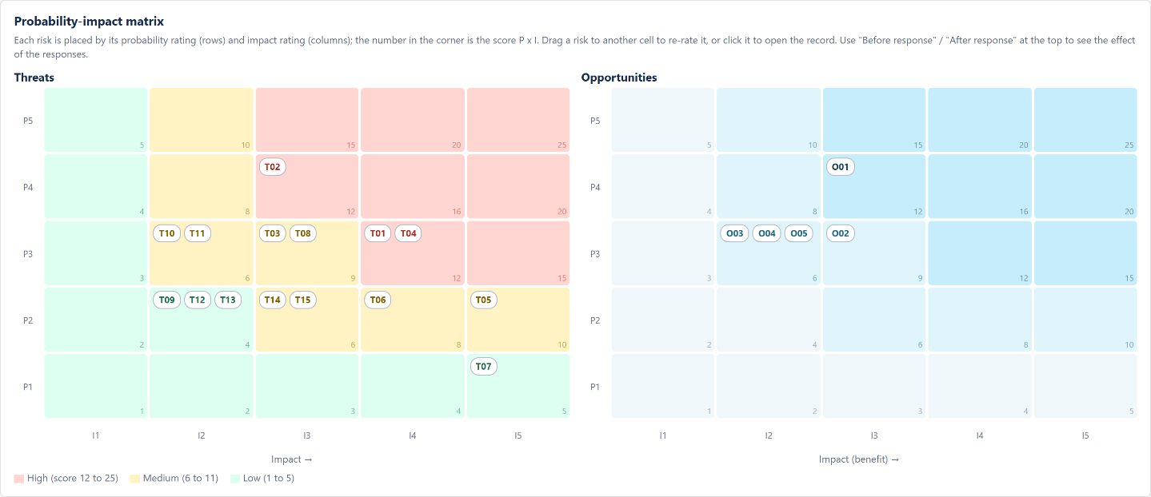
Figure 1: P-I matrices before response (interactive register)
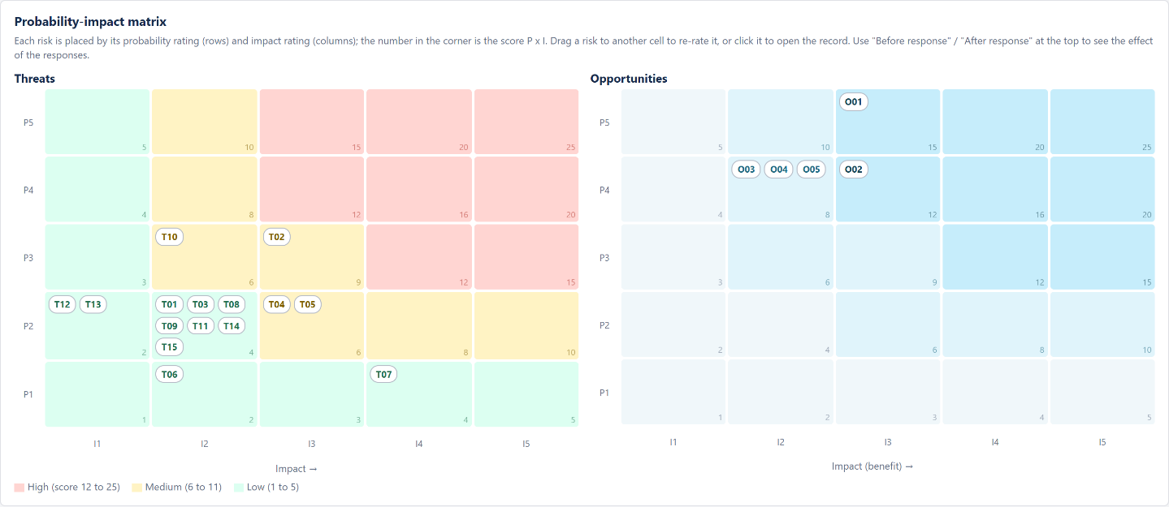
Figure 2: P-I matrices after response
Rank | ID | Risk | Owner | Score | EMV
1 | T04 | Scope creep from new feature requests | PM | 12 | Rs 32,000
2 | T02 | Product data and photos from suppliers late or incomplete | BA | 12 | Rs 20,000
3 | T01 | Payment gateway KYC approval delayed | PM | 12 | Rs 18,000
4 | O01 | Reuse an open-source UI component library | DEV | 12 | -Rs 15,000
5 | T05 | A developer leaves or is unavailable for long | PM | 10 | Rs 12,000
6 | T08 | Requirements misunderstood, causing rework | BA | 9 | Rs 10,500
7 | O02 | Cloud provider start-up credits | OPS | 9 | -Rs 10,000
8 | T03 | Store staff resist the new order process | OH | 9 | Rs 9,000
9 | T06 | Site slows down or fails under launch traffic | OPS | 8 | Rs 5,000
10 | O03 | Suppliers provide professional product photos | BA | 6 | -Rs 6,000
Table 12: Top 10 risks by score (then by EMV)

6.2 Expected Monetary Value and Contingency
 | Before response | After response
Threat EMV | Rs 1,36,750 | Rs 35,850
Opportunity EMV (saving) | -Rs 39,500 | -Rs 67,000
Net EMV | Rs 97,250 | -Rs 31,150
Response cost | - | Rs 16,000
Contingency reserve | Rs 1,02,000 | Rs 1,02,000
Reserve left after net EMV (and response cost) | Rs 4,750 | Rs 1,17,150
Table 13: EMV and contingency reconciliation
Before any response the net EMV (Rs 97,250) is just inside the contingency reserve (Rs 1,02,000), so the reserve set in Assignment 2 is still adequate even with the eight new threats, because the opportunities offset part of them. The planned responses cost Rs 16,000 and reduce the threat EMV by Rs 1,00,900, which is a strong return on the response cost.
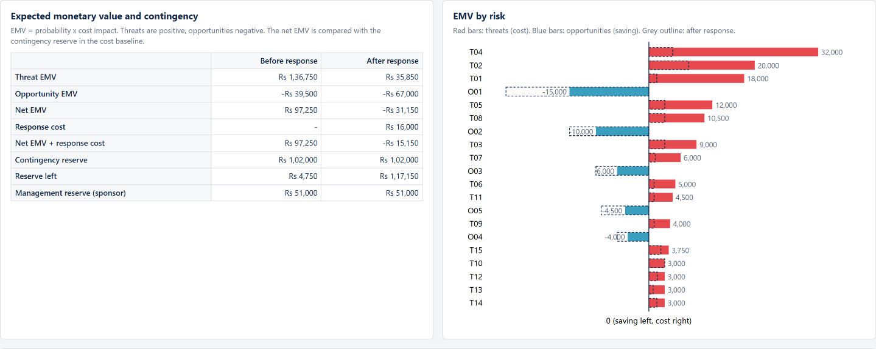
Figure 3: EMV and contingency panel of the interactive register; bars show EMV per risk before (filled) and after (dashed) response

6.3 Decision Tree: Backup Payment Gateway (T01)
The highest-scoring threat on the critical path is the payment gateway KYC delay. The decision is whether to open a second gateway account now (cost Rs 8,000 for documents and a basic integration) so that a delay would cost only Rs 15,000 instead of Rs 60,000.
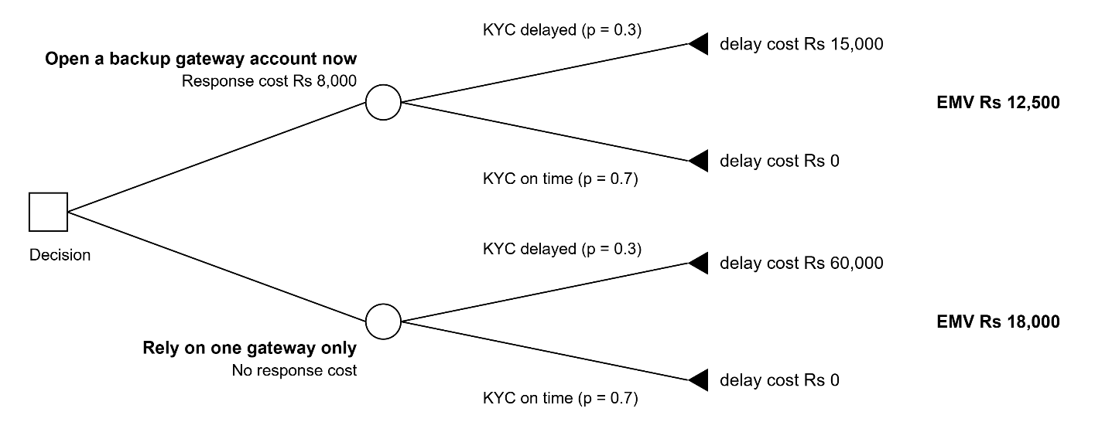
Figure 4: Decision tree for the backup payment gateway
Option | Calculation | EMV
Backup gateway now | Rs 8,000 + 0.3 x Rs 15,000 | Rs 12,500
One gateway only | 0.3 x Rs 60,000 | Rs 18,000
Table 14: Decision tree result
The backup option has the lower expected cost (Rs 12,500 against Rs 18,000), saving Rs 5,500 on average, and it also limits the worst case on the critical path. The backup gateway was therefore chosen as the response to T01.

6.4 Monte Carlo Simulation
The interactive register contains a Monte Carlo simulation of the project network from Assignment 2. In each run, every activity duration is drawn from its PERT (beta) distribution, each risk occurs with its probability and adds (threat) or removes (opportunity) 50% to 150% of its days on its activity and its cost, and the forward pass is recalculated with all FS, SS and FF links and lags. Results of 10,000 runs (seed 2026):
Scenario | On-time go-live (by 27 Jan 2027) | P50 go-live | P80 go-live | Average delay | P80 cost | Within cost baseline
Duration uncertainty only | 26% | 29 Jan 2027 | 02 Feb 2027 | 2.0 days | Rs 10,17,800 | 100%
With risks, before response | 13% | 09 Feb 2027 | 19 Feb 2027 | 9.8 days | Rs 11,78,118 | 56%
With risks, after response | 57% | 27 Jan 2027 | 01 Feb 2027 | 0.1 days | Rs 10,12,947 | 100%
Table 15: Monte Carlo results (10,000 runs)
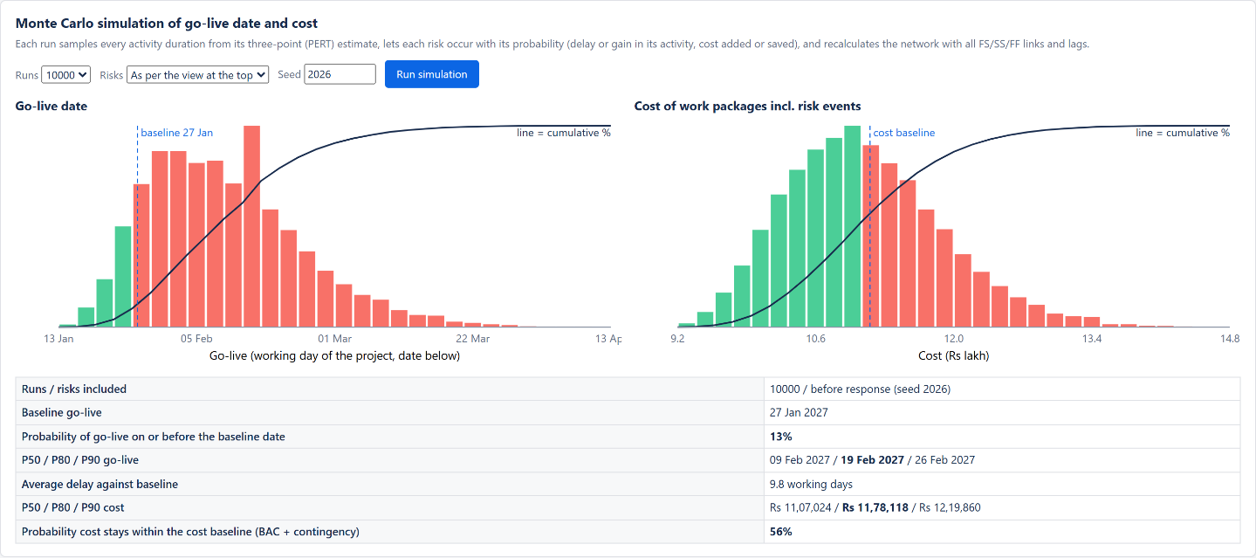
Figure 5: Monte Carlo panel before response: go-live and cost distributions with cumulative curves
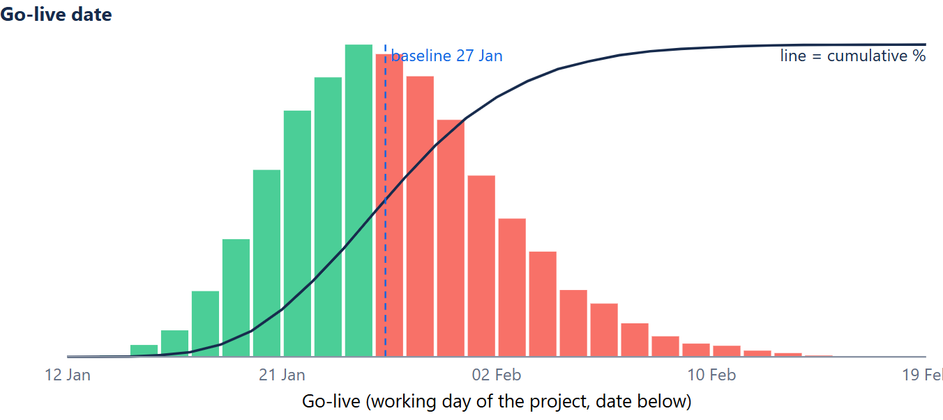
Figure 6: Go-live distribution after response
- Even without risk events the baseline date has only a 26% chance, because the PERT distributions are skewed to the right and several paths merge before testing (merge bias). The baseline is a most-likely plan, not a safe one.
- With the identified risks and no responses, the chance falls to 13% and the P80 date is 19 Feb 2027, well beyond the 5-day tolerance.
- With the planned responses the chance rises to 57% and the P80 date is 01 Feb 2027, within the 5-day tolerance. The cost stays within the cost baseline in 100% of the runs.
- To reach a higher confidence, the crashing option from Assignment 2 (requirements and design, 5 days for Rs 27,000) is kept ready as a schedule reserve.

7. RISK STATUS ON 10 OCTOBER 2026
ID | Status | Update
T01 | Active | KYC documents submitted to the gateway on 08 Oct; backup gateway account application started; sandbox integration planned in K
T02 | Active | Data template sent to all 8 suppliers; 3 have replied; first completeness check on 16 Oct
T04 | Active | Change control in use; one request (festival banner) handled inside existing scope, no CCB needed
T05 | Active | Replacement clause added to the staffing contract on 07 Oct (transfer in place)
T08 | Active | Requirements finished 1 day late; probability kept at 30% and prototype test D4 brought forward
T14 | Escalated | Sponsor agreed vendor payment dates for December; reviewed at the next monthly meeting
O01 | Active | Component library selected in the architecture document (E1), designer mapping started
O02 | Active | Start-up credit application submitted on 09 Oct
Table 16: Status of key risks at the review

8. THE INTERACTIVE RISK REGISTER
The register is a single HTML file (ShopEase_Risk_Register.html) that runs offline in any browser. It is published with GitHub Pages and can be opened directly at https://abhxym.github.io/project-management/assignment-4-risk-management/ShopEase_Risk_Register.html; the source is in the assignment-4-risk-management folder of the GitHub repository. Its tabs are:
- Register: all risks with editable owner, probability, cost, days, strategy and status; the P, I, score and EMV are recalculated as soon as a value changes; filters by type, owner and zone; sorting by score or EMV; a full record for each risk with cause, event, effect, response, trigger, fallback and residual values; adding and deleting risks; CSV export.
- P-I matrix: separate matrices for threats and opportunities with risk IDs in their cells; dragging a risk to another cell re-rates it; switch between before and after response.
- Quantitative analysis: EMV totals, contingency cover, EMV chart per risk and the Monte Carlo simulation of go-live date and cost.
- Scales and rules: the scales, zones and strategies of this plan.
Example of the dynamic behaviour: raising the probability of T01 from 30% to 60% in the register moved it from P3 x I4 = 12 to P4 x I4 = 16, its EMV from Rs 18,000 to Rs 36,000, and the net EMV from Rs 97,250 to Rs 1,15,250, which is above the contingency reserve. The contingency cover indicator turned red, which is the signal to escalate to the sponsor.
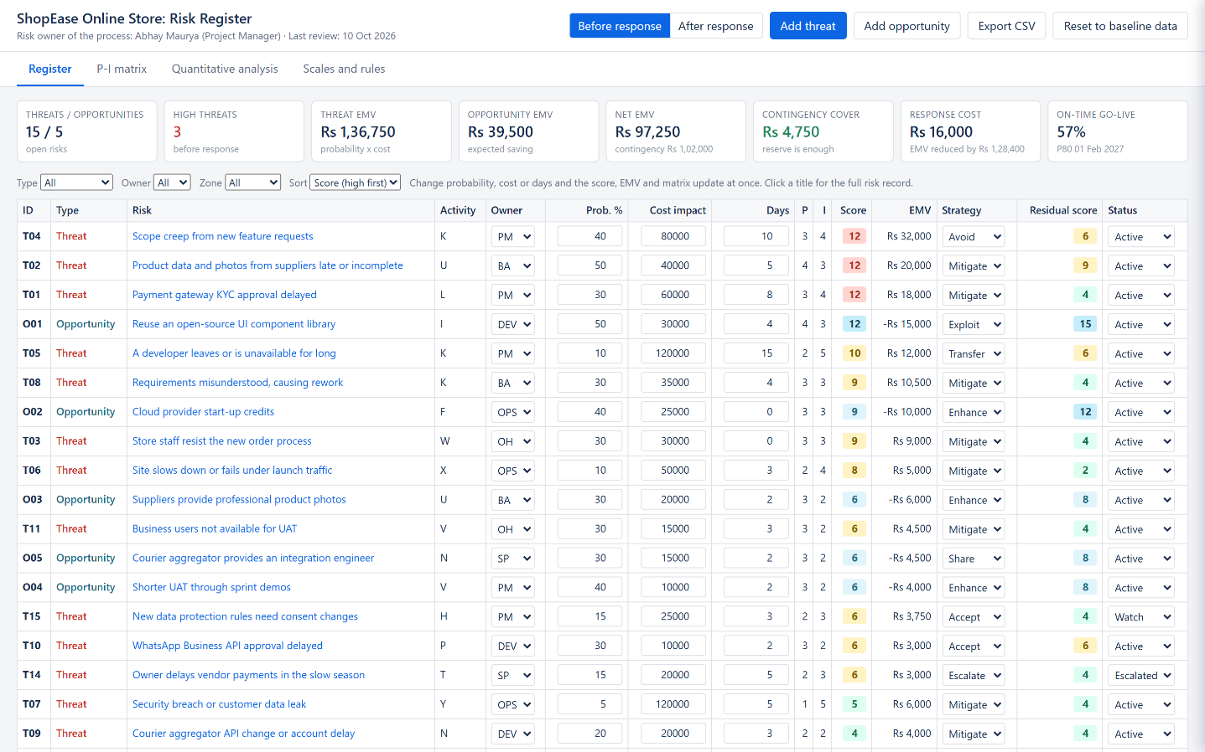
Figure 7: Register tab of the interactive risk register

9. CONCLUSION
The risk management plan sets clear scales, thresholds, roles and a review rhythm for the ShopEase project. The register contains 15 project-specific threats and 5 opportunities, each with an owner, a quantitative P x I score and EMV, and a response that is justified by cost and by its effect on the critical path. Quantitative analysis confirms that the contingency reserve of Rs 1,02,000 covers the net EMV of the identified risks, that a backup payment gateway is worth its cost, and that the planned responses raise the chance of an on-time go-live from 13% to 57%. Because the register is interactive, it is used in every weekly review to re-rate risks and see their effect on the P-I matrix, the reserve and the go-live date at once.

❖ GitHub Repository
All four Project Management assignments of the ShopEase project (reports, Excel model, Kanban board and risk register) are available on GitHub:
GitHub Repository Link:
https://github.com/Abhxym/project-management
Risk register (opens in the browser):
https://abhxym.github.io/project-management/assignment-4-risk-management/ShopEase_Risk_Register.html
Files for this assignment (assignment-4-risk-management):
- ShopEase_Risk_Register.html - the interactive risk register with P-I matrices, EMV and Monte Carlo simulation.
- PM_Assignment4_Risk_Management_Plan.pdf and .docx - this report.

REFERENCES
- Project Management Institute. A Guide to the Project Management Body of Knowledge (PMBOK Guide), 7th Edition, 2021.
- Project Management Institute. The Standard for Risk Management in Portfolios, Programs, and Projects, 2019.
- Hillson, D. Effective Opportunity Management for Projects: Exploiting Positive Risk. Marcel Dekker, 2004.
- Hillson, D., Simon, P. Practical Project Risk Management: The ATOM Methodology, 2nd Edition. Management Concepts, 2012.
- Vose, D. Risk Analysis: A Quantitative Guide, 3rd Edition. Wiley, 2008.
- ISO 31000:2018 Risk management: Guidelines. International Organization for Standardization.
- Government of India. The Digital Personal Data Protection Act, 2023.

