Name - Abhyanshu Singh

College - KIIT DU

Roll no. - 2006374

MIDAS LAB PROJECT

Problem Statement 2

In this task you will be testing a Java-based application built with Spring Boot, using the

Cucumber framework. Cucumber is a tool for running automated acceptance tests written in

a behaviour-driven development (BDD) style.

End-to-End Testing of a Spring Boot Java Project

with Cucumber

Instructions:

- Understand the Spring Boot Java project provided at the given GitHub link.

- Set up Cucumber in the Spring Boot environment.

- Write test scenarios and step definitions using Cucumber.

- Execute tests and generate a detailed test report.

Step by Step Breakdown of the Task:

Step 1: Understand the Project

1. Clone the Spring Boot project from the provided GitHub link.

2. Explore the project to understand its structure and function

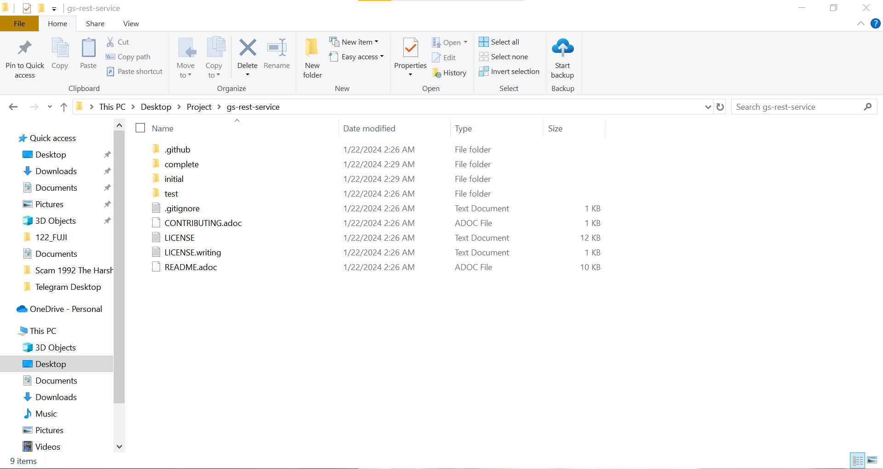

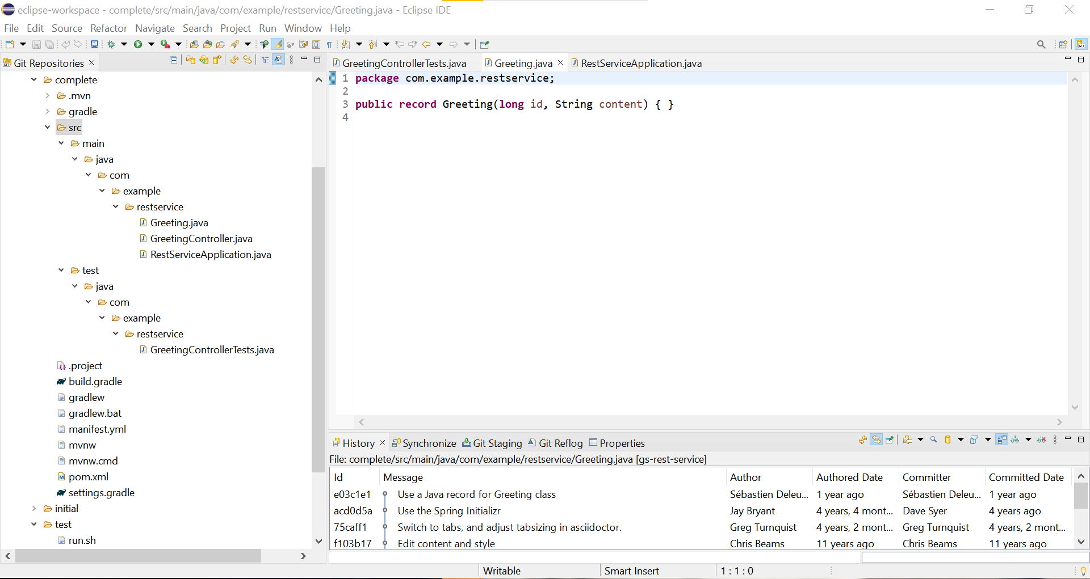

Step 2: Set Up Cucumber

1. Add Cucumber dependencies to the project's build configuration file (`pom.xml` for Maven

or `build.gradle` for Gradle).

2. Set up the Cucumber environment in your IDE.

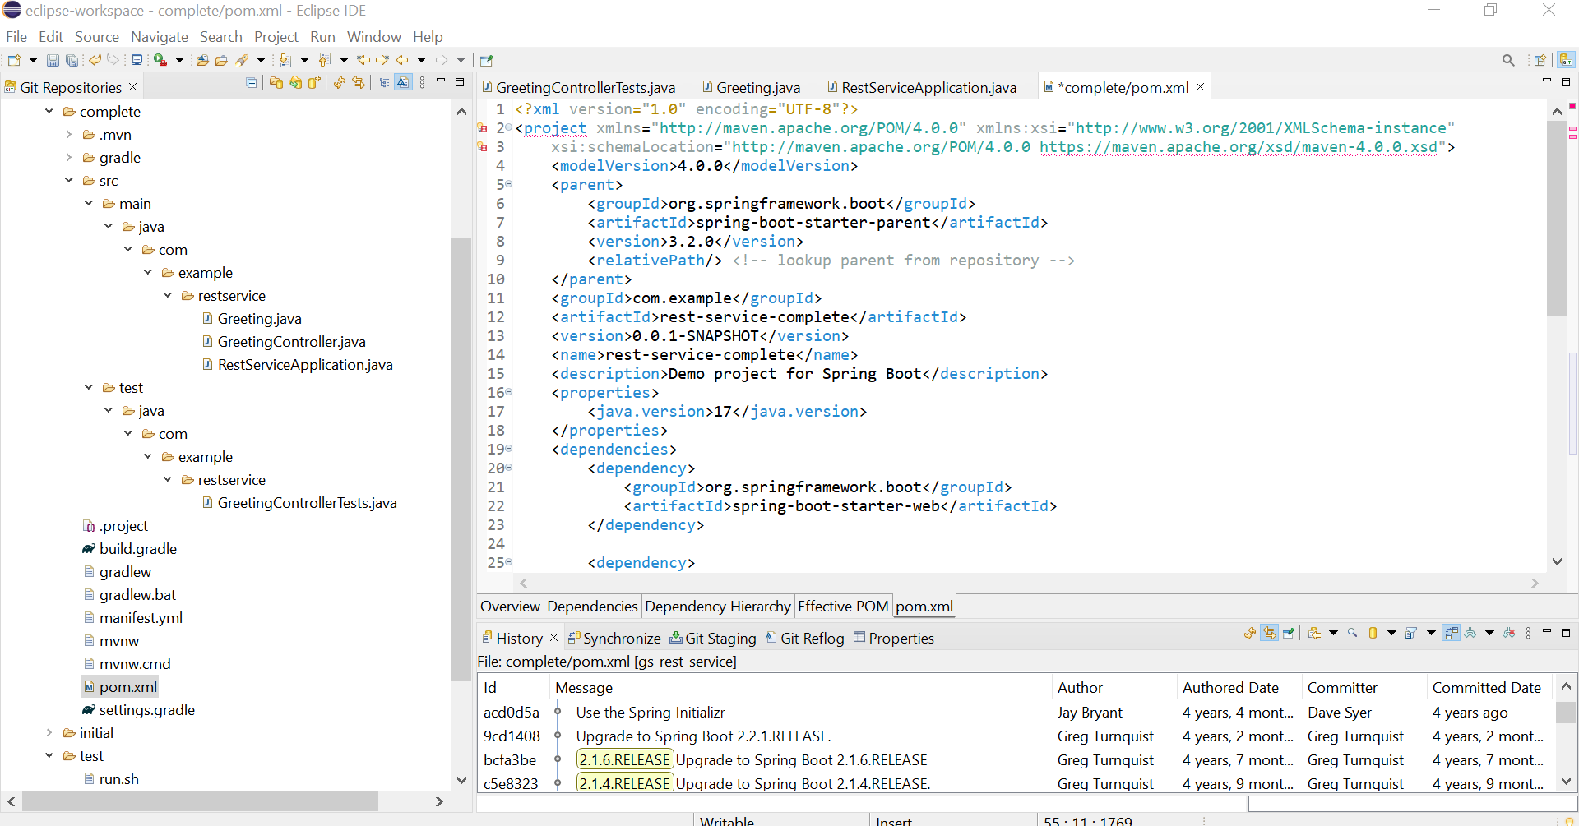

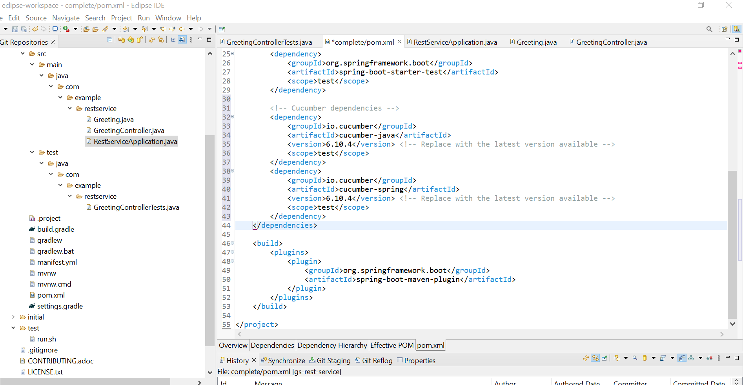

Step 3: Write Cucumber Test Scenarios

1. Create feature files in the `src/test/resources` directory.

2. Write test scenarios in Gherkin language that describe the expected behavior of the

application.

Step 4: Implement Step Definitions

1. Create step definition classes in the `src/test/java` directory.

2. Implement the steps for each scenario written in the feature files.

Step 5: Configure Cucumber Options

1. Configure Cucumber options in a runner class or using a `cucumber.properties` file to

specify features, glue, plugins, etc.

