INTERNET OF THINGS LAB
Exam Experiment Sets – CSA 3005

Experiments Covered
Set | Experiment | Manual Ref.
Set 1 | Interactive Traffic Control System (Push Button) | Experiment 6
Set 1 | Raspberry Pi – Blinking LED | Experiment 15
Set 1 | Blinking of Odd and Even LEDs (with LED scrolling) | Experiment 4
Set 2 | Fading of LED (Brightness) – with Potentiometer | Experiment 7
Set 2 | Fading of LED (Brightness) – without Potentiometer | Experiment 8
Set 2 | IR Sensor with Arduino | Section 11
Set 2 | Alternate LED Blinking ("Alternative bulb") | Experiment 3

SET 1

Experiment 6: Arduino Program to Implement Interactive Traffic System Using Push Button

Aim of the Experiment
To implement a traffic control system using Arduino.

Components Required
- Arduino Uno R3 board
- Power cable (1)
- Breadboard (1)
- LEDs (5): 2 Red, 1 Yellow, 2 Green
- 200 Ω Resistor (6)
- Jumper Wires
- Tactile Switch (Push button)

Circuit Diagram
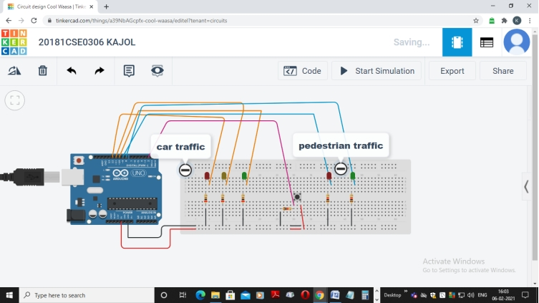

Program / Arduino Sketch
int carRed = 12;
int carYellow = 11;
int carGreen = 10;
int pedRed = 9;
int pedGreen = 8;
int button = 2;
int crossTime = 5000;
unsigned long changeTime;
void setup()
{
pinMode(carRed, OUTPUT);
pinMode(carYellow, OUTPUT);
pinMode(carGreen, OUTPUT);
pinMode(pedRed, OUTPUT);
pinMode(pedGreen, OUTPUT);
pinMode(button, INPUT);
digitalWrite(carGreen, HIGH);
digitalWrite(pedRed, HIGH);
}
void loop()
{
int state = digitalRead(button);
if (state == HIGH && (millis() - changeTime) > 5000)
{
changeLights();
}
}
void changeLights()
{
digitalWrite(carGreen, LOW);
digitalWrite(carYellow, HIGH);
delay(2000);
digitalWrite(carYellow, LOW);
digitalWrite(carRed, HIGH);
delay(1000);
digitalWrite(pedRed, LOW);
digitalWrite(pedGreen, HIGH);
delay(crossTime);
for (int x = 0; x < 10; x++)
{
digitalWrite(pedGreen, HIGH);
delay(250);
digitalWrite(pedGreen, LOW);
delay(250);
}
digitalWrite(pedRed, HIGH);
delay(500);
digitalWrite(carYellow, HIGH);
digitalWrite(carRed, LOW);
delay(1000);
digitalWrite(carGreen, HIGH);
digitalWrite(carYellow, LOW);
changeTime = millis();
}

Output Screenshot
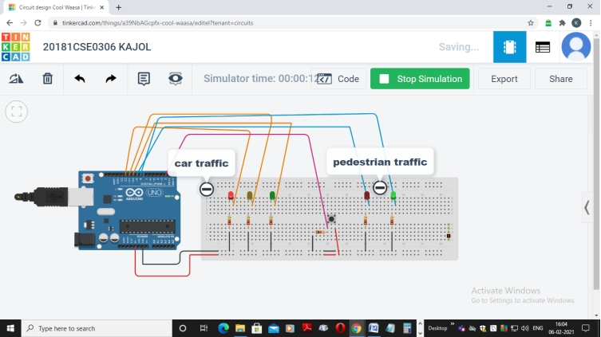

Result / Outcome
The traffic control system was implemented successfully using Arduino Uno.

Experiment 15: Raspberry pi program to implement blinking LED
Sl no. | Equipment’s Needed
1 | Raspberry Pi
2 | VGA cable
3 | Power Cable
4 | Jumper Cables

Step 1: | Understanding of Raspberry pi Pin out diagram and Bread board connections
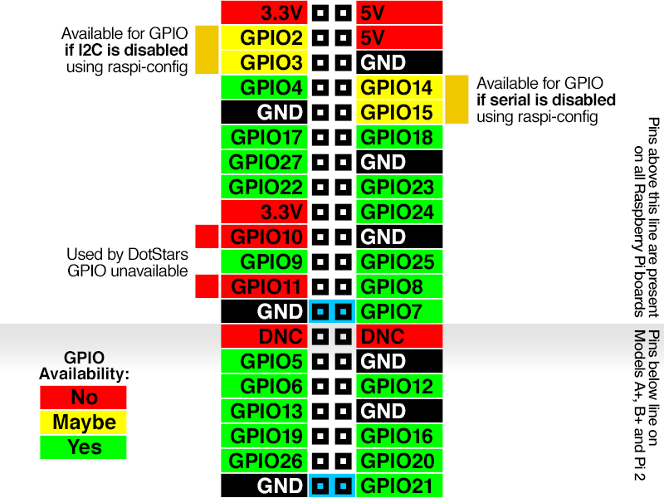
Raspberry Pi tutorials

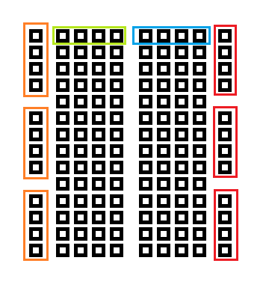
Raspberry Pi tutorials
Step 2: | Make the connections as follows
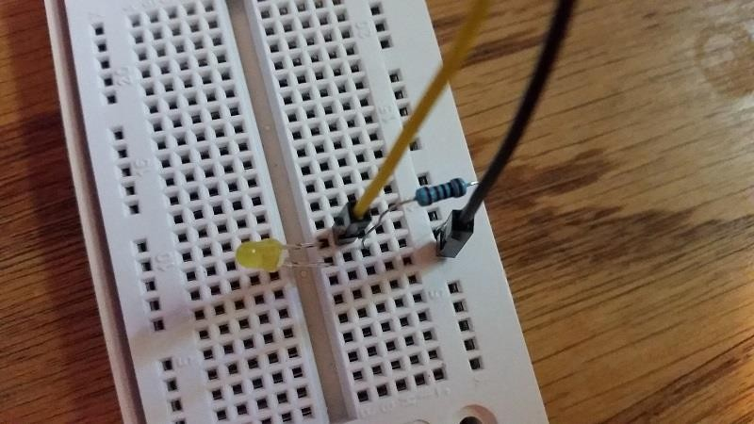
Raspberry Pi tutorials

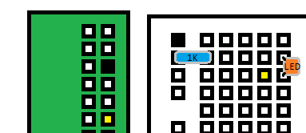
Raspberry Pi tutorials
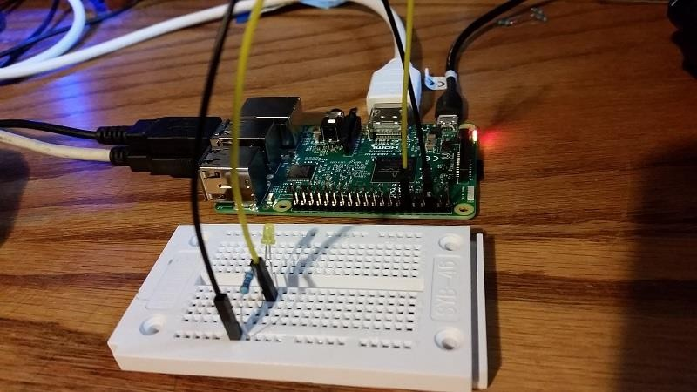
Raspberry Pi tutorials
Step 3: | Write the python program to implement blinking LED
import RPi.GPIO as GPIO import time
GPIO.setmode(GPIO.BCM)
GPIO.setup(18, GPIO.OUT)
GPIO.output(18, GPIO.HIGH)
time.sleep(3)
GPIO.output(18, GPIO.LOW)
GPIO.cleanup()

Experiment 4: Arduino Program to Implement Blinking of Odd and Even LEDs, Scrolling of LEDs

Aim of the Experiment
To blink odd and even LEDs on Arduino Uno and to verify the result on Arduino IDE.

Components Required
- Arduino Uno R3
- 8 LEDs
- 8 × 1 kΩ Resistor
- Small Breadboard
- Jumper Wires

Circuit Diagram
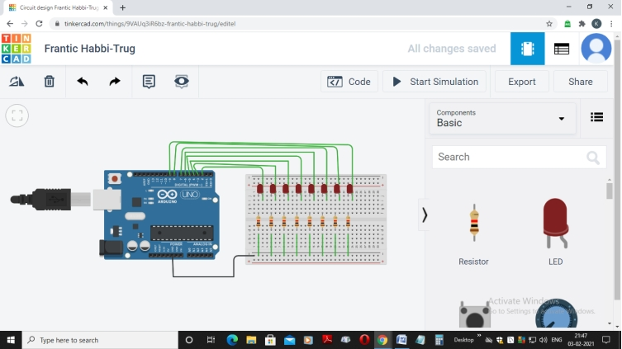

Program / Arduino Sketch
int i;
void setup()
{
for (i = 2; i <= 9; i++)
pinMode(i, OUTPUT);
}
void loop()
{
digitalWrite(2, HIGH);
digitalWrite(4, HIGH);
digitalWrite(6, HIGH);
digitalWrite(8, HIGH);
delay(1000);
digitalWrite(2, LOW);
digitalWrite(4, LOW);
digitalWrite(6, LOW);
digitalWrite(8, LOW);
digitalWrite(3, HIGH);
digitalWrite(5, HIGH);
digitalWrite(7, HIGH);
digitalWrite(9, HIGH);
delay(1000);
digitalWrite(3, LOW);
digitalWrite(5, LOW);
digitalWrite(7, LOW);
digitalWrite(9, LOW);
// LED Scrolling
for (i = 2; i <= 9; i++)
{
digitalWrite(i, HIGH);
delay(200);
digitalWrite(i, LOW);
}
}

Result / Outcome
The odd and even LEDs blinked successfully, followed by a scrolling LED pattern.

SET 2

Experiment 7: Adjusting LED Brightness (Fading) Using a Potentiometer

Aim of the Experiment
To adjust the brightness (fading) of an LED using a potentiometer.

Components Required
- Arduino Uno
- LED
- Potentiometer (knob)
- Resistor
- TinkerCAD simulator

Circuit Diagram
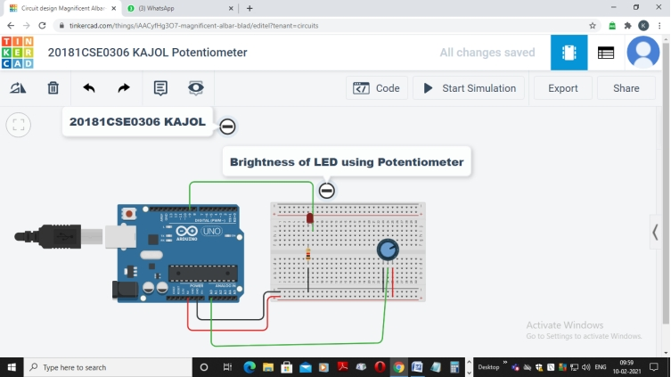

Program / Arduino Sketch
const int analogInput = A0;
const int analogOutput = 9;
int sensorValue = 0; // wiper-read voltage from potentiometer
int outputValue = 0; // value output to the PWM (analog output)
void setup()
{
Serial.begin(9600);
}
void loop()
{
sensorValue = analogRead(analogInput);
outputValue = map(sensorValue, 0, 1023, 0, 255);
analogWrite(analogOutput, outputValue);
Serial.print("Sensor=");
Serial.print(sensorValue);
Serial.print("\t Output=");
Serial.println(outputValue);
}

Output Screenshot
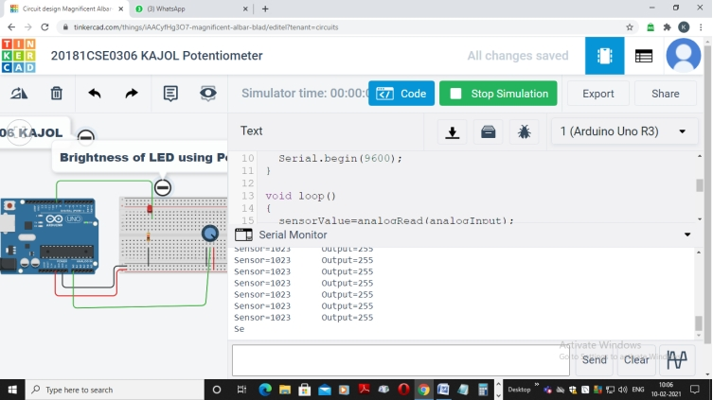

Result / Outcome
The brightness of the LED was adjusted successfully using the potentiometer.

Experiment 8: Adjusting LED Brightness (Fading) Without Using a Potentiometer

Aim of the Experiment
To adjust the brightness (fading) of an LED without using a potentiometer.

Components Required
- Arduino Uno
- LED
- Resistor
- TinkerCAD simulator

Circuit Diagram
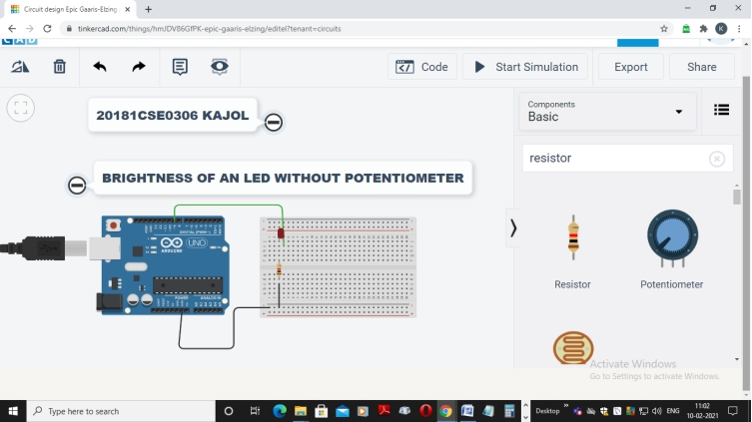

Program / Arduino Sketch
const int analogOutput = 9;
int sensorValue = 0;
int outputValue = 0;
void setup()
{
Serial.begin(9600);
}
void loop()
{
for (int i = 0; i <= 1023; i++)
{
sensorValue = analogRead(i);
outputValue = map(sensorValue, 0, 1023, 0, 255);
analogWrite(analogOutput, outputValue);
Serial.print("Sensor=");
Serial.print(sensorValue);
Serial.print("\t Output=");
Serial.println(outputValue);
}
for (int i = 1023; i >= 0; i--)
{
sensorValue = analogRead(i);
outputValue = map(sensorValue, 0, 1023, 0, 255);
analogWrite(analogOutput, outputValue);
Serial.print("Sensor=");
Serial.print(sensorValue);
Serial.print("\t Output=");
Serial.println(outputValue);
}
}

Output Screenshot
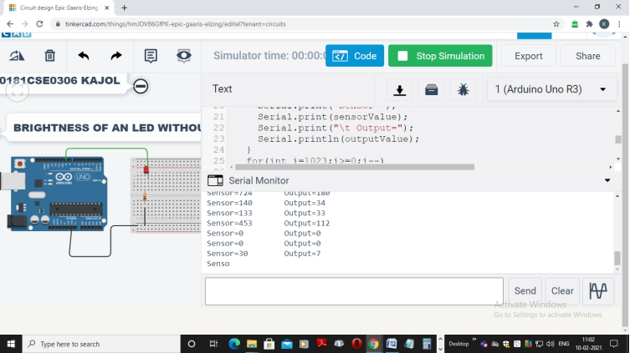

Result / Outcome
The brightness of the LED was adjusted successfully without using a potentiometer.

IR Sensor with Arduino
11. IR SENSOR MODULE
What is an infrared sensor ?
An infrared sensor is an electronic device, that emits in order to sense some aspects of the surroundings. An IR sensor can measure the heat of an object as well as detects the motion.These types of sensors measures only infrared radiation, rather than emitting it that is called as a passive IR sensor.
Can an IR sensor detect humans?
The Passive Infrared (PIR) sensor is used to detect the presence of human The Grid-EYE sensor detects the
human using the infrared radiation radiated by the human body. Every human radiates the infrared energy of specific wavelength range. The absorbed incident radiation changes the temperature of a material.IR sensors? 2.8V at 15cm to 0.4V at 150cm with a supply voltage between 4.5 and 5.5 VDC.
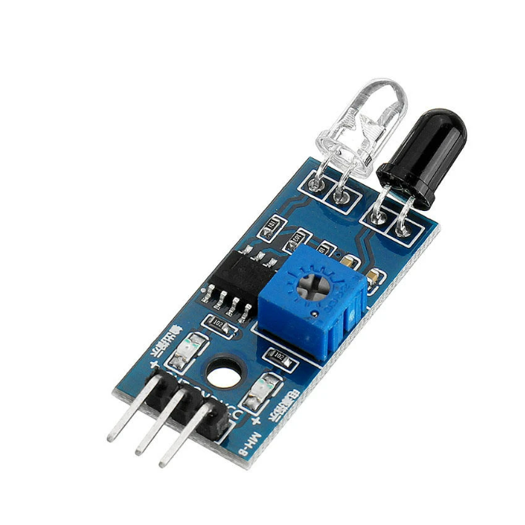
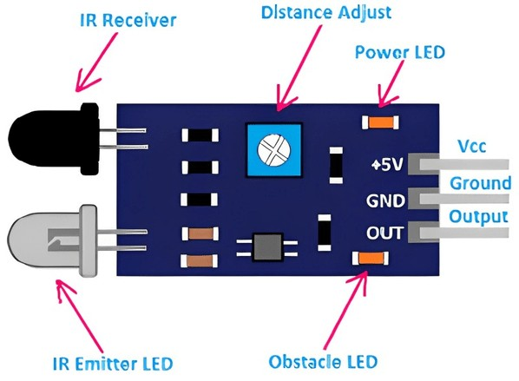
How to use IR Sensor Module with Arduino - Simple Guide
Components Required
- Arduino Uno
- IR sensor
- LED
- Arduio cable
- Jumper wire
IR Sensor Module
The connections for the IR sensor with the Arduino are as follows:
Connect the negative wire on the IR sensor to GND on the Arduino. Connect the middle of the IR sensor which is the VCC to 5V on the Arduino. Connect the signal pin on the IR sensor to pin 8 on the Arduino.
void setup() {
// put your setup code here, to run once: pinMode(8,INPUT);
pinMode(12,OUTPUT);//LED
}
void loop() {
// put your main code here, to run repeatedly: if(digitalRead(8)==LOW){
digitalWrite(12,HIGH);
}
Note: the loop above is incomplete in the manual. Complete it with: else { digitalWrite(12, LOW); } so the LED turns off when no obstacle is detected.

Experiment 3: Arduino Program to Implement Blinking of Alternate LEDs

Aim of the Experiment
To blink two LEDs on Arduino Uno alternately and to verify the result on Arduino IDE.

Components Required
- Arduino Uno R3
- 2 LEDs
- 2 × 1 kΩ Resistor
- Small Breadboard
- Jumper Wires

Circuit Diagram
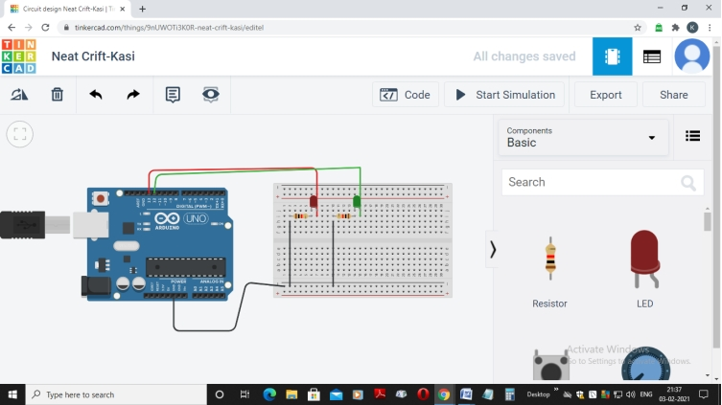

Program / Arduino Sketch
int led1 = 13;
int led2 = 12;
void setup()
{
pinMode(13, OUTPUT);
Serial.begin(9600);
}
void loop()
{
digitalWrite(led1, HIGH);
Serial.println("LED1 is On");
delay(1000); // Wait for 1000 millisecond(s)
digitalWrite(led2, LOW);
Serial.println("LED2 is Off");
digitalWrite(led2, HIGH);
Serial.println("LED2 is On");
delay(1000);
digitalWrite(led1, LOW);
Serial.println("LED1 is Off");
delay(1000); // Wait for 1000 millisecond(s)
}

Output Screenshot
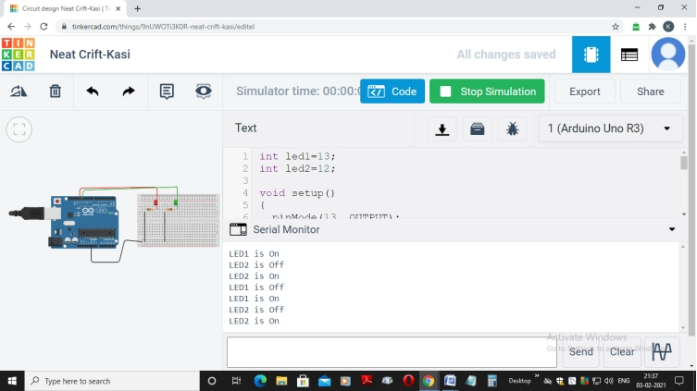

Result / Outcome
The two LEDs were successfully blinked alternately every one second.

