CodeForge AI
AI-Powered Collaborative Coding Platform

Project Progress Report & System Demonstration

Project title | CodeForge AI
Team member(s) | Abhyudai Tiwari(2024bcs0140)  Himmat (2024bcs0040)  Kaushal Wagh(2024bcs0208)  Sawan Kumar(2024bcs0164)
Repository | github.com/Abhyudai-ajax/Codeforge-AI
Report date | September 8, 2026

1. Project Overview
CodeForge AI is a LeetCode/Replit/GitHub-Copilot-style platform for practicing data-structures-and-algorithms problems: a Monaco-based in-browser editor, a judged run/submit workflow across five languages, AI-assisted hints and code review, real-time collaborative rooms, contests, a leaderboard, mock interviews, and DSA roadmaps. The stack is a Next.js 14 frontend and a FastAPI (Python) backend backed by PostgreSQL, Redis and Celery in production.
This report demonstrates the current working system, summarizes what is complete versus outstanding, and documents the changes and issues encountered while getting the project running end-to-end locally.

2. Demonstration

2.1 Working version & navigation
The application runs locally with a FastAPI backend on http://localhost:8000 and a Next.js frontend on http://localhost:3000. Screenshots below were captured directly from the running application (not mockups).
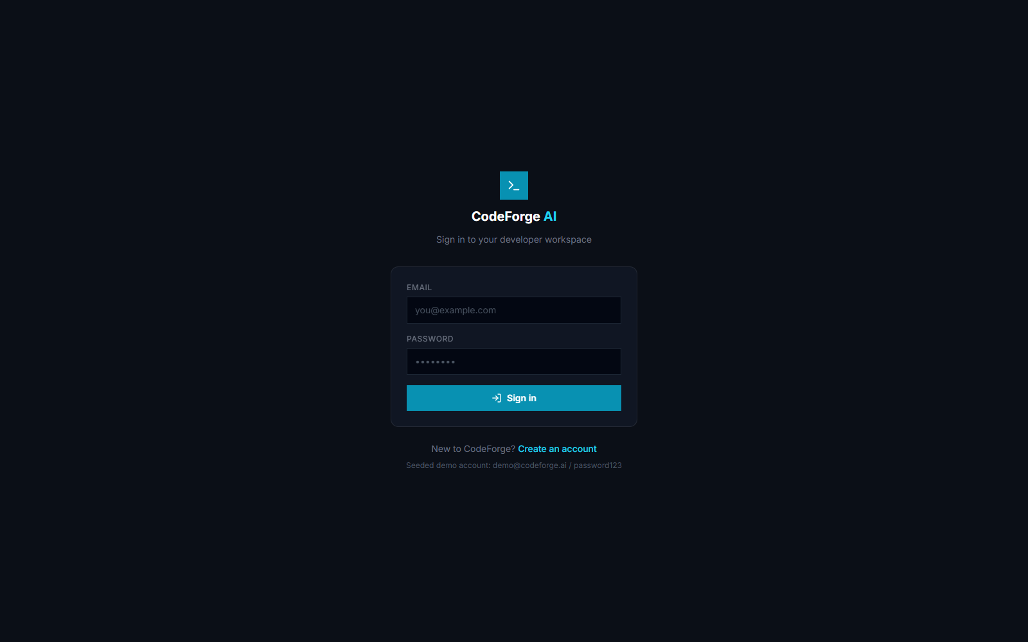
Login screen — JWT-based authentication.

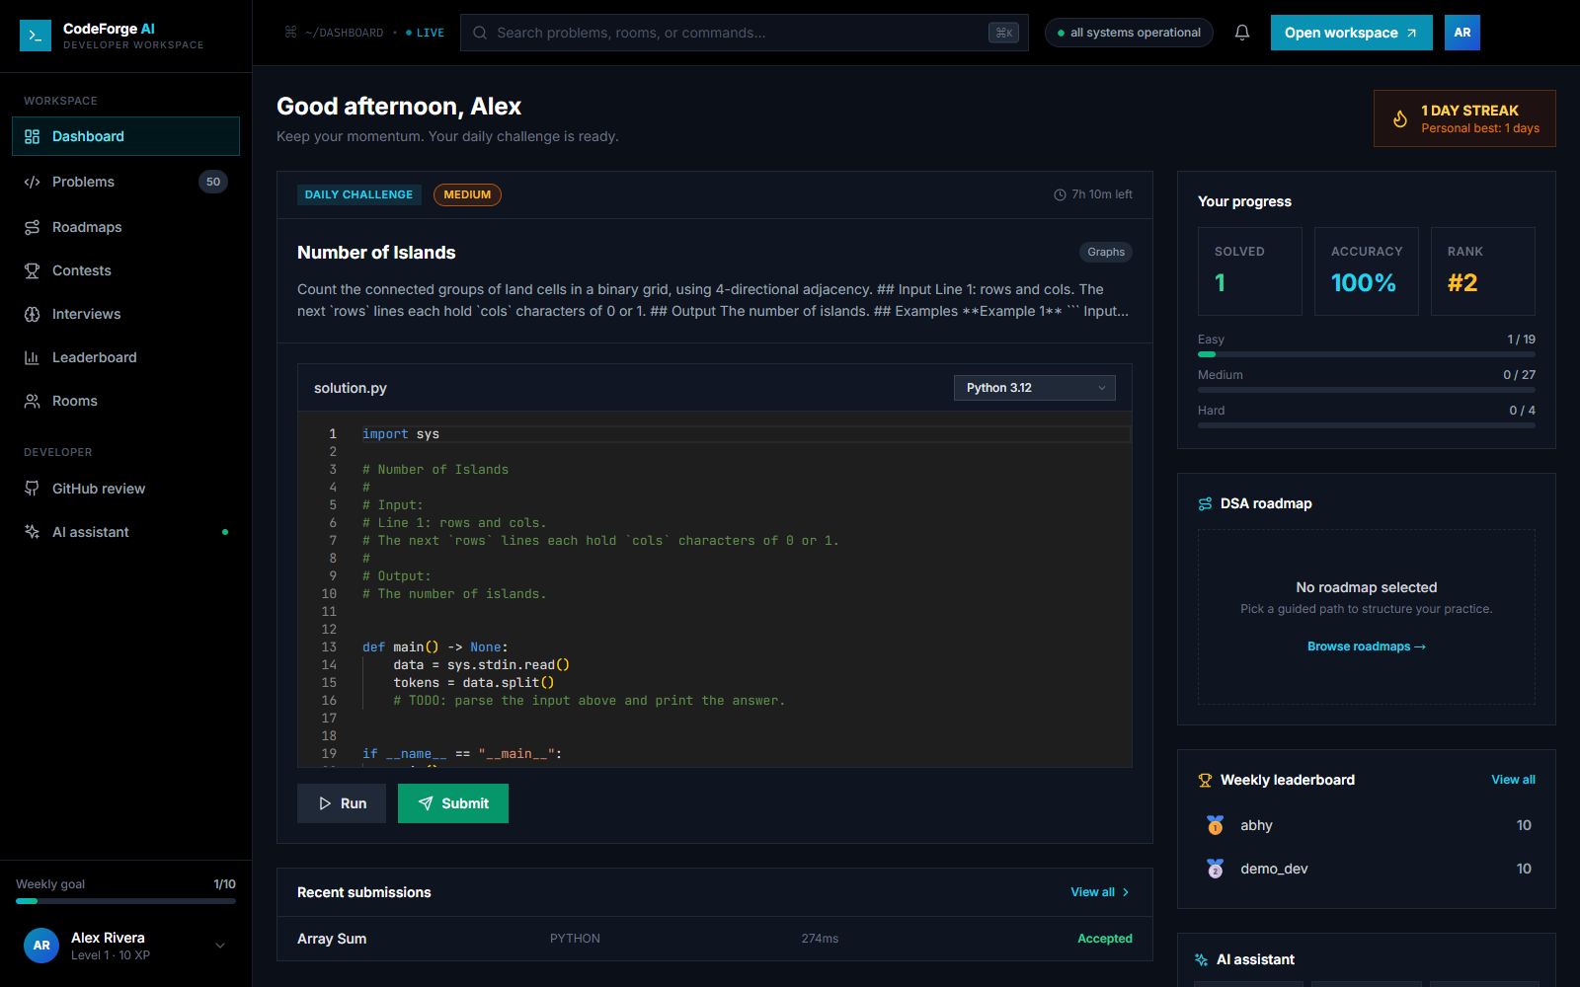
Dashboard — daily challenge, per-user progress (solved/accuracy/rank), weekly leaderboard preview and recent submissions, all backed by live data.

2.2 Problems module
50 curated DSA problems across 19 topics and three difficulty levels, seeded into the database and served through the Problems API with search and difficulty filtering.
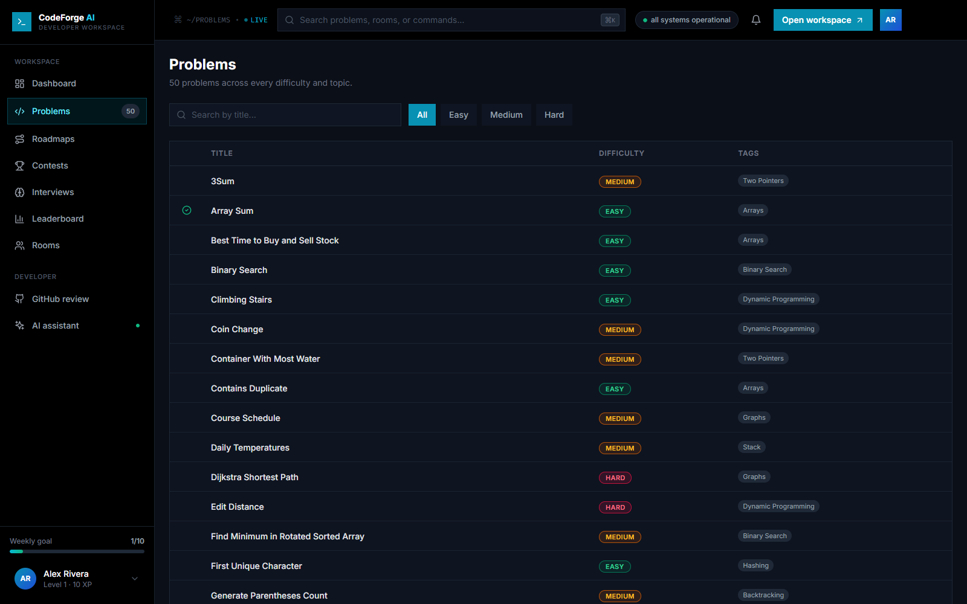
Problems list — 50 seeded problems, filterable by difficulty.

2.3 Code execution (Run / Submit)
Run executes the solution against the problem's public sample cases; Submit judges it against the full hidden test suite and records a graded submission. Both are backed by the same sandboxed execution engine, supporting Python, C, C++, JavaScript and Java. 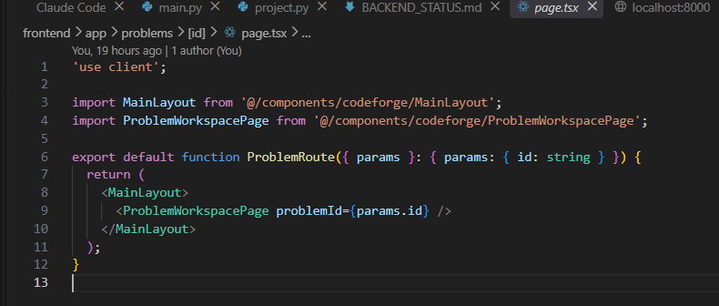

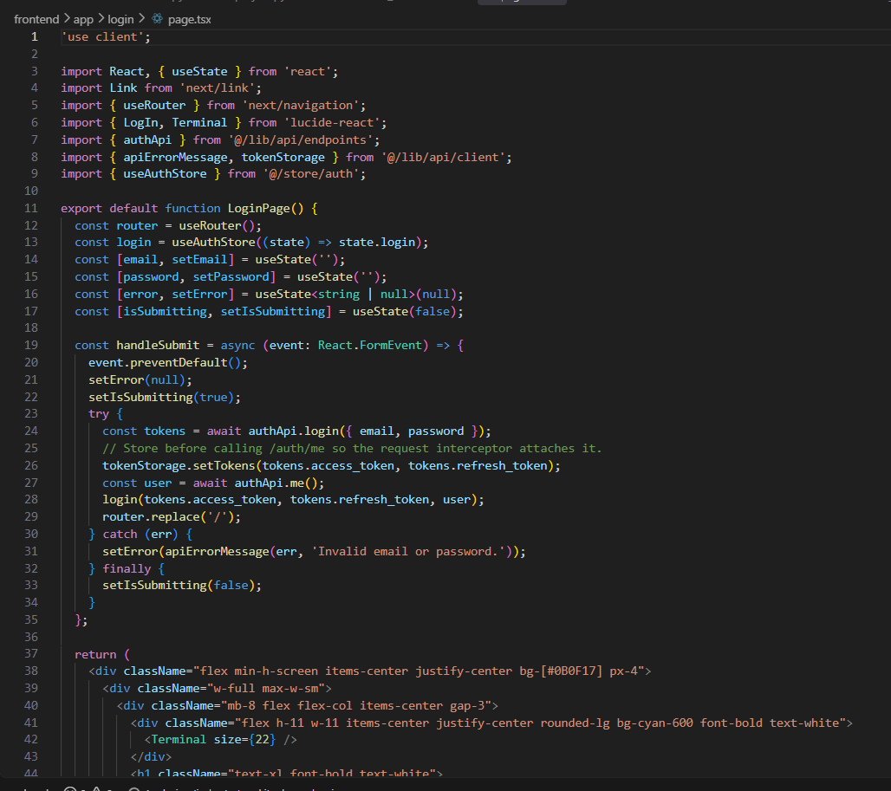

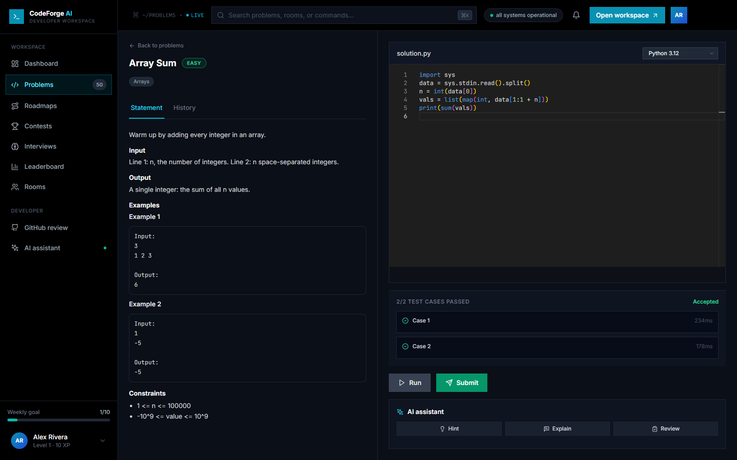
A correct Python solution to ‘Array Sum’ run against both sample cases — 2/2 passed, Accepted.

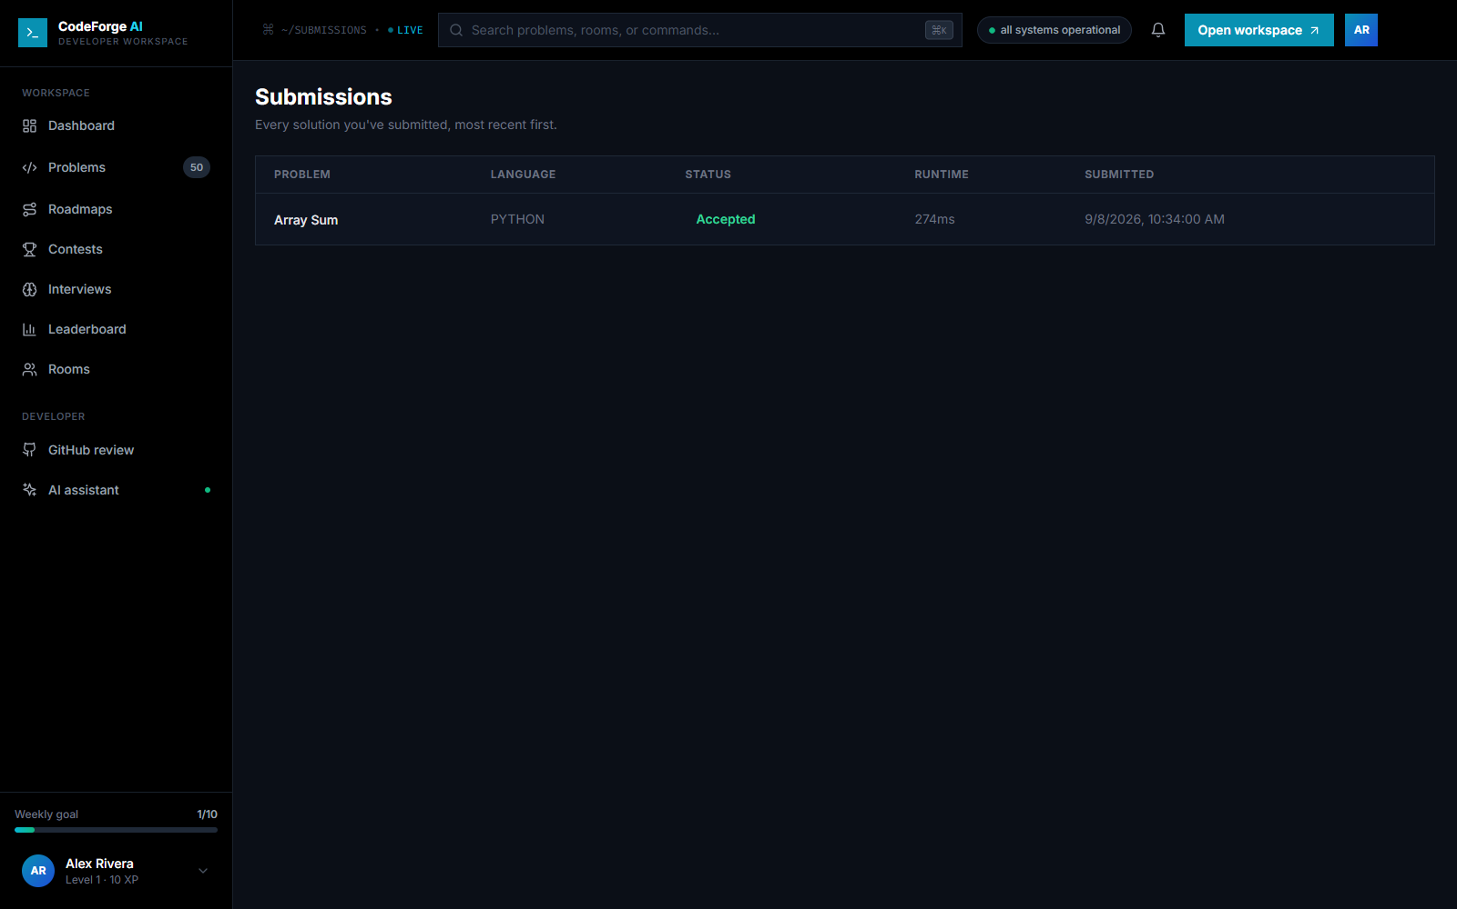
Submission history — the graded result of the Submit above, persisted and queryable per user.

2.4 Collaboration, growth & assessment modules
Additional modules wired end-to-end through both the UI and the backend API:
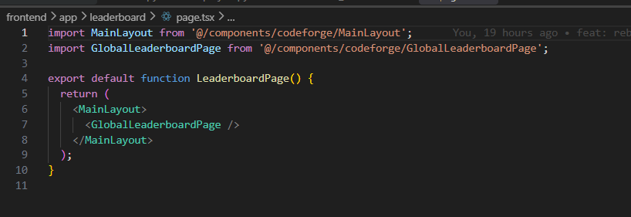
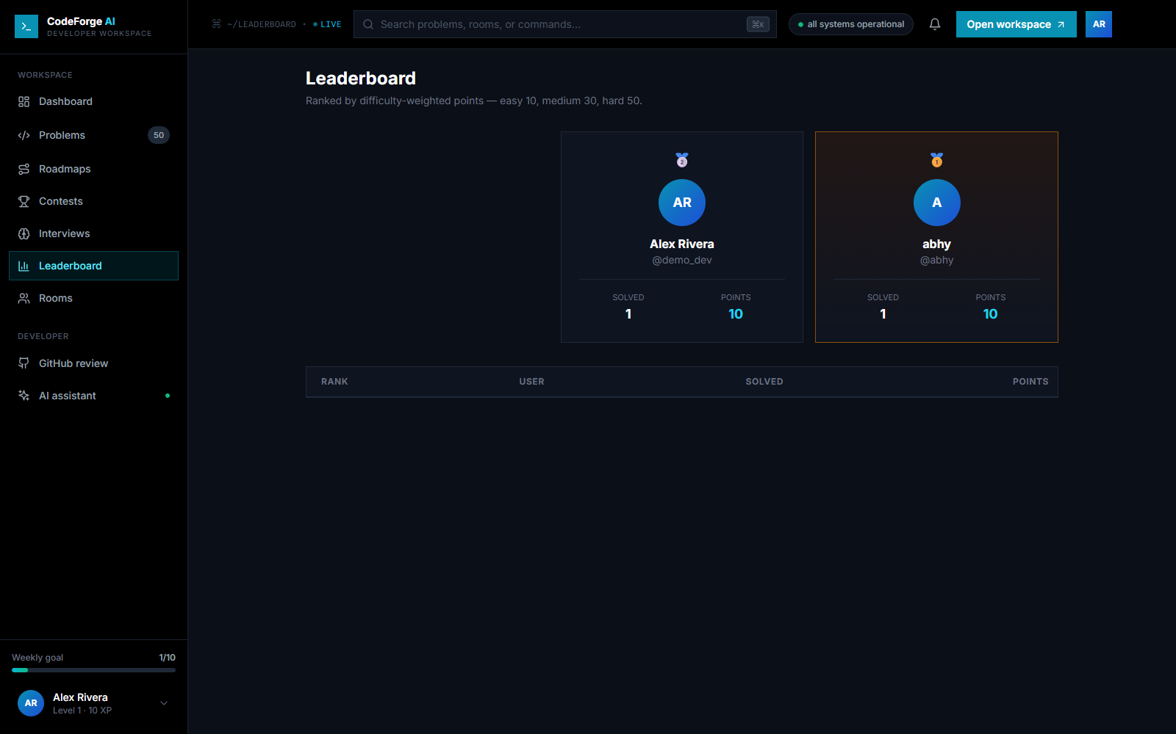
Leaderboard — live, difficulty-weighted ranking.

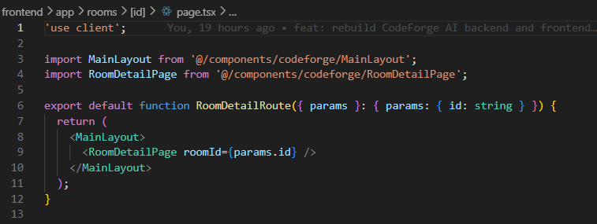
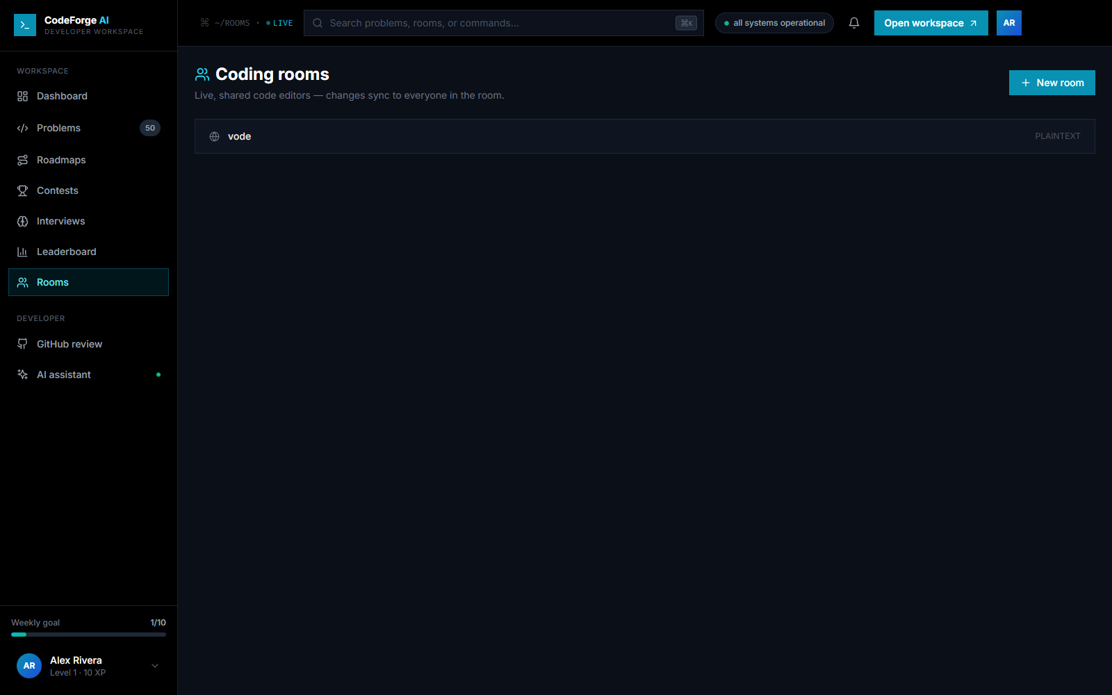
Coding rooms — real-time shared editors over WebSockets.
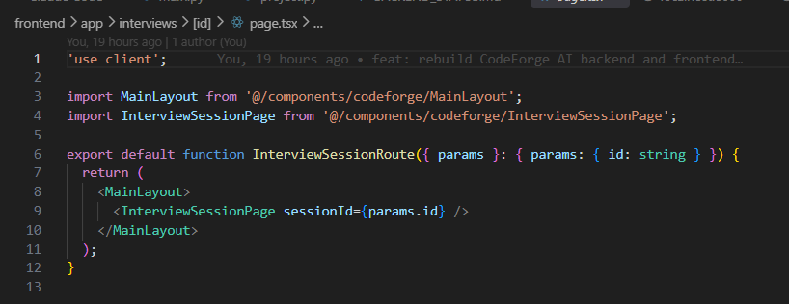
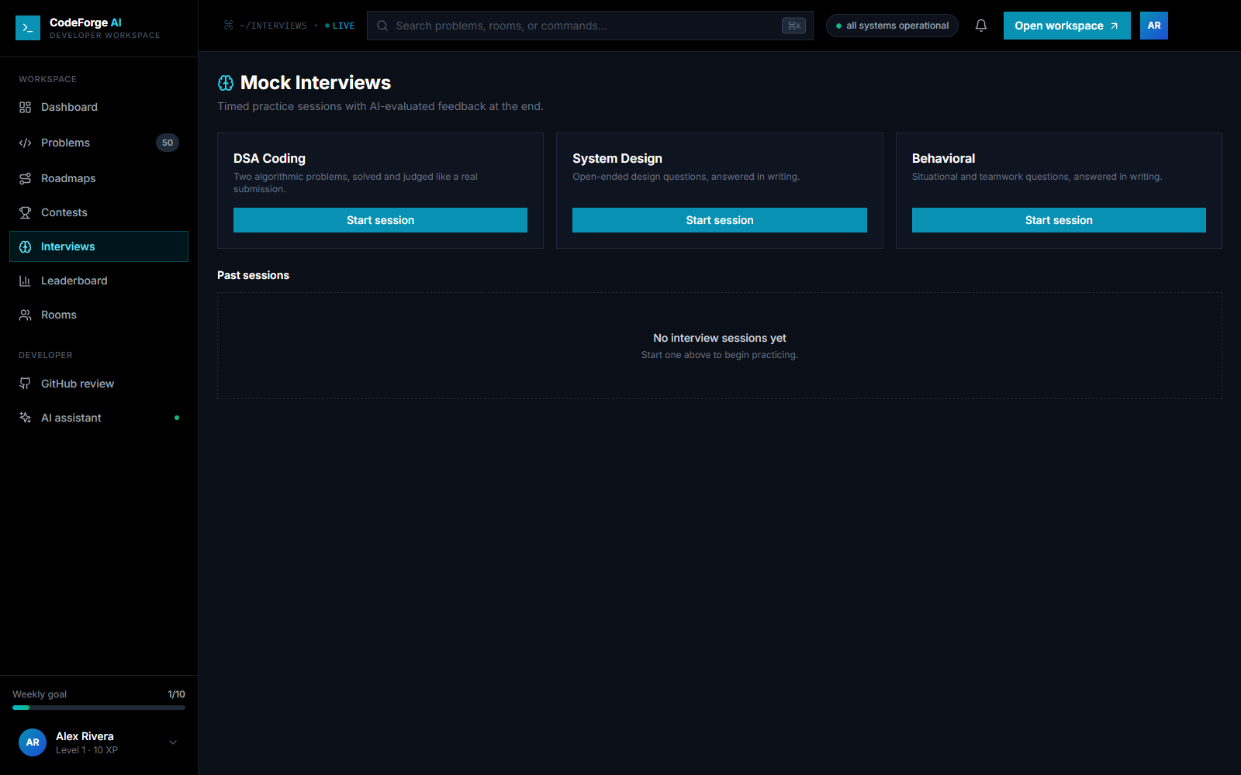
Mock interviews — DSA / System Design / Behavioral session types.

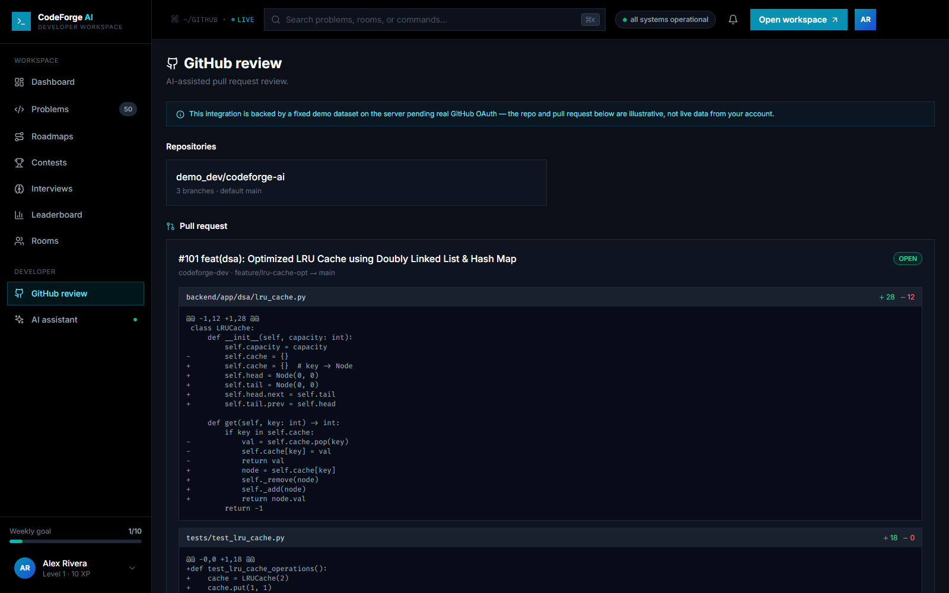
AI-assisted GitHub PR review UI, currently served from a fixed demo dataset on the backend pending real GitHub OAuth (see Section 4).

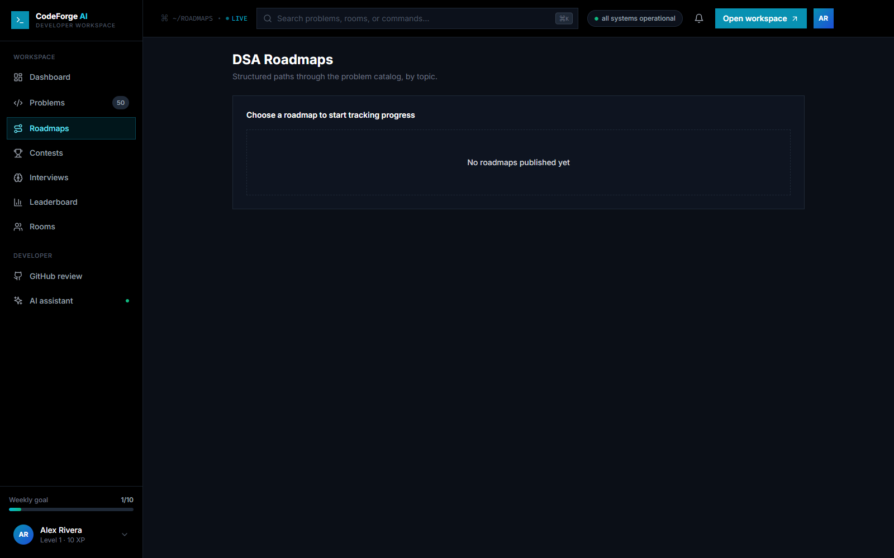
DSA roadmaps — UI and API are implemented; no roadmap records have been seeded yet, so the list is empty (see Section 4).
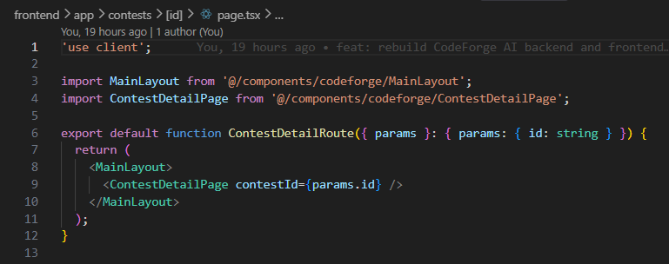
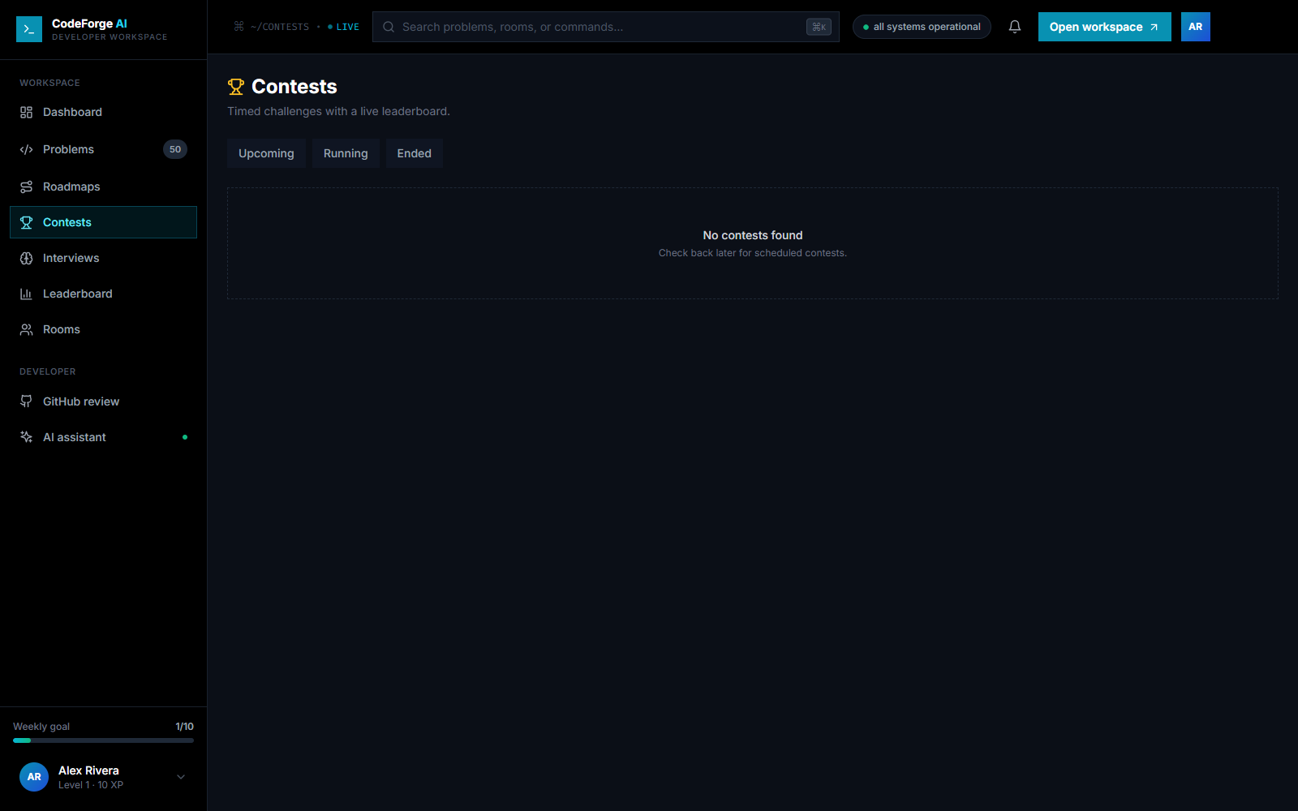
Contests — UI and API are implemented; no contest records have been seeded yet, so the list is empty (see Section 4).

2.5 Backend & database
The backend exposes 19 versioned route modules under /api/v1 (auth, users, problems, submissions, executions, coding_rooms, contests, roadmaps, interviews, notifications, leaderboard, languages, github, ai, projects, admin, health) backed by 10 SQLAlchemy model modules and 9 Alembic migrations. Interactive API docs are served at /api/docs in development.
Locally the database runs on SQLite (see Section 3); in production it targets PostgreSQL through the same async SQLAlchemy layer, with Alembic managing schema migrations.
301 of the 323 automated backend tests pass in this local configuration (pytest, SQLite in-memory test database). The remaining 22 failures / 5 errors are all in test_runner_images.py and test_sandbox_invocation.py, which assert the Docker-specific ‘docker run ...’ invocation directly — see Section 5.

3. Functionality Status

3.1 Completed
- User registration, JWT login/refresh, and role-based access.
- 50-problem DSA catalog (seeded), search and difficulty filtering.
- Monaco-based problem workspace with per-language starter templates.
- Run (sample tests) and Submit (full judge) across Python, C, C++, JavaScript, Java.
- Submission history and per-user progress/accuracy/rank tracking.
- Live, difficulty-weighted leaderboard.
- Real-time collaborative coding rooms over WebSockets.
- AI assistant: hint / explain / review actions, with a graceful fallback response when no LLM provider is configured.
- Mock interview sessions (DSA, System Design, Behavioral).
- In-app notifications (unread count).
- CI pipeline: frontend lint/build, backend lint/type-check/tests against a real PostgreSQL + Redis service in GitHub Actions.

3.2 Partially completed
Item | Status | Notes
GitHub PR review | UI + backend wired | Backend returns a fixed demo repo/PR dataset; real GitHub OAuth and live API calls are not yet implemented.
AI provider integration | Functional with fallback | OpenAI/Ollama providers are implemented, but no API key is configured in this environment, so responses come from the built-in fallback generator rather than a real model call.
Roadmaps & Contests | API + UI implemented, unseeded | Endpoints and pages work; no roadmap or contest records exist yet in the seed data, so both list views are currently empty.
Sandboxed code execution | Working, not isolated locally | Production design runs submissions in a Docker container with no network, read-only FS, and resource limits. Verified in this environment through a local (non-Docker) fallback that runs code directly via the host toolchains — functionally correct but without that isolation (see Section 4).
Docker-runner test suite | 22 failing / 5 erroring | test_runner_images.py and test_sandbox_invocation.py assert the Docker-only code path directly and were not updated for the local fallback; they fail/error without Docker installed.

3.3 Pending / not yet implemented
- Real GitHub OAuth and live PR data for the GitHub review module.
- Seed data / admin tooling to populate roadmaps and contests.
- A configured LLM provider (OpenAI or Ollama) for genuine AI-generated hints/explanations/reviews rather than the fallback responder.
- Updating or gating the Docker-runner test suite for environments without Docker.

4. Significant Changes from the Original Design
The project was originally designed around Docker for both local development (docker-compose with PostgreSQL, Redis, the API, and Celery workers) and code execution (a Docker-isolated sandbox container per submission). Docker was not available in the development environment, which drove the following changes:
- Removed docker-compose.yml, the docker/ directory (Dockerfiles for the frontend, backend, and five language runners), the Docker-related CI jobs, and Docker references throughout the README and Makefile.
- Local development now defaults to SQLite (DATABASE_URL) instead of requiring a PostgreSQL server. Because one Alembic migration used PostgreSQL-only DDL (ALTER TYPE ... ADD VALUE), the local schema is created directly from the SQLAlchemy models instead of via the migration chain; PostgreSQL + full migrations remain the production path.
- Celery now runs in-process (CELERY_TASK_ALWAYS_EAGER) for local development, judging submissions synchronously without requiring a Redis broker or a separate worker process. A real broker is still expected in production.
- app/workers/sandbox.py gained a local execution fallback: when the ‘docker’ binary is not found on PATH, it compiles/runs submissions directly via the host's python/node/gcc/g++/javac toolchains instead of inside a container. This keeps Run/Submit functional without Docker, but unlike the Docker path it provides no network, filesystem or memory isolation — it is explicitly for trusted local development only, and logs a warning on startup to make that visible.
No changes were made to the UML/data model or the overall system architecture — these changes are confined to local-development infrastructure and execution isolation, not to the application's design or API contracts.

5. Issues Encountered & Resolutions
Issue | Cause | Resolution
Submissions stuck on ‘Submitting...’ for 1–2 minutes | Celery retried connecting to a Redis broker that wasn't running, ~20 times before giving up. | Enabled CELERY_TASK_ALWAYS_EAGER so tasks run synchronously in-process; no broker needed locally.
asyncio.run() RuntimeError under eager Celery execution | Eager mode runs the task body inside the caller, which for a FastAPI request is already inside a running event loop; asyncio.run() cannot nest. | Added a run_task_coroutine() helper that detects a running loop and, if found, runs the coroutine on a dedicated thread instead.
Run/Submit failed with FileNotFoundError: [WinError 2] | The sandbox executor unconditionally shelled out to ‘docker run’, which isn't installed. | Added a local (non-Docker) execution path per language, auto-selected when Docker isn't found on PATH.
uvicorn --reload crashed with WinError 10013 | A known Windows-specific issue in uvicorn's file-watcher IPC socket used by the --reload supervisor. | Run the backend without --reload locally; restart manually after backend changes.
git pre-commit hook failed: 'eslint' is not recognized | The husky hook ran lint-staged from the repo root, but ESLint and Prettier are installed only under frontend/node_modules (there is no root package.json). | Updated frontend/.husky/pre-commit to cd into frontend/ before invoking lint-staged, matching where its dependencies live.
22 backend tests fail/error without Docker | test_runner_images.py and test_sandbox_invocation.py assert the Docker-only sandbox invocation directly. | Left as a known gap (Section 3.2) — these validate the production Docker path and are expected to fail in a Docker-less environment; not modified in this pass.

6. Progress Report Summary

Functionalities completed
See Section 3.1 for the full list.

Functionalities pending
See Section 3.2 (partial) and 3.3 (not started) for the full list.

Current status
Layer | Status
UI | Next.js 14 app with 12 route groups covering every module (dashboard, problems, rooms, contests, interviews, roadmaps, leaderboard, submissions, GitHub review, AI assistant, settings, auth). All pages render against live backend data except Roadmaps/Contests, which are empty pending seed data.
Backend | FastAPI app with 19 API route modules, 301/323 automated tests passing locally. Runs standalone on uvicorn.
Database | SQLAlchemy async ORM, 10 model modules, 9 Alembic migrations. SQLite locally (schema created from models); PostgreSQL in production via the full migration chain.
Integration | UI → REST API → service layer → database is exercised end-to-end for auth, problems, run/submit, submissions, leaderboard, rooms and interviews, verified live in Section 2.

