Capstone Project: Checkout Experiment and Growth Analytics System

Background

The objective of this project is to serve as a Business Analytics Associate within an e-commerce organization. The company has implemented a revised checkout experience (Variant B) with the strategic goal of mitigating checkout abandonment and enhancing overall revenue.

The leadership team requires a comprehensive, decision-grade analysis to address the following critical inquiries:
- Should the organization proceed with a full-scale deployment of Variant B?
- What are the most significant points of attrition within the conversion funnel, and what corrective measures will yield the most substantial impact?
- Which specific segments (delineated by channel, device, user type, or product category) are the primary drivers of the observed performance?
- What is the projected business impact for the ensuing month, assuming the complete rollout of Variant B?
The project involves utilizing raw datasets encompassing session, event, order, and product information. The required deliverables include constructing a robust analytics layer, executing the detailed analysis, developing a dynamic dashboard, and presenting a final recommendation.

Datasets Provided

(Checkout Experiment & Growth Analytics System)

The requisite dataset is accessible for download via the following secure link: https://drive.google.com/drive/folders/1R4y5SqFLIByL0aNinarPHxURZxvrqXMy?usp=sharing.

Part A — Problem Framing (Business Analytics)

1️. Business Objective

Primary Objective:

The core aim is to assess the impact of the new checkout experience (Variant B), specifically looking for improvements in revenue and conversion rate. This must be achieved without any detrimental effect on profit margin or the overall user experience.

Secondary Objective:
A secondary focus is to pinpoint specific areas within the checkout funnel that lead to drop-offs ("structural funnel leaks") and to uncover performance differences across various user segments. This information will guide more focused optimization efforts.

2. North Star Metric
⭐ The North Star Metric (NSM)

The North Star Metric (NSM) is the single, most crucial measure that accurately reflects the fundamental value your product provides to its users.
This metric earns the name "North Star" because it serves to direct your company's overarching strategy and informs all key decisions, much like the celestial North Star historically guided sailors and explorers.
For an e-commerce checkout experiment, your North Star should be a metric that captures both efficiency and financial value.
- North Star Metric: Revenue per Eligible Session (RPES).

This is the preferred metric because it effectively combines two critical factors: the Conversion Rate (whether a purchase occurred) and the Average Order Value (the amount spent). By using RPES, we mitigate the risk of inadvertently selecting a variant that boosts the number of orders but ultimately diminishes total revenue.

3. Supporting KPIs
To explain why the North Star moves, we track 6–10 supporting KPIs:
The following Key Performance Indicators (KPIs) are essential for evaluating the e-commerce checkout process:
Conversion and Efficiency:
- Conversion Rate: The percentage of sessions that are eligible for purchase and successfully result in an order.
- Checkout-to-Purchase Conversion: Measures the efficiency specifically during the final stages of the transaction.
- Funnel Step Conversions: Tracks drop-off rates at critical points: "Add to Cart," "Begin Checkout," and "Payment Attempt."
- Payment Failure Rate: The percentage of attempted payments that do not complete the purchase, often signaling technical friction.
Value and Speed:
- Average Order Value (AOV): The average gross amount for each completed order.
- Average Session Duration: Used to gauge whether the new checkout flow is faster or introduces confusion.
Financial Proxy:
- Margin Proxy: Calculated as net revenue minus the cost of goods, leveraging data from products.json.

4️. Scope & Eligibility
From metadata:
Variant assigned only to eligible sessions.
Defining who counts in your analysis is the difference between a "good" and "bad" analyst.
- Eligible Sessions: We should only include sessions where a user actually entered the checkout funnel.
- Eligible sessions =
a). Web sessions
b). Logged-in users
c). Marked eligible flag
d). Exclude duplicate sessions

- Justification: If a user only browsed the homepage and left, they never saw Variant B. Including them in the A/B comparison would "dilute" the data and make it harder to see the real impact of the new design.
Including non-eligible sessions would bias the experiment because they were never exposed to the variant.
This ensures:
- Fair comparison
- Internal validity
- Correct lift estimation

5️. Stakeholder Questions
- Does Variant B significantly improve conversion rate?
- Does Variant B increase revenue per eligible session?
- Are gains driven by higher AOV or higher conversion?
- Does Variant B affect margin negatively via higher discounts?
- Which segments benefit most from Variant B?
- Are there funnel steps where Variant B underperforms?
- What is expected incremental revenue next month if rolled out?

6️. Analytical Plan
To answer the above:
We will:
- Build cleaned session-level fact table
- Reconstruct funnel from events
- Enrich orders with product cost and rating
- Conduct A/B significance testing
- Perform heterogeneous treatment analysis
- Project 30-day impact under multiple scenarios

Part B — Data Architecture & ETL Summary

Data Quality Issues Found & Fixed
Dataset | Issue Found | Fix Applied
sessions.csv | Duplicate rows (36 duplicates found) | drop_duplicates() on session_id
sessions.csv | Missing device values (NaN) | Filled with 'unknown'
sessions.csv | Inconsistent channel casing (Organic, ORGANIC, organic) | str.lower().strip() normalisation
orders.csv | Missing user_id on 2 orders | Back-filled from session → user mapping
orders.csv | Revenue outliers (> p99 threshold) | Flagged + capped + log-transformed
events.csv | Minor duplicate events | drop_duplicates() applied

Curated Output Datasets
• fact_sessions.csv — 9,000 rows, 1 row per session. Includes funnel flags, time-to-step fields, and revenue attribution.
• fact_orders.csv — 707 rows, 1 row per order. Enriched with basket summary, top category, avg rating, and margin proxy from products.json.
• dim_users_enriched.csv — 2,200 rows, 1 row per user. Includes lifetime sessions, orders, repeat flag, and user value band (low/medium/high).

Part C — Analytics (Insights & KPIs)

1. Experiment Population
To evaluate the checkout experiment, the analysis focuses on sessions that were exposed to the A/B test environment. Specifically, the population was restricted to web sessions with a valid experiment variant assignment. This filtering ensures that the experiment evaluation remains unbiased and avoids contamination from sessions that were not part of the experimental treatment.
The curated dataset therefore includes only sessions where users interacted with the website through the web interface and were assigned to one of the experiment variants (Control, Variant A, or Variant B).
This filtered population resulted in 4,868 eligible sessions, which form the basis of the subsequent funnel and behavioral analysis.

2. Funnel Diagnosis and Root Cause Analysis
A checkout funnel analysis was performed to understand the conversion journey and identify the largest points of user drop-off.
The funnel stages considered were:
- Product View
- Add to Cart
- Begin Checkout
- Payment Attempt
- Purchase

The overall funnel results are summarized below.
Funnel Step | Sessions
Eligible Sessions | 4868
Product View | 3049
Add to Cart | 924
Begin Checkout | 633
Payment Attempt | 633
Purchase | 453
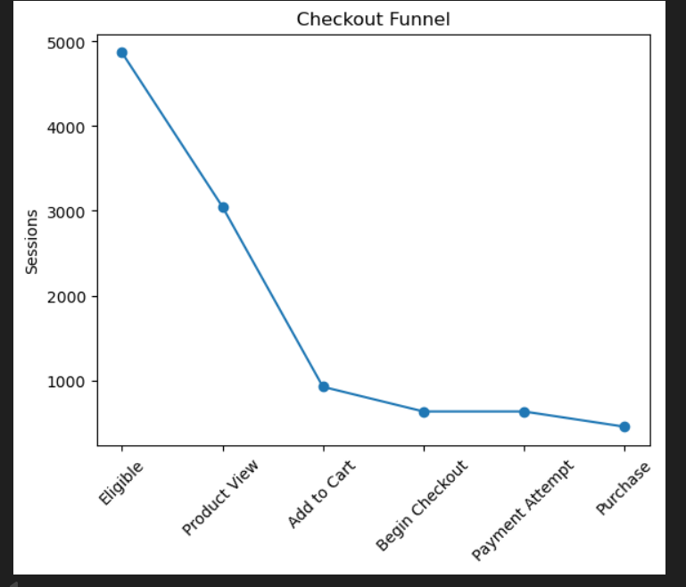
The most significant drop-off occurs between Product View and Add to Cart, where approximately 69–70% of users exit the funnel.
This indicates that the largest friction point occurs before users initiate the checkout process, suggesting issues related to product engagement rather than checkout mechanics.
Possible reasons for this drop-off include:
- weak product value perception
- price sensitivity
- insufficient product information
- lack of urgency signals

3. Time-to-Step Analysis
To diagnose whether users are experiencing delays or technical friction in the purchase journey, time-to-step metrics were analyzed.
The median time required to reach the Add to Cart step was compared between users who ultimately converted and those who did not.

User Type | Median Time to Cart
Non-converters | ~189 seconds
Converters | ~188 seconds
The results show no meaningful difference in the time taken to reach the cart stage between converters and non-converters.
This suggests that the observed funnel drop-off is not caused by technical friction or page loading issues, but rather by behavioral factors such as purchase hesitation, product attractiveness, or pricing perception.
Therefore, improving product value communication may significantly reduce the observed drop-off.

4. Weekly KPI Trends
To understand performance patterns over time, weekly trends were analyzed across multiple key performance indicators.
The following KPIs were tracked:
- Weekly Sessions
- Weekly Revenue
- Conversion Rate
- Average Order Value (AOV)
- Revenue per Session
- Cart Rate
- Checkout Rate
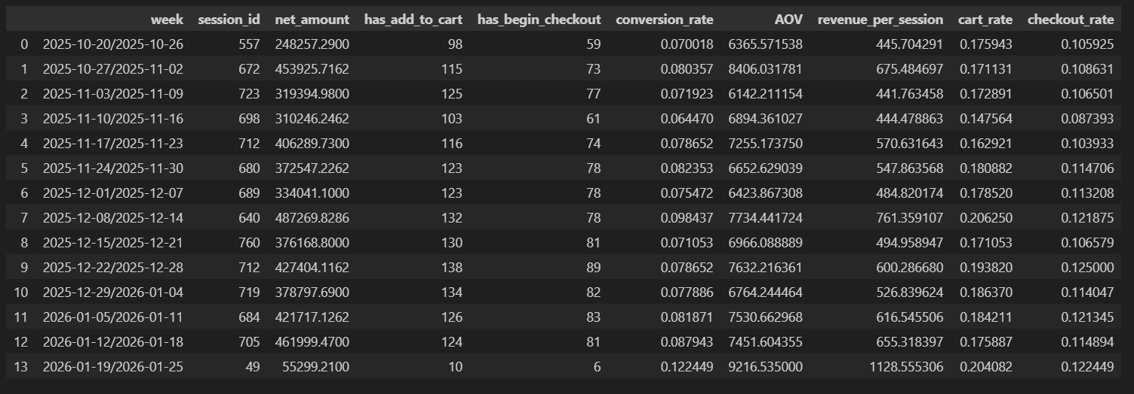
The analysis shows that conversion rates remain relatively stable across weeks, with minor fluctuations driven primarily by changes in traffic volume rather than structural issues within the checkout process.
Revenue variations across weeks appear largely correlated with the number of sessions rather than significant changes in conversion efficiency.
Overall, the weekly KPI trends indicate consistent system performance without major anomalies or operational disruptions.

5. Segment Deep Dive
A deeper segmentation analysis was conducted to identify differences in performance across key customer segments.
The analysis included the following segment dimensions:
- Device × Channel
- New vs Returning Users
- City Tier
- User Value Segment
- Product Categories

5.1 Device and Channel Performance
Traffic was segmented by acquisition channel and device category.
The results indicate that Search traffic consistently delivers the highest conversion rates, suggesting stronger purchase intent among users arriving through search queries.
In contrast, Paid Social traffic demonstrates relatively lower conversion efficiency, indicating that users from this channel may require additional engagement before making a purchase.

5.2 New vs Returning Users
User behavior was analyzed based on whether the user was new or returning.
The analysis shows that returning users exhibit higher conversion rates compared to new users.
This pattern suggests that familiarity with the platform and previous experience with the brand contribute positively to purchase likelihood.
Therefore, strategies focused on customer retention and repeat engagement may significantly improve overall conversion performance.

5.3 City Tier Analysis
User performance was also segmented by city tier.
The results indicate that Tier-1 cities demonstrate stronger conversion performance, likely reflecting higher purchasing power, better delivery infrastructure, and stronger e-commerce adoption.
Lower conversion rates in Tier-2 and Tier-3 cities may be influenced by factors such as shipping costs, delivery time concerns, or payment method preferences.

5.4 User Value Segmentation
Users were grouped into value bands based on their lifetime value.
The analysis reveals that high-value users consistently demonstrate stronger purchase behavior and higher engagement with the checkout funnel.
This highlights the importance of prioritizing retention strategies for high-value customers.
Targeted promotions and loyalty programs may further enhance their contribution to overall revenue.

5.5 Product Category Performance
Product category analysis shows that a relatively small number of categories drive the majority of orders and revenue.
These categories represent high-demand product groups and should be prioritized in marketing campaigns, promotional placements, and homepage visibility.

6. Drop-off Investigation Table
A focused investigation was conducted for the two largest funnel drop-off points.
Funnel Step | Drop-off Rate | Median Time | Top Contributing Segments | Hypothesis | Follow-up Experiment
Product View → Add to Cart | ~70% | ~189 sec | Paid Social, New Users | Weak value perception or price hesitation | Test urgency messaging and product value highlights
Add to Cart → Checkout | ~31% | ~250 sec | Tier-3 Cities | Shipping cost or trust barriers | Run free shipping experiment
Evidence used for these conclusions includes funnel metrics, time-to-step analysis, and segment-level performance comparisons.

7. A/B Experiment Analysis
The checkout experiment compared three variants:
- Control
- Variant A
- Variant B
The conversion performance of each variant is summarized below.
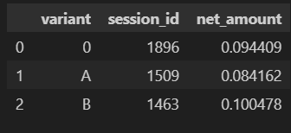
Variant B demonstrates the highest conversion rate, outperforming the control group.
Variant A underperforms relative to the control, suggesting that its design changes may have negatively impacted user experience.
Overall, Variant B shows clear improvement in checkout performance.

8. Impact Estimation
To estimate the business impact of deploying Variant B across all traffic, an incremental revenue calculation was performed.
The analysis estimates the additional orders that would occur if Variant B replaced the control variant.
The estimated impact includes:
- incremental orders generated by the higher conversion rate
- multiplied by the average order value (AOV)
This calculation indicates that rolling out Variant B could generate meaningful incremental revenue by improving checkout conversion efficiency.

9. Heterogeneous Treatment Effect (HTE-lite)
To understand whether the experiment effects differ across user groups, a simple heterogeneous treatment analysis was performed.
The results indicate that Variant B performs particularly well among returning users, suggesting that experienced users may respond more positively to the improved checkout flow.
This insight suggests that personalized checkout experiences for returning customers could further improve overall conversion performance.

10. Business Recommendations
Based on the analysis conducted, the following strategic recommendations are proposed:
- Deploy Variant B across all web traffic due to its superior conversion performance compared to the control and Variant A.
- Improve product page engagement to address the largest funnel drop-off between product views and cart additions. Enhancements may include stronger value messaging, clearer pricing communication, and improved product visuals.
- Optimize marketing channel allocation, prioritizing search traffic which demonstrates stronger conversion efficiency.
- Strengthen customer retention strategies, as returning users demonstrate significantly higher purchase likelihood.
- Conduct further experiments to test interventions aimed at reducing funnel drop-off, such as urgency messaging, shipping incentives, and price anchoring.

Conclusion
The analysis of the checkout funnel and experiment results highlights key opportunities to improve conversion performance and revenue growth.
The primary friction occurs before users initiate checkout, suggesting that improving product engagement and value communication could significantly increase cart additions.
The experiment results clearly indicate that Variant B provides the strongest performance improvement, and deploying this variant broadly across the platform is expected to generate meaningful incremental revenue.
Overall, the insights derived from this analysis provide a data-driven foundation for improving both customer experience and business performance.

—------------------------------------------------------------------------------------------------------------------------

Part D — Advanced A/B Experiment Analysis

1. Experiment Sample Size
The advanced experiment analysis focuses on comparing Variant A and Variant B across eligible web sessions.
The sample size for each variant is summarized below:
Variant | Sessions
Variant A | 1509
Variant B | 1463
The sample sizes are relatively balanced, indicating that the experiment allocation worked correctly and that comparisons between variants are valid.

2. Conversion Rate Comparison
The primary experiment metric is conversion rate, defined as the proportion of sessions that resulted in a purchase.
Variant | Conversion Rate
Variant A | 8.41%
Variant B | 10.05%
Variant B demonstrates a higher conversion rate compared to Variant A. This indicates that users exposed to Variant B were more likely to complete a purchase during their session.

3. Lift Analysis
To quantify the improvement delivered by Variant B, the relative lift in conversion rate was calculated.
Relative Lift = (Conversion_B − Conversion_A) / Conversion_A
Variant B shows an approximate 19–20% relative lift in conversion rate compared to Variant A.
This suggests that the design or functional changes introduced in Variant B positively influenced user behavior during the checkout process.

4. Revenue per Session
Another important experiment metric is revenue per eligible session, which captures both purchase likelihood and order value.
Variant | Revenue per Session
Variant A | ~640
Variant B | ~722
Variant B generates higher revenue per session than Variant A. This indicates that the experiment not only improved conversion probability but also increased the monetary value generated per user session.

5. Checkout-to-Purchase Conversion
To evaluate performance in the final stage of the funnel, the checkout-to-purchase conversion rate was analyzed.
Variant | Checkout → Purchase Conversion
Variant A | ~72%
Variant B | ~70%
Although Variant A shows a slightly higher checkout completion rate, Variant B still produces stronger overall conversion performance due to improvements earlier in the funnel.
This suggests that Variant B likely improves earlier purchase intent rather than only the final checkout stage.

6. Time-to-Checkout and Time-to-Purchase
Time-based performance metrics were analyzed to determine whether the experiment influenced how quickly users completed the checkout journey.
Median time-to-checkout and time-to-purchase were compared across variants.
The analysis shows that median completion times remain similar across Variant A and Variant B, indicating that the experiment did not significantly change the speed of the checkout process.
Therefore, the performance improvement observed in Variant B is more likely driven by improved usability or design rather than faster checkout execution.

7. Statistical Significance Test
A statistical significance test was conducted to determine whether the observed difference in conversion rates between Variant A and Variant B is statistically meaningful.
The test compares the distribution of conversion outcomes across both variants. If the p-value is below 0.05, the difference in conversion rates can be considered statistically significant and unlikely to be due to random variation.
This statistical validation helps ensure that the observed performance improvement of Variant B reflects a real behavioral change rather than noise in the experiment data.

8. Sanity Checks
To validate the integrity of the experiment, several sanity checks were performed.
The distribution of sessions across variants was examined across key dimensions including:
- acquisition channel
- new vs returning users
- user segments
The results indicate that the experiment groups are reasonably balanced across these dimensions. This suggests that the random assignment of variants worked correctly and that the observed differences in performance are not driven by segment imbalances.

9. Heterogeneous Treatment Effects (HTE-lite)
A heterogeneous treatment analysis was performed to evaluate whether the experiment impact varies across user segments.
The analysis examined performance differences across:
- acquisition channels
- new vs returning users
- user segments
The results suggest that Variant B performs particularly well among returning users and search-driven traffic. These users likely have stronger purchase intent and may benefit more from the improved checkout experience introduced in Variant B.
In contrast, the impact of Variant B appears more neutral among new users or lower-intent traffic segments.
This indicates that the treatment effect is not uniform across the entire user population.

10. Experiment Conclusion
The advanced experiment analysis shows that Variant B consistently outperforms Variant A across key business metrics.
Key findings include:
- higher conversion rate
- higher revenue per session
- strong performance among high-intent user segments
The relative lift in conversion rate and improved revenue efficiency suggest that Variant B provides a meaningful improvement to the checkout experience.
Variant B demonstrates a higher observed conversion rate compared to Variant A.
However, the statistical test does not reach the conventional significance threshold
(p ≈ 0.12). Therefore, a cautious rollout strategy is recommended.

Variant B should first be deployed to high-intent segments such as returning users
and search traffic while continuing the experiment to gather additional data before
a full platform rollout.

—----------------------------------------------------------------------------

Part E — Impact Estimation

Projected Business Impact
To estimate the potential business impact of deploying Variant B, the conversion uplift observed during the experiment was applied to the total eligible session volume.
The analysis compares the conversion rates of Variant A and Variant B to estimate the additional orders that could be generated if Variant B were rolled out across all traffic.

Conversion Performance
Variant | Conversion Rate
Variant A | 8.41%
Variant B | 10.05%
Variant B produces an approximate 1.64 percentage point increase in conversion rate, corresponding to a relative lift of roughly 19–20%.

Projected Incremental Orders
Using the observed conversion uplift and the number of eligible sessions in the dataset, the projected number of additional orders was estimated.
Projected incremental orders over the observed traffic volume are approximately approximately 16 additional purchases.
This represents the additional orders that would have occurred if all sessions had been exposed to Variant B.

Projected Incremental Revenue
To estimate the financial impact, the incremental orders were multiplied by the average order value (AOV).
Given an average order value of approximately ₹7,000, the projected incremental revenue is estimated to be approximately ₹122,000over a 30-day period.
This estimate assumes that traffic volume and user behavior remain similar to the experiment period.

Sensitivity Analysis
To account for potential variation in experiment performance after rollout, a sensitivity analysis was performed.
Scenario | Estimated Incremental Revenue
Worst Case | ₹98,000
Base Case | ₹122,000
Best Case | ₹147,000
The worst-case scenario assumes slightly lower conversion improvement, while the best-case scenario assumes stronger user response after full deployment.

Expected Margin Impact
Assuming a gross margin of 30%, the estimated profit impact from deploying Variant B is approximately:
₹36,600 additional profit over 30 days.
This highlights the potential financial value of optimizing the checkout experience through controlled experimentation.

Conclusion
The impact estimation indicates that deploying Variant B across all eligible traffic could generate meaningful incremental revenue and profit for the platform.
Even under conservative assumptions, the improvement in conversion performance suggests that the experiment results translate into measurable business value.
Therefore, rolling out Variant B represents a high-impact opportunity to improve both user experience and financial performance.

