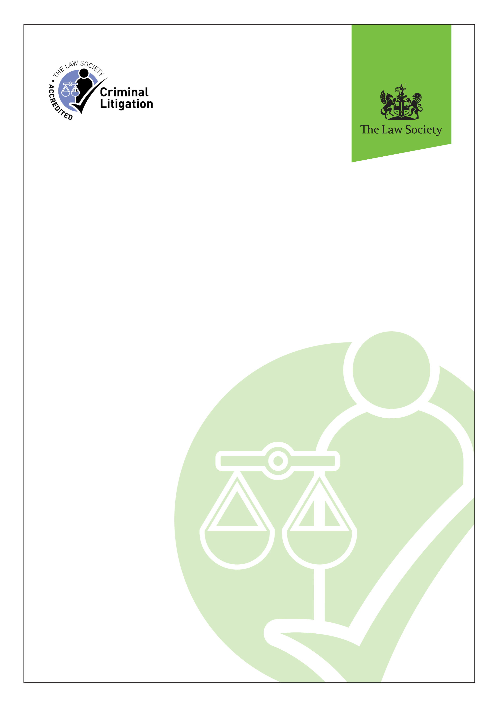
Criminal Litigation Accreditation
Application form

Application form - Criminal Litigation Accreditation

Contents
Section 1 - General information 4
A - Your details 4
B - Organisation information 5
C - Suitability for accreditation 5

Section 2 - Initial assessment 6
D - Scheme specific requirements 6
Declaration - Applicant 7
Declaration - Partner / senior manager (solicitor applicants) 7

Section 3 - Supporting documentation checklist 8

Section 4 - How to pay and return your application form to us 8

Step 1 – Read the guidance notes
- The guidance notes set out the obligations in respect of membership of the Criminal Litigation Accreditation. By signing the declaration contained at the end of the application form, you are agreeing to comply with the application process and the obligations contained in the guidance notes.
- We will not accept any amendments to the form of declaration. Any amendments will make the declaration unacceptable and the application will be returned to you to re-sign in the correct format.
- The guidance notes can be downloaded at: www.lawsociety.org.uk/support-services/accreditation/criminal-litigation/.
Step 2 – Complete the application form
- You must complete all sections and check that the information provided is true and accurate before signing the declaration. In addition, a partner or senior partner should review the information provided and sign the declaration.
- This application form should be completed in conjunction with the accompanying guidance notes. Emboldened words are defined in the glossary of terms in the guidance notes.
- The application form is designed to be completed electronically in Microsoft Word (1997 and later). Use the ‘tab’ key to progress through the form. Answers require a combination of typed answers, choosing an option from a drop-down menu or confirmation using a check box. You are also required to provide separate supporting documentation, which must be submitted along with this completed application form.
- If any development affecting your application after submission of this form would affect the answers given (whether in relation to complaints, claims, regulatory matters, changes to relevant persons or otherwise), you must notify the Accreditation office as soon as possible and, in any event, within 14 days of the change or the decision to make the change, whichever is the earlier.
- Please keep a copy of your completed application form for your records.
Step 3 – Return your application to us
- Email your completed application form to us. Please do not make payment when submitting your application. Upon receipt of your application, the amount payable will be determined and an invoice will be sent to the individual applying for accreditation.
- When emailing your application, please do not send files exceeding 18MB. If necessary please send your supporting documents in separate emails.
Questions?
We cannot process your application if any relevant data or documentation is missing from your application form. If you are unable to resolve your query using information provided in the guidance notes, please contact us:
Tel: 0207 320 5797 Email: accreditation@lawsociety.org.uk

Section 1 - General information

A - Your details
1. | Title and full name (forename[s], surname and any former names) | Title:  Forename(s):  Surname:  Former names:
2. | Telephone number
3. | Email address
Questions 4 – 6. To be completed by solicitor applicants
4. | SRA ID
5. | Do you hold a current practising certificate?  If 'No', provide details
6. | Have you held an unconditional practising certificate at all times since admission as a solicitor?  If 'No', provide details
Questions 7 – 8. To be completed by other (non-solicitor) applicants
7. | Please give your job title and a description of your role | If ‘Other’, please state:  Role description:
8. | Do you hold a relevant professional qualification(s)?  If ‘Yes’, please provide details: | Name of qualification #1:  Professional body awarded by:  Your membership number:  Date of qualification (MM/YYYY):  Name of qualification #2:  Professional body awarded by:  Your membership number:  Date of qualification (MM/YYYY):  Name of qualification #3:  Professional body awarded by:  Your membership number:  Date of qualification (MM/YYYY):

B - Organisation information
Solicitor applicants: postal and email communications will only be sent to you at your regulated practice. This is the information you provide in MySRA. Please ensure that your contact details for the practice at which you currently work are up-to-date in your MySRA account, as we are not able to update this for you.
Non-solicitor applicants: If you are employed in an SRA regulated practice, postal communications will only be sent to you at your regulated practice address. If you are employed in an organisation which is not regulated by the SRA, please also answer questions 11-12.
9. | Name of practice
10. | Practice's main office SRA ID, if applicable
Questions 11 – 12. To be completed by applicants employed in a non SRA regulated organisation
11. | Organisation name
12. | Organisation address | Address:  Town/city:  County:  Postcode:

C - Suitability for accreditation
13. | Have you ever been convicted of an offence in a court of England and Wales or elsewhere, other than convictions which are considered spent under the Rehabilitation of Offenders Act 1974?  If 'Yes', please provide full details
14. | Are there any other matters affecting your suitability for membership of the scheme, of which the Law Society should be aware?  If 'Yes', please provide full details
15. | Are you currently involved in an investigation by the SRA or Legal Ombudsman or other regulatory or enforcement agency?  If 'Yes', please provide full details  Please note that a check may be made against all internal Law Society and SRA records.
16. | Do you have any open or closed complaints?  If 'Yes', please provide brief details of the number and nature of all open and closed complaints received by your practice or previous practice relating to you during the last five years.  Client names should be redacted to protect confidentiality. | Total number of open / closed complaints:  Nature / detail of complaints:

Section 2 - Initial assessment

D - Scheme specific requirements
I have successfully completed the Police Station Qualification (PSQ) assessments, within the last three years.
If yes, please move to question 19. If no please move to question 18.
I am accredited to the Police Station Representative Accreditation Scheme (PSR).
I have successfully completed the Magistrates Court Qualification (MCQ) assessments, within the last three years.

Declaration - Applicant
I confirm that the information provided above is accurate.
I have read, understood and agree to comply with the Law Society’s terms and conditions for membership of the Law Society's Accreditation Schemes.
I authorise the Law Society to seek verification of any matters pertinent to a proper consideration of my application.
I agree that any records held by the Law Society, the Solicitors Regulation Authority (SRA) or other relevant professional or regulatory body may be accessed and used in considering this application.
I agree to notify the Law Society if I move from my present employment or of any change in my name or contact information.
I agree that any records held by the Law Society, the SRA or other relevant professional or regulatory body may be accessed and used in considering this application. I authorise the Law Society to discuss with the relevant professional or regulatory body any findings disclosed as a result of checks with the relevant professional or regulatory body.

Data Protection Act 1998
I understand that any details collected about me in relation to the Scheme may be shared with the SRA for regulatory purposes. I understand that details of my membership of a professional accreditation scheme may be made publicly available by the Law Society.
Data Protection Notice
The accreditation office will keep hard copies of your application form for three years (from the date accreditation is either approved or refused) at which point it will be securely destroyed. This complies with our legal obligation under the Data Protection Act 1998 not to keep records containing personal data for any longer than is necessary.
Signature | For electronic applications: I have read and understood the declaration above. Please check box to confirm your acceptance
Name (BLOCK CAPITALS)
Date (DD/MM/YYYY)

Declaration - Partner / senior manager (solicitor applicants)
I hereby certify and acknowledge that:
- the information provided in this application is correct to the best of my knowledge.
Signature | For electronic applications: I have read and understood the declaration above. Please check box to confirm your acceptance
Name (BLOCK CAPITALS)
Date (DD/MM/YYYY)

Section 3 - Supporting documentation checklist
Please check the boxes below to confirm the relevant documentation that is included with your application:

 | Copy of PSQ certificate or PSR certificate  Section 2, D, question 17 and 18 |  | Copy of MCQ certificate  Section 2, D, question 19

Section 4 - How to pay and return your application form to us
Please do not make payment when submitting your application. Upon receipt of your application, the amount payable will be determined and an invoice will be sent to the individual applying for accreditation. Pricing can be found on our website at: www.lawsociety.org.uk/Criminal-Litigation-Fees.

- Upon receipt of your invoice, please make payment by bank transfer, credit or debit card.
- The terms of your invoice are immediate. Accreditation will not be awarded until payment has been received in full.
- If payment has not been received within 30 days of the invoice date, your application will be withdrawn.

Payment method | Instructions
Bank transfer  (BACS) | - Email your completed application form to us at accreditation@lawsociety.org.uk.  - Upon receipt of your invoice, pay directly to our bank: Quote the invoice number as the payment reference.
Credit or debit card | - Email your completed application form to us at accreditation@lawsociety.org.uk.  - Upon receipt of your invoice, please telephone the cashiering team on 0121 329 6100 (option 2) to make payment.  - A handling charge of 1.75% will be added for payment by credit card.

Billing address
Is your billing address the same as your practice's main office address provided in Section 1B?
If 'No', please provide your billing address below
Billing address  Complete if different from the address for your practice's main office | Address line 1:  Address line 2:  Address line 3:  Town/city:  County:  Postcode:

Invoice query?
Contact the credit control team at creditcontrol@lawsociety.org.uk or telephone: 0121 329 6100 (option 3).

Payment query?
Contact the cashiering team at cashiers@lawsociety.org.uk or telephone: 0121 329 6100 (option 2).

