Transformer-Based Customer Journey Prediction on the Criteo Attribution Dataset
Group Members: Shashank Ashoka, Rachel Huang, and Abhyudaya Lohani
Background
Customer purchase journeys comprise temporally ordered interactions across marketing channels, including email, search, display advertising, and direct visits. Modeling how these interactions precede conversions is central to customer-behavior prediction, marketing attribution, and budget allocation. Hidden Markov Models (HMMs) and Long Short-Term Memory networks (LSTMs) model sequential behavior but may struggle to efficiently represent complex dependencies between distant touchpoints [1]. We first aim to adapt the heterogeneous multi-head self-attention Transformer of Lu and Kannan [1], which represents customer touchpoint histories as token sequences, learns customer-specific attention-head weights, and predicts next-period channel interactions and conversion probabilities. We will additionally investigate two complementary Transformer architectures: PatchTST [2], which partitions temporal sequences into patches to capture local patterns while enabling efficient long-context forecasting, and iTransformer [3], which applies attention across variables to model inter-campaign dependencies. These contrasting inductive biases are relevant to the Criteo Attribution dataset [4], where 30 days of observations correspond to 60–120 possible 12-hour or 6-hour time windows, but individual customer histories may be substantially shorter and sparse. To exploit historical interactions beyond the limited conversion labels, we are also investigating self-supervised contrastive learning, drawing on the hierarchical temporal representations of TS2Vec [5] and momentum-encoder training in MoCo v2 [6]. Specifically, we will examine whether a momentum-updated encoder and temporally consistent augmented views can improve Transformer representations before supervised sequence forecasting.

At the aggregate level, Marketing Mix Modeling (MMM) provides a complementary perspective: DeepCausalMMM combines Gated Recurrent Units (GRUs) for adstock and lag effects, directed acyclic graph (DAG) learning for channel dependencies, and Hill functions for nonlinear saturation [7, 8]. Our primary focus, however, remains Transformer-based prediction of future customer-interaction sequences, rather than causal attribution or budget optimization.

Significance and Problem Statement
From a customer's historical sequence of advertising touchpoints, we aim to predict which campaigns the customer will interact with in the next time window and whether the customer will convert. Accurate predictions can support customer targeting and marketing budget allocation (Lu & Kannan, 2026). Unlike recurrent models such as LSTMs, Transformer self-attention directly relates to distant touchpoints while enabling parallel sequence processing (Vaswani et al., 2017). We will first implement and adapt Lu and Kannan's heterogeneous multi-head Transformer, whose attention heads capture distinct patterns in customer interactions. We will additionally investigate PatchTST and iTransformer as comparative architectures and explore whether self-supervised contrastive learning with momentum encoders improves temporal representations. Attention patterns may reveal predictive relationships among campaigns and potentially inform complementary Marketing Mix Modeling (MMM), although they do not independently establish causal attribution.

Training Data
Because the proprietary dataset used by Lu and Kannan [1] is unavailable, we will primarily use the publicly released Criteo Attribution Modeling for Bidding dataset [4], comprising 30 days of advertising traffic, approximately 16.5 million impressions, 45,000 conversions, and 700 anonymized campaigns. We will reconstruct customer-level interaction sequences from user identifiers and timestamps, aggregate observations into 12-hour windows (approximately 60 global periods), and examine 6-hour windows (approximately 120 periods) to assess temporal resolution. Chronological training, validation, and test splits will measure future-period prediction, while a separate user-disjoint evaluation will assess generalization to unseen customers. To benchmark architectural robustness beyond advertising data, we may additionally evaluate Retailrocket [10], containing timestamped product views, cart additions, and purchases; YOOCHOOSE [11], containing session-level click and purchase sequences; and Taobao UserBehavior [12], containing timestamped browsing, cart, favorite, and purchase events. These datasets permit analogous next-period interaction and conversion prediction, although their behavioral labels differ from Criteo's campaign-level targets. For the optional aggregate Marketing Mix Modeling (MMM) extension, PySiMMMulator [13] will provide synthetic channel-response data with known ground-truth ROI, compensating for Criteo's limited weekly coverage. Synthetic experiments enable controlled validation but may not reproduce real-world behavioral complexity [14].

Deep Learning Framework
DeepCausalMMM integrates GRU-based temporal modeling to learn advertising carryover and lag effects, DAG-based structure learning to capture channel dependencies, and Hill transformations to model nonlinear saturation. Unlike customer-level Transformers, it operates on aggregate marketing time series to estimate business outcomes and support response-curve analysis [7].
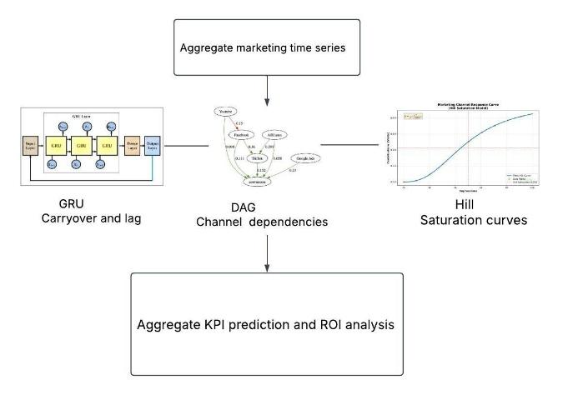

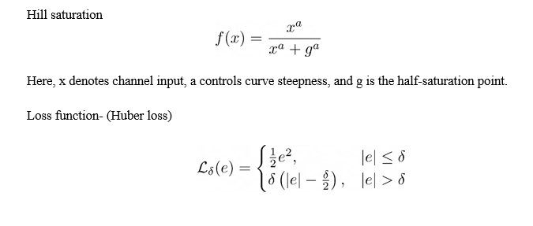

We will investigate two complementary Transformer architectures: PatchTST [2], which captures long-range temporal dependencies through patch-based self-attention, and iTransformer [3], which models cross-campaign dependencies using inverted variable embeddings. Both will be adapted for next-window campaign and conversion prediction, with exploratory MoCo-inspired momentum-contrastive pretraining [6] to improve temporal representations and LoRA-based parameter-efficient fine-tuning [17, 18] to adapt pretrained attention projections through low-rank updates.
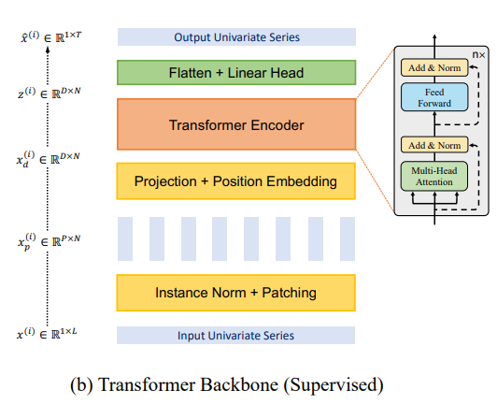
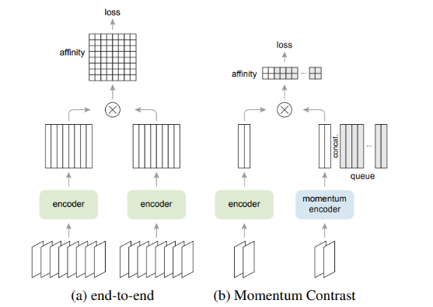

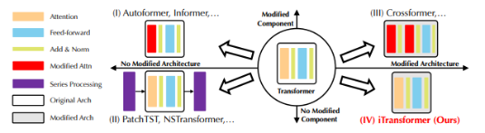
iTransformer

PatchTST
Momentum Encoder
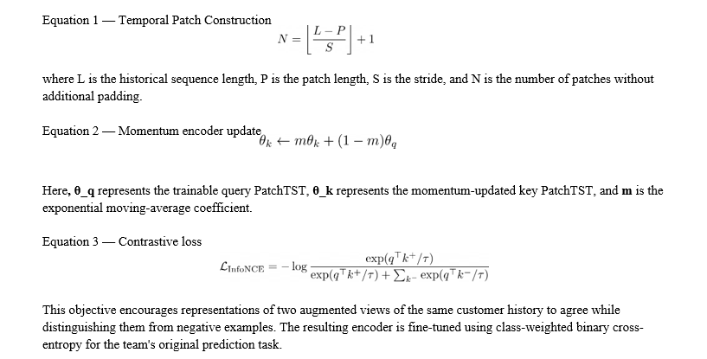
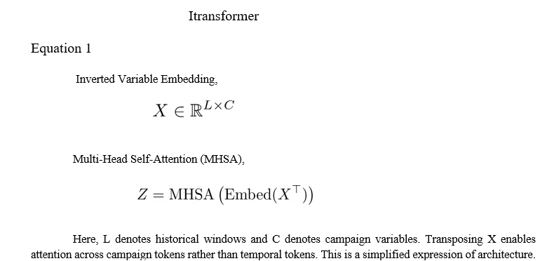

Followed by Eq(ii) and Eq(iii) momentum encoder update and contrastive loss

Model training, hyperparameter optimization, and comparative benchmarking will be conducted using PyTorch on the University of Maryland's Zaratan HPC cluster, leveraging NVIDIA A100 GPUs for computational acceleration.

We will evaluate LoRA-based parameter-efficient fine-tuning (PEFT) [17, 18] for PatchTST and iTransformer, freezing pretrained attention weights while optimizing low-rank updates, and benchmark against full fine-tuning in predictive accuracy, memory usage, training time, and trainable parameters.

Validation and Verification Metric
Validation and Verification. We will report ROC-AUC, PR-AUC (primary for imbalanced conversions), balanced accuracy, F1, and cross-entropy, alongside Precision@K/Recall@K for campaign prediction and top-decile conversion rate, lift, and gain [1]. Optional MMM evaluation will use holdout R², RMSE, and estimated versus ground-truth channel ROI [7]. Models will be compared against HMM/LSTM baselines on consistent chronological and user-disjoint splits, with ablations on attention heads (1–4), customer-specific weighting, window length, and random seeds. We will visualize attention patterns and assess LoRA efficiency through trainable parameters, GPU memory, and training time, reporting both improvements and negative results.
Group Member Project Tasks
Each area has one lead, and everyone codes and contributes documents to reports.
Shashank: Lead transformer, tuning, and Zaratan runs. Lead reports and presentations.
Rachel: Lead data preparation and the MMM extension. Assist with baselines.
Abhyudaya: Lead repository, documentation, baselines, and evaluation harness.

References
[1] Z. Lu and P. K. Kannan. AI for Customer Journeys: A Transformer Approach. Journal of Marketing Research, 63(1), 2026. https://doi.org/10.1177/00222437251347268

[2] Y. Nie, N. H. Nguyen, P. Sinthong, and J. Kalagnanam. A Time Series Is Worth 64 Words: Long-term Forecasting with Transformers. In International Conference on Learning Representations (ICLR), 2023. https://arxiv.org/abs/2211.14730

[3] Y. Liu et al. iTransformer: Inverted Transformers Are Effective for Time Series Forecasting. In International Conference on Learning Representations (ICLR), 2024. https://arxiv.org/abs/2310.06625

[4] E. Diemert, J. Meynet, P. Galland, and D. Lefort. Attribution Modeling Increases Efficiency of Bidding in Display Advertising. arXiv preprint arXiv:1707.06409, 2017. https://arxiv.org/abs/1707.06409

[5] Z. Yue et al. TS2Vec: Towards Universal Representation of Time Series. In AAAI Conference on Artificial Intelligence, 2022. https://arxiv.org/abs/2106.10466

[6] X. Chen, H. Fan, R. Girshick, and K. He. Improved Baselines with Momentum Contrastive Learning. arXiv preprint arXiv:2003.04297, 2020. https://arxiv.org/abs/2003.04297

[7] Tirumala. DeepCausalMMM: A Deep Learning Framework for Marketing Mix Modeling with Causal Inference. arXiv preprint arXiv:2510.13087, 2025. https://arxiv.org/abs/2510.13087

[8] X. Zheng, B. Aragam, P. Ravikumar, and E. P. Xing. DAGs with NO TEARS: Continuous Optimization for Structure Learning. In Advances in Neural Information Processing Systems (NeurIPS), 2018.
https://arxiv.org/abs/1803.01422

[9] A. Vaswani et al. Attention Is All You Need. In Advances in Neural Information Processing Systems (NeurIPS), 2017. https://arxiv.org/abs/1706.03762

[10] Retailrocket. E-Commerce Dataset. Kaggle, 2017.
https://www.kaggle.com/datasets/retailrocket/ecommerce-dataset

[11] ACM RecSys. RecSys Challenge 2015: YOOCHOOSE Dataset. 2015.
https://recsys.acm.org/recsys15/challenge/

[12] Alibaba Tianchi. Taobao UserBehavior Dataset. https://tianchi.aliyun.com/dataset/649

[13] R. August. PySiMMMulator: Synthetic Marketing Mix Modeling Data Simulator. GitHub repository. https://github.com/RyanAugust/PySiMMMulator

[14] J. Jordon et al. Synthetic Data—What, Why and How? arXiv preprint arXiv:2205.03257, 2022.
https://arxiv.org/abs/2205.03257

[15] A. Paszke et al. PyTorch: An Imperative Style, High-Performance Deep Learning Library. In Advances in Neural Information Processing Systems (NeurIPS), 2019. https://arxiv.org/abs/1912.01703

[16] A. M. Rush. The Annotated Transformer. In Proceedings of the Workshop for NLP Open Source Software, 2018. https://doi.org/10.18653/v1/W18-2509

[17] E. J. Hu et al. LoRA: Low-Rank Adaptation of Large Language Models. In International Conference on Learning Representations (ICLR), 2022. https://arxiv.org/abs/2106.09685

[18] S. Mangrulkar et al. PEFT: State-of-the-Art Parameter-Efficient Fine-Tuning Methods. Hugging Face software library, 2022. https://github.com/huggingface/peft

