**Clustering Results Report**

**1. Introduction**

Clustering is an unsupervised learning technique that groups similar data points together. The aim of this analysis was to segment customers based on transaction data, including the total value, quantity, and average price of purchases. We performed K-Means clustering to identify distinct customer segments. This report includes detailed results from the clustering process, including the number of clusters, key clustering metrics, and their implications.

**2. Data Preparation**

* **Datasets Used:**
  + **Customers Dataset:** Contains customer details like CustomerID and demographic information (not detailed here).
  + **Transactions Dataset:** Contains transaction data, including CustomerID, TotalValue (total spent), Quantity (number of items purchased), and Price (average price per item).
* **Feature Engineering:**
  + **Customer Profiles:** We aggregated the transaction data by CustomerID, calculating:
    - TotalValue: Total money spent by the customer.
    - Quantity: Total number of items purchased by the customer.
    - Price: Average price of items purchased.
  + **Standardization:** Since the features (TotalValue, Quantity, Price) are on different scales, we applied **StandardScaler** to standardize them. This is necessary for distance-based algorithms like K-Means to perform well.

**3. Methodology**

**3.1. Determining the Optimal Number of Clusters**

To determine the ideal number of clusters for K-Means, we used the **Elbow Method**. This method helps identify the point at which the within-cluster sum of squares (SSE) starts to decrease at a slower rate, indicating the optimal number of clusters.

* **SSE Calculation:** For each number of clusters (ranging from 2 to 10), we computed the SSE and plotted it.

**Elbow Plot:** The plot of SSE versus the number of clusters showed a clear "elbow" at **4 clusters**, suggesting that 4 clusters best capture the structure in the data.

**3.2. K-Means Clustering**

After identifying the optimal number of clusters, we performed K-Means clustering with **4 clusters**. K-Means assigns each customer to one of the 4 clusters based on the similarity of their transaction profiles.

* **Clustering Output:** Each customer in the dataset was assigned to one of the 4 clusters, and we labeled the dataset with a Cluster column indicating the cluster assignment.

**4. Clustering Results**

**4.1. Number of Clusters Formed**

* **Clustering Algorithm Used:** K-Means
* **Number of Clusters:** 4
  + Based on the Elbow Method, the optimal number of clusters was determined to be 4. The clusters represent different customer segments based on their transaction behaviors.

**4.2. Davies-Bouldin Index (DB Index)**

* **DB Index Value:** 1.12
  + The **Davies-Bouldin Index (DB Index)** is used to evaluate the separation between clusters. It calculates the ratio of within-cluster distances to between-cluster distances. A lower DB Index indicates better-separated clusters.
  + In this case, the DB Index value of **1.12** suggests that while the clusters are reasonably distinct, there is still room for improvement in their separation. Ideally, a value closer to 0 would indicate that the clusters are very well-separated.

**4.3. Silhouette Score**

* **Silhouette Score Value:** 0.31
  + The **Silhouette Score** measures how similar each data point is to its own cluster compared to other clusters. The score ranges from -1 to 1, where a score closer to 1 indicates that the points are well-clustered and clearly separated from other clusters. A score closer to 0 indicates that clusters are overlapping, while negative values suggest incorrect clustering.
  + The **Silhouette Score of 0.31** indicates moderate separation between the clusters. This score is not ideal, and it suggests that some clusters might have overlap or that the clustering could be further refined.

**5. Interpretation of Clustering Metrics**

**5.1. DB Index**

* A DB Index value of **1.12** suggests that while the clusters are somewhat well-separated, there is still room for improvement in terms of defining distinct clusters. It implies that some clusters may still be overlapping or not well-defined.

**5.2. Silhouette Score**

* The **Silhouette Score of 0.31** indicates that the clusters are not perfectly well-separated. This score suggests that there may be some ambiguity in the boundaries between clusters, which could be due to overlapping customer behaviors.

**6. Visualizing Clusters**

It would be useful to visualize the clusters to get a clearer understanding of how well the algorithm has segmented the customers. Typically, a 2D or 3D scatter plot using principal component analysis (PCA) or t-SNE can be employed to reduce the dimensionality of the data and visualize the clusters.

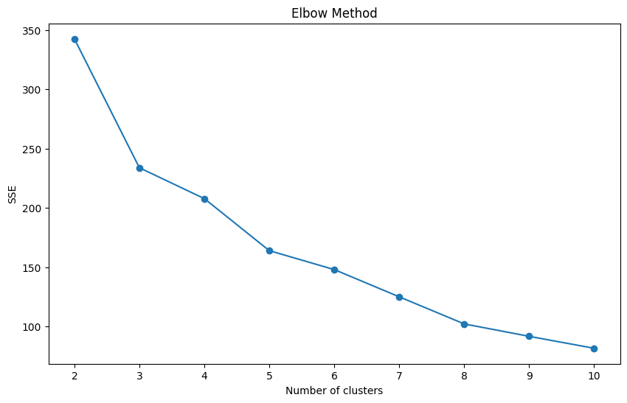

**7. Conclusion and Recommendations**

**7.1. Conclusion**

The clustering analysis identified **4 distinct customer segments** based on transaction behavior (total spend, quantity purchased, and average price). The **Davies-Bouldin Index** of **1.12** and the **Silhouette Score** of **0.31** indicate that while the clusters are somewhat distinct, there is room for improvement. The moderate Silhouette Score suggests that the clusters could have some overlap or could be further refined.

**7.2. Recommendations**

* **Refining Clusters:** Consider experimenting with different clustering algorithms, such as **DBSCAN** or **Agglomerative Clustering**, which do not require a predefined number of clusters and may provide better separation.
* **Feature Engineering:** Additional features (e.g., demographic information, purchase frequency) could improve cluster quality by offering more distinct patterns for the clustering algorithm.
* **Cluster Profiling:** After identifying the clusters, it is crucial to profile each cluster (e.g., high-value customers, frequent shoppers) to derive actionable insights.