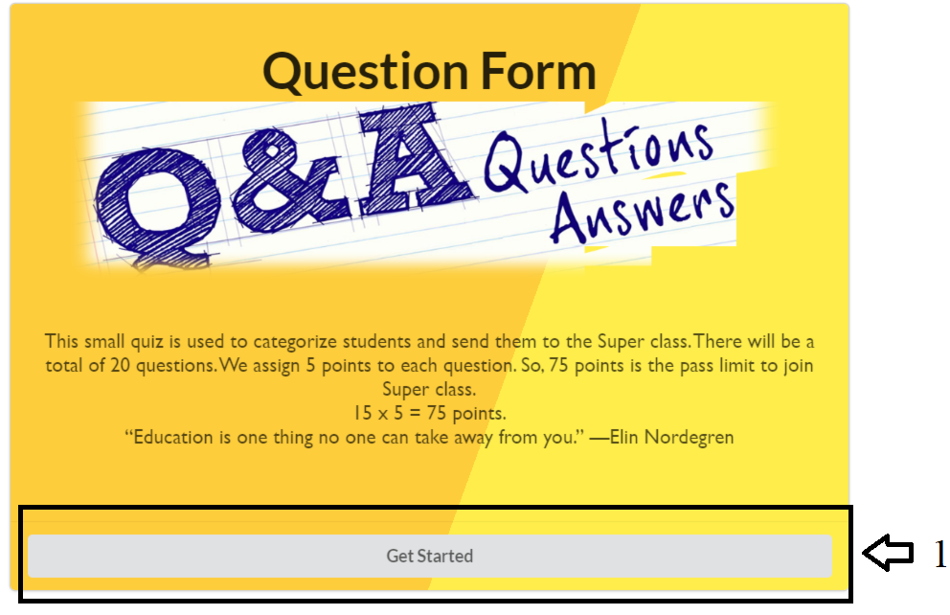

This Application is Question form, which has 20 questions which is coming from the API (Axios).

It is a basic UI that developed for the function that I have added. This UI is made of with **Semantic-ui.**

1 <- After click on this button Get Started it will navigate to the next page **Registration form**.

This is the second UI **Registration Form.**

**1 <--** There are 2 text boxes which is needed compulsory.

2 <-- After filling upper part clicking on the Submit/ Next button it will navigate to the **Questions page.**

This is the third page which is need to do the questions.

1 <-- This is the question count which is will automatically change after the seconds completed or after submitting the answer.

2 <-- This is the timer which I have allocated 180 seconds for each question.

All together 20 questions x 3 mins = 60mins.

Even if we are unable to submit the answer within the time (180 seconds) it will go to next question. After the 20th question it will navigate to the last page of the application.

3 and 4 <-- Third one is the question shown in image format, This images are coming from the API.

Fourth one is the input textbox which is needed to write our answer, and this answer will be compared with the API answer and give the results at the last of the questions.

5 <-- Submit button will help to submit the answers and after the completing the 20th question it will be navigate to the last page.

This is the last page of the Application and after clicking on the Home button it will navigate to the First page again.