SIMATS ENGINEERING
ASSESSMENT TOOL 1 - Concept Mapping

COURSE NAME: Data Structures COURSE CODE: CSA03
Register Number | 1921260133
Name | Abinayasri K

COURSE OUTCOME COVERED

CO1: Apply suitable data structures and ADTs for efficient problem solving by analyzing time and space complexity. (BL2, BL3)

Assessment Tool Weightage: 35%

Questions:2 | EACH QUESTIONS CARRIES: 10 MARKS Total Marks:20 Duration: ONE HOUR
Q1 A smart healthcare system processes large volumes of patient data such as temperature readings, medical history, and diagnostic details. Construct a concept map linking the progression from Data → Data Object → Data Structure → Abstract Data Type (ADT) → Implementation in C. Identify relevant sub-concepts such as structures, pointers, and operations, and establish meaningful relationships among them. Organize the concept map hierarchically and justify how each level contributes to efficient data organization, processing, and improved system performance.
Q2 A smart city traffic management system handles data related to vehicle movement, road networks, and signal control. Construct a concept map connecting Primitive Data Structures → Non-Primitive Data Structures → Linear → Non-Linear Structures. Include examples such as arrays, linked lists, trees, and graphs, and illustrate their applications in traffic management. Explain the relationships between these structures and justify their classification based on functionality and efficiency.

Code of Conduct:

I (Abinayasri K / 1921260133) (Name / Reg No) certify that this submission is my original work and that I have adhered to the guidelines specified for this assessment.
I understand that any violation of academic integrity rules will result in disciplinary action.

Signature of the student:

Abinayasri K

RUBRICS FOR CALCULATION:

Concept Mapping
Criteria | Weightage | Level 4 (Exemplary) | Level 3 (Proficient) | Level 2 (Developing) | Level 1 (Beginning)
Concept Identification | 25% | Identifies all key concepts from literature accurately and comprehensively | Identifies most key concepts with minor omissions | Identifies limited concepts; some are irrelevant or missing | Fails to identify essential concepts
Linkages | 25% | Establishes clear, meaningful, and accurate relationships between concepts | Shows correct relationships with minor gaps | Relationships are weak, unclear, or partially incorrect | No meaningful relationships established
Organization | 20% | Concepts are well-structured hierarchically with logical flow and grouping | Mostly organized with minor structural issues | Some organization but lacks clear hierarchy | No logical organization or structure
Integration of Literature | 20% | Integrates multiple studies effectively to show connections and comparisons | Shows some integration of literature | Limited integration; mostly isolated concepts | No integration of literature evidence
Clarity | 10% | Concept map is clear, neat, visually structured, and easy to interpret | Generally clear with minor readability issues | Clarity is reduced; difficult to interpret in parts | Poorly presented and hard to understand

Answer 1

Concept Map for Question 1: Data → Data Object → Data Structure → ADT → Implementation in C
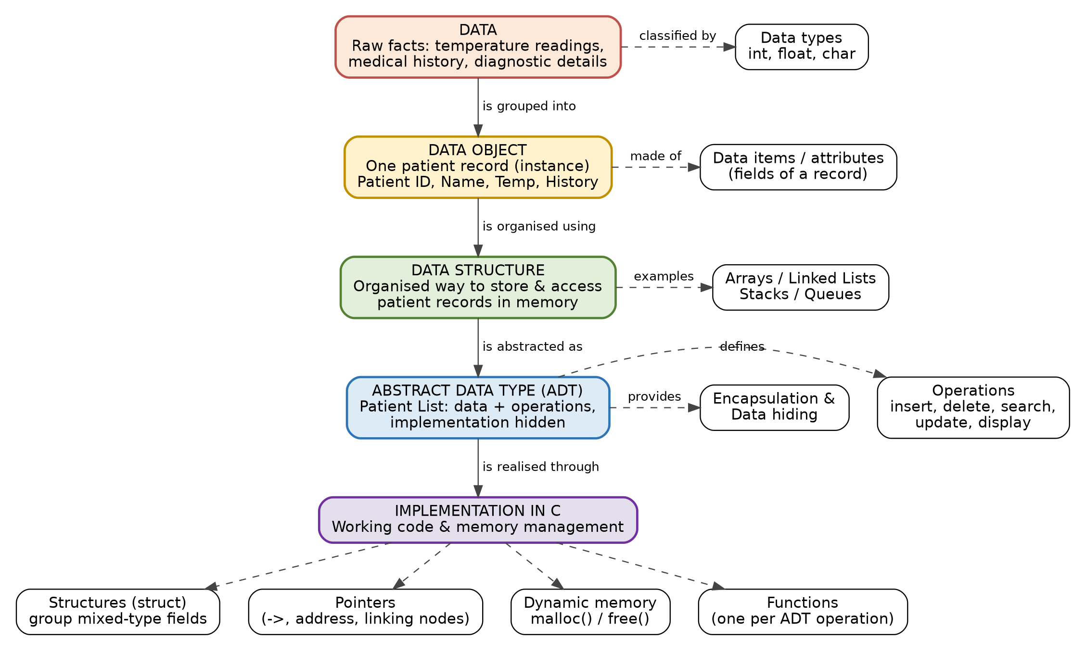

Explanation of the Hierarchy and Justification of Each Level
Level | Meaning | Example in healthcare system | Contribution to efficiency
1. Data | Raw, unprocessed facts with no structure of their own. | Temperature 38.5, "diabetic", "X-ray normal". | Gives the basic values to be stored. Choosing the right data type (int, float, char) saves memory and prevents errors.
2. Data Object | A group of related data items that describes one real-world entity. | One patient record: ID, name, temperature, history. | Keeps all details of one patient together, so a whole record is read or updated in one step.
3. Data Structure | A way of organising many data objects in memory so they can be accessed and changed efficiently. | Array of patients, or a linked list of patients. | Decides speed and memory use: arrays give O(1) access by index; linked lists give O(1) insertion and grow as needed.
4. Abstract Data Type (ADT) | A logical model that defines the data and the operations allowed on it, hiding how it is built. | Patient List ADT with insert, delete, search, update, display. | Separates "what" from "how". The implementation can be changed (array to linked list) without changing the programs that use it. Supports reuse and fewer bugs.
5. Implementation in C | Turning the ADT into working code using the language features. | struct Patient, pointers to link nodes, malloc()/free(), one function per operation. | Gives actual performance: dynamic memory avoids waste, pointers avoid shifting data, functions keep the code modular.

Key Relationships (Linkages) in the Concept Map
- Data is grouped into a Data Object: individual values (temperature, history) become one meaningful patient record.
- A Data Object is organised using a Data Structure: thousands of patient records need an arrangement such as an array or linked list.
- A Data Structure is abstracted as an ADT: the structure and its permitted operations are defined logically, as a "Patient List".
- An ADT is realised through an Implementation in C: the logical design is coded using structures, pointers and functions.

Important Sub-concepts
- Structures (struct): group fields of different types (int, float, char array) into one patient record.
- Pointers: store the address of the next record, link the nodes of a list, and give fast access without copying data.
- Dynamic memory (malloc / free): memory is allocated only when a patient is admitted and released after discharge.
- Operations: insert (admit), delete (discharge), search (find by ID), update (new reading) and display (report).
- Encapsulation and data hiding: users of the ADT call the operations without knowing the internal storage.

Sample C Implementation of the Patient List ADT
#include <stdio.h>
#include <stdlib.h>

struct Patient { /* Data Object: one patient record */
int id;
char name[30];
float temperature; /* temperature reading */
char history[50]; /* medical history / diagnosis */
struct Patient *next; /* pointer links records together */
};

/* ADT operation: insert a new patient at the front - O(1) */
struct Patient* insert(struct Patient *head, int id, char *name, float temp) {
struct Patient *p = (struct Patient*)malloc(sizeof(struct Patient));
p->id = id; p->temperature = temp;
snprintf(p->name, 30, "%s", name);
p->next = head;
return p; /* new head of the Patient List */
}

/* ADT operation: search by id - O(n) */
struct Patient* search(struct Patient *head, int id) {
for (; head != NULL; head = head->next)
if (head->id == id) return head;
return NULL;
}

Overall Justification
Each level adds one kind of efficiency. Data and Data Objects give correct, complete and well-grouped information. The Data Structure gives fast access and low memory use for a large number of patient records. The ADT gives clean design, easy maintenance and reuse because the operations are fixed while the implementation can change. The C implementation turns this design into a fast, memory-efficient program: the linked list inserts a new patient in O(1) time and uses space proportional to the number of patients, while searching by ID takes O(n) (and can be improved to O(log n) with a balanced tree). Together, the five levels make the healthcare system organised, scalable and quick in processing patient data.

Answer 2

Concept Map for Question 2: Primitive → Non-Primitive → Linear → Non-Linear
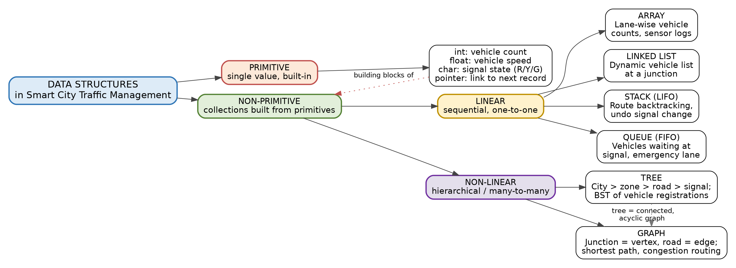

Applications and Efficiency of Each Structure
Structure | Category | Application in traffic management | Key operations (time) | Why it fits
Primitive types (int, float, char, pointer) | Primitive | int: vehicle count; float: speed; char: signal state R/Y/G; pointer: link to the next record. | Direct access, O(1) | Hold a single value; fastest and smallest, but cannot show relations between many values.
Array | Linear | Vehicle counts per lane per hour; fixed list of sensor readings. | Access O(1); insert/delete O(n) | Contiguous memory gives instant access by index when the size is known.
Linked list | Linear | Vehicles currently at a junction (they arrive and leave all the time). | Insert/delete at head O(1); search O(n) | Grows and shrinks dynamically; no shifting of elements.
Stack (LIFO) | Linear | Backtracking a route; undoing the last signal-timing change. | Push / pop O(1) | Last item added is the first needed.
Queue (FIFO) | Linear | Vehicles waiting at a red signal; emergency-vehicle request queue. | Enqueue / dequeue O(1) | First come, first served ordering.
Tree (BST) | Non-linear | City > zone > road > signal hierarchy; fast lookup of vehicle registration numbers. | Search/insert O(log n) average | Hierarchical data with fast search in a sorted tree.
Graph | Non-linear | Road network: junctions are vertices, roads are edges with distance or time as weight; shortest path and congestion-aware routing. | BFS/DFS O(V+E); Dijkstra O((V+E) log V) | Many-to-many connections between junctions; the only natural model of a road network.

Relationships Between the Structures
- Primitive → Non-Primitive: primitive types are the building blocks. An array is a collection of ints; a linked-list node is a primitive value plus a pointer; a graph vertex stores primitive data such as a junction ID.
- Non-Primitive → Linear / Non-Linear: non-primitive structures are split by how elements are arranged. In linear structures each element has one predecessor and one successor; in non-linear structures an element can connect to many others.
- Within Linear: arrays use fixed contiguous memory, while linked lists use dynamic memory. Stacks and queues are restricted-access forms that can be built on either an array or a linked list.
- Within Non-Linear: a tree is a special graph that is connected and has no cycles. A graph is more general and can contain cycles, as roads do.

Justification of the Classification
Based on functionality. Primitive structures store one value and are provided by the language. Non-primitive structures store many values and are defined by the programmer. Among them, linear structures are used when data is processed in order (a queue of vehicles, a list of sensor readings). Non-linear structures are used when data has a hierarchy or a network of connections (city zones, road networks), which cannot be shown in a single sequence.
Based on efficiency. Linear structures are simple and have low overhead, and their operations are mostly O(1) or O(n). Non-linear structures cost more memory and more complex code, but they give much faster searching (O(log n) in a balanced tree) and make route calculations possible that a linear structure cannot handle without scanning everything. Space for a graph is O(V+E) as an adjacency list or O(V²) as an adjacency matrix, so the adjacency list suits sparse road networks.

Conclusion
A smart traffic system uses all categories together: primitive types for individual readings, arrays and queues for lane data and waiting vehicles, a tree for hierarchical zones and fast vehicle lookup, and a graph for the road network and shortest-path routing. Choosing each structure according to how its data is accessed gives the best time and space efficiency, which is the main aim of CO1.

