RTL DESIGN AND VERIFICATION OF DIGITAL CALCULATOR USING ALU USING EDA PLAYGROUND
EMPLOYABILITY ENANCEMENMT COURSE
SD0212 RTL DESIGN AND VERIFICATION
PROJECT REPORT
Submitted by
ABINAYA M | 312324106004
DHARSHINIPRIYA G S | 312324106033
HARSHINI S A | 312324106057
MATHI SREE R | 312324106101
SHWETHA G | 312324106163
in partial fulfillment for the award of the degree
of
BACHELOR OF ENGINEERING
IN
ELECTRONICS AND COMMUNICATION ENGINEERING

St. JOSEPH’S COLLEGE OF ENGINEERING
(AN AUTONOMOUS INSTITUTION)
OMR, CHENNAI – 600 119
BATCH: 2024-2028
NOVEMBER 2026

BONAFIDE CERTIFICATE
Certified that the Employability Enhancement Course Project Report titled “RTL design and verification using EDA Tool” is the bonafide work of “ABINAYA M” (312324106004), “DHARSHINIPRIYA G S” (312324106033), “HARSHINI S A” (312324106057), “MATHI SREE” (312324106101), “SHWETHA G” (312324106163) who completed the training program under my supervision.
SIGNATURE | SIGNATURE
Dr. S. RAJESH KANNAN., M.E., Ph.D..,  HEAD OF THE DEPARTMENT,  Professor,  Electronics and Communication Engineering,  St. Joseph’s College of Enginnering,,  Old Mamallapuram Road,  Chennai – 600 119. | Dr. P. LATHA, M.E., Ph.D..,  SUPERVISOR,  Associate Professor,  Electronics and Communication Engineering,  St. Joseph’s College of Engineering,  Old Mamallapuram Road,  Chennai – 600 119.
ACKNOWLEDGEMENT
At the outset, I would like to express my sincere gratitude to our beloved Chairman Dr. B. BABU MANOHARAN, M.A., M.B.A., Ph.D., for his constant guidance and support.
I would like to express my sincere thanks to our respected Executive Director, Mrs. S. JESSIE PRIYA, M. Com., and our Managing Director, Mr. B. SASHISEKAR, M.Sc for their kind encouragement and blessings.
I express my sincere gratitude and wholehearted thanks to our Principal Dr. VADDI SESHAGIRI RAO, M. E., Ph.D., for his encouragement to make this Training a successful one.
I wish to express our truthful thanks and gratitude to our Head of the Department Dr. S. RAJESH KANNAN M.E., Ph.D., Department of Electronics and Communication Engineering for his constant support and motivation throughout my internship.
I have no words to express my heartfelt thanks to Dr. P. LATHA , M.E., Ph.D.., Associate Professor for her guidance, support and encouragement in completing the Training and Project within the stipulated time

ABSTRACT
This project focuses on the design and verification of a Digital Calculator Using an Arithmetic Logic Unit (ALU) using EDA Playground, showcasing the complete RTL-to-GDSII design flow using Cadence tools. The design incorporates an ALU-based architecture to perform multiple arithmetic and logical operations efficiently, providing a structured and hardware-oriented approach to digital computation. The calculator is designed using modular Verilog building blocks, ensuring reusability, scalability, and ease of verification.
At the RTL stage, the Verilog description of the digital calculator was developed and functionally verified using self-checking testbenches. The ALU supports fundamental arithmetic operations such as addition, subtraction, multiplication, and division, along with logical operations such as AND, OR, XOR, and NOT. Functional verification covers normal operations, boundary conditions, zero inputs, overflow conditions, and invalid operation selections to ensure accurate results and reliable functionality.
Following RTL verification, logic synthesis was performed with appropriate area, power, and timing constraints to evaluate the hardware implementation and optimize the design while maintaining functional correctness. The synthesized netlist was then used for the physical design process.
The physical design phase involved floor planning, placement, and power grid planning to establish an efficient layout and reliable power distribution. Clock Tree Synthesis (CTS) was performed to minimize clock skew and latency while ensuring balanced clock distribution. Global and detailed routing were subsequently carried out to establish optimized interconnections while maintaining signal integrity and satisfying design constraints.
Subsequently, Static Timing Analysis (STA) was performed to validate setup and hold timing requirements and achieve timing closure. Power analysis was conducted to evaluate dynamic and leakage power consumption. Design Rule Check (DRC) and Layout Versus Schematic (LVS) verification were also performed to ensure layout correctness and manufacturability. The project ultimately aims to generate a GDSII file, representing the final physical layout of the digital calculator and completing the RTL-to-GDSII implementation flow.
CONTENTS

LIST OF TABLES
Table No. | Name
Table 3.1 | Port description of the Digital Calculator
Table 2.1 | Functional verification results of the Digital Calculator
LIST OF FIGURES
Figure No. | Name
Figure 3.1 | System architecture of the Digital Calculator using ALU
Figure 3.2 | Flow chart of the Digital Calculator using ALU
Figure 2.1 | RTL design code for 8x8 Sequential Multiplier
Figure 2.2 | RTL Testbench code for 8x8 Sequential multiplier
Figure 2.3 | Output by using Cadence Xcelium 23.09
Figure 2.4 (a) | Design, testbench and Xcelium simulation log on EDA Playground
Figure 2.4 (b) | EPWave output of the Digital Calculator (hexadecimal radix)
Figure 2.4 (c) | EPWave output of the Digital Calculator (binary radix)
Figure 2.5 | EP wave generation of the 8x8 sequential multiplier

CHAPTER 1
INTRODUCTION

1.1 Overview

What is VLSI?
VLSI, or Very Large-Scale Integration, is a cutting-edge technology in the field of electronics that involves the design and fabrication of integrated circuits (ICs) by integrating millions or even billions of transistors onto a single silicon chip. These chips serve as the "brains" of electronic devices, enabling a wide range of functionalities from complex calculations to high-speed data processing.

The Revolution of VLSI Technology
VLSI technology has transformed the way we create electronic circuits. Traditionally, electronic devices were built using bulky circuits composed of individual components like resistors, capacitors, and discrete transistors. VLSI replaces these cumbersome designs with highly compact and efficient chips, often no larger than a coin. This miniaturization has led to the development of powerful, portable, and energy-efficient devices that are integral to modern life.

Why VLSI is Important
Miniaturization of Devices:
Impact: VLSI allows for the creation of incredibly small and compact electronic devices. This miniaturization is what makes modern gadgets like smartphones, laptops, and smartwatches possible.
Example: A smartphone today has more computing power than the room-sized computers of the past, all thanks to VLSI technology.
Improved Performance:
Impact: By integrating more transistors onto a single chip, VLSI enhances the performance of electronic devices. This means faster processing speeds, better data handling, and overall improved functionality.
Example: High-performance gaming consoles and graphics cards rely on VLSI to deliver seamless and immersive gaming experiences.
Reduced Power Consumption:
Impact: VLSI chips are designed to be energy-efficient, reducing the power consumption of electronic devices. This makes devices not only faster but also more environmentally friendly.
Example: Energy-efficient processors in laptops and smartphones extend battery life, allowing users to stay connected for longer periods.
Cost Efficiency:
Impact: The mass production of VLSI chips reduces manufacturing costs significantly. This cost efficiency makes advanced electronics more affordable for consumers.
Example: The affordability of smartphones and other consumer electronics is largely due to the cost-effective production of VLSI chips.

1.2 Key Steps in the VLSI Design Process
Specification:
Purpose: Engineers define the functional requirements of the chip. This includes deciding what the chip should do, such as powering a smartphone, processing video, or managing data in a server.
Output: A detailed specification document outlining the chip's intended capabilities and performance metrics.
Design:
Purpose: A blueprint of the chip is created using specialized software tools. This design phase includes both the behavioural and structural aspects of the chip.
Process: Engineers use hardware description languages (HDLs) like Verilog or VHDL to describe the chip's functionality. This high-level design is then synthesized into a gate-level netlist.
Output: A comprehensive design that includes the layout and interconnections of all components on the chip.
Fabrication:
Purpose: The chip is physically built in a fabrication facility, also known as a foundry. This process involves layering and connecting millions of tiny components to create a functional integrated circuit.
Process: The design is translated into a series of photolithographic masks, which are used to pattern the layers of the chip. Advanced manufacturing techniques ensure precision and accuracy.
Output: A fully fabricated chip ready for testing and integration into electronic devices.
Testing:
Purpose: The final chip is rigorously tested to ensure it meets the specified performance and reliability standards. This includes functional testing, electrical testing, and environmental testing.
Process: Automated test equipment (ATE) is used to simulate various operating conditions and verify the chip's functionality.
Output: A certified chip that is ready for mass production and integration into end-user devices.
Applications of VLSI
VLSI chips are used in a wide range of devices and industries, such as
1. Consumer Electronics:
- Smartphones (processors, memory, and sensors)
- Laptops and PCs (CPUs, GPUs, and RAM)
- Smart TVs and home assistants
2. Automotive Industry:
- Advanced driver-assistance systems (ADAS)
- Engine control units (ECUs) for efficient vehicle performance
- Electric vehicles (EVs) for battery management
3. Medical Devices:
- Wearable health monitors (like fitness trackers)
- Imaging systems (like MRI machines)
- Portable diagnostic tools
4. Aerospace and Defence:
- Satellite communication systems
- Radar and navigation systems
- High-speed data processing for military applications
5. Communication Networks:
- 5G and wireless communication infrastructure
- Routers and modems for internet connectivity

1.3 Summary
VLSI is at the heart of modern technology, powering the devices and systems we use daily. Its ability to integrate countless functions into a small chip makes it indispensable for innovation. From healthcare to entertainment, VLSI enables industries to thrive and evolve, pushing the boundaries of what’s possible.

CHAPTER 2
RTL DESIGN AND VERIFICATION

2.1 Introduction
The entire Chip life cycle can be characterized by a few key stages that are briefly discussed below. The focus of this report will be the IC design stage

2.1.1 IC Design:
IC design is where the journey begins. It's the process of conceptualizing, defining, and creating the blueprint for an integrated circuit. It can be broadly divided into:
- System-Level Design: Translating user requirements and device functionality into system specifications.
- RTL Design (Digital): Using hardware description languages like Verilog or VHDL to describe the logical behaviour.
- Analog/Custom Design: Creating precise transistor-level schematics for analog and mixed-signal components.
- Verification and Validation: Ensuring correctness through simulation, synthesis, and formal verification.
- Physical Design: Transforming logical designs into layouts for fabrication, including placement, routing, and timing closure.
This step combines creativity and engineering precision to design ICs that are smaller, faster, and energy efficient.

2.1.2 IC Manufacturing:
Once the design is finalized, the IC undergoes fabrication in highly specialized semiconductor foundries. This process includes:
- Wafer Fabrication: Creating wafers with multiple chips using photolithography, doping, etching, and deposition techniques.
- Material Science: Using advanced materials like silicon, gallium arsenide, or even emerging technologies like graphene.
- Moore's Law in Action: Shrinking transistor sizes for each generation to pack billions of transistors onto a single chip.
- Packaging: Encasing the fabricated chip in protective materials, ensuring electrical connections and heat dissipation.
This is a highly capital-intensive stage, requiring precision and expertise to achieve high yield and quality.

2.1.3 Post Tape-out IC Testing and Validation:
After tape-out (finalizing the layout for fabrication), rigorous testing and validation are performed to ensure the IC functions as intended:
- Wafer Testing: Probing individual chips on the wafer to test functionality before cutting them.
- Package-Level Testing: Checking electrical, thermal, and mechanical properties after packaging.
- Burn-In Testing: Running the chip at elevated temperatures and voltages to screen for early-life failures.
- Field Tests and Debugging: Evaluating performance in real-world conditions and fine-tuning as needed.
This stage ensures the IC is reliable and meets the required performance standards before it enters the market.

2.1.4 Integration into Devices:
Once validated, these ICs are integrated into smart devices such as smartphones, IoT devices, and autonomous vehicles. The entire process—from design to post-tape-out testing—is a marvel of modern engineering, pushing the boundaries of what’s possible in technology.
The IC Design is the focus of the work we are concerned with here. To begin, we first understand the classification of IC design flows.
- RTL to GDSII Flow
- Custom / AMS Design flow

2.2 RTL Design and Verification:
RTL design and verification is a crucial step in the digital IC design flow. In this stage, designers write RTL (Register Transfer Level) code in languages like Verilog or VHDL to describe the digital circuit's behavior. The RTL code is then simulated and verified using EDA tools like VCS, Xcelium, or Riviera-PRO to ensure that the design meets the required specifications.
A testbench is created to apply inputs, generate clock and reset signals, and check results. The simulation waveforms are analyzed to identify and fix any issues, ensuring the design's functionality and performance. By verifying the RTL design thoroughly, designers can catch and fix errors early on, reducing the risk of costly rework later in the design cycle.

2.2.1 Front-End Design
Front-End Design involves defining the functionality and behaviour of the integrated circuit. It is focused on the logical and architectural aspects of the design. Here's a deeper look at its key components:
1. Design Entry (RTL Coding):
- Specifying the architecture and functionality of the 8x8 sequential multiplier to meet its intended application needs in digital processing.
- Defines how different components (e.g., processors, memory, communication interfaces) interact with each other.
2. Test Bench Creation:
- A self-checking testbench is written to apply inputs, generate clock/reset, and check results.
- Edge cases: zero input maximum values random inputs.
3. Simulation:
- Utilized EDA Playground for simulation and verification. The Commercial Simulators which are used are Synopsys VCS 2023.3, Cadence Xcelium 23.09, Aldec Riviera Pro 2023.04 and Siemens Questa 2024 and free simulators like: Icarus Verilog 12.0.
- Techniques include simulation, formal verification, and emulation to identify bugs early in the process.
4. Debug and Verification:
- Verified the functional correctness of the design and Checked corner cases and edge cases to ensure robustness.
- Debugged and fixed any issues that arose during simulation.
5. Logical Synthesis:
- In the real world design flow, the next step would be a synthesize the RTL design to a gate-level netlist. Where Yosys 0.37 is used for the generation of the RTL to Gate level netlist conversion.
- Gate-level simulation would be performed to verify the design’s functionality and timing

2.3 SUMMARY:
In this chapter, we have given a brief about the RTL DESIGN AND VERIFICATION model. In the forthcoming chapter, we will be dealing in depth with the implementation and the result obtained from the project work.

CHAPTER 3
RESULT AND DISCUSSION

3.1. PROPOSED SYSTEM

3.1.1. Design Specification
The proposed system is a Digital Calculator Using Arithmetic Logic Unit (ALU), designed and implemented using SystemVerilog. The system performs basic arithmetic and logical operations on two 8-bit binary inputs, A and B, based on a 4-bit opcode.
The ALU acts as the main processing unit of the calculator. It selects and executes the required operation according to the opcode and generates the corresponding result internally. The design supports eight operations: addition, subtraction, multiplication, division, AND, OR, XOR and NOT.
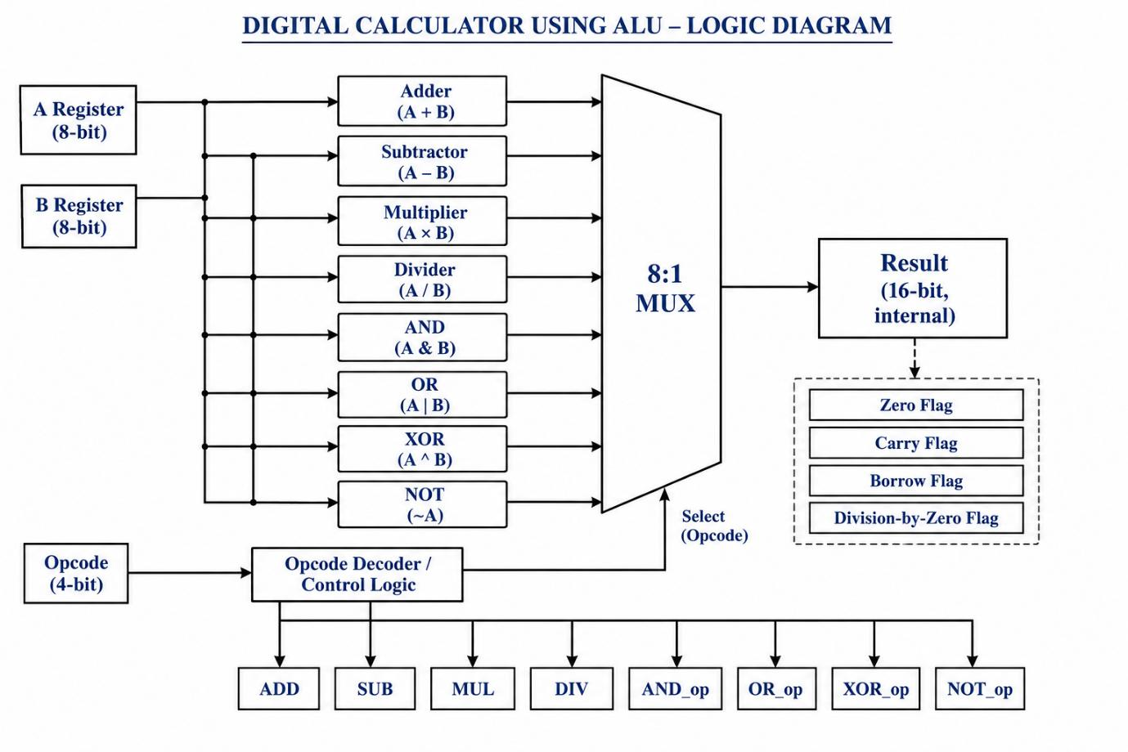
The design specifications are as follows:
- Input Data: Two 8-bit inputs, A and B, are provided to the ALU.
- Opcode: A 4-bit opcode is used to select the required arithmetic or logical operation.
- Arithmetic Operations:
  - Addition (A + B)
  - Subtraction (A − B)
  - Multiplication (A × B)
  - Division (A / B)
- Logical Operations:
  - Bitwise AND (A & B)
  - Bitwise OR (A | B)
  - Bitwise XOR (A ^ B)
  - Bitwise NOT (~A)
- Output Result: A 16-bit internal result signal is used to store the calculated output, allowing the system to accommodate multiplication results.
- Status Flags: Internal status signals are included to indicate zero result, carry, borrow and division-by-zero conditions.
- Operation Indicators: Eight individual output signals indicate which operation is currently selected. Only the corresponding operation indicator becomes HIGH at a time.
- Design Language: SystemVerilog is used to describe the digital hardware functionality.
- Simulation Tool: Cadence Xcelium is used for functional simulation, and EDA Playground is used as the development and testing environment.
- Verification: A separate testbench applies different input combinations and opcodes to verify the functionality of all eight operations.
Opcode Assignment Table
Opcode | Operation | Description
0000 | ADD | Addition
0001 | SUB | Subtraction
0010 | MUL | Multiplication
0011 | DIV | Division
0100 | AND | Bitwise AND
0101 | OR | Bitwise OR
0110 | XOR | Bitwise XOR
0111 | NOT | Bitwise NOT of A

3.1.2 System Architecture and Flow Chart
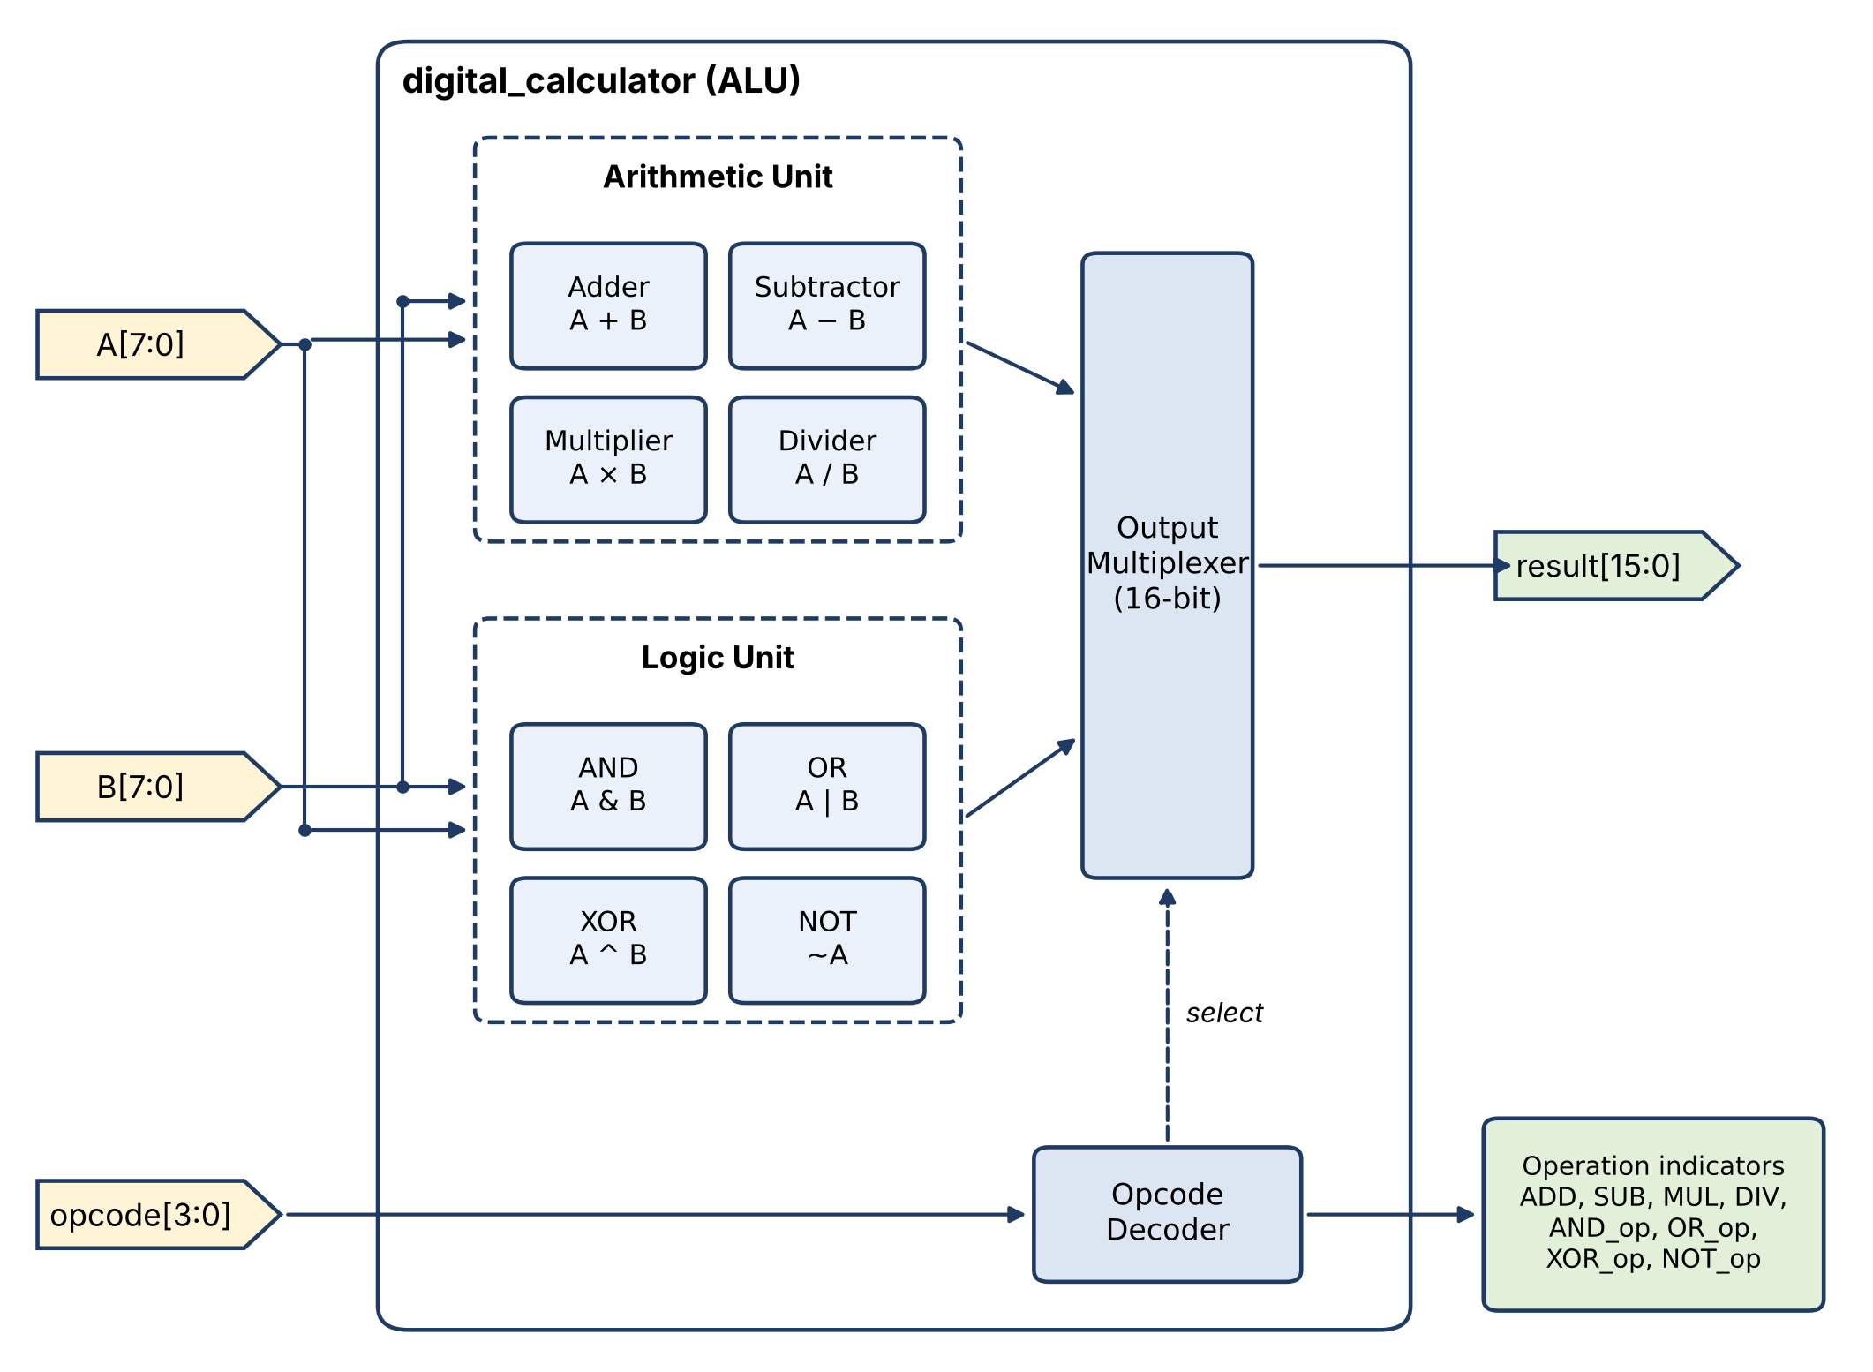
Figure 3.1 System architecture of the Digital Calculator using ALU
Table 3.1 Port description of the Digital Calculator
Signal | Direction | Width | Description
A | Input | 8 | First operand
B | Input | 8 | Second operand
opcode | Input | 4 | Selects the operation to be performed
result | Output | 16 | Output of the selected operation
ADD, SUB, MUL, DIV | Output | 1 each | Arithmetic operation indicators
AND_op, OR_op, XOR_op, NOT_op | Output | 1 each | Logic operation indicators

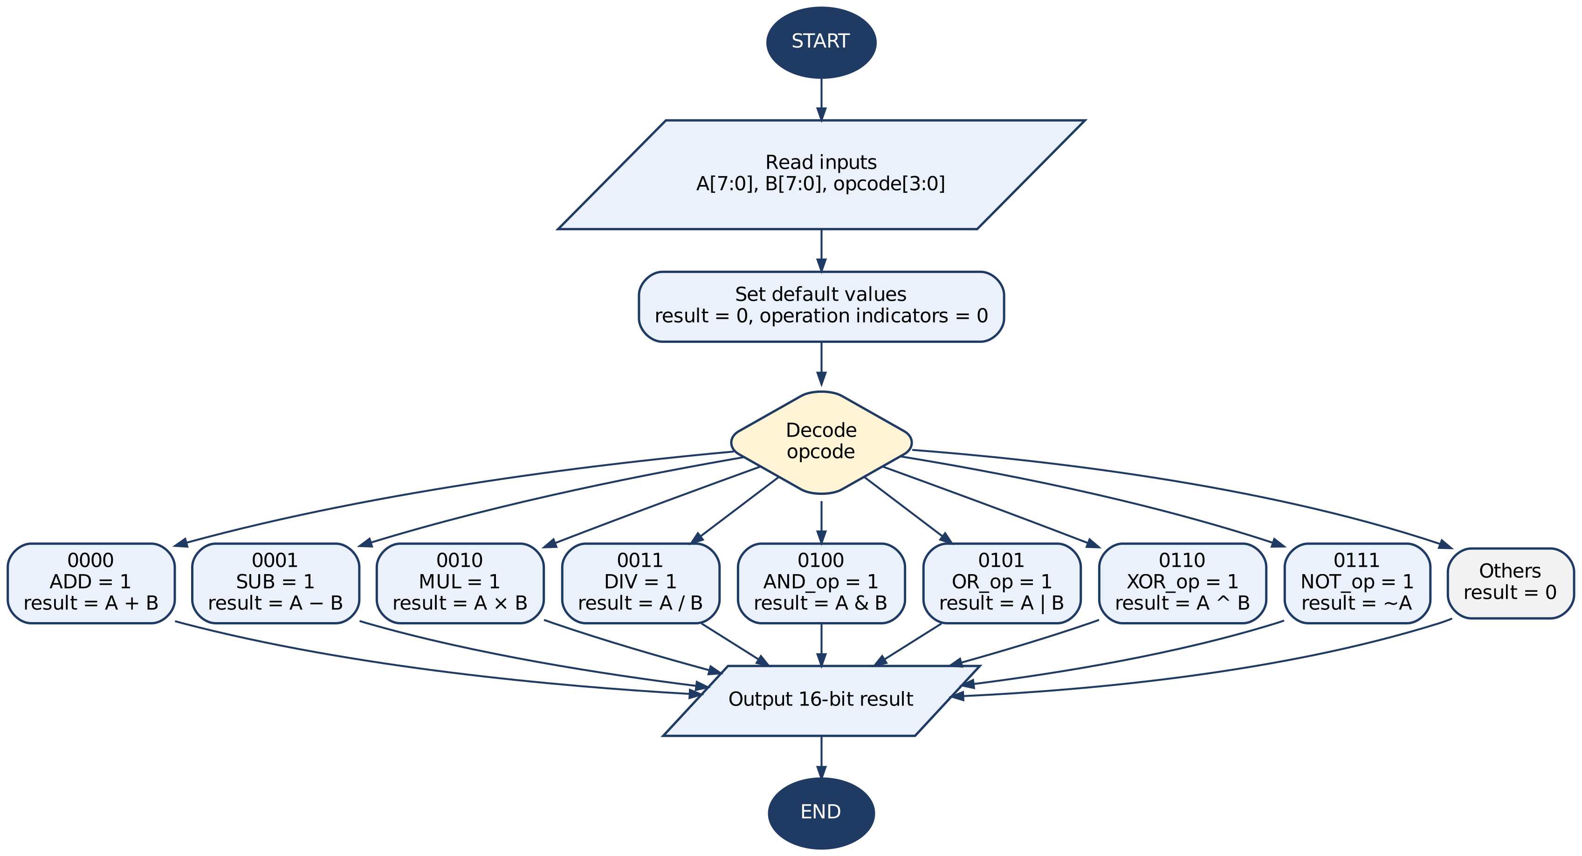
Figure 3.2 Flow chart of the Digital Calculator using ALU

3.1.3 RTL Design of Digital Calculator Using ALU
// Code your design here
module digital_calculator (
input logic [7:0] A,
input logic [7:0] B,
input logic [3:0] opcode,
output logic [15:0] result,
output logic ADD,
output logic SUB,
output logic MUL,
output logic DIV,
output logic AND_op,
output logic OR_op,
output logic XOR_op,
output logic NOT_op
);
// Internal status flags
logic zero_flag;
logic carry_flag;
logic borrow_flag;
logic div_by_zero;

always_comb begin
// Default values
result = 16'b0;
zero_flag = 1'b0;
carry_flag = 1'b0;
borrow_flag = 1'b0;
div_by_zero = 1'b0;
ADD = 1'b0;
SUB = 1'b0;
MUL = 1'b0;
DIV = 1'b0;
AND_op = 1'b0;
OR_op = 1'b0;
XOR_op = 1'b0;
NOT_op = 1'b0;

case (opcode)
// ADD
4'b0000: begin
ADD = 1'b1;
result = {8'b0,A} + {8'b0,B};
carry_flag = ({1'b0,A} + {1'b0,B}) > 9'd255;
end

// SUB
4'b0001: begin
SUB = 1'b1;
result = {8'b0,(A-B)};
borrow_flag = (A < B);
end

// MUL
4'b0010: begin
MUL = 1'b1;
result = A * B;
end

// DIV
4'b0011: begin
DIV = 1'b1;
if (B != 0)
result = A / B;
else begin
result = 16'b0;
div_by_zero = 1'b1;
end
end

// AND
4'b0100: begin
AND_op = 1'b1;
result = A & B;
end

// OR
4'b0101: begin
OR_op = 1'b1;
result = A | B;
end

// XOR
4'b0110: begin
XOR_op = 1'b1;
result = A ^ B;
end

// NOT
4'b0111: begin
NOT_op = 1'b1;
result = {8'b0,~A};
end

default: begin
result = 16'b0;
end
endcase

zero_flag = (result == 16'b0);
end
endmodule

3.1.4 RTL Verification
Front-End RTL Verification refers to the process of ensuring that a digital design, expressed at the Register Transfer Level (RTL) using hardware description languages (HDLs) such as Verilog or VHDL, meets its intended functional specifications. This verification is a critical step in the pre-silicon design lifecycle, as it identifies and rectifies potential design flaws before the design is sent for physical implementation.
Digital Calculator testbench:
`timescale 1ns/1ps
module tb_digital_calculator;
// Input signals
logic [7:0] A, B;
logic [3:0] opcode;

// Output signals
logic [15:0] result;
logic ADD, SUB, MUL, DIV;
logic AND_op, OR_op, XOR_op, NOT_op;

// DUT Instantiation
digital_calculator DUT (
.A(A),
.B(B),
.opcode(opcode),
.result(result),
.ADD(ADD),
.SUB(SUB),
.MUL(MUL),
.DIV(DIV),
.AND_op(AND_op),
.OR_op(OR_op),
.XOR_op(XOR_op),
.NOT_op(NOT_op)
);

//Waveform
initial begin
$dumpfile("dump.vcd");
$dumpvars(0,
A,
B,
opcode,ADD,SUB,MUL,DIV,AND_op,OR_op,XOR_op,NOT_op,result
);

// ADD: 20 + 10 = 30
A = 8'd20;
B = 8'd10;
opcode = 4'b0000;
#10;

// SUB: 50 - 20 = 30
A = 8'd50;
B = 8'd20;
opcode = 4'b0001;
#10;

// MUL: 10 * 5 = 50
A = 8'd10;
B = 8'd5;
opcode = 4'b0010;
#10;

// DIV: 100 / 10 = 10
A = 8'd100;
B = 8'd10;
opcode = 4'b0011;
#10;

// AND: 204 & 170 = 136
A = 8'd204;
B = 8'd170;
opcode = 4'b0100;
#10;

// OR: 204 | 170 = 238
A = 8'd204;
B = 8'd170;
opcode = 4'b0101;
#10;

// XOR: 204 ^ 170 = 102
A = 8'd204;
B = 8'd170;
opcode = 4'b0110;
#10;

// NOT: ~204 = 51
A = 8'd204;
B = 8'd0;
opcode = 4'b0111;
#10;

$display("SIMULATION COMPLETED");
$finish;
end
endmodule

3.1.5 Waveform Generation using EDA PLAYGROUND:
Waveform generation is carried out to verify functional correctness before synthesis. Two tools are primarily used:
RTL Design code
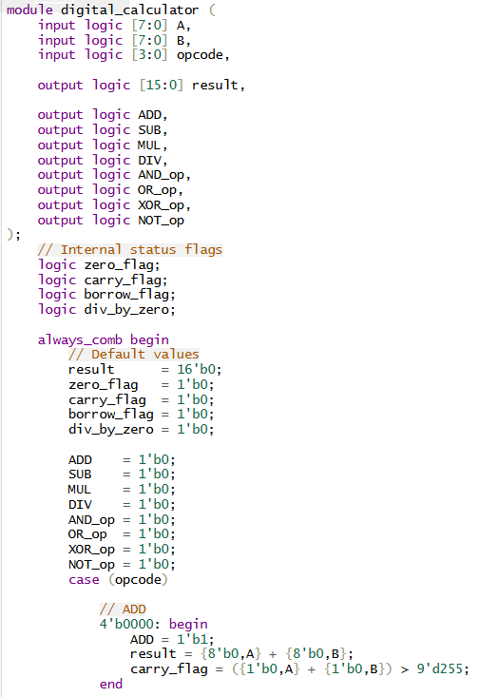
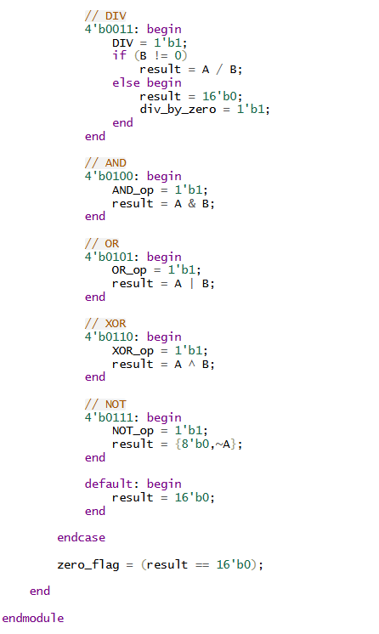
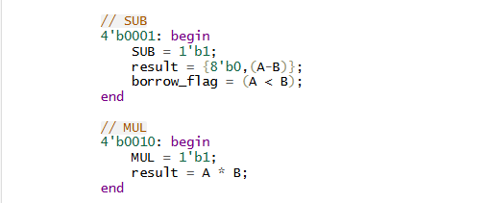
Figure 2.1 RTL design code for 8x8 Sequential Multiplier
RTL Testbench code for Digital Calculator
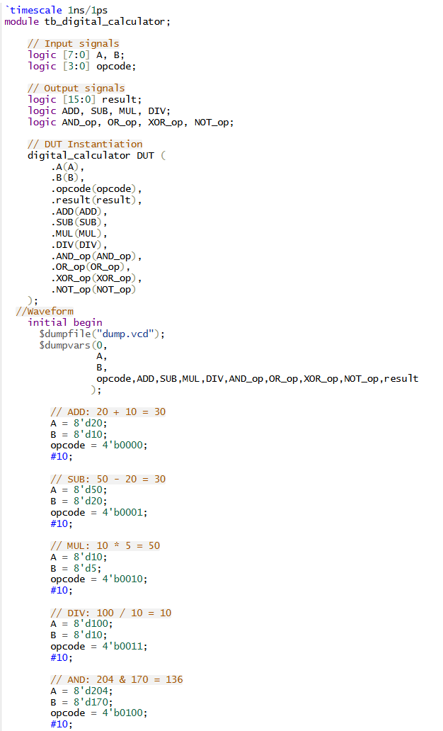
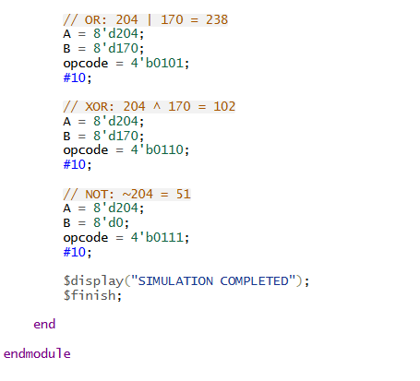
Figure 2.2 RTL Testbench code for 8x8 Sequential multiplier
Respected Output by using Cadence Xcelium 23.09
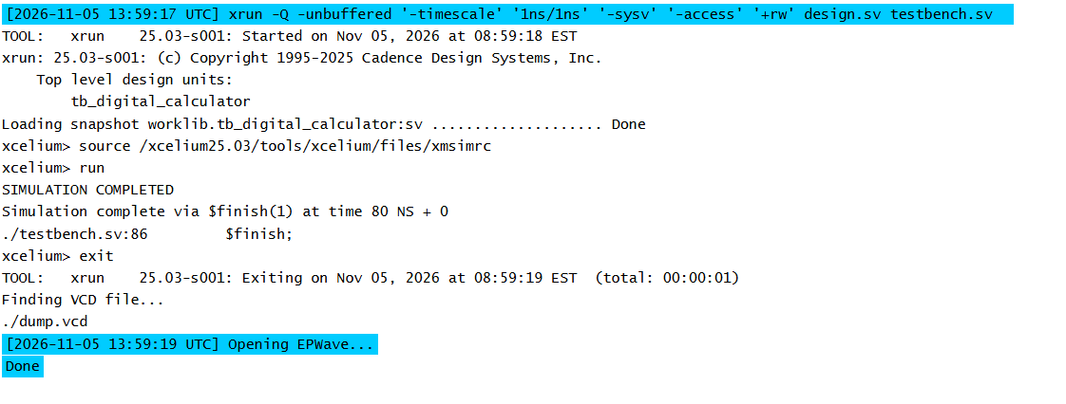
Figure 2.3 Output by using Cadence Xcelium 23.09
Simulation on EDA Playground using Cadence Xcelium
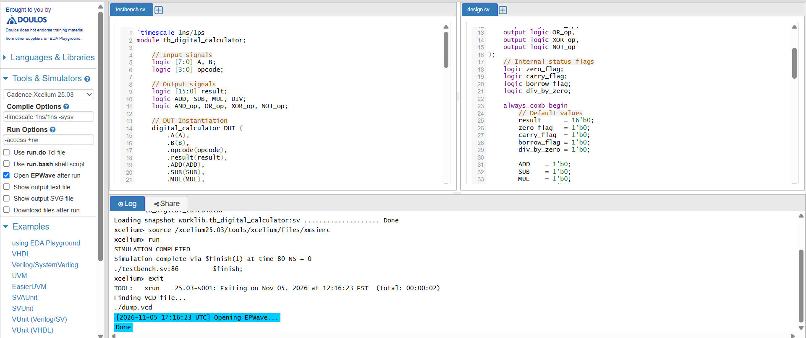
Figure 2.4 (a) Design, testbench and Xcelium simulation log on EDA Playground
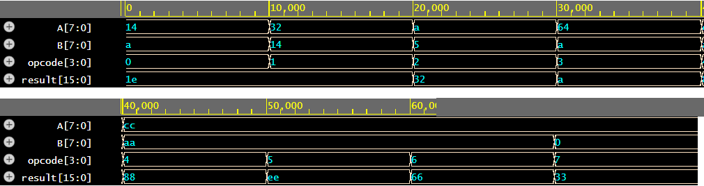
Figure 2.4 (b) EPWave output of the Digital Calculator (hexadecimal radix)
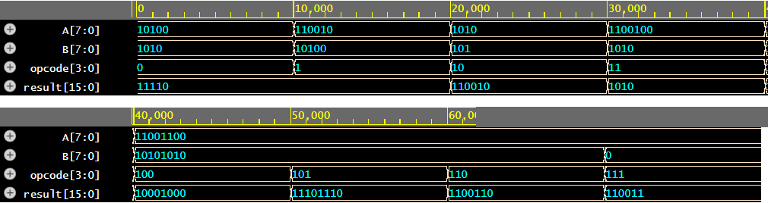
Figure 2.4 (c) EPWave output of the Digital Calculator (binary radix)
Table 2.1 Functional verification results of the Digital Calculator
Time (ns) | Opcode | Operation | A (hex) | B (hex) | Expected (hex) | Simulated (hex) | Status
0 | 0000 | ADD | 14 | 0A | 001E | 001E | PASS
10 | 0001 | SUB | 32 | 14 | 001E | 001E | PASS
20 | 0010 | MUL | 0A | 05 | 0032 | 0032 | PASS
30 | 0011 | DIV | 64 | 0A | 000A | 000A | PASS
40 | 0100 | AND | CC | AA | 0088 | 0088 | PASS
50 | 0101 | OR | CC | AA | 00EE | 00EE | PASS
60 | 0110 | XOR | CC | AA | 0066 | 0066 | PASS
70 | 0111 | NOT | CC | 00 | 0033 | 0033 | PASS

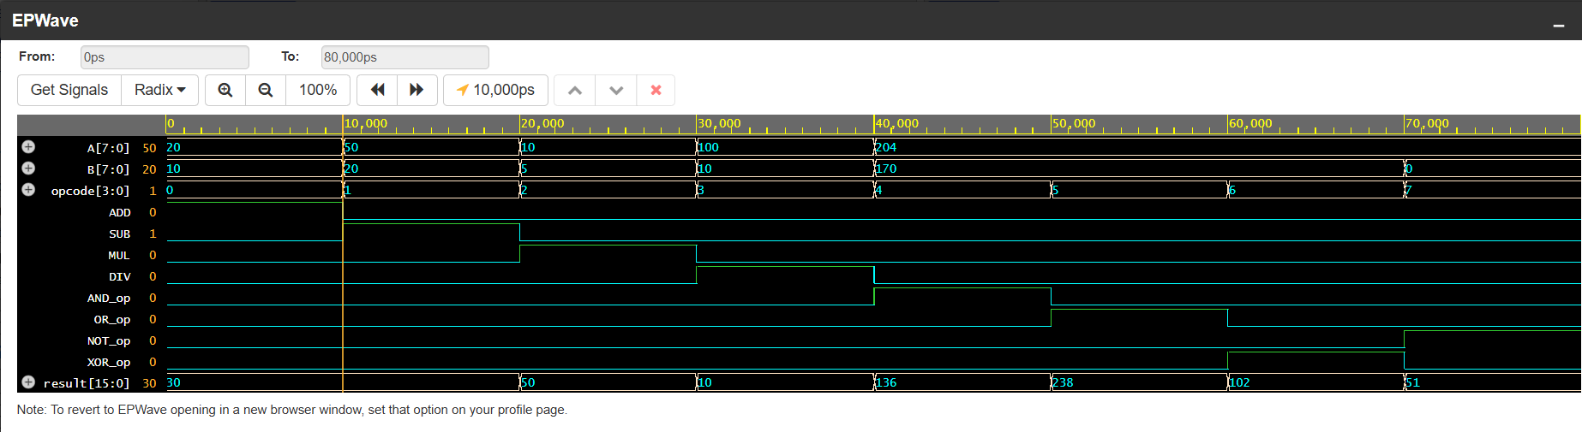
Figure 2.5 EP wave generation of the 8x8 sequential multiplier

3.2. Member Project Links

3.3 SUMMARY
The project, titled “Digital Calculator Using ALU,” focuses on designing an 8-bit digital calculator using System Verilog. It performs eight arithmetic and logical operations: addition, subtraction, multiplication, division, AND, OR, XOR, and NOT, selected using a 4-bit opcode. The ALU accepts two 8-bit inputs, A and B, and produces a 16-bit result. It also includes four status flags: Zero Flag, Carry Flag, Borrow Flag, and Division-by-Zero Flag to indicate specific conditions during operation. The design is simulated using Cadence Xcelium through EDA Playground. A separate testbench verifies all eight operations, and the results are observed using EPWave waveforms.
Overall, this project provides practical knowledge of SystemVerilog programming, ALU design, combinational logic, opcode-based operation selection, and functional verification, demonstrating the fundamental concepts used in digital hardware systems.

CHAPTER 4
CONCLUSION AND FUTURE SCOPE
The design and functional verification of the proposed 8-bit Digital Calculator using an Arithmetic Logic Unit (ALU) demonstrate the application of SystemVerilog in developing a multifunctional digital computing system. The project focuses on implementing a combinational ALU capable of performing arithmetic and logical operations based on a 4-bit opcode. Two 8-bit input operands, A and B, are processed to generate the corresponding 16-bit result.
The ALU supports eight operations: addition, subtraction, multiplication, division, bitwise AND, bitwise OR, bitwise XOR, and bitwise NOT. Each operation is selected using a unique opcode through case-based selection logic. The design also incorporates internal status flags, including Zero Flag, Carry Flag, Borrow Flag, and Division-by-Zero Flag, to monitor arithmetic conditions and identify exceptional cases.
The RTL design was developed using SystemVerilog and functionally verified using Cadence Xcelium through the EDA Playground platform. A dedicated testbench was developed to apply different input combinations and opcode values to verify all eight operations. The simulation waveforms were analyzed using EPWave to observe the input operands, opcode, operation indicator signals, and corresponding result output.
Functional simulation confirmed the correct execution of the implemented arithmetic and logical operations for the tested input combinations. The 16-bit result output provides sufficient width to accommodate the maximum product of two unsigned 8-bit operands. The internal status flags further enhance the design by indicating zero results, carry generation, subtraction borrow, and division-by-zero conditions.
Overall, the project demonstrates the implementation of an opcode-controlled combinational datapath and provides practical knowledge of RTL coding, ALU architecture, SystemVerilog programming, functional verification, and waveform analysis. It establishes a foundation for developing more complex digital systems and processor-based architectures.

FUTURE SCOPE
Future enhancements can focus on improving the functionality, scalability, and implementation efficiency of the proposed ALU. The existing 8-bit architecture can be extended to 16-bit or 32-bit data widths to support larger operand sizes and evaluate the scalability of the design.
Additional arithmetic and logical operations, such as modulus, increment, decrement, logical shifts, arithmetic shifts, and rotate operations, can be incorporated by extending the opcode decoding logic. Advanced status flags, such as Sign Flag and Overflow Flag, can also be implemented to provide additional information about arithmetic operations.
The combinational RTL design can be synthesized using industry-standard EDA tools to generate a gate-level netlist and evaluate hardware parameters such as cell area, propagation delay, and power consumption. Logic optimization techniques can be explored to improve the overall performance and efficiency of the ALU.
Furthermore, the design can be implemented on an FPGA using Xilinx Vivado to validate its functionality on physical hardware. The RTL design can also be integrated into a larger processor data path, enabling its application in arithmetic processing units, embedded systems, and digital computing architectures.
The project establishes a strong foundation in SystemVerilog-based digital design and provides practical exposure to the fundamental concepts involved in VLSI design and verification.

REFERENCES
1. IEEE, IEEE Standard for SystemVerilog—Unified Hardware Design, Specification, and Verification Language, IEEE Std 1800-2023, 2023.
2. S. Palnitkar, Verilog HDL: A Guide to Digital Design and Synthesis, 2nd ed., Prentice Hall, 2003.
3. M. Morris Mano and Michael D. Ciletti, Digital Design, 5th ed., Pearson, 2013.
4. J. F. Wakerly, Digital Design: Principles and Practices, 4th ed., Pearson, 2005.

