**RFID RC522 Attendance System Using Arduino with Data Logger**

In this project, we have designed RFID RC522 Based Attendance System Using Arduino with Data Logger. MFRC522 RFID Reader is a very simple yet effective module. It is an RFID module and is used for scanning RFID cards. It’s a new technology and is expanding day by day. Nowadays it is extensively used in offices where employees have issued an RFID card and their attendance is marked when they touch their card to the RFID reader. We have seen it in many movies that when someone places one’s card over some machine then the door opens or closes. In short, its a new emerging technology which is quite useful.

### ****Bill of Materials****

[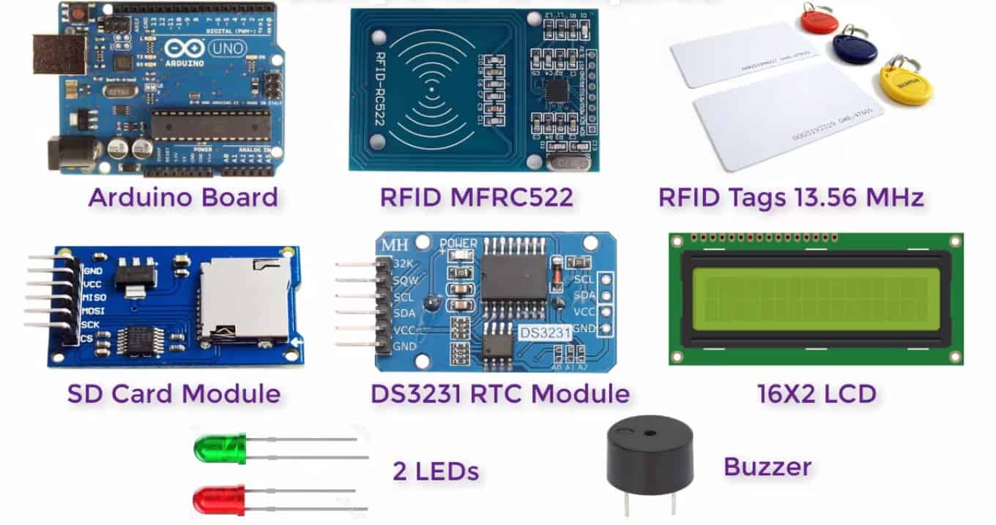](https://how2electronics.com/wp-content/uploads/2019/05/Components-for-RFID-Attendance-System-1.jpg)

### ****RFID MFRC522 Module****

RC522 – RFID Reader / Writer 13.56MHz with Cards Kit includes a 13.56MHz RF reader cum writer module that uses an RC522 IC and two S50 RFID cards. The MF RC522 is a highly integrated transmission module for contactless communication at 13.56 MHz. RC522 supports ISO 14443A/MIFARE mode.

[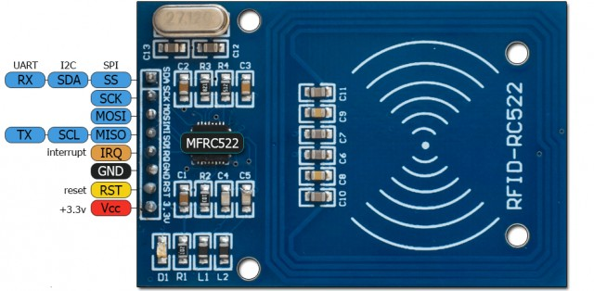](https://how2electronics.com/wp-content/uploads/2019/05/NFC-RC522-Module-for-Arduino.jpg)

RC522 – RFID Reader features an outstanding modulation and demodulation algorithm to serve effortless RF communication at 13.56 MHz. The S50 RFID Cards will ease up the process helping you to learn and add the 13.56 MHz RF transition to your project.

The following table shows the connection between Arduino UNO & RFID MFRC522:

[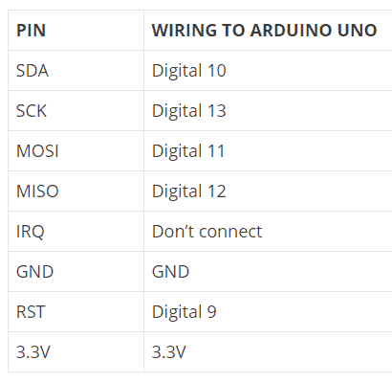](https://how2electronics.com/wp-content/uploads/2019/05/mfrc522.png)

**Note:** different Arduino boards have different SPI pins. If you’re using another Arduino board, check the Arduino documentation.

**DS3231 RTC Module**

RTC means Real-Time Clock. RTC modules are simply TIME and DATE remembering systems that have battery setup which in the absence of external power keeps the module running. This keeps the TIME and DATE up to date. So we can have accurate TIME and DATE from the RTC module whenever we want.

[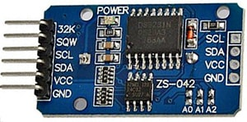](https://how2electronics.com/wp-content/uploads/2019/05/cheaprtc.jpg)

DS3231 is a six terminal device, out of the two pins are not compulsory to use. It works on I2C Communication Protocols with SDA and SCL pins. So we have mainly four pins.</p

The following table shows the connection between Arduino UNO & DS3231 Module:

[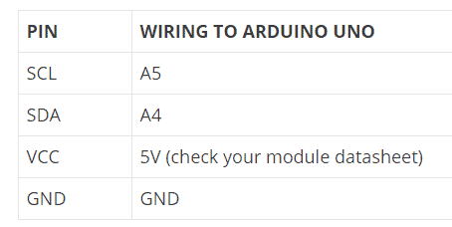](https://how2electronics.com/wp-content/uploads/2019/05/rtc.png)

**Note:** different Arduino boards have different I2C pins. If you’re using another Arduino board, check the Arduino documentation.

### ****Circuit Diagram & Connection****

The circuit for this project RFID RC522 Based Attendance System Using Arduino with Data Logger is shown in the circuit schematics below.

In this circuit there are 3.3V and 5V devices, make sure you wire them correctly. Also, if you’re using different modules, check the recommend voltage before powering the circuit. Wire one module at a time and follow the pinout tables if needed.

[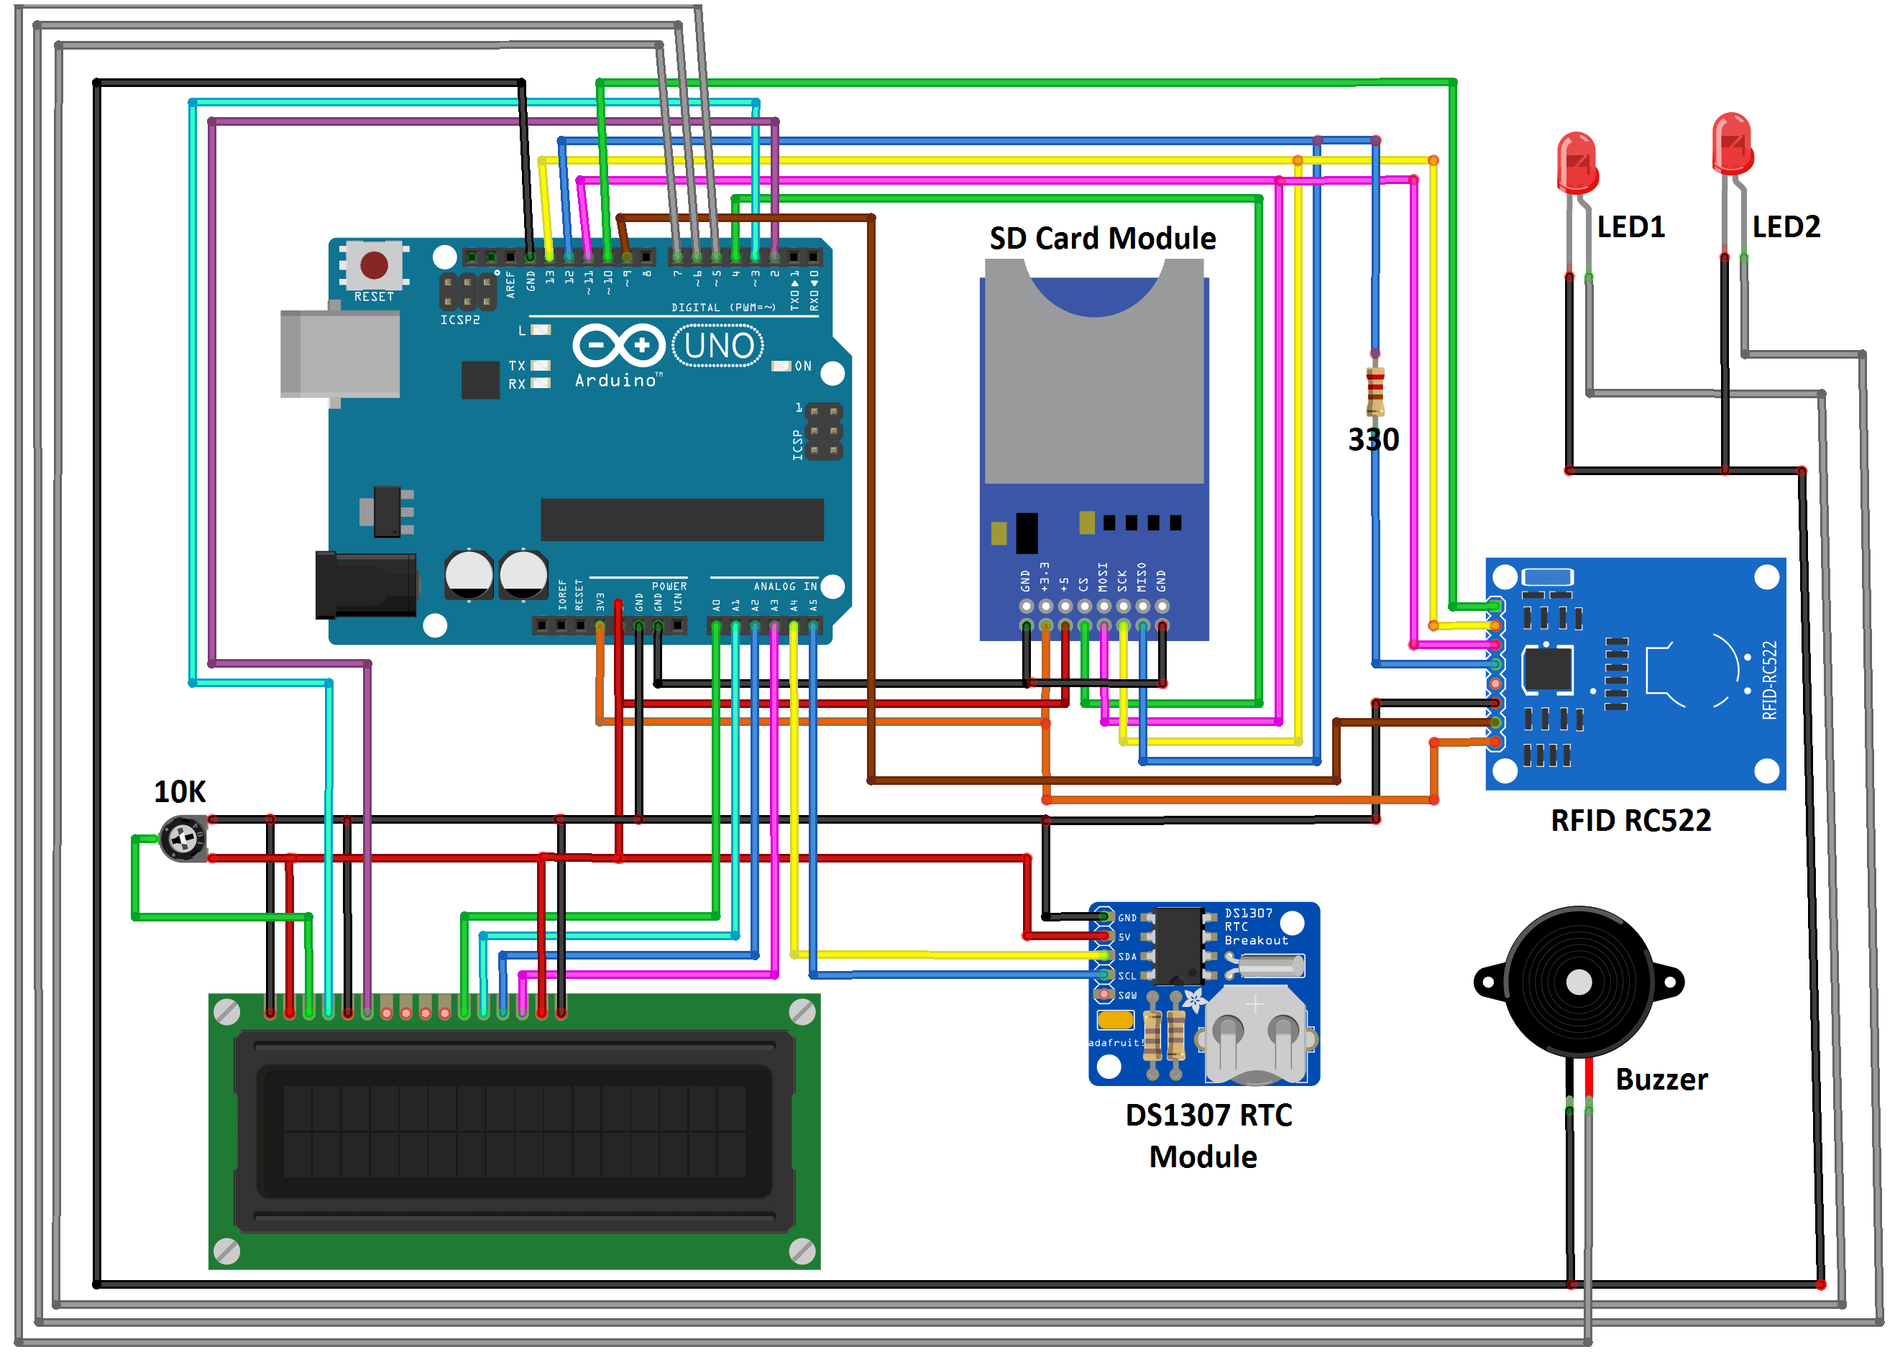](https://how2electronics.com/wp-content/uploads/2019/05/Circuit-Diagram.png)

**PROCEDURE:**

1.Connect the Circuit as per circuit diagram.

2.Download the all libraries and Extract those libraries and include to Arduino ide.

3.Open the Arduino Ide and paste the source code(Available in Git).

4.Please include the all libraries. If not included it may generate the Error.

5.Please comment the Serial port commands ex: ( //Serial.begin(9600);, //Serial.println(“…..”);)

Because if we are including the both Serial.print and Lcd.print both are same class so they are over lapping. Output on LCD display it will show some characters.

6.Compile the code and upload to the Arduino.

7.Take the small buzzer and connect positive to the 8pin of the Arduino(D8) and negative to GND.

8.Please check the Output. 😊

9.If you want to save the output on Excel sheet ?

10.Please uncomment the Serial port commands

11.Downlaod the “ArduSpreadsheet.1.1.zip” from the git.

12.Please extract the zip file and Open file



13.Goto /c/users/…/Documents/Arduino Create the new folder (Tools)



14.Copy the Extracted file

And paste in Tools folder



15.That Tool will be appear on the Arduino ide tools

16.Click on the tool and Connect to the port

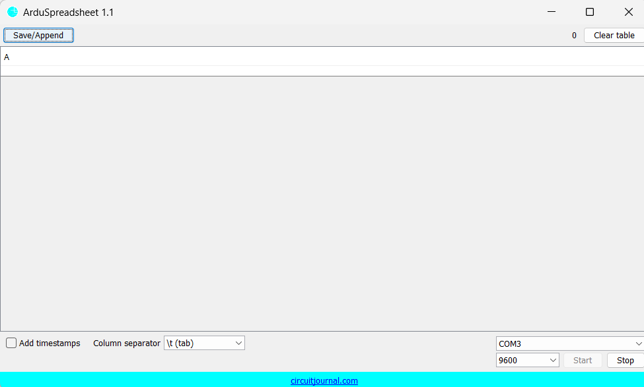

17.Data will appear on the window.

18.Save the output and Excel.

THANK YOU