
Republic of the Philippines
BATANGAS STATE UNIVERSITY
The National Engineering University
ARASOF-Nasugbu Campus
R. Martinez St., Brgy. Bucana, Nasugbu, Batangas, Philippines 4231
Tel Nos.: (+63 43) 416-0350 local 207
E-mail Address: cics.nasugbu@g.batstate-u.edu.ph | Website Address: http://www.batstate-u.edu.ph

College of Informatics and Computing Sciences

DEAN’S HONORS LIST APPLICATION FORM

A student’s scholastic achievement is recognized by the publication of the Dean’s Honors List (DHL) every semester of each school year.

The applicant must:
- apply at the end of the semester;
- be enrolled in the required academic load prescribed by the program;
- have no grade lower than 2.50 in any course;
- have no failed, dropped or withdrawn grade;
- have not committed any major offense during the semester of application;
- not include NSTP in the computation of General Weighted Average (GWA);
- not be enrolled in OJT in the previous semester (semester of application); and
- have obtained an average rating as follows:
Reference Formula

WA = total WG/total units

WA = Weighted Average
WG = Weighted Grade

Tech Savant : GWA of 1.0000 to 1.2500
Tech Virtuoso : GWA of 1.2501 to 1.5000
Tech Prodigy : GWA of 1.5001 to 1.7500

REPORT OF RATINGS
First Semester, AY 2024 - 2025

Name: MENDOZA KARLO MATEO C.
Last First M.I.
Contact Number: 09665530679
Course: BACHELOR OF SCIENCE IN INFORMATION TECHNOLOGY
Yr./Sec.: FOURTH Track: BUSINESS ANALYTICS
Scholarship Grant: HIGHER EDUCATION SUPPORT PROGRAM

COURSES | FINAL GRADE | UNITS | WEIGHTED GRADE
BAT 405 Analytics Application | 1.25 | 3 | 3.75
CS 423 Social Issues and Professional Practice | 1.25 | 3 | 3.75
ENGG 405 Technopreneurship | 2.25 | 3 | 6.75
IT 411 Capstone Project 2 | 2.00 | 3 | 6.00
IT 412 Platform Technologies | 1.75 | 3 | 5.25
IT 413 Advanced Information Assurance and Security | 1.50 | 3 | 4.50
IT 414 Systems Quality Assurance | 1.25 | 3 | 3.75
TOTAL |  | 21 | 33.75
WEIGHTED AVERAGE |  | 1.6071
RANK |  | Tech Prodigy

Attached herewith are the photocopy of my Certificate of Registration and Copy of Grades.
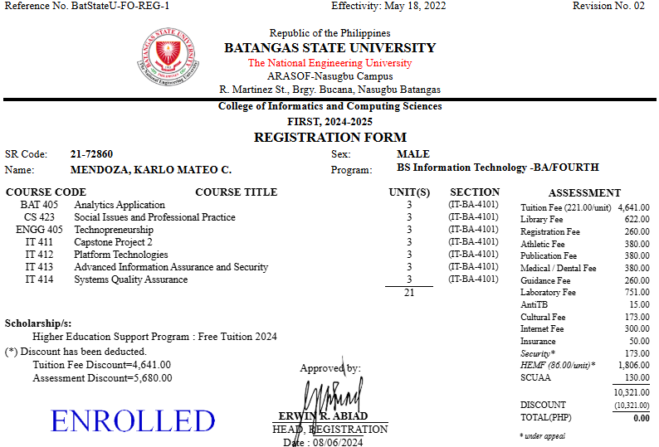

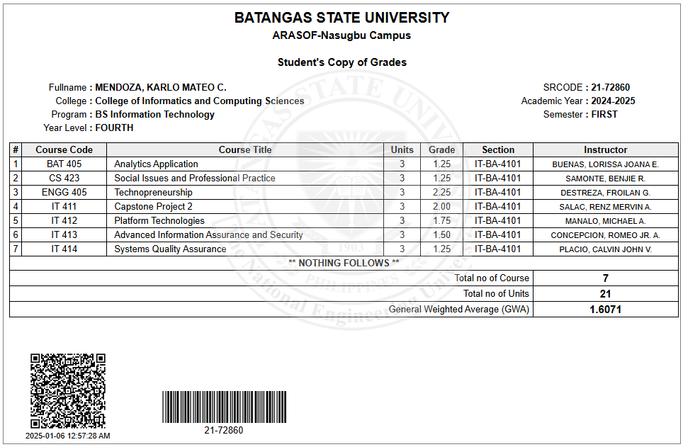

INFORMED CONSENT DECLARATION
Directions: Kindly check the box to signify your consent in the following statements:
- I have read and understand the terms and conditions of applying in the CICS DHL
- I grant permission for the forms and documents to be recorded and saved for the purpose of review by the CICS
- I grant permission for the data generated from the documents and forms (online and offline) to be posted in the CICS Facebook group including my name, program, photo, year level and section, rank, and rating/GWA

Submitted by: KARLO MATEO C. MENDOZA _________________
BSIT BA - 4101 Date

Verified by: Asst. Prof. BENJIE R. SAMONTE ________________
Department Chairperson, ITE Programs Date

Approved by: Dr. LORISSA JOANA E. BUENAS ________________
Dean, CICS Date

