**Exercise 2: E-commerce Platform Search Function**

package ecommerce_platform;

import java.util.Arrays;

import java.util.Comparator;

class Product {

int productId;

String productName;

String category;

public Product(int productId, String productName, String category) {

this.productId = productId;

this.productName = productName;

this.category = category;

}

public static int linearSearch(Product[] products, String targetName) {

for (int i = 0; i < products.length; i++) {

if (products[i].productName.equalsIgnoreCase(targetName)) {

return i;

}

}

return -1;

}

public static int binarySearch(Product[] products, String targetName) {

Arrays.*sort*(products, Comparator.*comparing*(p -> p.productName.toLowerCase())); // Ensure sorted

int left = 0, right = products.length - 1;

while (left <= right) {

int mid = left + (right - left) / 2;

int comparison = products[mid].productName.compareToIgnoreCase(targetName);

if (comparison == 0)

return mid;

else if (comparison < 0)

left = mid + 1;

else

right = mid - 1;

}

return -1;

}

public static void main(String[] args) {

Product[] products = {

new Product(101, "Laptop", "Electronics"),

new Product(102, "Shoes", "Fashion"),

new Product(103, "Book", "Stationery"),

new Product(104, "Camera", "Electronics")

};

int indexLinear = *linearSearch*(products, "Camera");

System.***out***.println("Linear Search Index: " + indexLinear);

int indexBinary = *binarySearch*(products, "Camera");

System.***out***.println("Binary Search Index: " + indexBinary);

}

}

Output:

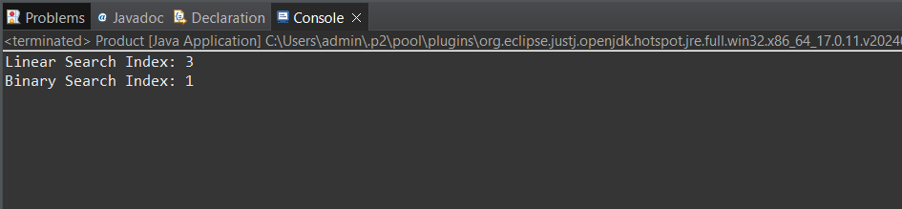

**Exercise 7: Financial Forecasting**

package financial_forecast.java;

public class FinancialForecasting {

public static double futureValue(double presentValue, double growthRate, int years) {

if (years == 0) {

return presentValue;

}

return *futureValue*(presentValue, growthRate, years - 1) * (1 + growthRate);

}

public static void main(String[] args) {

double presentValue = 10000;

double growthRate = 0.08;

int years = 5;

double result = *futureValue*(presentValue, growthRate, years);

System.***out***.printf("Predicted value after %d years: ₹%.2f\n", years, result);

}

}

Output