3. PLSQL Programming Exercises

# Exercise: 1: Conditional Statements

**Scenario 1**: The bank wants to apply a discount to loan interest rates for customers above 60 years old.

**Question**: Write a PL/SQL block that loops through all customers, checks their age, and if they are above 60, apply a 1% discount to their current loan interest rates.

SET SERVEROUT ON;

BEGIN

    FOR customer_rec IN (

        SELECT C.CustomerID, C.Name, C.DOB, L.LoanID, L.InterestRate

        FROM Customers C

        JOIN Loans L ON C.CustomerID = L.CustomerID

    ) LOOP

        IF MONTHS_BETWEEN(SYSDATE, customer_rec.DOB)/12 > 60 THEN

            UPDATE Loans

            SET InterestRate = InterestRate - 1

            WHERE LoanID = customer_rec.LoanID;

            DBMS_OUTPUT.PUT_LINE('1% discount applied to ' || customer_rec.Name);

        END IF;

    END LOOP;

    COMMIT;

END;

/

Output

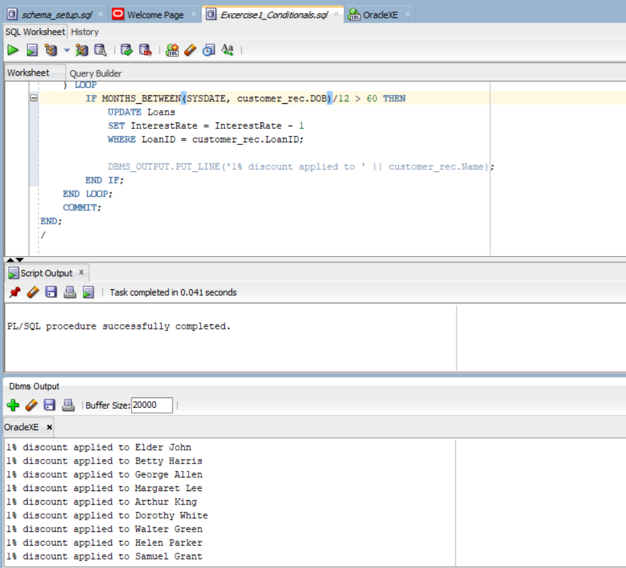

**Scenario 2:** A customer can be promoted to VIP status based on their balance.

**Question:** Write a PL/SQL block that iterates through all customers and sets a flag IsVIP to TRUE for those with a balance over $10,000.

ALTER TABLE Customers ADD IsVIP VARCHAR2(5);

BEGIN

    FOR Cust IN (

    SELECT CustomerID, Name, Balance From Customers ) LOOP

    IF cust.balance>1000 THEN

         UPDATE Customers

         SET IsVIP='True'

         WHERE CustomerID=cust.CustomerID;

         DBMS_OUTPUT.PUT_LINE(cust.Name || 'promoted to VIP');

    ELSE

        DBMS_OUTPUT.PUT_LINE(cust.Name || ' not elligible to VIP');

    END IF;

   END LOOP;

   COMMIT;

END;

/

Output:

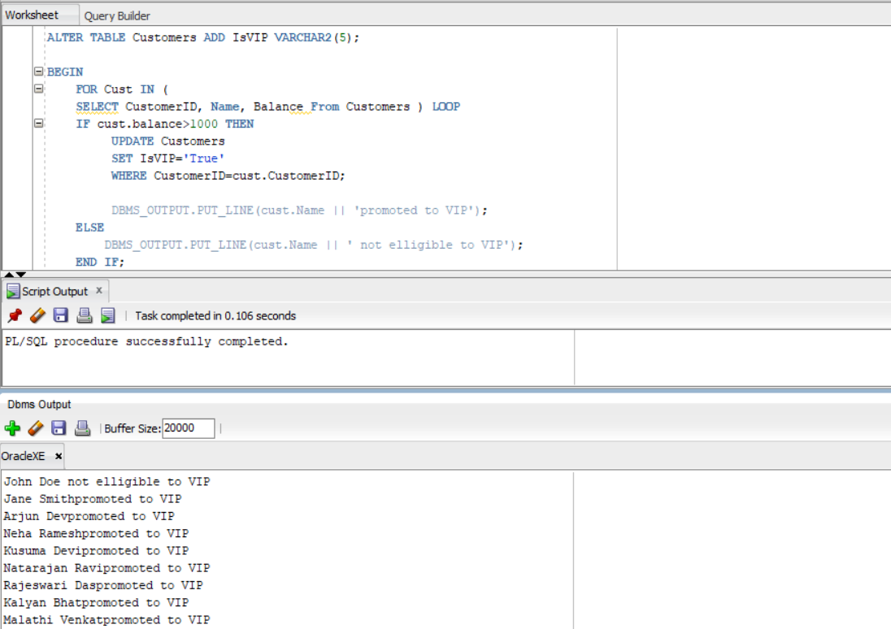

**Scenario 3:** The bank wants to send reminders to customers whose loans are due within the next 30 days.

**Question:** Write a PL/SQL block that fetches all loans due in the next 30 days and prints a reminder message for each customer.

BEGIN

    For rec in (SELECT  L.LoanID, L.CustomerID, C.Name, L.EndDate

    FROM Loans L

    JOIN Customers C

    On L.CustomerID=C.CustomerID

    WHERE L.EndDate BETWEEN SYSDATE AND SYSDATE+30

    ) LOOP

    DBMS_OUTPUT.PUT_LINE('Reminder: Loan ID ' || rec.LoanID ||

                             ' for customer ' || rec.Name ||

                             ' is due on ' || TO_CHAR(rec.EndDate, 'DD-MON-YYYY'));

     END LOOP;

    END;

/

Output

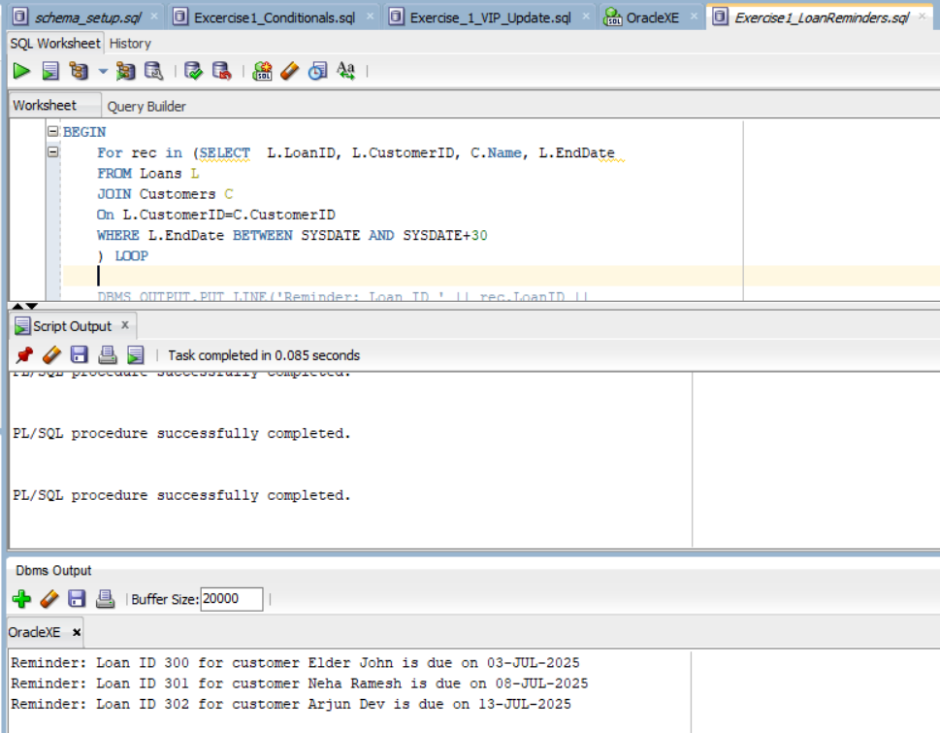

# Exercise: 2: Error Handling

**Scenario 1:** Handle exceptions during fund transfers between accounts.

**Question:** Write a stored procedure **SafeTransferFunds** that transfers funds between two accounts. Ensure that if any error occurs (e.g., insufficient funds), an appropriate error message is logged and the transaction is rolled back.

CREATE OR REPLACE PROCEDURE SafeTransferFunds (

    p_from_account IN NUMBER,

    p_to_account IN NUMBER,

    p_amount IN NUMBER

) IS

    v_balance NUMBER;

BEGIN

    -- Check balance of source account

    SELECT Balance INTO v_balance

    FROM Accounts

    WHERE AccountID = p_from_account;

    -- Raise error if balance is insufficient

    IF v_balance < p_amount THEN

        RAISE_APPLICATION_ERROR(-20001, 'Insufficient funds in source account.');

    END IF;

    -- Deduct from source account

    UPDATE Accounts

    SET Balance = Balance - p_amount

    WHERE AccountID = p_from_account;

    -- Add to destination account

    UPDATE Accounts

    SET Balance = Balance + p_amount

    WHERE AccountID = p_to_account;

    COMMIT;

    DBMS_OUTPUT.PUT_LINE('Funds transferred successfully.');

EXCEPTION

    WHEN NO_DATA_FOUND THEN

        DBMS_OUTPUT.PUT_LINE('Error: One of the accounts does not exist.');

        ROLLBACK;

    WHEN OTHERS THEN

        DBMS_OUTPUT.PUT_LINE('Error: ' || SQLERRM);

        ROLLBACK;

END;

/

BEGIN

    SafeFundsTransfer(1, 2, 1000);

END;

/

BEGIN

    SafeFundsTransfer(3, 2, 1000);

END;

/

Output:

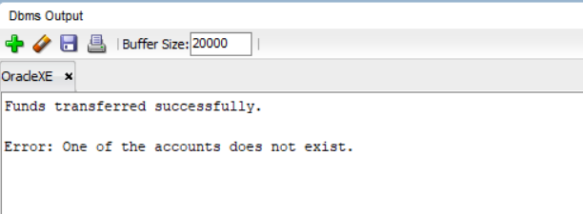

**Scenario 2:** Manage errors when updating employee salaries.

**Question:** Write a stored procedure **UpdateSalary** that increases the salary of an employee by a given percentage. If the employee ID does not exist, handle the exception and log an error message.

CREATE OR REPLACE PROCEDURE UpdateSalary (

    p_emp_id IN NUMBER,

    p_percent IN NUMBER

) IS

BEGIN

    -- Update salary with percentage

    UPDATE Employees

    SET Salary = Salary + (Salary * p_percent / 100)

    WHERE EmployeeID = p_emp_id;

    -- Raise error if no employee found

    IF SQL%ROWCOUNT = 0 THEN

        RAISE_APPLICATION_ERROR(-20002, 'Employee ID not found.');

    END IF;

    COMMIT;

    DBMS_OUTPUT.PUT_LINE('Salary updated successfully.');

EXCEPTION

    WHEN OTHERS THEN

        DBMS_OUTPUT.PUT_LINE('Error: ' || SQLERRM);

        ROLLBACK;

END;

/

BEGIN

    UpdateSalary(4, 15);  -- Meera

    UpdateSalary(5, 5);   -- Rahul

    UpdateSalary(6, 0);   -- Divya

END;

/

Output: 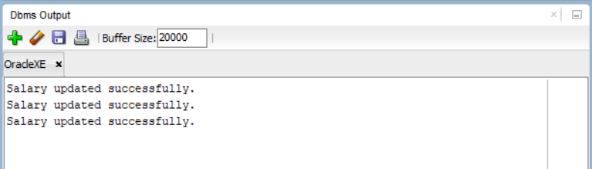

**Scenario 3:** Ensure data integrity when adding a new customer.

**Question:** Write a stored procedure **AddNewCustomer** that inserts a new customer into the Customers table. If a customer with the same ID already exists, handle the exception by logging an error and preventing the insertion.

CREATE OR REPLACE PROCEDURE AddNewCustomer(

    p_id IN NUMBER,

    p_name IN VARCHAR2,

    p_dob IN DATE,

    p_balance IN NUMBER

) IS

BEGIN

    INSERT INTO Customers(CustomerID, Name, DOB, Balance, LastModified)

    VALUES(p_id,p_name,p_dob,p_balance,SYSDATE);

    COMMIT;

    DBMS_OUTPUT.PUT_LINE('Customer Added Successfully');

EXCEPTION

    WHEN DUP_VAL_ON_INDEX THEN

    DBMS_OUTPUT.PUT_LINE('Error: A customer with the same ID already exists.');

    ROLLBACK;

    WHEN OTHERS THEN

    DBMS_OUTPUT.PUT_LINE('Error: '||SQLERRM);

    ROLLBACK;

END;

/

BEGIN

    AddNewCustomer(121, 'Deepa Menon', TO_DATE('1993-07-24', 'YYYY-MM-DD'), 9200);

END;

/

Output:

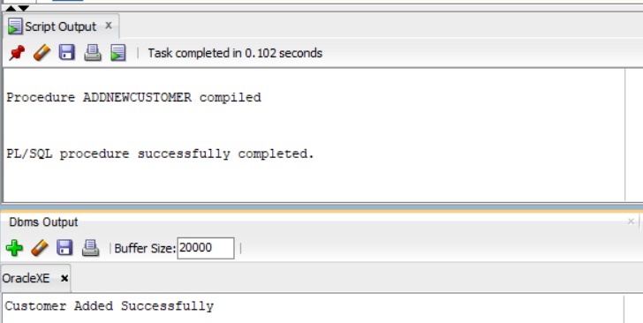

# Exercise: 3: Stored Procedures

**Scenario 1:**The bank needs to process monthly interest for all savings accounts.

**Question:** Write a stored procedure **ProcessMonthlyInterest** that calculates and updates the balance of all savings accounts by applying an interest rate of 1% to the current balance.

CREATE OR REPLACE PROCEDURE ProcessMonthlyInterest IS

BEGIN

     UPDATE Accounts

     SET BALANCE = BALANCE+(BALANCE*0.01)

     WHERE AccountType='Savings';

     COMMIT;

     DBMS_OUTPUT.PUT_LINE('Monthly Interest Applied to all Savings Account');

EXCEPTION

     WHEN OTHERS THEN

           DBMS_OUTPUT.PUT_LINE('Error applying monthly Interest'||SQLERRM);

           ROLLBACK;

END;

/

EXEC ProcessMonthlyInterest;

Output:

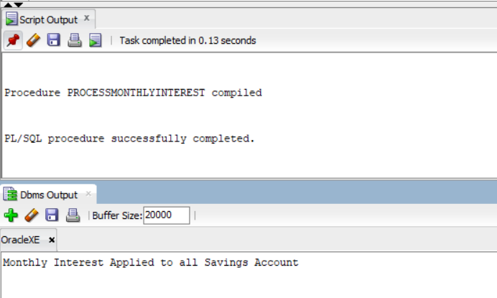

**Scenario 2:**The bank wants to implement a bonus scheme for employees based on their performance.

**Question:** Write a stored procedure **UpdateEmployeeBonus** that updates the salary of employees in a given department by adding a bonus percentage passed as a parameter.

CREATE OR REPLACE PROCEDURE UpdateEmployeeBonus (

    p_emp_id IN NUMBER,

    p_bonus_percent IN NUMBER

) IS

BEGIN

    UPDATE Employees

    SET Salary = Salary + (Salary * p_bonus_percent / 100)

    WHERE EmployeeID = p_emp_id;

    IF SQL%ROWCOUNT = 0 THEN

        DBMS_OUTPUT.PUT_LINE('No employee found with ID: ' || p_emp_id);

    ELSE

        DBMS_OUTPUT.PUT_LINE('Bonus applied to employee ID: ' || p_emp_id);

    END IF;

    COMMIT;

EXCEPTION

    WHEN OTHERS THEN

        DBMS_OUTPUT.PUT_LINE('Error updating bonus: ' || SQLERRM);

        ROLLBACK;

END;

/

EXEC UpdateEmployeeBonus(2, 10);

EXEC UpdateEmployeeBonus(5, 10);

Output:

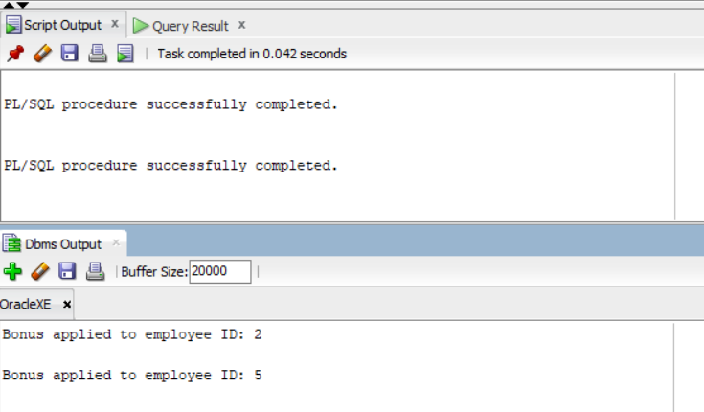

**Scenario 3:**Customers should be able to transfer funds between their accounts.

**Question:** Write a stored procedure **TransferFunds** that transfers a specified amount from one account to another, checking that the source account has sufficient balance before making the transfer.

CREATE OR REPLACE PROCEDURE TransferFunds (

    p_from_account IN NUMBER,

    p_to_account IN NUMBER,

    p_amount IN NUMBER

) IS

    v_balance NUMBER;

    v_trans_id NUMBER;

BEGIN

    SELECT Balance INTO v_balance FROM Accounts WHERE AccountID = p_from_account;

    IF v_balance < p_amount THEN

        RAISE_APPLICATION_ERROR(-20001, 'Insufficient balance in source account.');

    END IF;

    UPDATE Accounts SET Balance = Balance - p_amount WHERE AccountID = p_from_account;

    UPDATE Accounts SET Balance = Balance + p_amount WHERE AccountID = p_to_account;

    SELECT NVL(MAX(TransactionID), 0) + 1 INTO v_trans_id FROM Transactions;

    INSERT INTO Transactions (TransactionID, AccountID, TransactionDate, Amount, TransactionType)

    VALUES (v_trans_id, p_from_account, SYSDATE, p_amount, 'DEBIT');

    SELECT v_trans_id + 1 INTO v_trans_id FROM DUAL;

    INSERT INTO Transactions (TransactionID, AccountID, TransactionDate, Amount, TransactionType)

    VALUES (v_trans_id, p_to_account, SYSDATE, p_amount, 'CREDIT');

    COMMIT;

    DBMS_OUTPUT.PUT_LINE('Funds transferred and transactions recorded successfully.');

EXCEPTION

    WHEN NO_DATA_FOUND THEN

        DBMS_OUTPUT.PUT_LINE('Error: One of the accounts does not exist.');

        ROLLBACK;

    WHEN OTHERS THEN

        DBMS_OUTPUT.PUT_LINE('Error: ' || SQLERRM);

        ROLLBACK;

END;

/

BEGIN

    TransferFunds(2, 1, 10);

END;

/

Output:

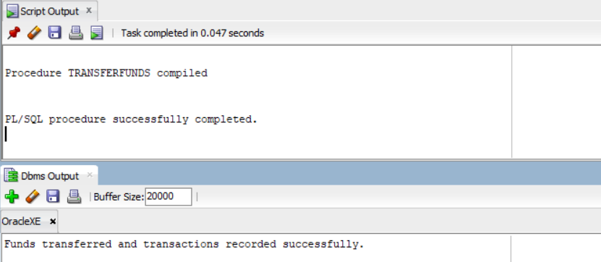

# Exercise: 4: Functions

**Scenario 1:** Calculate the age of customers for eligibility checks.

**Question:** Write a function CalculateAge that takes a customer's date of birth as input and returns their age in years.

CREATE OR REPLACE FUNCTION CalculateAge(p_dob DATE)

RETURN NUMBER IS

    v_age NUMBER;

BEGIN

    v_age := FLOOR(MONTHS_BETWEEN(SYSDATE, p_dob)/12);

    DBMS_OUTPUT.PUT_LINE('All Customer Ages are computed and Returned');

    RETURN v_age;

END;

/

Output:

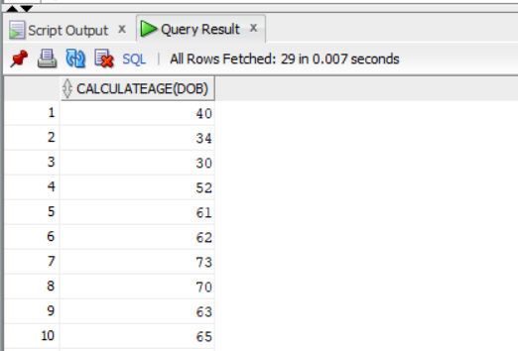

**Scenario 2:**The bank needs to compute the monthly installment for a loan.

**Question:** Write a function **CalculateMonthlyInstallment** that takes the loan amount, interest rate, and loan duration in years as input and returns the monthly installment amount.

CREATE OR REPLACE FUNCTION CalculateMonthlyInstallment(

         p_loan_amount NUMBER,

         p_annual_rate NUMBER,

         p_years NUMBER

) RETURN NUMBER IS

     v_monthly_rate NUMBER;

     v_months NUMBER;

     v_installment NUMBER;

BEGIN

    v_monthly_rate:=p_annual_rate/12/100;

    v_months:=p_years*12;

    IF v_monthly_rate = 0 THEN

        v_installment:=p_loan_amount/v_months;

    ELSE

        v_installment := (p_loan_amount * v_monthly_rate) /

                         (1 - POWER(1 + v_monthly_rate, -v_months));

    END IF;

    RETURN ROUND(v_installment,2);

   END;

/

SELECT CalculateMonthlyInstallment(500000, 8.5, 10) FROM DUAL;

SELECT CalculateMonthlyInstallment(500000, 8.5, 6) FROM DUAL;

Output:

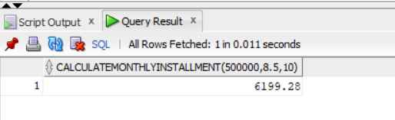

**Scenario 3:**Check if a customer has sufficient balance before making a transaction.

**Question:** Write a function **HasSufficientBalance** that takes an account ID and an amount as input and returns a boolean indicating whether the account has at least the specified amount.

CREATE OR REPLACE FUNCTION HasSufficientBalance(

    p_account_id IN NUMBER,

    p_amount IN NUMBER

) RETURN BOOLEAN IS

    v_balance NUMBER;

BEGIN

    SELECT Balance INTO v_balance FROM Accounts WHERE AccountID = p_account_id;

    IF v_balance >= p_amount THEN

        DBMS_OUTPUT.PUT_LINE('Sufficient balance available.');

        RETURN TRUE;

    ELSE

        DBMS_OUTPUT.PUT_LINE('Insufficient balance.');

        RETURN FALSE;

    END IF;

EXCEPTION

    WHEN NO_DATA_FOUND THEN

        DBMS_OUTPUT.PUT_LINE('Account not found.');

        RETURN FALSE;

    WHEN OTHERS THEN

        DBMS_OUTPUT.PUT_LINE('Unexpected error: ' || SQLERRM);

        RETURN FALSE;

END;

/

DECLARE

    v_result BOOLEAN;

BEGIN

    v_result := HasSufficientBalance(1, 5);

    IF v_result THEN

        DBMS_OUTPUT.PUT_LINE(' Function returned: TRUE');

    ELSE

        DBMS_OUTPUT.PUT_LINE(' Function returned: FALSE');

    END IF;

END;

/

Output:

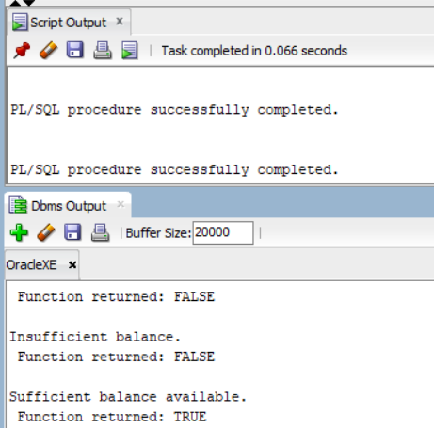

# Exercise: 5: Triggers

**Scenario 1:** Automatically update the last modified date when a customer's record is updated.

**Question:** Write a trigger **UpdateCustomerLastModified** that updates the LastModified column of the Customers table to the current date whenever a customer's record is updated.

CREATE OR REPLACE TRIGGER UpdateCustomerModified

BEFORE UPDATE ON Customers

FOR EACH ROW

BEGIN

     :NEW.LastMODIFIED := SYSDATE;

END;

/

UPDATE Customers

SET Name = 'Updated Name'

WHERE CustomerID = 1;

SELECT Name,LastModified FROM Customers WHERE CustomerID = 1;

DECLARE

    v_result BOOLEAN;

BEGIN

    v_result := HasSufficientBalance(1, 5);

    IF v_result THEN

        DBMS_OUTPUT.PUT_LINE(' Function returned: TRUE');

    ELSE

        DBMS_OUTPUT.PUT_LINE(' Function returned: FALSE');

    END IF;

END;

/

Output:

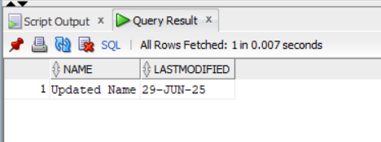

**Scenario 2:** Maintain an audit log for all transactions.

**Question:** Write a trigger **LogTransaction** that inserts a record into an AuditLog table whenever a transaction is inserted into the Transactions table.

CREATE TABLE AuditLogs (

    LogID NUMBER GENERATED ALWAYS AS IDENTITY PRIMARY KEY,

    TransactionID NUMBER,

    AccountID NUMBER,

    TransactionDate DATE,

    Amount NUMBER,

    TransactionType VARCHAR2(10),

    LoggedAt DATE DEFAULT SYSDATE

);

CREATE OR REPLACE TRIGGER LogTransaction

AFTER INSERT ON Transactions

FOR EACH ROW

BEGIN

    INSERT INTO AuditLogs (TransactionID, AccountID, TransactionDate, Amount, TransactionType)

    VALUES (:NEW.TransactionID, :NEW.AccountID, :NEW.TransactionDate, :NEW.Amount, :NEW.TransactionType);

END;

/

SELECT * FROM Accounts WHERE AccountID = 410;

-- Create customer first if not exists

INSERT INTO Customers (CustomerID, Name, DOB, Balance, LastModified)

VALUES (101, 'John Tester', TO_DATE('1980-05-10', 'YYYY-MM-DD'), 5000, SYSDATE);

-- Now create the account

INSERT INTO Accounts (AccountID, CustomerID, AccountType, Balance, LastModified)

VALUES (201, 101, 'Savings', 10000, SYSDATE);

INSERT INTO Transactions (TransactionID, AccountID, TransactionDate, Amount, TransactionType)

VALUES (411, 201, SYSDATE, 500, 'DEPOSIT');

SELECT * FROM AuditLogs;

Output:

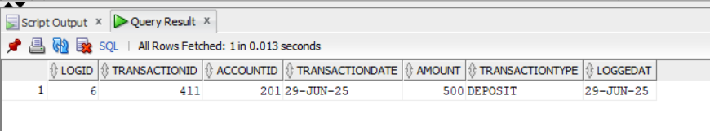

**Scenario 3:** Enforce business rules on deposits and withdrawals.

**Question:** Write a trigger **CheckTransactionRules** that ensures withdrawals do not exceed the balance and deposits are positive before inserting a record into the Transactions table.

CREATE OR REPLACE TRIGGER CheckTransactionRules

BEFORE INSERT ON Transactions

FOR EACH ROW

DECLARE

    v_balance NUMBER;

BEGIN

    SELECT Balance INTO v_balance FROM Accounts WHERE AccountID = :NEW.AccountID;

    IF :NEW.TransactionType = 'WITHDRAW' AND :NEW.Amount > v_balance THEN

        RAISE_APPLICATION_ERROR(-20001, 'Withdrawal exceeds available balance.');

    ELSIF :NEW.TransactionType = 'DEPOSIT' AND :NEW.Amount <= 0 THEN

        RAISE_APPLICATION_ERROR(-20002, 'Deposit amount must be positive.');

    END IF;

END;

/

INSERT INTO Transactions (TransactionID, AccountID, TransactionDate, Amount, TransactionType)

VALUES (103, 201, SYSDATE, 1000, 'DEPOSIT');

Output:

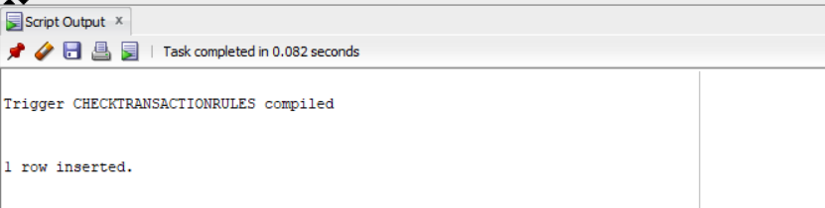

# Exercise: 6: Cursors

**Scenario 1:** Generate monthly statements for all customers.

**Question:** Write a PL/SQL block using an explicit cursor **GenerateMonthlyStatements** that retrieves all transactions for the current month and prints a statement for each customer.

DECLARE

      CURSOR trans_cursor IS

      SELECT C.CustomerID, C.Name, T.TransactionDate, T.Amount, T.TransactionType

      FROM Customers C

      JOIN Accounts A ON C.CustomerID=A.CustomerID

      JOIN Transactions T ON A.AccountID=T.AccountID

      WHERE TRUNC(T.TransactionDate,'MM') = TRUNC(SYSDATE,'MM');

BEGIN

FOR rec IN trans_cursor LOOP

       DBMS_OUTPUT.PUT_LINE('Customer: ' || rec.Name ||

                             ' | Date: ' || TO_CHAR(rec.TransactionDate, 'DD-MON-YYYY') ||

                             ' | Type: ' || rec.TransactionType ||

                             ' | Amount: ' || rec.Amount);

    END LOOP;

END;

/

Output:

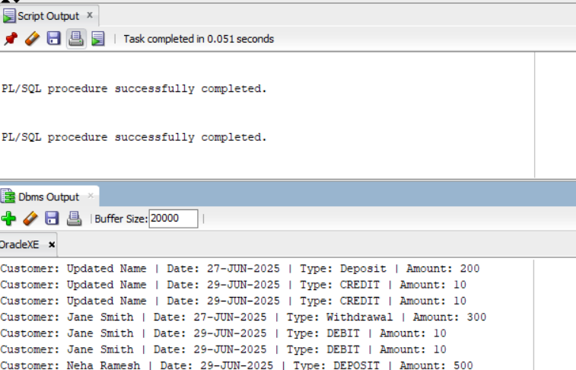

**Scenario 2:** Apply annual fee to all accounts.

**Question:** Write a PL/SQL block using an explicit cursor **ApplyAnnualFee** that deducts an annual maintenance fee from the balance of all accounts.

DECLARE

     CURSOR acc_cursor IS

        SELECT AccountID,Balance From Accounts;

BEGIN

    For rec in acc_cursor LOOP

        UPDATE Accounts

        SET BALANCE=BALANCE-250

        WHERE AccountID=rec.AccountID;

        DBMS_OUTPUT.PUT_LINE('Annual Fee of 250 applied to the Account ID:'||rec.AccountID);

        END LOOP;

        COMMIT;

    END;

/

Output:

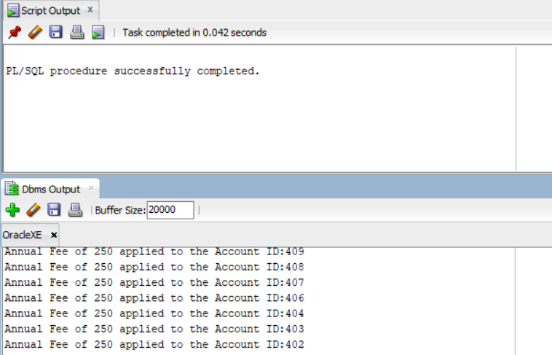

**Scenario 3:** Update the interest rate for all loans based on a new policy.

**Question:** Write a PL/SQL block using an explicit cursor **UpdateLoanInterestRates** that fetches all loans and updates their interest rates based on the new policy.

DECLARE

      CURSOR loan_cursor IS

            SELECT LoanID,InterestRate From Loans;

BEGIN

     For rec in loan_cursor LOOP

        UPDATE Loans

        SET InterestRate=rec.InterestRate+0.05

        WHERE LoanID=rec.LoanID;

        DBMS_OUTPUT.PUT_LINE('Loan ID: ' || rec.LoanID || ' updated with new interest rate: ' || (rec.InterestRate + 0.5));

    END LOOP;

END; /

Output:

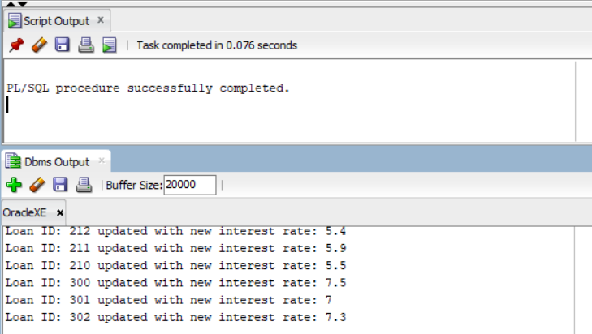

# Exercise: 7: Packages

**Scenario 1:** Group all customer-related procedures and functions into a package.

**Question:** Create a package **CustomerManagement** with procedures for adding a new customer, updating customer details, and a function to get customer balance.

CREATE OR REPLACE PACKAGE CustomerManagement AS

    PROCEDURE AddCustomer(p_id NUMBER, p_name VARCHAR2, p_dob DATE, p_balance NUMBER);

    PROCEDURE UpdateCustomer(p_id NUMBER, p_name VARCHAR2);

    FUNCTION GetCustomerBalance(p_id NUMBER) RETURN NUMBER;

END CustomerManagement;

/

CREATE OR REPLACE PACKAGE BODY CustomerManagement AS

    PROCEDURE AddCustomer(p_id NUMBER, p_name VARCHAR2, p_dob DATE, p_balance NUMBER) IS

    BEGIN

        INSERT INTO Customers (CustomerID, Name, DOB, Balance, LastModified)

        VALUES (p_id, p_name, p_dob, p_balance, SYSDATE);

    END;

    PROCEDURE UpdateCustomer(p_id NUMBER, p_name VARCHAR2) IS

    BEGIN

        UPDATE Customers

        SET Name = p_name, LastModified = SYSDATE

        WHERE CustomerID = p_id;

    END;

    FUNCTION GetCustomerBalance(p_id NUMBER) RETURN NUMBER IS

        v_balance NUMBER;

    BEGIN

        SELECT Balance INTO v_balance FROM Customers WHERE CustomerID = p_id;

        RETURN v_balance;

    END;

END CustomerManagement;

/

BEGIN

    CustomerManagement.AddCustomer(1002, 'Abi Ayshu', TO_DATE('2000-05-10','YYYY-MM-DD'), 12000);

    DBMS_OUTPUT.PUT_LINE('Customer added successfully.');

END;

/

BEGIN

    CustomerManagement.UpdateCustomer(1001, 'Ayshu Updated');

    DBMS_OUTPUT.PUT_LINE('Customer name updated.');

END;

/

DECLARE

    v_balance NUMBER;

BEGIN

    v_balance := CustomerManagement.GetCustomerBalance(101);

    DBMS_OUTPUT.PUT_LINE('Customer Balance: ' || v_balance);

END;

/

Output:

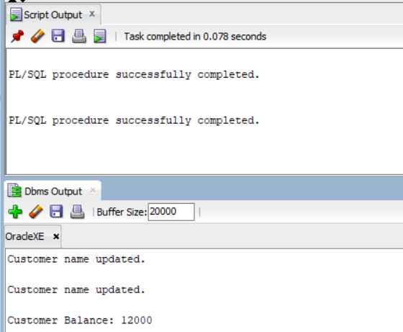

**Scenario 2:** Create a package to manage employee data.

**Question:** Write a package **EmployeeManagement** with procedures to hire new employees, update employee details, and a function to calculate annual salary.

CREATE OR REPLACE PACKAGE EmployeeManagement AS

    PROCEDURE HireEmployee(p_id NUMBER, p_name VARCHAR2, p_position VARCHAR2, p_salary NUMBER, p_department VARCHAR2);

    PROCEDURE UpdateEmployee(p_id NUMBER, p_salary NUMBER);

    FUNCTION CalculateAnnualSalary(p_id NUMBER) RETURN NUMBER;

END EmployeeManagement;

CREATE OR REPLACE PACKAGE BODY EmployeeManagement AS

    PROCEDURE HireEmployee(p_id NUMBER, p_name VARCHAR2, p_position VARCHAR2, p_salary NUMBER, p_department VARCHAR2) IS

    BEGIN

        INSERT INTO Employees (EmployeeID, Name, Position, Salary, Department, HireDate)

        VALUES (p_id, p_name, p_position, p_salary, p_department, SYSDATE);

    END;

    PROCEDURE UpdateEmployee(p_id NUMBER, p_salary NUMBER) IS

    BEGIN

        UPDATE Employees

        SET Salary = p_salary

        WHERE EmployeeID = p_id;

    END;

    FUNCTION CalculateAnnualSalary(p_id NUMBER) RETURN NUMBER IS

        v_salary NUMBER;

    BEGIN

        SELECT Salary INTO v_salary FROM Employees WHERE EmployeeID = p_id;

        RETURN v_salary * 12;

    END;

END EmployeeManagement;

/

BEGIN

    EmployeeManagement.HireEmployee(

        p_id         => 201,

        p_name       => 'Abi Ayshu',

        p_position   => 'Analyst',

        p_salary     => 40000,

        p_department => 'Tech'

    );

    DBMS_OUTPUT.PUT_LINE('Employee hired successfully.');

END;

/

BEGIN

    EmployeeManagement.UpdateEmployee(201, 45000);

    DBMS_OUTPUT.PUT_LINE('Employee salary updated.');

END;

/

DECLARE

    v_annual NUMBER;

BEGIN

    v_annual := EmployeeManagement.CalculateAnnualSalary(201);

    DBMS_OUTPUT.PUT_LINE('Annual Salary: ' || v_annual);

END;

/

Output:

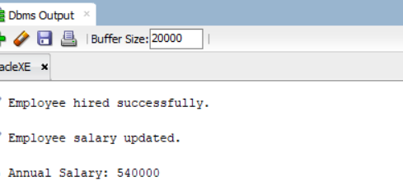

**Scenario 3:** Group all account-related operations into a package.

**Question:** Create a package **AccountOperations** with procedures for opening a new account, closing an account, and a function to get the total balance of a customer across all accounts.

CREATE OR REPLACE PACKAGE AccountOperations AS

    PROCEDURE OpenAccount(p_acc_id NUMBER, p_cust_id NUMBER, p_type VARCHAR2, p_balance NUMBER);

    PROCEDURE CloseAccount(p_acc_id NUMBER);

    FUNCTION GetTotalCustomerBalance(p_cust_id NUMBER) RETURN NUMBER;

END AccountOperations;

/

CREATE OR REPLACE PACKAGE BODY AccountOperations AS

    PROCEDURE OpenAccount(p_acc_id NUMBER, p_cust_id NUMBER, p_type VARCHAR2, p_balance NUMBER) IS

    BEGIN

        INSERT INTO Accounts (AccountID, CustomerID, AccountType, Balance, LastModified)

        VALUES (p_acc_id, p_cust_id, p_type, p_balance, SYSDATE);

    END;

    PROCEDURE CloseAccount(p_acc_id NUMBER) IS

    BEGIN

        DELETE FROM Accounts

        WHERE AccountID = p_acc_id;

    END;

    FUNCTION GetTotalCustomerBalance(p_cust_id NUMBER) RETURN NUMBER IS

        v_total NUMBER;

    BEGIN

        SELECT SUM(Balance) INTO v_total FROM Accounts WHERE CustomerID = p_cust_id;

        RETURN NVL(v_total, 0);

    END;

END AccountOperations;

/

INSERT INTO Customers (CustomerID, Name, DOB, Balance, LastModified)

VALUES (210, 'Riya Kapoor', TO_DATE('1995-07-12', 'YYYY-MM-DD'), 0, SYSDATE);

BEGIN

    AccountOperations.OpenAccount(

        p_acc_id   => 302,

        p_cust_id  => 210,

        p_type     => 'Current',

        p_balance  => 25000

    );

    DBMS_OUTPUT.PUT_LINE(' Account 302 opened for customer 210.');

END;

/

DECLARE

    v_total NUMBER;

BEGIN

    v_total := AccountOperations.GetTotalCustomerBalance(202);

    DBMS_OUTPUT.PUT_LINE('Total Balance for Customer 202: ' || v_total);

END;

/

BEGIN

    AccountOperations.CloseAccount(302);

    DBMS_OUTPUT.PUT_LINE('️ Account 302 closed successfully.');

END;

/

Output:

