ReactJS-HOL

# Exercise:1: cricketapp Application

Create a react app using the command

npx create-react-app cricketapp

cd cricketapp

src/components/ListOfPlayer.js

import React from 'react';

const ListOfPlayers=()=>{

    const players=[

        { name: 'Virat Kohli', score: 85 },

        { name: 'Rohit Sharma', score: 45 },

        { name: 'KL Rahul', score: 78 },

        { name: 'Rishabh Pant', score: 30 },

        { name: 'Hardik Pandya', score: 90 },

        { name: 'Ravindra Jadeja', score: 40 },

        { name: 'Bhuvneshwar Kumar', score: 72 },

        { name: 'Jasprit Bumrah', score: 65 },

        { name: 'Shreyas Iyer', score: 88 },

        { name: 'Shikhar Dhawan', score: 52 },

        { name: 'Mohammed Shami', score: 34 }

    ];

    const filteredPlayers=players.filter(player=>player.score<70)

    return(

        <div>

            <h2>All Players:</h2>

            <ul>

                {players.map((player,index)=>(

                  <li key={index}>{player.name}-{player.score}</li>

                ))}

            </ul>

            <h3>Players with score below 70:</h3>

            <ul>

                {filteredPlayers.map((player, index) => (

                    <li key={index}>{player.name} - {player.score}</li>

                 ))}

            </ul>

        </div>

    )

}

export default ListOfPlayers;

src/Components/IndianPlayers.js

import React from 'react';

const IndianPlayers=()=>{

    const T20players = ['Virat', 'Rohit', 'Pant', 'Hardik'];

    const RanjiTrophyPlayers = ['Jadeja', 'Rahane', 'Pujara'];

    const allPlayers = [...T20players,...RanjiTrophyPlayers];

    const oddTeam=allPlayers.filter((_, index)=>index%2===1);

    const evenTeam=allPlayers.filter((_,index)=>index%2===0);

    return (

        <div>

            <h2>Merged Players: </h2>

            <ul>

                {allPlayers.map((player,index)=>(

                    <li key={index}>{player}</li>

                ))}

            </ul>

            <h3>Even Team: </h3>

            <ul>

                {evenTeam.map((player,index)=>(

                    <li key={index}>{player}</li>

                ))}

            </ul>

            <h3>Odd Team: </h3>

            <ul>

                {oddTeam.map((player,index)=>(

                    <li key={index}>{player}</li>

                ))}

            </ul>

        </div>

    )

}

export default IndianPlayers;

App.js

import './App.css';

import ListOfPlayers from './Components/ListOfPlayers';

import IndianPlayers from './Components/IndianPlayers';

const App=()=>{

  const flag=true;

  return (

    <div>

      <h1>Cricket App</h1>

      {flag ? <ListOfPlayers/>: <IndianPlayers/>}

    </div>

  )

}

export default App;

Output

When flag=true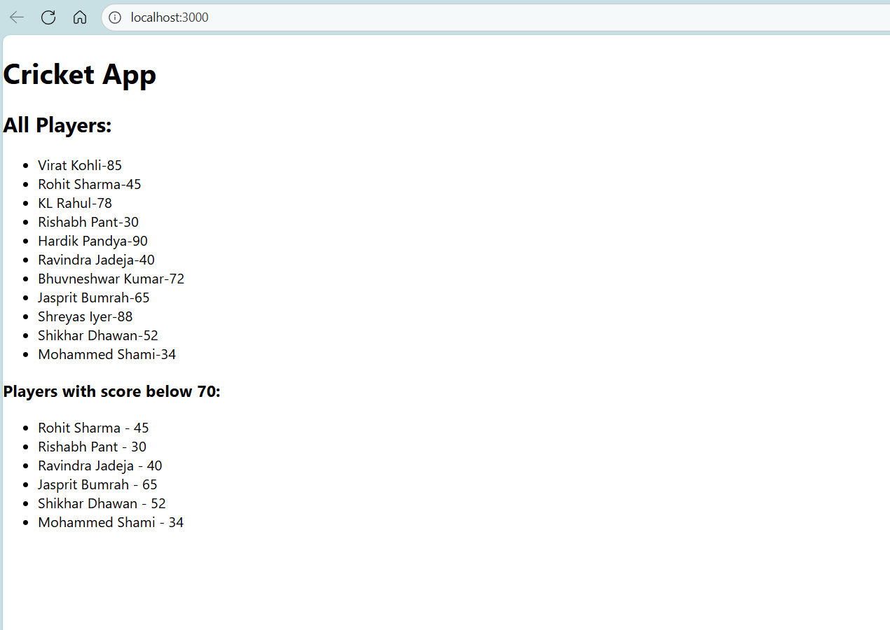

When flag=false

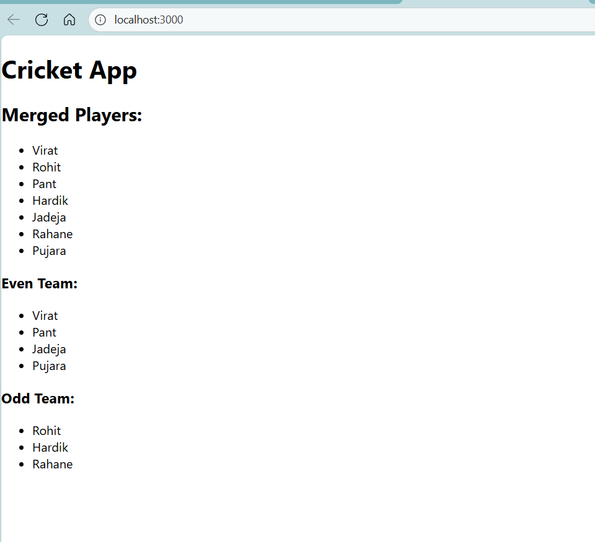

# Exercise: 2: Create App officespacerentalapp

Create a react app using the command

npx create-react-app officespacerentalapp

cd officespacerentallapp

src/Components/OfficeList.js

import React from 'react';

const OfficeList = () => {

  const officeImageUrl = "https://plus.unsplash.com/premium_photo-1683880730745-ed19bbd9ef45?q=80&w=1148&auto=format&fit=crop&ixlib=rb-4.1.0&ixid=M3wxMjA3fDB8MHxwaG90by1wYWdlfHx8fGVufDB8fHx8fA%3D%3D";

  const offices = [

    { name: 'Cozy Corner', rent: 45000, address: 'MG Road, Bangalore' },

    { name: 'Sky Tower', rent: 75000, address: 'Cyber City, Gurgaon' },

    { name: 'TechHub', rent: 55000, address: 'HITEC City, Hyderabad' },

    { name: 'PrimeWorks', rent: 85000, address: 'BKC, Mumbai' }

  ];

  return (

    <div>

      <h2>Available Offices</h2>

      <img src={officeImageUrl} alt="Office" style={{ width: '100%', maxWidth: '500px' }} />

      <ul>

        {offices.map((office, index) => (

          <li key={index} style={{ marginBottom: '20px', listStyle: 'none' }}>

            Name:<strong>{office.name}</strong> <br />

            Address: {office.address} <br />

            Rent: <span style={{ color: office.rent < 60000 ? 'red' : 'green' }}>

              ₹{office.rent}

            </span>

          </li>

        ))}

      </ul>

    </div>

  );

};

export default OfficeList;

App.js

import React from 'react';

import OfficeList from './Components/OfficeList';

function App() {

  return (

    <div style={{ padding: '20px', fontFamily: 'Arial' }}>

      <h1>Office Space at Affordable Age</h1>

      <OfficeList />

    </div>

  );

}

export default App;

index.js

import React from 'react';

import ReactDOM from 'react-dom/client';

import App from './App';

const root = ReactDOM.createRoot(document.getElementById('root'));

root.render(

  <React.StrictMode>

    <App />

  </React.StrictMode>

);

Output:



Exercise: 3: EventExamplesApp

Create a react app using the command

npx create-react-app eventexamplesapp

cd eventexamplesapp

App.js

import React, { useState } from 'react';

import CurrencyConvertor from './components/CurrencyConverter';

function App() {

  const [count, setCount] = useState(0);

  const increment = () => {

    setCount(prev => prev + 1);

    sayHello();

  };

  const decrement = () => {

    setCount(prev => prev - 1);

  };

  const sayHello = () => {

    console.log("Hello, this is a static message.");

  };

  const sayWelcome = (message) => {

    alert(message);

  };

  const handleSyntheticEvent = (event) => {

    alert("I was clicked");

    console.log(event); // Logs synthetic event details

  };

  return (

    <div style={{ textAlign: 'center', marginTop: '30px' }}>

      <h1>React Events Example</h1>

      <h2>Counter: {count}</h2>

      <button onClick={increment}>Increment</button>

      <button onClick={decrement} style={{ marginLeft: '10px' }}>Decrement</button>

      <br /><br />

      <button onClick={() => sayWelcome("Welcome!")}>Say Welcome</button>

      <br /><br />

      <button onClick={handleSyntheticEvent}>Synthetic Event Button</button>

      <br /><br />

      <CurrencyConvertor />

    </div>

  );

}

export default App;

src/components/CurrencyConverter.js

import React, { useState } from 'react';

function CurrencyConvertor() {

  const [rupees, setRupees] = useState('');

  const [euros, setEuros] = useState('');

  const handleSubmit = (e) => {

    e.preventDefault();

    const euroValue = parseFloat(rupees) * 0.011; // Example conversion rate

    setEuros(euroValue.toFixed(2));

  };

  return (

    <div style={{ marginTop: '30px' }}>

      <h3>Currency Convertor (INR to Euro)</h3>

      <form onSubmit={handleSubmit}>

        <input

          type="number"

          placeholder="Enter INR"

          value={rupees}

          onChange={(e) => setRupees(e.target.value)}

          required

        />

        <button type="submit" style={{ marginLeft: '10px' }}>Convert</button>

      </form>

      {euros && <p>Euro Value: €{euros}</p>}

    </div>

  );

}

export default CurrencyConvertor;

Output:

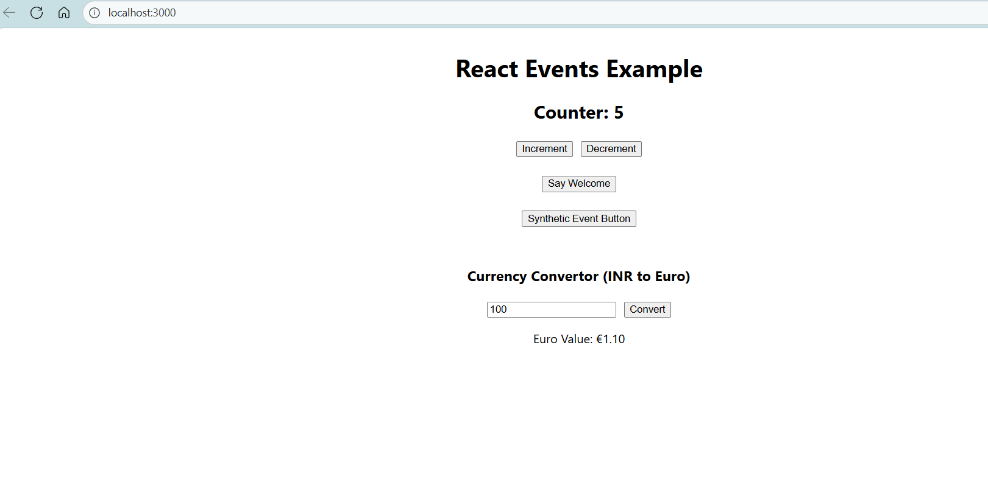

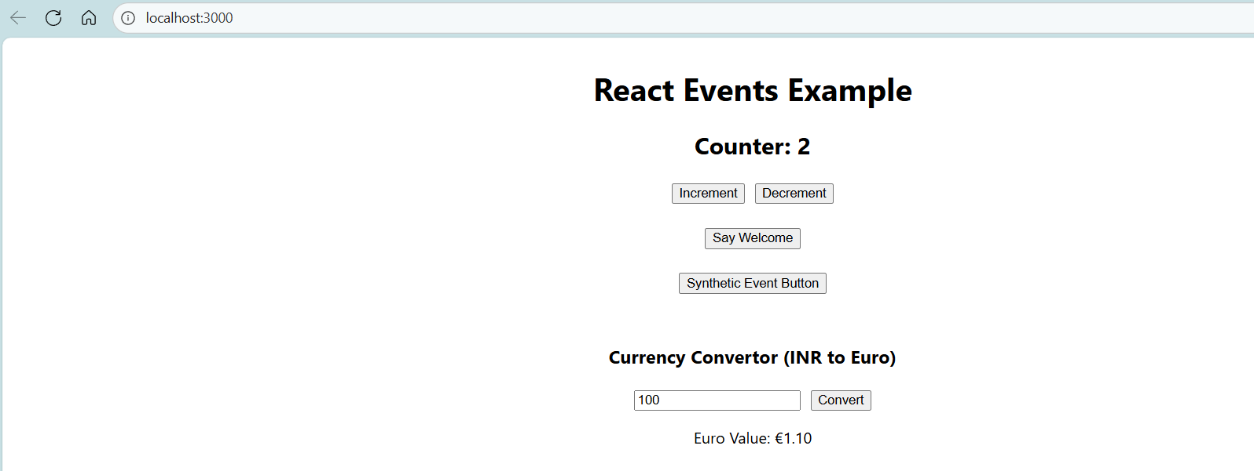

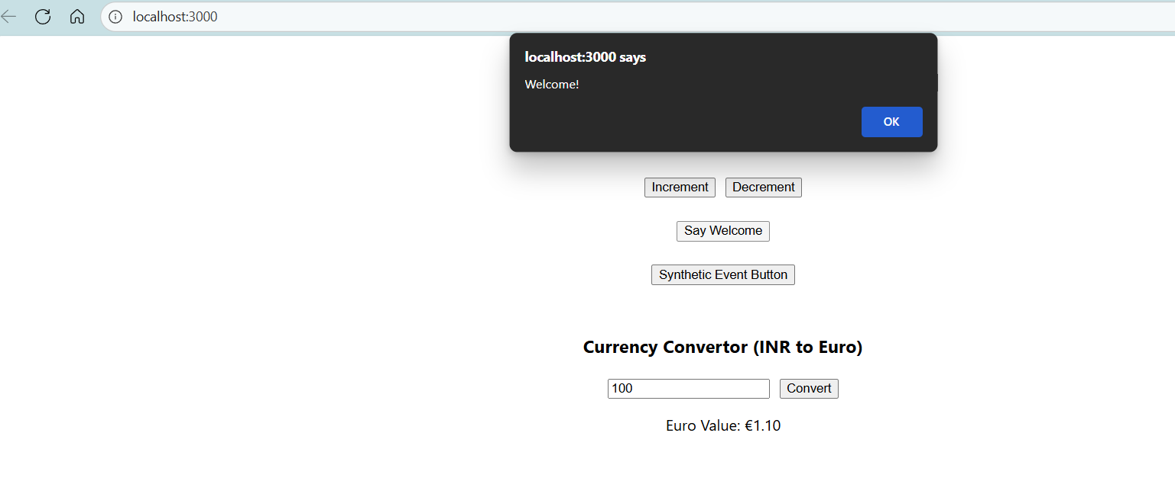

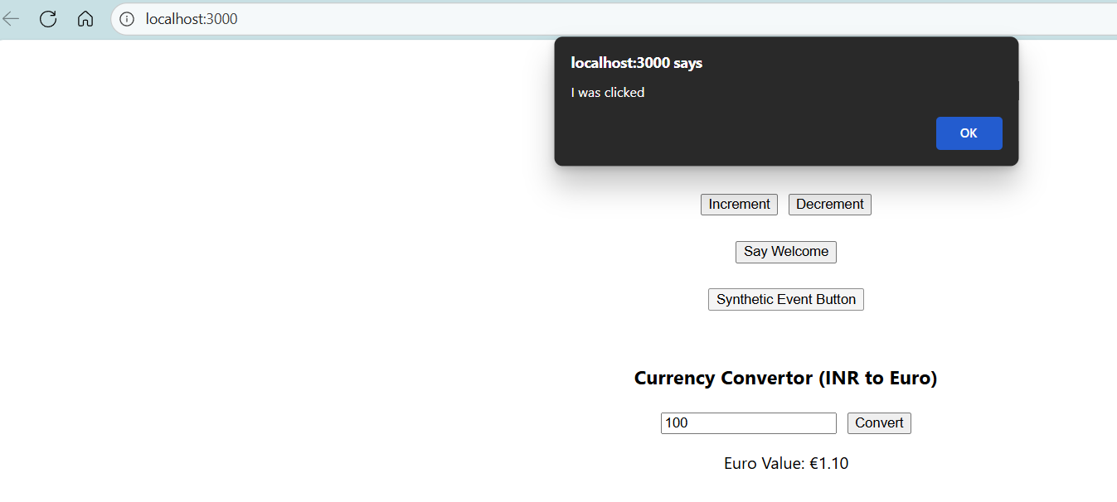

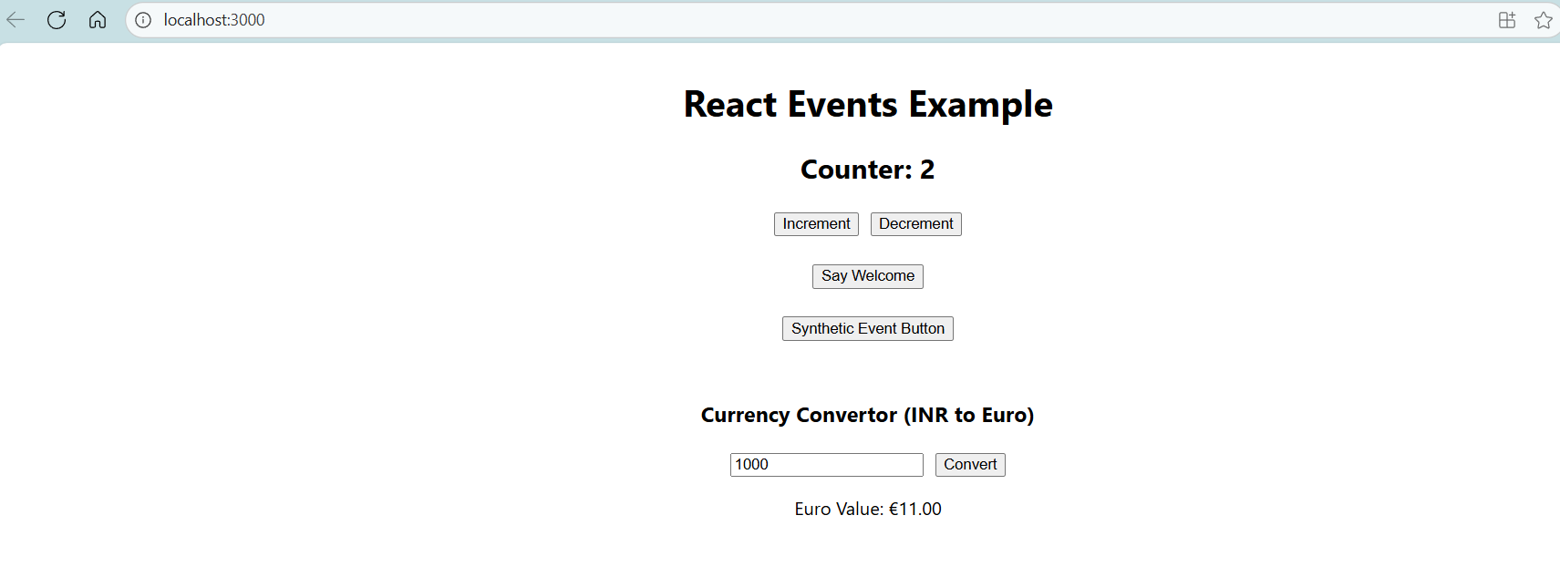

Exercise: 4: TicketBookingApp

Create a react app using the command

npx create-react-app ticketbookingapp

cd ticketbookingapp

src/components/GuestApp.js

import React from 'react';

function GuestApp() {

  return (

    <div>

      <h2>Welcome, Guest!</h2>

      <p>Here are some flight details:</p>

      <ul>

        <li>Flight: AI-202 | Chennai ➜ Delhi | ₹4500</li>

        <li>Flight: IX-340 | Bangalore ➜ Mumbai | ₹3900</li>

      </ul>

    </div>

  );

}

export default GuestApp;

src/components/UserPage.js

import React from 'react';

function UserPage() {

  return (

    <div>

      <h2>Welcome, User!</h2>

      <p>You can now book your tickets:</p>

      <button>Book Flight</button>

    </div>

  );

}

export default UserPage;

App.js

import React, { useState } from 'react';

import GuestApp from './components/GuestApp';

import UserPage from './components/UserPage';

function App() {

  const [isLoggedIn, setIsLoggedIn] = useState(false);

  const handleLogin = () => setIsLoggedIn(true);

  const handleLogout = () => setIsLoggedIn(false);

  let content;

  if (isLoggedIn) {

    content = <UserPage />;

  } else {

    content = <GuestApp />;

  }

  return (

    <div style={{ textAlign: 'center', marginTop: '30px' }}>

      <h1>Ticket Booking App</h1>

      {isLoggedIn ? (

        <button onClick={handleLogout}>Logout</button>

      ) : (

        <button onClick={handleLogin}>Login</button>

      )}

      <hr />

      {content}

    </div>

  );

}

export default App;

Output:

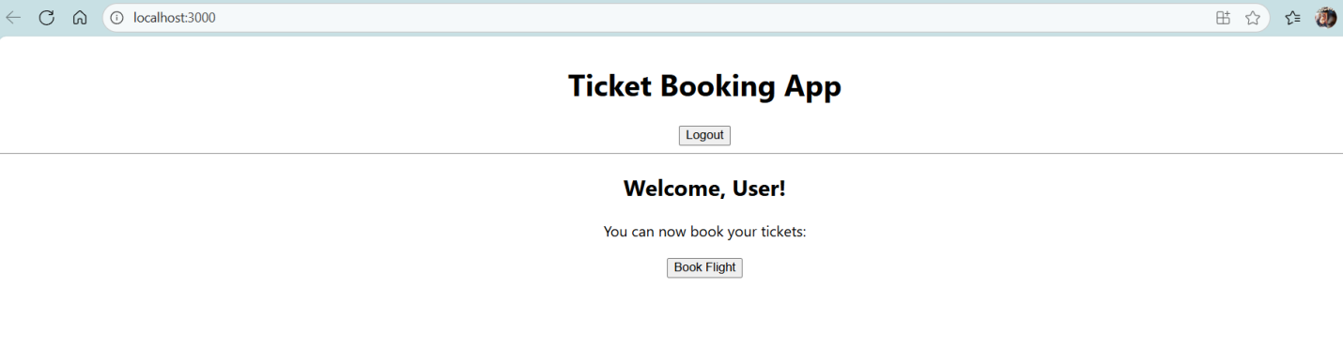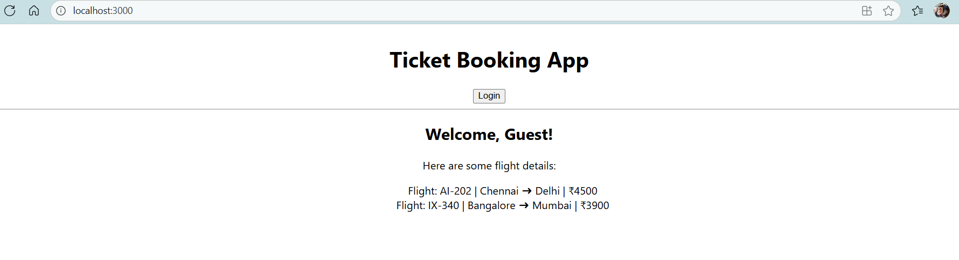

Exercise: 5: blogapp

Create a react app using the command

npx create-react-app blogapp

cd blogapp

BookDetails.js

import React from 'react';

function BookDetails({ books }) {

  return (

    <div>

      <h2> Book Details</h2>

      <ul>

        {books.map((book, index) => (

          <li key={index}>

            {book.title} by {book.author}

          </li>

        ))}

      </ul>

    </div>

  );

}

export default BookDetails;

BlogDetails.js

import React from 'react';

function BlogDetails({ blogs }) {

  if (blogs.length === 0) return <p>No blogs available.</p>;

  return (

    <div>

      <h2>📝 Blog Details</h2>

      {blogs.map((blog, index) => (

        <div key={index}>

          <h4>{blog.title}</h4>

          <p>{blog.content}</p>

        </div>

      ))}

    </div>

  );

}

export default BlogDetails;

CourseDetails.js

import React from 'react';

function CourseDetails({ courses }) {

  return (

    <>

      {courses.length > 0 && (

        <div>

          <h2>🎓 Course Details</h2>

          <ul>

            {courses.map((course, index) => (

              <li key={index}>

                {course.name} - {course.duration}

              </li>

            ))}

          </ul>

        </div>

      )}

    </>

  );

}

export default CourseDetails;

App.js

import React, { useState } from 'react';

import BookDetails from './components/BookDetails';

import BlogDetails from './components/BlogDetails';

import CourseDetails from './components/CourseDetails';

function App() {

  const [showBooks, setShowBooks] = useState(true);

  const [showBlogs, setShowBlogs] = useState(true);

  const [showCourses, setShowCourses] = useState(true);

  const books = [

    { title: 'React Explained', author: 'Zac Gordon' },

    { title: 'JavaScript: The Good Parts', author: 'Douglas Crockford' }

  ];

  const blogs = [

    { title: 'Intro to React', content: 'React makes it painless to create UIs.' },

    { title: 'JSX in Depth', content: 'JSX is a syntax extension for JavaScript.' }

  ];

  const courses = [

    { name: 'React Basics', duration: '4 weeks' },

    { name: 'Advanced React', duration: '6 weeks' }

  ];

  return (

    <div style={{ padding: '20px' }}>

      <h1>Welcome to BloggerApp</h1>

      <button onClick={() => setShowBooks(!showBooks)}>

        {showBooks ? 'Hide Books' : 'Show Books'}

      </button>

      <button onClick={() => setShowBlogs(!showBlogs)}>

        {showBlogs ? 'Hide Blogs' : 'Show Blogs'}

      </button>

      <button onClick={() => setShowCourses(!showCourses)}>

        {showCourses ? 'Hide Courses' : 'Show Courses'}

      </button>

      <hr />

      {/* Conditional Rendering */}

      {showBooks && <BookDetails books={books} />}

      {showBlogs ? <BlogDetails blogs={blogs} /> : <p>Blog section hidden.</p>}

      {showCourses && <CourseDetails courses={courses} />}

    </div>

  );

}

export default App;

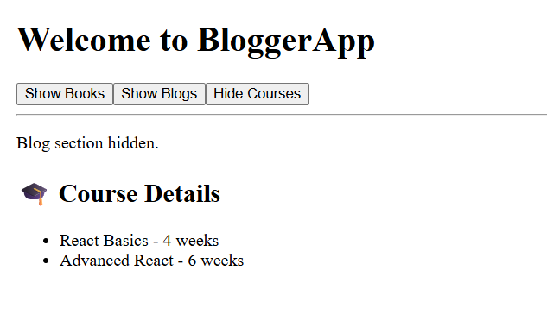

Output:

