Git

# Assignment No: 1

## Step: 1:

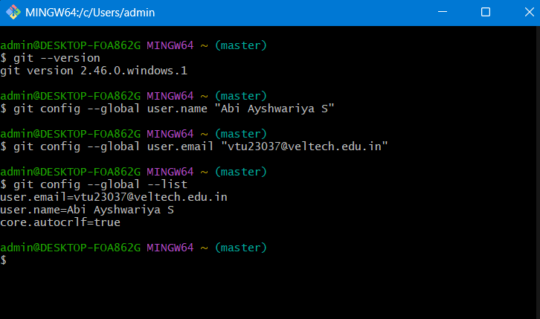

Step: 2: 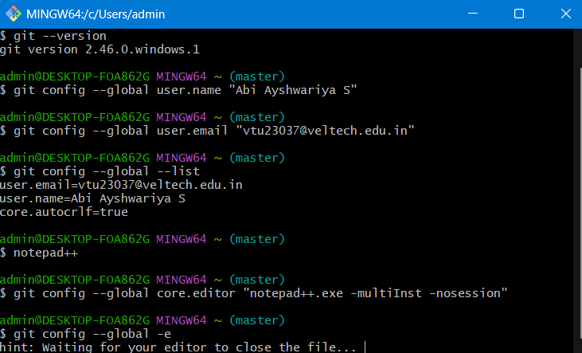

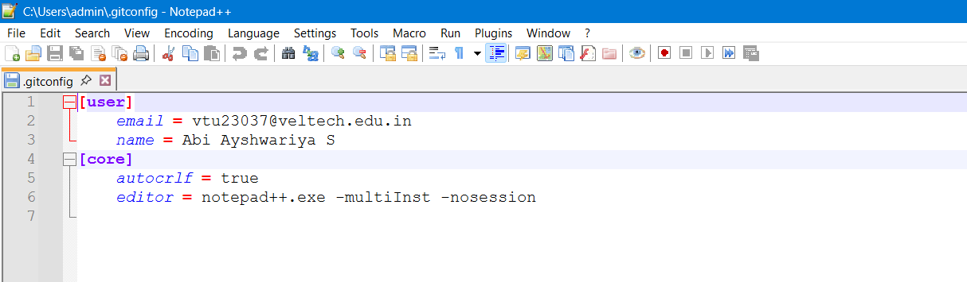

## Step: 3:

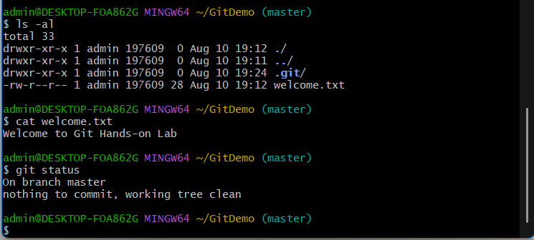

# Assignment No: 2

## Step: 1:

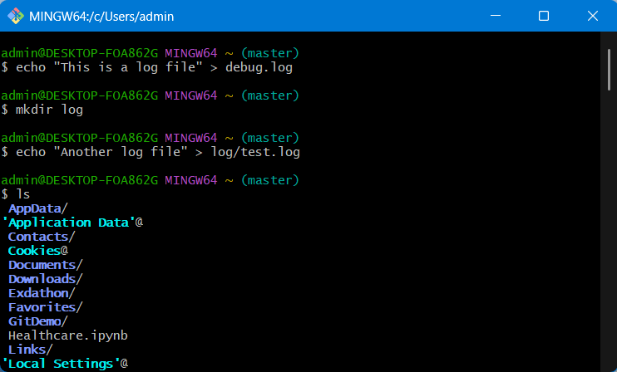

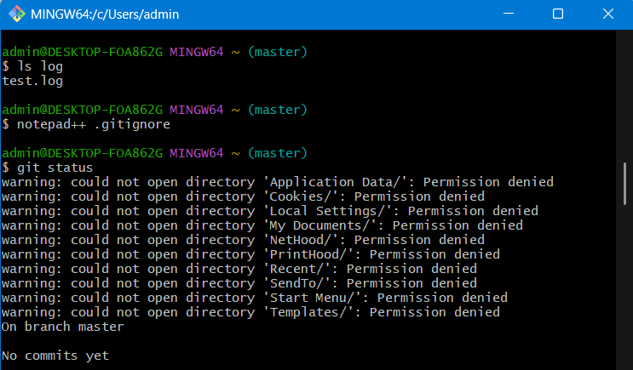

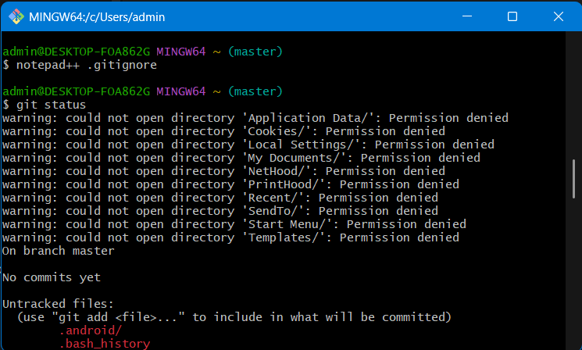

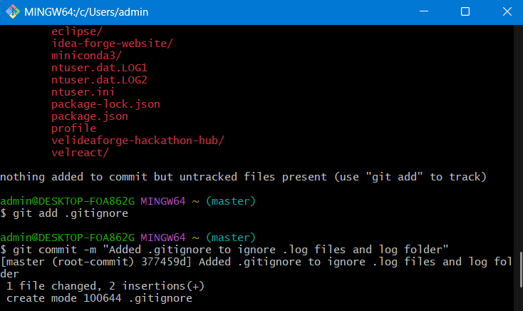

# Assignment No: 3

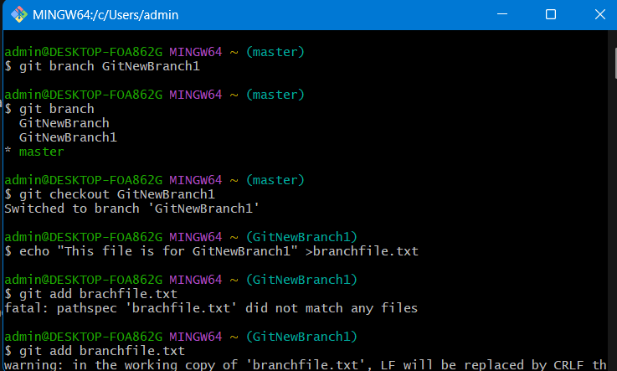

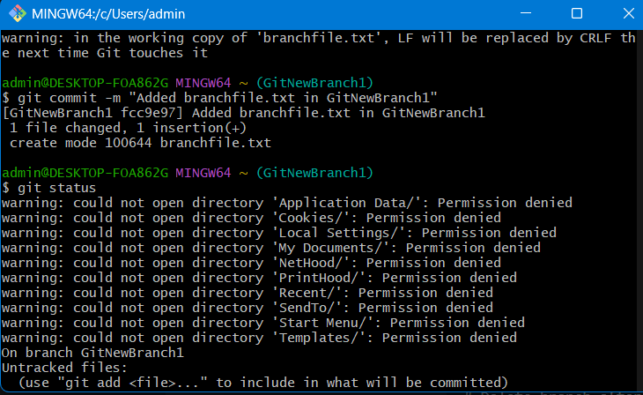

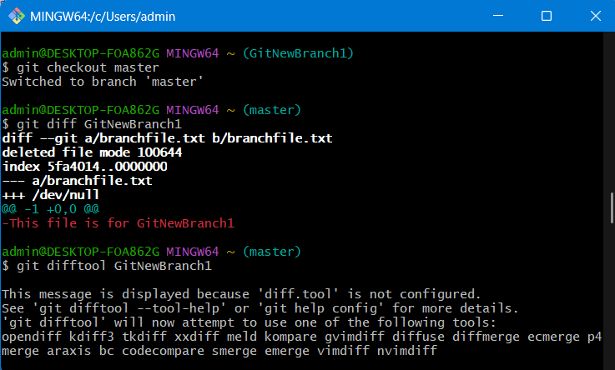

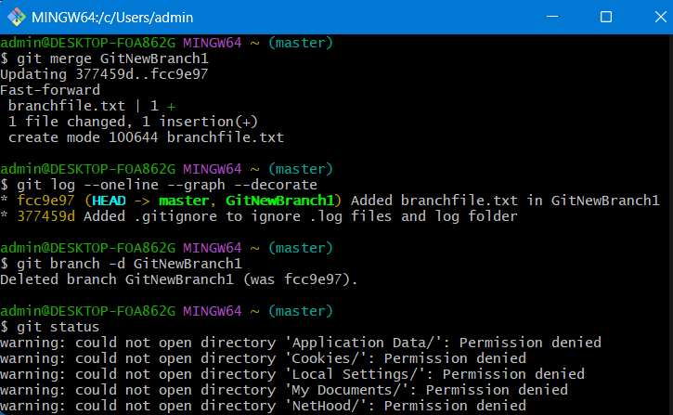

## Assignment: 4:

git checkout -b GitWork

echo "<message>Hello from branch</message>" > hello.xml

git add hello.xml

git commit -m "Add hello.xml in GitWork"

git checkout master

echo "<message>Hello from master</message>" > hello.xml

git add hello.xml

git commit -m "Add hello.xml in master"

git merge GitWork

# FIX CONFLICT

git add hello.xml

git commit -m "Resolve merge conflict in hello.xml"

echo "*.orig" >> .gitignore

git add .gitignore

git commit -m "Update .gitignore for merge backups"

git branch -d GitWork

git log --oneline --graph --decorate

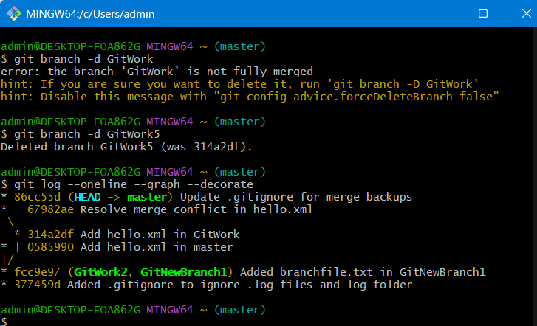

## Assignment: 5:

