HITL Agent Runtime — System Overview
Summary
A Human-in-the-Loop (HITL) agent runtime for enterprise workflows. Operators ask the agent to do work in plain English. The agent classifies the request, gathers the right data from connected systems, and either executes autonomously (read-only lookups, parameter changes within a pre-approved envelope) or pauses for a named human reviewer (anything irreversible — sanctions overrides, vendor onboarding, regulatory actions). Every step is recorded in an append-only audit trail.
Why it exists
Off-the-shelf agent platforms have one of two failure modes:
- Too autonomous — they execute, but you can't see what knowledge informed each decision, and you can't insert a human approval step where you need one.
- Too rigid — they stop at "auto-suggest the next form to fill in" and don't actually take action.
This system aims for the middle: the agent does real work, with real provenance, and with HITL review wired into the spine of every risky action.
Architecture at a glance
The diagram below shows the full system. Each row is a layer, and arrows show how a request flows from operator (top) down through the connected data systems (bottom).
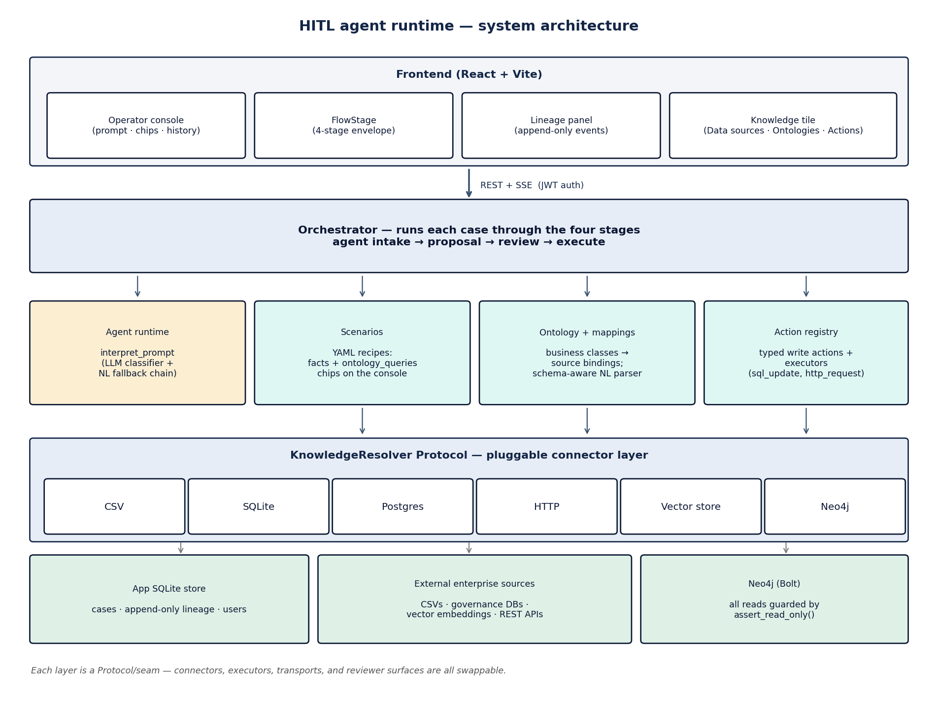
Figure 1. Layered architecture. The four cyan/amber boxes in the middle are the operator's mental model: scenarios, ontology, actions, and the agent runtime that ties them together.
Three audiences and what each gets
Audience | What they touch | What they get
Operator | Chat composer + a row of suggested-prompt chips | A natural-language way to kick off pre-approved workflows + ad-hoc data queries against any registered source. No SQL or ontology authoring required.
Reviewer | A Teams Adaptive Card (or in-app card) per pending decision | Approve / Reject / Need more info, with the full context (active policy, actor scope, master data, prior similar cases, SOPs) bound into the card automatically.
Engineer / scenario author | YAML files + a Knowledge admin tile | Add a new connected system and the agent can use it across every existing scenario without rewriting any of them. Author one ontology, get many scenarios for free.
Model Analogy
Three nouns + three verbs.
Nouns (what the system knows about)
- Data sources — connections to things that hold data. CSVs, SQLite, Postgres, HTTP APIs, vector stores, Neo4j graphs.
- Ontology — a business-language description of the entities the operator cares about (Supplier, Product, PurchaseOrder, etc.) and how each entity maps to columns in the data sources. Authored once; reused everywhere.
- Scenarios — recipes the agent follows. Each one is a pattern: the operator typed something like X → here's what the agent should fetch, what it should propose, who reviews it, and what happens on approve.
Verbs (what happens to a request)
- Classify — the agent's LLM picks the scenario that best matches the operator's prompt.
- Bind — the framework gathers the knowledge each stage of the scenario needs (active policy, actor's scope, master-data record, prior decisions, SOPs) into a typed envelope. Every fact carries provenance.
- Decide — either auto-execute (low-risk, deterministic) or pause for a named human reviewer.
That's it. Everything else is implementation.
A walkthrough: one operator request
"Override the SC-TC-001 sanctions block on order ORD-44216 — customer says they have an OFAC license."
- Step 1 — Operator types it. The chat composer sends the prompt to the backend.
- Step 2 — The agent classifies. The LLM looks at the catalog of scenarios, picks SC-TC-007 (Trade override — sanctioned counterparty), and rephrases the request. The operator sees the rephrasing as a clarifier and clicks Confirm.
- Step 3 — The framework binds knowledge. Two stages run in sequence: the agent intake stage pulls the active TC-override policy + the agent's IAM scopes; the proposal stage pulls the product master record (encryption module P-EL-9001), the OFAC sanctions hit on the counterparty, and the contract value.
- Step 4 — Policy decides. Sanctions overrides require named compliance officer approval, so the case enters the review stage. A Teams Adaptive Card is rendered with all the bound facts plus prior similar overrides and three relevant SOP excerpts retrieved by semantic search.
- Step 5 — Reviewer decides. The named compliance officer reads the card. If they approve, the agent proceeds with the override and the case completes. If they reject or ask for more info, the case captures the rationale.
- Step 6 — Audit trail. Every fact bound, every query issued, every decision is appended to an immutable log keyed by case id. Replayable later for compliance review.
The whole loop happens in ~10 seconds for autonomous cases, or pauses indefinitely at the review step for HITL cases. The reviewer's decision arrives through a webhook (or the in-app surface today) and the orchestrator picks the case back up where it left off.
What's been built
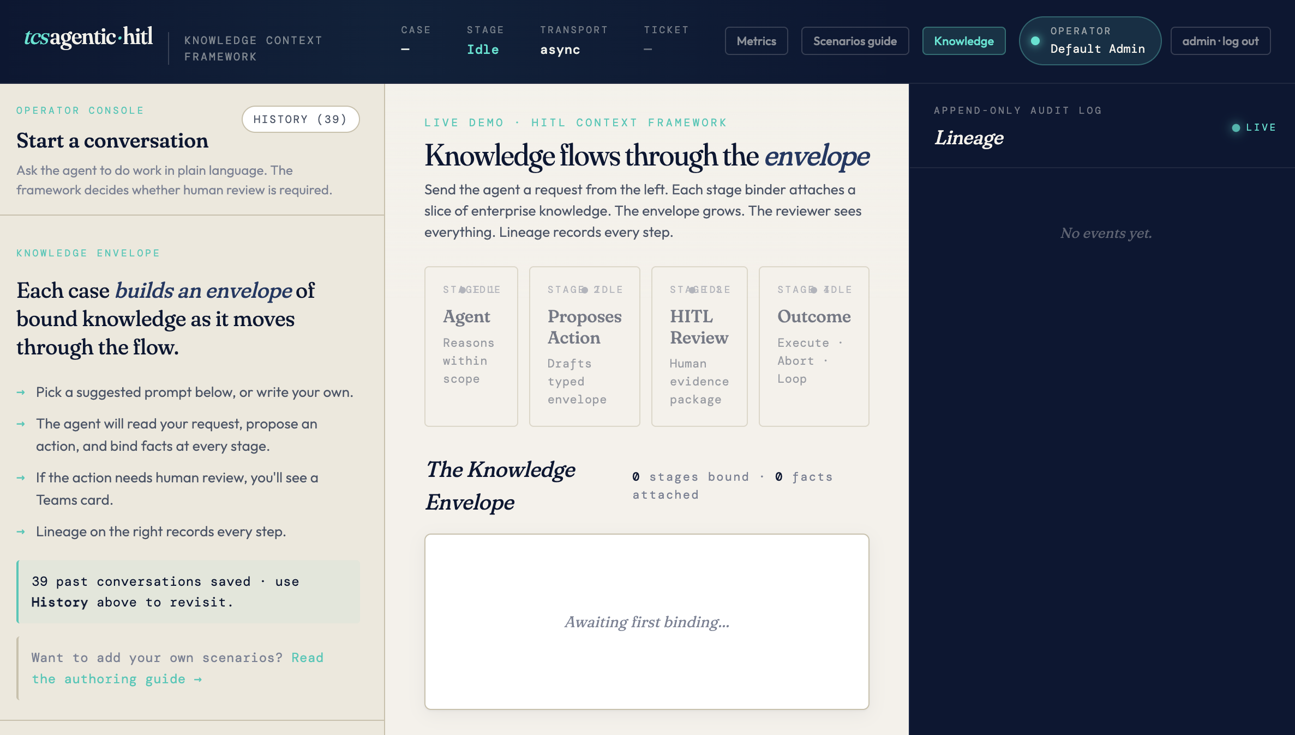
Operator-facing
- Suggested-prompt chips sorted newest-first so freshly added recipes surface to the top.
- Two opt-in fallback toggles below the composer: Try ontology lookup if no scenario matches (one-shot read-only data lookup) and Try write action (HITL-gated NL writes).
- Live envelope view — the operator can watch each stage's bound facts populate as the agent works.
- History panel — past conversations, search, replay with a forced reviewer decision.
Knowledge admin (the "Knowledge" tile)
- Data sources tab — register a CSV, SQLite, Postgres, HTTP API, vector store, or Neo4j graph. Test the connection. Run ad-hoc SQL or Cypher in a playground.
- Ontologies tab — upload a YAML/JSON ontology defining business entities. Click "Suggest mappings" to have the LLM propose how each business attribute maps to columns in registered sources, then review and confirm. Per-class "Generate lookup chip" button creates an autonomous chip on the operator console.
- Actions tab — view registered write actions, preview what the LLM would extract from a natural-language prompt, remove non-default ones.
Audit and observability
- Append-only lineage per case: every fact fetched, every query issued, every decision. Survives restart.
- Per-fact provenance in the reviewer card: each fact shows both what was asked (the ontology class) and which source answered (the physical data source).
- Live metrics dashboard — totals, decisions-by-scenario, top rejection reasons, cases-per-day sparkline.
- CSV export of cases + lineage with date-range filters.
Safety
- HITL by default for write actions. The natural-language write path always sends the proposed action to a human reviewer; the executor only runs after approve.
- Read-only Cypher guard on every Neo4j query path. Writes via Cypher are rejected at the application layer.
- Default-flagged knowledge artefacts (built-in ontologies, seeded actions) refuse delete via the API.
- JWT auth + bcrypt passwords + token blocklist on logout. Per-user case isolation; admin role bypasses scoping.
- Rate limiting on login + register (10/min/IP) + app-wide 120/min default.
Why it's different from a generic agent platform
Generic agent platform | This system
LLM picks a function, calls it, returns. | LLM picks a scenario; the framework binds the right knowledge at each stage and routes through HITL when policy says to.
Audit trail is a chat transcript. | Audit trail is a typed envelope: every fact has provenance, every decision has rationale, every step is replayable.
Adding a new data source means re-prompting the LLM with new tool definitions. | Adding a new data source means registering a connection and clicking "Suggest mappings." Existing scenarios pick it up via the ontology layer without changes.
Human review is a chat message you can ignore. | Human review is a structured Teams Adaptive Card with three buttons; the case literally pauses until a named reviewer decides.
Write actions go through the LLM. | Write actions are operator-authored YAML with typed argument schemas and named executors. The LLM only fills the arguments; the executor is hand-written.
Quality gates today
- 214 automated tests passing (124 backend + 90 framework).
- Frontend type-check clean and production bundle builds.
- Live demo verified through every chip + the Neo4j graph + the ontology Query playground + the NL write-action preview.
Recommended next steps
Implementable in 2 weeks (pilot prep + obvious feature gaps)
- Pick one real customer data source (e.g. their Postgres governance store) and run the full flow: register → AI-map → review with a domain expert → confirm → click "Generate lookup chip" → demo. Proves the value prop on real data.
- Tighten the production deployment per docs/production.md — generate JWT secret, rotate the seeded admin password, set up HTTPS, configure backups.
- Decide the mapping governance model — who can confirm a mapping? Mappings are effectively access-control documents; treat the confirm step like an ACL change.
- RDF/Turtle ontology import (~2 days). For teams that already maintain ontologies in industry-standard formats.
- Bulk "generate all chips" in the Mappings tab — today operators click per class. Quality-of-life improvement.
- Cypher action executor (~2 days). The action registry has SQL + HTTP today. Adding a Cypher write executor lets operators kick off graph mutations through the same HITL path.
Production readiness (one quarter)
- Move from in-memory to durable transport. Single worker with in-memory queues today; production scale needs Redis (case store) and Kafka/SQS (review-decision queue). The framework was designed for this swap; ~2 weeks.
- Observability — structured JSON logging, Prometheus metrics, audit-log retention policy. ~1 week.
- Cross-source entity resolution. Currently if Supplier S-001 lives in two sources, both records show up separately. Adding ER rules would dedupe with confidence scores. Defer until a customer asks; ~2 weeks of real engineering work.
The architecture is intentionally built so each of these is additive, not a rewrite — the resolver layer, the binder protocols, and the mapping/ontology contracts are all "swap-points" the framework was designed around.

