A= mod1

ME RMSE MAE MPE MAPE MASE ACF1

Training set 0.9094473 1.260813 0.9767553 1.449865 1.563518 0.9992382 0.1778649

> b=mod2

ME RMSE MAE MPE MAPE MASE ACF1

Training set 0.1791496 0.9639373 0.6018127 0.2751079 0.9633255 0.6156651 -0.1073017

> c=mod3

ME RMSE MAE MPE MAPE MASE ACF1

Training set 0.1223277 1.030244 0.6417654 0.1842092 1.026059 0.6565375 -0.2872695

|  |
| --- |
| Ap=modp1  ME RMSE MAE MPE MAPE MASE ACF1  Training set 0.9094473 1.260813 0.9767553 1.449865 1.563518 0.9992382 0.1778649  > bp=modp2  ME RMSE MAE MPE MAPE MASE ACF1  Training set 0.1791496 0.9639373 0.6018127 0.2751079 0.9633255 0.6156651 -0.1073017  > cp=modp3  ME RMSE MAE MPE MAPE MASE ACF1  Training set 0.1223277 1.030244 0.6417654 0.1842092 1.026059 0.6565375 -0.2872695 |
|  |
| |  | | --- | | > | |

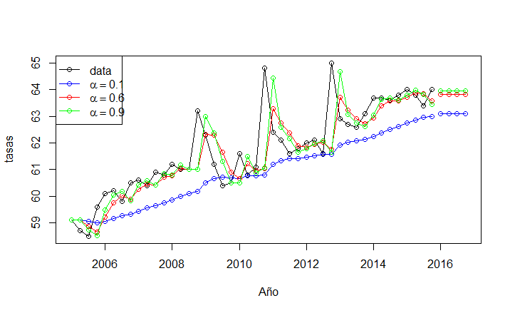

En este caso el método que más se acerca a la serie de tiempo es el número 3, que tiene alpha de .9, ya que la gráfica se asemeja mucho. Podemos observar que entre más cercana el alpha sea a 1 se apega más a la original.

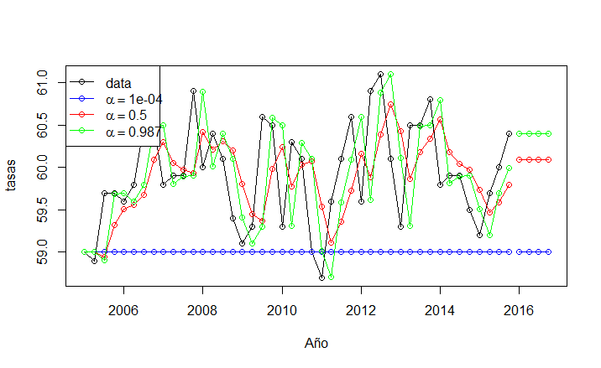

En este caso se puede observar es que tiene el mismo comportamiento, es decir el método que más se apega a la serie de tiempo es la que tiene alpha más cercano a uno.

install.packages("foreign")

require (foreign)

install.packages("fpp")

library (fpp)

install.packages("forecast")

require(forecast)

lab<- read.csv("C:\\Users\\SALA-C27\\Documents\\asa.csv") ##tasa de asalariados

asa<-ts(lab [,1], start=2005, frequency=4)

la<- read.csv("C:\\Users\\SALA-C27\\Documents\\par.csv")### tasa de participacion

par<-ts(la [,1], start=2005, frequency=4)

mod1<- ses(asa,alpha = 0.1, initial = "simple", h=4)

mod2<- ses(asa,alpha = 0.6, initial = "simple", h=4)

mod3<- ses(asa,alpha = .9, initial = "simple", h=4)

plot(mod1,plot.conf=FALSE, ylab="tasas", xlab="Año", main=" ", fcol="white", type="o")

lines(fitted(mod1), col="blue", type="o")

lines(fitted(mod2), col="red", type="o")

lines(fitted(mod3), col="green", type="o")

lines(mod1$mean, col="blue", type="o")

lines(mod2$mean, col="red", type="o")

lines(mod3$mean, col="green", type="o")

legend("topleft",lty=1, col=c(1,"blue","red","green"),

c("data", expression(alpha == 0.1), expression(alpha == 0.6),

expression(alpha == .9)), pch=1)

a<-accuracy(mod1)

b<-accuracy(mod2)

c<-accuracy(mod3)

a

b

c

modp1<- ses(par,alpha = 0.0001, initial = "simple", h=4)

modp2<- ses(par,alpha = 0.5, initial = "simple", h=4)

modp3<- ses(par,alpha = .987, initial = "simple", h=4)

plot(modp1,plot.conf=FALSE, ylab="tasas", xlab="Año", main=" ", fcol="white", type="o")

lines(fitted(modp1), col="blue", type="o")

lines(fitted(modp2), col="red", type="o")

lines(fitted(modp3), col="green", type="o")

lines(modp1$mean, col="blue", type="o")

lines(modp2$mean, col="red", type="o")

lines(modp3$mean, col="green", type="o")

legend("topleft",lty=1, col=c(1,"blue","red","green"),

c("data", expression(alpha == 0.0001), expression(alpha == 0.5),

expression(alpha == .987)), pch=1)

ap<-accuracy(mod1)

bp<-accuracy(mod2)

cp<-accuracy(mod3)

ap

bp

cp