GIT CONFIGURATION

1. Git version
2. Git config –global user.name “AbiGanesh-13”
3. Git config –global user.email [abirami.ganesh2013@gmail.com](mailto:abirami.ganesh2013@gmail.com)
4. Git config –global –list
5. git clone <https://github.com/AbiGanesh-13/Stage1---CTS.git>
6. ls
7. git status – Your branc is up to date nothing to commit

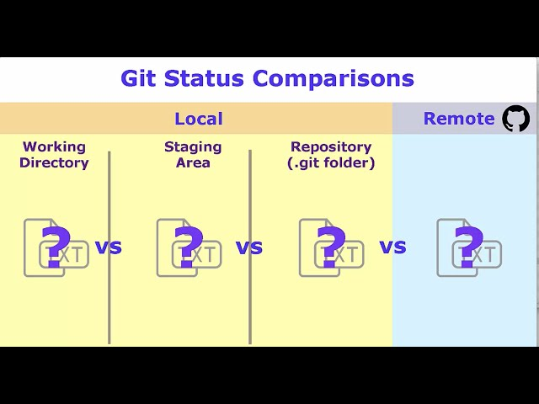

LINUX COMMANDS :

1. Moving file: mv source file destinarion file

mv /home/Users/Documents/GIT_CONFIGURATION.docx /c/Users/Abinesh/projects/Stage1---CTS/

1. Creating new file with name first.txt & print the content

Echo “Test git quick start” >> first.txt

1. DISPLAYING CONTENT IN THE FILE

Cat first.txt