PROBLEM 1 :
Objective:
To work with PL/SQL procedures.
Concept Explanation:
Procedures are precompiled sets of SQL statements stored in a database. They encapsulate logic to perform specific tasks like querying data or updating records.
Concept Implementation:
The procedure GetDepartmentName retrieves the department name associated with a given employee ID. It takes an employee ID (p_empid) as input and outputs the department name (p_dname). If no data is found for the employee ID, it sets the department name to 'Invalid Detail' using an exception handling block.
Description:
Consider the below schema and create a procedure named GetDepartmentName that takes an employee id an input parameter and returns the department name for that given employee id. If the given employee id is not found, then it should return 'Invalid Detail'.
Check for the following while creating the procedure GetDepartmentName(p_empid IN VARCHAR2, p_dname OUT VARCHAR2)
Procedure name: GetDepartmentName
Input parameter: p_empid as varchar2
: p_dname as varchar2
Sample Input:
GetDepartmentName('EMP1')
Sample Output:
Technology Automation
Design rules:
1. Procedure NAME MUST NOT be changed.
2. IN/ OUT parameters/types MUST NOT be changed.
(Hint : Use '/' symbol for termination of PLSQL block. Data is case sensitive.)
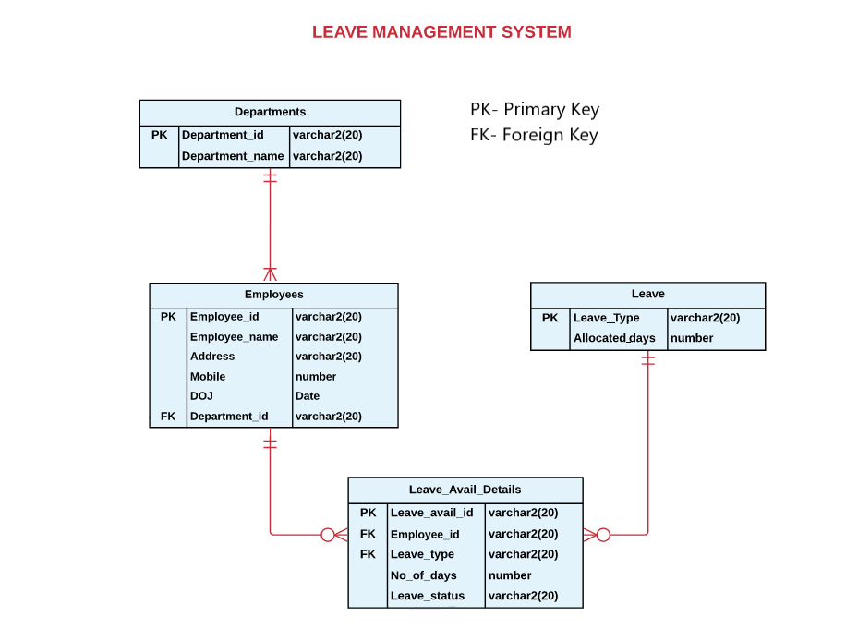
SOLUTION :
CREATE OR REPLACE PROCEDURE GetDepartmentName(
p_empid IN VARCHAR2,
p_dname OUT VARCHAR2
) IS
BEGIN
SELECT department_name INTO p_dname
FROM employees e, departments d
WHERE e.department_id = d.department_id AND employee_id = p_empid
;

EXCEPTION
WHEN NO_DATA_FOUND THEN
p_dname := 'Employee not found';
END GetDepartmentName;
/

PROBLEM 2 :
RATING INFO-PROCEDURE USING CURSOR
Concept Implementation:
The procedure RatingComments categorizes employee ratings and generates corresponding comments. It iterates over employee records from the Employee_Appraisal table. Based on their final_rating, it assigns comments such as 'Excellent(4-5)', 'Good(3-3.99)', 'Average(1-2.99)', or 'Rating Out of Range'. The procedure then prints each employee's ID, final rating, and the assigned comments using DBMS_OUTPUT.PUT_LINE.
Description:
Create a procedure with the name RatingComments that will display the employee id, final rating, and Comments in the following format:
Employee ID: E001
Final Rating: 3
Performance Comments: Good(3-3.99)
Comments are based on the following conditions:
If the final rating ranges from 4 to 5, then display 'Excellent(4-5)'.
If the final rating is greater than or equal to 3 and less than 4, then display 'Good(3-3.99)'.
If the final rating is greater than or equal to 1 and less than 3, then display 'Average(1-2.99)'.
otherwise, display 'Rating Out of Range'.
(Hint: Use case statement.)
Table Name: Employee
S.NO | Attributes | DataTypes | Constraint
1. | Emp_Id | Varchar2(10) | Primary Key
2. | Emp_Name | Varchar2(20)
3. | Address | Varchar2(20)
4. | Salary | Number(10)
5. | Phone_No | Number(10)
6. | Email_Id | varchar2(20)
7. | Grade | Int

Table Name:Employee_Appraisal
S.NO | Attributes | DataTypes | Constraint
1. | Emp_Id | Varchar2(10) | Foreign Key
2. | Self_Rating | Int
3. | Appraisar_Rating | Int
4. | Final_Rating | Int

Table Name:Revision
S.NO | Attributes | DataTypes | Constraint
1. | Emp_Id | Varchar2(10) | Foreign Key
2. | Increment_Percentage | Int
3. | New_CTC | Number(10)

(Hint: Use '/' symbol for termination of PLSQL block. Data is case sensitive.)
SOLUTION :
CREATE OR REPLACE PROCEDURE RatingComments AS
BEGIN
FOR employee_rec IN (SELECT emp_id, Final_rating,
CASE
WHEN Final_rating between 4 and 5 THEN 'Excellent'
WHEN Final_rating >=3 and Final_rating<4 THEN 'Good'
WHEN Final_rating >=1 and Final_rating<3 then 'Average'
ELSE 'Rating out of Range'
END AS Comments
FROM Employee_Appraisal) -- Assuming you have a table named StudentData
LOOP
DBMS_OUTPUT.PUT_LINE('Employee ID: ' || employee_rec.emp_id);
DBMS_OUTPUT.PUT_LINE('Final Rating: ' || employee_rec.Final_rating);
DBMS_OUTPUT.PUT_LINE('Performance Comments: ' || employee_rec.comments);
END LOOP;
END;
/

PROBLEM 3 :
ALPHA COUNT – FUNCTION
Concept Explanation:
Functions are reusable blocks of code that perform specific tasks or calculations. It encapsulates logic and can accept inputs (arguments) and produce outputs (return values). The functions can be used to manipulate data, perform calculations, or return specific results based on given parameters.
Concept Implementation:
The function stringCount counts the number of digits in a given input string. It initializes a counter and loops through each character, incrementing if the character is digit. The function then returns the total count of digits found in the input string.
Description:
Create a simple function named stringCount that takes a word (varchar) as input and returns the count of digits that word as output.
Sample Data:
If we execute the function with "Welcome123" it should return 3.
If we execute the function with "WELCOme1234" it should return 4.
(Hint: You may use ascii() function to find ascii value)
Use the skeleton file, to develop the function.
CREATE FUNCTION stringCount(str IN VARCHAR)
Function name: stringCount
Parameter: str [datatype VARCHAR]
Function return type: number
(Hint: Use '/' symbol for termination of PLSQL block. Data is case sensitive.)

SOLUTION :
CREATE OR REPLACE FUNCTION stringCount(str IN VARCHAR2)
RETURN NUMBER
IS
letterCount NUMBER := 0;
ascii_val NUMBER;
len NUMBER := LENGTH(str);
BEGIN
FOR i IN 1..len LOOP
ascii_val := ASCII(SUBSTR(str, i, 1));
IF (ascii_val BETWEEN 65 AND 90) OR (ascii_val BETWEEN 97 AND 122) THEN
letterCount := letterCount + 1;
END IF;
END LOOP;

RETURN letterCount;
END stringCount;
/

PROBLEM 4 :
Concept Implementation:
The function Eligibility determines an employee's eligibility for promotion based on years of service. It calculates years of service using the date of joining (doj) and compares it to 5 years. If eligible, it returns a message stating eligibility otherwise, it indicates ineligibility
Description:
Consider the below schema and create a function named 'Eligibility' that takes employee id as input and returns the 'Message' of type varchar(200).
This function should retrieve the necessary details from the employees table by using employee_id.
Function name: Eligibility
Input Parameter : eid in EMPLOYEES.EMPLOYEE_ID%TYPE
Output variable: message variable of type varchar
Design rules:
1. Employees are eligible for promotion only if their experience is more than 5. So, if the experience of an employee is above 5, then set the message 'EMP1 into the output variable 'Message'.
2. Otherwise, set the message 'E has been with the company for 2 years and does not meet eligibility criteria for promotion' into the output variable 'Message'.
EMP1 - is the employee id.
Note: Use DOJ for calculating experience. Use trunc().
Design rules:
1. Procedure NAME MUST NOT be changed.
2. IN parameters/types MUST NOT be changed

(Hint : Use '/' symbol for termination of PLSQL block. Data is case sensitive.)

SOLUTION :
create or replace function Eligibility(eid in EMPLOYEES.EMPLOYEE_ID%type)
return varchar
as
message varchar(200);
abc number;
begin
select trunc((sysdate-doj)/365,0) into abc from employees where employee_id=eid;
message := eid || ' has been with the company for ' || abc || ' years and ';

if abc > 5 then
message := message || 'meets eligibility criteria for promotion';
else
message := message || 'does not meet eligibility criteria for promotion';
end if;
return message;
end;
/
PROBLEM 5 :
ADDRESS VALIDATION – EXCEPTION HANDLING
Concept Explanation:
1. Procedures are precompiled sets of SQL statements stored in a database. They encapsulate logic to perform specific tasks like querying data or updating records
2. Exception handling deals with managing and responding to unexpected or exceptional situations that may occur during the execution of a query.
Concept Implementation:
The procedure Validation checks if an employee's address is 'Bangalore' before inserting a new record into the EMPLOYEES table. It defines an exception, InvalidAddressException, to handle cases where the address is not 'Bangalore'. If the address is 'Bangalore', it inserts the employee details into the EMPLOYEES table and prints a success message. If the address is not 'Bangalore', it raises the InvalidAddressException and prints an error message indicating that the record was not inserted.
Description:
Create a PL/SQL procedure to insert employee details into the employees table. Employee address should be 'Bangalore'. Before inserting, check whether the employee's address is 'Bangalore' or not. Values are passed as arguments to the procedure as mentioned in the functional requirements given below.
If the address is Bangalore, then insert the employee id, name, address, mobile number,doj and department id into the employees table and print the message as "Record inserted successfully", else print the message as "Invalid Address - Record not inserted" by declaring and raising an exception.
Functional Requirement:
PROCEDURE VALIDATION(
v_empid EMPLOYEES.EMPLOYEE_ID%TYPE,
v_name EMPLOYEES.EMPLOYEE_NAME%TYPE,
v_address EMPLOYEES.ADDRESS%TYPE,
v_mobile EMPLOYEES.MOBILE%TYPE,
v_doj EMPLOYEES.doj%TYPE,
v_deptid EMPLOYEES.department_id%TYPE
)
Sample Input 1 :
VALIDATION('E2006','Julie','Bangalore',765489033,'12-May-17','D1') ;
Sample Output 1:
Record inserted successfully
Sample Input 2:
VALIDATION('E05','Peter','Florida',9894189213,12-JUN-18','D2') ;
Sample Output 2:
Invalid Address - Record not inserted

Design rules:
1. Procedure NAME MUST NOT be changed.
2. IN parameters/types MUST NOT be changed
(Hint : Use '/' symbol for termination of PLSQL block. Data is case sensitive.)

SOLUTION :
CREATE OR REPLACE PROCEDURE VALIDATION(
v_empid EMPLOYEES.EMPLOYEE_ID%TYPE,
v_name EMPLOYEES.EMPLOYEE_NAME%TYPE,
v_address EMPLOYEES.ADDRESS%TYPE,
v_mobile EMPLOYEES.MOBILE%TYPE,
v_doj EMPLOYEES.doj%TYPE,
v_deptid EMPLOYEES.department_id%TYPE)
IS
InvalidAddressException EXCEPTION;
BEGIN
IF (v_address != 'Bangalore') THEN
RAISE InvalidAddressException;
ELSE
INSERT INTO EMPLOYEES (EMPLOYEE_ID, EMPLOYEE_NAME, ADDRESS, MOBILE, doj, department_id)
VALUES (v_empid, v_name, v_address, v_mobile, v_doj, v_deptid);
DBMS_OUTPUT.PUT_LINE('Record inserted successfully');
END IF;
EXCEPTION
WHEN InvalidAddressException THEN
DBMS_OUTPUT.PUT_LINE('Invalid Address - Record not inserted');
END VALIDATION;
/

PROBLEM 6 :
DELETE A RECORD – TRIGGER
Concept Explanation:
Triggers are database objects used to automatically perform actions, such as inserting, updating, or deleting data in response to specified events, like before or after an operation on a table.
Concept Implementation:
The trigger named t_remove_employee is executed before a deletion in the employees table for each affected row. It captures the details of the employee being deleted and inserts these values into the employee_archive3 table. This archival process ensures that employee data is retained even after deletion, providing a historical record of removed employees' details.
Description:
In the dynamic realm of database management, organizations often seek effective mechanisms to maintain historical records and preserve valuable information even when employees are no longer part of the active workforce. Your task is to design a database trigger that facilitates the seamless archiving of employee details before they are deleted from the "employees" table.
Consider the scenario where you are entrusted with the responsibility of creating or replacing a trigger named t_remove_employee. This trigger is specifically designed to execute before a deletion operation on the "employees" table, ensuring that relevant employee details are archived in a designated table called "employee_archive."
Design rules:
1. Trigger NAME MUST NOT be changed.
2. Assume that employee_archive3 table is already created.
(Hint : Use '/' symbol for termination of PLSQL block. Data is case sensitive.)
employee_archive3 Table Structure
Column name | Data type | Constraints
Employee_id | VARCHAR2(20) | Primary Key
Employee_name | VARCHAR2(20)
DOJ | DATE
Department_id | VARCHAR2(20)

SOLUTION :
create or replace trigger t_remove_employee
before delete on employees
for each row
begin
insert into employee_archive3 values
(:old.employee_id,:old.employee_name,:old.DOJ,:old.DEPARTMENT_ID);
end;
/
PROBLEM 7 :
UPDATE SALARY :
Concept Explanation:
An anonymous block is a block of code that is not named and is executed directly in the database without being stored as a procedure or function.
Concept Implementation:
An anonymous block first updates the salaries of employees in department 'D2' by decreasing them by 30%.
Description:
Create a PL/SQL block to update the salary of the employees, which has been decreased to 30% only for those who belong to the 'D2' department.

(Hint: Use '/' symbol for termination of PLSQL block. Data is case sensitive.)
Table Name: Employees
S.No | Attributes | Data | Constraint
1 | employee_id | varchar2(20) | Primary Key
2 | employee_name | varchar2(20)
3 | salary | number(9,2)
4 | address | varchar2(20)
5 | mobile | number
6 | DOJ | date
7 | Department_id | varchar2(20) | Foreign Key

SOLUTION :
BEGIN
UPDATE employees SET salary=salary-(salary*0.3) where department_id='D2';
END;
/
PROBLEM 8 :
DELETE EMPLOYEES :
Concept Implementation:
An anonymous block deletes records from the employees table where the address is either 'Hyderabad' or 'Coimbatore'.
Description:
Create a PL/SQL block to delete all the entries from the employees table for the employees from 'Hyderabad' or 'Coimbatore'.

(Hint: Use '/' symbol for termination of PLSQL block. Data is case sensitive.)

SOLUTION :
begin
delete from employees where address in ('Hyderabad','Coimbatore');
end;
/

PROBLEM 9 :
EMPLOYEE INFORMATION – PACKAGE :
Concept Explanation:
A package is a schema object that groups related procedures, functions, variables, and other PL/SQL constructs together. It helps in organizing and modularizing code and improving code reusability. A package consists of two main parts: the package specification and the package body.
Concept Implementation:
A package pkemployee contains a procedure findEmployeeDetails that retrieves and displays specific details of an employee based on their employee ID (eid). The procedure fetches the employee's id, name, department name, and date of joining from the departments and employees tables. It calculates the employee's experience in years and prints this information using dbms_output.put_line. If no data is found for the provided employee ID, it outputs 'No employee details found for Employee ID: EMP'.
Description:
Create a package pkemployee with specification and body.
The package has a procedure named findEmployeeDetails which accepts the employee Id as input and prints the employee id, name, department name and experience (in years and months). If no such employee id is present, print 'No employee details found for Employee ID: E1'.
EMP1 is the employee id.
Use the skeleton file to develop the package
PACKAGE pkemployee PROCEDURE findEmployeeDetails
Package name: pkemployee
Procedure name: findEmployeeDetails
Parameter: eid [data type: varchar2]
Sample Input:
pkemployee.findEmployeeDetails('EMP01');
Sample Output:
Employee ID: EMP01 - Employee Name: Steven
Department Name: Administration
Experience: 2 years and 6 months
Hint:
1. Use doj to calculate the experience.
2. Use '/' symbol for termination of PLSQL block. Data is case sensitive.

SOLUTION :
CREATE OR REPLACE PACKAGE pkemployee
AS
PROCEDURE findEmployeeDetails(eid varchar2);
END pkemployee;
/

CREATE OR REPLACE PACKAGE BODY pkemployee
AS
PROCEDURE findEmployeeDetails(eid varchar2)
AS
vname varchar2(20);
vdname varchar2(20);
vdoj date;
exp number;
BEGIN
select employee_name,department_name,doj into vname,vdname,vdoj
from departments d, employees e
where d.department_id=e.department_id and employee_id=eid;
if SQL%FOUND then
exp:=trunc((sysdate-vdoj)/365,0);
dbms_output.put_line('Employee Name:'||vname);
dbms_output.put_line('Department Name:'||vdname);
dbms_output.put_line('Experience:'||exp);
end if;
EXCEPTION
when no_data_found then
DBMS_OUTPUT.PUT_LINE('No employee details found for Employee ID: ' || eid);
END ;
END pkemployee;

