A **reactive web framework** is designed to handle asynchronous data streams efficiently, ensuring **non-blocking** operations for better scalability and responsiveness. One of the most popular frameworks in this space is **Spring WebFlux**, introduced in Spring 52.

### **Key Features of Reactive Web Frameworks:**

* **Non-blocking I/O**: Uses event-driven architecture to process requests without waiting for responses.
* **Reactive Streams**: Implements **Publisher-Subscriber** patterns to manage data flow efficiently.
* **Backpressure Handling**: Ensures that fast producers do not overwhelm slower consumers.
* **Functional Programming Support**: Leverages Java 8 features like **lambda expressions** for declarative composition.
* **Scalability**: Optimized for handling high concurrency with fewer threads.

In traditional synchronous programming models, I/O operations such as reading from a file or making network requests block the execution of the program until the operation completes. This means that if there are multiple I/O operations, they are processed sequentially, leading to potential bottlenecks and wasted resources as the program waits for each operation to finish.

Non-blocking I/O, on the other hand, allows a program to continue executing other tasks while waiting for I/O operations to complete. Instead of halting the entire program, non-blocking I/O utilizes asynchronous callbacks or promises to handle I/O operations in the background. This enables to handle multiple operations concurrently without being blocked, resulting in better performance and responsiveness.

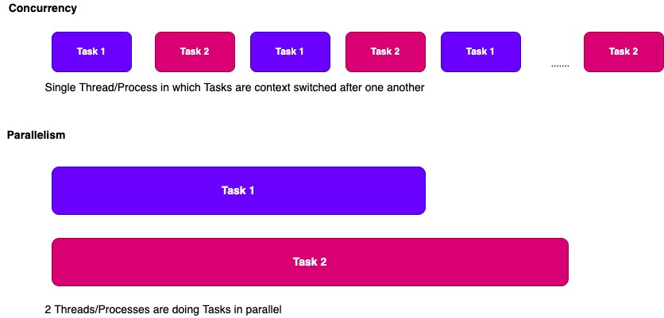

### **Spring WebFlux Overview:**

Spring WebFlux is a **reactive alternative** to traditional Spring MVC, built to support **non-blocking** applications. It works seamlessly with **Netty**, **Tomcat**, and other async servers. The framework introduces **Mono** and **Flux**, which are essential for handling reactive data streams.

**overview of reactive web framework with non blocking**

A **reactive web framework** is designed to handle asynchronous data streams efficiently, ensuring **non-blocking** operations for better scalability and responsiveness. One of the most popular frameworks in this space is **Spring WebFlux**, introduced in Spring 52.

### **Key Features of Reactive Web Frameworks:**

* **Non-blocking I/O**: Uses event-driven architecture to process requests without waiting for responses.
* **Reactive Streams**: Implements **Publisher-Subscriber** patterns to manage data flow efficiently.
* **Backpressure Handling**: Ensures that fast producers do not overwhelm slower consumers.
* **Functional Programming Support**: Leverages Java 8 features like **lambda expressions** for declarative composition.
* **Scalability**: Optimized for handling high concurrency with fewer threads.

### **Spring WebFlux Overview:**

Spring WebFlux is a **reactive alternative** to traditional Spring MVC, built to support **non-blocking** applications. It works seamlessly with **Netty**, **Tomcat**, and other async servers. The framework introduces **Mono** and **Flux**, which are essential for handling reactive data streams.

### 

### 

### 

### 

### **Spring MVC vs. Spring WebFlux**

| **Feature** | **Spring MVC** | **Spring WebFlux** |
| --- | --- | --- |
| **Processing Model** | Synchronous (blocking) | Asynchronous (non-blocking) |
|  |  |  |
| **Thread Management** | Each request handled by a separate thread | Uses event-driven, reactive streams |
| **Performance** | Can struggle under high concurrency | Optimized for handling large concurrent requests |
| **Use Case** | Traditional web applications | Microservices, streaming, real-time applications |
| **Programming Model** | Imperative | Reactive |
| **Backpressure Handling** | Not supported | Supported via Project Reactor |
| **Server Compatibility** | Works with Tomcat, Jetty | Works with Netty, Tomcat, Jetty |

Spring MVC follows a **blocking request-response model**, meaning each request is handled by a dedicated thread. This can lead to performance bottlenecks under heavy load. On the other hand, **Spring WebFlux** is built for **reactive programming**, allowing non-blocking execution and better scalability.

If you're working on **high-concurrency applications**, **real-time data processing**, or **microservices**, WebFlux is a great choice. However, if your application is **traditional**, with simpler request-response interactions, **Spring MVC** might be more suitable.

Spring WebFlux is widely used in scenarios where **high concurrency**, **real-time data processing**, and **non-blocking operations** are essential. Here are some real-world applications:

### **1. Real-Time Streaming Applications**

Spring WebFlux is ideal for **live data streaming**, such as:

* **Stock market updates**: Continuously push stock price changes to users.
* **Live sports scores**: Deliver real-time match updates without polling.
* **Social media feeds**: Stream new posts and comments instantly.

### **2. High-Concurrency APIs**

WebFlux efficiently handles **massive concurrent requests**, making it perfect for:

* **E-commerce platforms**: Managing thousands of simultaneous product searches.
* **Social media interactions**: Handling likes, comments, and shares at scale.
* **IoT applications**: Processing data from millions of connected devices.

### **3. Chat Applications & WebSockets**

WebFlux supports **WebSockets**, enabling:

* **Instant messaging apps**: Real-time chat without blocking operations.
* **Collaborative tools**: Live document editing and team collaboration.
* **Gaming servers**: Multiplayer game interactions with minimal latency.

### **4. Microservices & Cloud-Native Applications**

Spring WebFlux is a great fit for **microservices architectures**, allowing:

* **Efficient inter-service communication**: Non-blocking API calls between microservices.
* **Scalable cloud applications**: Optimized resource usage in cloud environments.
* **Serverless computing**: Handling event-driven workloads efficiently.

### **5. Reactive Database Access**

WebFlux works seamlessly with **reactive databases** like **MongoDB**, **Cassandra**, and **R2DBC**, making it useful for:

* **Big data processing**: Handling large-scale datasets efficiently.
* **Analytics dashboards**: Streaming real-time analytics to users.
* **Recommendation engines**: Delivering personalized content dynamically.

### **Mono in WebFlux**

* **Mono<T>** represents **0 or 1** element in a reactive stream.
* Used for **single-value responses**, such as fetching a single database record.
* Supports **operators** like map(), flatMap(), and filter() for transformation.

### **Example: Using Mono in WebFlux**

@RestController

@RequestMapping("/user")

public class UserController {

@GetMapping("/{id}")

public Mono<User> getUserById(@PathVariable String id) {

return userRepository.findById(id);

}

}

**In this example, Mono<User> ensures non-blocking retrieval of a single user.**

**Mono** and **Flux** are both part of **Project Reactor**, which powers **Spring WebFlux**. They represent **reactive streams**, but they differ in how they handle data.

### **Mono vs. Flux in Spring WebFlux**

| **Feature** | **Mono** | **Flux** |
| --- | --- | --- |
| **Data Emission** | 0 or 1 item | 0 to many items |
| **Use Case** | Single response (e.g., fetching one user) | Multiple responses (e.g., fetching a list of users) |
| **Operators** | Supports map(), flatMap(), onErrorResume() | Supports map(), flatMap(), filter(), buffer() |
| **Backpressure Handling** | Not needed (single item) | Required for large data streams |
| **Example** | Mono.just("Hello") | Flux.just("A", "B", "C") |

### **Example Usage**

#### **Mono Example (Fetching a Single User)**

@GetMapping("/{id}")

public Mono<User> getUserById(@PathVariable String id) {

return userRepository.findById(id);

}

#### **Flux Example (Fetching Multiple Users)**

@GetMapping("/users")

public Flux<User> getAllUsers() {

return userRepository.findAll();

}

If you need **one result**, use **Mono**. If you need **multiple results**, use **Flux**.