**Advance Programming Documentation**

Done By:

Shanya Connell

Abi Matthews-Gordon

Lecturer:

Christopher Panther

This application was developed based on the requirements of Micro-Star Cable Vision. The purpose of the application is to allow seamless communication between MicroStar client, their customer server centre and their technicians. The application is designed on a client-server architecture and is organised into three components. The base component contains all the common code necessary for both client and server to operate together while a client component contains all the codes necessary for the client only, in addition to the common code and the server component contains all the code necessary for the operations of the server.

The client application acts as a front facing interface which can be used to interact with the application for daily use while, the server application provides the backend functionality. The applications communicates over TCP/IP.

**Technologies Used**

The application will be built on open-sourced platforms namely:

1. The Java Programming Language
2. MySQL Database
3. The application will also utilise server third party libraries including, MySQl Connector, Log4J2 and Hibernate 5.

**Test Data**

Customer:

Username: abi1

Password: P@ssword1

Customer Representative:

Username: admin

Password: P@ssword123

Technician:

Username: abie

Password: P@ssword123

**User Interface**

Technician Dashboard

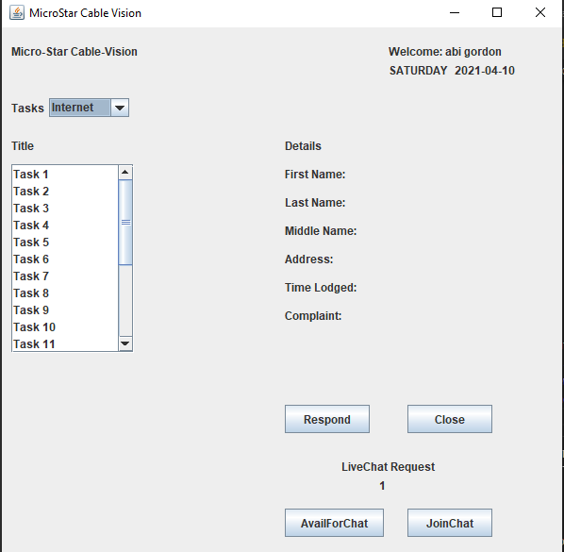

Customer Representative Dashboard

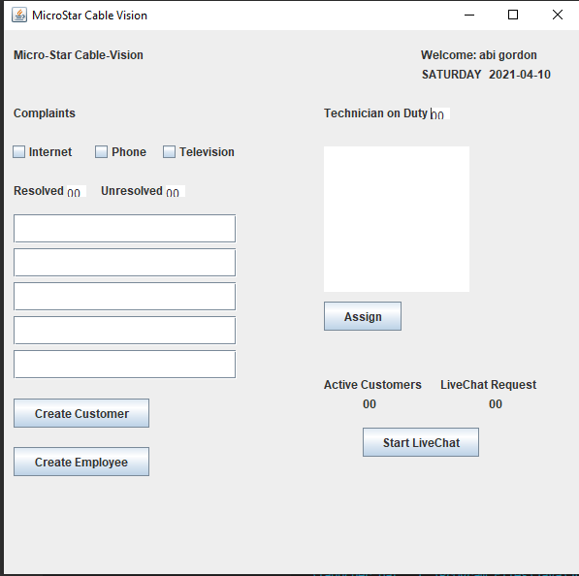

Customer Dashboard

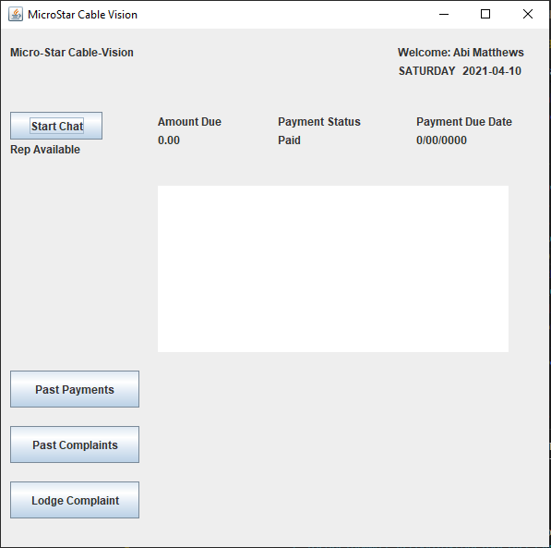

Complaint Form

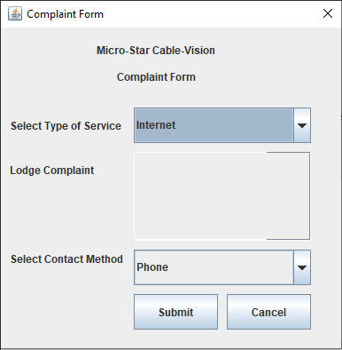

Complaint History

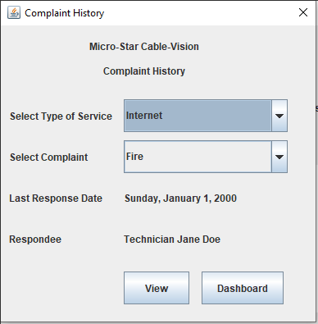

Payment History

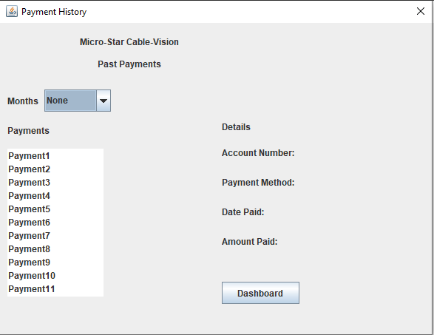

Specific Complaint

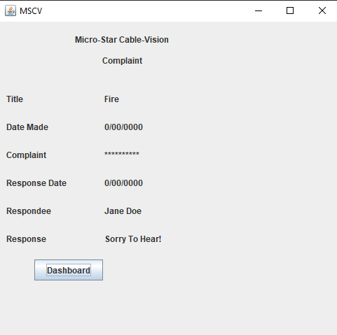

Assigning Technician

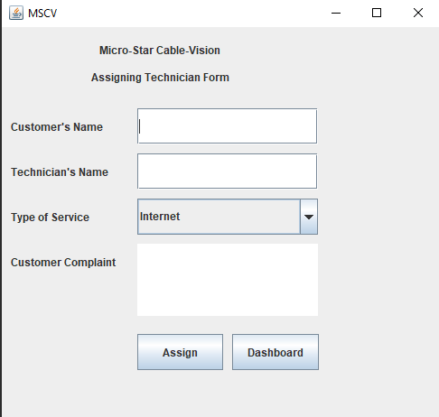

Register Customer

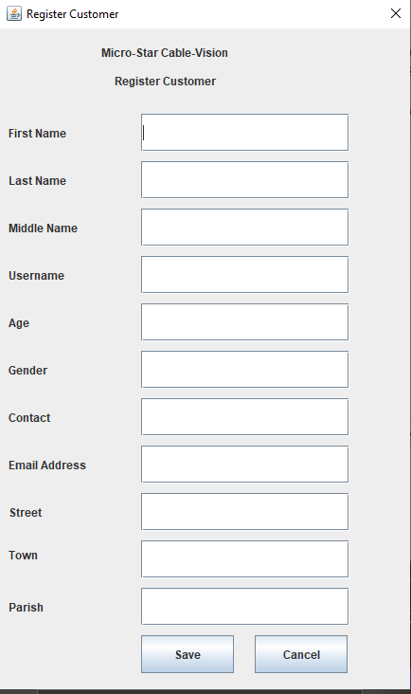

Register Employee

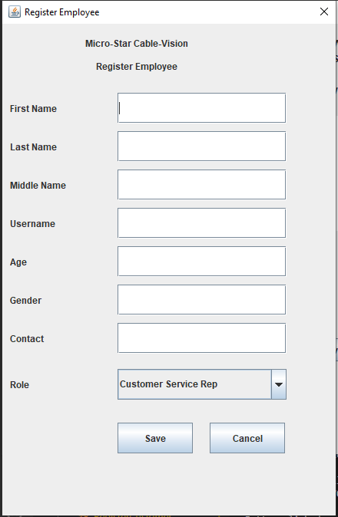

Viewing Customer Details

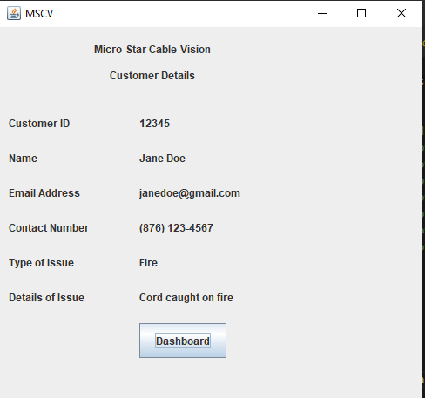

Sign In

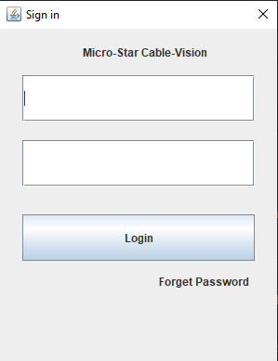

Preparing Response

