AbiWord 2.2
by Martin Sevior
Tons of Cool new Features!


Even Prettier than Before!
Now Even Faster!
World-leading usability!

Abstract
Amaze your friends with what GTK can do!

AbiWord is a cross platform Word Processor and is GNOME's word processor.
Over the last year we've made many, many improvements to the code base that will become AbiWord-2.2
We've made a number of genuinely innovative improvements that will improve the ability of users to turn their thoughts into nicely structured documents.

Outline
- Brief History of AbiWord
- How it works
- What we did since 2.0
- Cool new stuff in 2.2
- Demonstration of AbiWord-2.2
- Questions?

History of AbiWord
Started by some people who are now SourceGear in 1998.
Jeff Hostetler, Eric Sink, Paul Rohr, Bob Sievers
Abandoned except for Paul and Bob in 1999.
Dom and Martin took over as maintainers in 2000.
1.0 released in 2002.
2.0 September 2003.
2.2 Real Soon Now!

AbiWord's Goals and Ambitions
"Word Processing for Everyone"
AbiWord aims to be the word processor of and for the masses.
The most powerful, fastest, easiest and most pleasant way to write stuff.
AbiWord does its best to inter-operate with the user's native environment and its existing applications, toolkits, and file formats while providing an incomparable level of quality, service, and performance.
AbiWord achieves this through:
- A unique approach to cross-platform application development.
- A strenuous effort to separate GUI components from the document model.
- Focused effort to correctly define interfaces and base classes.
- A very robust import/export architecture, with a profound focus on inter-operability with the many existing word processors on the market today
- An ever-growing array of plugins, capable of everything from providing new image loaders to inline translations to dictionaries and thesauri.

AbiWord Internals

Is a C++ program with a large effort to abstract and re-use code.
It has a cross Application Architecture (xap), cross platform architecture (xp)
AbiWord was designed to be the first of a full suite of applications.
A large fraction of the code was identified as being useful to other applications.
This code was placed in (xap) classes.
Examples include the event logic, much of the code for dealing with windows and frames, many dialogs.

The Cross Platform Architecture

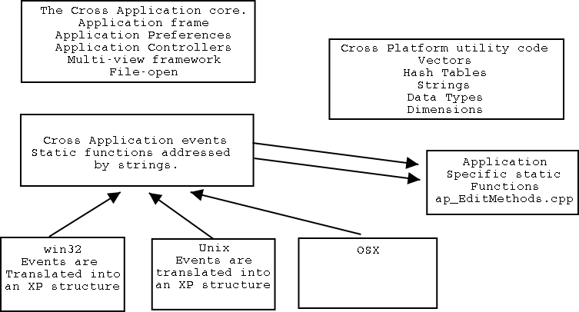

The code snippet opposite shows how events are mapped into actions.  (This case the Backspace command)  The events mapped to static functions makes it very easy to extend AbiWord.  One simply defines new static functions and adds them to the list methods.  Makes it easy to extend write plugins.  The menu and toolbar code is similar.  Menu and toolbar items are defined in XP structures and then built with platform code.  Menus and Toolbars are easily configurable. | static EV_EditMethod_Fn delLeft;  .  .  static EV_EditMethod s_arrayEditMethods[] =  {  #if defined(PT_TEST) || defined(FMT_TEST) || defined(UT_TEST)  EV_EditMethod(NF(Test_Dump), 0, ""),  EV_EditMethod(NF(Test_Ftr), 0, ""),  #endif  // a  EV_EditMethod(NF(activateWindow_1), 0, ""),  EV_EditMethod(NF(activateWindow_2), 0, ""),  .  EV_EditMethod(NF(delLeft), 0, ""),  }  .  #define Defun1(fn) bool F(fn)(AV_View* pAV_View, EV_EditMethodCallData * /*\pCallData*/)  Defun1(delLeft)  {  CHECK_FRAME;  ABIWORD_VIEW;  pView->cmdCharDelete(false,1);  return true;  }

AbiWord makes extensive use of abstract virtual methods in base classes to implement platform specific code.
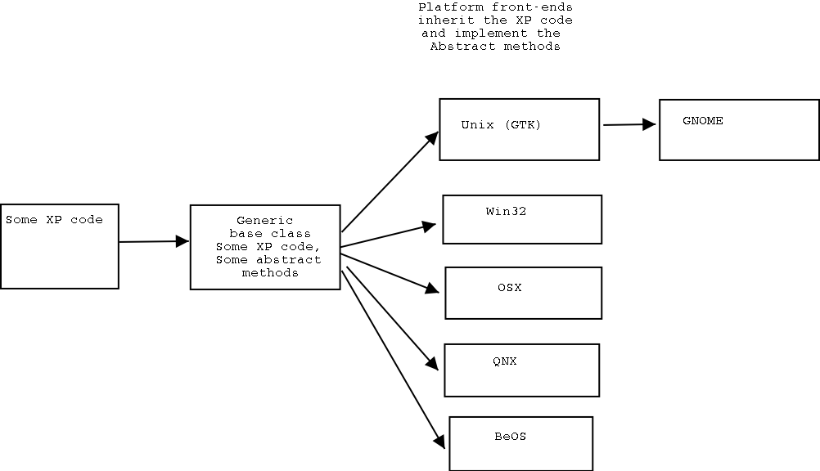

Example - The Graphics class

The base class gr_Graphics has both virtual methods and real code.  The code snippet opposite is from the header file of the gr_Graphics base class.  "findNearestFont" looks up a hash table of cached fonts implemented for all platforms.  The other methods in the class are pure virtual which are implemented in the platform code.  The code for drawing with the Win32 API is  totally different from GTK. | virtual GR_Font* getGUIFont() = 0;  virtual GR_Font* findFont(const char* pszFontFamily,  const char* pszFontStyle,  const char* pszFontVariant,  const char* pszFontWeight,  const char* pszFontStretch,  const char* pszFontSize) =0;  static const char* findNearestFont(const char* pszFontFamily,  const char* pszFontStyle,  const char* pszFontVariant,  const char* pszFontWeight,  const char* pszFontStretch,  const char* pszFontSize);  virtual void drawChars(const UT_UCSChar* pChars,  int iCharOffset,  int iLength,  UT_sint32 xoff,  UT_sint32 yoff,  int* pCharWidths = NULL) = 0;

The net result of the approach used by AbiWord is that the application is a native application on each target platform
pure win32 program on win32, pure Gtk on Unix, pure OSX on Apple
can easily implement GNOME architecture to override Gtk as needed.
Complete separation of GUI from backend.
Leads to a modular and stable platform despite huge complexity.
Downside is that platform developers are needed.
Quite resource intensive.

Text and other objects in AbiWord
AbiWord uses a Model-View-Controller architecture.
The "Model" is the PieceTable.
The "View" are the Layout classes.
The "Controller" is split between document level manipulations and manipulations on the view via the insertion point.
The PieceTable is a doubly-linked list of objects that contain pointers to text, data and const char * text strings which represent attribute-value pairs.
These attribute-value pairs can be arbitrarily complex.
Represent the attributes of the text (font, font-size, sub/superscript etc)
Represent the attributes of the Text structures like (paragraphs, sections, table, cells etc)
You can get a feel for this by browsing *.abw files. (These are basically XML-ized dumps of the piecetable.

This little snippet of an *.abw shows how a simple 2x2 table is defined.  <table> represents a table structure fragment  <cell ....> represents a cell structure.  Notice the list of props=.....  These are key-value pairs.  The values assigned to bot-attach, top-attach etc tell the Layout classes where to place the  cell in the table | <table>  <cell props="bot-attach:1; left-attach:0; right-attach:1; top-attach:0">  <p style="Normal">Cell 1</p>  </cell>  <cell props="bot-attach:1; left-attach:1; right-attach:2; top-attach:0">  <p style="Normal">cell 2</p>  </cell>  <cell props="bot-attach:2; left-attach:0; right-attach:1; top-attach:1">  <p style="Normal">cell 3</p>  </cell>  <cell props="bot-attach:2; left-attach:1; right-attach:2; top-attach:1">  <p style="Normal">cell 4</p>  </cell>  </table>

Layout Classes
There is only one Piecetable per document but each document can have any number of views.
The Views are created by the Layout classes, which interpret the attribute-value pairs, text and data in the PieceTable and create formatted text on the screen.
Each Structure fragment in the PieceTable has a vector of pointers to corresponding Layout classes.
Changes to the PieceTable are recorded in Change Record classes.
These are both recorded in a Stack for Undo and broadcast out the Layout classes.

The MVC arrangement of AbiWord  Documents are imported/exported directly through the controller  Users interact firstly with the frame, then the layout control.  PieceTable changes are broadcast to all Layouts via the controller | 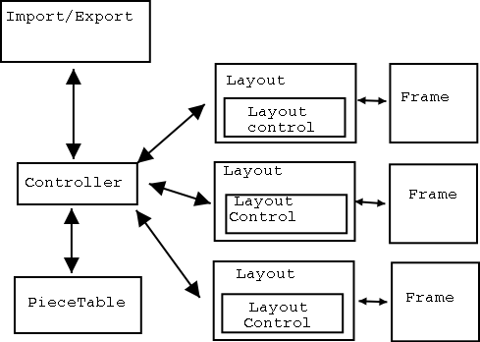

What we've done since 2.0
- Numerous additional Table controls. Split Cells, column selection, improved nested table support.
- Instant zoom.
- Lots of speed ups. A factor 6 loading documents with large tables.
- Visual text and Object Selection, drag and drop.
- Text Boxes.
Can position Text with Text Boxes
- Table of Contents.
- Text Folding.
- Background Images (Pages, Tables and Text Boxes)
- Stylist Dialog (Copied from OOo)
- OSX Port!
- Refactored the graphics class to enable platform specific backends
(Along the use of platform specific libraries for complex script handling, eg. uniscribe for Windows, pango for Linux)
- More HIG compliance for dialogs. eg. Preferences are now instant apply.
- Improved Import/Export Filters.
- Paste Gnumeric data into Tables.
- Tons of bug fixes.
Still ironing out bugs.

Demo Time!

The Command line
AbiWord embraces the Unix platform by providing numerous command-line options.
These enable power-users to get more done quickly and...
Provide an easy to-use way to do server-side document manipulation.
Some examples of AbiWord "Back Office" usage are:
- As a Document conversion server
- eg: serve up MS Word documents to web browsers as HTML
- As a Print server:
- Do Mail Merge and generate postscript for printing on the fly.
- Convert documents to PDF
- Manipulate AbiWord programmatically via a console-like interface (AbiCommand plugin)
- No need for a running X server!

Extend AbiWord with plugins.
AbiWord has a powerful plugin architecture. Some of the existing plugins are:
aiksaurus | A powerful and unique thesaurus.
abigimp | Use the GIMP image processing software to manipulate images
Text Summarizer | Choose this option to summarize the text of your document.
Wikipedia | Select some text and search the wikkipedia online encyclopedia.
freetranslation | Automatically translate text. your text into the language of your choice.
abicommand | Powerful and extensible command line interface to AbiWord.
gypsython | Use a python interface to interface directly AbiWord's internal API.
urldict | Select a word and then search an online dictionary for it's meaning.
gda | Interface into the GNOME database program Mergeant.
scripthappy | Run external programs and scripts from within AbiWord.
import/export filters | filters for applix,bzip2 abiword files, clarisworks, coquille, docbook, eml, Human readable ascii text, html, kword, latex, mif, OpenWriter, pdb (Palm), psion, pw (Pathetic writer), sdw, t602, wml, wordperfect,xhtml, xsl-fo

Embed AbiWord.
AbiWord-2.0 can be used as embeddable bonobo component.
The Component is fully editable.
This gives GNOME programmers a powerful word processor they can plug into their application with just a few lines of C!

Can also be used as Viewer.  As Nautilus View it allows quick browsing of documents.  Might be worth making part of the GNOME platform | 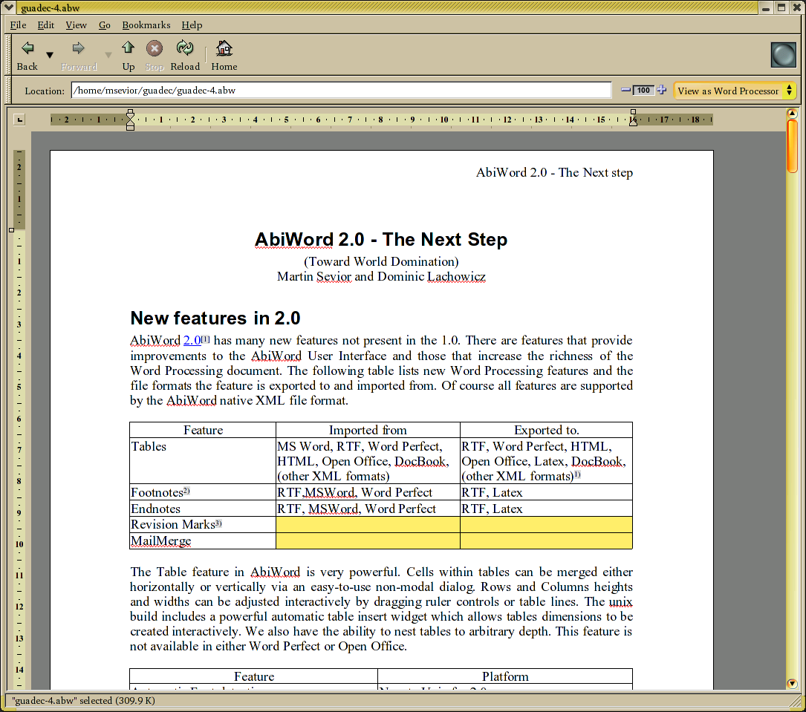

The Future of GNOME Office

Much effort has gone into porting existing applications to the tremendous Gnome 2 platform. AbiWord and the other GNOME Office applications are no exceptions. Not only have these applications been "ported' to the new framework, but they were also re-architected to leverage the many wonderful new controls, widgets, and technologies that it provides. Some of the more important technologies are:
- Bonobo
- GConf
- GTK+2
- LibGSF
AbiWord 2.0 strives to utilize many of these technologies to its advantage.

Gnome Office
The AbiWord team has worked with the Gnumeric team in order to create a very solid, robust, full-featured office applications for the GNOME desktop. We endeavor to work on:
- Better support for popular MS Windows graphic types (WMF and EMF included)
- Better support for popular MS Windows file formats (DOC, XLS, ...), using LibGSF
- Cross-Application embeddability
- Shared dialogs and other controls (toolbars, menus, font selection dialogs, etc...)
- Improved font handling
- Improved printing support

The Future.
There are many additional features that we intend to add to AbiWord.

- Handle equations and maths.
- Additional table features (sort tables, text to tables, repeated rows on pages).
- Do genuine text wrapping around objects.
- Paragraph borders.
- More sophisticated Lists.
- Embedded bonobo and (maybe mozilla) objects.
- Genuine Scalable Graphics support.
- More and improved import/export filters.
- Finish HIG compliance.
- Split View, Tab Views
- Reveal Codes
- Auto-correction framework
  - Auto-completion
  - Grammar checker
  - Text substituion: eg. (c) => 
- Use libgsf which will enable use to use the large variety of gnome-vfs backends. With this in place we can stream documents to and from AbiWord using a variety of internet protocols.

With these in place and continued improvements in our filters we should meet 99% of everyones Word Processing needs.

(Certainly meet mine!)

How you can help AbiWord

You can help AbiWord development through a number of ways:
- Use it! Tell others to use it. Send *.abw docs to people!
- File bugs and perform regression and stress tests
- Help us out with maintaining Bugzilla
- Help out with "bug-days"
- Help answer questions on the abiword-user list
- Write user and developer documentation
- Translate or update an existing translation
- Contribute code
- Sponsor a developer
- Port Abi to your favorite platform (eg: Qt/KDE, MacOS 9)

All of this and more is explained at http://www.abisource.com/howtohelp.html

Conclusions
- AbiWord-2.2 is an extremely useful program already.
- Elegant design, very fast.
- Easy to use. Visual drag and drop is the easiest way to move text around.
- Get's out of your way
- Being deployed at 10,000 seats at Crowell Systems and their clients
- Developers are absolutely committed to continued development.
- Continued strong development after 2.2

Questions/Comments



