**ACCESSING THE CU REPORTING SYSTEM IN MY.CU.EDU PORTAL**

1. Login to the My.CU.Edu portal (<https://my.cu.edu>) . Use your campus identikey and password to login.

2. Go to the MY.REPORTS tab:

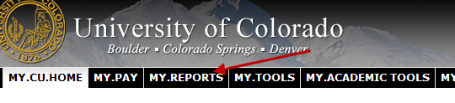

3. Open the PUBLIC FOLDERS link:

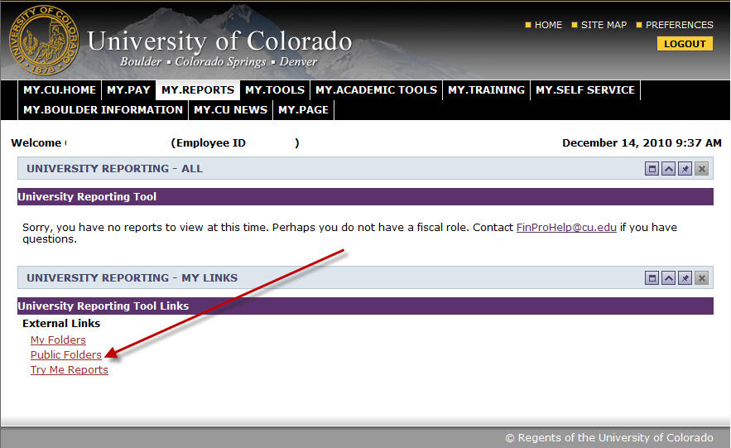

4. If you are a staff member in an academic department or are an advisor, you should have the CUBLD folder in the Public Folders listing that will allow you access to the queries we have written for you. If you do not see these queries and work in an academic unit as a staff member, please contact [ISISAccess.Registrar@colorado.edu](mailto:ISISAccess.Registrar@colorado.edu) .

Those individuals requesting access who do not work in academic departments will have to apply for access and have it evaluated on an individual basis – requests will only be approved due to demonstrated “student data legitimate need to know”. For more information on applying for access to the CU Reporting System **in My.CU.edu** portal, please contact ISISAccess.Registrar@colorado.edu.

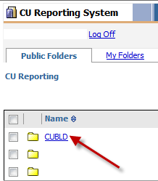

5. Click on RECORDS AND REGISTRATION (some of you may have FINANCIALS or ADMISSIONS – for the purpose of this training document, the focus is only on RECORDS AND REGISTRATION).

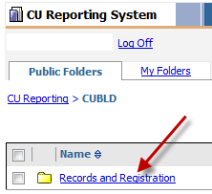

6. Click on GENERAL STUDENT RECORDS DATA REPORTS. Some of you may have access to specific custom-written queries. These appear under DEPARTMENT SPECIFIC DATA REPORTS. This training document will only focus on the general queries.

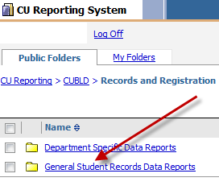

7. You should see a list that looks like this:

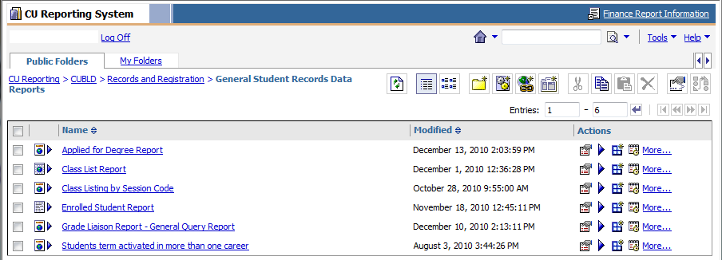

Currently, the specific queries include:

**Applied for Degree Report** – tentative list of graduates for the specified term.

**Class List Report** – may be renamed – this is a list of course information including enrollment information for the term specified. It is suggested that you run this report with as many parameters indicated as possible to speed up the running of the report. NOTE: We will look to create a new version of this report soon that will narrow down the data to provide a quick summary of enrollment information on the campus. We hope to make this available to all faculty in the future.

**Class listing by session code** – this is a list of course information by term sessions. This will primarily be useful on the main campus to look at summer term enrollment. This also identifies enrollment for all of the CEPS courses by session.

**Enrolled Student Report** – this is a list of all students currently enrolled within the parameters specified. This provides you with a great deal of term data. It is recommended, especially in Arts and Sciences, that you narrow your selections down (for example, by plan) in order to facilitate the running of this report.

**Grade Liaison Report** – this is a list of all students in courses by department and their grades for each course/section. As grading is all web-based now, there are no grade sheet copies for faculty to provide to departments. Thus, this report can be run by term/subject (or specific class and section) to determine what grades have been submitted by the faculty.

**TIPS ON USING THE CU REPORTING SYSTEM IN MY.CU.EDU PORTAL**

* If you get what looks like an error message when opening up your report – don’t worry. Just say “yes”! This message can differ by browser or security settings.

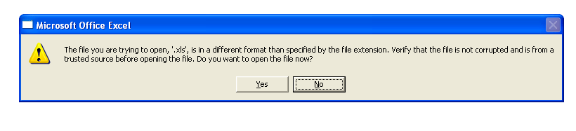

* ACTIONS – Over to the right of the reports are a set of actions that you can use to select for your reports. The only one that we really recommend for usefulness is the purple arrow. This will allow you to select in different formats (HTML, PDF, Excel, CSV, etc.); languages (I made the mistake of selecting French but then didn’t understand the language well enough to change it back); and delivery. You can also schedule your report to run when needed.

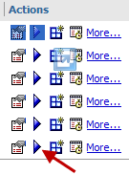

* The boxes to the left of each report tell you what type of report it is set to default to – the one for the Applied for Degree Report is HTML; the one for the Class List Report is Excel; the one for the Enrolled Student Report is a CSV file.

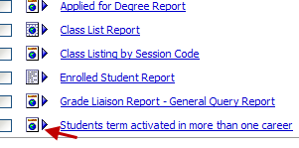

* When selecting parameters for the report, you can select more than one by holding the CTRL key. Or, in some cases, you can use the SELECT ALL option at the bottom of the box:

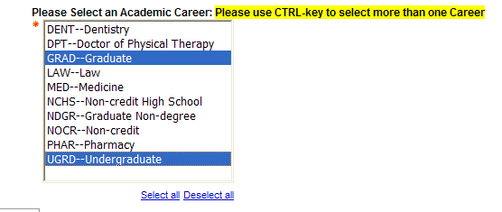

* You can only run reports out of the CU Reporting System via the CU network or VPN.

FUTURE DEVELOPMENT

We will constantly be developing reports for this system. In the near future, look for:

- Missing grades reports (may be there by the time we do the demo on Wednesday.)

- Second-half of the degree report (that will show students who have been awarded degrees).

- Final exam report.