# Creating Accessible PDF Documents from Microsoft Word: Sample Content

This simple sample file contains common structures we can edit, style, and mark-up for practice in creating accessible PDF documents.

## Basic Structures, Links, and Graphics

Some quoted text to inspire us non-insects:

"A human being should be able to change a diaper, plan an invasion, butcher a hog, conn a ship, design a building, write a sonnet, balance accounts, build a wall, set a bone, comfort the dying, take orders, give orders, cooperate, act alone, solve equations, analyze a new problem, pitch manure, program a computer, cook a tasty meal, fight efficiently, die gallantly. Specialization is for insects."   
– Robert A. Heinlein

Non-decorative graphics (images, charts, etc.) should have an Alt Text Description. Decorative images should have no description, that is, the Description field in the Alt Text dialog should be blank. WebAIM’s [“Appropriate Use of Alternative Text”](http://webaim.org/techniques/alttext/) lists four basic criteria for good alt text for the web. The same criteria apply to print documents. As quoted from WebAIM, alternative text should typically:

1. **Be accurate and equivalent** in presenting the same content and function as presented by the image.
2. **Be succinct.** This means the correct content (if there is content) and function (if there is a function) of the image should be presented as succinctly as is appropriate. Typically no more than a few words are necessary, though rarely a short sentence or two may be appropriate.
3. **NOT be redundant** or provide the exact same information as text within the context of the image.
4. **NOT use the phrases "image of ..." or "graphic of ..."** to describe the image. It is usually apparent to the user that it is an image. And if the image is conveying content, it is typically not necessary that the user know that it is an image that is conveying the content, as opposed to text.

In Word, for non-decorative graphics, use both a Caption and a (non-redundant) Alt Text Description. To see the alt text, right-click and Format Picture > Alt Text and see the Description field.

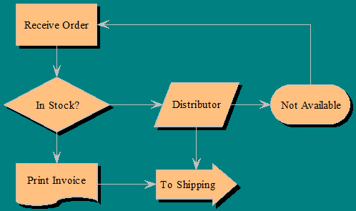

Figure 1: Flow chart showing progress from receiving an order to shipping.

## Tables (and Setting a Language)

|  |  |
| --- | --- |
| **English** | **Spanish** |
| Would you write that down please? | Puede usted escribirlo, por favor? |
| Could you explain that please? | Puede-usted explicarlo, por favor? |
| How is that pronounced? | Cómo le pronuncia? |
| What does that mean? | Qué quiere decirlo? |
| Can you repeat that please? | Me lo repite, por favor? |
| How do you say that in English? | Cómo se lo dice en Inglés? |

Table 1: Example table. Left hand column has English phrases, the right, their Spanish translations. Spanish language is set using the Language Dialog.

|  |  |  |
| --- | --- | --- |
|  | **Column Header 1** | **Column Header 2** |
| **Row Header 1** | Data 1 | Data 2 |
| **Row Header 2** | Data 3 | Data 4 |

Table 2: "Ideal" simple table structure.

|  |  |  |  |  |
| --- | --- | --- | --- | --- |
|  | **Column Header 1** | | **Column Header 2** | |
|  | **Col Head 3** | **Col Head 4** | **Col Head 5** | **Col Head 6** |
| **Row Header 1** | Data 1 | Data 2 | Data 3 | Data 4 |
| Data 5 | Data 6 | Data 7 | Data 8 |
| **Row Header 2** | Data 9 | Data 10 | Data 11 | Data 12 |
| Data 13 | Data 14 | Data 15 | Data 16 |

Table 3: A complex table example

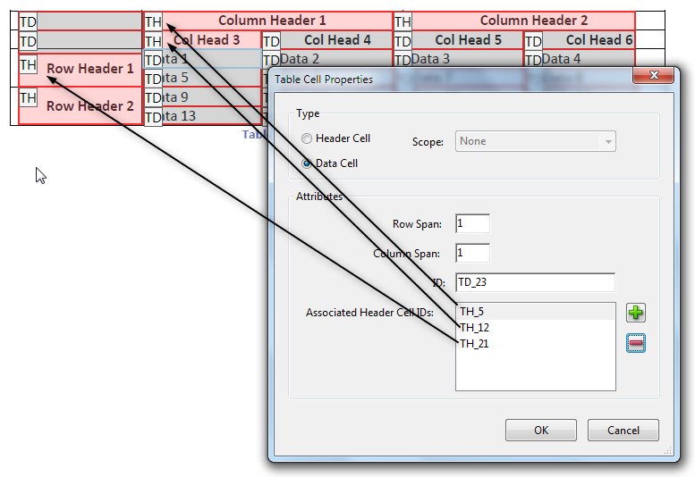

Figure 2: Marking up a complex table by associating table cells with multiple header cells.