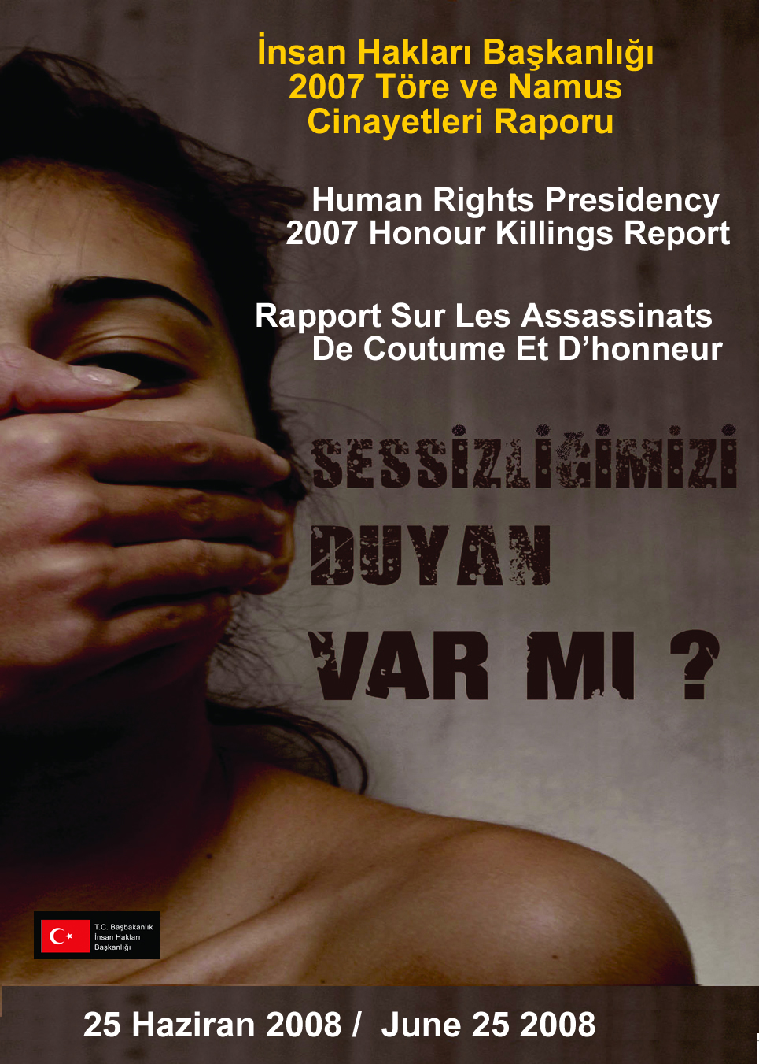

**HONOUR KILLINGS REPORT**

**1. INTRODUCTION**

The human rights concept which takes the respect for human dignity to its center, -even in most countries- exist in documents. Therefore, rather than the theory of human rights, its reflection on practice is important. **Implementation**, especially **internalization** of the subject itself is necessary. For the honor killings that we take into consideration, this conclusion should be emphasized.

The constitutional reforms that are made in the human rights area (especially the article 90 of the constitution of 1982), particularly for women’s rights, and the Prime Ministry circulars besides the amendments in acts are very important. The successful work done by the General Directorate of Security Forces (Asayiş Daire Başkanlığı), Honor Killings Research Commission of TGNA and the General Directorate of the Statue of Women, the enforcement of the most important Prime Ministry circular on honor killings (Official Gazette, 4 July 2006/26218; circular no. 2006/17; 12 pages including the annexes) is well known. With particular attention, by the contribution of the academics, the work done by the NGOs –especially by Kadın Merkezi Dayanışma Derneği (KAMER)- is evaluated. Being the Prime Ministry Human Rights Presidency, we would like to submit the report that we prepared with our Human Rights Boards in 81 provinces (and also in 892 sub-provinces) – which means almost all around Turkey- as a result of a three months of hard work.This report is prepared at the end of a evaluation process by closely examining of the reports on honor killings cases, that we receive from Human Rights Boards. In preparing this report we benefitted from the above reports and that are sent from the all Boards.

As it is known, our Presidency is an institution consisting of more than 14.000 human rights defenders including the Board members. Approximately, 2000 of them are appointed, and approximately 12.000 are civilian members. Besides the individuals, NGOs can also make applications to our presidency and to the Boards. Since 2001 (2001-2007= 7 years), there have been 9145 applicants.

**An important aim of our work is that especially for all our boards in provinces and sub-provinces, they consider this issue and assist to implement the laws and that they conduct awareness rising activities.**

During our meeting on June the 19th, 2008, at Swiss Hotel Ankara, we announced the conclusion of the report we received on honor killings, from 71 human rights boards from the provinces. At our report dated to 25 june 2008, we could explain the situation throught the country as we received reports from all of the 81 provinces.

With the wishes for a future respectful for human rights.

Ankara, 25 June 2008

Prof. Dr. Hasan Tahsin Fendoğlu

President of

Prime Ministry Human Rights Presidency

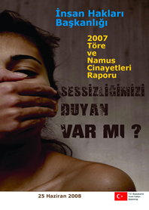**2. DISRIBUTION OF ETHICS AND HONOR KILLING ACCORDING TO YEARS**

According to reports from Provincial and District Human Rights Boards, mentioned below results between 2003 and 2007 are as follows:

• Ethics and honor killing, which is the heaviest violation of human rights, unfortunately, still happens in our country and is serious communal problem. Every year, over 200 people are killed in this scope. According to reports of Boards in 81 provinces, there is no serious change between 2006 and 2007. Number of victims in 2003 is 159, in 2006 233, in 2007 231. in last 5 years, total amount of these victims became over 1100.

**3. REASONS OF HONOUR KILLING**

* Although so many educational and consciousness-rising activities for human rights, women rights and developed implementations, ethics and honor killing protect their character, it shows that this problem comes from economical, social and cultural spheres and serious ideal change is required. Shortly, this problem is not one-dimensional that can be solved from today to future. Solution for problem can be possible with systematical, detailed and long termed activities and decisive implementations. Collaboration and support of government, media, professional organizations, universities, civil organizations and all active communal actors have got vital importance.
* As a factor of ethics and honor killing, opposite behavior of women against sexuality in patriarchal structure or behaviors against traditional norms about sexuality can be shown as an example. (In narrow sense) murder amount related to ethics and honor killing is over 370. It refers 30% of total amount. Number of victims due to prohibited relations are 106, victims due to sexual harassment are 72 and victims due to aggression are 18. When prohibited relations, aggression and sexual harassment are categorized in honesty concept (honesty concept in wide sense), this amount will increase and be more than 50%.

**• Psychological and sociological reasons of ethics and honor killing are as follows:**

1. Sexual relation of married woman with another man,
2. Problems due to polygamy,
3. Marriage of divorced woman with relative or close friend of old husband,
4. Sexual experience of single women before marriage,
5. Family pressure for marriage,
6. Kidnapping and aggression of married woman,
7. Socio-cultural pressures to men,
8. Various problems on individuals due to domestic violence.

• Other reasons are blood feud, marriage relations among families and disharmony in families. All mentioned reasons are related to “given” roles to women in community.

**4. COMPOSITION OF HONOR KILLING ACCORDING TO PROVINCES**

* This kind of murders happens in metropolitans having high population and immigration rates such as Istanbul, Ankara, Izmir, Bursa, Diyarbakır, Antalya. The rates of murders related to ethics and honor killing in the last five years; Istanbul 167 (15%), Ankara 144 (13%), İzmir 121 (11%), Diyarbakır 69 (6%), Bursa 58 (5%) and Antalya 46 (4%). Over half of total murders in Turkey happen in these provinces.
* Honor killing in Istanbul doubled from 2006 to 2007. In 2006, this amount was 27, but it was 53 in 2007. On the other hand, it means that approximately 1 person is killed every week due to honor killing.
* The most important explaining about reason of murders in these provinces is high rates of immigrations. The problems from immigrations such as insufficient sheltering, uneducated people, unemployment, destitution, crowd families are highlights.

• Traditional ideas and life norms with heavy problems due to immigrations meet with serious problems in new environment, cities and social conditions and this kind of people can convert to more heartless.

**5. ETHNICS AND HONOR KILLING ACCORDING TO REGIONS**

• This kind of murders happens in Marmara, Aegean and Central Anatolian Regions contrary to Eastern and Southeastern Anatolian Regions.

• According to regions the amount of murders; Marmara Region 294 (28%), Aegean Region 217 (20%), Central Anatolian Region 220 (20%), Southeastern Anatolian Region 141 (12%), Eastern Anatolian Region 94 (8%) and Mediterranean Region 84 (6%). The lowest rates are seen as 71 (6%) in Black Sea Region. This amount and rates are suitable to data of “Report on Ethics and Honor Killing” of Security General Directorate, which was prepared in 2005.

|  |  |  |  |  |
| --- | --- | --- | --- | --- |
| **REGIONS** | **1148** | **Total Population**  **(2007 TÜİK)** | **Ratio of total population** | **Ratio of density of crime** |
| **Marmara** | 294 | 20.724.950 | 29% | 25,61% |
| **Central Anatolia** | 219 | 11.327.675 | 16% | 19,08% |
| **Ege** | 217 | 9.299.322 | 13% | 18,90% |
| **South-east Anatolia** | 162 | 7.170.849 | 10% | 14,11% |
| **East Anatolia** | 94 | 5.694.582 | 8% | 8,19% |
| **Mediterranean** | 83 | 8.906.427 | 13% | 7,23% |
| **Black Sea** | 79 | 7.462.451 | 11% | 6,88% |
| **TOTAL** | **1148** | **70.586.256** | **100%** | **100%** |

• Composition of regions according to population rate of regions; the first place–25,61% Marmara Region with the most population rate and industrial area, the second–19,00% Central Anatolian Region and the last one–6,88% Black Sea Region.

**6. GENERAL TABLES OF ALL PROVINCES CONCERNING HONOUR KILLINGS**

|  |  |  |  |  |  |  |  |  |  |  |  |  |  |  |  |  |
| --- | --- | --- | --- | --- | --- | --- | --- | --- | --- | --- | --- | --- | --- | --- | --- | --- |
| **General Tables Of All Provinces Concerning Honour Killıings 2003-2007** | | | | | | | | | | | | | | | | |
| **PRONINCE** | **2003** | **2004** | **2005** | **2006** | **2007** | **Year undefined** | **Last 5 years** | **Blood Feud** | **"To"-" Take "a daughter** | **Disagreement between family** | **Sexual Abuse** | **To be banned relation by Costum** | **Rape** | **Honour** | **Costum** | **Detail undiefined** |
| **ADANA** | 3 | 3 | 3 | 2 | 1 |  | 12 |  |  |  |  |  |  | 12 |  |  |
| **ADIYAMAN** |  |  |  |  |  | 16 | 16 |  |  |  |  |  |  |  |  | 16 |
| **AFYON** | 2 | 2 | 5 | 7 | 2 |  | 18 |  |  |  |  |  |  | 18 |  |  |
| **AĞRI** | 2 | 0 | 3 | 0 | 6 |  | 11 |  |  |  |  |  |  | 2 | 9 |  |
| **AKSARAY** | 1 |  | 1 | 1 | 1 |  | 4 |  |  |  | 1 | 3 |  |  |  |  |
| **AMASYA** | 3 | 4 | 3 | 1 | 0 |  | 11 | 0 | 0 | 3 | 1 | 5 | 1 | 1 |  |  |
| **ANKARA** | 16 | 31 | 29 | 40 | 28 |  | 144 | 4 | 2 | 68 | 7 | 29 |  | 34 |  |  |
| **ANTALYA** | 10 | 7 | 5 | 17 | 7 |  | 46 |  |  |  |  |  |  |  |  | 46 |
| **ARDAHAN** |  |  |  |  |  |  | 0 |  |  |  |  |  |  |  |  |  |
| **ARTVİN** |  |  |  |  |  |  | 0 |  |  |  |  |  |  |  |  |  |
| **AYDIN** | 5 | 11 | 6 | 8 | 8 |  | 38 | 4 | 2 | 14 | 1 | 7 |  | 10 |  |  |
| **BALIKESİR** |  | 1 | 1 |  | 1 |  | 3 |  |  |  |  |  |  | 3 |  |  |
| **BARTIN** |  |  |  |  | 3 |  | 3 |  | 1 |  |  | 1 |  | 1 |  |  |
| **BATMAN** | 2 | 1 | 1 | 2 | 2 |  | 8 | 1 |  | 1 |  | 1 |  | 5 |  |  |
| **BAYBURT** |  |  |  |  |  |  | 0 |  |  |  |  |  |  |  |  |  |
| **BİLECİK** |  |  |  |  |  |  | 0 |  |  |  |  |  |  |  |  |  |
| **BİNGÖL** |  |  |  |  |  | 2 | 2 |  |  |  |  |  |  |  |  | 2 |
| **BİTLİS** |  |  |  |  |  | 3 | 3 | 1 | 1 | 1 |  |  |  |  |  |  |
| **BOLU** |  |  |  |  |  |  | 0 |  |  |  |  |  |  |  |  |  |
| **BURDUR** |  |  |  | 1 |  |  | 1 |  |  |  |  |  |  |  | 1 |  |
| **BURSA** | 12 | 16 | 5 | 14 | 11 |  | 58 | 2 | 1 | 22 | 6 | 6 | 3 | 18 |  |  |
| **ÇANAKKALE** |  |  |  |  |  | 1 | 1 |  |  |  |  |  |  | 1 |  |  |
| **ÇANKIRI** |  |  |  |  |  |  | 0 |  |  |  |  |  |  |  |  |  |
| **ÇORUM** |  |  |  |  |  | 1 | 1 |  |  | 1 |  |  |  |  |  |  |
| **DENİZLİ** | 2 | 3 |  | 4 | 2 |  | 11 |  |  |  |  |  |  | 11 |  |  |
| **DİYARBAKIR** | 16 | 12 | 19 | 15 | 7 |  | 69 | 20 | 3 | 6 | 6 | 6 | 2 | 26 |  |  |
| **DÜZCE** | 3 |  |  | 1 | 3 |  | 7 |  |  |  |  |  |  | 7 |  |  |
| **EDİRNE** |  |  |  |  |  |  | 0 |  |  |  |  |  |  |  |  |  |
| **ELAZIĞ** |  |  | 2 |  | 1 |  | 3 |  |  |  |  |  |  | 3 |  |  |
| **ERZİNCAN** |  |  |  |  | 1 |  | 1 |  |  |  |  |  |  | 1 |  |  |
| **ERZURUM** |  | 2 | 2 | 1 | 3 |  | 8 | 5 |  | 2 | 1 |  |  |  |  |  |
| **ESKİŞEHİR** | 0 | 0 | 1 | 1 | 1 |  | 3 |  |  |  |  |  |  | 3 |  |  |
| **GAZİANTEP** | 1 | 6 | 10 | 7 | 4 |  | 28 | 3 | 0 | 1 | 0 | 7 | 0 | 17 |  |  |
| **GİRESUN** | 0 | 0 | 0 | 0 | 0 |  | 0 |  |  |  |  |  |  |  |  |  |
| **GÜMÜŞHANE** |  |  | 1 | 1 | 1 |  | 3 | 1 |  |  |  |  |  | 2 |  |  |
| **HAKKÂRİ** |  |  |  |  | 2 |  | 2 |  |  |  |  | 2 |  |  |  |  |
| **HATAY** |  | 4 | 1 | 3 | 1 |  | 9 |  |  |  |  |  |  |  |  | 9 |
| **IĞDIR** | 1 |  | 2 | 1 |  |  | 4 |  |  |  | 1 |  |  | 3 |  |  |
| **ISPARTA** | 0 | 0 | 0 | 0 | 0 | 0 | 0 |  |  |  |  |  |  |  |  |  |
| **İSTANBUL** | 31 | 32 | 24 | 27 | 53 |  | 167 | 14 | 5 | 72 | 30 | 19 | 11 |  | 2 | 14 |
| **İZMİR** | 23 | 22 | 26 | 24 | 26 |  | 121 | 4 | 2 | 38 | 12 | 7 |  | 58 |  |  |
| **K.MARAŞ** | 1 | 0 | 3 | 4 | 1 |  | 9 |  |  |  |  |  |  | 9 |  |  |
| **KARABÜK** |  |  |  |  |  |  | 0 |  |  |  |  |  |  |  |  |  |
| **KARAMAN** |  |  |  |  |  |  | 0 |  |  |  |  |  |  |  |  |  |
| **KARS** | 4 | 4 | 3 | 5 | 3 |  | 19 | 7 | 2 |  | 3 |  |  | 7 |  |  |
| **KASTAMONU** | 1 | 2 | 2 | 2 | 2 |  | 9 |  |  |  |  |  |  | 9 |  |  |
| **KAYSERİ** | 5 | 7 | 9 | 4 | 9 |  | 34 | 3 | 1 | 15 | 1 | 1 |  | 13 |  |  |
| **KIRIKKALE** |  |  |  |  |  | 17 | 17 | 1 | 1 | 5 | 1 |  |  | 9 |  |  |
| **KIRKLARELİ** |  |  |  |  |  | 3 | 3 |  |  |  |  |  |  |  |  | 3 |
| **KIRŞEHİR** | 1 | 2 | 1 |  | 2 |  | 6 |  | 1 |  |  | 5 |  |  |  |  |
| **KİLİS** |  |  |  |  |  |  | 0 |  |  |  |  |  |  |  |  |  |
| **KOCAELİ** |  |  |  |  |  | 21 | 21 |  |  |  |  |  |  |  |  | 21 |
| **KONYA** |  | 1 |  | 1 | 1 |  | 3 |  |  |  |  |  |  | 3 |  |  |
| **KÜTAHYA** |  |  | 2 | 1 |  |  | 3 |  |  |  |  |  |  | 3 |  |  |
| **MALATYA** | 1 | 1 | 1 |  | 1 |  | 4 |  |  |  |  |  |  | 4 |  |  |
| **MANİSA** | 3 | 4 | 3 | 5 | 4 |  | 19 |  |  |  |  |  |  | 17 | 2 |  |
| **MARDİN** |  | 1 | 2 | 3 | 4 |  | 10 | 2 |  | 1 |  |  |  | 7 |  |  |
| **MERSİN** |  |  |  | 2 | 1 |  | 3 |  |  |  |  |  |  |  |  | 3 |
| **MUĞLA** |  |  | 3 | 1 |  | 3 | 7 |  |  | 2 |  | 1 | 1 | 3 |  |  |
| **MUŞ** | 2 | 6 | 5 |  | 5 |  | 18 |  |  |  |  |  |  | 18 |  |  |
| **NEVŞEHİR** |  |  |  |  | 1 |  | 1 |  |  | 1 |  |  |  |  |  |  |
| **NİĞDE** |  |  |  | 2 | 2 |  | 4 | 1 |  | 1 | 1 |  |  |  |  | 1 |
| **ORDU** |  |  |  |  |  |  | 0 |  |  |  |  |  |  |  |  |  |
| **OSMANİYE** |  | 1 | 1 |  | 1 |  | 3 |  |  |  |  |  |  | 3 |  |  |
| **RİZE** |  |  |  |  |  |  | 0 |  |  |  |  |  |  |  |  |  |
| **SAKARYA** |  | 4 | 9 | 8 | 9 |  | 30 |  |  |  |  |  |  |  |  | 30 |
| **SAMSUN** |  |  |  |  |  | 32 | 32 |  |  |  |  |  |  |  |  | 32 |
| **SİİRT** |  |  |  |  |  | 2 | 2 |  |  |  |  |  |  | 2 |  |  |
| **SİNOP** |  | 1 |  |  |  |  | 1 |  |  |  |  |  |  | 1 |  |  |
| **SİVAS** | 1 | 1 | 1 | 0 | 0 |  | 3 | 1 |  |  |  |  |  | 2 |  |  |
| **ŞANLIURFA** |  | ? | ? | 5 | 2 | 11 | 18 |  |  | 2 |  |  |  | 5 |  | 11 |
| **ŞIRNAK** | 2 | 3 | 2 | 3 | 1 |  | 11 |  |  | 4 |  |  |  | 4 | 3 |  |
| **TEKİRDAĞ** |  |  | 3 | 2 |  |  | 5 |  |  |  |  |  |  | 5 |  |  |
| **TOKAT** |  |  |  |  |  | 8 | 8 |  |  |  |  |  |  | 8 |  |  |
| **TRABZON** |  |  |  |  | 0 |  | 0 |  |  |  |  |  |  |  |  |  |
| **TUNCELİ** |  |  |  |  |  |  | 0 |  |  |  |  |  |  |  |  |  |
| **UŞAK** |  |  |  |  |  |  | 0 |  |  |  |  |  |  |  |  |  |
| **VAN** | 4 | 5 | 1 | 4 | 5 |  | 19 | 5 |  | 6 |  | 4 |  | 4 |  |  |
| **YALOVA** |  | 1 |  | 3 | 2 |  | 6 |  |  |  |  |  |  | 6 |  |  |
| **YOZGAT** |  |  |  |  |  |  | 0 |  |  |  |  |  |  |  |  |  |
| **ZONGULDAK** | 1 | 3 |  |  |  |  | 4 |  |  | 1 |  | 2 |  |  | 1 |  |
| **TOPLAM** | **159** | **204** | **201** | **233** | **231** | **120** | **1148** | **79** | **22** | **267** | **72** | **106** | **18** | **378** | **18** | **188** |

**7. EVALUATION**

* The number of murderers and victims of honor killing increases according to low education level.
* 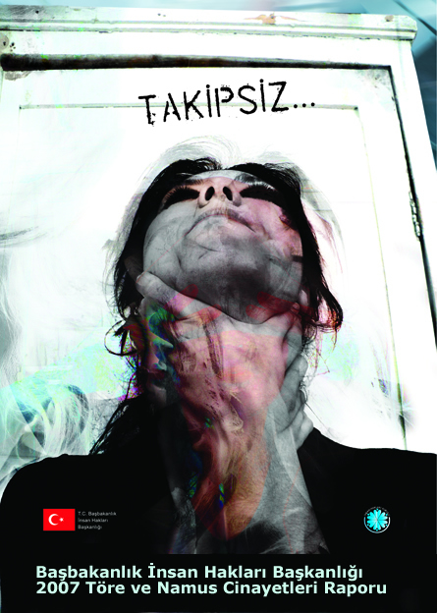Not only women but also men can be victim.
* Murderers in these murders are generally men, but sometimes women can be murderer.
* Contrary to expected evaluation, children’s amount is low (9%). Murderers are generally between 19 and 35 ages.
* Penalties implemented for murder cases have not aversive character against murderers. Murderers have no compunction. Traditional decency view becomes social and individual existence for these characters.
* Educational and consciousness-rising activities must be suitable to cultural values and life conditions of target groups.
* Quality and quantity development of women’s shelter, current amount is 44, will be serious tool for struggle within murders and emphasis against women.
* In addition to all organizations mentioned in Prime Ministry Circular for struggle education against honor killing, Provincial and District Boards have got serious duties.

***This is an unofficial translation and the original report is in Turkish.***