# Font Styles

Vehicula *italic* odio nec lacus fringilla SmallCaps sodales est tristique. Underline commodo ***bolditalic*** nunc, euismod typewriter lacinia non. allcaps sit amet egestas eros m2.

## Lists and Special Characters

* arête, förvånad, žlutý, søndag, kůň, słychać, Dziękuję, enseñar, Leão, Doviđenja
  + wünscht, große, Betätigung, körperlicher, engleză, ağaç, aydınlık

## Equations

Lorem $\sqrt{a^{2}+b^{2}}$ ipsum ${\left(x+a\right)}^{n}=\sum_{k=0}^{n}{\left({n \atop k}\right)x^{k}a^{n-k}}$ dolor sit amet $\frac{dy}{dx}$ eli.

$$f\left(x\right)=a_{0}+\sum_{n=1}^{∞}{\left(a_{n}\cos{\frac{nπx}{L}}+b_{n}\sin{\frac{nπx}{L}}\right)}$$

# Table

Lorem ipsum dolor sit amet, **consectetur** adipiscing elit.

|  |  |  |  |
| --- | --- | --- | --- |
| abcd | $e^{-tiθ}$ | $A=πr^{2}$ | $\max_{0≤x≤1}{xe^{-x^{2}}}$ |
| 123 | 456 | **789** | 123 |

# Images

Excel graph embedded in the document (**vector** *image*).

Donald Knuth[1] – creator of TEX (**raster** *image*).

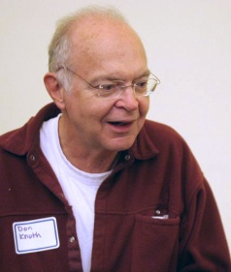

1. computer scientist and Professor Emeritus at **Stanford** University