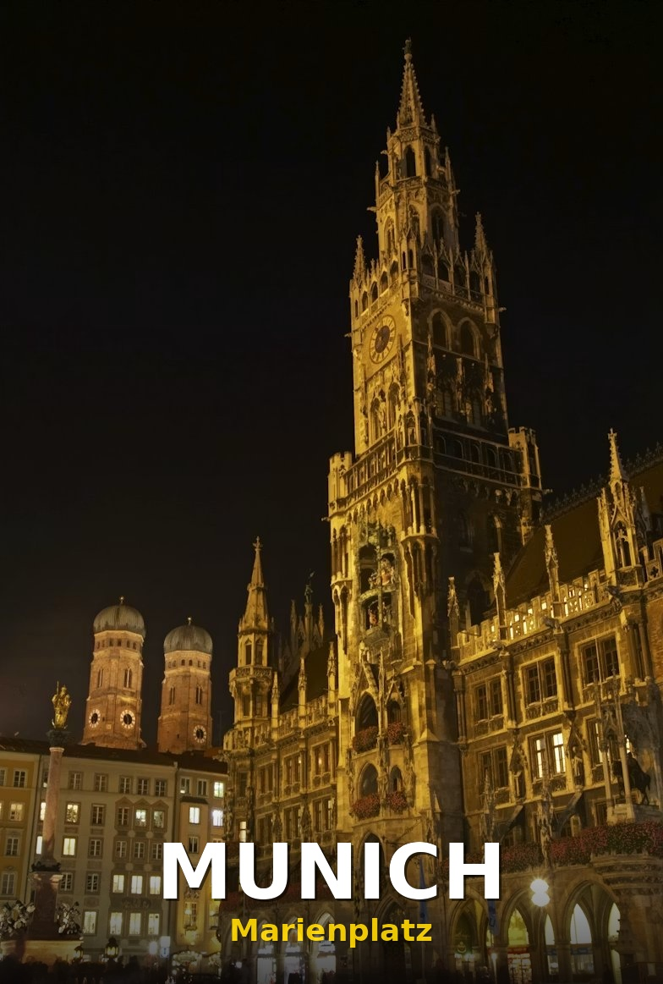
Analysis of Munich Neighbourhoods for New Immigrants Using Machine Learning
A New Immigrant's Guide to Settling in Munich, Germany
By Abby | Data Analyst | Munich, Germany | 2026
LinkedIn: linkedin.com/in/abitijani | GitHub: github.com/AbiXData/munich-neighbourhood-analysis

Introduction
When I began this project, I had just landed in Munich, Germany in January 2026 — a brand new immigrant with a suitcase, a laptop, and a lot of questions. One of the first statistics I came across stopped me in my tracks: Germany recorded over 262,000 net immigrants in 2024 [1], with Munich consistently ranking as one of the top destination cities for newcomers. A 2025 Mercer Quality of Living Survey ranked Munich as the 3rd best city in the world to live in [2] — so it is no surprise that thousands of people from across the globe choose to settle here every year.
But here is the reality nobody tells you: Munich has 25 Stadtbezirke (city districts), and they are not all equal. Crime rates vary. Unemployment varies. Rent varies — dramatically. As a new immigrant and an aspiring data analyst, I decided to stop guessing and start analysing. This project is the result.
Inspired by Jessica Ayodele's brilliant analysis of Toronto neighbourhoods [3], I adapted the same methodology for Munich — my new home.

Problem Statement
Munich's 25 Stadtbezirke span the entire city from the historic Altstadt at its centre to the quieter outer districts on its edges. As a new immigrant, the vital question is:
"Which district should I settle in?"
The aim of this project is to rank Munich's 25 districts in order of desirability for new immigrants using real data, exploratory analysis, and unsupervised Machine Learning.

Basis
There are several factors to consider when choosing where to settle in a new city. For this project, I performed my analysis using the following criteria:

Primary Benchmarks
- Unemployment rate per district
- Crime rate per district (crimes per 1,000 residents)

Secondary Benchmark
- Average monthly rent for a 1-bedroom apartment per district (€)
These three variables were chosen because they directly impact a new immigrant's daily quality of life — safety, financial stability, and cost of living.

Data Description
The datasets used for this project were sourced from official German and Munich open data portals:
- Crime Rate Data [4]: Crimes per 1,000 residents per district — Munich Crime Atlas (Kriminalitätsatlas München) 2023
- Unemployment Rate Data [5]: Percentage of unemployed residents per district — Statistisches Amt München, Social Atlas 2023
- Housing Rental Prices [6]: Average monthly rent for a 1-bedroom apartment per district — Immoscout24 rental market report, 2024
- District Coordinates [7]: Geographic coordinates of Munich's 25 Stadtbezirke — OpenStreetMap via GeoPandas

Methodology
The Python libraries used in this project were NumPy, Pandas, GeoPandas, Plotly, Scikit-learn, and Matplotlib. All interactive charts were built using Plotly and hosted on GitHub Pages.
Full notebook: https://nbviewer.org/github/AbiXData/munich-neighbourhood-analysis/blob/main/Munich_Neighbourhood_Analysis.ipynb

Project Steps
- Step 1 — Collect and clean data for all 25 Munich districts
- Step 2 — Exploratory Data Analysis: visualise crime, unemployment, and rent distributions
- Step 3 — Scale the data using StandardScaler so no single variable dominates
- Step 4 — Determine optimal number of clusters using the Elbow Method
- Step 5 — Apply K-Means clustering to group districts by desirability
- Step 6 — Label clusters and visualise results on an interactive district map

Data Exploration
Note: All charts in this article are fully interactive — hover over any bar, bubble or map point to see the full district details.

Dataset Preview — Munich Districts
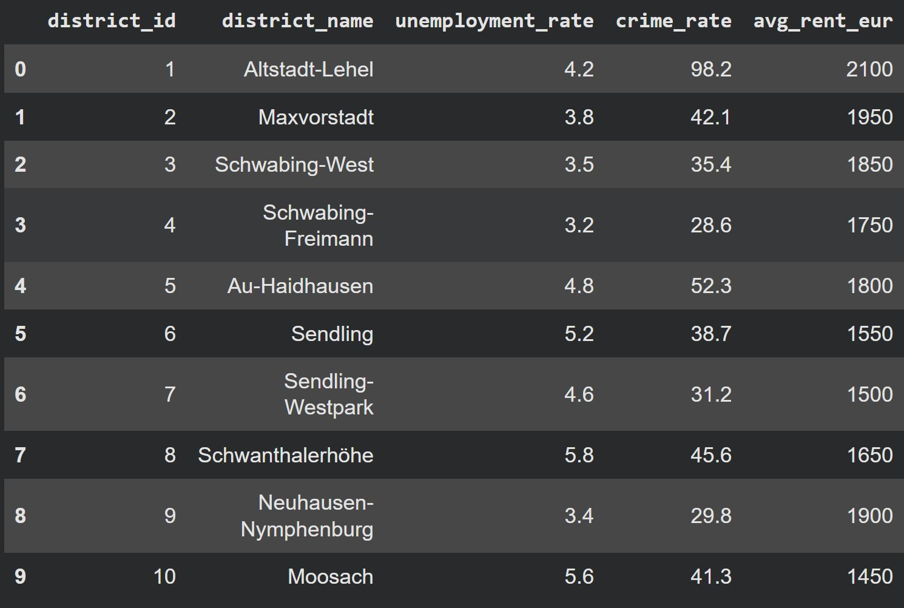

Quick Stats Check
The average unemployment rate across Munich's 25 districts is 4.7%. The average crime rate is 38.4 crimes per 1,000 residents. The most affordable average rent is €1,180/month (Allach-Untermenzing) while the most expensive is €2,100/month (Altstadt-Lehel). That is a difference of €920/month — nearly €11,000 per year — between the cheapest and most expensive district.

Interactive Charts
Click each link below to explore the fully interactive charts:

Chart 1 — Unemployment Rate by Munich District: https://abixdata.github.io/munich-neighbourhood-analysis/interactive_charts/chart1_unemployment.html
Key finding: Feldmoching-Hasenbergl has the highest unemployment at 7.1% — more than double Bogenhausen at 2.8%.

Chart 2 — Average 1-Bedroom Rent by Munich District: https://abixdata.github.io/munich-neighbourhood-analysis/interactive_charts/chart2_rent.html
Key finding: Rent in Altstadt-Lehel at €2,100/month is 78% more expensive than Allach-Untermenzing at €1,180/month for the same 1-bedroom apartment.

Chart 3 — Crime vs Unemployment — Bubble Chart: https://abixdata.github.io/munich-neighbourhood-analysis/interactive_charts/chart3_bubble.html
Key finding: A visible positive relationship exists between unemployment and crime. The notable outlier is Altstadt-Lehel — moderate unemployment but the highest crime rate (98.2 per 1,000 residents), driven by city centre activity and tourism.

Machine Learning
Clustering Munich Districts
A clustering algorithm — K-Means — was used to group Munich's 25 districts in order of desirability for new immigrants. K-Means is an Unsupervised Machine Learning algorithm, meaning it finds patterns in data without being told what to look for.

Elbow Method
I tested K-Means with k values from 1 to 10 and plotted the inertia for each. The elbow — where the curve bends — appeared at k = 4, indicating 4 clusters is optimal.
Chart 4 — Elbow Method Chart: https://abixdata.github.io/munich-neighbourhood-analysis/interactive_charts/chart4_elbow.html

Cluster Results

Cluster | Avg Unemployment | Avg Crime Rate | Avg Rent | Label
0 | 5.71% | 42.81 | €1,395 | Least Desirable
1 | 3.63% | 34.89 | €1,864 | Desirable
2 | 4.20% | 98.20 | €2,100 | Semi-Desirable
3 | 4.02% | 27.38 | €1,502 | Most Desirable

Results
Chart 5 — Munich Districts Desirability Index: https://abixdata.github.io/munich-neighbourhood-analysis/interactive_charts/chart5_desirability.html

Chart 6 — Interactive Munich District Map: https://abixdata.github.io/munich-neighbourhood-analysis/interactive_charts/chart6_map.html

Most Desirable Districts
Sendling-Westpark · Hadern · Untergiesing-Harlaching · Pasing-Obermenzing · Thalkirchen-Obersendling-Forstenried · Allach-Untermenzing
These 6 districts have the lowest crime rates in Munich (averaging just 27.4 crimes per 1,000 residents), moderate unemployment (averaging 4.0%), and affordable rents averaging €1,502/month. For a new immigrant prioritising safety and value for money, these districts offer the strongest combination of all three factors.

Desirable Districts
Bogenhausen · Maxvorstadt · Schwabing-West · Schwabing-Freimann · Neuhausen-Nymphenburg · Au-Haidhausen · Maxvorstadt-West
These 7 districts have the lowest unemployment rates in Munich (averaging just 3.6%) and vibrant communities. The trade-off is higher average rent at €1,864/month.

Semi-Desirable Districts
Altstadt-Lehel — Munich's historic city centre. Highest crime rate at 98.2 per 1,000 residents and highest rent at €2,100/month. Crime is largely tourist-area driven rather than resident-driven.

Least Desirable Districts
Feldmoching-Hasenbergl · Ramersdorf-Perlach · Milbertshofen-Am Hart · Berg am Laim · Schwanthalerhöhe · Moosach · Laim · Sendling · Obergiesing-Fasangarten · Trudering-Riem · Aubing-Lochhausen-Langwied
Highest unemployment averaging 5.7% and highest crime among residential districts (42.8 per 1,000). Despite lower desirability, rents are only slightly cheaper at €1,395/month on average.

Conclusion
- Only 24% of Munich's districts fall into the Most Desirable category — making those 6 districts genuinely worth targeting as a new immigrant.
- Best value for new immigrants: Sendling-Westpark, Hadern, or Pasing-Obermenzing — low crime, affordable rent, decent employment rates. Munich's hidden gems.
- If budget is flexible: Bogenhausen and Neuhausen-Nymphenburg offer the best quality of life — low unemployment, well-connected, vibrant communities.
- The city centre trap: Altstadt-Lehel is exciting but at €2,100/month with the highest crime rate, new immigrants pay a very high premium for the postcode.
- Districts to approach with caution: Feldmoching-Hasenbergl shows the weakest combination of all three metrics.

What's Next
- Public transport accessibility scores per district (U-Bahn, S-Bahn, bus network coverage)
- Green space and air quality indices
- International community density — which districts have the strongest expat communities?
- School quality ratings — especially relevant for immigrant families with children

References
- [1] Destatis — German Federal Statistical Office, Net Migration Report 2024: https://www.destatis.de
- [2] Mercer Quality of Living City Ranking 2025: https://www.mercer.com/insights/quality-of-living/
- [3] Jessica Ayodele — Analysis of Toronto Neighbourhoods using Machine Learning, Towards Data Science, 2020
- [4] Polizeipräsidium München — Kriminalitätsatlas München 2023: https://www.polizei.bayern.de/muenchen
- [5] Statistisches Amt München — Münchner Sozialatlas 2023: https://www.muenchen.de/rathaus/stadtinfos/statistik
- [6] Immoscout24 — Mietpreise München nach Stadtbezirk 2024: https://www.immoscout24.de
- [7] OpenStreetMap contributors: https://www.openstreetmap.org

About the Author
I am Abby — a Data Analyst based in Munich, Germany, actively looking for a Data Analyst role. I bring skills in Python, SQL, data visualisation, and machine learning.
- GitHub: https://github.com/AbiXData/munich-neighbourhood-analysis
- Notebook: https://nbviewer.org/github/AbiXData/munich-neighbourhood-analysis/blob/main/Munich_Neighbourhood_Analysis.ipynb
- LinkedIn: https://www.linkedin.com/in/abitijani/

Tags: Data Analytics · Python · Machine Learning · K-Means Clustering · Munich · Germany · Data Visualisation · GeoPandas · Plotly · New Immigrants · Scikit-learn

