Phase 4 & 5: Architecture and Detailed Design

for

Intelligent AI Powered Circular Campus Resource Exchange and Asset Life Cycle Management System

Version 1.4
Prepared by Group 6
Abi Ali Murtaza Ghadiyali — 100066653
Ahmed Mohamed Moustafa Ghandour — 100066431
Abdulrahman Feras Junaid — 100066011
Muhammad Awais Afzal Mirza — 100066617
COSC 336: Introduction to Software Engineering
Lab Instructors: Basima Kurungadan and Natnael Takele
Course Professor: Dr. Jamal Bentahar
Fall 2026
2nd November 2026

Table of Contents
Scope and conventions 3
1 Context Diagram 4
2 Data Flow Diagrams 5
2.1 Level 2 Matching and Reservation 6
2.2 Flow Balancing Tables 6
Parent 3.0 to Level 2 boundary 7
3 Architecture 8
4 AI Services 9
Failure and version handling 9
5 Human Approval Points 10
6 Security 11
6.1 Role and Action Matrix 11
6.2 Audit Backup and Recovery 12
Enforcement and data boundaries 12
Audit and notifications 12
Backup and isolated recovery 13
7 Mockups 13
7.1 Asset Registration 13
7.2 Request Submission 14
7.3 Recommendation Review 14
7.4 Transfer Approval and Receipt 15
7.5 Maintenance Tracking 16
7.6 Sustainability Dashboard 16
7.7 Operational Reports 17
7.8 Conversational Assistant 18
8 Structural UML 19
8.1 Whole System Use Cases 19
8.2 Domain Class Model 20
8.2.1 Life-Cycle, AI and Notification Classes 21
8.3 Deployment Design 22
9 Behavioral UML 24
9.1 Registration with Classification 24
9.2 Matching and Reservation Sequence 26
9.3 Transfer and Receipt Sequence 27
9.4 Assistant Request Sequence 28
9.5 Exchange Activity 29
9.6 AI Recommendation Workflows 30
9.7 Asset State Model 32
9.8 Request and Maintenance States 33
9.9 Transfer and Approval States 35
10 Database Design 36
10.1 Exchange and Catalogue Entities 36
10.2 Life-Cycle, AI and Audit Entities 37
10.3 Core Data Dictionary 38
Portion and allocation invariants 38
10.4 Supporting Data Dictionary 39
11.1 Asset and Request Contracts 40
Transaction and retry rule 41
11.2 Movement Maintenance and Reporting Contracts 41
11.3 AI Interface Contracts 42
Model monitoring records 42
12 AI and Sustainability Design 42
12.1 Eligibility and transparent scoring 42
12.2 Sustainability Methods 43
EPA WARM v16 factor basis 43
12.3 Independently Worked Examples 44
12.4 Evaluation and Model Monitoring 44
Planned technical checks 45
13 Traceability and Design Checks 45
13.1 Requirement Traceability 45
13.2 Decision Status and Design Verification 46
Design verification evidence 47
References AI Use and Team Review 47
AI-use statement 48
Individual review and repository responsibilities 48

Revision History
Name | Date | Reason for Changes | Version
Group 6 | 25 October 2026 | Combined architecture and detailed design based on SRS v1.2. | 1.1
Group 6 | 26 October 2026 | Redrawn context and data-flow diagrams, UML, ERD and mockups; added the AI recommendation workflow (Figure 22a); renumbered headings; rebuilt the flow-balancing tables. | 1.2
Group 6 | 1 November 2026 | Redrew Figure 2 (Level 1 DFD) and Figure 4 (component view) with straight connectors, separate read/write arrows and labels beside each connector; aligned six Figure 2 flow names with the balancing table. | 1.3
Group 6 | 2 November 2026 | Readability corrections to Figures 8, 13, 14a, 14b, 16-23, 27a and 27b: separate release decision, «extend» arrows, UML visibility and typed signatures, guarded sequence fragments, re-routed activity, state and ERD connectors, run_id relationship. | 1.4

Scope and conventions
All SRS ‘Must’ capabilities remain in scope, including the assistant, sustainable-action advice and report summaries. High/Medium priority indicates implementation order. The three ‘Should’ refinements retain their SRS priority. This document does not add institutional identity, procurement, accounting, email/SMS, sensors or automated physical handling.
A role is a permission assignment, not a separate user account. Nine human role classes are represented; Department Representative / Asset Custodian is the combined SRS role. AI Services is an external system, not an approver. A person may hold multiple roles, but self-approval remains denied in the prototype.
Figures use UML for structure/behavior and process/store notation for DFDs. A DFD arrow carries named data, not an approval condition. Entities and stores marked * are repeated only to avoid crossing lines. Question marks in the dictionary denote optional fields. Example dates, prices, quantities and forecasts are synthetic.

1 Context Diagram
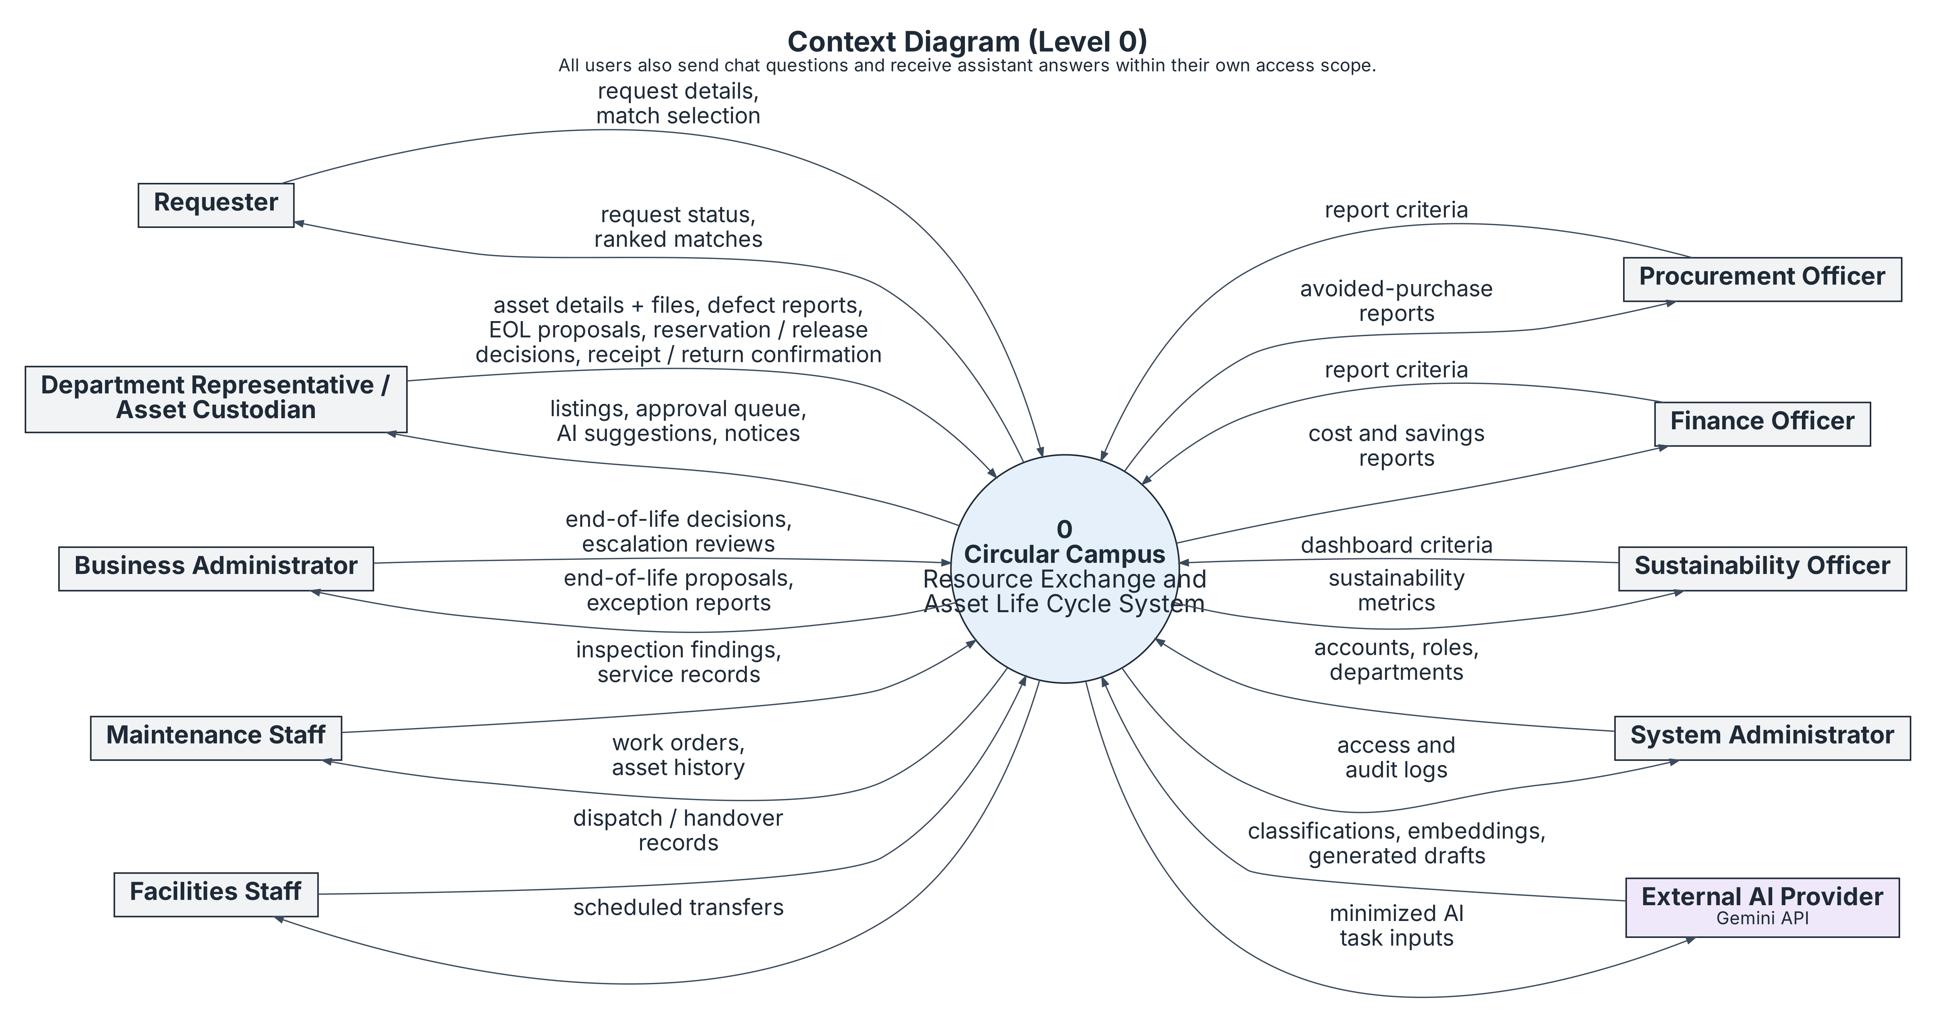
Figure 1 Context boundary and grouped external interfaces
Figure 1 presents the system as a single process and shows the nine SRS role classes and the external AI provider around its boundary. The arrows summarize the main information exchanged with each entity. Assistant questions and scoped responses are shared across signed-in roles, so the figure notes this exchange once rather than repeating it for every role. Procurement, Finance and Sustainability remain separate because each role requests and receives different information.
The external AI provider receives task-specific inputs and returns advisory outputs such as classifications, embeddings and generated drafts. These outputs do not authorize transactions or replace human approval. Managed authentication, database and storage services are internal implementation components rather than KU institutional integrations, so they do not appear as external entities.
Trace: SRS 2.3; UI-001/002; SI-001/002; CI-001/002; FR-USER-001 to 005; AI-REQ-003..

2 Data Flow Diagrams
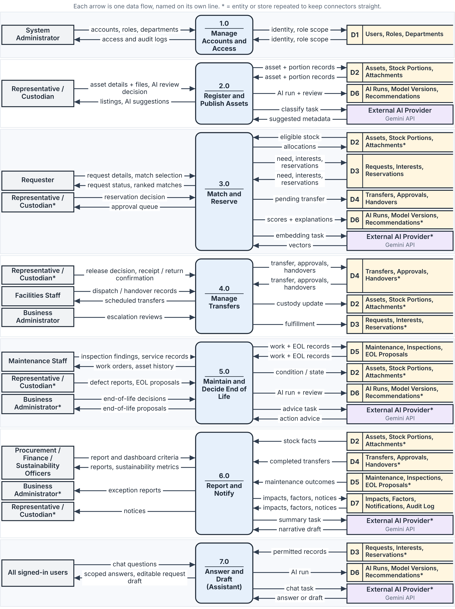
Figure 2 Level 1 decomposition of the whole system
Figure 2 decomposes Process 0 into seven Level 1 processes. External entities exchange data through the process responsible for each interaction, while data stores are read or updated only through processes. Paired store arrows represent separate read and write flows. The external AI provider exchanges task inputs and advisory outputs with Processes 2.0, 3.0, 5.0, 6.0 and 7.0; AI output does not approve or authorize business actions.

2.1 Level 2 Matching and Reservation
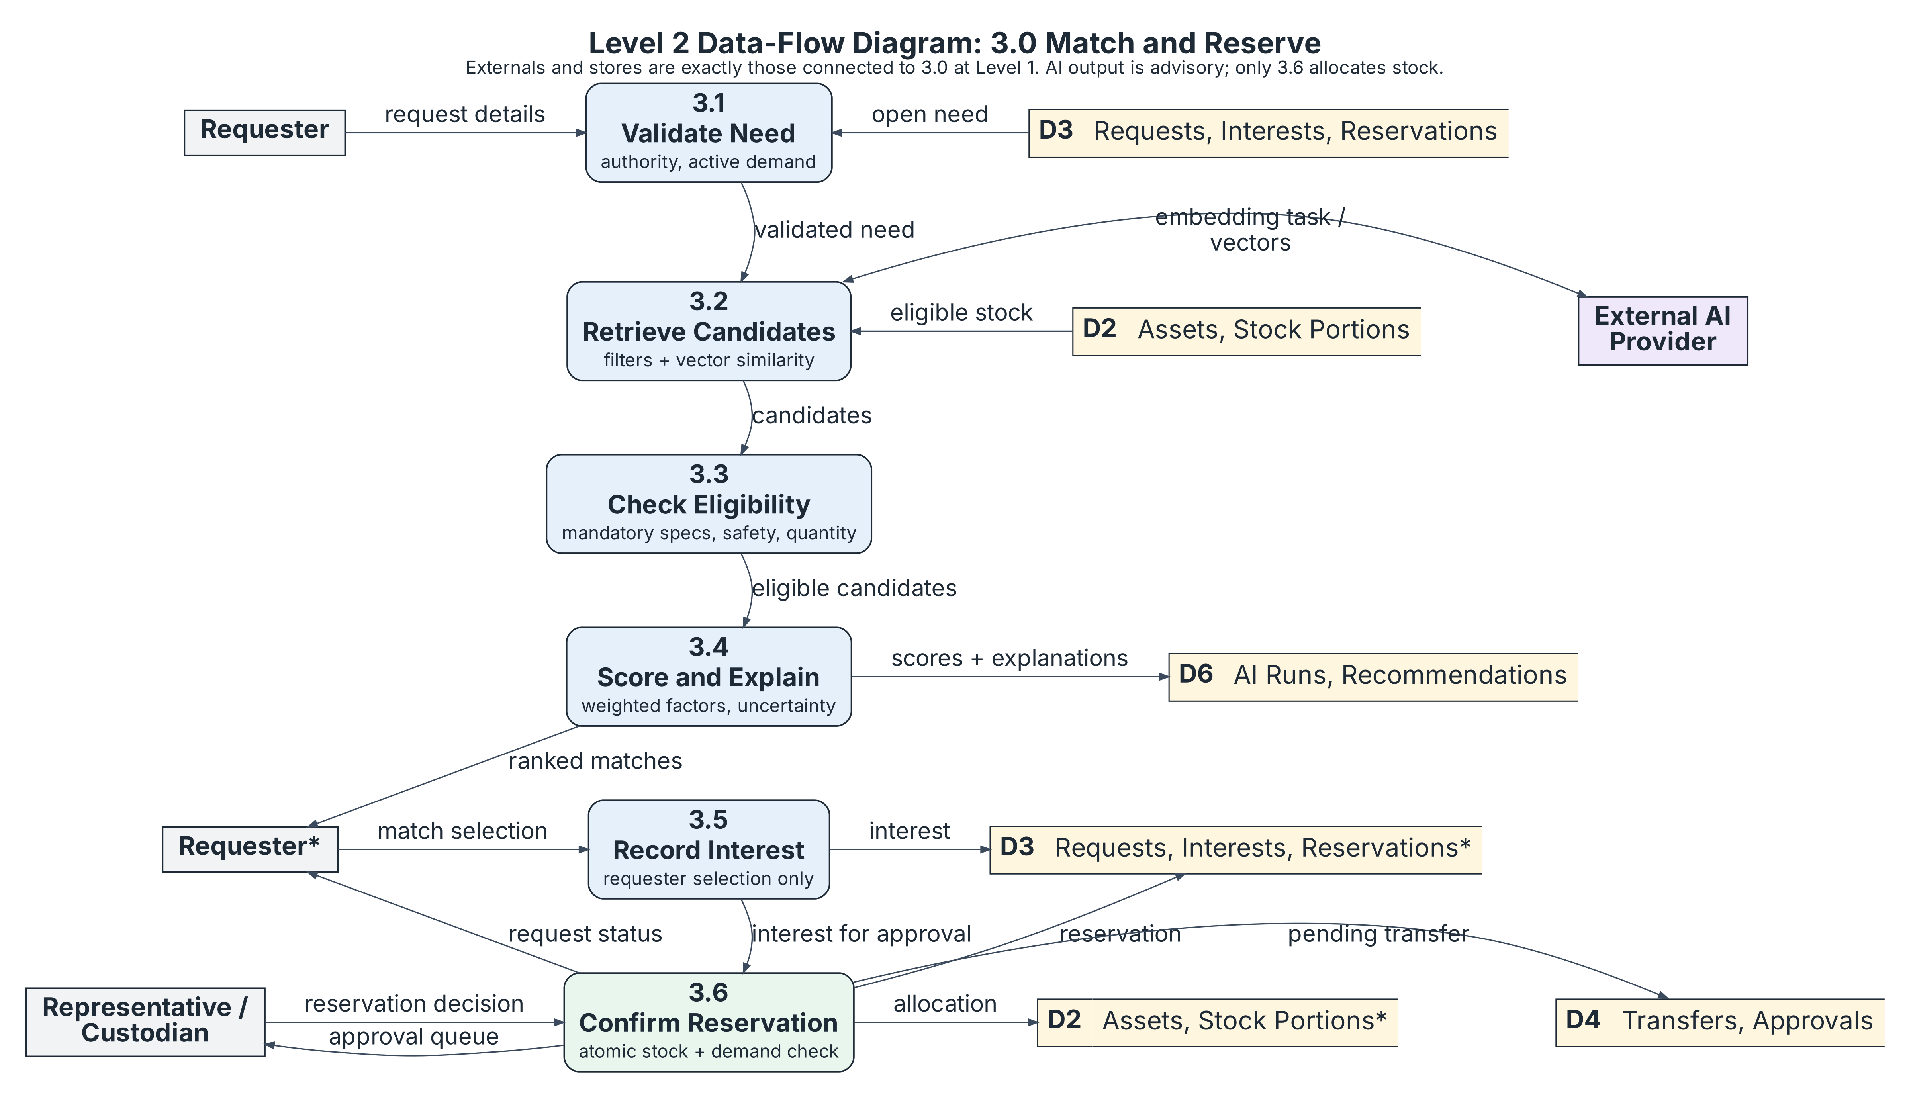
Figure 3 Level 2 Matching and Reservation
Process 3.0 is decomposed because a recommendation is easy to confuse with a reservation and to show how competing approvals are checked before stock is allocated. Retrieval and scoring produce candidate recommendations, while expressing interest does not reserve stock. After supplier approval, Process 3.6 rechecks available stock, remaining unallocated need, authority and suitability before committing the reservation, allocation, pending transfer and approval records.
If any reservation-transaction check fails, none of those records is committed. If AI is unavailable, the system uses conventional retrieval and the request remains active. Matching does not change formal ownership or custody.
Trace: FR-REQUEST-003 to 007; FR-AI-MATCH-001 to 011; NFR-SAFE-002; NFR-QUAL-003.

2.2 Flow Balancing Tables
In the following tables, in and out are relative to the system: in means data received by the system, while out means data sent from it. The first table maps each context-level flow to its Level 1 process. Figure 2 groups Procurement, Finance and Sustainability in one external-entity box for layout, but their report criteria and outputs remain role-specific.
External entity | Level 0 flow (direction) | Level 1 process
Requester | in: request details, match selection | 3.0
Requester | out: request status, ranked matches | 3.0
Representative / Custodian | in: asset details + files, AI review decision | 2.0
Representative / Custodian | in: reservation decision | 3.0
Representative / Custodian | in: release decision, receipt / return confirmation | 4.0
Representative / Custodian | in: defect reports, EOL proposals | 5.0
Representative / Custodian | out: listings, AI suggestions / approval queue / notices | 2.0 / 3.0 / 6.0
Business Administrator | in: end-of-life decisions / escalation reviews | 5.0 / 4.0
Business Administrator | out: end-of-life proposals / exception reports | 5.0 / 6.0
Maintenance Staff | in: inspection findings, service records; out: work orders, asset history | 5.0
Facilities Staff | in: dispatch / handover records; out: scheduled transfers | 4.0
Procurement / Finance / Sustainability | in: report and dashboard criteria; out: reports, sustainability metrics | 6.0
System Administrator | in: accounts, roles, departments; out: access and audit logs | 1.0
All signed-in users | in: chat questions; out: scoped answers, editable request draft | 7.0
External AI Provider | out: minimized AI task inputs; in: classifications, embeddings, generated drafts | 2.0, 3.0, 5.0, 6.0, 7.0

Parent 3.0 to Level 2 boundary
Level 1 flow of 3.0 | Peer | Level 2 process
in: request details | Requester | 3.1 Validate Need
in: match selection | Requester | 3.5 Record Interest
out: ranked matches | Requester | 3.4 Score and Explain
out: request status | Requester | 3.6 Confirm Reservation
in: reservation decision; out: approval queue | Representative / Custodian | 3.6 Confirm Reservation
read: eligible stock; write: allocations | D2 Assets, Stock Portions | 3.2 (read), 3.6 (write)
read: open need; write: interests, reservations | D3 Requests, Interests, Reservations | 3.1 (read), 3.5 and 3.6 (write)
write: pending transfer | D4 Transfers, Approvals | 3.6 Confirm Reservation
write: scores + explanations | D6 AI Runs, Recommendations | 3.4 Score and Explain
embedding task / vectors | External AI Provider | 3.2 Retrieve Candidates
The second table maps every flow crossing the Process 3.0 boundary to its corresponding Level 2 interaction. Combined entries describe separate inbound and outbound flows. Stores D2 and D3 are repeated only for layout; no direct store-to-store or actor-to-store flow is shown.

3 Architecture
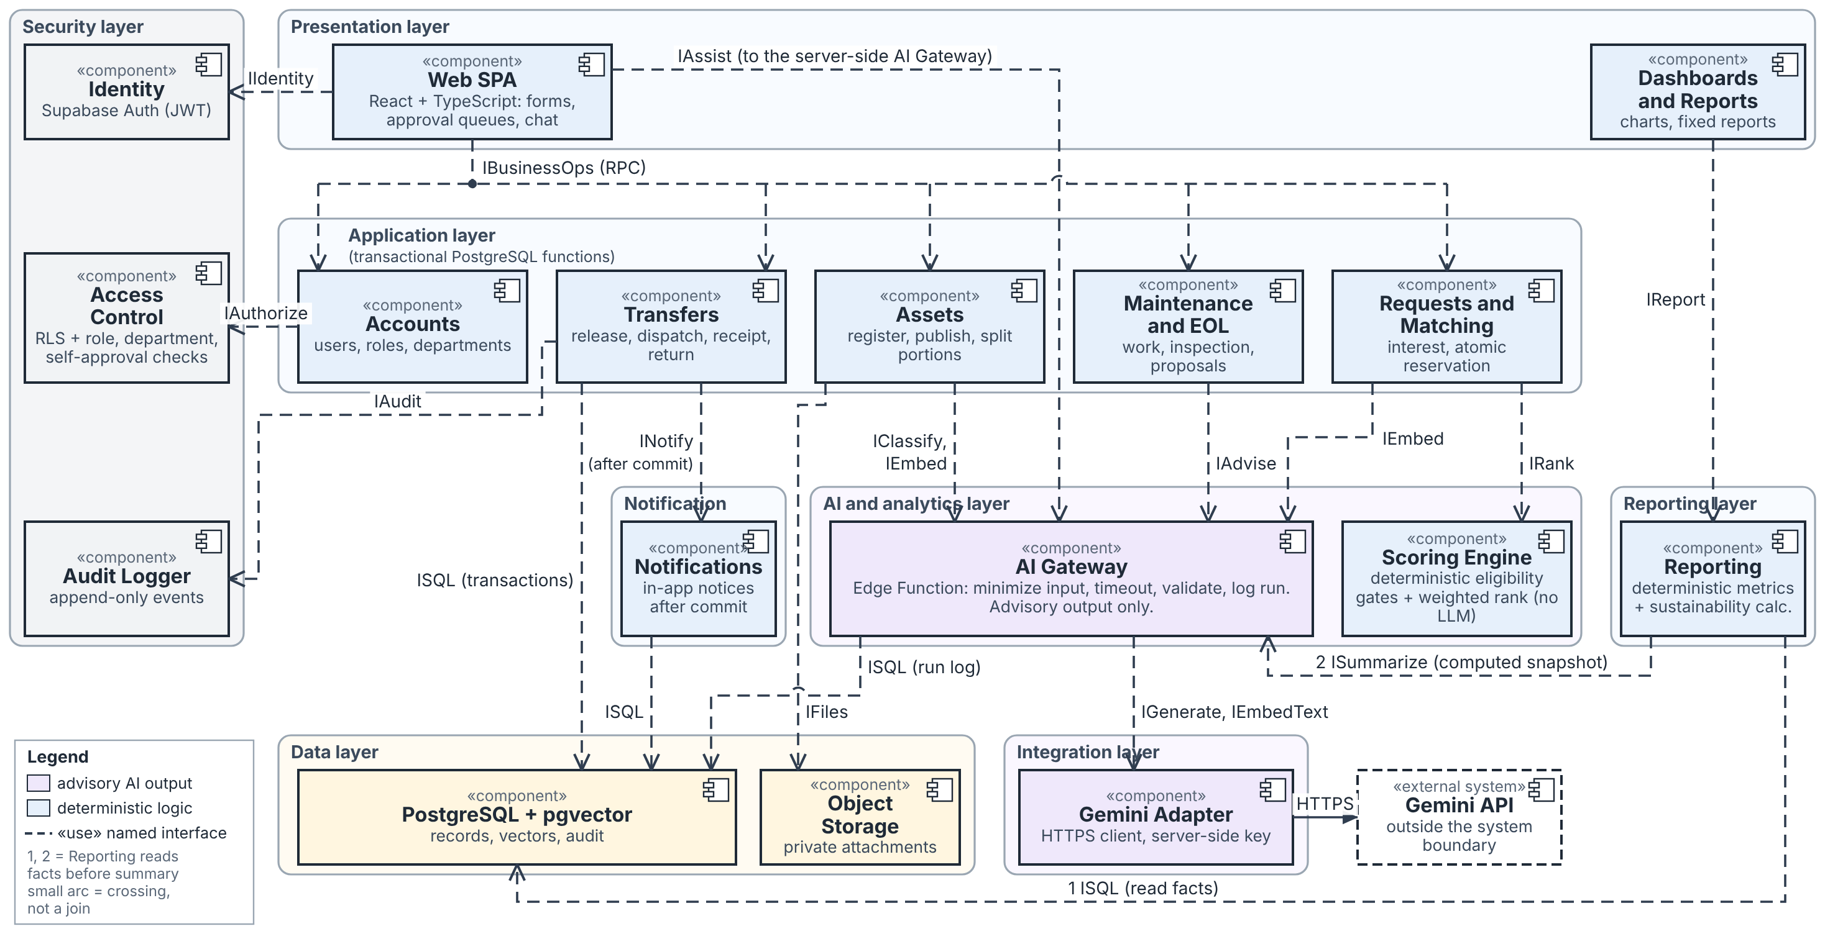
Figure 4 Logical architecture and UML component view
Decision 01 selects a layered modular web application using the managed-backend approach proposed in Phase 2. The main alternative was a separately hosted Django/PostgreSQL backend. Managed authentication, storage and database services are expected to reduce new hosting and configuration work, but they increase dependence on the managed platform and require careful RLS and function-level authorization.
The business modules remain in one deployable application. Separate microservices are not proposed for the planned five-concurrent-session prototype workload, this is a design choice rather than a measured capacity result.
Ordinary reads are intended to use caller-scoped access, while protected state changes use transactional database operations. A server-side AI gateway exposes task-level advisory interfaces, keeps provider credentials outside the client and validates returned outputs. Authorization, eligibility checks and transaction outcomes remain outside this gateway. Reporting calculates authoritative facts before requesting an optional narrative, and notifications follow committed events without controlling transaction success.
The design was checked against the required presentation, application, AI and analytics, data, integration, notification, security and reporting areas. Runtime behavior and capacity remain to be verified during implementation; TBD-001 is still open.
Trace: Decision 01-architecture; NFR-QUAL-003/005/006; NFR-SEC-001/003; SI-001/002. Figure 4 also serves as the Phase 5 component diagram.

4 AI Services
One gateway provides five logical service interfaces. These rows describe implementation capabilities. Matching combines semantic retrieval with deterministic suitability and ranking, while the shared LLM interface supports conversational assistance and report-summary drafting as separate tasks.
“Ask/wait” means the system calls the service on demand and waits for its response. The timeout values below are provisional design limits, not measured response-time results.
Service / pattern | Input and output | Limit / unavailable / unsure
Classification: ask/wait | Permitted asset metadata and approved images or files produce a suggested category and subcategory from the allowed taxonomy, standardized tags and description, possible materials, missing metadata and evidence references. The user accepts, corrects or rejects each suggestion. Confirmed metadata is not overwritten without acceptance. | 15 seconds, provisional. Manual entry remains available when the service fails. Unsupported or missing evidence is identified. Confidence is not treated as a calibrated probability.
Semantic matching: compute ahead and ask/wait | Listing and request text support vector retrieval alongside keyword and category retrieval. The service returns candidate identifiers, a similarity signal and model/content-version information. | 15 seconds per provider call, provisional. Stale or failed vectors fall back to keyword and category retrieval. Semantic similarity indicates textual relevance, not suitability.
Suitability and ranking: local deterministic calculation | Candidate records are checked against mandatory category, specification, condition, availability, quantity and permission requirements. Eligible candidates receive documented compatibility and ranking factors, explanations, missing-data warnings and uncertainty indicators. | Runs locally without a generation call. Missing mandatory evidence blocks reservation and produces a Needs review status. A rank below 60 is labelled Weak match. Scores are not probabilities, and selecting a candidate records interest only.
Sustainable-action advice: ask/wait | Condition, history, demand, cost and eligible sustainability evidence produce a suggested action with reasons, referenced evidence and uncertainty. | 15 seconds, provisional. Authorized staff can continue manually when the service fails. Missing essential evidence produces Needs review; approval remains human.
LLM assistant and report drafting: ask/wait | Assistant tasks use authorized facts or policy to answer permitted search, history, status, navigation, policy and sustainability questions or prepare an editable request draft. Report tasks use a computed report snapshot to prepare a narrative draft. | 15 seconds for assistant tasks and 30 seconds for report drafting, provisional. Normal screens and fixed reports remain available when the service fails. Every narrative number is checked against the computed snapshot, and unsupported facts or numbers are withheld. The LLM cannot approve or execute transactions.

Failure and version handling
The business record is saved before optional embedding work begins. An embedding failure does not reverse publication. The system records the failure and retries after a later edit or an explicit retry.
For each provider call, record the provider-visible model identifier, configuration version, referenced input or input hash, duration, call count and human review outcome. Paid generation calls are not retried indefinitely. A user may retry explicitly, while transaction retries reuse the original operation key.
These timeout limits are design proposals rather than measured targets. TBD-005 remains open until technical checks measure the selected provider, dataset, hosting environment and network.
Trace: Decision 02-ai-integration; AI-REQ-001 to 008; NFR-AI-001; NFR-PERF-002/003; NFR-QUAL-006; SI-002.

5 Human Approval Points
Authorized people make and record business decisions. The system validates rules, enforces permissions and records outcomes, while AI output remains advisory. This authority model is proposed for the prototype and does not claim confirmed institutional delegation.
Reservation and release are separate decisions. A requester’s selection records interest only and does not reserve stock. The supplying representative approves the reservation, after which an authorized supplying representative makes the release decision before dispatch. If a combined approval interaction is implemented, the system still records the reservation and release decisions separately.
Decision | Authorized person and evidence | Retained control
Confirm asset metadata | Representative/Custodian reviews source fields, AI suggestions, evidence and uncertainty. | Accept, correct or reject suggestions. Retain the confirmed values and review outcome. Accepting an AI suggestion does not authorize publication or another transaction.
Select a match and express interest | Requester reviews mandatory checks, score, reasons, missing evidence and remaining need. | Record interest only. Selection does not allocate stock, approve a reservation or change custody.
Approve reservation | Authorized supplying Representative/Custodian reviews the request, competing interests, suitable available quantity, remaining demand and authority. The approver must not be the requester or the person whose interest is being approved under the prototype rule. | Recheck authority, suitability, available stock and outstanding need atomically. Approval commits the reservation, allocation, approval and pending transfer together; failure commits none of them.
Approve release | Authorized supplying Representative/Custodian reviews the approved reservation, current condition, quantity and readiness for transfer. The same prototype self-approval restriction applies. Institutional delegation remains unresolved under TBD-006. | Record a distinct release decision. Release permits scheduling and dispatch but does not record physical movement or formal custody change.
Record dispatch | Facilities Staff records the dispatched quantity, time, physical holder and location after release. | Dispatch updates physical tracking only. It does not complete the transfer or change formal departmental assignment or custody.
Accept receipt | Authorized receiving Representative/Custodian compares delivered quantity and condition with the approved transfer. | Complete the transfer only after the approved quantity and condition are reconciled and accepted. A short, damaged or disputed receipt remains open and unavailable and does not count as completed fulfilment.
Reconcile a dispute or confirm return | Authorized representatives record the discrepancy, observations and reason. The supplying Representative/Custodian confirms the returned quantity and condition when stock is physically returned. | Keep the receipt observation, reconciliation and return as distinct records. A confirmed return releases the allocation and restores unmet demand. Returned units do not count as accepted fulfilment.
Complete maintenance and update condition | Maintenance Staff records work performed, findings and assessed suitability. An authorized Representative/Custodian makes the condition or state update under the proposed prototype authority model. | Work completion alone does not establish safe condition or restore availability. Preserve or reconcile active allocations. Unsafe or unresolved stock remains unavailable.
For every approval, rejection, override, reconciliation and other consequential decision, record the actor, decision, UTC time and reason, together with the affected record and before/after state where applicable. Exceptions remain within the prototype’s recorded role scope. Elapsed storage time or low demand does not grant disposal authority, and institutional delegation is not presented as confirmed policy.
Trace: Decision 03-human-approval; BR-001 to 011; UC-02/06/07/08/09/10/11/12; TBD-006.

6 Security

6.1 Role and Action Matrix
Default deny applies to direct requests, database operations, file access and assistant retrieval. Authorization is checked against the authenticated user’s active role assignments, department, target record and requested action.
The matrix uses the following codes:
- O: the user’s own record or request
- D: the user’s department
- A: assigned work
- M: eligible marketplace listings across departments
- S: permitted specialist records and reports required for the role’s work
- X: authorized cross-department business scope
- T: technical administration only
- —: no permission
An asterisk (*) limits access to the underlying permitted record, task or escalation. Every scope is enforced server-side and during file access. AI has no independent user scope, approval authority or mutation permission. It receives only task-required information that the authenticated caller is permitted to access.
Action | Req | Rep | BA | Maint | Fac | Proc | Fin | Sust | Sys | AI
Search or view eligible listings | M | M | X | A | A | S | S | S | — | read*
Create or track request | O | D | — | — | — | — | — | — | — | draft
Register or publish asset | — | D | — | — | — | — | — | — | — | suggest
Approve reservation or release | — | D | — | — | — | — | — | — | — | —
Review escalated exception | — | — | X* | — | — | — | — | — | — | —
Record dispatch or handover | — | — | — | — | A | — | — | — | — | —
Accept receipt or confirm return | — | D | — | — | — | — | — | — | — | —
Report defect | O | D | — | A | — | — | — | — | — | —
Inspect, service or assess condition | — | D* | — | A | — | — | — | — | — | suggest
Propose or complete final action | — | D | — | A* | A* | — | — | — | — | suggest
Authorize final action | — | — | X** | — | — | — | — | — | — | —
Operational or sustainability report | — | D | X | S | — | S | S | S | — | draft*
Financial or relevant costs | — | D | X | S | — | — | S | — | — | draft*
Manage users, roles or departments | — | — | — | — | — | — | — | — | T | —
Review audit records | — | D* | X | S* | A* | S* | S* | S* | T | —
* Access is limited to the permitted record, task or escalation and grants no general approval or mutation authority.
** Business Administrator final-action authority is limited to the proposed prototype role scope. It does not establish institutional delegation. Institutional delegation and retention policy remain subject to confirmation under TBD-006.
- Req = Requester | - Proc=Procurement
- Rep = Department Representative / Asset Custodian | - Fin=Finance
- BA=Business Administrator | - Sust=Sustainability
- Maint=Maintenance | - Sys=System Administrator
- Fac=Facilities

Department-scoped roles may view eligible listings across departments without gaining unrestricted access to another department’s records. A role assignment never grants another role’s permissions. Business audit and history access follows the reader’s permitted records. Technical administrators see technical audit information only. Finance may inspect supporting financial activity without receiving unrelated operational authority. Sustainability may inspect calculation inputs without gaining unrestricted financial access.
Trace: SRS 2.3; FR-USER-004; FR-REPORT-009; NFR-SEC-001 to 004; NFR-PRIV-001/002; BR-011; TBD-006.

6.2 Audit Backup and Recovery

Enforcement and data boundaries
Supabase Auth supplies identity. Server-side handlers and database functions verify the authenticated caller, active role, department and target-record scope. Row-level security protects ordinary reads and file metadata, while private file access is checked against the associated record’s permissions. Browser-visible navigation is not authorization.
State-changing functions recheck business authority and restrict execution grants. Privileged functions explicitly verify the authenticated caller and pin their search path. Direct state updates that bypass approved workflows are denied.
The prototype uses synthetic records and approved sample files only. Before retrieval and again before provider invocation, enforce the authenticated caller’s role, department, record and task scope. Send only permitted fields and files required for the task. Exclude credentials, personal contact details and unrelated financial or operational information. The provider receives no unrestricted lookup capability. Validate structured output, enum values and evidence references before display. AI output cannot authorize or execute business actions.

Audit and notifications
Append an audit event for account and role changes, asset edits, approvals, allocations, custody changes, physical handovers, condition assessments, AI reviews and exceptions. Each event records the actor or service identity, action, affected record, UTC timestamp, before and after values, and correlation or operation key. Credentials, passwords and tokens are excluded. Business mutations and their audit events commit together. Ordinary roles cannot alter or delete audit history.
Generate in-application notifications for:
- New matches against active remaining unmet demand
- Pending approvals and exceptions
- Request and reservation status changes
- Transfer arrangements, dispatch, receipt and confirmed return
- Formal assignment or ownership changes
- Maintenance and condition updates
- Final-action decisions
Resolve recipients from the committed event. Opening a notification or linked record triggers another authorization check. Notification failure remains visible and retryable and does not reverse the committed business outcome.

Backup and isolated recovery
The following backup and recovery approach is proposed but has not been configured or tested. A database backup alone does not include uploaded file objects, so each backup set includes the database, private file objects and an object-key/checksum manifest.
Policy | Prototype design
Contents and frequency | Proposed daily and pre-change backup containing a database export, private file-object copy and object-key/checksum manifest. The schedule has not been implemented or verified.
Destination and protection | Proposed encrypted storage outside the repository and separate from the live project, with access limited to the technical operator. The exact location and encryption configuration remain to be selected and verified.
Retention | Retention duration, rotation and deletion rules remain unresolved under TBD-006. No retention period is claimed as approved.
Restore frequency | Restore-test frequency remains to be set. Tests must use an isolated project or database rather than the live environment.
Trace: Decision 04-security-recovery; NFR-QUAL-003/004; NFR-SEC-001/003; Supabase Database Backups R6; TBD-006.

7 Mockups

7.1 Asset Registration
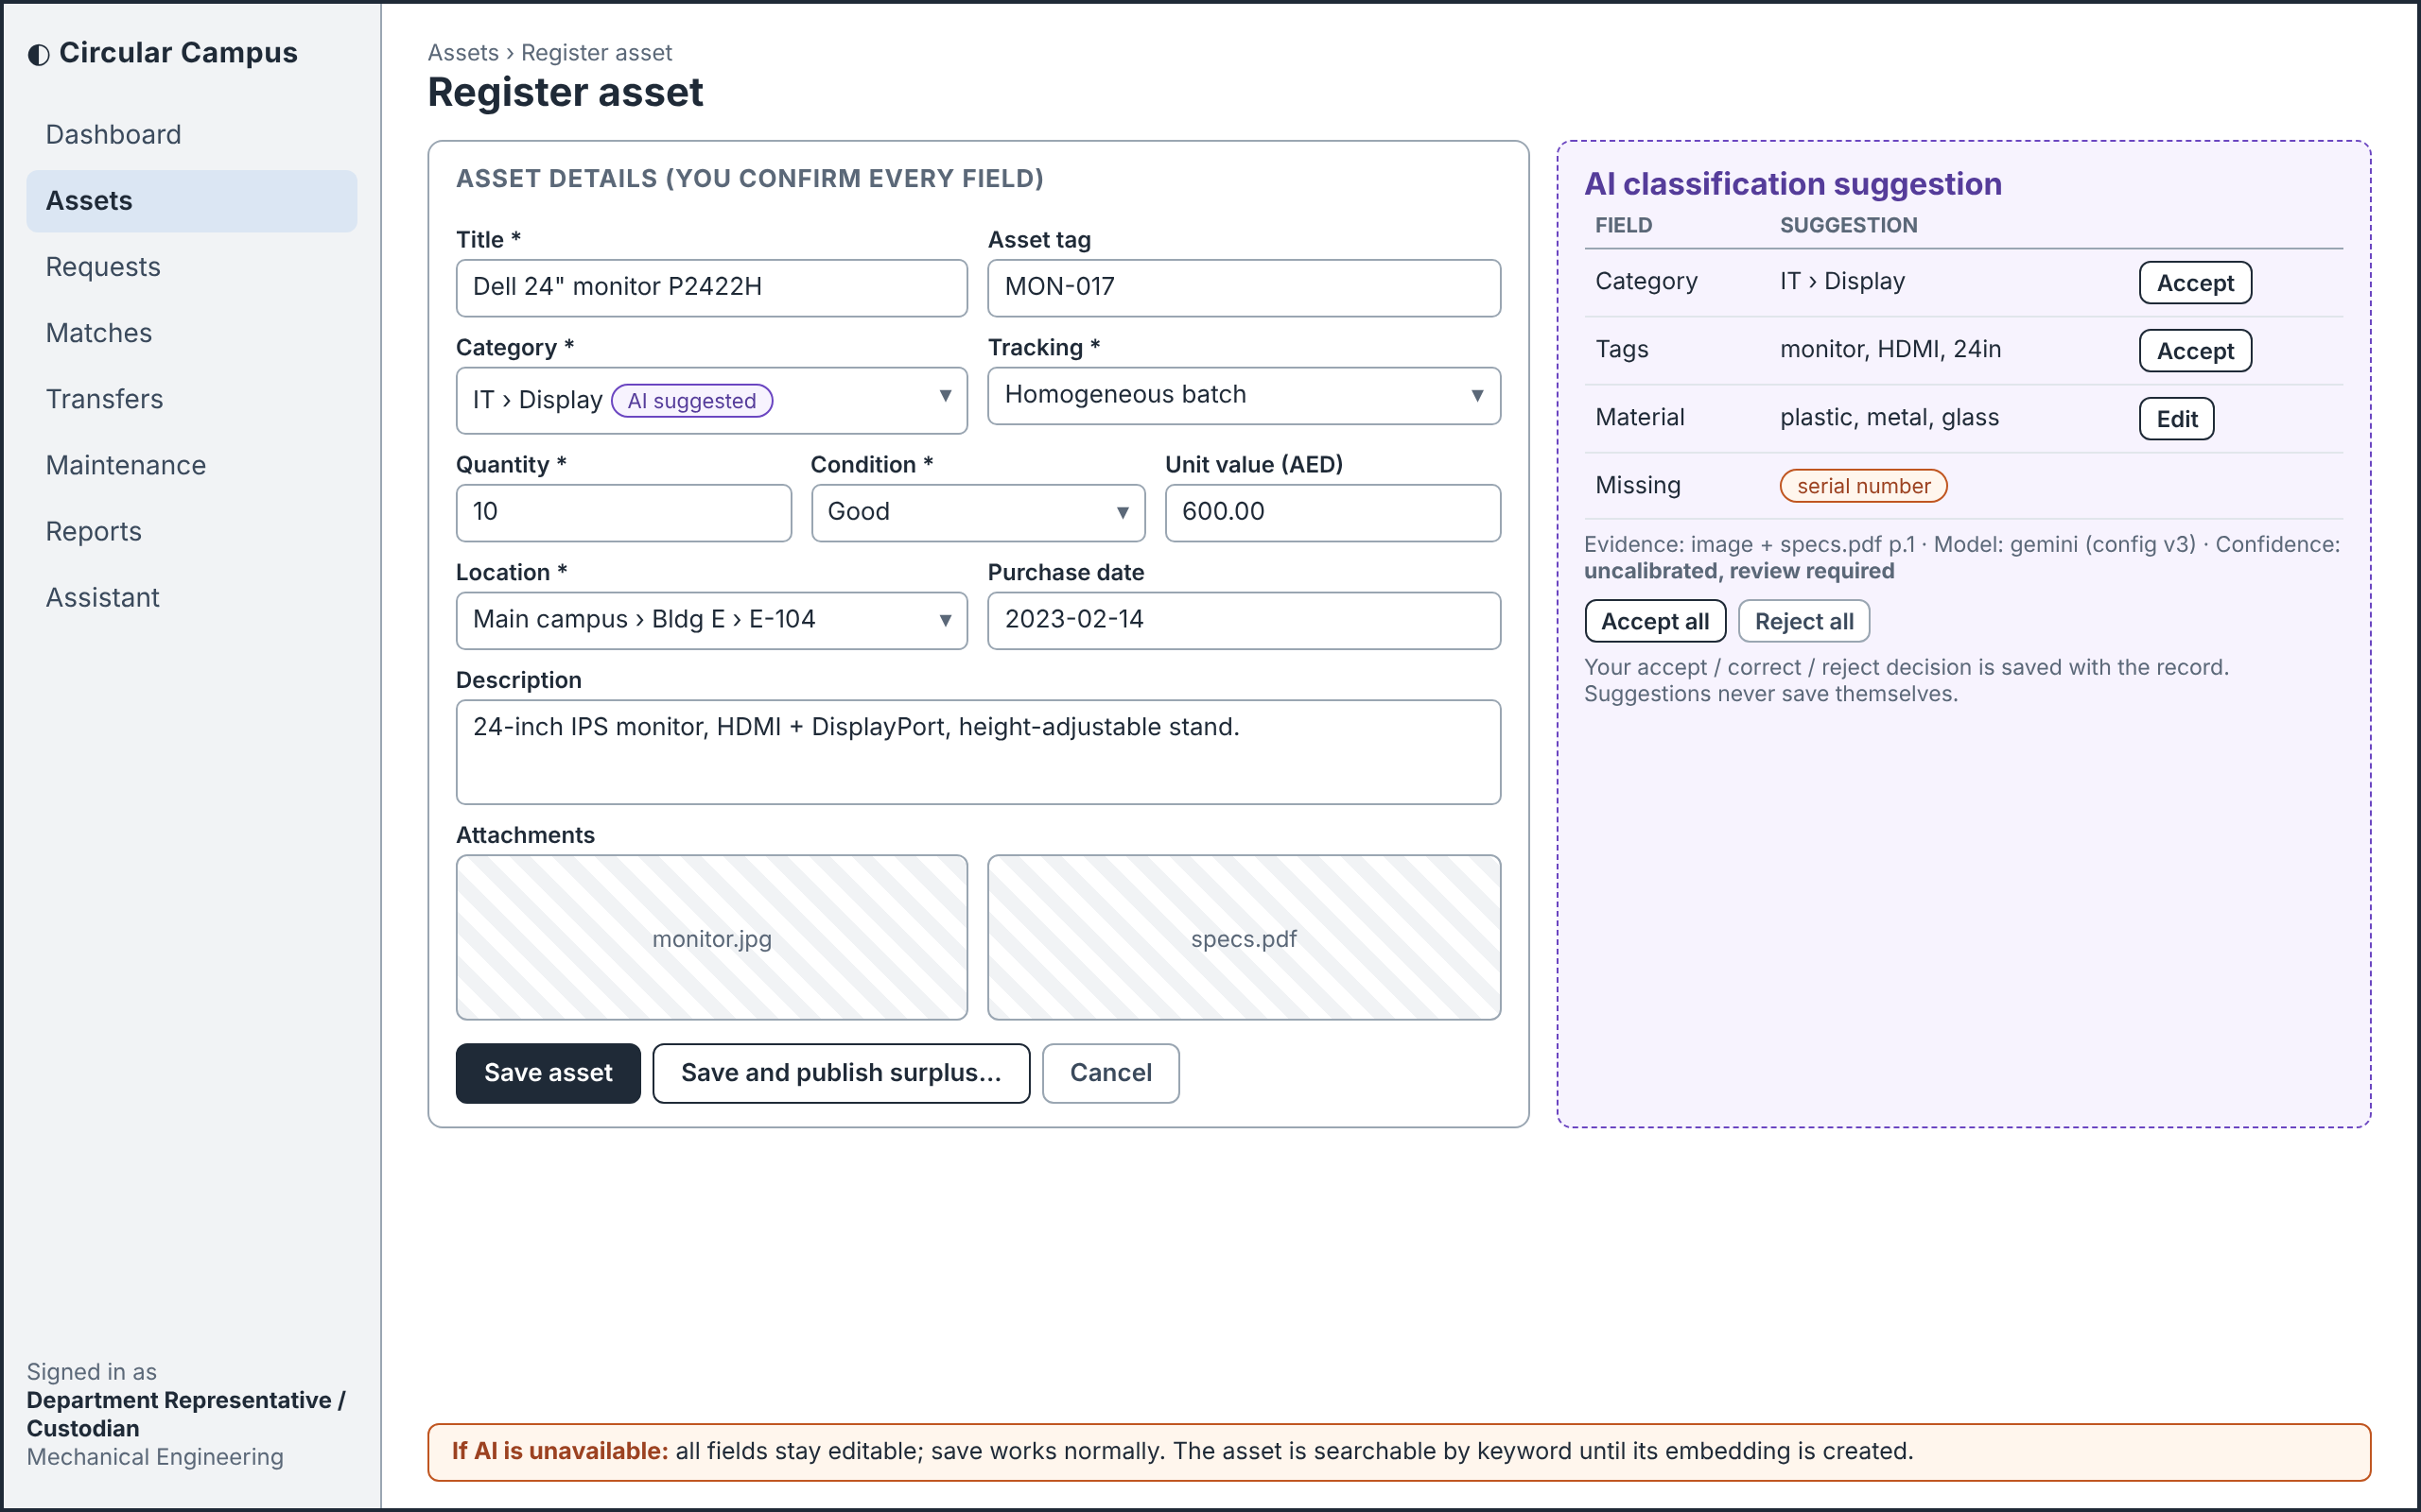
Figure 5 Asset registration (Representative / Custodian)
The representative reviews and confirms asset details before saving or publishing, classification suggestions never save themselves.
UC-02/03; FR-ASSET-001 to 008; FR-AI-CLASS-001 to 004.

7.2 Request Submission
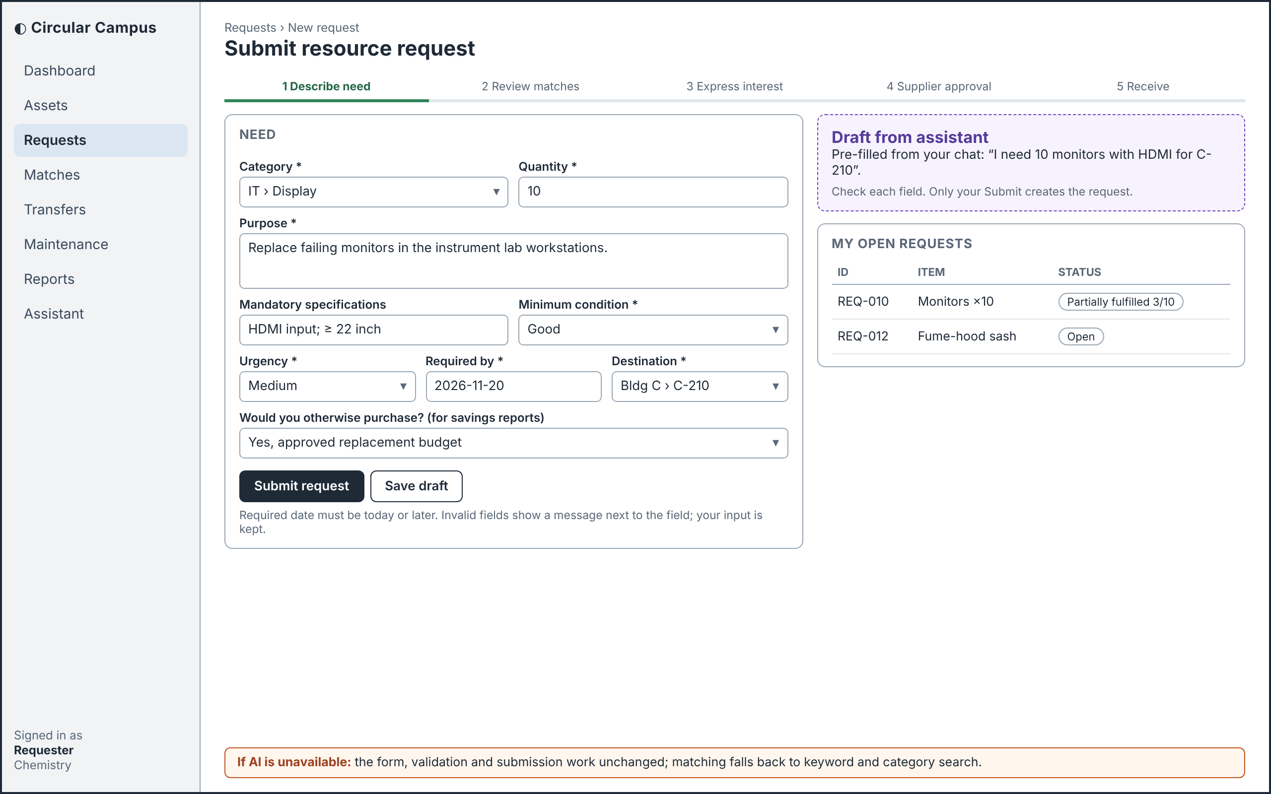
Figure 6 Request submission (Requester)
The requester reviews and submits the need, an assistant-prepared draft creates no request until the requester submits it.
UC-04; FR-REQUEST-001/002/005/008; UI-001/002.

7.3 Recommendation Review
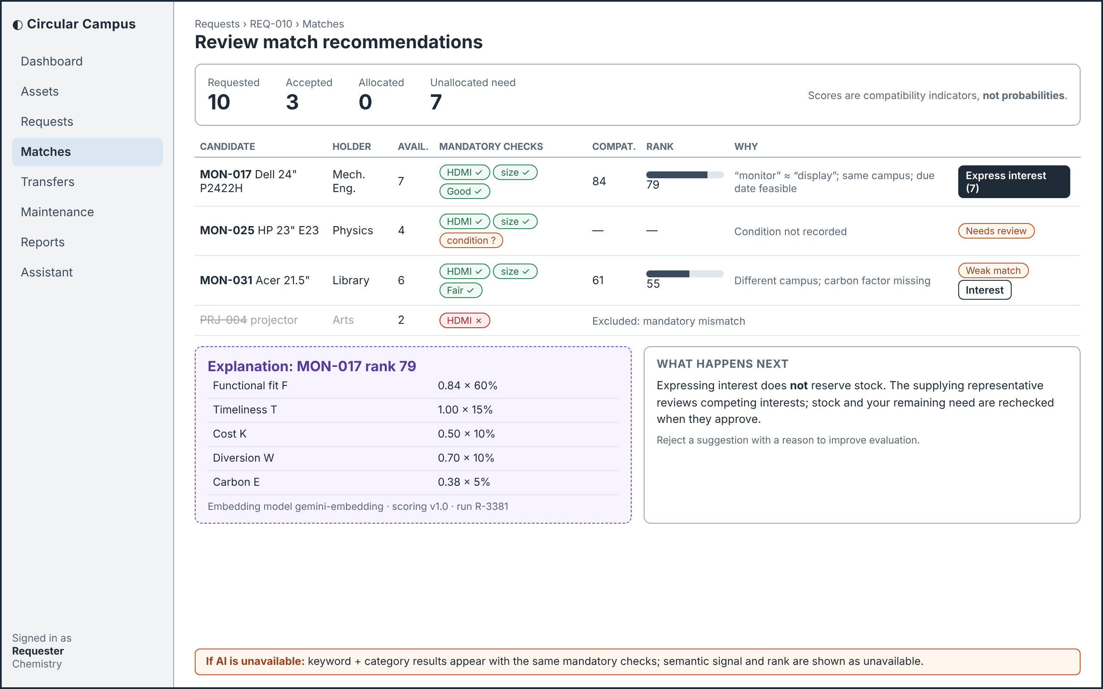
Figure 7 Recommendation review (Requester)
The requester reviews suitability checks, uncertainty and reasons; expressing interest does not reserve stock.
UC-06/07; FR-AI-MATCH-001 to 011; FR-REQUEST-003 to 007.

7.4 Transfer Approval and Receipt
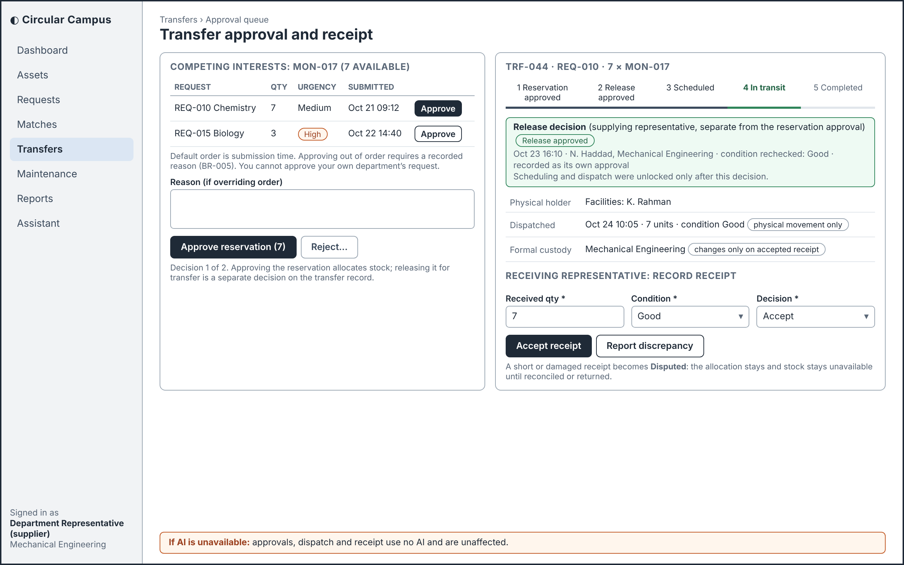
Figure 8 Transfer approval and receipt (supplying and receiving representatives)
The supplying representative records separate reservation and release decisions before dispatch, while the receiving representative accepts or disputes receipt. Custody changes only after accepted receipt.
UC-08; FR-TRANSFER-001 to 008; BR-007.

7.5 Maintenance Tracking
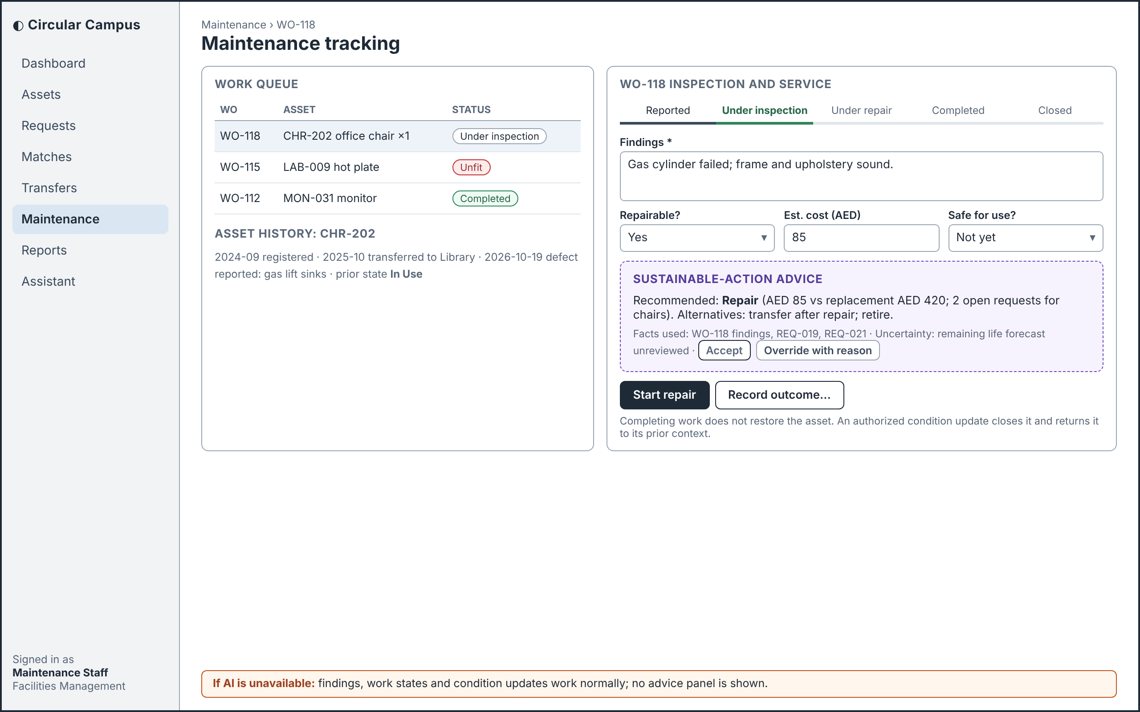
Figure 9 Maintenance tracking (Maintenance Staff)
Maintenance Staff record findings and completed work, but an authorized condition update, not work completion alone, restores availability.
UC-09/10; FR-MAINT-001 to 006; FR-AI-SUST-001 to 004.

7.6 Sustainability Dashboard
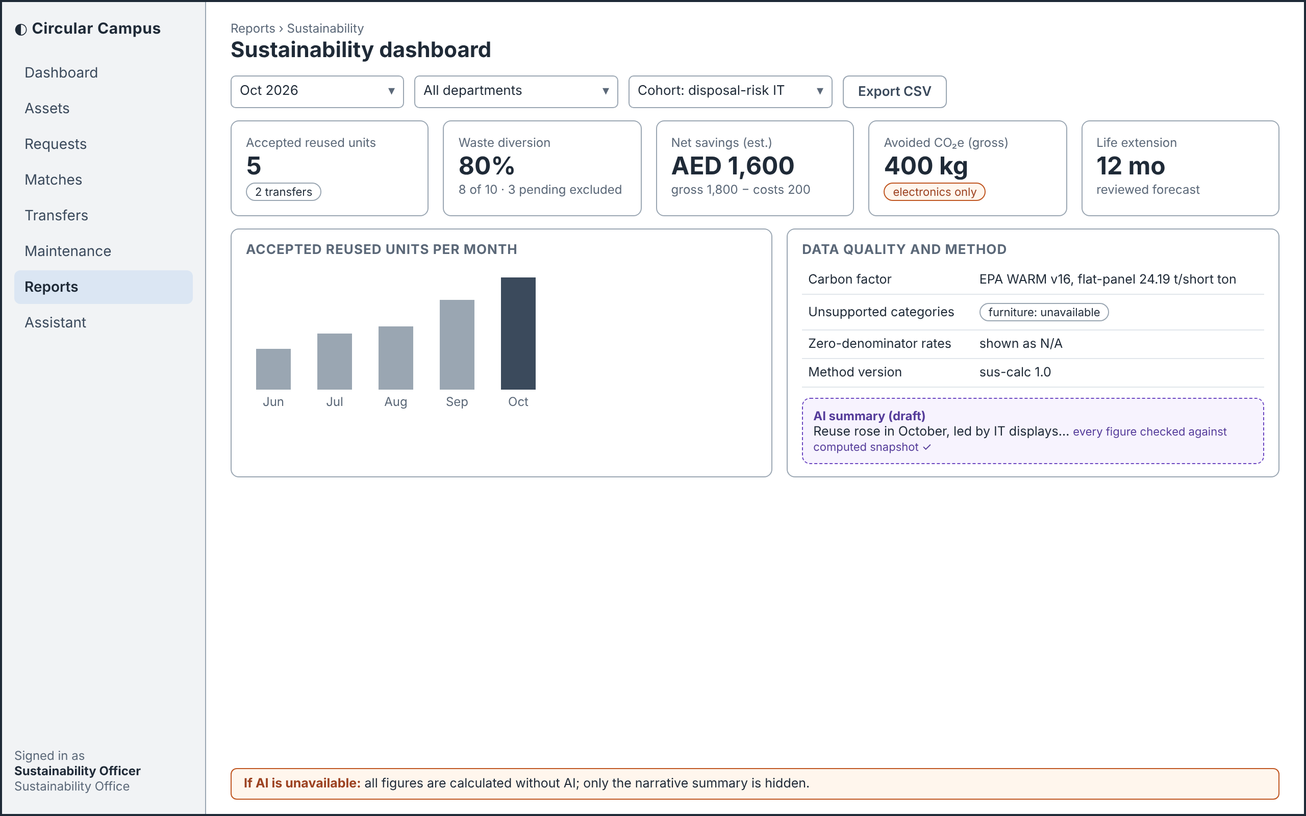
Figure 10 Sustainability dashboard (Sustainability Officer)
The Sustainability Officer reviews calculated indicators and the optional draft summary; the calculated figures remain available without AI.
UC-12; SUS-001 to 007; FR-REPORT-003/005.

7.7 Operational Reports
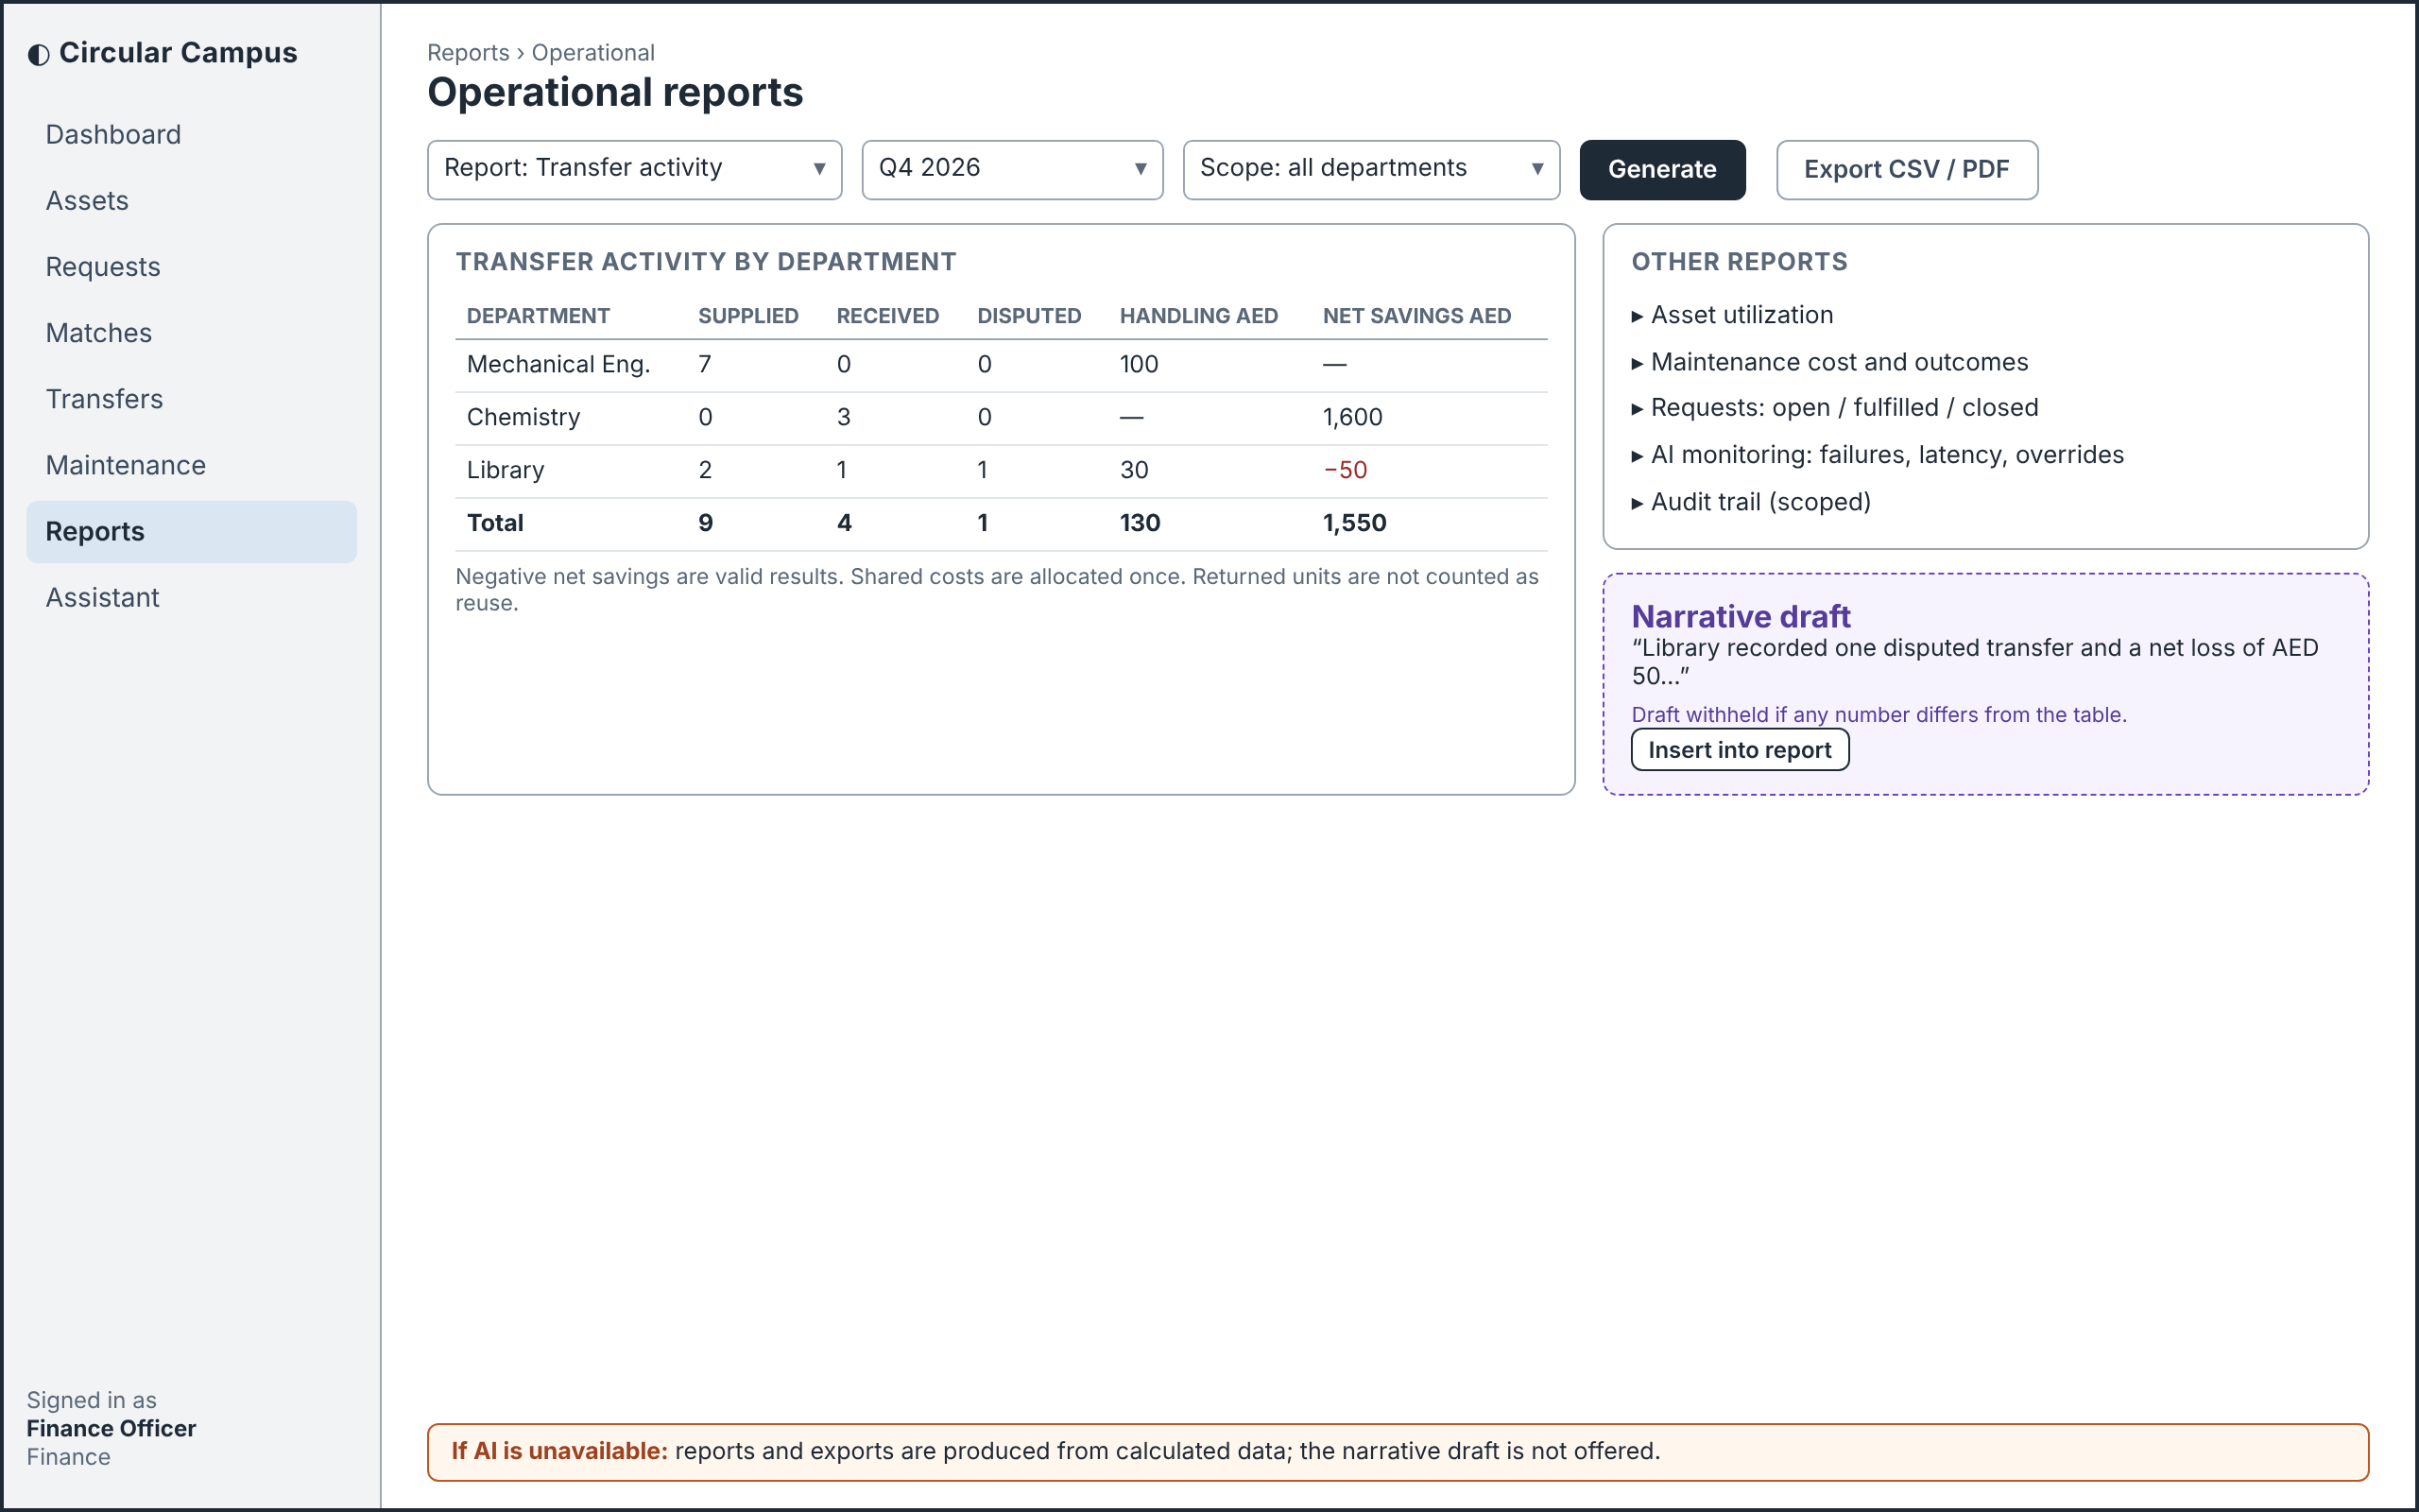
Figure 11 Operational reports (Finance Officer view)
The Finance Officer reviews calculated activity and savings; the narrative is optional and is withheld if its figures do not match the report.
UC-12; FR-REPORT-001 to 009; AI-REQ-007.

7.8 Conversational Assistant
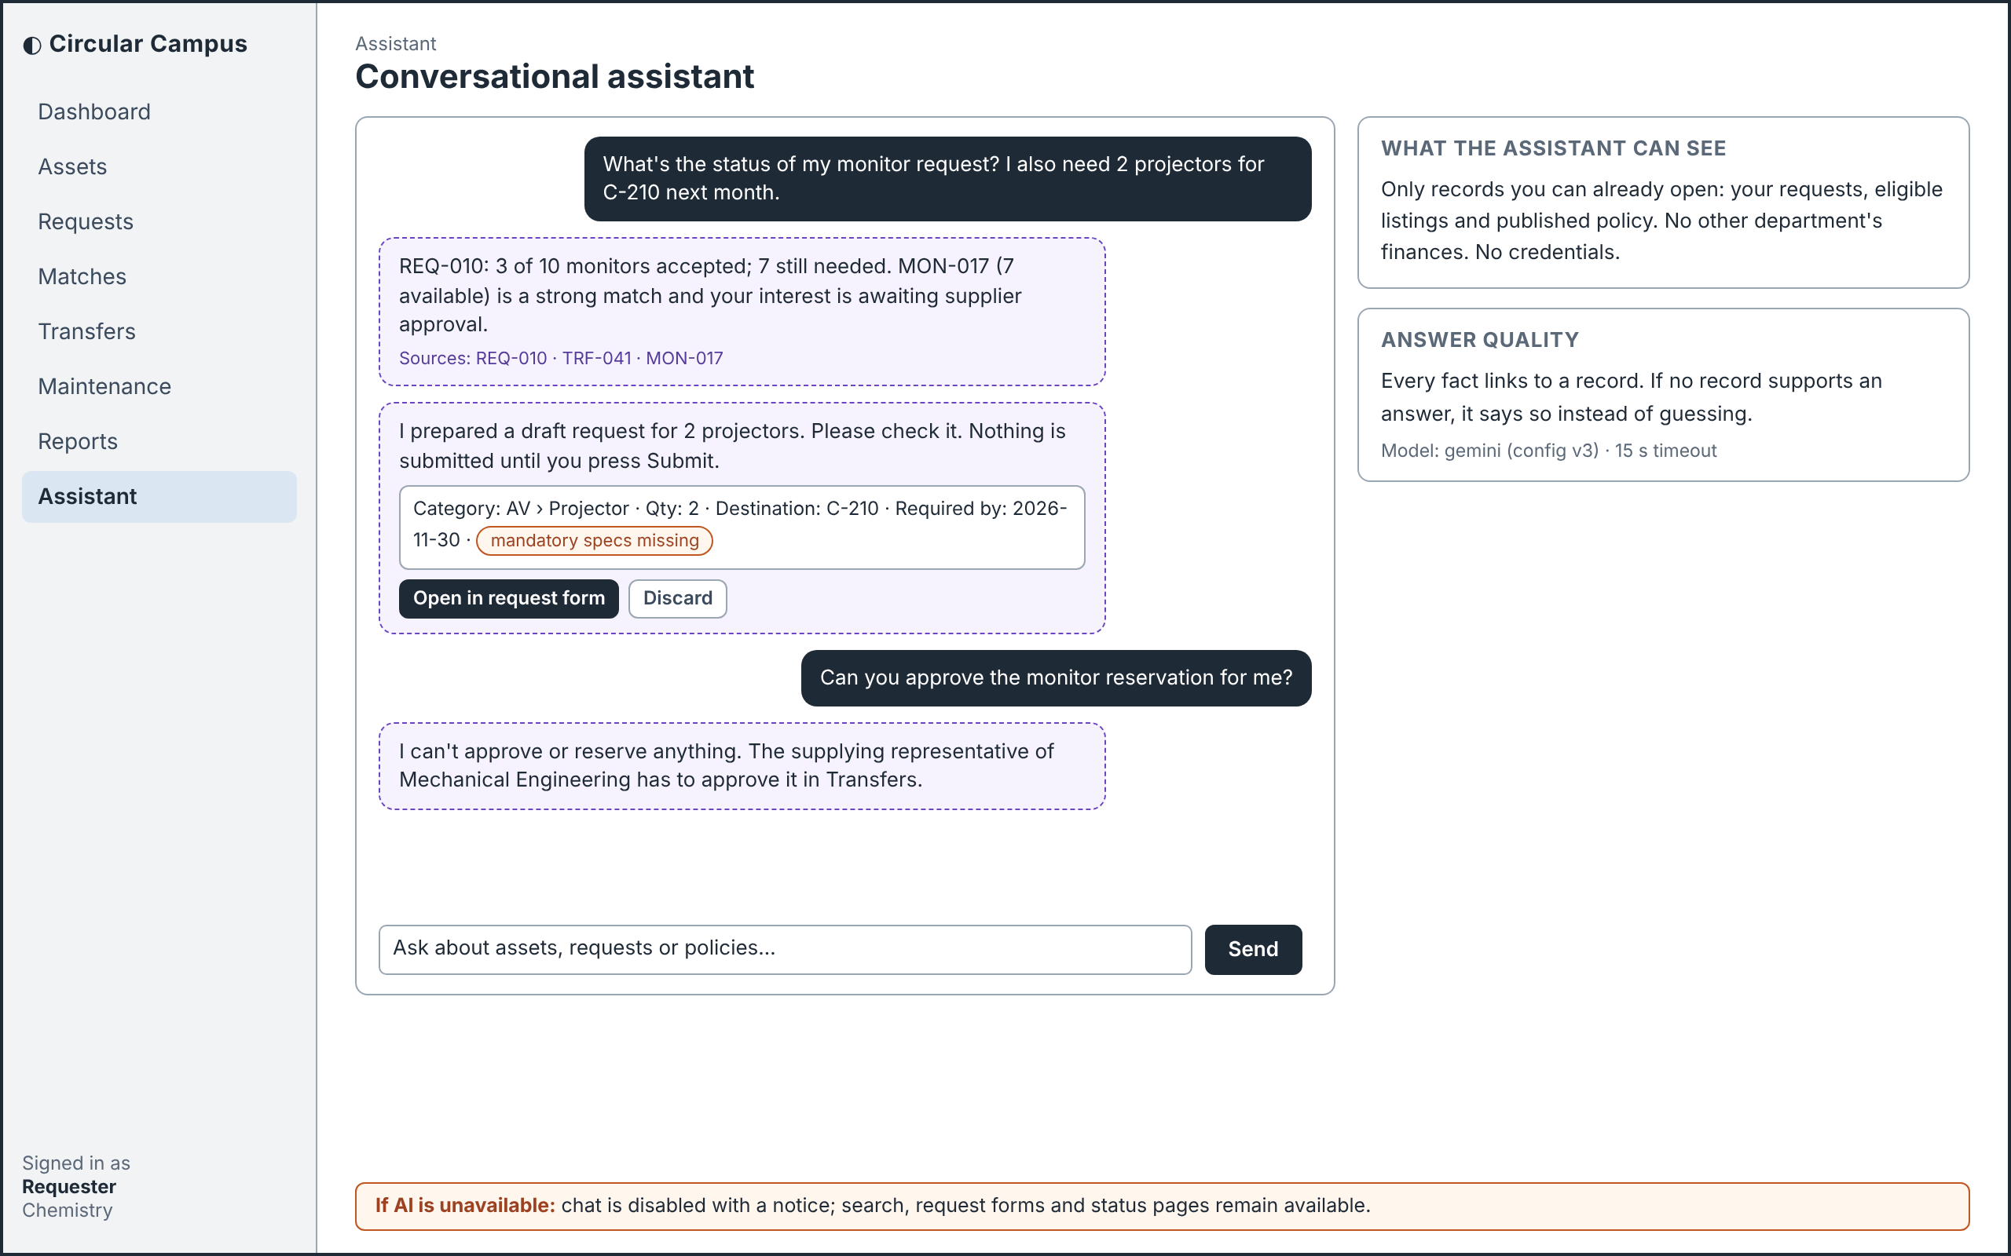
Figure 12 Conversational assistant (Requester)
The requester reviews any assistant-prepared draft and submits it through the normal form; the assistant cannot approve or reserve.
UC-11/04; FR-ASSIST-001 to 005; BR-002/011.
Interaction rules for all eight screens: visible labels and keyboard order; valid input is kept after errors; processing state and specific corrections are shown. AI suggestions sit in a dashed panel, separate from confirmed facts. The named role makes the final decision, and the bottom bar of each screen states the normal path when AI is unavailable.

8 Structural UML

8.1 Whole System Use Cases
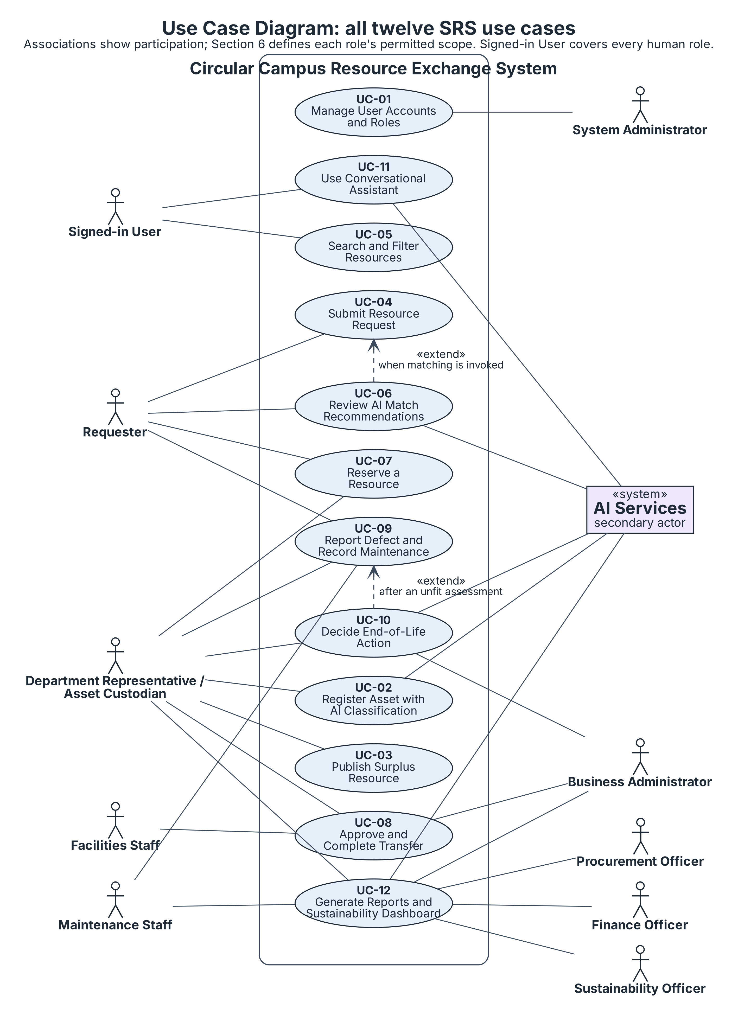
Figure 13 Use case participation for all twelve SRS use cases
UC-06 conditionally extends UC-04 when the requester invokes matching. UC-10 may extend UC-09 after an unfit assessment and may start independently. The assistant is available to every signed-in human role within its existing access. Procurement/Finance/Sustainability share UC-12 participation while retaining distinct report scopes. Operational associations mean assigned participation, not common permissions.

8.2 Domain Class Model
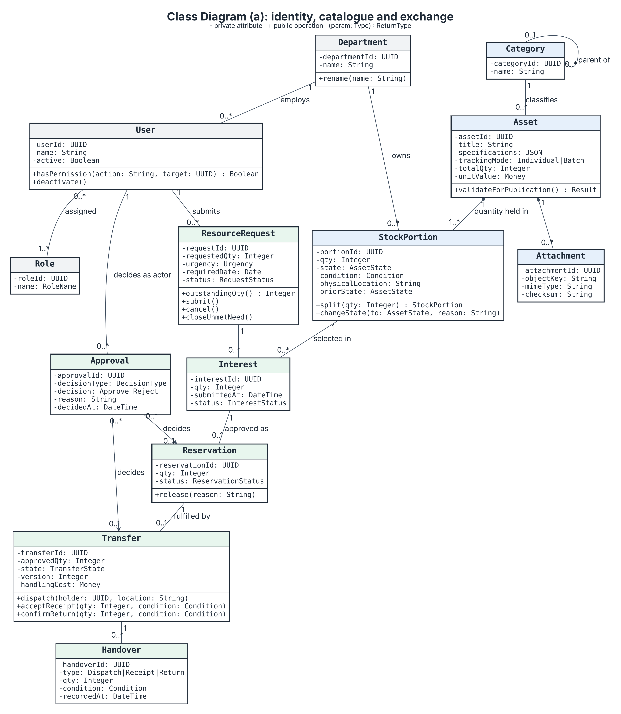
Figure 14a Identity, catalogue and exchange classes

8.2.1 Life-Cycle, AI and Notification Classes
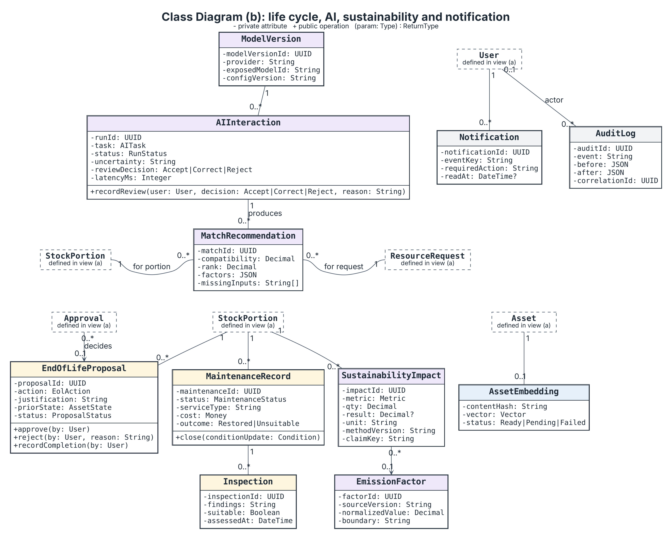
Figure 14b Life-cycle, AI, sustainability and notification classes
In the figures, attributes and operations use UML visibility markers (+ public, - private, # protected). Operation parameters and return types are shown where specified.
Figures 14a and 14b are two views of one class model; dashed boxes in 14b are classes detailed in 14a. Multiplicity is shown at both ends of every association, and a filled diamond marks composition. Asset owns shared descriptive identity; StockPortion carries quantity, state, condition and current assignment. A request has many interests/reservations over time; one reservation creates one transfer. The dictionary states all foreign keys and optionality. No inheritance or composition is added merely to demonstrate notation: asset categories are data, and historical records must survive deactivation.
Operations name domain responsibilities, not a requirement to implement every entity as a mutable TypeScript class. State changes are orchestrated by the transactional operation contracts in Section 11.
MaintenanceRecord holds inspection evidence. EndOfLifeProposal retains the prior state that a rejection restores. AIInteraction references one ModelVersion and retains the human review; each MatchRecommendation links one request and one stock portion. ReportingService calculates deterministic facts; AIGateway handles suggestions; NotificationService acts on committed events. Stored entities are expanded in Section 10.
The component diagram is Figure 4 in Section 3. Logical module boundaries do not require separate deployments, brokers or databases.

8.3 Deployment Design
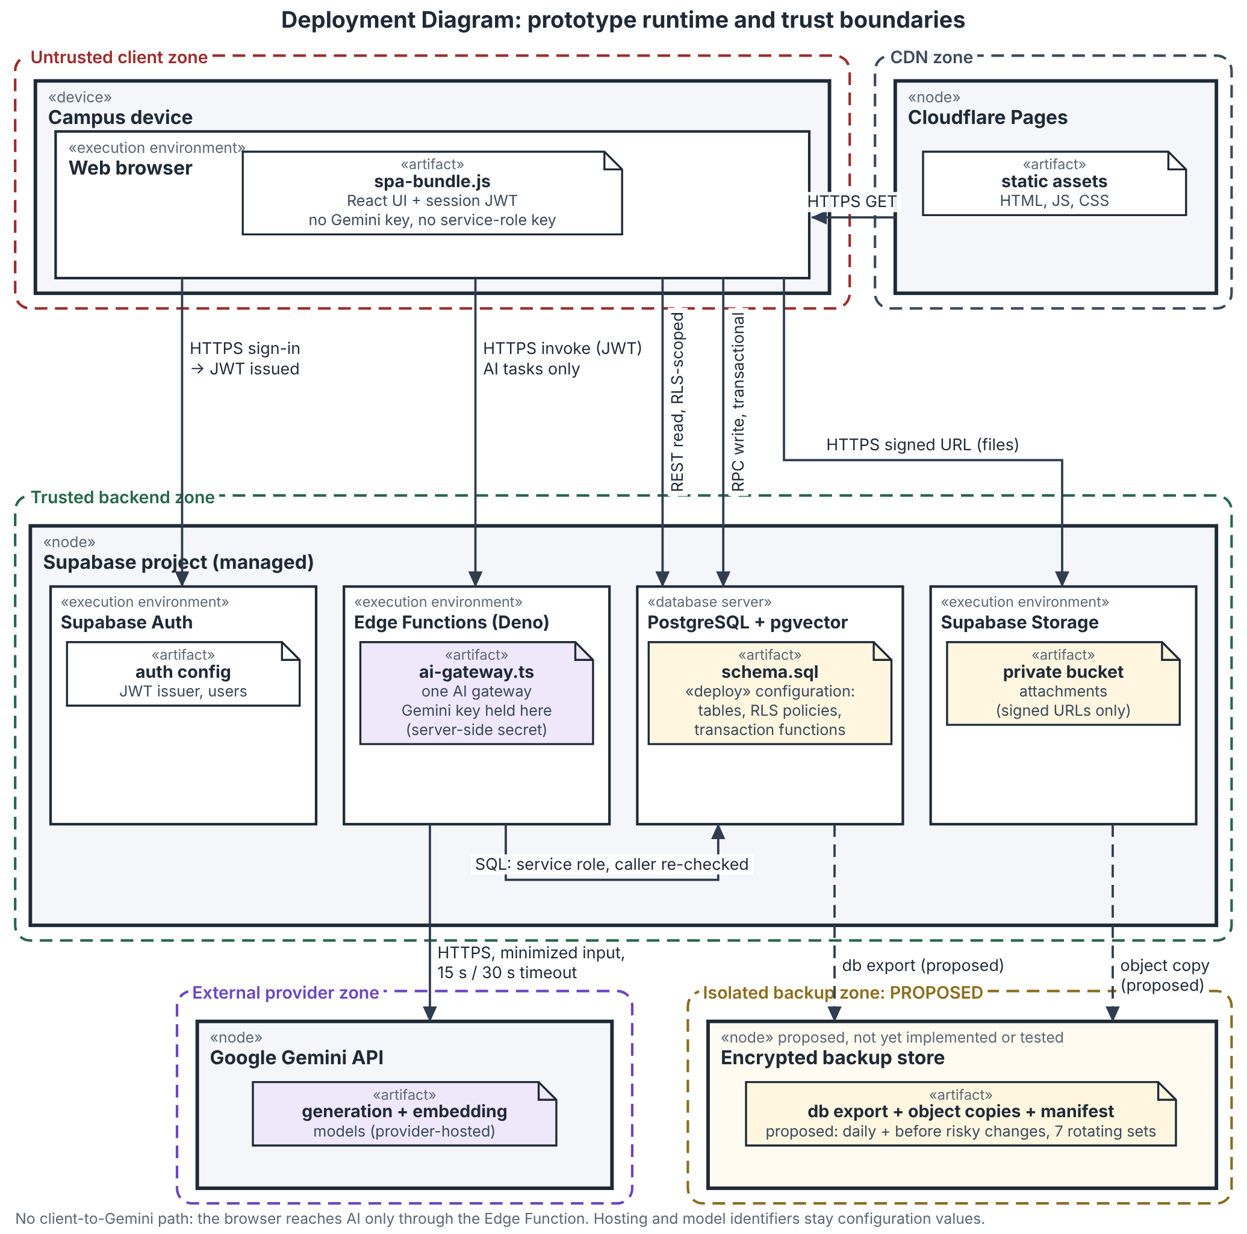
Figure 15 Prototype deployment and trust boundaries
The application’s Gemini credential is server-side and is not included in client assets. Hosting and model identifiers remain configuration values.
The browser downloads static application assets over HTTPS. Authenticated client requests use the managed Supabase backend: protected writes go through transactional operations, while reads remain scoped to the caller. One logical server-side Edge Function gateway calls Gemini using server-side credentials; pgvector remains in PostgreSQL. A separate backup set is proposed for database exports and file objects. The depicted backup schedule, seven-set rotation, and isolated store are proposed design assumptions; restore and retention behavior remain to be verified during implementation. Provider or network failures degrade optional advisory functions; they do not create new business states.
The prototype does not introduce institutional SSO/accounting endpoints, a separate vector database, a GPU host, Docker, or a microservice fleet. Hosting/model identifiers remain configuration values; implementation records the exposed model and configuration version. Approximate $35/month remains the Phase 2 planning allowance, not an updated supplier quotation.

9 Behavioral UML

9.1 Registration with Classification
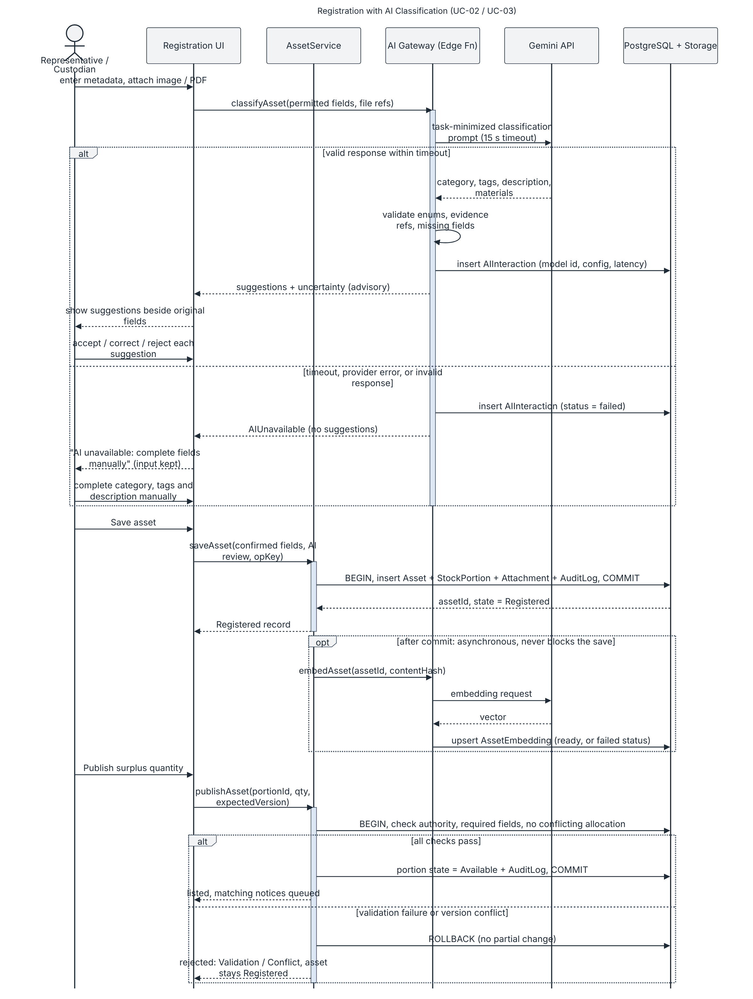
Figure 16 Asset registration classification and publication
UC-02/03. The person confirms or corrects suggested metadata. Persist the asset record and audit event before attempting optional embedding; embedding failure must not undo the saved record. Registration and publication remain separate actions, and publication makes only eligible quantity Available.
Solid messages: calls; dashed messages: replies; activation bars: executing participant. This notation applies to Figures 16 to 19. In each Alt frame, mutually exclusive guards identify the available outcomes; opt frames represent behavior that may be omitted without changing the main outcome.

9.2 Matching and Reservation Sequence
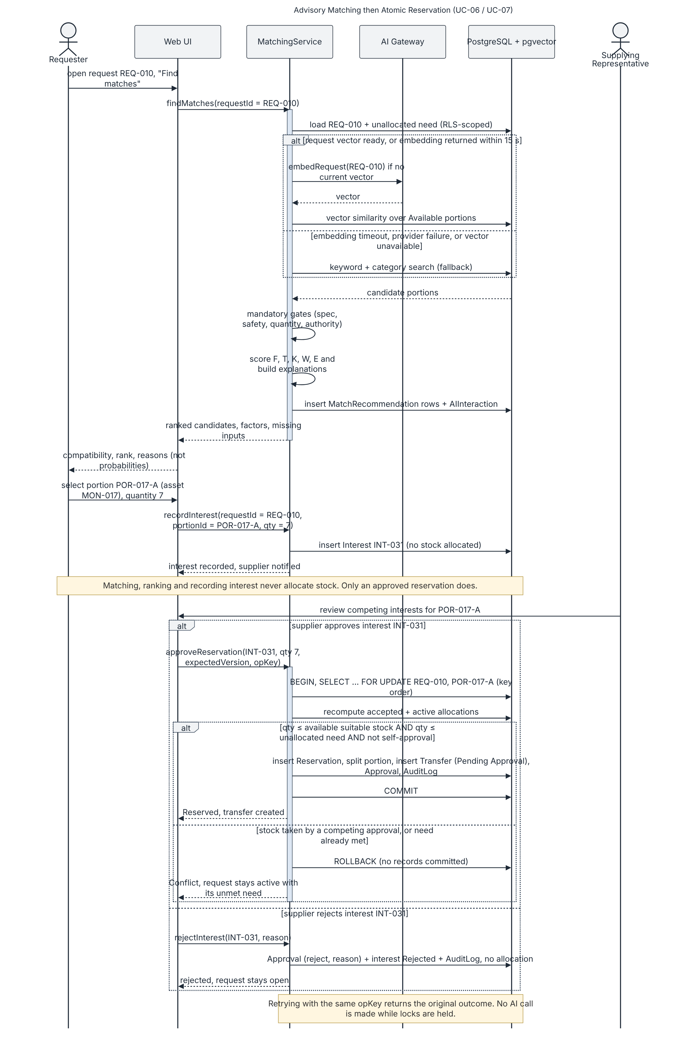
Figure 17 Advisory matching followed by atomic reservation
UC-06/07. REQ-010 identifies the request and MON-017 the selected portion. Selection records interest only. Supplier approval is separate; the transaction rechecks eligible stock, outstanding need, authority and self-approval, then commits all reservation records together or none. A repeated operation key returns the original outcome.

9.3 Transfer and Receipt Sequence
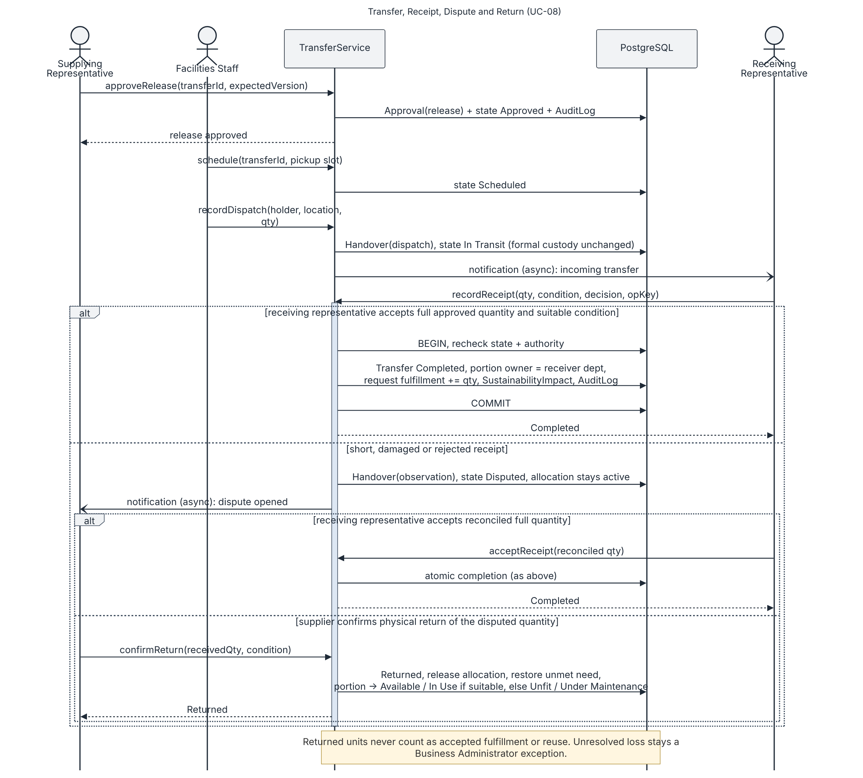
Figure 18 Physical movement accepted receipt dispute and return
UC-08. Dispatch changes physical tracking only. The transfer completes only after the receiving representative accepts the full approved quantity and its condition is suitable. A short, damaged or rejected receipt remains Disputed with its allocation active until reconciled acceptance or supplier-confirmed return; unresolved loss remains an exception.

9.4 Assistant Request Sequence
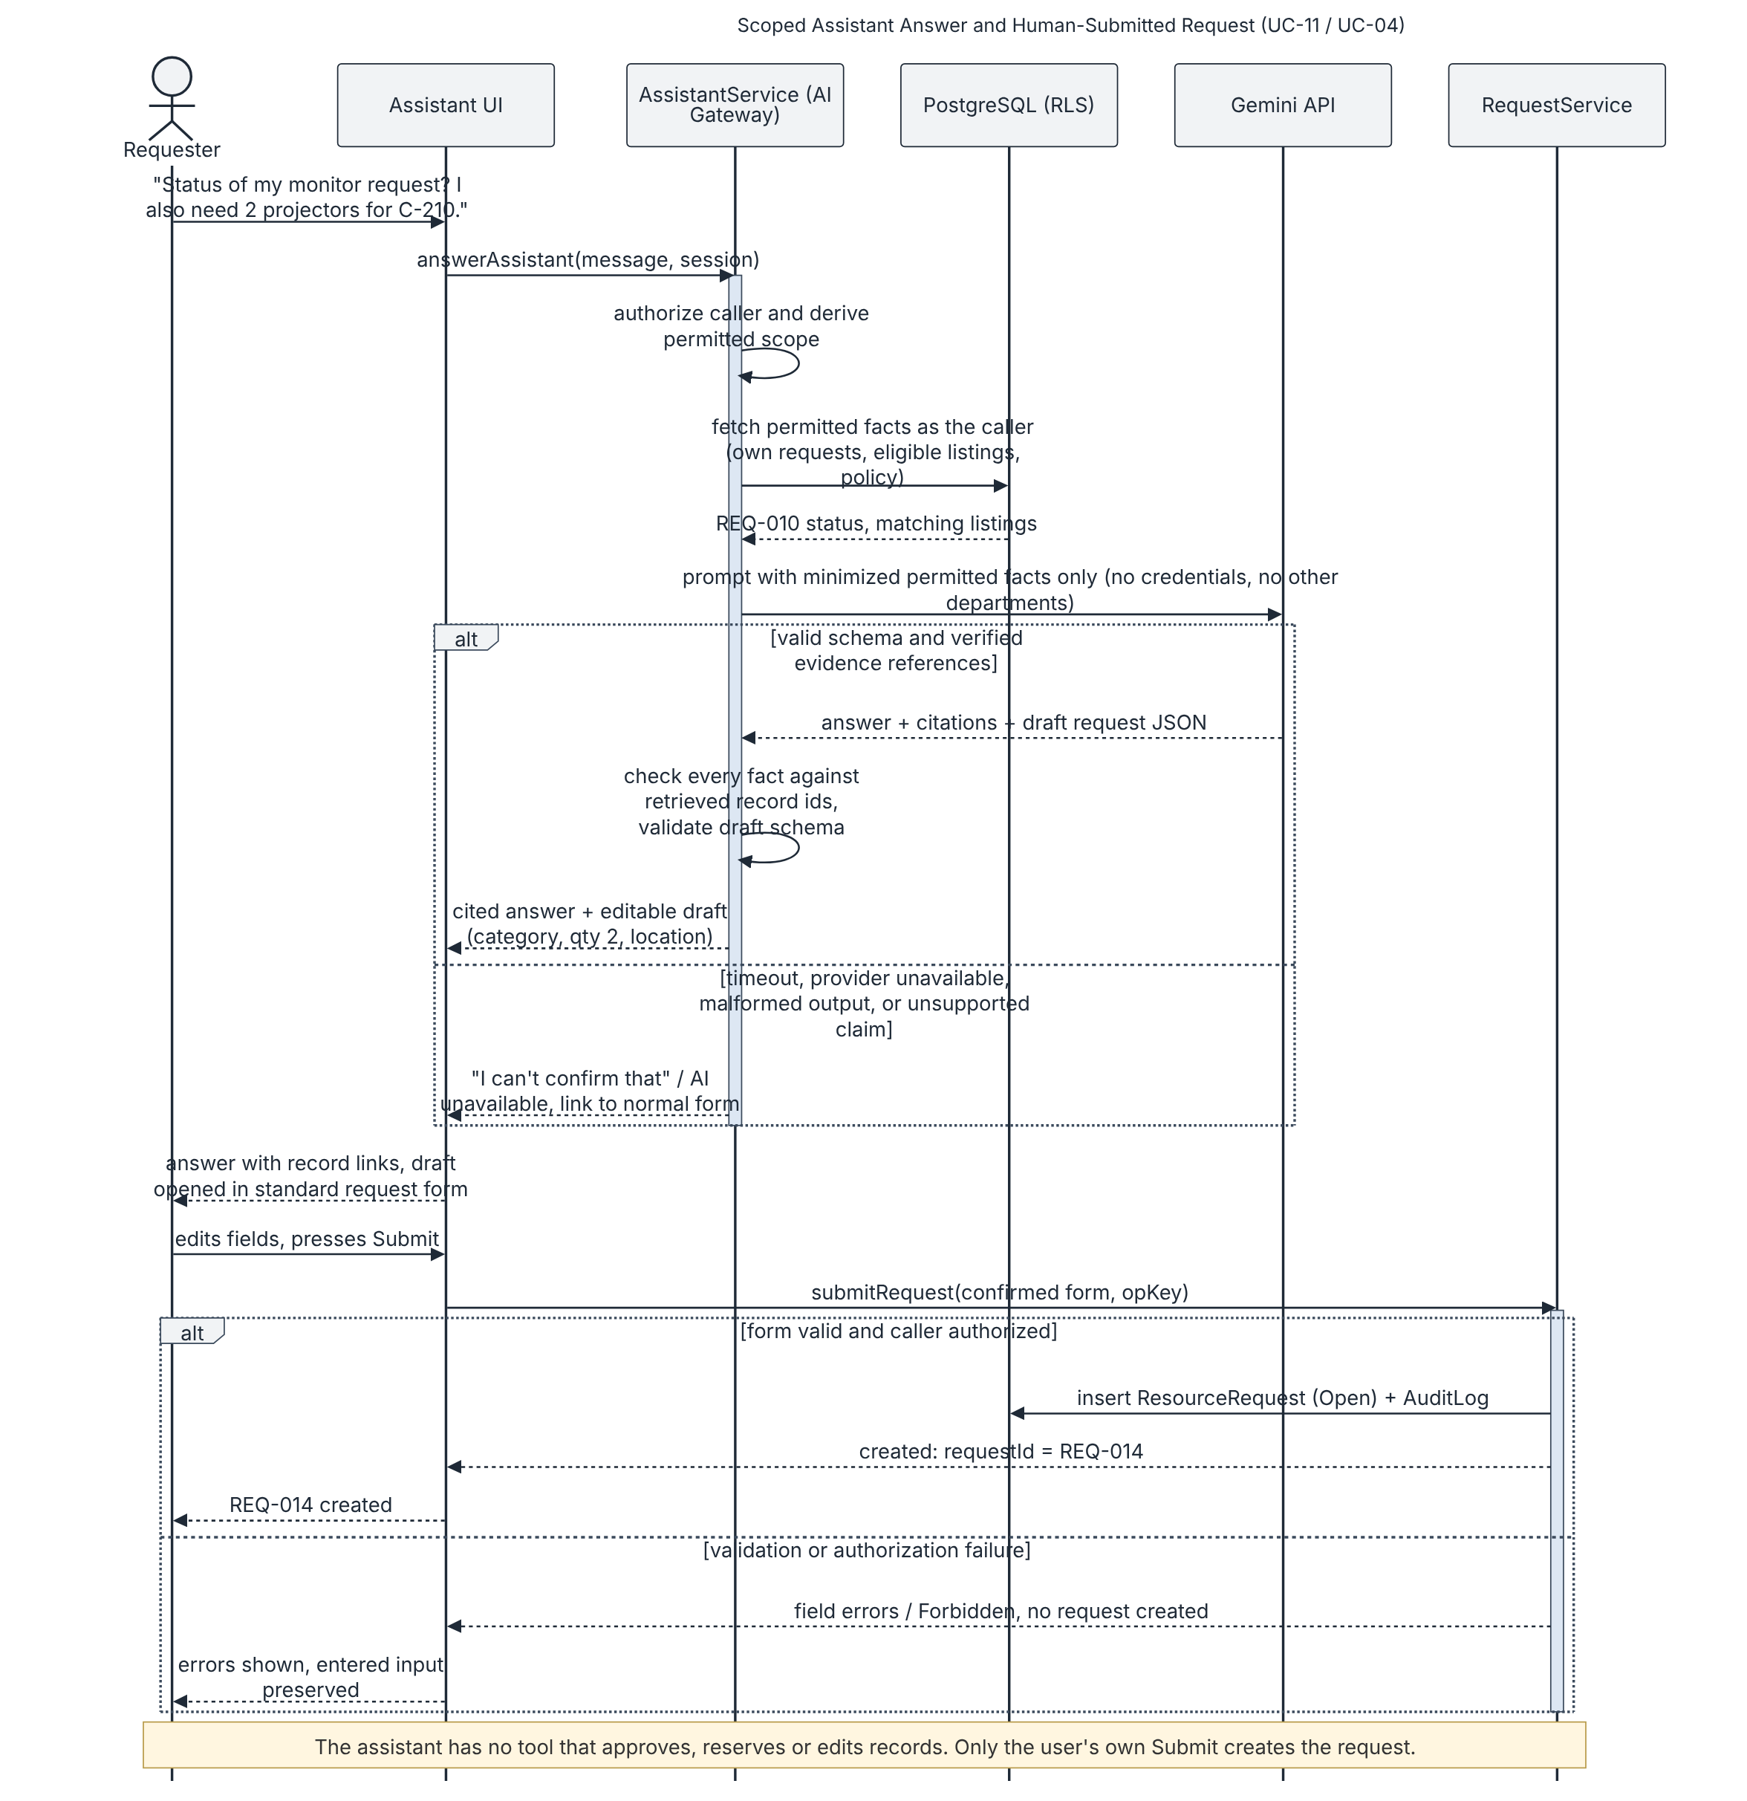
Figure 19 Scoped assistant response and normal request submission
UC-11/04. The assistant answers only from caller-permitted facts and returns an editable request draft. The person reviews and submits it through the standard form; only that submission creates a request. Unsupported or unavailable answers provide a lack-of-evidence response and a conventional workflow link. The assistant cannot approve or reserve.

9.5 Exchange Activity
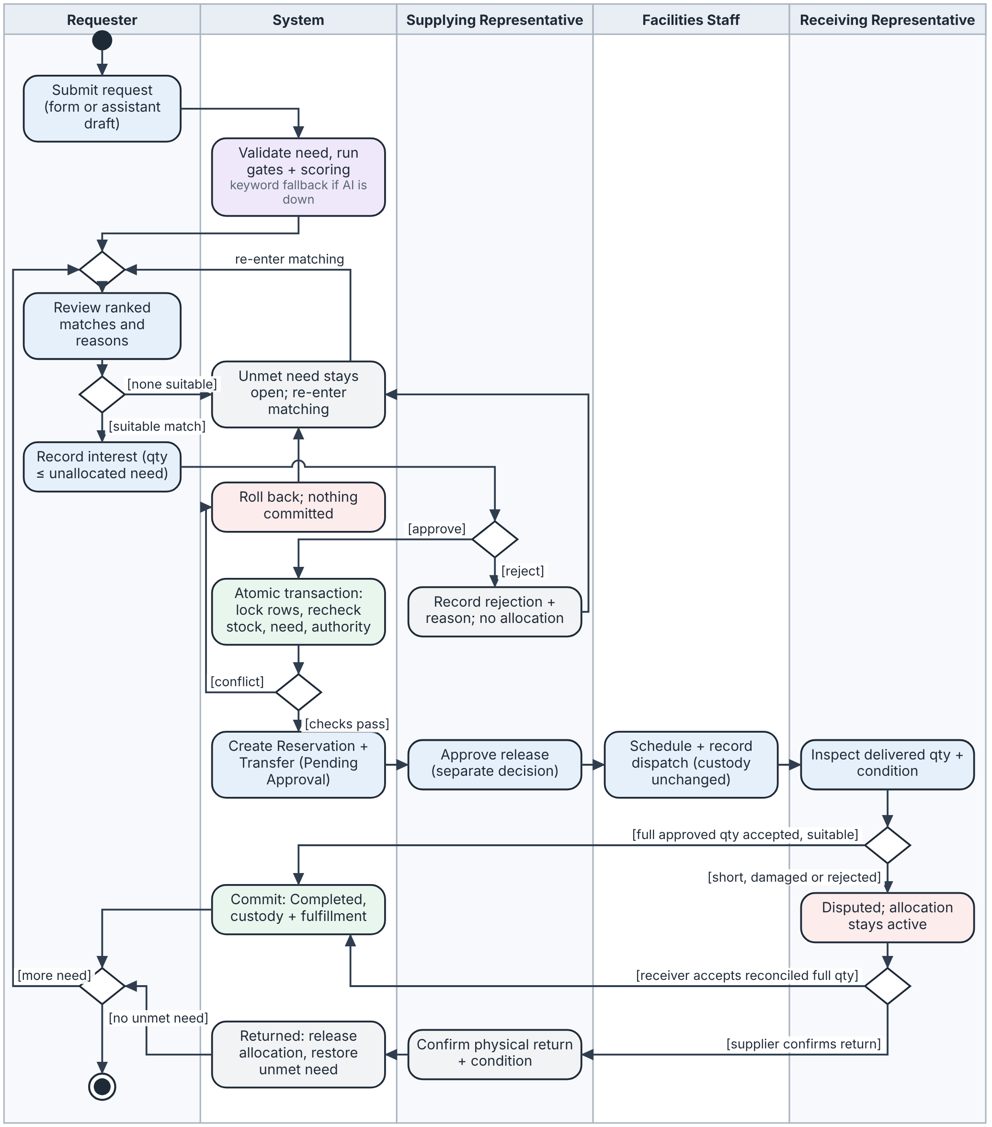
Figure 20 Exchange activity from request to accepted receipt
A rejected reservation leaves the request’s unallocated need open. After reservation approval, the supplying representative separately approves release before Facilities Staff schedules and records dispatch. Before-dispatch cancellation releases the allocation atomically; after dispatch, cancellation cannot restore stock until movement and custody are reconciled. Full suitable receipt completes the transfer. A short, damaged or disputed receipt remains open and unavailable until reconciled acceptance or supplier-confirmed return; unresolved loss remains an exception. After completion, any remaining unallocated need stays active.

9.6 AI Recommendation Workflows
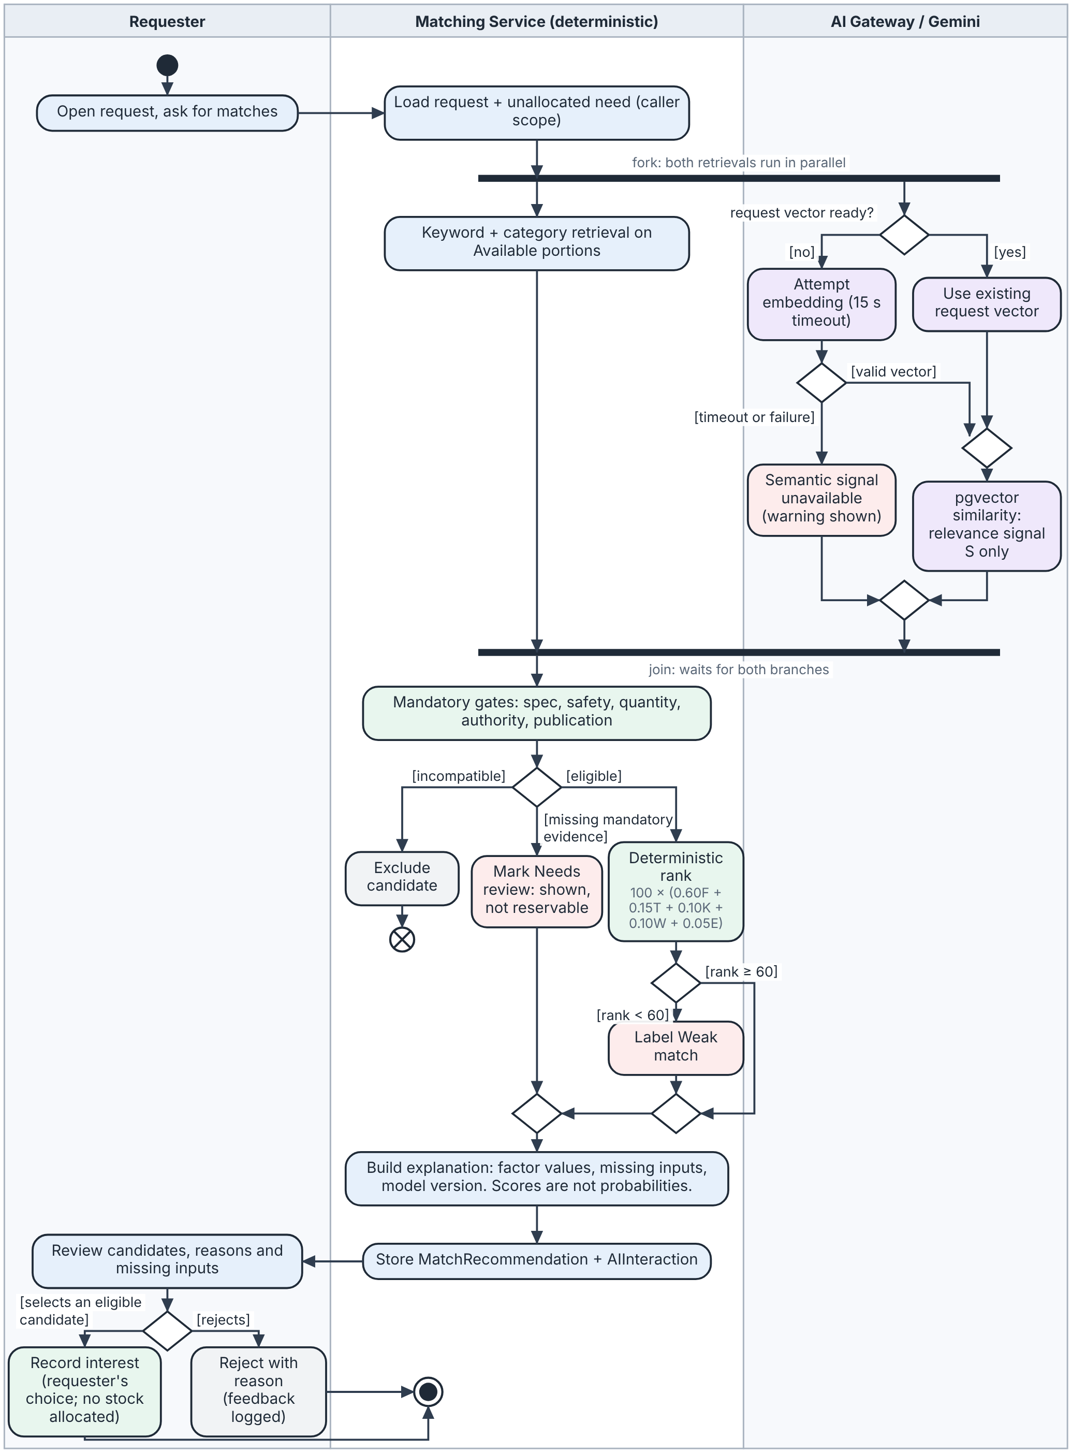
Figure 21a AI recommendation workflow: matching, confidence handling and human decision
This is the AI recommendation workflow required by the brief. Keyword retrieval and vector retrieval run in parallel; if the embedding call fails or times out, the keyword branch continues alone and the semantic signal is shown as unavailable. Mandatory gates run before any score: a confirmed mismatch is excluded, and missing mandatory evidence is marked Needs review and blocks reservation. A rank below 60 is labelled Weak match rather than hidden. Only the requester's selection records an interest; no score allocates stock.
Semantic retrieval contributes a relevance signal only; deterministic mandatory checks determine eligibility, and the documented deterministic calculation determines suitability and rank. Scores are ranking values, not probabilities. A Needs review result is not selectable for reservation; the request remains open for more evidence or conventional search.
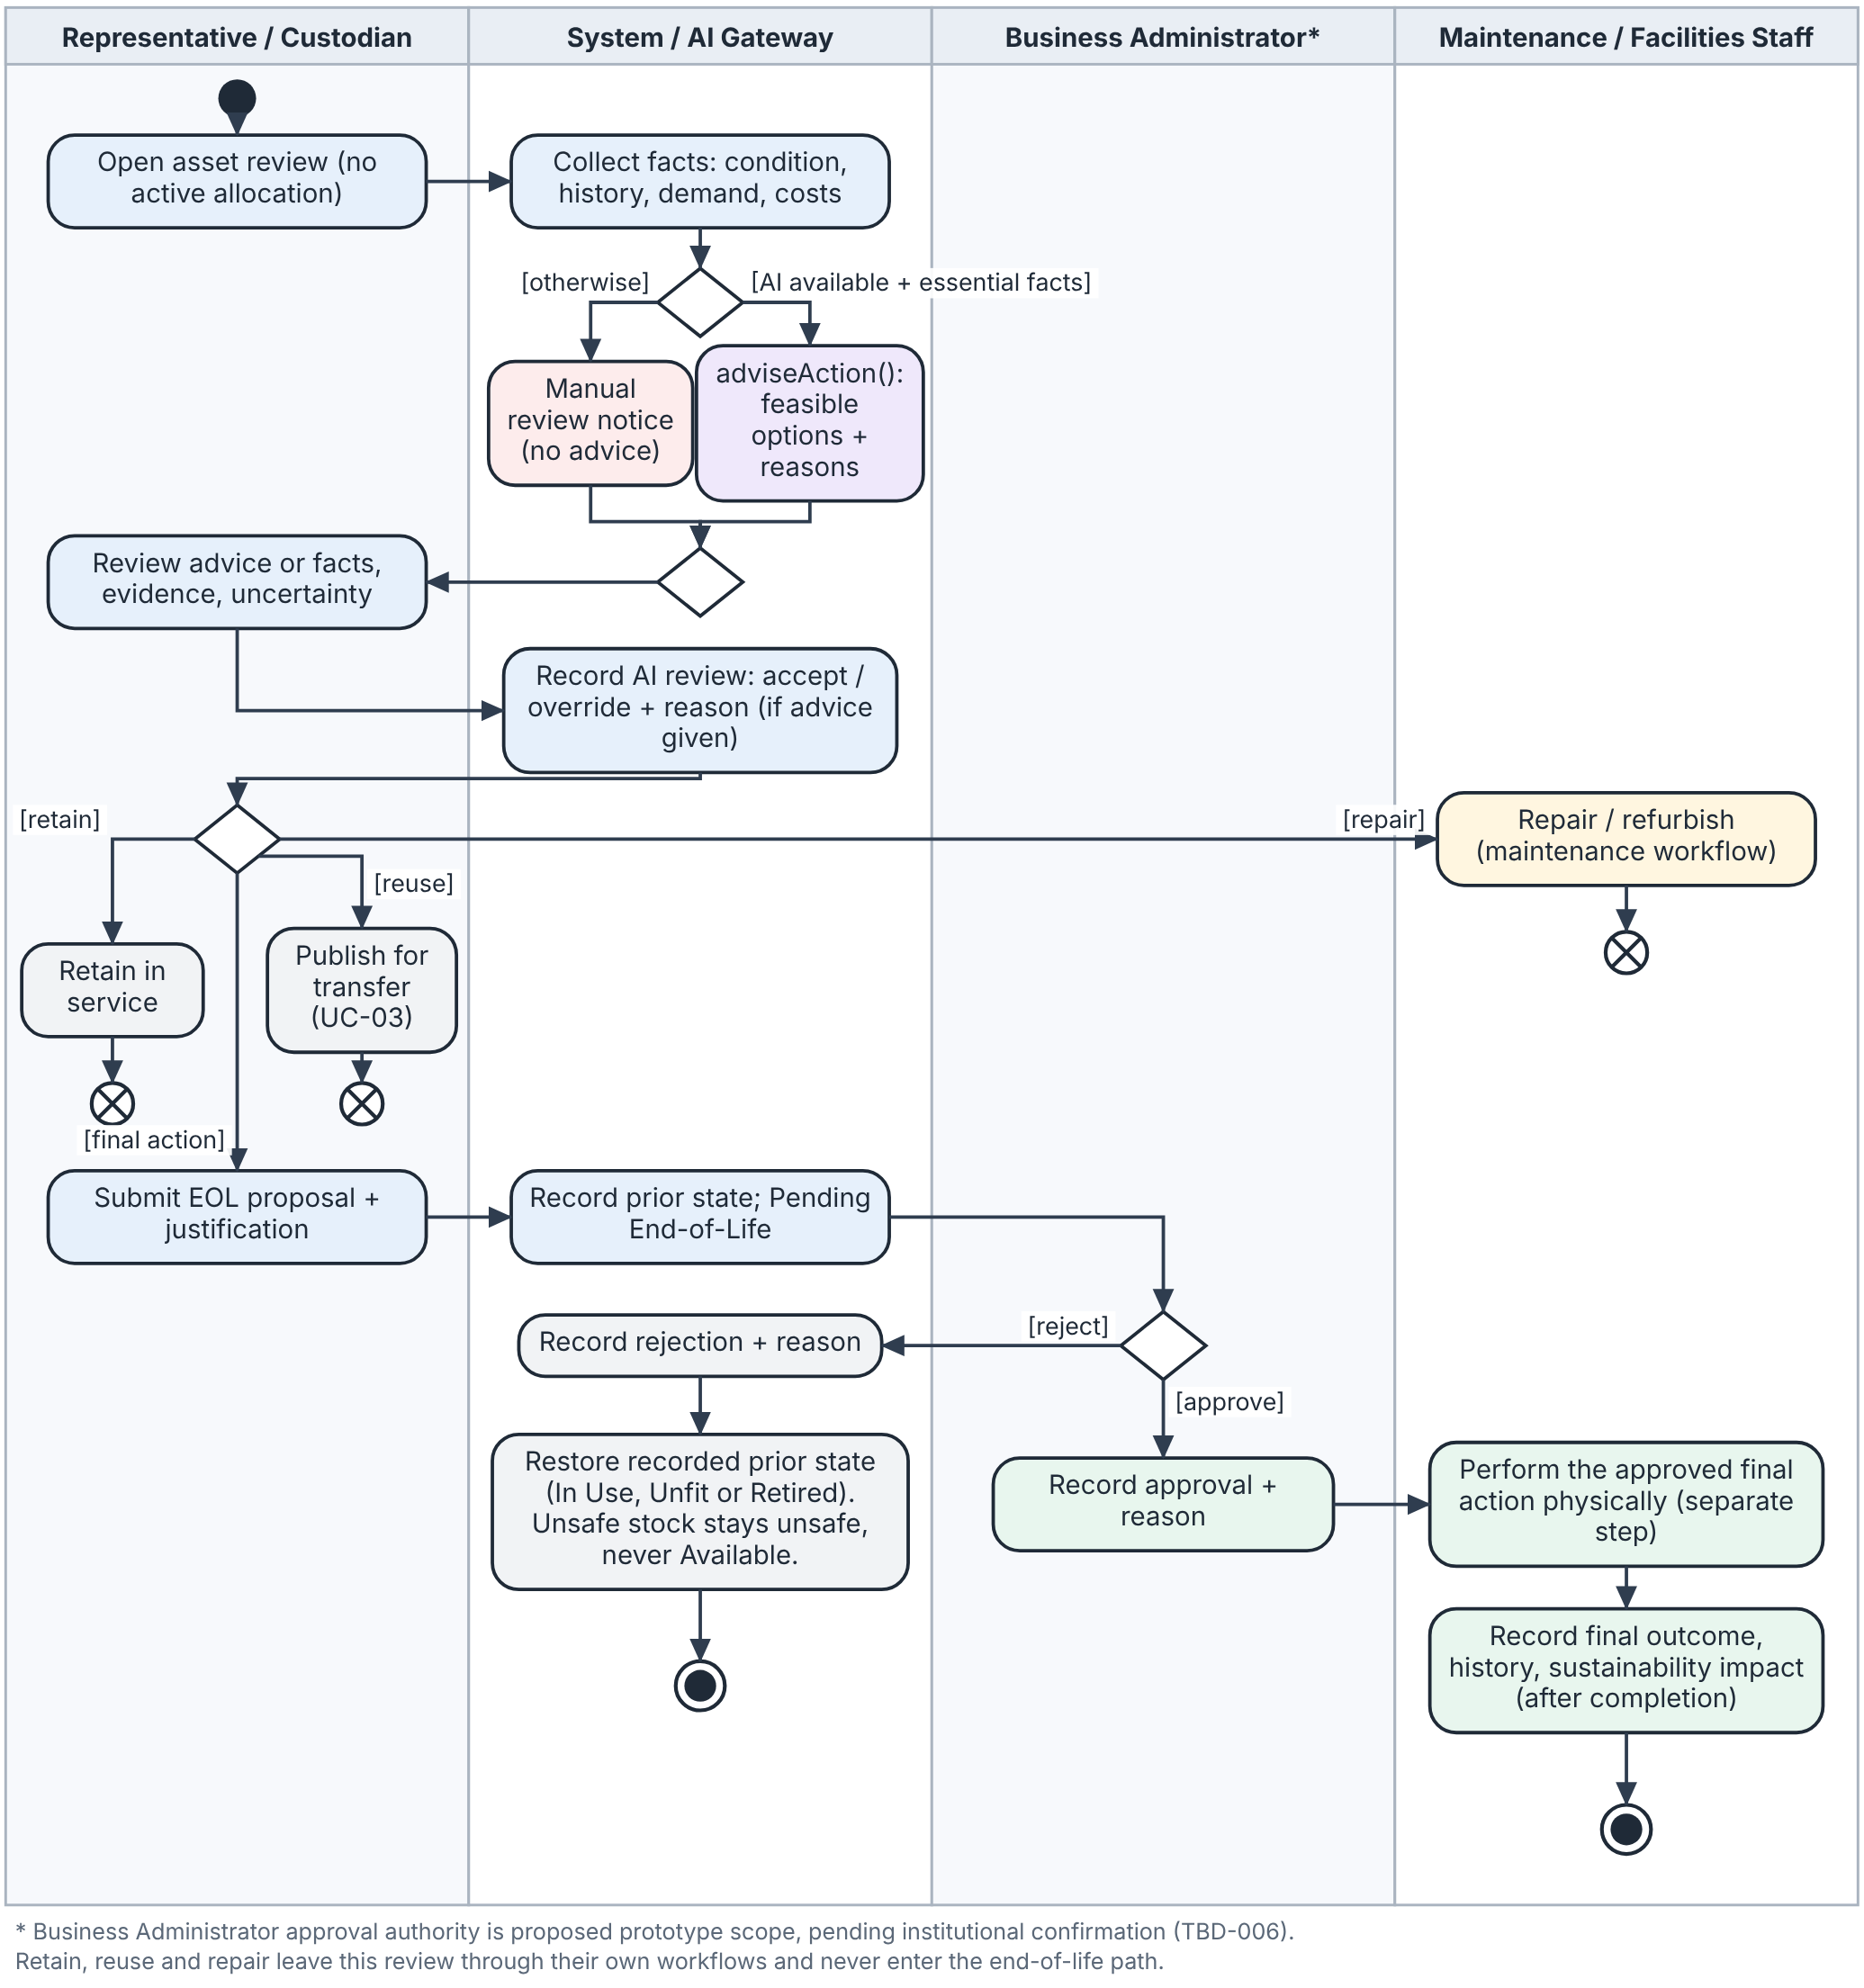
Figure 21b Sustainable-action recommendation through human approval
Missing essential evidence or unavailable AI produces a reasoned manual-review path. Retain, repair and transfer enter their respective workflows; none falls through to disposal. An EOL proposal requires an authorized human decision under the proposed prototype role scope; institutional delegation remains TBD-006. Record approval or rejection and its reason separately from performance of the action. Rejection restores the recorded prior state but does not establish that an unsafe item is usable; approved final action is recorded only after authorized physical completion.

9.7 Asset State Model
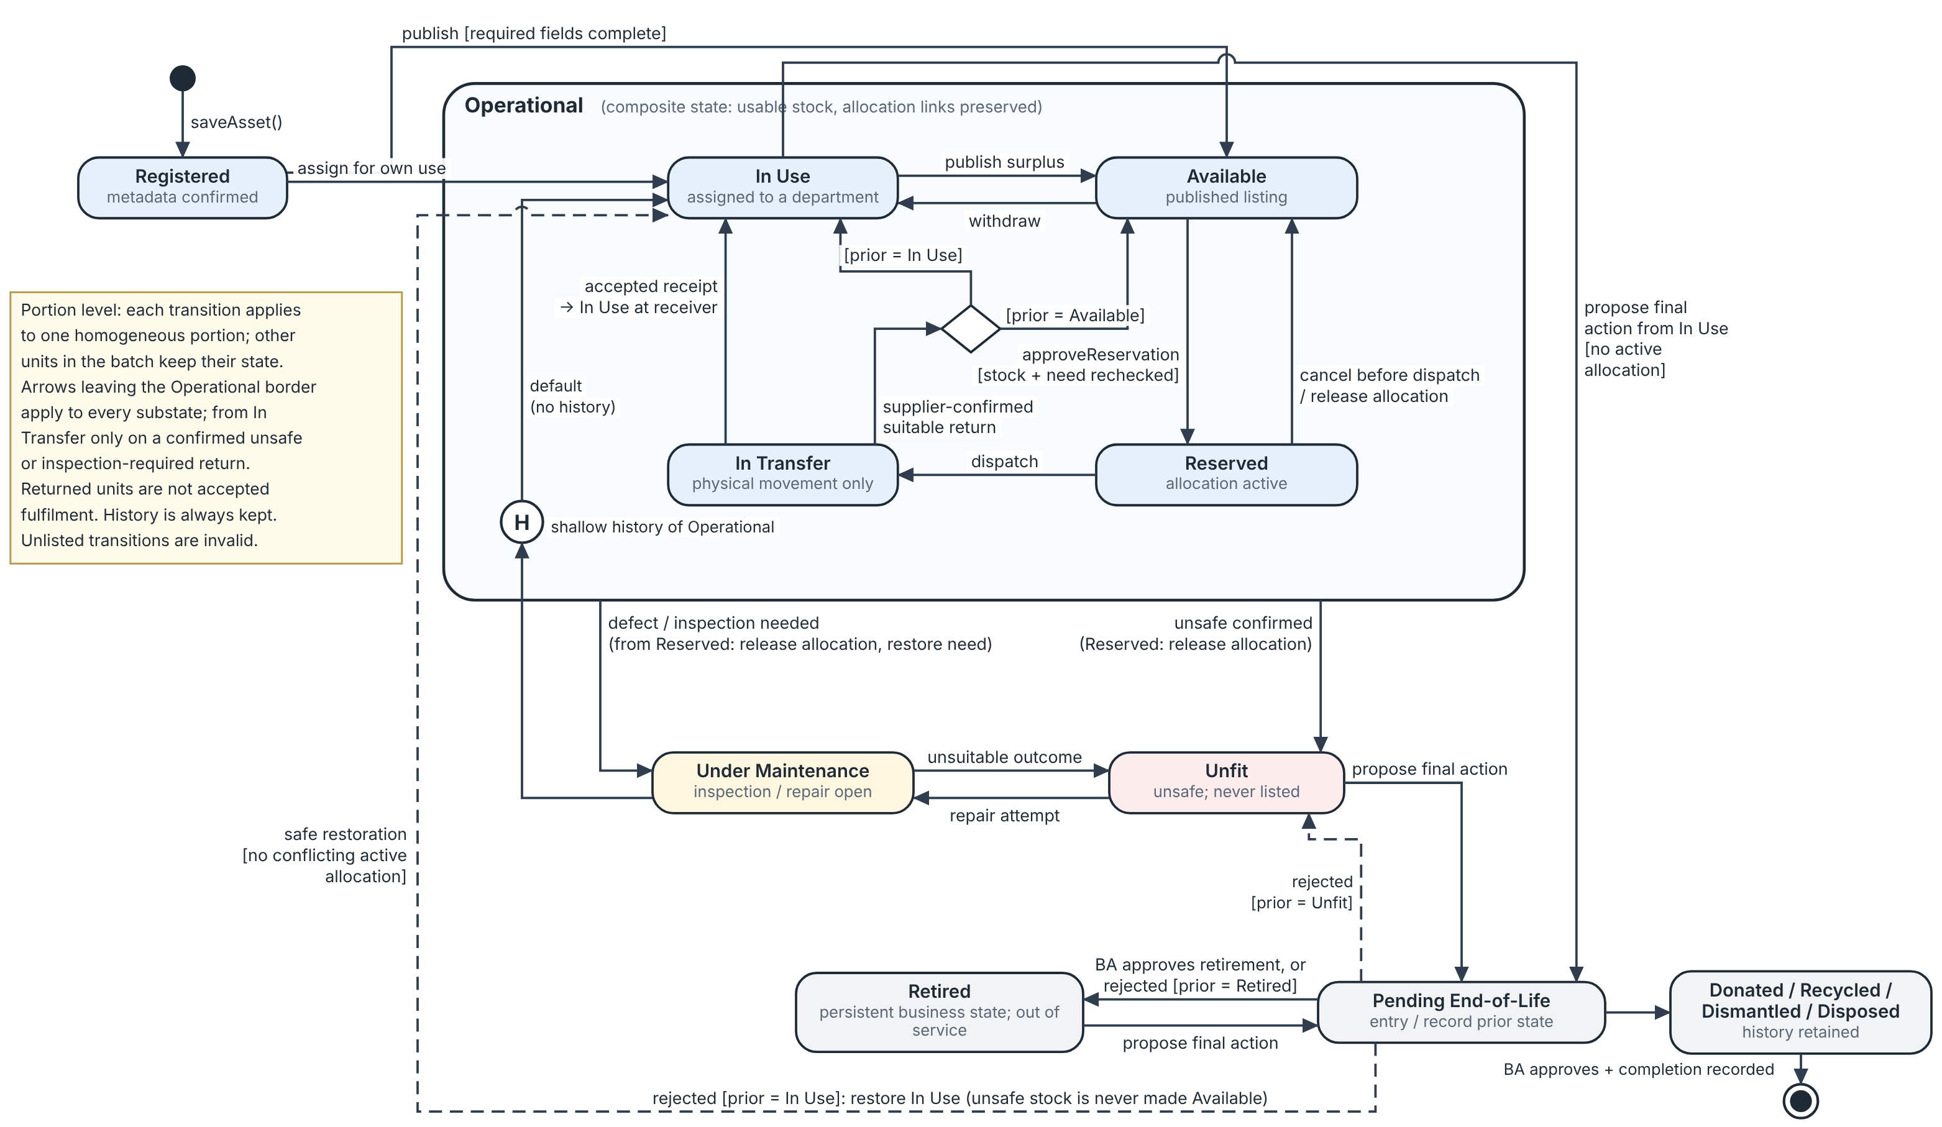
Figure 22 Asset or homogeneous portion state transitions
Figure 22 draws every SRS B.3.1 transition. Transitions leaving the Operational composite state apply to each of its substates; from In Transfer they occur only on a confirmed unsafe or inspection-required return. A reserved condition failure releases the allocation and restores unmet need. The history pseudostate H returns a safely restored portion to its recorded In Use or Available context without overriding another active allocation.
Pending End-of-Life rejection restores the recorded prior state; rejection from Unfit does not establish suitability. Accepted receipt moves the allocated portion to the receiving department’s In Use context only after receipt acceptance. A return from In Transfer restores stock to the supplier’s prior context only after supplier receipt is confirmed; an unsafe or inspection-required return instead enters Unfit or Under Maintenance. Final disposal outcomes retain history. Each transition applies to one portion, not every unit in a batch. In Figure 22, H denotes the history pseudo state for the Operational composite and restores the recorded In Use or Available substate only when no conflicting active allocation exists.

9.8 Request and Maintenance States
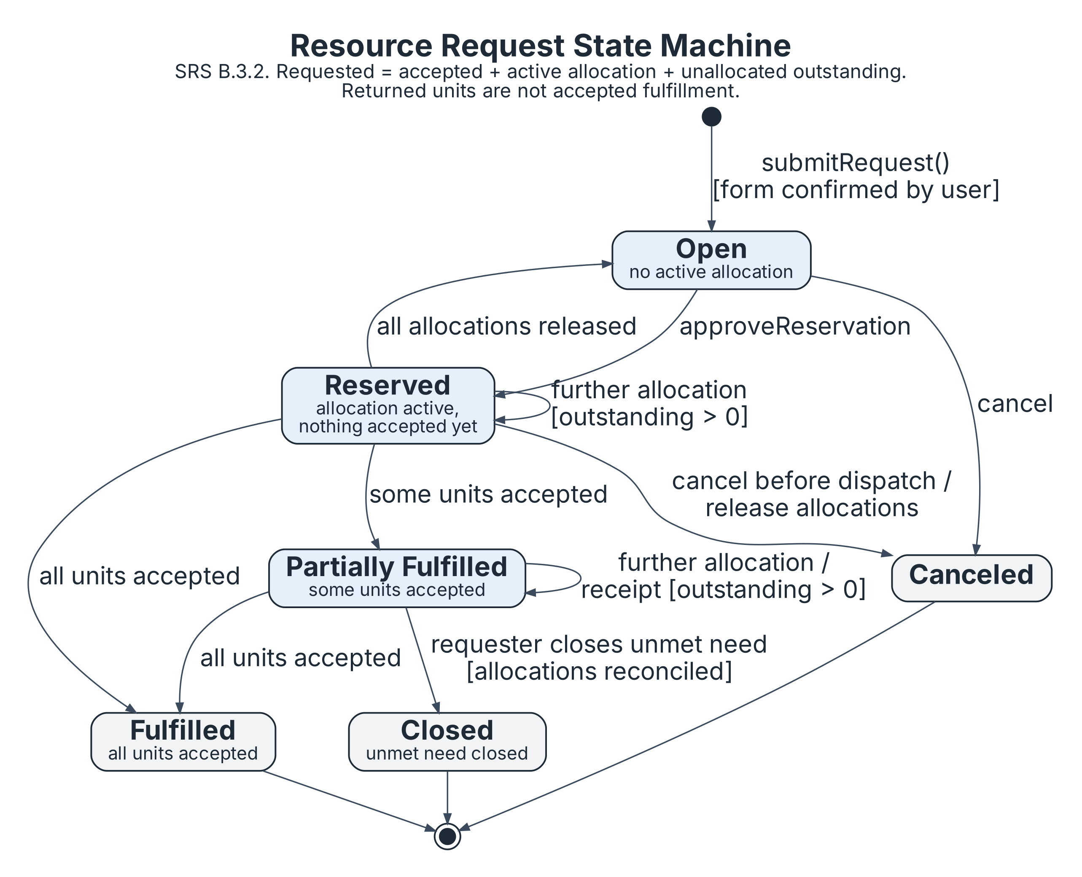
Figure 23 Request states
Reserved and Partially Fulfilled permit further eligible reservations while unallocated outstanding need remains. Request state reflects accepted fulfillment and all active allocations: releasing one allocation does not reopen the request if another remains active. Full acceptance of all requested units gives Fulfilled; explicit closure of unmet need gives Closed. Cancel only after allocations and any movement are reconciled. Returned units are not accepted fulfillment.
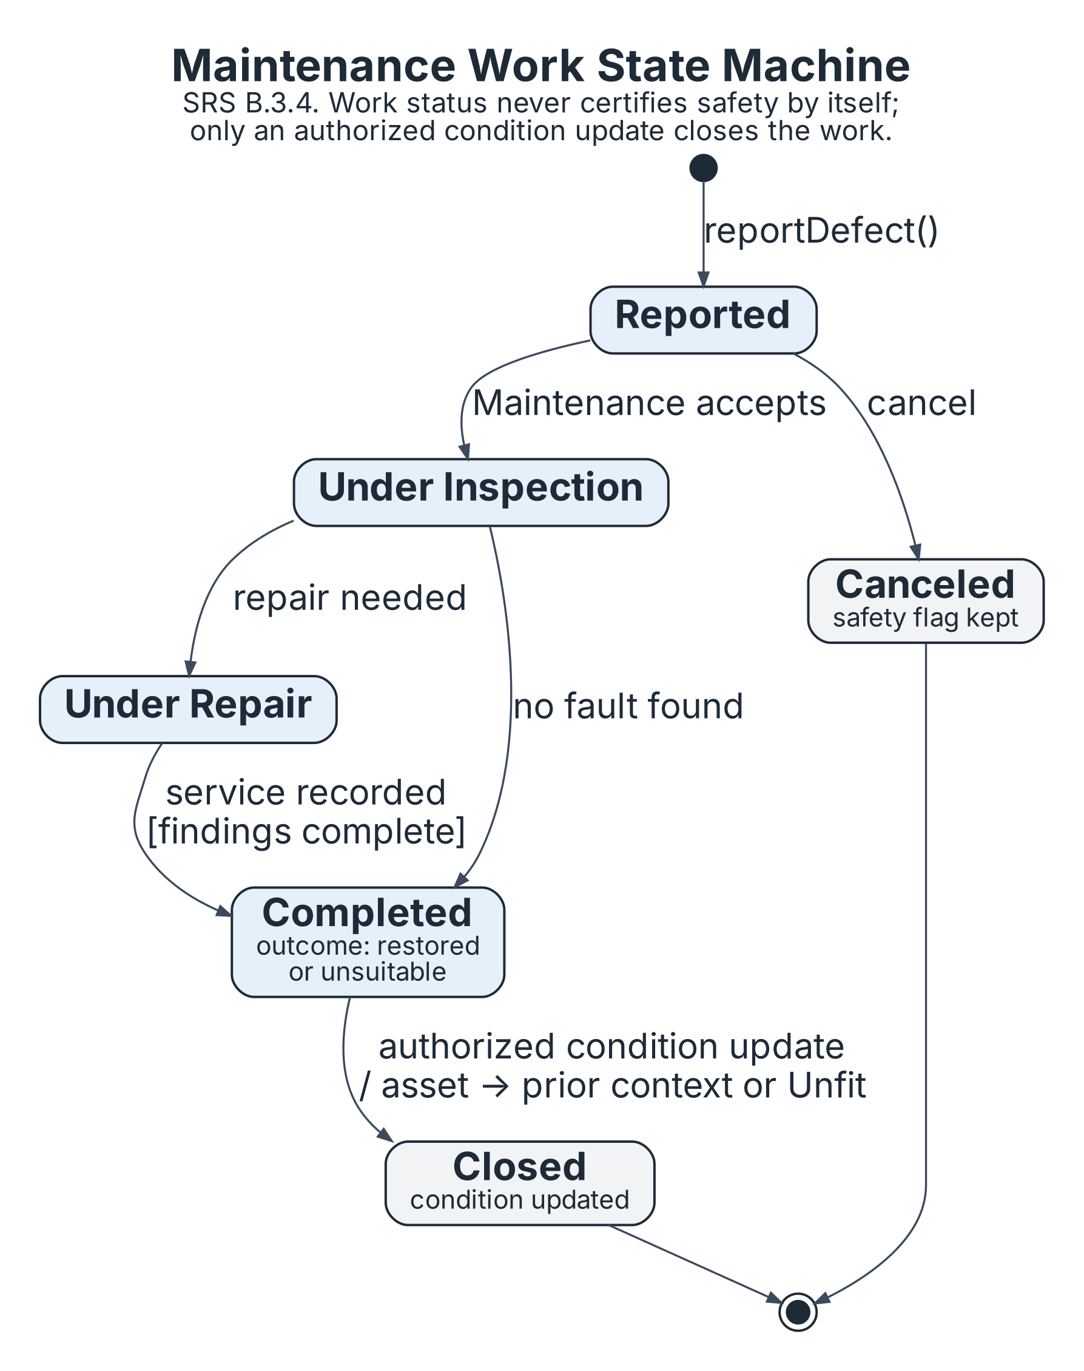
Figure 24 Maintenance work states
No-fault inspection may complete without repair. Completed work records its assessed outcome; only an authorized condition update closes the work, and that update does not override an active allocation or make unsuitable stock available. Canceling a work order does not clear an unsafe assessment. Closed and Canceled retain history.

9.9 Transfer and Approval States
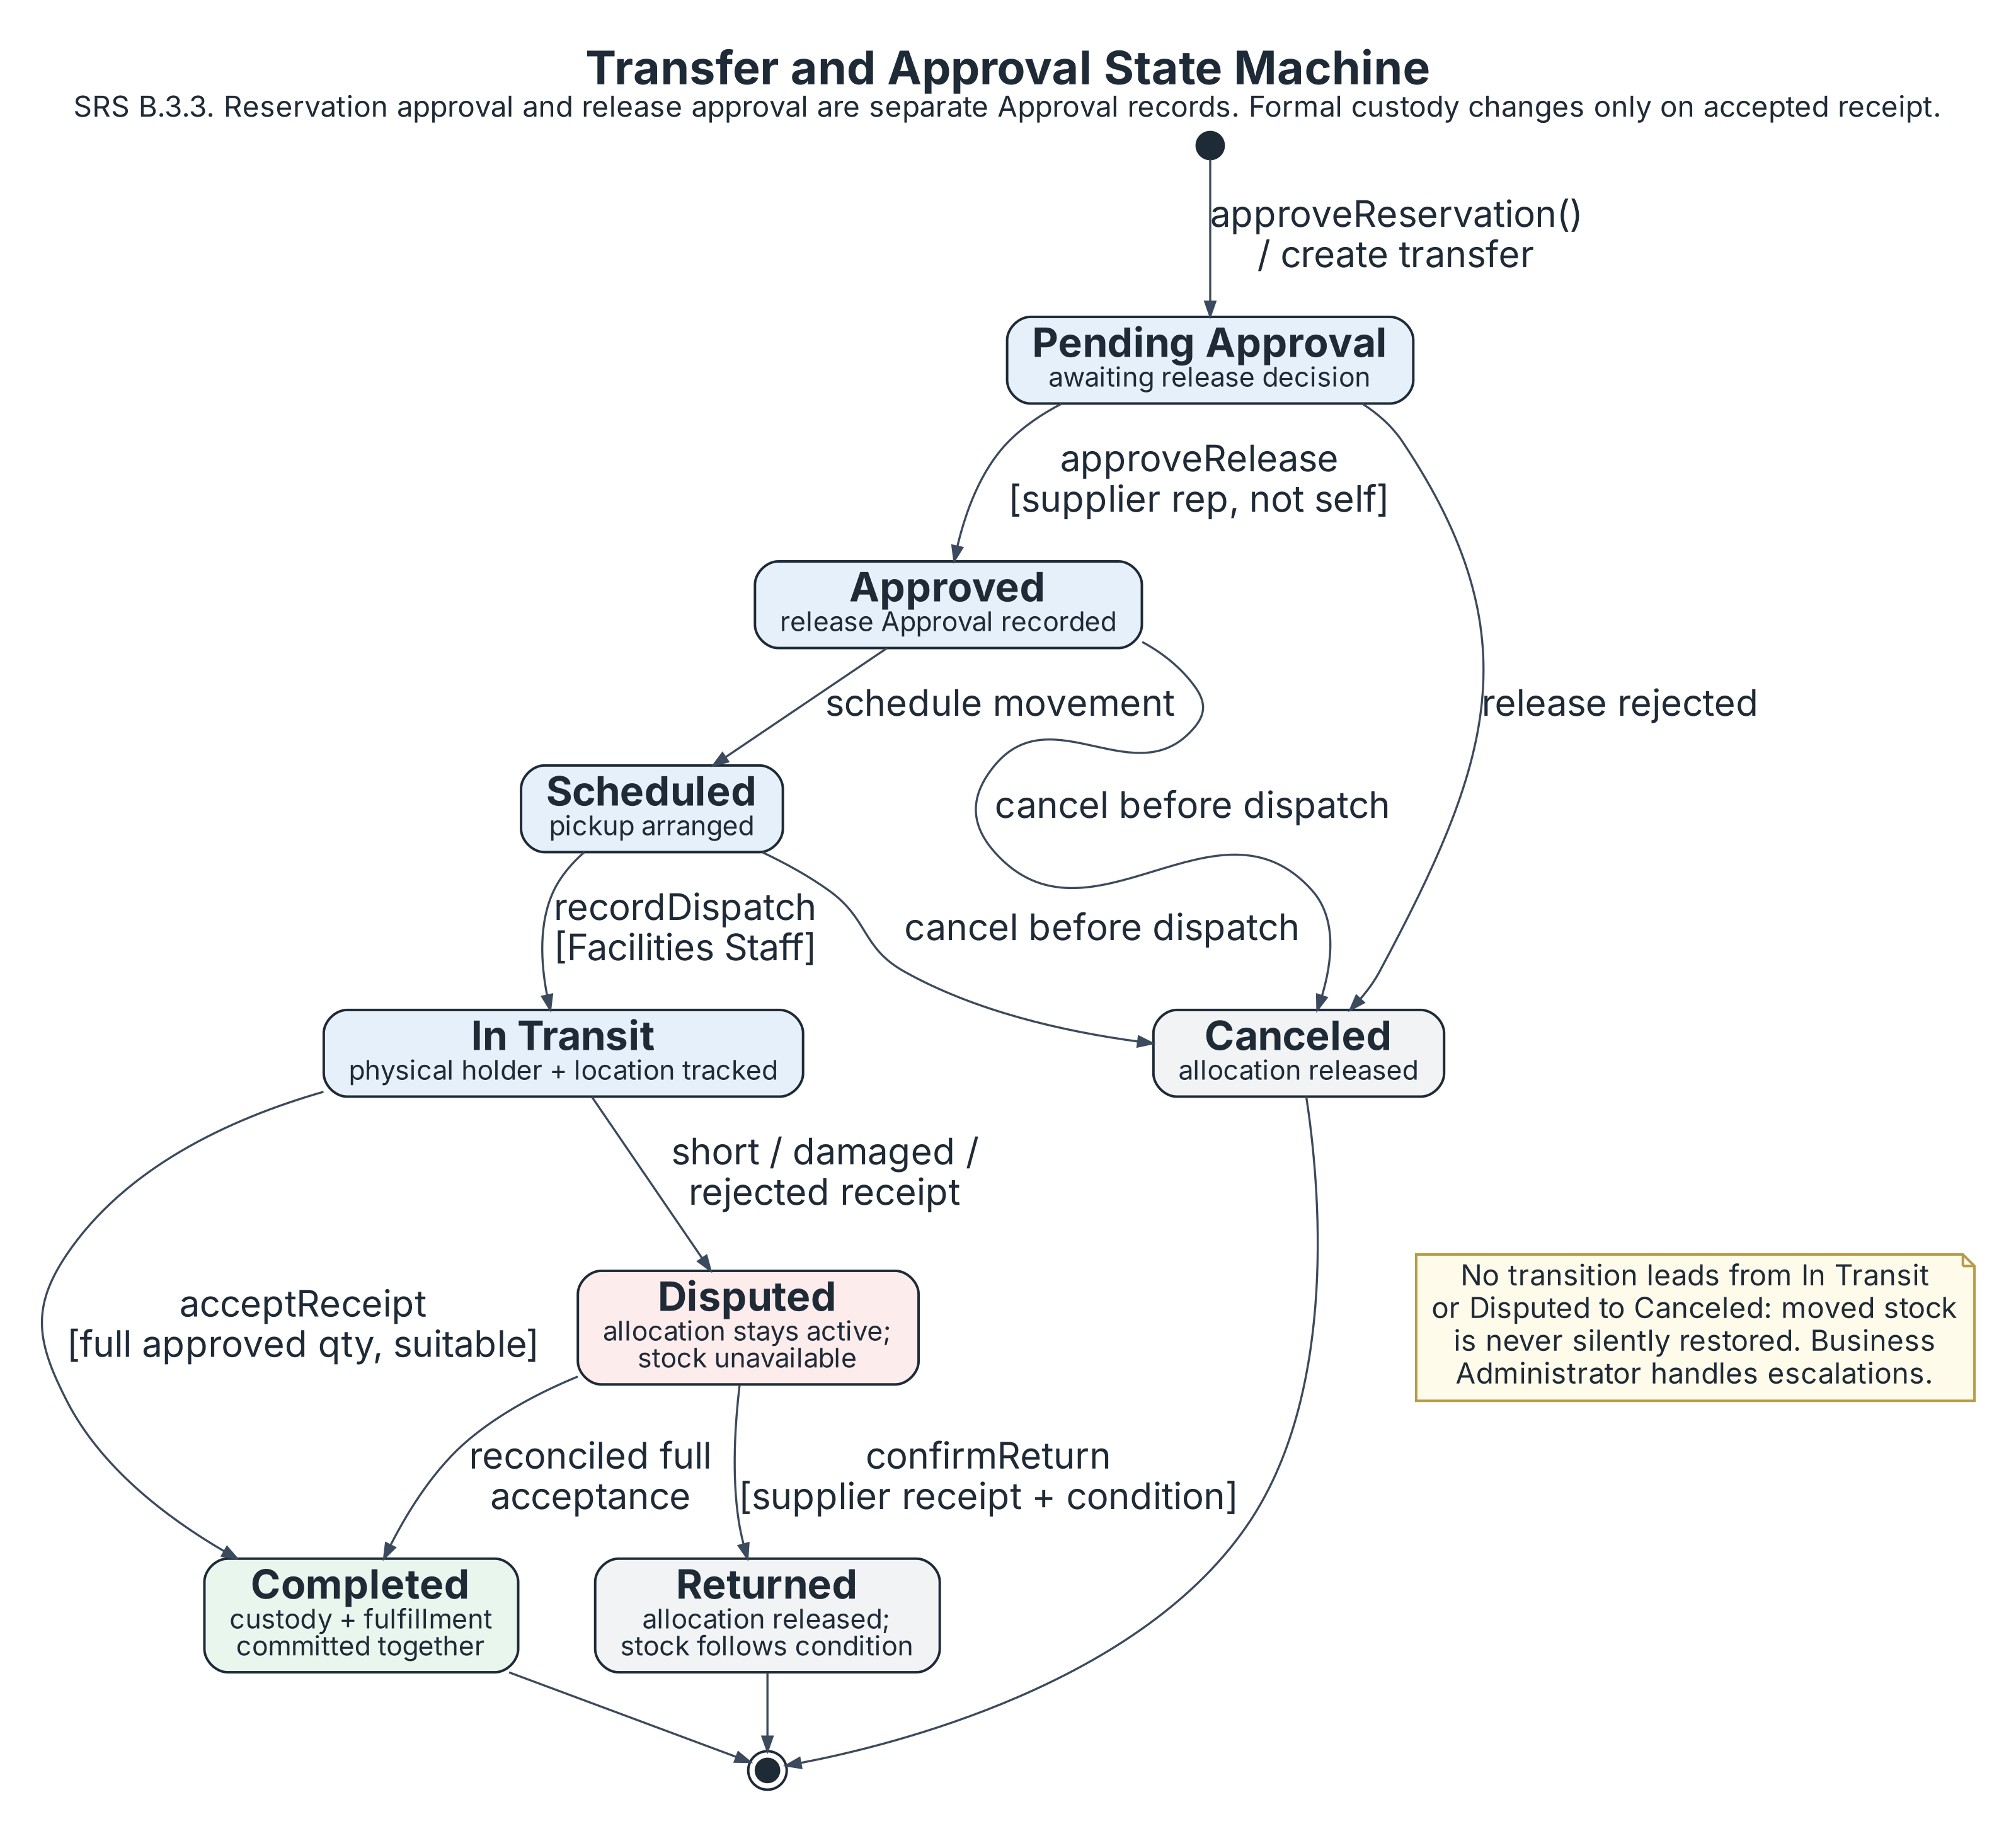
Figure 25 Transfer states and approval guards
Figure 25 begins after reservation approval has created the transfer; reservation rejection remains a separate decision that creates no transfer. Pending Approval is the transfer-release decision. Reservation approval and release approval are separate retained decision types, even when a permitted Should refinement combines their user interaction. Rejection/cancellation before dispatch releases allocation atomically. No path from In Transit directly to Canceled restores stock.
Disputed remains open and unavailable. The receiving representative’s accepted, reconciled receipt of the full approved quantity completes the transfer, formal assignment and request fulfillment together. Supplier-confirmed return releases allocation and restores remaining need; stock condition controls whether it becomes Available/In Use or remains unsafe. Terminal transfer states retain history.

10 Database Design

10.1 Exchange and Catalogue Entities
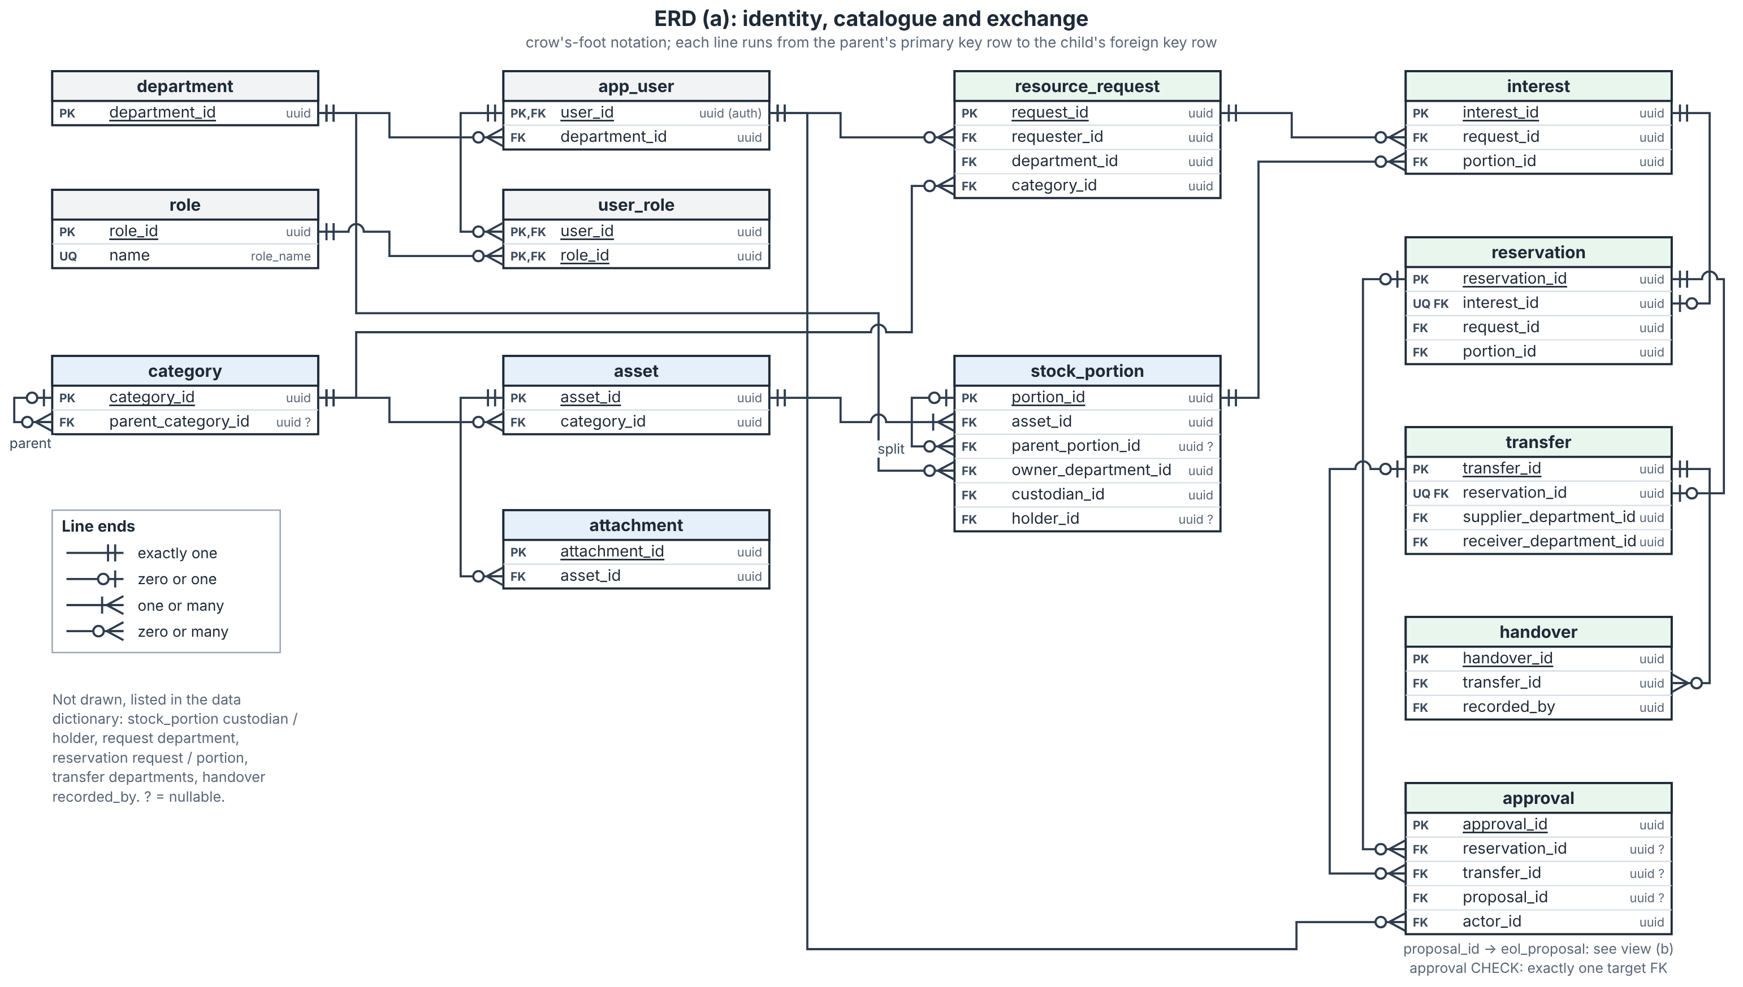
Figure 26a Identity, catalogue and exchange entities (crow's-foot notation)

10.2 Life-Cycle, AI and Audit Entities
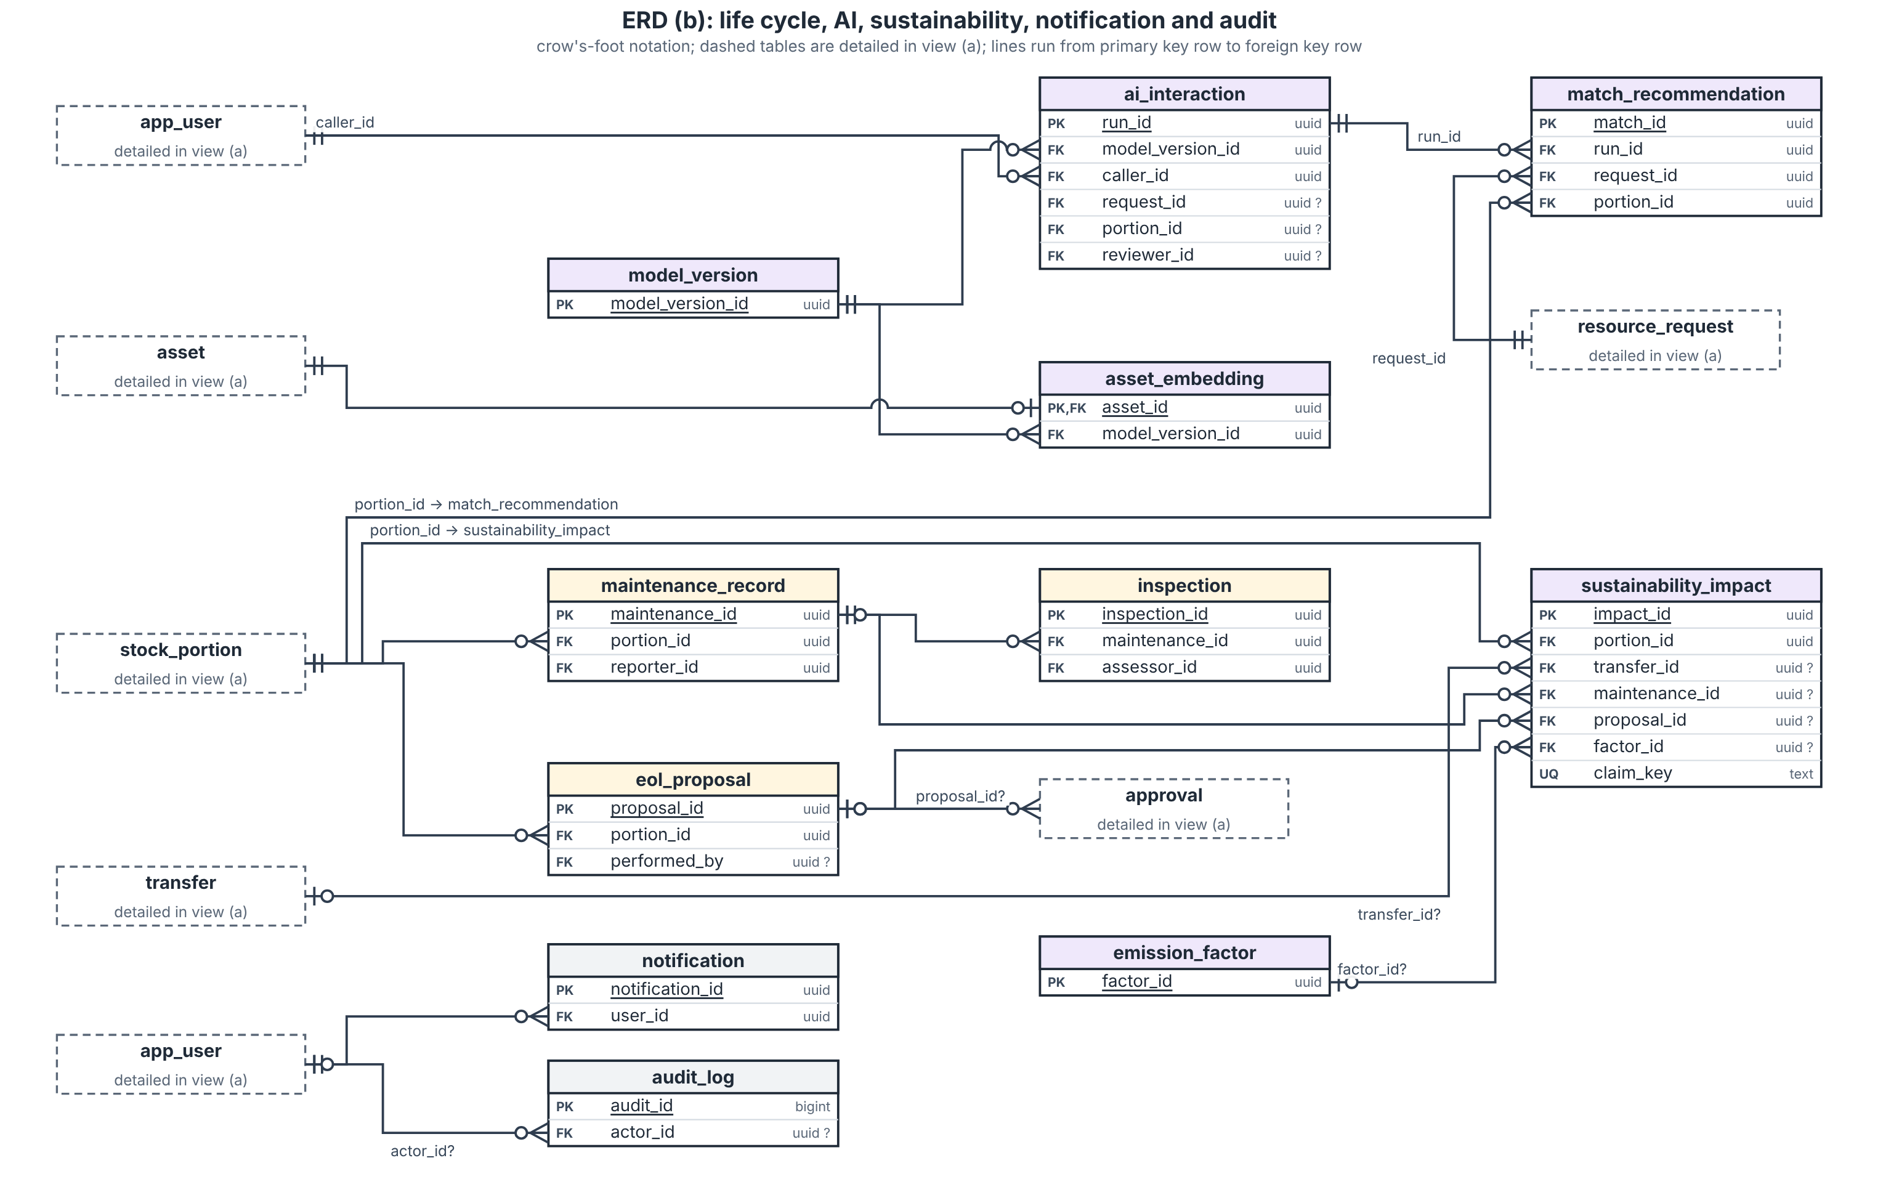
Figure 26b Life-cycle, AI, sustainability, notification and audit entities
Figures 26a and 26b are two views of one relational model; dashed entities in 26b are tables detailed in 26a. Each view shows primary, foreign and unique keys; every column and constraint is listed in the data dictionary. A reservation has at most one transfer through a unique foreign key, and UserRole implements many role assignments. Shared role labels do not grant a common report scope. Each request belongs to one requester and department.
Cross-view links: Attachment, StockPortion, MaintenanceRecord and EndOfLifeProposal refer to Asset/portion; AIInteraction identifies its caller and optional request or portion; each MatchRecommendation links one request, one portion and one AIInteraction run. SustainabilityImpact keeps a qualifying source outcome and factor snapshot. Notification targets are resolved through authorized application access, not exposed as unrestricted URLs.

10.3 Core Data Dictionary
Entity / keys | Principal fields | Meaning and constraint
Department | departmentId PK; name | Organizational scope; no deletion while referenced.
User | userId PK/Auth FK; departmentId FK; name; active | One current department; assigned roles are separate.
Role / UserRole | roleId PK; name / (userId FK, roleId FK) PK | Nine human role classes; many assignments per user.
Category | categoryId PK; parentCategoryId FK?; name | Parent links subcategory; no artificial asset subclasses required.
Asset | assetId PK; categoryId FK; metadata; trackingMode; totalQty; purchaseDate; unitValue | Shared identity/specifications. Quantity ownership/state live on leaf portions.
StockPortion | portionId PK; assetId FK; parentPortionId FK?; qty; active; state; condition; ownerDepartmentId FK; custodianId FK; assignedLocation; holderId FK?; physicalLocation; priorState | Active leaf portions sum to asset total. Individual tracking has quantity one.
ResourceRequest | requestId PK; requesterId FK; departmentId FK; categoryId FK; requestedQty; status; specifications; condition; urgency; requiredDate; destination; purchaseBasis | Accepted/allocated/outstanding are computed from reconciled records, not editable totals.
Interest | interestId PK; requestId FK; portionId FK; qty; submittedAt; status | Selection only. Submission order supports fairness; no stock allocation.
Reservation | reservationId PK; interestId FK; requestId FK; portionId FK; qty; status | One approved allocation. The request and portion must match the referenced Interest; enforce this through a composite foreign key or equivalent transactional constraint. The reservation transaction checks both eligible stock and unallocated outstanding demand.
Transfer | transferId PK; reservationId FK UNIQUE; supplierDepartmentId FK; receiverDepartmentId FK; approvedQty; state; version; handlingCost | One tracked asset/portion per transfer. No multi-asset transfer engine.
Approval | approvalId PK; reservationId FK?; transferId FK?; proposalId FK?; actorId FK; decisionType; decision; reason; time | Exactly one target FK is present. Distinct approval types remain separate records.
Handover | handoverId PK; transferId FK; recordedBy FK; type; qty; condition; accepted; holderId FK?; location; time | Dispatch, receiver observation and confirmed supplier return are retained separately.

Portion and allocation invariants
For each stock portion and request, the total quantity in active allocations cannot exceed currently eligible, unallocated portion quantity or the request’s unallocated outstanding demand, and reservation approval checks both atomically. In-transit, disputed, or otherwise unresolved quantities remain allocated and unavailable.
Only active leaf portions count toward current stock; closed parents remain for lineage and are not counted. Splitting closes the parent and creates active children whose quantities sum to the parent quantity. At every committed state, active leaf quantities sum to the asset’s recorded total, with no unit counted in more than one active portion. An allocation withholds quantity from ordinary availability but does not change formal departmental assignment. Dispatch changes physical tracking only. On accepted receipt, the transferred quantity is removed from the supplier’s active quantity and assigned to a receiving-department portion; any remainder stays with the supplier. In-transit or disputed quantity remains allocated and unavailable until reconciled acceptance or supplier-confirmed return. Return releases allocation only after confirmed receipt, and condition determines whether the returned stock is usable. Individually tracked assets have quantity one.

10.4 Supporting Data Dictionary
Entity / keys | Principal fields | Meaning and constraint
Attachment | attachmentId PK; assetId FK; objectKey; mimeType; name; checksum | Private object storage; download permission follows the asset.
MaintenanceRecord | maintenanceId PK; portionId FK; reporterId FK; status; serviceType; priorState; cost; outcome | Records reported work and its completion or outcome. Work completion does not establish suitable condition or availability; those require a separate authorized condition assessment.
Inspection | inspectionId PK; maintenanceId FK; assessorId FK; findings; suitable; evidence; assessedAt | Explicit condition assessment permits return to service.
EndOfLifeProposal | proposalId PK; portionId FK; priorState; action; justification; status; performedBy FK?; completedAt? | Records a proposed action and its status. Approval or rejection is retained as a separate decision; physical completion is recorded only after authorized approval and performance. Rejection restores the recorded prior state without clearing an unsafe condition.
ModelVersion | modelVersionId PK; provider; exposedModelId; configVersion; observedAt; revisionLimitation | Keep provider-visible identifier; do not invent an exact model revision.
AIInteraction | runId PK; modelVersionId FK; callerId FK; task; requestId FK?; portionId FK?; inputReferenceOrHash; status; result; uncertainty; reviewDecision?; reviewerId FK?; reason?; latency; callCount; tokens?; cost? | Proposed task-scoped provenance for minimized inputs and validated outputs. Distinguishes classification, matching, assistant, sustainability and report-drafting tasks. Retains the human review decision when one occurs. Usage and cost fields depend on provider availability; credentials and secrets are never stored.
AssetEmbedding | assetId PK/FK; modelVersionId FK; contentHash; vector; status | Ready/pending/failed. Invalidate on relevant metadata/model changes.
MatchRecommendation | matchId PK; runId FK; requestId FK; portionId FK; compatibility; rank; factors; missing; review | One request and one portion per recommendation; no authorization authority.
EmissionFactor | factorId PK; categoryMapping; sourceURL; sourceVersion; originalValue; originalUnit; normalizedValue; boundary | Source and unit conversion are retained with calculation snapshots.
SustainabilityImpact | impactId PK; portionId FK; transferId FK?; maintenanceId FK?; proposalId FK?; claimKey; cohort; metric; qty; result?; unit; inputs; factorId FK?; methodVersion; resultStatus; unavailableReason? | Proposed calculation snapshot with source, factor, inputs, units and method information. Records whether a result is available and why it is unavailable. A stored estimate is not a measured outcome.
Notification | notificationId PK; userId FK; eventKey; targetType; targetId; requiredAction; readAt? | Unique (userId, eventKey). The target is a proposed polymorphic reference rather than an ordinary foreign key; validate the target type and identifier and recheck recipient authorization whenever it is resolved.
AuditLog | auditId PK; actorId FK?; event; targetType; targetId; time; before; after; correlationId | Append-only to ordinary roles. Retain the responsible human identity or an explicitly identified system actor. Validate polymorphic targets and restrict access to the affected record’s authorized scope.
The rows identify proposed keys and relationships; conditional and cross-record invariants may require transactional validation rather than ordinary foreign-key constraints. Approval has exactly one non-null reservation, transfer, or proposal target. Active allocation quantities are checked against both eligible portion stock and unallocated outstanding request demand. Polymorphic notification and audit targets require explicit target validation and authorization. Costs use fixed-decimal values with currency; quantities, mass, dates and timestamps use stated units or time bases. Category, method and model identifiers should be documented as controlled values if adopted. These are proposed schema and integrity choices, not additional SRS policy.11 Interface Contracts
Protected operations receive the authenticated caller, target record, expected version and operation key where retry could duplicate a mutation. Return a typed outcome and current record/version; never trust a role/department supplied only by the browser. Error categories are Unauthorized, Forbidden, Validation, Conflict, NotFound and AIUnavailable. No partial mutation survives a failed transaction.

11.1 Asset and Request Contracts
Operation / caller | Input and preconditions | Committed output / failure
saveAsset / publishAsset — Representative / Custodian | Asset metadata, ownership or department, custodian, location, positive quantity, declared availability, condition and permitted files. The caller must be authorized for the asset’s department. Publication requires all FR-ASSET-005 fields, valid values and no conflicting active reservation or transfer. Unknown condition is identified and is not evidence of transfer suitability. | Save confirmed asset data and an audit event. Publication exposes only eligible quantity. Validation errors identify fields and preserve entered input. Optional embedding runs after save and cannot undo it.
submitRequest  Requester / Rep | Category, purpose, specs, qty>0, condition, urgency, date, destination; user confirms form, including assistant draft. | Open request; no interest/reservation. Validation returns field errors without losing input.
recordInterest  Requester / Rep | Active request, selected portion and positive quantity; permission and current listing rechecked. | Linked Interest; no stock or demand allocation. Closed/fulfilled/canceled requests reject new interest.
approveReservation  Supplying Rep | Interest ID, approved quantity, expected version, operation key; no self-approval. Lock request and portion; check suitable available stock and outstanding need. | Reservation, allocated portion, Pending Approval transfer, decision, audit/event all commit. Conflict or unsafe state rolls back everything.

Transaction and retry rule
Lock affected request and stock rows in a consistent key order. Recompute accepted fulfillment and active allocations from authoritative records, then check the new quantity against both limits. Keep a unique operation key per caller/operation; replay returns the previous committed result. Never perform AI/network calls while the stock transaction holds locks.
FR-ASSET-001 to 008; FR-REQUEST-001 to 008; CI-001; NFR-QUAL-003; BR-003/005/006.

11.2 Movement Maintenance and Reporting Contracts
Operation / caller | Required input / guard | Result
approveRelease / recordDispatch  Supplying Rep / Facilities | Transfer ID/version; separate authorized release, suitable condition, approved quantity; assigned facilities records actual holder/location. | Approved -> Scheduled -> In Transit. Dispatch does not change formal departmental custody.
acceptReceipt — Receiving Representative / Custodian | Transfer ID and version; quantity actually received, observed condition, physical holder and location, and acceptance or discrepancy. Recheck authority and transfer state; use the same operation key on retry. | Record the receipt observation. Complete the transfer only when the full approved quantity is accepted and its condition is reconciled. Then update transfer, formal assignment, stock, fulfillment, history, costs and audit event atomically. A short, damaged or disputed receipt remains open and allocated until reconciled acceptance or supplier-confirmed return.
confirmReturn  Supplying Rep | Disputed transfer; physical returned quantity reconciled; supplier confirms receipt and assessed condition. | Returned; allocation released, unmet need restored, supplying portion state selected from recorded condition/prior context. Unsafe stock unavailable.
recordMaintenanceOutcome / updateCondition — Maintenance Staff / authorized Representative or Custodian | Maintenance Staff records work performed, findings, costs and outcome. A separately authorized Representative or Custodian records the condition and suitability update. Reconcile any active allocation before changing availability. | Retain service evidence independently from condition authority. Work completion alone does not establish suitability or availability. Unsafe or unresolved stock remains unavailable; cancellation does not clear an unsafe assessment.
propose / decide / completeEndOfLife  Custodian / BA / assigned staff | No active allocation; prior state, reason/action; authorized approval before recorded completion. | Retention/service/transfer route separately. Rejection restores recorded state; approved performed final action changes state/history.
generateReport / summarizeReport  Scoped report reader | Permitted department/category/period; fixed inputs/factors/cohort; AI receives only computed permitted snapshot. | Deterministic report first. Missing data -> unavailable; zero denominator -> N/A; unsupported AI numbers withhold draft.
FR-TRANSFER-001 to 008; FR-MAINT-001 to 006; FR-AI-SUST-004; FR-REPORT-001 to 009; SUS-001 to 007; BR-007/008/010.

11.3 AI Interface Contracts
Each AI interface receives only task-required inputs that the authenticated caller is permitted to access. The gateway validates structured outputs, allowed values, evidence references and task scope. Missing, malformed, unsupported, low-confidence, unavailable or timed-out results follow the fallback specified in Section 4; they do not authorize, commit or alter a business transaction. Inputs, outputs, privacy limits and fallback behavior are specified by the corresponding service contract in Section 4.
Interface | Advisory payload and validation
classifyAsset | category/subcategory from allowed taxonomy, tags, standardized description, materials, missing fields, evidence references; reject malformed/unknown enum output.
embedAndMatch | vector with known model/dimension/content hash; candidates with portion/request IDs and constraint evidence. Stale/incompatible vectors cannot be silently compared.
rankCandidates | compatibility/rank scores, factors, blocked/needs-review flags and readable reasons; results come from the declared calculation, not a fabricated model score.
adviseAction | allowed action, feasible alternatives, supporting facts, costs/benefits, assumptions and uncertainty. Missing essential facts -> Needs review; no execution command.
answerAssistant / summarizeReport | permitted-source answer or editable draft; report snapshot references and numeric evidence. No unrestricted record lookup, approval tool or model-generated transaction.

Model monitoring records
AIInteraction retains provider-visible model ID, configuration/prompt/scoring version, task, input references/hash, result status, latency, call count, usage and estimated cost when a known rate exists. Retain acceptance/correction/rejection/override and reason. Operational reports show failure rate, latency distribution, review outcomes and counts per task. This is a small log/report design, not a separate monitoring platform.
Report validation compares all numeric claims to the computed snapshot; a failed check withholds the AI draft and keeps the fixed report. Confidence is a labeled uncertainty signal; unsupported self-assessments are never described as calibrated probabilities.

12 AI and Sustainability Design

12.1 Eligibility and transparent scoring
First enforce current publication/availability, ordinary-use safety, mandatory category/specification/condition constraints, authority and remaining need. Confirmed incompatibility is excluded. Missing mandatory evidence is Needs review and blocks reservation until resolved. Semantic similarity never overrides these checks.
For eligible candidates, define S = semantic signal in [0,1] from clamp(cosine,0,1); C = acceptable-condition fit; Q = min(available quantity / unallocated need,1); L = 1 for same building, 0.5 for same campus, 0 for different/unknown location. C = 1 if matching preferred condition, 0.5 if suitable but below preference and allowed; unknown mandatory condition remains blocked.
Compatibility = 100 x (0.65S + 0.15C + 0.10Q + 0.10L). These coefficients are prototype assumptions, versioned and checked on fixed labeled cases; they are not learned accuracy claims.
Rank = 100 x (0.60F + 0.15T + 0.10K + 0.10W + 0.05E), where F = compatibility/100; T = 1 for supported delivery by required date, 0 for unavailable/unknown timing; K = clamp(1 − (transfer cost + relevant repair cost) / replacement value, 0, 1), only when all required cost inputs and a positive replacement value are available. Otherwise, K contributes zero with an explicit missing-input warning; no cost or saving is inferred. W = supported diverted fraction in [0,1]; E = clamp(estimated avoided manufacturing emissions / declared reference emissions for the same category,0,1). Missing optional cost/benefit factors contribute 0 with a warning; weights are not silently redistributed.
Urgency guides review across competing requests, with submission order as the default. A departure for urgency/suitability/timing requires a recorded human reason (BR-005); it is not automatic preferential allocation. Required-date feasibility is checked before release. Display each contributing factor and missing input. Rank below 60 is labeled Weak match; any mandatory uncertainty takes precedence over that threshold.
Worked factor set | Result
F=0.80; T=1; K=0.50; W=1; E=0.40 | Rank = 100 x (0.48+0.15+0.05+0.10+0.02) = 80.
Same factors, missing carbon evidence | E=0; rank=78; carbon estimate unavailable; explicit warning.
Mandatory HDMI incompatibility | Excluded regardless of any calculated score.
TBD-004 prototype decision; FR-AI-MATCH-001 to 011; AI-REQ-004/007/008; Decision 02-ai-integration.

12.2 Sustainability Methods
Metric | Method and boundary
Avoided purchases / gross value | Count only accepted reused units with a declared otherwise-purchase scenario. Gross value = qualifying units x replacement unit value. No purchase basis -> no avoided-purchase claim.
Waste diversion | Declare one disposal-risk cohort, period and unit. Rate = diverted / (diverted + disposed) x 100 for completed outcomes. Pending excluded; count a physical quantity once even if repaired then transferred.
Financial savings | Net = gross avoided-purchase value - relevant repair - allocated handling/transport costs. Shared costs allocated explicitly once. Negative net savings are valid.
Reuse / repair | Separate completed transfer events from accepted reused units, and repair events from units restored. Reuse rate = distinct accepted reused cohort units / distinct eligible cohort units x 100. Repair is not reuse until accepted transfer.
Life extension | Additional service months = max(expected post-action remaining service months - baseline remaining service months, 0). Inputs are human-reviewed forecasts with a date/basis; latest non-overlapping forecast per physical quantity prevents summing repeat claims.
Carbon / unknown inputs | Use only a documented category mapping and source factor. Retain mass, source version, unit conversion and boundary. Unsupported category or missing essential input -> unavailable. Zero rate denominator -> N/A.

EPA WARM v16 factor basis
Use source-reduction raw-material/manufacturing factors from the December 2023 Electronics chapter [R7]: desktop CPUs 20.86, portable electronic devices 29.83 and flat-panel displays 24.19 metric tonnes CO2e per US short ton. Source table values are negative reductions; the estimate below uses their positive avoided-emission magnitude. Desktop CPU excludes its display/peripherals. Map a monitor to flat-panel display; do not assign these factors to furniture, laboratory equipment or unsupported mixed assets.
kg CO2e per kg = source magnitude x 1000 / 907.18474. Gross avoided manufacturing = eligible otherwise-purchased mass in kg x normalized factor. Subtract documented incremental repair/transfer emissions when known; otherwise label the result a gross estimate with those emissions excluded. This is a limited avoided-manufacturing scenario, not the full WARM disposal-pathway comparison or measured campus savings. US category-average data are not UAE-specific product footprints.
SUS-001 to 007; TBD-002/003; EPA WARM v16 Electronics, Exhibit 1-7 [R7].

12.3 Independently Worked Examples
Case | Inputs | Expected result
Partial fulfillment | Request 10; accepted transfer 3; active reservation 2. | Unallocated outstanding = 10-3-2=5. Further reservation up to 5 only.
Batch conservation | 10 available; reserve 3; cancel before dispatch. | 7 Available + 3 Reserved, then 10 Available. Parent/child leaf quantities remain 10.
Financial savings | 3 units x AED 600; relevant repair AED 100; handling AED 100. | Gross AED 1,800; net AED 1,600. One shared AED 100 handling cost is allocated once.
Negative savings | 1 unit x AED 100; repair AED 120; handling AED 30. | Net = -AED 50; show negative result.
Waste diversion | Same cohort/period: 8 diverted units, 2 disposed, 3 pending. | 80%; pending 3 separately. A repaired-then-reused unit counts once.
Reuse units / events | Two completed transfers containing 3 and 2 distinct units; 10 eligible cohort units. | 2 transfer events; 5 reused units; reuse rate 50%.
Carbon illustration | 3 eligible monitors; 5 kg each; source 24.19; documented incremental emissions 10 kg CO2e. | Gross avoided-manufacturing estimate: approximately 400 kg CO₂e. Scenario net after the assumed 10 kg incremental emissions: approximately 390 kg CO₂e. These are illustrative estimates based on synthetic mass and emissions assumptions using a category-average factor, not measured product or campus emissions.
Forecast extension | Baseline 6 remaining months; post-repair forecast 18; same portion/action. | Estimated additional life 12 months. A later overlapping forecast replaces rather than adds the claim.
Missing / zero / return | Missing mass or mapping; no completed outcomes; dispatched units returned. | Carbon unavailable; zero-denominator rates N/A; returned units are not accepted reuse/fulfillment.
Every result stores its scope, period/cohort, physical quantity, supporting outcome, method/configuration, input values and source. Distinct unit/portion lineage is used to deduplicate benefits; database row counts are not physical quantities. The examples demonstrate arithmetic and workflow design using synthetic data.

12.4 Evaluation and Model Monitoring
Use a fixed, independently labeled synthetic case set before evaluating the model. Compare semantic matching with keyword/category search on exactly the same requests and listings. Record model/configuration, results and limitations; do not invent an accuracy target or claim production performance.
Evaluation area | Fixed design cases and evidence
Matching baseline | Synonym match (display/monitor), exact keyword, mandatory connector mismatch, unsafe asset, insufficient/partial quantity, unknown condition, missing cost/carbon, new match for outstanding need, closed request, stale embedding. Report suitable results in top 3 and unsuitable suggestions.
Classification | Clear title + image; conflicting title/document; unsupported category; missing metadata; invalid JSON; unavailable provider. Check suggestions against supplied metadata and retain acceptance/correction/rejection.
Sustainable actions | Repairable item; usable surplus; no demand; unsafe item; missing costs; active allocation; rejected EOL proposal. Verify feasible alternatives and human authority.
Assistant / reporting | Own request status; forbidden department/finance query; missing policy; draft request with missing fields; attempted approval; AI report with wrong/unsupported number. Check evidence, abstention and normal form flow.
Fairness and resources | Create paired synthetic cases with equivalent need, listing, constraints and timing, changing only department identity. Compare eligibility, rank and explanation; investigate any difference attributable solely to department identity. Record justified urgency exceptions and their human reasons. Log calls, latency and cost estimates only where a valid rate is available.

Planned technical checks
Measure conventional filtered search at five sessions against the declared approximately 5,000-asset/500-listing dataset and the SRS p95 2-second requirement. Separately measure each AI task’s elapsed time, errors and fallback; 15/30-second limits are provisional. Confirm that AI-disabled registration, search, request, approval, maintenance and fixed reports still work. Measure backup restore only in an isolated environment during implementation.
Evaluation records retain case ID, predeclared expected outcome, inputs, model/configuration, baseline results, AI results, reviewer judgment and uncertainty. Human evaluation must actually occur before recording a reviewer verdict. This design submission does not report implementation/model test passes.

13 Traceability and Design Checks
The SRS v1.2 remains unchanged. Every requirement ID is mapped below; related IDs are grouped only where they share the same design evidence. Section references refer to this report.

13.1 Requirement Traceability
SRS requirement IDs | Design evidence / use cases
UI-001 to UI-002 | 7, 9.1-4
SI-001 to SI-002 | 3-4, 8.3, 10-11
CI-001 to CI-002 | 6, 8.3, 11
FR-USER-001 to FR-USER-005 | 3, 6, 8, 10; UC-01
FR-ASSET-001 to FR-ASSET-008 | 1-3, 7, 9.1, 10-11; UC-02/03
FR-SEARCH-001 to FR-SEARCH-004 | 2, 4, 7.3, 10, 12.4; UC-05
FR-REQUEST-001 to FR-REQUEST-008 | 2.1, 7.2/3, 9.2/8, 10-11; UC-04/07
FR-TRANSFER-001 to FR-TRANSFER-008 | 5-7, 9.3/9, 10-11; UC-08
FR-MAINT-001 to FR-MAINT-006 | 5-7, 9.6-8, 10-11; UC-09/10
FR-AI-CLASS-001 to FR-AI-CLASS-004 | 4, 7.1, 9.1, 11.3, 12.4; UC-02
FR-AI-MATCH-001 to FR-AI-MATCH-011 | 2.1, 4, 7.3, 9.2, 11-12; UC-06/07
FR-AI-SUST-001 to FR-AI-SUST-004 | 4-5, 7.5, 9.6/7, 11-12; UC-10
FR-ASSIST-001 to FR-ASSIST-005 | 4, 6, 7.8, 9.4, 11.3; UC-11
FR-REPORT-001 to FR-REPORT-009 | 3-7, 10-12; UC-12
NFR-PERF-001 to NFR-PERF-003 | 4, 12.4; provisional AI timing
NFR-SAFE-001 to NFR-SAFE-002 | 5, 9, 11; unsafe / unauthorized cases
NFR-SEC-001 to NFR-SEC-004 | 6, 10-11; allowed / denied requests
NFR-PRIV-001 to NFR-PRIV-002 | 4, 6, 11.3; minimized task inputs
NFR-QUAL-001 to NFR-QUAL-006 | 3, 6-7, 11-12; reliability / recovery
NFR-AI-001 | 4, 7, 11.3, 12; evidence / override
AI-REQ-001 to AI-REQ-008 | 4-7, 9, 11-12; all five AI capabilities
SUS-001 to SUS-007 | 10.4, 11.2, 12.2/3; worked calculations
DD-001 to DD-002 | 6.2, 10-12; reproducible data / setup
BR-001 to BR-011 | Sections 5, 6, 9, 10 and 11; business authority, quantity, custody, safety and reporting rules
AD-001 to AD-006 | AD-001: Sections 2 and 10, current-record assumption. AD-002: Sections 3, 4, 11 and 12, AI-outage fallback. AD-003: Sections 12, synthetic-data test basis. AD-004: Sections 2, 5 and 9, staff-performed physical work. AD-005: Sections 5, 6, 9 and 11, representative approvals and receipt. AD-006: Section 12.2, unavailable estimates when factors are missing.
TBD-001 to TBD-006 | TBD-001: Section 3. TBD-002–003: Section 12.2. TBD-004: Section 12.1. TBD-005: Section 4. TBD-006: Sections 5 and 6. Unresolved items and proposed decisions are distinguished from confirmed policy.
BR-001 to 011 map to Sections 5, 6, 9 and 11. AD-001 to 006 remain assumptions in the SRS and are reflected in scope/fallback/source limitations. TBD-001 to 006 are tracked on the next page. The table maps each SRS requirement family to its principal design evidence. Figure 13 contains the twelve SRS use cases; Sections 9 and 11 provide detailed behavior and contracts for selected interactions.

13.2 Decision Status and Design Verification
SRS item | Status in this design
TBD-001 Technology approval | Unresolved. The technology-stack decision remains open; no instructor or institutional approval is claimed.
TBD-002 Emission factors | Prototype source/mapping/conversion fixed in Section 12.2; unsupported categories remain unavailable. No institution-specific factor claim.
TBD-003 Life extension | Forecast-difference method selected in Section 12.2; human-reviewed assumptions retained.
TBD-004 Matching / uncertainty | Gates, factor weights, explanations and weak-score label selected in Section 12.1; calibration/effectiveness not claimed.
TBD-005 AI timing | Provisional 15/30-second timeout policy; measured targets pending technical checks.
TBD-006 Delegation / retention | Prototype matrix, no self-approval and assessment-period retention selected. Institutional delegation/retention remains external policy confirmation.

Design verification evidence
The specification was checked by hand for consistency: Level 0, Level 1 and Level 2 flows balance (Section 2.2); schema references in the class model, ERD and contracts agree; every SRS requirement ID is mapped; and the score arithmetic and cohort/quantity examples were recalculated. These are checks of this specification and its examples, not tests of an implemented application.
Walkthrough reasoning: two approvals for the last unit serialize on the same stock row; only one can commit. A request for ten with three accepted and two actively allocated has five unallocated units. A disputed transfer retains its allocation; a confirmed return releases it without adding fulfillment. Rejected EOL restores recorded Unfit, and no cancellation clears a safety assessment. Direct/assistant access is filtered using the same permissions before any data reaches AI.
During implementation, execute the corresponding concurrency, authorization, interrupted-operation and restore tests. The document does not claim live database execution, instructor approval, teammate review or measured model performance.

References AI Use and Team Review
[R1] COSC336_Group6_Phase3_SRS_v1.2.docx, supplied repository baseline; Phase 1 v1.0 and Phase 2 v1.1, Fall 2026.
[R2] COSC 336 Project Description, Project-September2026.pdf, Phase 4/5 requirements, physical PDF page 8.
[R3] Phase_4_Architecture_Design_fall26_Blackboard.pptx, slides 3-4 and 23-24; Phase_4_5_2.pptx, UML and ER notation. Supplied course material.
[R4] Supabase, Database Functions: https://supabase.com/docs/guides/database/functions (accessed 25 October 2026).
[R5] Supabase, Row Level Security: https://supabase.com/docs/guides/database/postgres/row-level-security (accessed 25 October 2026).
[R6] Supabase, Database Backups: https://supabase.com/docs/guides/platform/backups (accessed 25 October 2026).
[R7] US EPA, WARM v16 Electronics, December 2023, Exhibit 1-7: https://www.epa.gov/system/files/documents/2023-12/warm_electronics_v16_dec.pdf (accessed 25 October 2026).
[R8] Google, Gemini API Structured Outputs: https://ai.google.dev/gemini-api/docs/structured-output (accessed 25 October 2026).
[R9] Django, Django at a Glance: https://docs.djangoproject.com/en/stable/intro/overview/ (accessed 25 October 2026).

AI-use statement
OpenAI Codex assisted with requirements comparison, architecture/design drafting, editable diagrams and mockups, calculation examples, document generation and automated consistency checks. The generated specification was checked against the supplied course files and SRS. Diagram and mockup images were inspected, and the Word package was checked structurally. AI assistance does not establish institutional approval or measured implementation performance. Team members remain responsible for understanding and reviewing the work before submission. Anthropic Claude redrew the context and data-flow diagrams, UML diagrams, ERD and mockups from the same design content and checked them against the SRS v1.2 transition tables and the project brief.

Individual review and repository responsibilities
Member | Responsibility
Abi Ali | Architecture/DFDs, deployment and security/recovery.
Ahmed | ER model, dictionary, classes and business contracts.
Abdulrahman | Sequences, activities, states and approval consistency.
Muhammad Awais | Mockups, AI contracts, scoring, calculations/evaluation.
Each member reviewed/explained their part and created their own meaningful commits.
The combined Phase 4 & 5 submission is due 02/11/26. The project repository is https://github.com/Abiali1210/ai-campus-resource-exchange-and-asset-management-Group-6.

