

Architecture and Detailed Design
  - Intelligent AI Powered Circular Campus Resource Exchange
and Asset Life Cycle Management System
  - Phases 4 and 5
Version 1.1
25 October 2026
Prepared by Group 6
Team member | Student ID
Abi Ali Murtaza Ghadiyali | 100066653
Ahmed Mohamed Moustafa Ghandour | 100066431
Abdulrahman Feras Junaid | 100066011
Muhammad Awais Afzal Mirza | 100066617
COSC 336 Introduction to Software Engineering
Fall 2026
Professor Dr Jamal Bentahar
Lab Instructors Basima Kurungadan and Natnael Takele
This document translates the SRS v1.2 into the architecture, interfaces, data structures and controlled workflows for the semester prototype. It preserves human authority for transactions and keeps conventional functions usable when AI is unavailable.
The prototype uses synthetic data. This submission describes the design; implementation and measured evaluation follow in later phases.

Contents and document conventions
Phase 4 uses the seven section numbers required by the architecture lab. Sections 8-13 provide the detailed design. Figures and table references use those same section names.
1 Context Diagram 3
2 Data Flow Diagrams 4
3 Architecture 9
4 AI Services 10
5 Human Approval Points 11
6 Security 12
7 Mockups 14
8 Structural UML 18
9 Behavioral UML 24
10 Database Design 33
11 Interface Contracts 39
12 AI and Sustainability Design 42
13 Traceability and Design Checks 46
Version | Date | Change
1.1 | 25 October 2026 | Combined architecture and detailed design based on SRS v1.2.

Scope and conventions
All SRS Must capabilities remain in scope, including the assistant, sustainable-action advice and report summaries. High/Medium priority indicates implementation order. The three Should refinements retain their SRS priority. This document does not add institutional identity, procurement, accounting, email/SMS, sensors or automated physical handling.
A role is a permission assignment, not a separate user account. Nine human role classes are represented; Department Representative / Asset Custodian is the combined SRS role. AI Services is an external system, not an approver. A person may hold multiple roles, but self-approval remains denied in the prototype.
Figures use UML for structure/behavior and process/store notation for DFDs. A DFD arrow carries named data, not an approval condition. Question marks in the dictionary denote optional fields. Example dates, prices, quantities and forecasts are synthetic.

1 Context Diagram
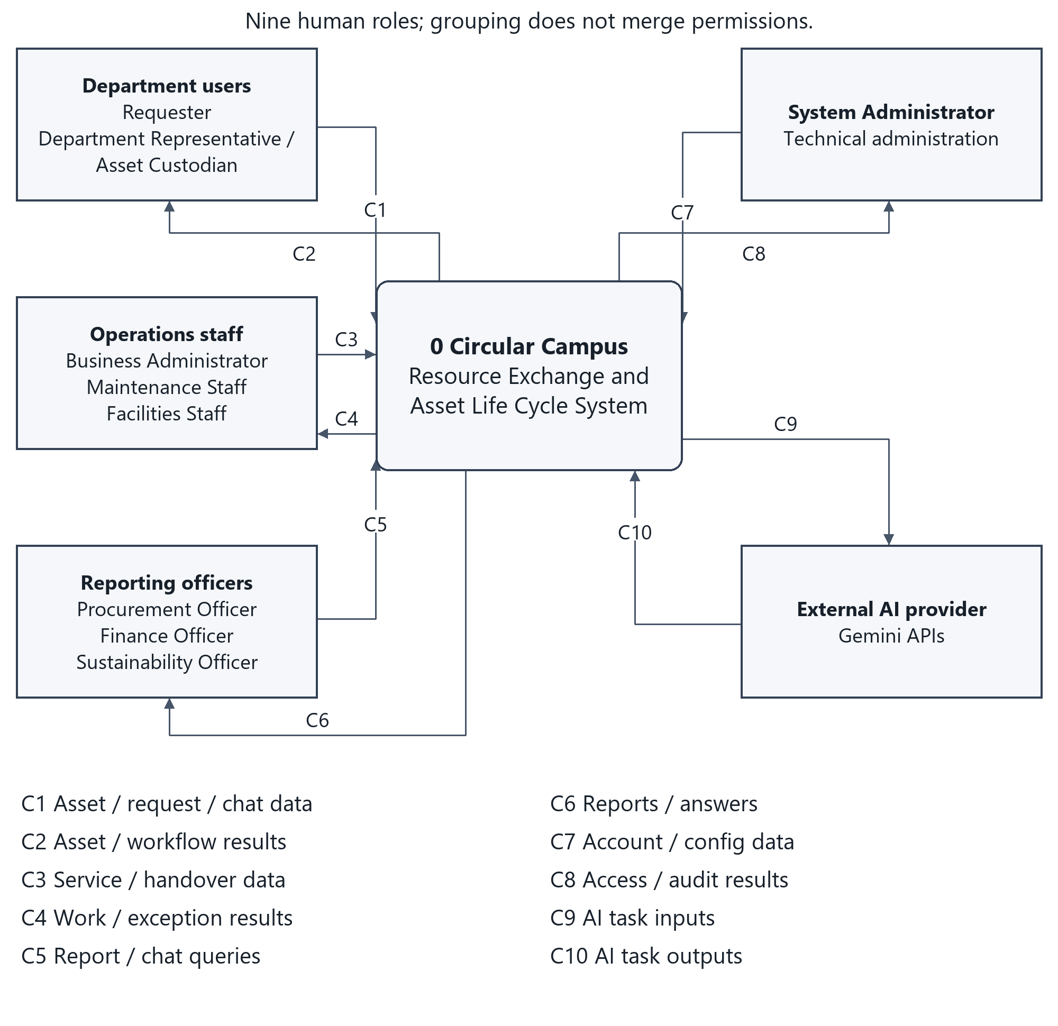
Figure 1 Context boundary and grouped external interfaces
The four human interface groups explicitly cover all nine SRS role classes. Grouping reduces crossing lines; it does not merge permissions. Requesters and custodians share the departmental interface, operations staff have assigned work, and the three reporting roles retain different data scopes.
The external AI provider receives minimized task input and returns advisory output. Supabase authentication/database/storage are managed implementation components inside the application boundary, not KU institutional integrations. Protected role input includes session/credential information; returned role results include the applicable access outcome.
Trace: SRS 2.3; UI-001/002; SI-001/002; CI-001/002; FR-USER-001 to 005; AI-REQ-003.

2 Data Flow Diagrams
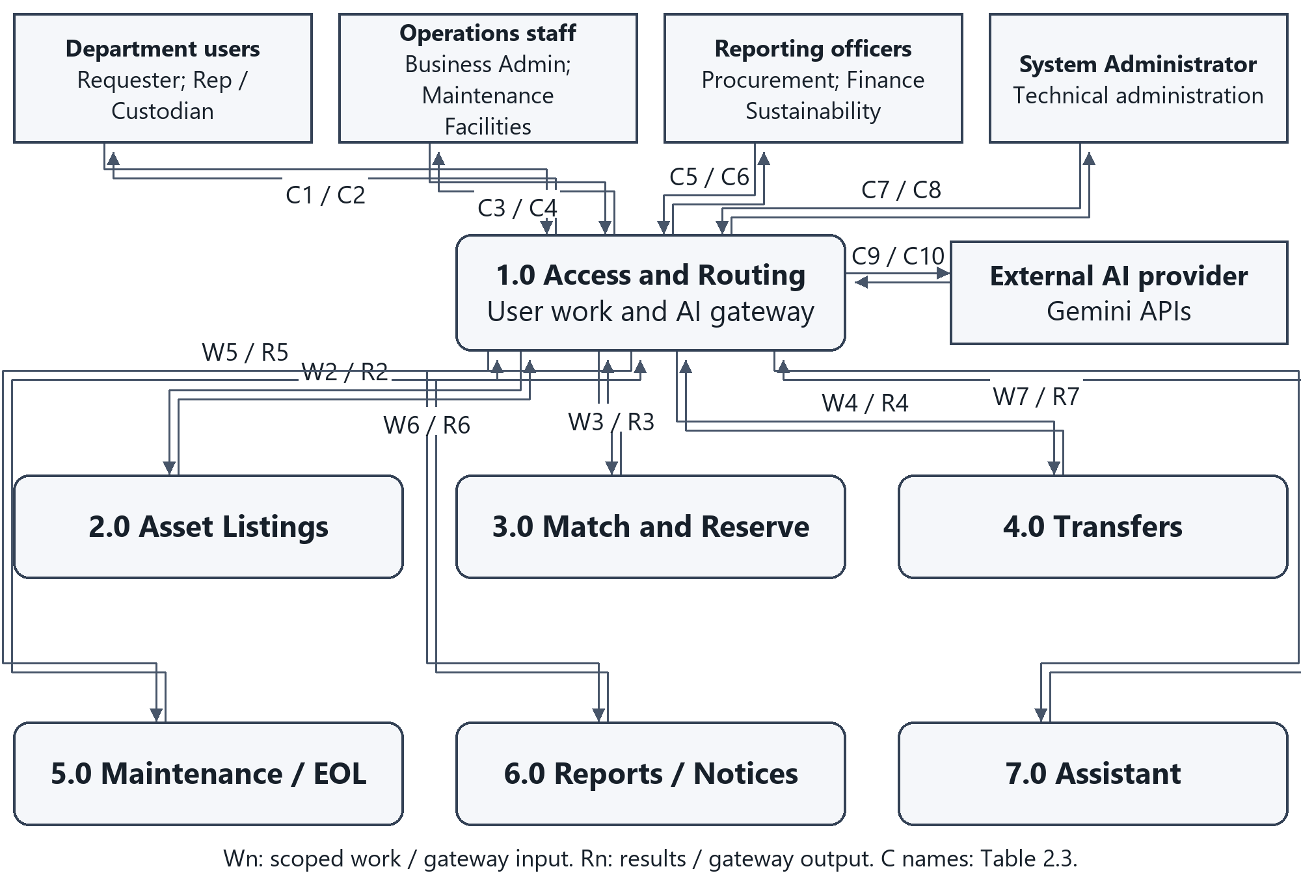
Figure 2 Level 1 decomposition of the whole system
Figure 2a shows the complete Level 1 process boundary. Each paired channel is two one-way data flows. The gateway routes external AI task inputs and outputs for the calling business processes; no AI result grants business authority.

2.1 Process and Data Interfaces
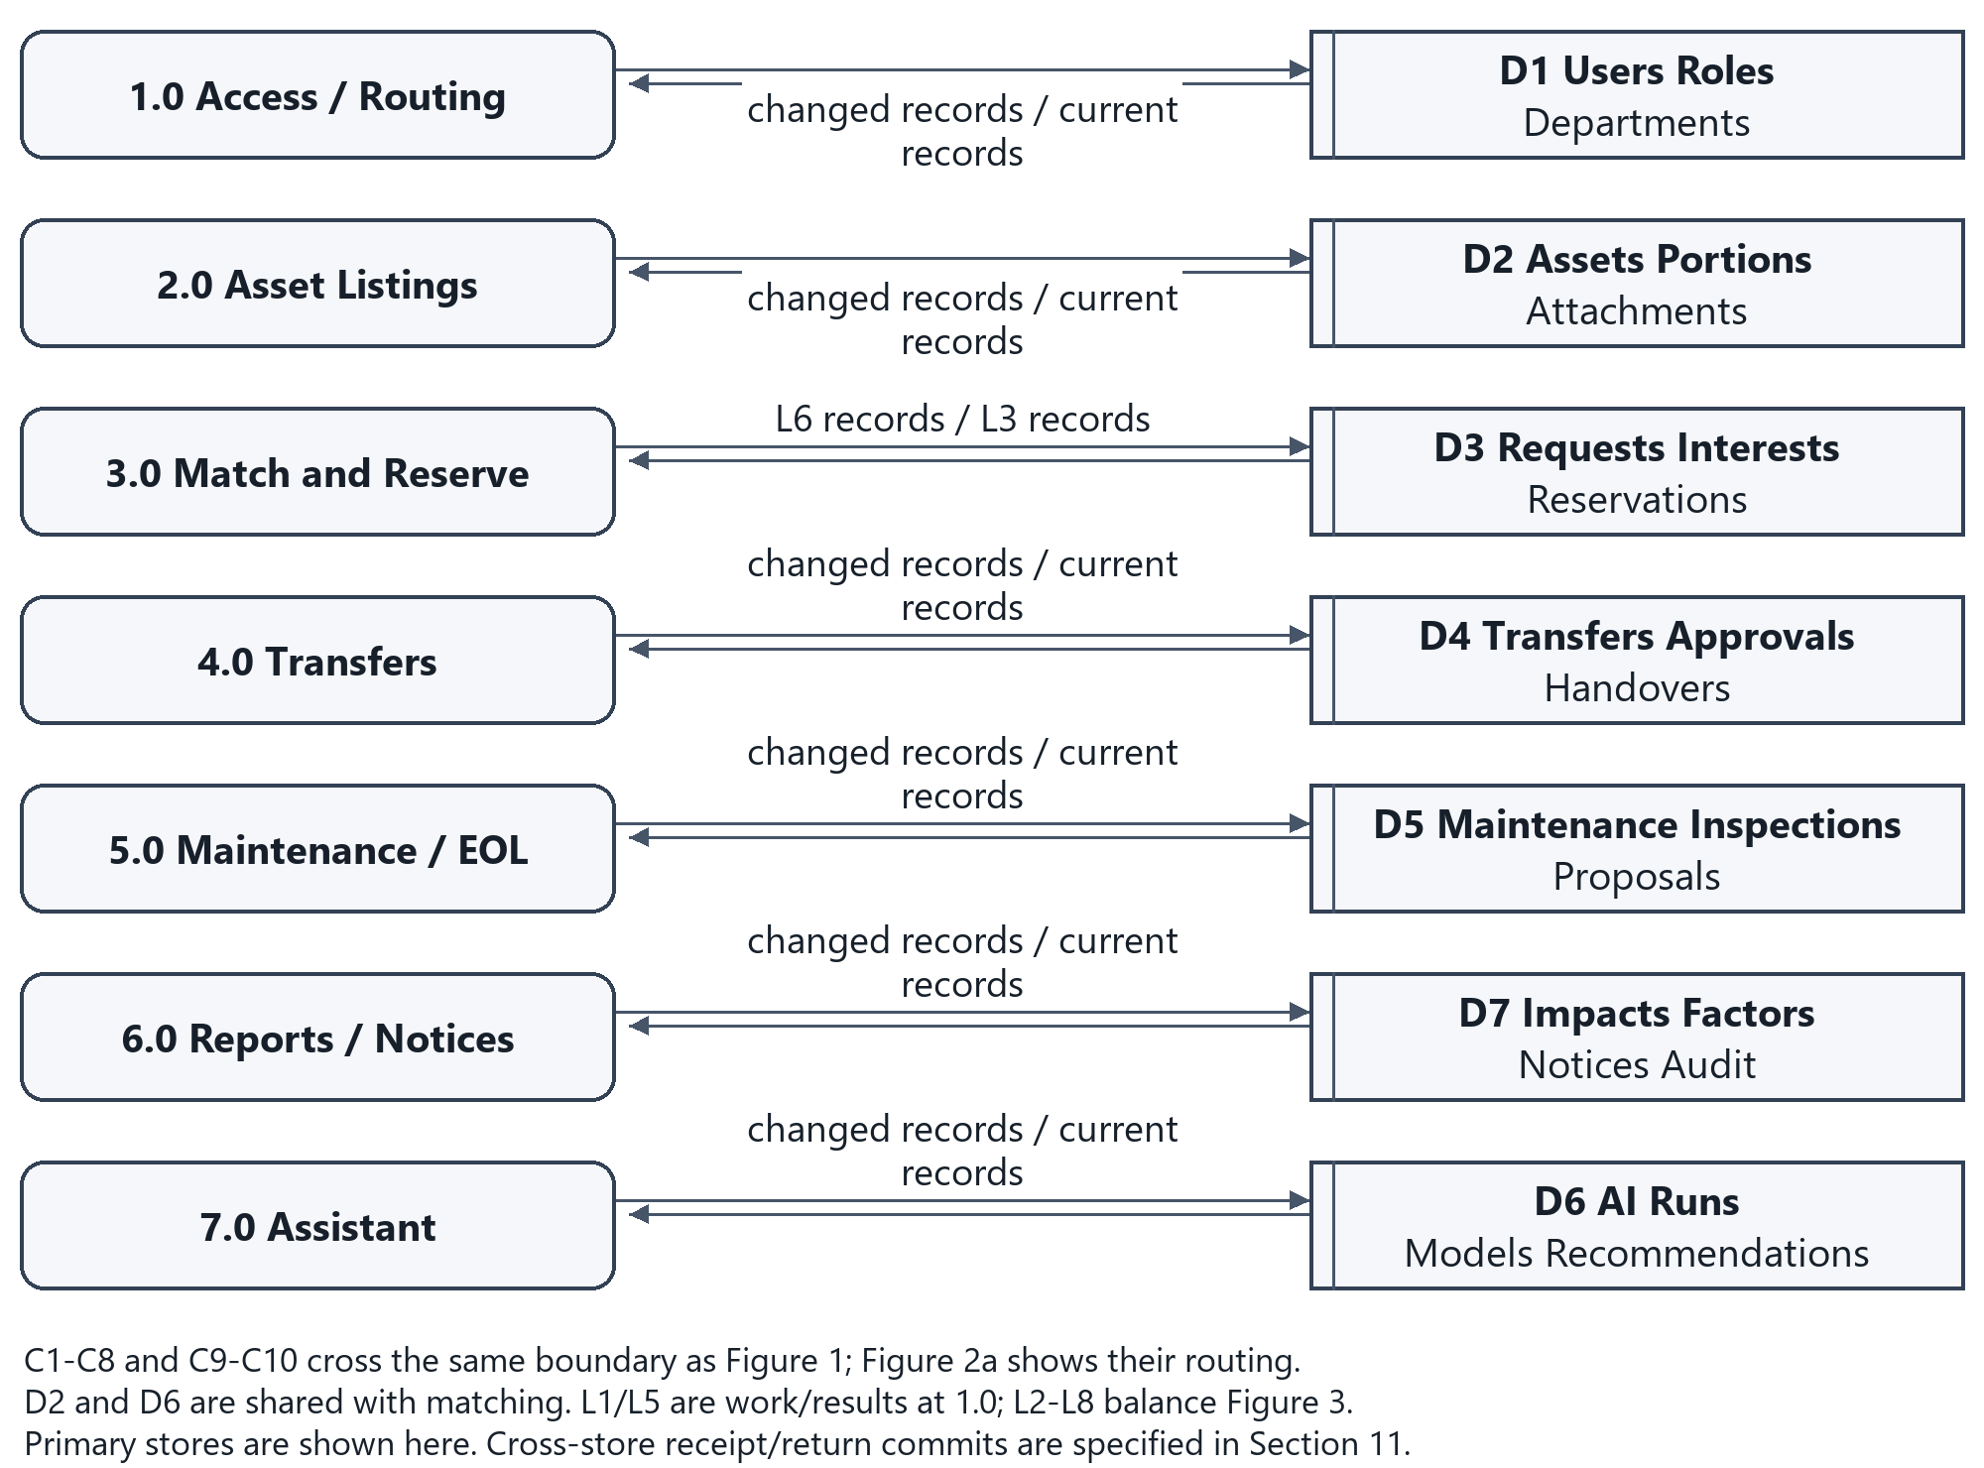
Figure 2b Level 1 primary data interfaces

2.1.1 Matching Parent Interfaces
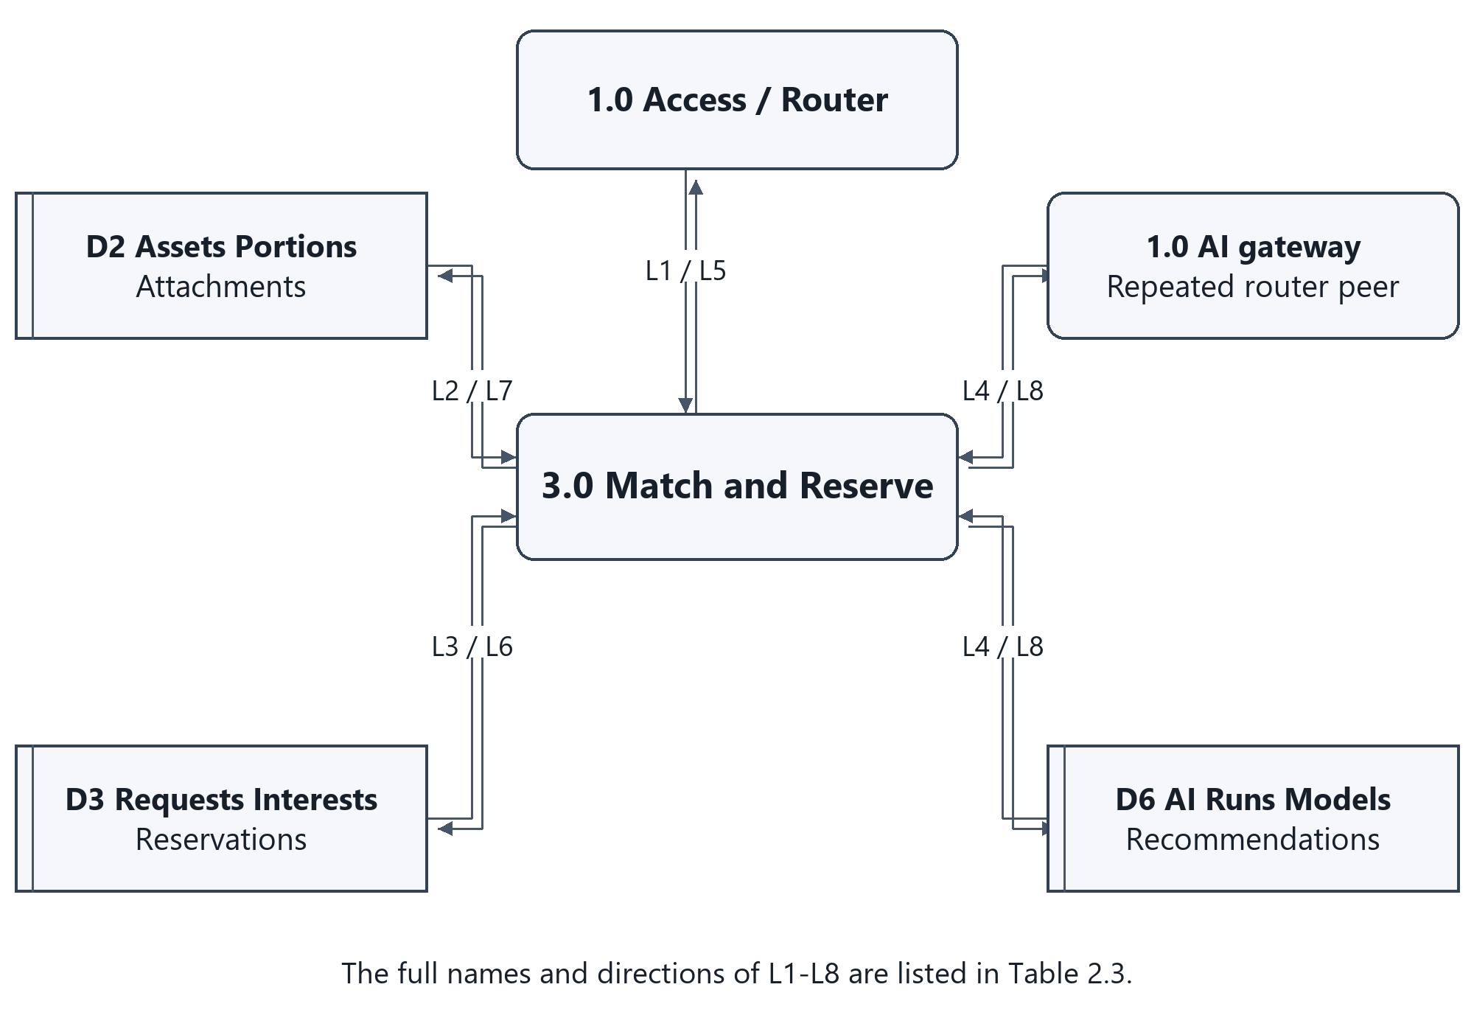
Figure 2c Parent process 3.0 data boundary

2.2 Level 2 Matching and Reservation
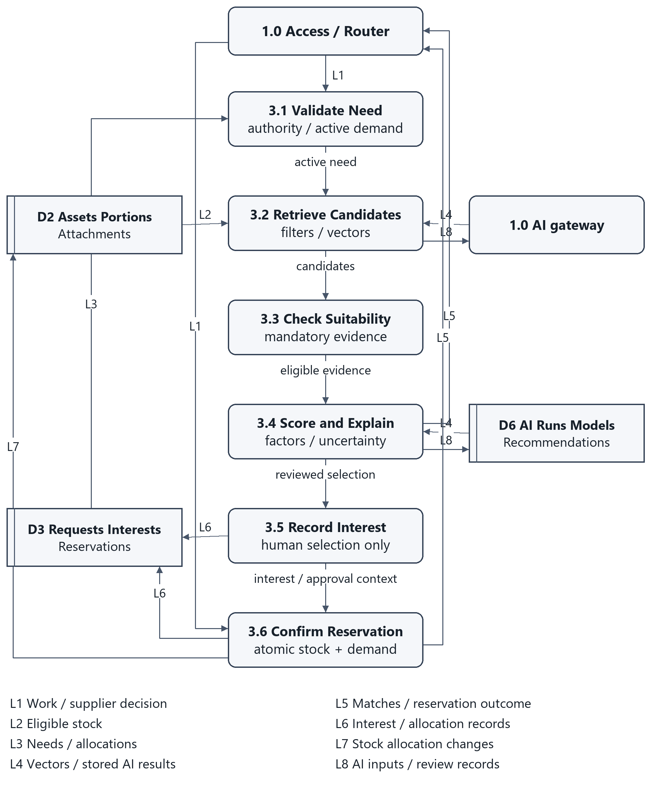
Figure 3 Level 2 decomposition of process 3.0
Process 3.0 is decomposed because a recommendation is easy to confuse with a reservation, while competing approvals can allocate the same stock. Retrieval/scoring prepares advisory candidates. A selected candidate creates only Interest. Supplier approval invokes one transaction that rechecks current stock, remaining unallocated need, authority and suitability.
Any failed check rolls back the complete reservation operation. AI failure selects the conventional retrieval path, leaving the request active. Matching never changes formal ownership or custody.
Trace: FR-REQUEST-003 to 007; FR-AI-MATCH-001 to 011; NFR-SAFE-002; NFR-QUAL-003.

2.3 Flow Balancing Tables
C1-C10 keep the same external entity, direction and name between the context and Level 1. Level 1 work-routing data expands the grouped payloads; it introduces no new external integration. C1-C8 are handled by 1.0 and routed internally as required.
Flow / external group | Direction and unchanged data name | Level 1 handling
C1 / U | in / Asset / request / chat data | 1.0
C2 / U | out / Asset / workflow results | 1.0
C3 / O | in / Service / handover data | 1.0
C4 / O | out / Work / exception results | 1.0
C5 / R | in / Report / chat queries | 1.0
C6 / R | out / Reports / answers | 1.0
C7 / S | in / Account / config data | 1.0
C8 / S | out / Access / audit results | 1.0
C9 / A | out / AI task inputs | 1.0 gateway
C10 / A | in / AI task outputs | 1.0 gateway

Parent 3.0 to Level 2 boundary
Boundary | Named data | Parent peer
L1 in | authorized request / interest | 1.0
L2 in | eligible stock and specifications | D2
L3 in | request / allocation records | D3
L4 in | vectors / model results | 1.0 AI gateway / D6
L5 out | matches / reservation outcome | 1.0
L6 out | request / allocation updates | D3
L7 out | stock allocation changes | D2
L8 out | AI inputs / review records | 1.0 AI gateway / D6
D2, D3 and D6 connections are internal Level 1 data flows; they therefore appear only when process 0 is decomposed. Each Level 2 boundary is a constituent of the same parent 3.0 interface. No store-to-store or actor-to-store flow is permitted.

3 Architecture
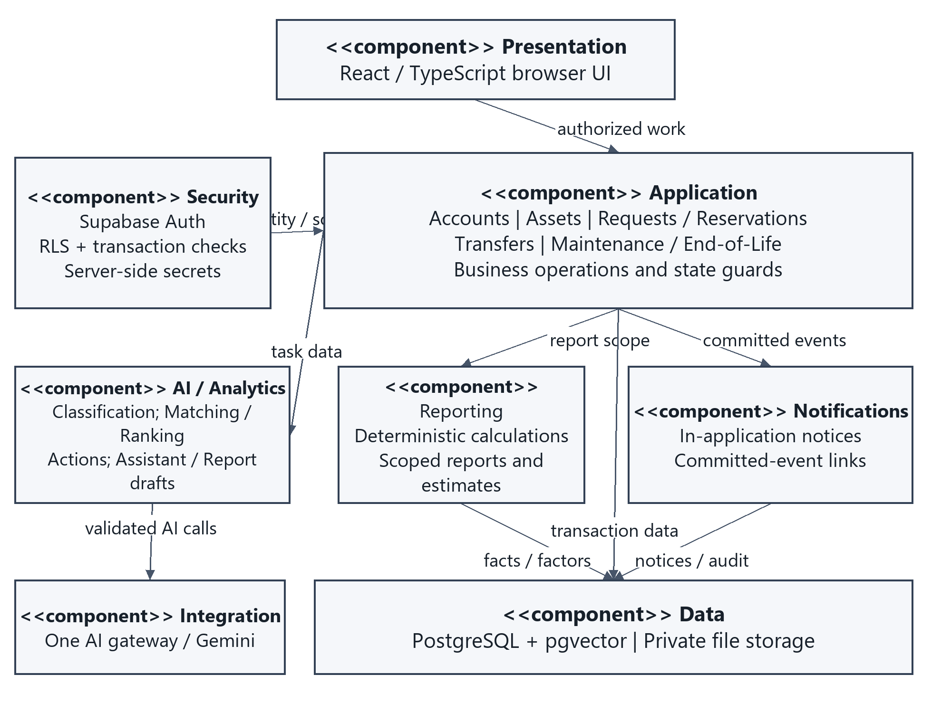
Figure 4 Logical architecture and UML component view
Choose a layered modular web application with a managed backend over Django/PostgreSQL. Managed authentication/storage and the existing Phase 2 approach reduce new hosting work. The cost is careful RLS/function authorization and stronger dependence on the managed platform. Business modules remain together; separate microservices are unnecessary for the five-concurrent-session planning workload.
Ordinary reads use caller-scoped access. Protected state changes use transactional database operations. Edge Functions form one logical AI gateway; API keys stay server-side. The reporting component calculates facts before the gateway drafts a narrative. Notifications follow committed events and never control transaction success.
Decision 01-architecture; NFR-QUAL-003/005/006; NFR-SEC-001/003; SI-001/002. Figure 4 is also the Phase 5 component diagram.

4 AI Services
One gateway supplies five logical service interfaces. Matching/ranking together implement the SRS matching capability; the LLM interface serves both conversational assistance and report drafting. There is no separate trained ranking model.
Service / pattern | Input and output | Limit / unavailable / unsure
Classification: ask/wait | Permitted metadata and images/PDFs -> category, tags, description, material and missing fields; human reviews. | 15 s provisional. Manual entry if down. Missing/unsupported evidence is flagged; self-reported certainty is uncalibrated.
Semantic matching: compute ahead + ask/wait | Asset text vector stored after save; request text vector on request/edit. Return candidates with model/content version. | 15 s per provider call. Stale/failed vectors use keyword/category fallback. Similarity is not a suitability guarantee.
Ranking: local deterministic model | Eligible candidates + factor evidence -> compatibility, rank, reasons and missing inputs. | Ordinary calculation path; no generation call. Missing mandatory evidence means Needs review; rank <60 is labeled weak, not a probability.
Sustainable action: ask/wait | Condition/history, demand, costs, eligible benefits -> recommended next action and supporting evidence. | 15 s provisional. Manual decision if down. Missing essential evidence gives Needs review; approval remains human.
LLM assistant / report draft: ask/wait | Authorized facts/policy -> supported answer or editable request. Computed snapshot -> narrative draft. | 15 s chat / 30 s report, provisional. Normal screens/fixed reports if down. Unsupported facts/numbers are withheld.

Failure and version handling
Save the business record before optional embedding work. A failed embedding never reverses publication; record failed status and retry on a later edit or explicit retry. Store provider-visible model ID, configuration version, input references/hash, duration, call count and human review. Do not retry a paid generation call indefinitely. A user may retry explicitly; transaction retries reuse the original operation key.
These are timeout design limits, not measured response-time targets. TBD-005 remains open until technical checks measure the selected provider, dataset, hosting and network.
Decision 02-ai-integration; AI-REQ-001 to 008; NFR-AI-001; NFR-PERF-002/003; NFR-QUAL-006; SI-002.

5 Human Approval Points
The application can suggest, validate and calculate. Authorized people establish confirmed metadata, allocations, custody and end-of-life outcomes. An AI acceptance records a review decision; it is never a transaction authorization.
Decision | Authorized person and evidence | Retained control
Confirm metadata | Representative/Custodian reviews original fields, AI changes and uncertainty. | Accept/correct/reject; retain confirmed values and AI review.
Choose a match | Requester reviews mandatory checks, scores, reasons and remaining need. | Interest only; no allocation.
Reserve / release | Supplying representative reviews competing interests, suitable available stock, remaining demand and authority. | Atomic check; no self-approval. Combined approvals are optional Should behavior and retain separate records.
Dispatch | Facilities Staff records arrangements, actual holder/location and dispatched quantity after release. | Physical tracking changes; formal assignment remains.
Accept receipt / confirm return | Receiving representative accepts approved quantity/condition; supplying representative confirms returned quantity/condition. | One atomic completion/return; discrepancies remain open and unavailable.
Restore safe service | Maintenance assessment plus authorized condition update, with inspection findings and prior listing context. | Completion alone cannot clear Unfit or overwrite an active allocation.
End-of-life action | Custodian proposes; Business Administrator approves; authorized staff record performed action. | No active allocation. Rejection restores prior In Use/Unfit/Retired state.
Assistant / reports | User checks editable request; report reader reviews calculated inputs, units, source and uncertainty. | Standard Submit required; AI cannot approve or invent totals.
Exceptions use the Business Administrator’s recorded review within the prototype role scope; elapsed storage time and low demand do not grant disposal authority. Institutional delegation remains unconfirmed.
Decision 03-human-approval; BR-001 to 011; UC-02/06/07/08/09/10/11/12.

6 Security
Default deny applies to direct requests, file access, database operations and assistant retrieval. The matrix uses: O = own record/request; D = own department; A = assigned work; S = specialist scope; X = cross-department business scope; T = technical scope; dash = no permission. AI has no approval or mutation authority.
Action | Req | Rep | BA | Maint | Fac | Proc | Fin | Sust | Sys | AI
Search / view eligible listings | O | D | X | A | A | S | S | S | - | read*
Create / track request | O | D | - | - | - | - | - | - | - | draft
Register / publish asset | - | D | - | - | - | - | - | - | - | suggest
Approve reservation / release | - | D | X* | - | - | - | - | - | - | -
Record dispatch / handover | - | - | - | - | A | - | - | - | - | -
Accept receipt / confirm return | - | D | - | - | - | - | - | - | - | -
Report defect | O | D | - | A | - | - | - | - | - | -
Inspect / service / condition | - | D* | - | A | - | - | - | - | - | suggest
Propose / complete final action | - | D | X* | A* | A* | - | - | - | - | suggest
Authorize final action | - | - | X | - | - | - | - | - | - | -
Operational / sustainability report | - | D | X | S | - | S | S | S | - | draft*
Financial / relevant costs | - | D | X | S | - | - | S | - | - | draft*
Manage users / roles / departments | - | - | - | - | - | - | - | - | T | -
Audit review | - | D* | X | S* | A* | S* | S* | S* | T | -
Assistant within existing scope | O | D | X | S | A | S | S | S | T | answer
Req=Requester; Rep=Department Representative / Asset Custodian; BA=Business Administrator; Maint=Maintenance; Fac=Facilities; Proc=Procurement; Fin=Finance; Sust=Sustainability; Sys=System Administrator. An asterisk limits access to the underlying permitted record/task: BA transfer intervention is escalation only; staff complete an already approved physical action; AI receives minimized data from the caller’s authorized scope.
Business audit/history follows the reader’s permitted records; technical administrators see technical audit only. Finance may inspect supporting financial activity, not unrelated operational authority. Sustainability sees calculation inputs, not unrestricted financial reports. A role assignment never grants a second role’s permissions.
SRS 2.3; FR-USER-004; FR-REPORT-009; NFR-SEC-001 to 004; NFR-PRIV-001/002; BR-011.

6.2 Audit Backup and Recovery

Enforcement and data boundaries
Supabase Auth supplies identity. Server-side handlers and database functions verify active identity, assigned role, department and target-record scope. RLS protects ordinary reads and file metadata. Browser-visible navigation is not authorization. State-changing functions recheck business authority and restrict execution grants; any privileged function must check the authenticated caller explicitly and pin its search path. Direct state updates that bypass the workflows are denied.
The prototype uses synthetic records and approved sample files only. AI requests exclude credentials, personal contact details and unrelated financial records. The assistant retrieves permission-filtered facts before model invocation; it cannot generate executable SQL or arbitrary business actions. Validate structured AI output, enum values and evidence references before displaying it.

Audit and notifications
Append an event for accounts/roles, asset edits, approvals, allocations, formal custody, physical handovers, condition assessments, AI reviews and exceptions. Retain actor/service identity, action, record key, UTC timestamp, before/after values and correlation/operation key. Exclude passwords/tokens. Business mutations and their audit/event record commit together. An in-application notification failure is visible/retryable and cannot reverse a committed business outcome.

Backup and isolated recovery
Policy | Prototype design
Frequency / contents | Daily and before risky data changes: database export, private file objects and object-key/checksum manifest. Provider database backup alone does not cover uploaded objects.
Destination / retention | Seven rotating encrypted sets outside the repository; access limited to the technical operator. Retain business/audit history through assessment; no automatic hard deletion of referenced records.
Restore procedure | Use an isolated project/database. Restore schema/data then file objects; reapply required secrets separately. Never restore over a live project for this check.
Acceptance | Check entity counts, foreign keys, one completed transfer, role-denied reads, and attachment object keys/checksums. Record actual recovery time only when tested.
Decision 04-security-recovery; NFR-QUAL-003/004; NFR-SEC-001/003; Supabase Database Backups [R6]. Recovery is specified, not claimed as executed.

7 Mockups

7.1 Asset Registration
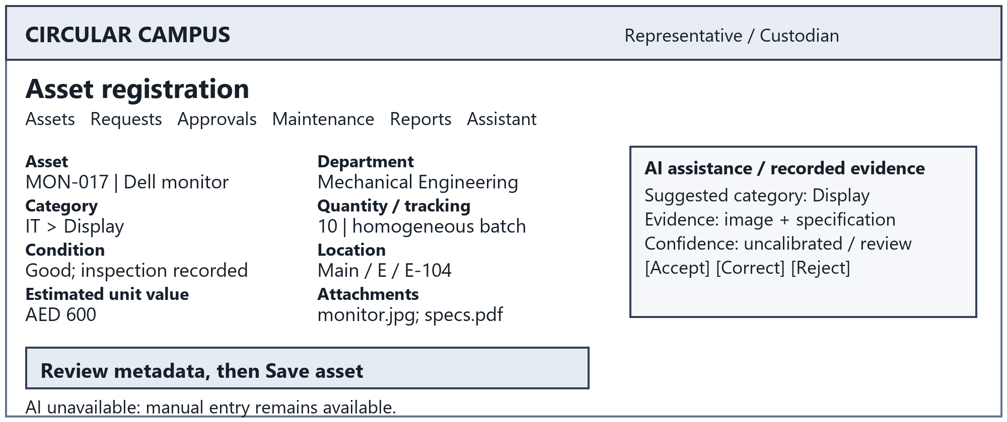
Figure 5 Required screen 1
UC-02/03; FR-ASSET-001 to 008; FR-AI-CLASS-001 to 004.

7.2 Request Submission
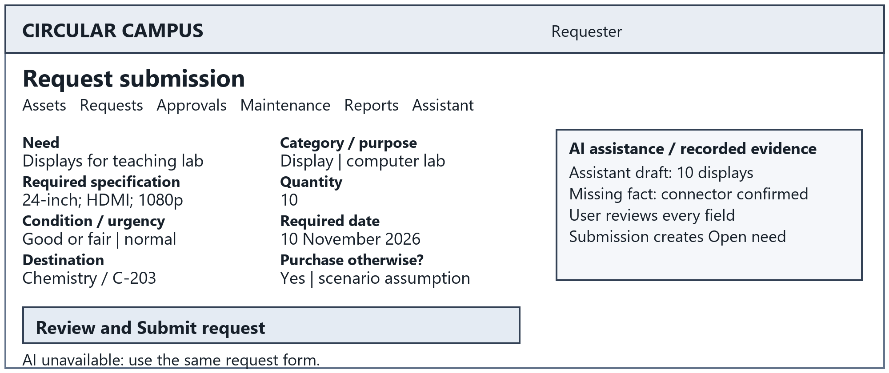
Figure 6 Required screen 2
UC-04; FR-REQUEST-001/002/005/008; UI-001/002.
Interaction rules: visible labels and keyboard order; retain valid input after errors; display processing state and specific corrections. Show suggestions separately from confirmed facts. The named role makes the final decision; the bottom message identifies the normal path when AI is unavailable.

Mockups continued

7.3 Recommendation Review
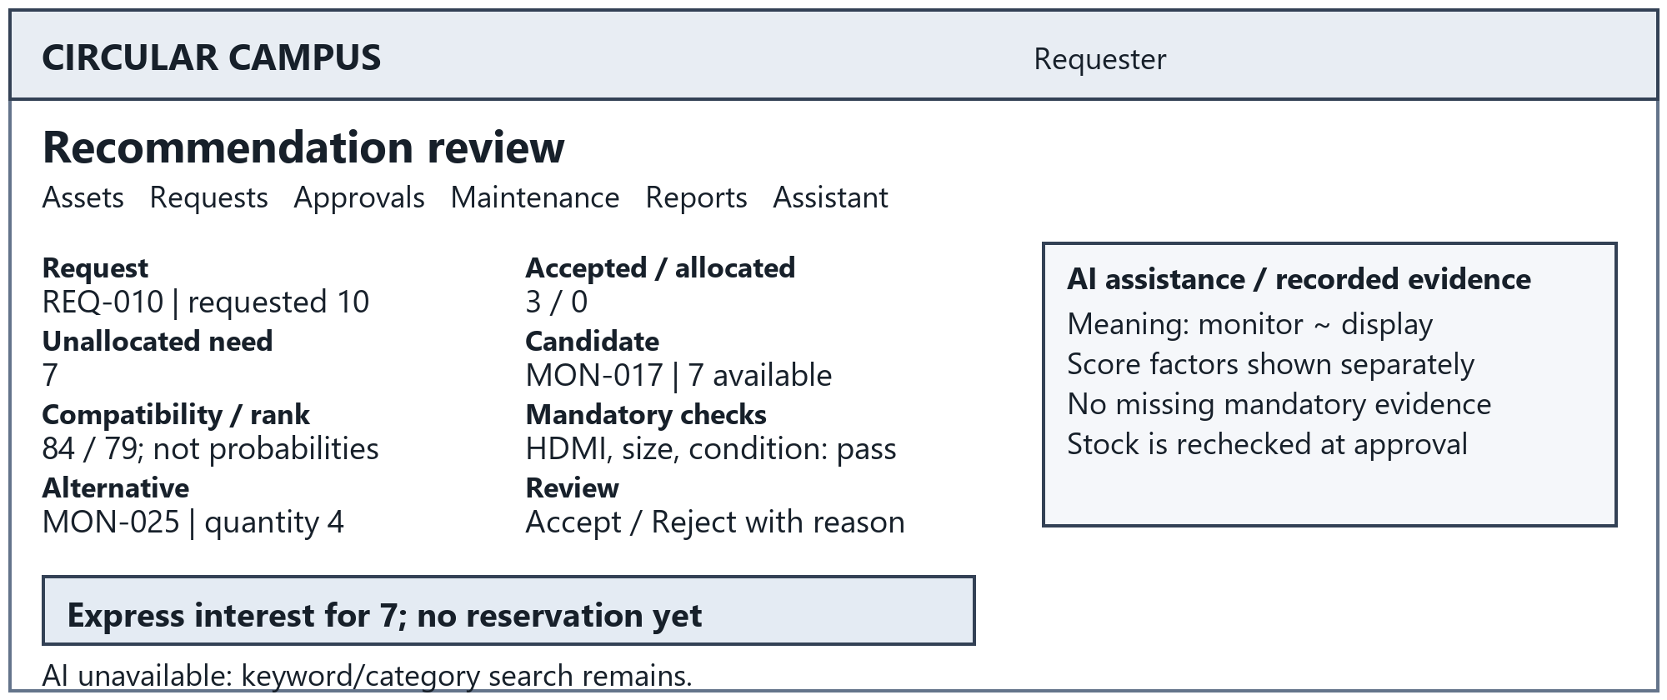
Figure 7 Required screen 3
UC-06/07; FR-AI-MATCH-001 to 011; FR-REQUEST-003 to 007.

7.4 Transfer Approval and Receipt
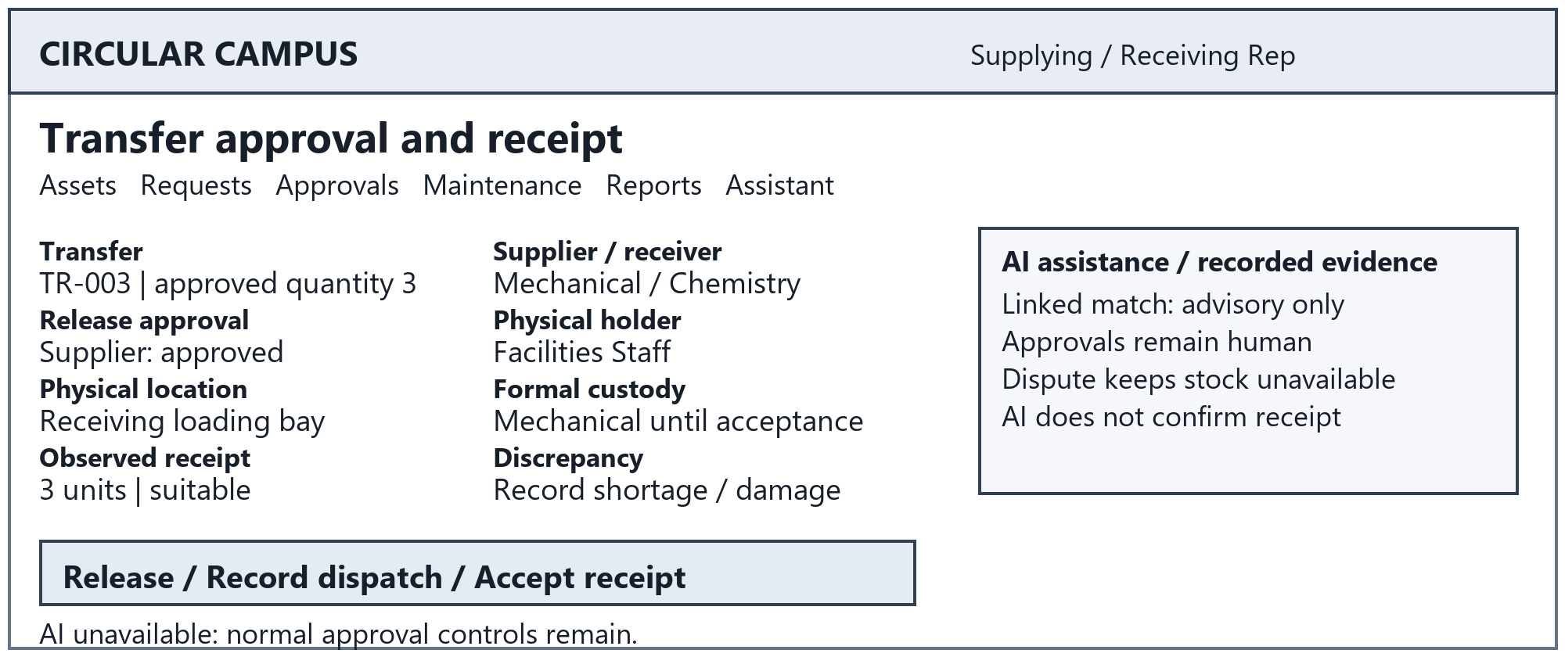
Figure 8 Required screen 4
UC-08; FR-TRANSFER-001 to 008; BR-007.
Interaction rules: visible labels and keyboard order; retain valid input after errors; display processing state and specific corrections. Show suggestions separately from confirmed facts. The named role makes the final decision; the bottom message identifies the normal path when AI is unavailable.

Mockups continued

7.5 Maintenance Tracking
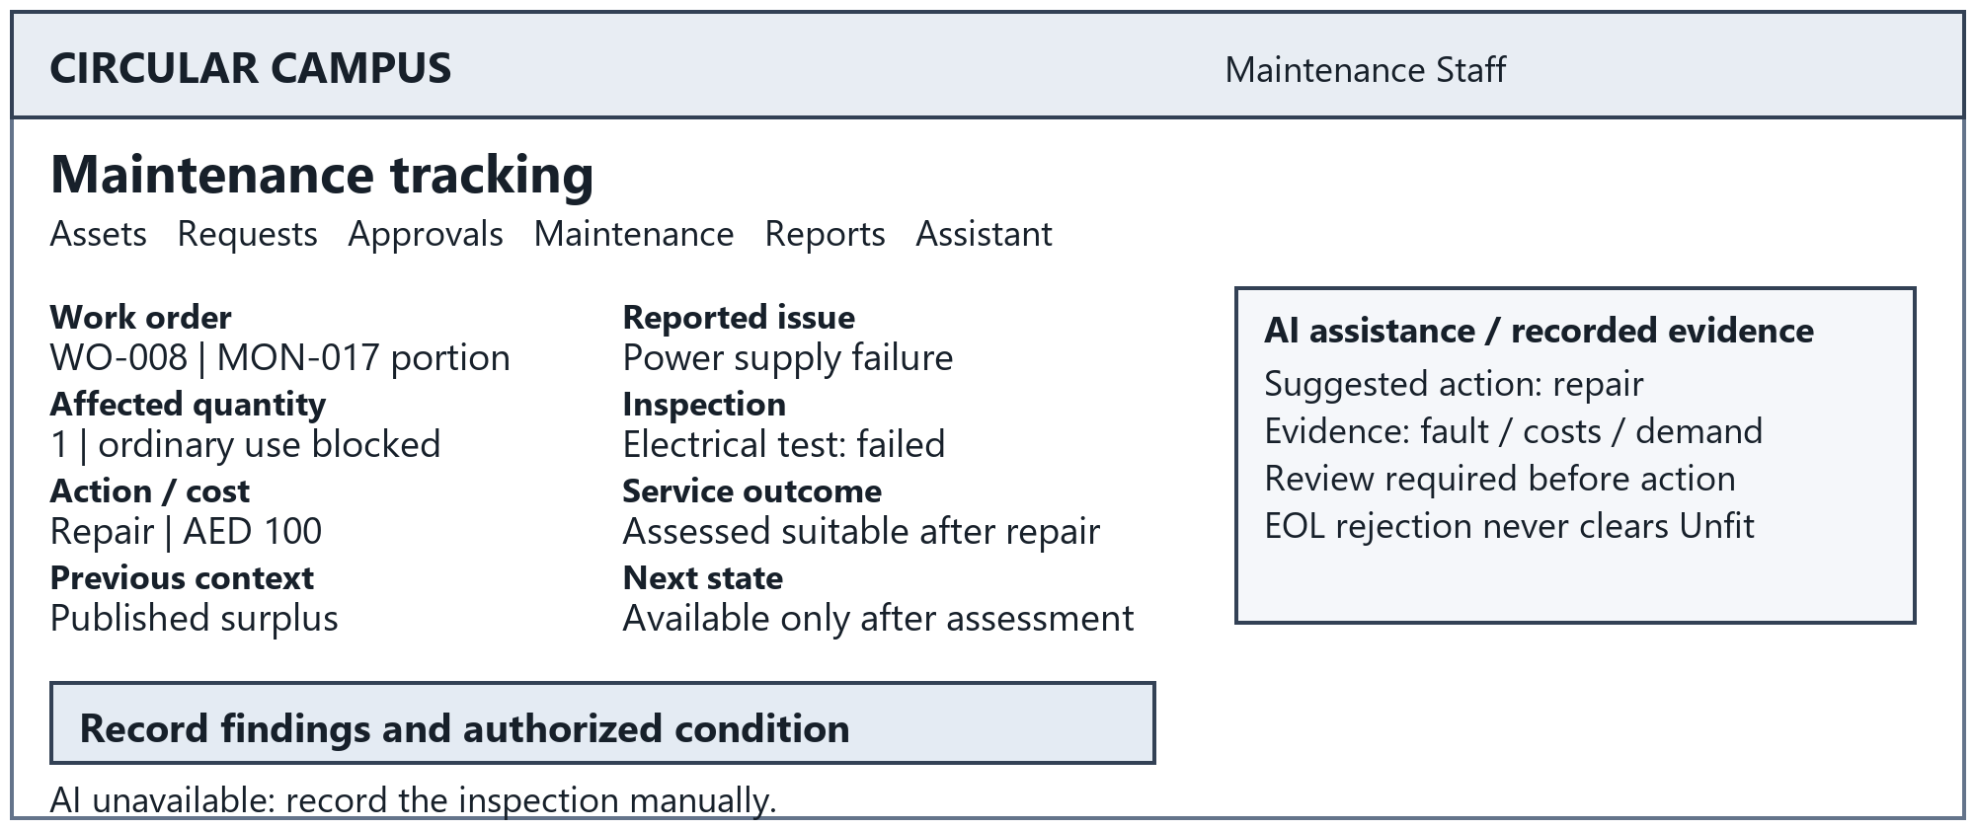
Figure 9 Required screen 5
UC-09/10; FR-MAINT-001 to 006; FR-AI-SUST-001 to 004.

7.6 Sustainability Dashboard
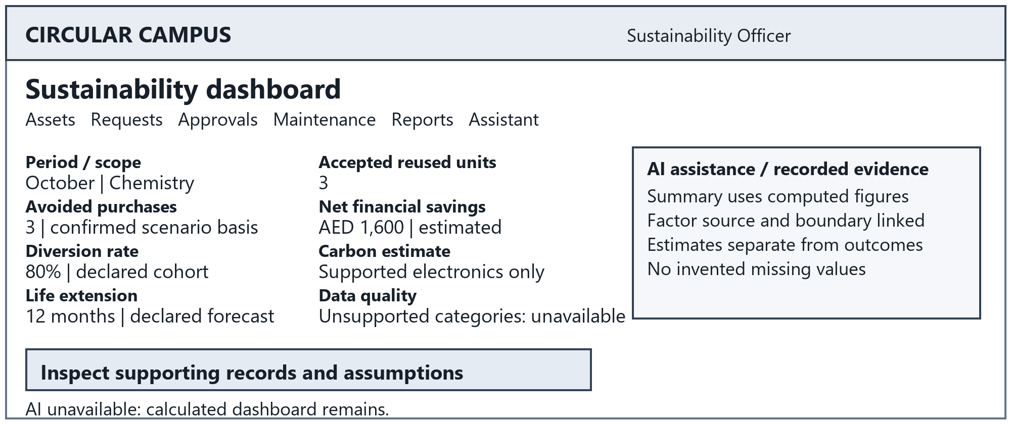
Figure 10 Required screen 6
UC-12; SUS-001 to 007; FR-REPORT-003/005.
Interaction rules: visible labels and keyboard order; retain valid input after errors; display processing state and specific corrections. Show suggestions separately from confirmed facts. The named role makes the final decision; the bottom message identifies the normal path when AI is unavailable.

Mockups continued

7.7 Operational Reports
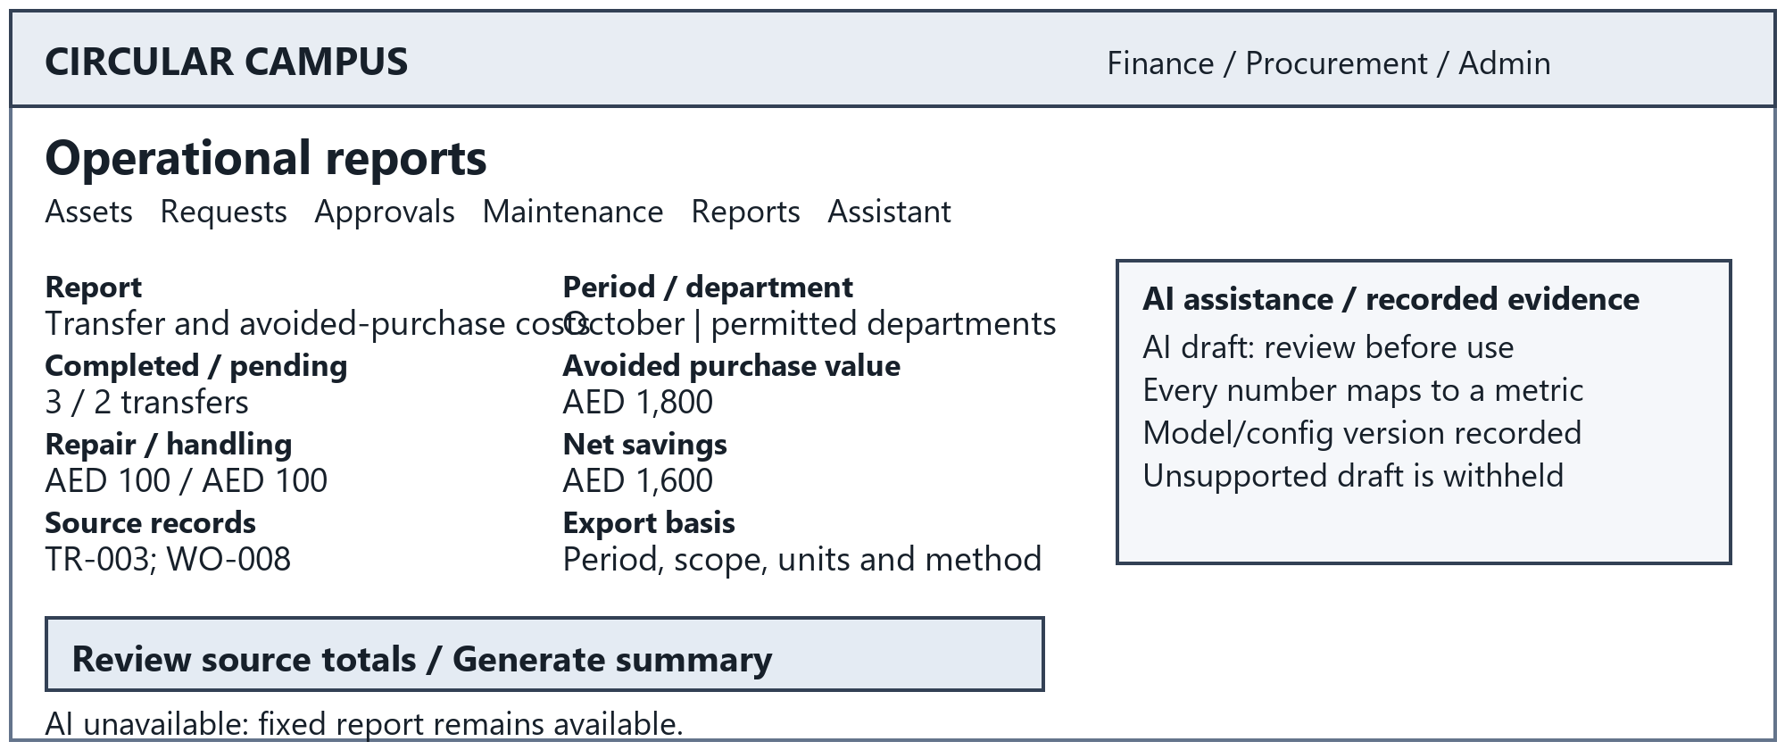
Figure 11 Required screen 7
UC-12; FR-REPORT-001 to 009; AI-REQ-007.

7.8 Conversational Assistant
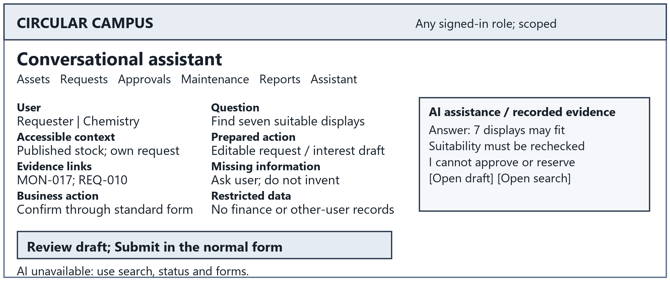
Figure 12 Required screen 8
UC-11/04; FR-ASSIST-001 to 005; BR-002/011.
Interaction rules: visible labels and keyboard order; retain valid input after errors; display processing state and specific corrections. Show suggestions separately from confirmed facts. The named role makes the final decision; the bottom message identifies the normal path when AI is unavailable.

8 Structural UML

8.1 Whole System Use Cases
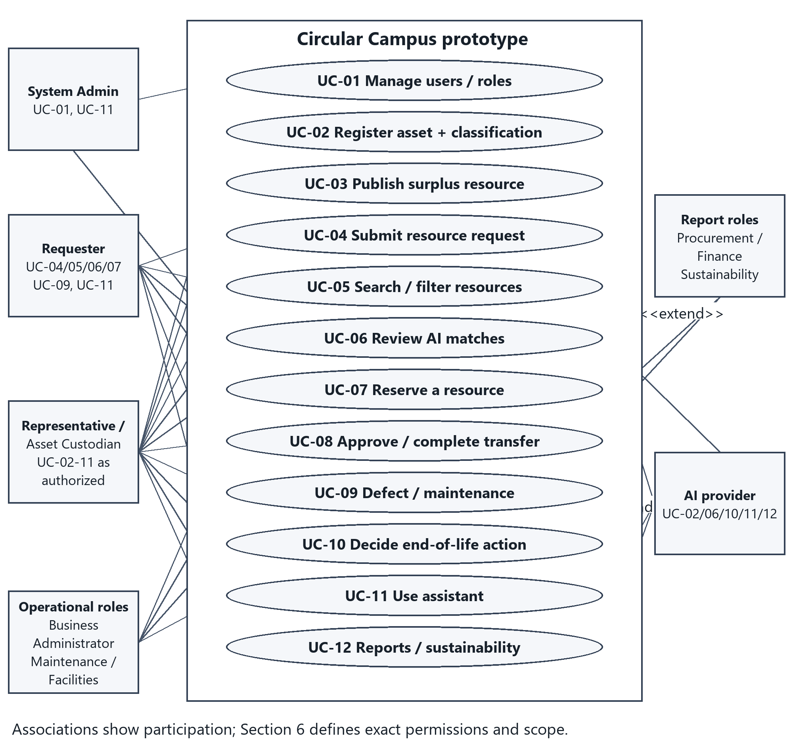
Figure 13 Use case participation for all twelve SRS use cases
UC-06 extends UC-04 when matching is invoked; UC-10 may extend UC-09 after an unfit assessment and may start independently. The assistant is available to every signed-in human role within its existing access. Procurement/Finance/Sustainability share UC-12 participation while retaining distinct report scopes. Operational associations mean assigned participation, not common permissions.

8.2 Domain Class Model
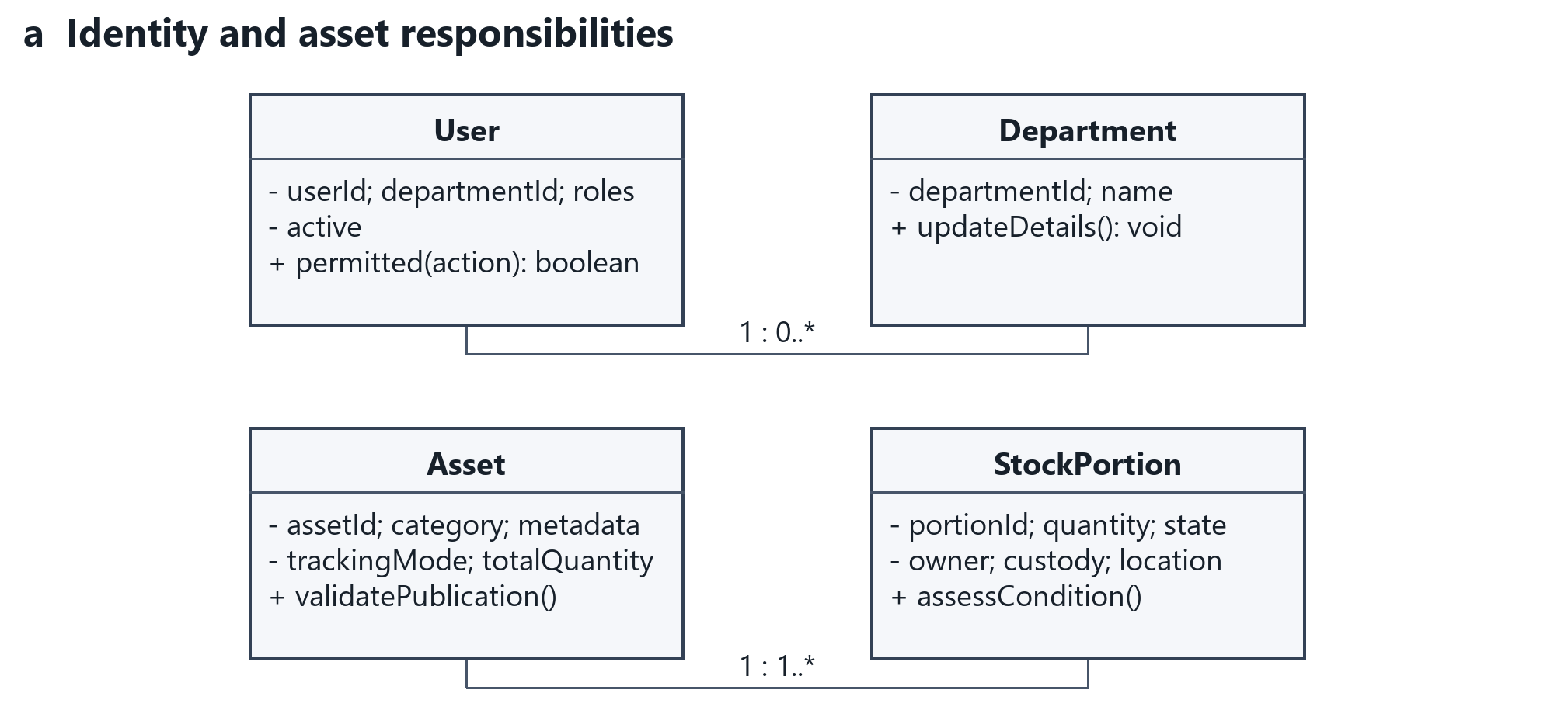
Figure 14 Core domain classes and selected operations

8.2.1 Request Approval and Transfer Classes
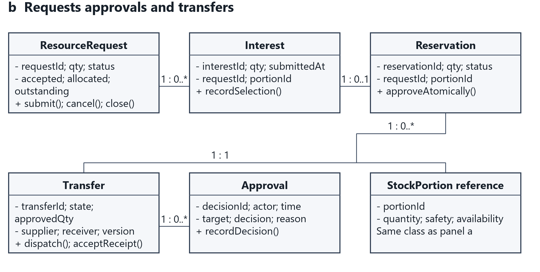
Figure 14b Request approval and transfer classes
Each association label states multiplicity. Asset owns shared descriptive identity; StockPortion carries quantity, state, condition and current assignment. A request has many interests/reservations over time; one reservation creates one transfer. The dictionary states all foreign keys and optionality. No inheritance or composition is added merely to demonstrate notation: asset categories are data, and historical records must survive deactivation.
Operations name domain responsibilities, not a requirement to implement every entity as a mutable TypeScript class. State changes are orchestrated by the transactional operation contracts in Section 11.

8.3 Supporting Classes and Components
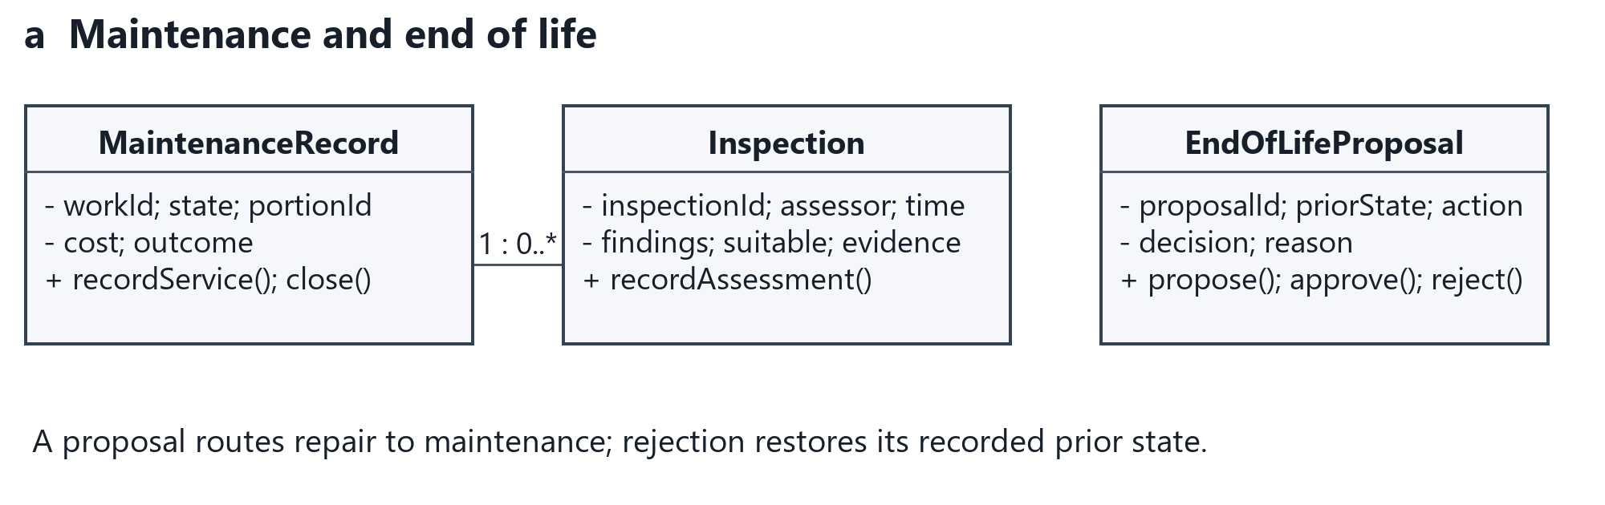
Figure 15 Maintenance AI and reporting responsibilities

8.3.1 AI Reporting and Notification Classes
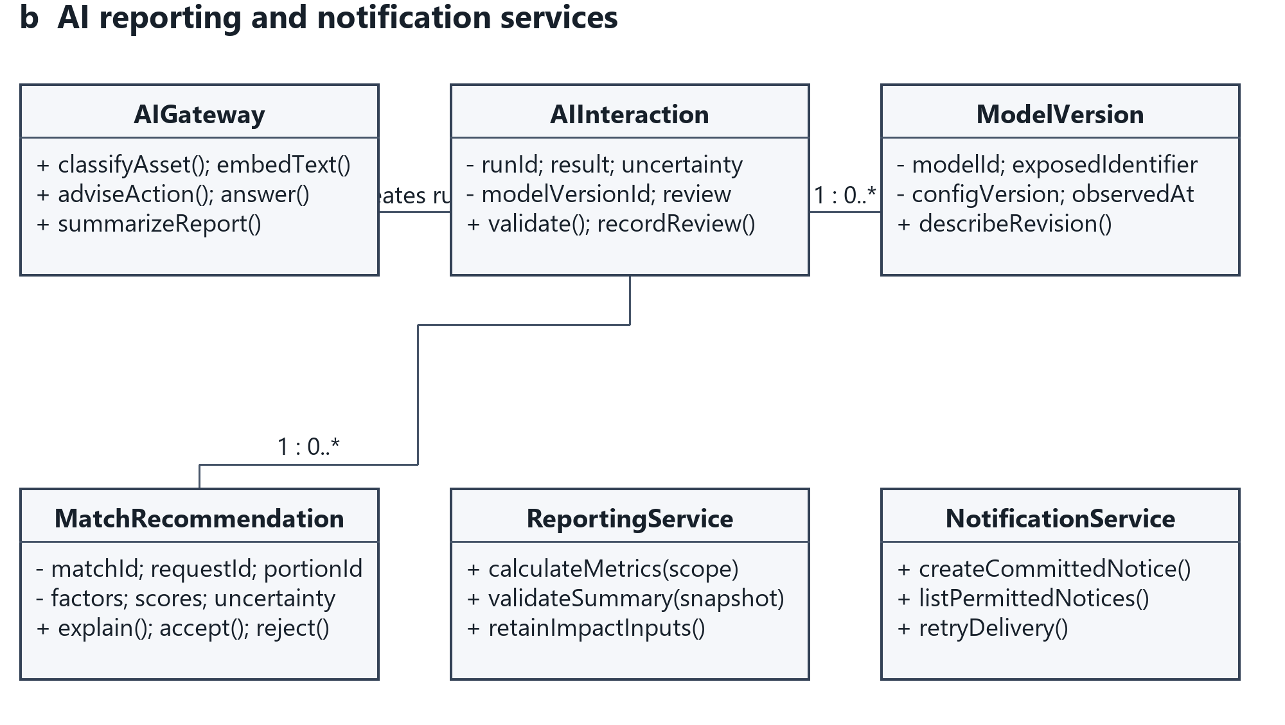
Figure 15b AI reporting and notification responsibilities
MaintenanceRecord has inspection evidence. EndOfLifeProposal retains the prior state. AIInteraction references one ModelVersion and retains reviews; recommendations reference their request/portion. ReportingService calculates deterministic facts; AIGateway handles suggestions. NotificationService operates on committed events. Supporting stored entities are expanded in Section 10.
The component diagram is Figure 4 in Section 3. Logical module boundaries do not require separate deployments, brokers or databases.

8.4 Deployment Design
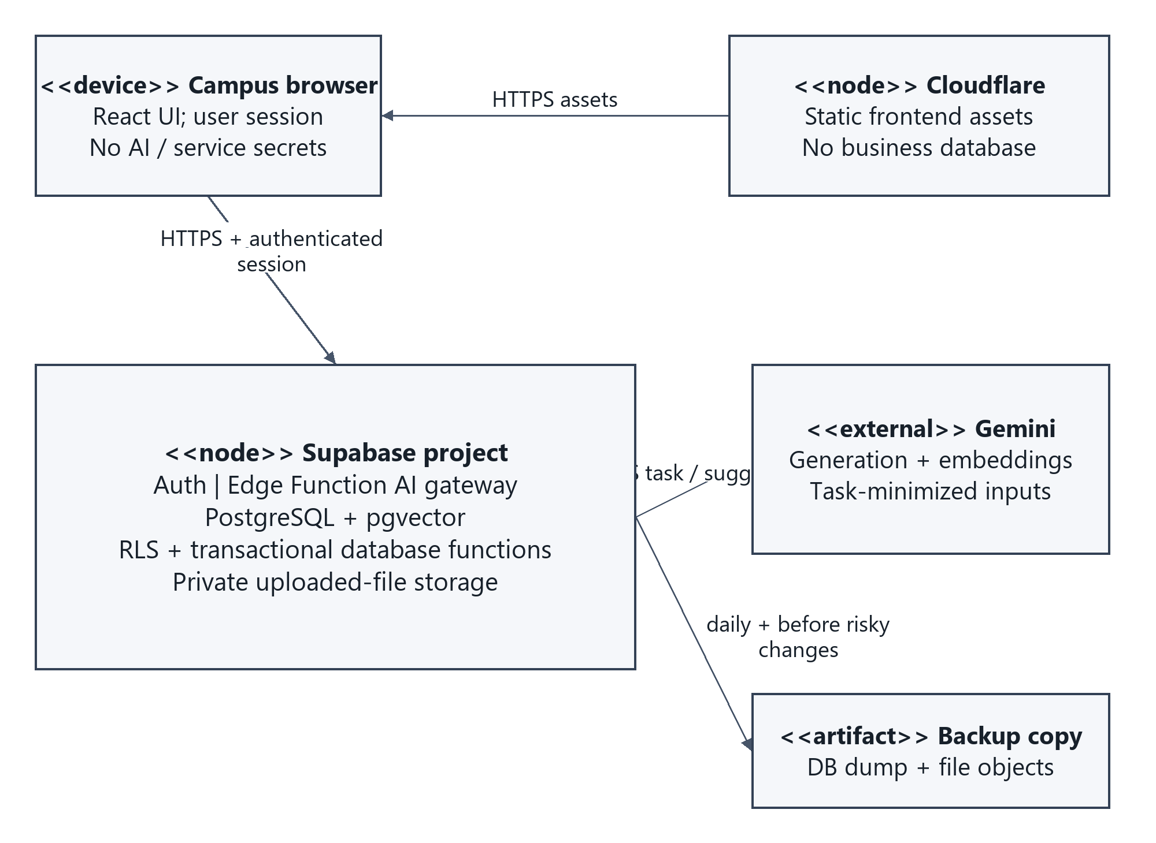
Figure 16 Prototype deployment and trust boundaries
The browser downloads static application assets over HTTPS. Authenticated requests reach the Supabase project. One logical Edge Function gateway calls Gemini with server-side credentials; pgvector stays in PostgreSQL. A separate backup set contains the database export and file objects. Provider/network failures are represented as degraded advisory functions rather than new business states.
No institutional SSO/accounting endpoints, separate vector database, GPU host or microservice fleet is introduced. Hosting/model identifiers remain configuration values; implementation records the exposed model and configuration version. Approximate $35/month remains the Phase 2 planning allowance, not an updated supplier quotation.

9 Behavioral UML

9.1 Registration with Classification
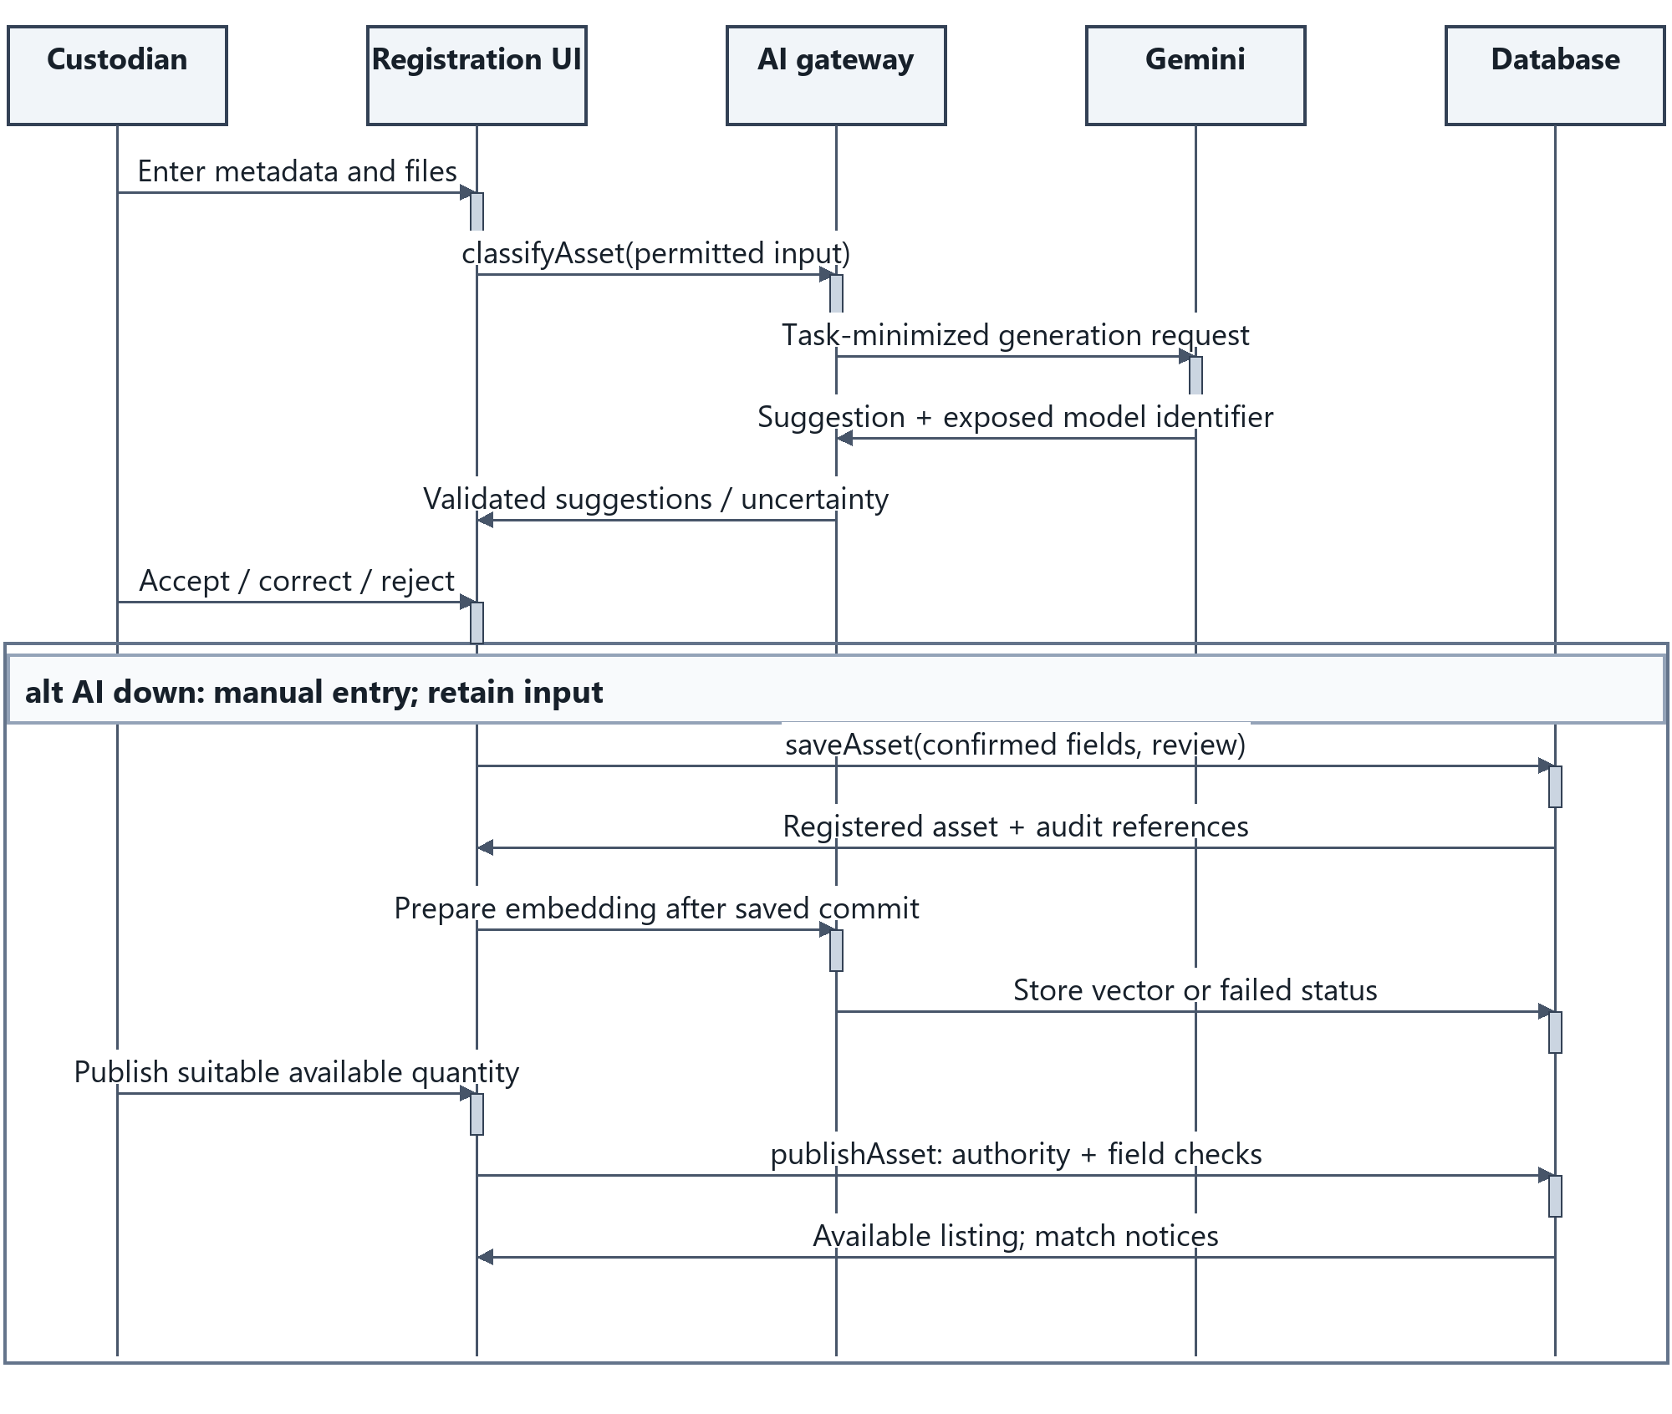
Figure 17 Asset registration classification and publication
UC-02/03. The person confirms metadata; Registered and Available are distinct. Persisted metadata remains usable if vector preparation fails. Human review and provider/config identifiers remain traceable.
Solid messages: calls; dashed messages: replies; activation bars: executing participant. Alternative bands identify guarded branches; review the corresponding operation contracts in Section 11.

9.2 Matching and Reservation Sequence
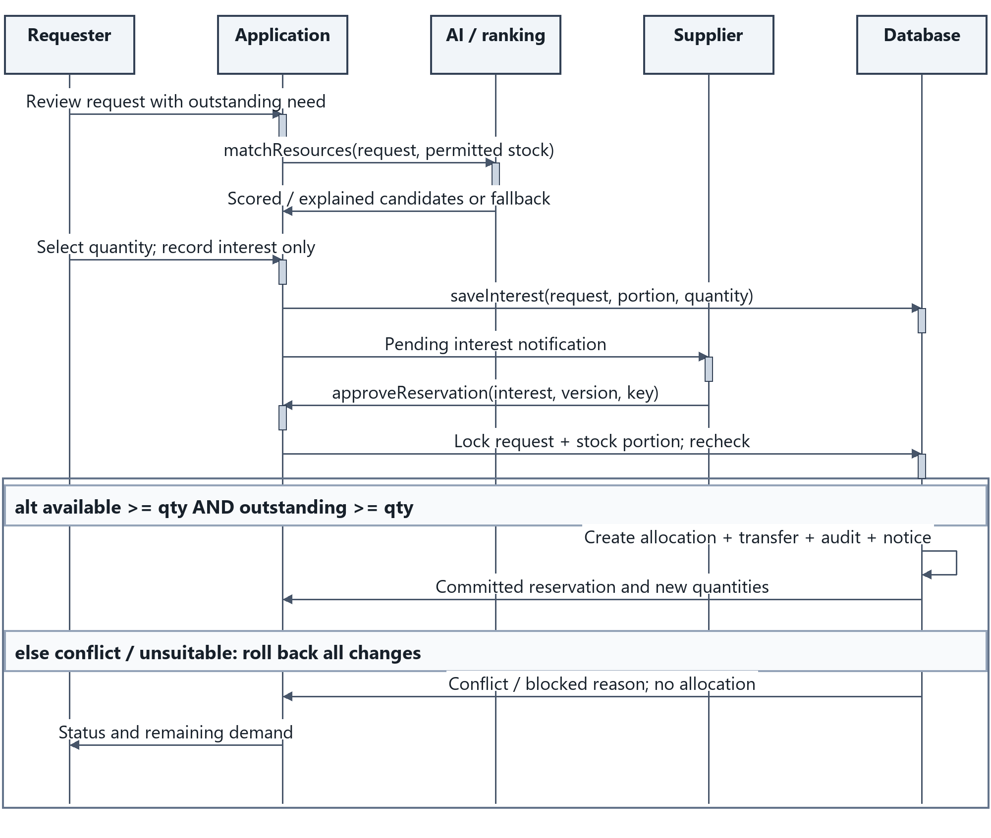
Figure 18 Advisory matching followed by atomic reservation
UC-06/07. Supplier approval is a separate message after requester selection. Locks and guards run inside the database transaction; a UI availability snapshot is insufficient. A repeated operation key returns the original outcome.
Solid messages: calls; dashed messages: replies; activation bars: executing participant. Alternative bands identify guarded branches; review the corresponding operation contracts in Section 11.

9.3 Transfer and Receipt Sequence
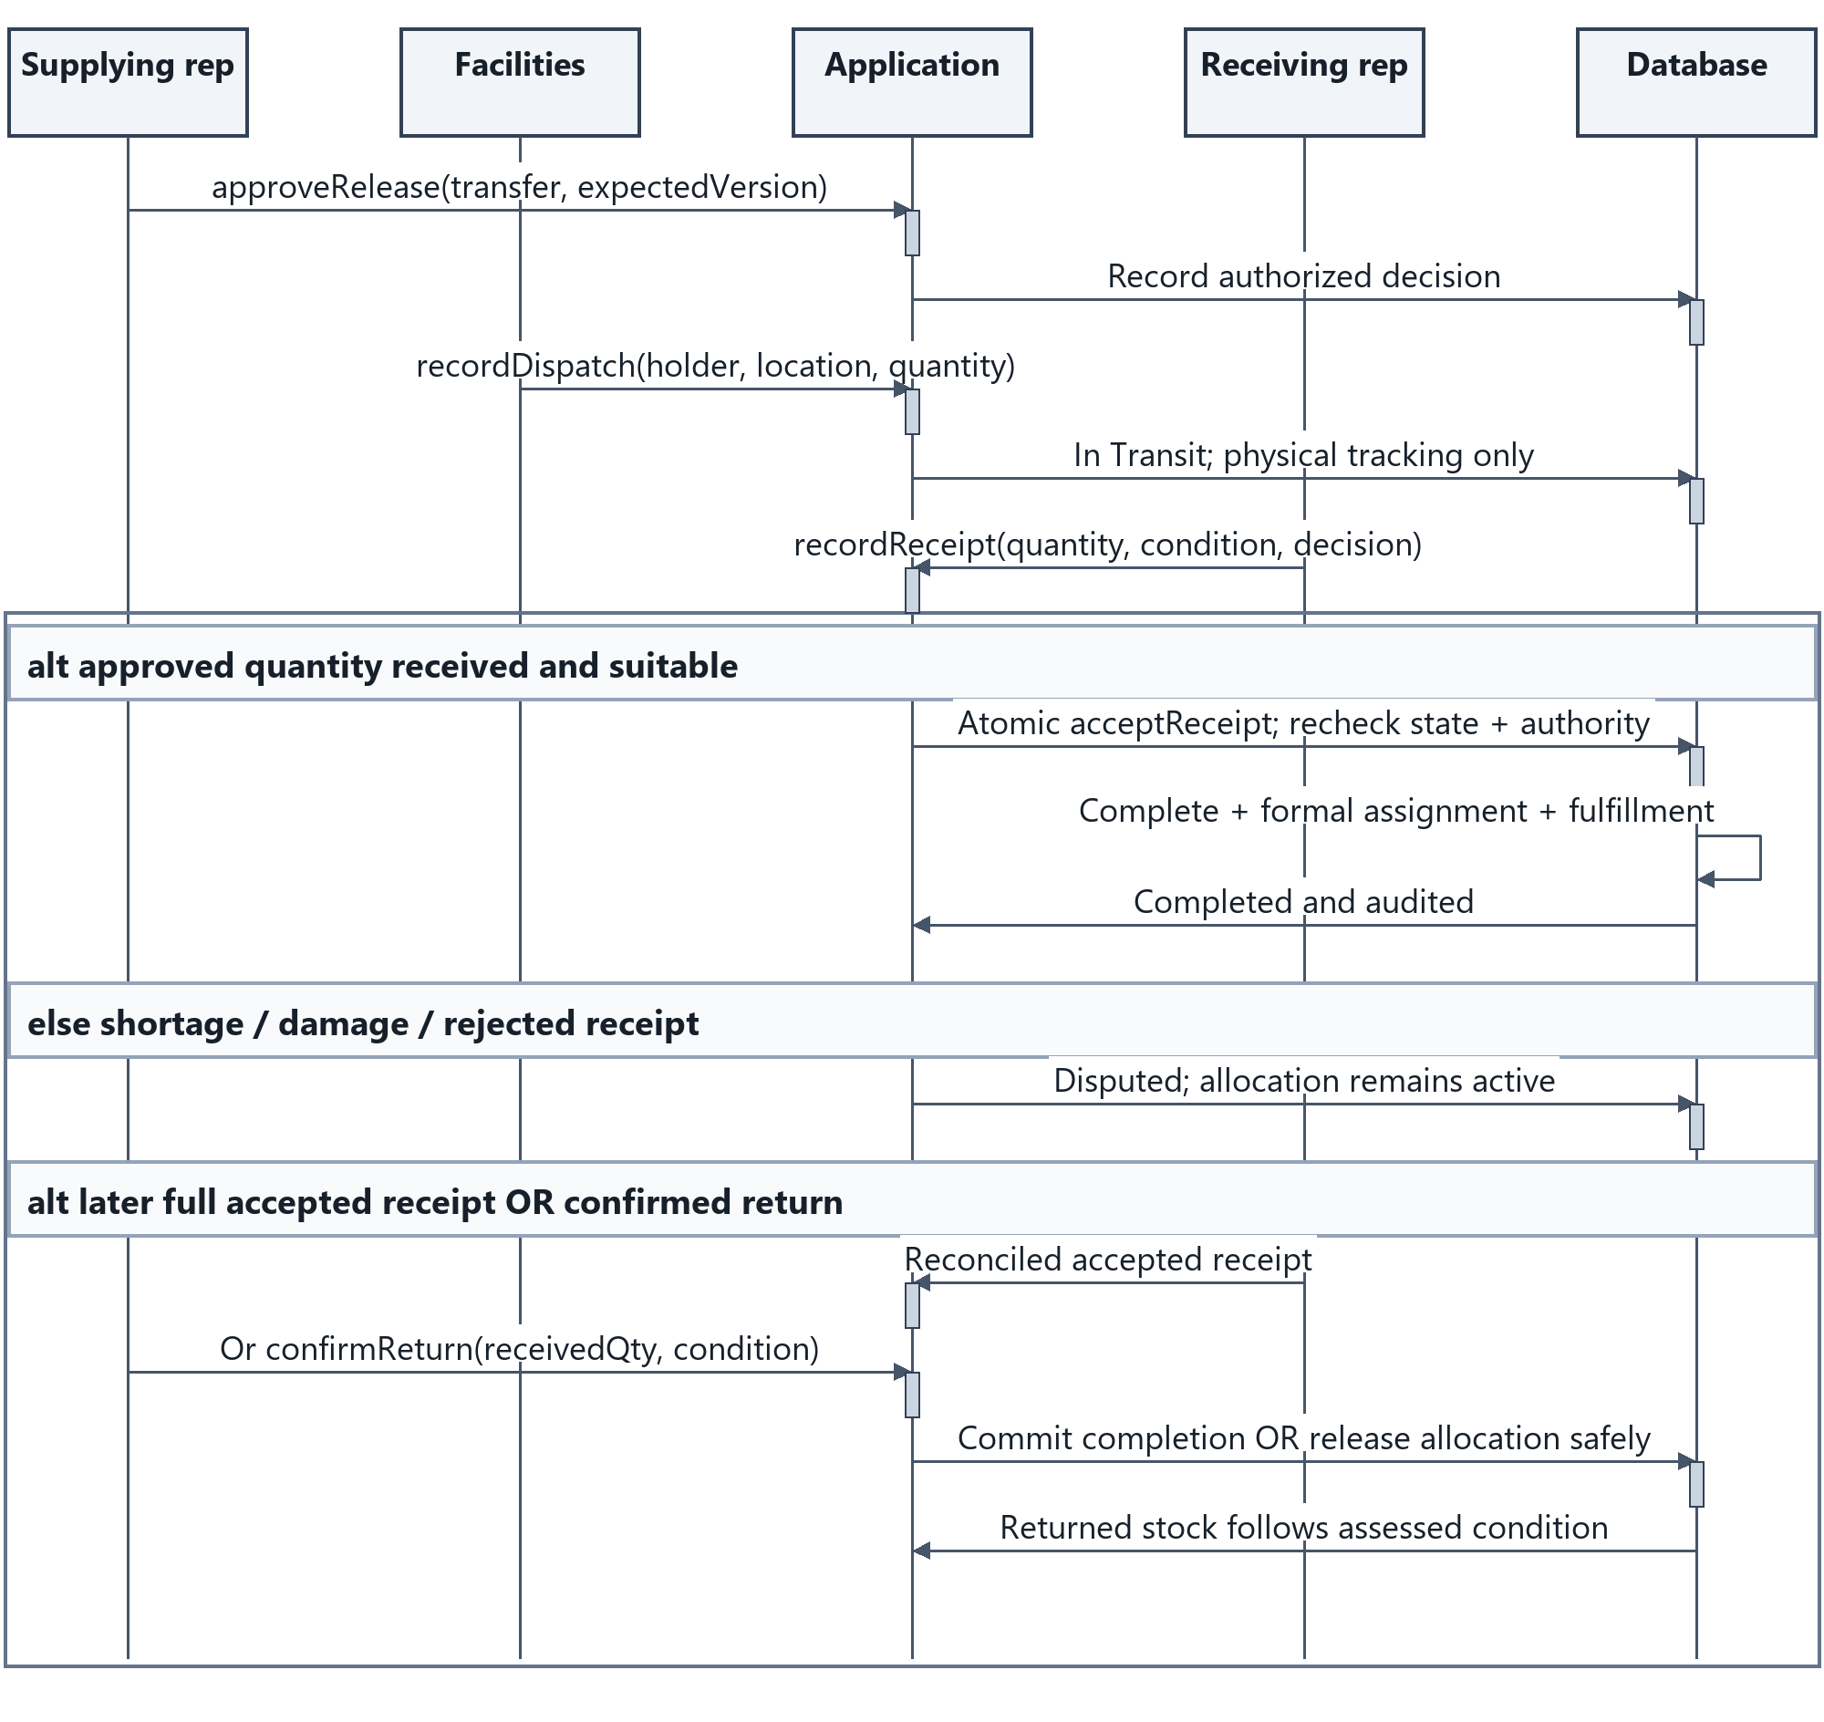
Figure 19 Physical movement accepted receipt dispute and return
UC-08. Dispatch changes physical tracking only. Completion requires accepted receipt of the approved quantity. A short receipt is Disputed; its allocation remains until a full reconciled acceptance or confirmed return. Unresolved loss remains an exception rather than invented fulfillment.
Solid messages: calls; dashed messages: replies; activation bars: executing participant. Alternative bands identify guarded branches; review the corresponding operation contracts in Section 11.

9.4 Assistant Request Sequence
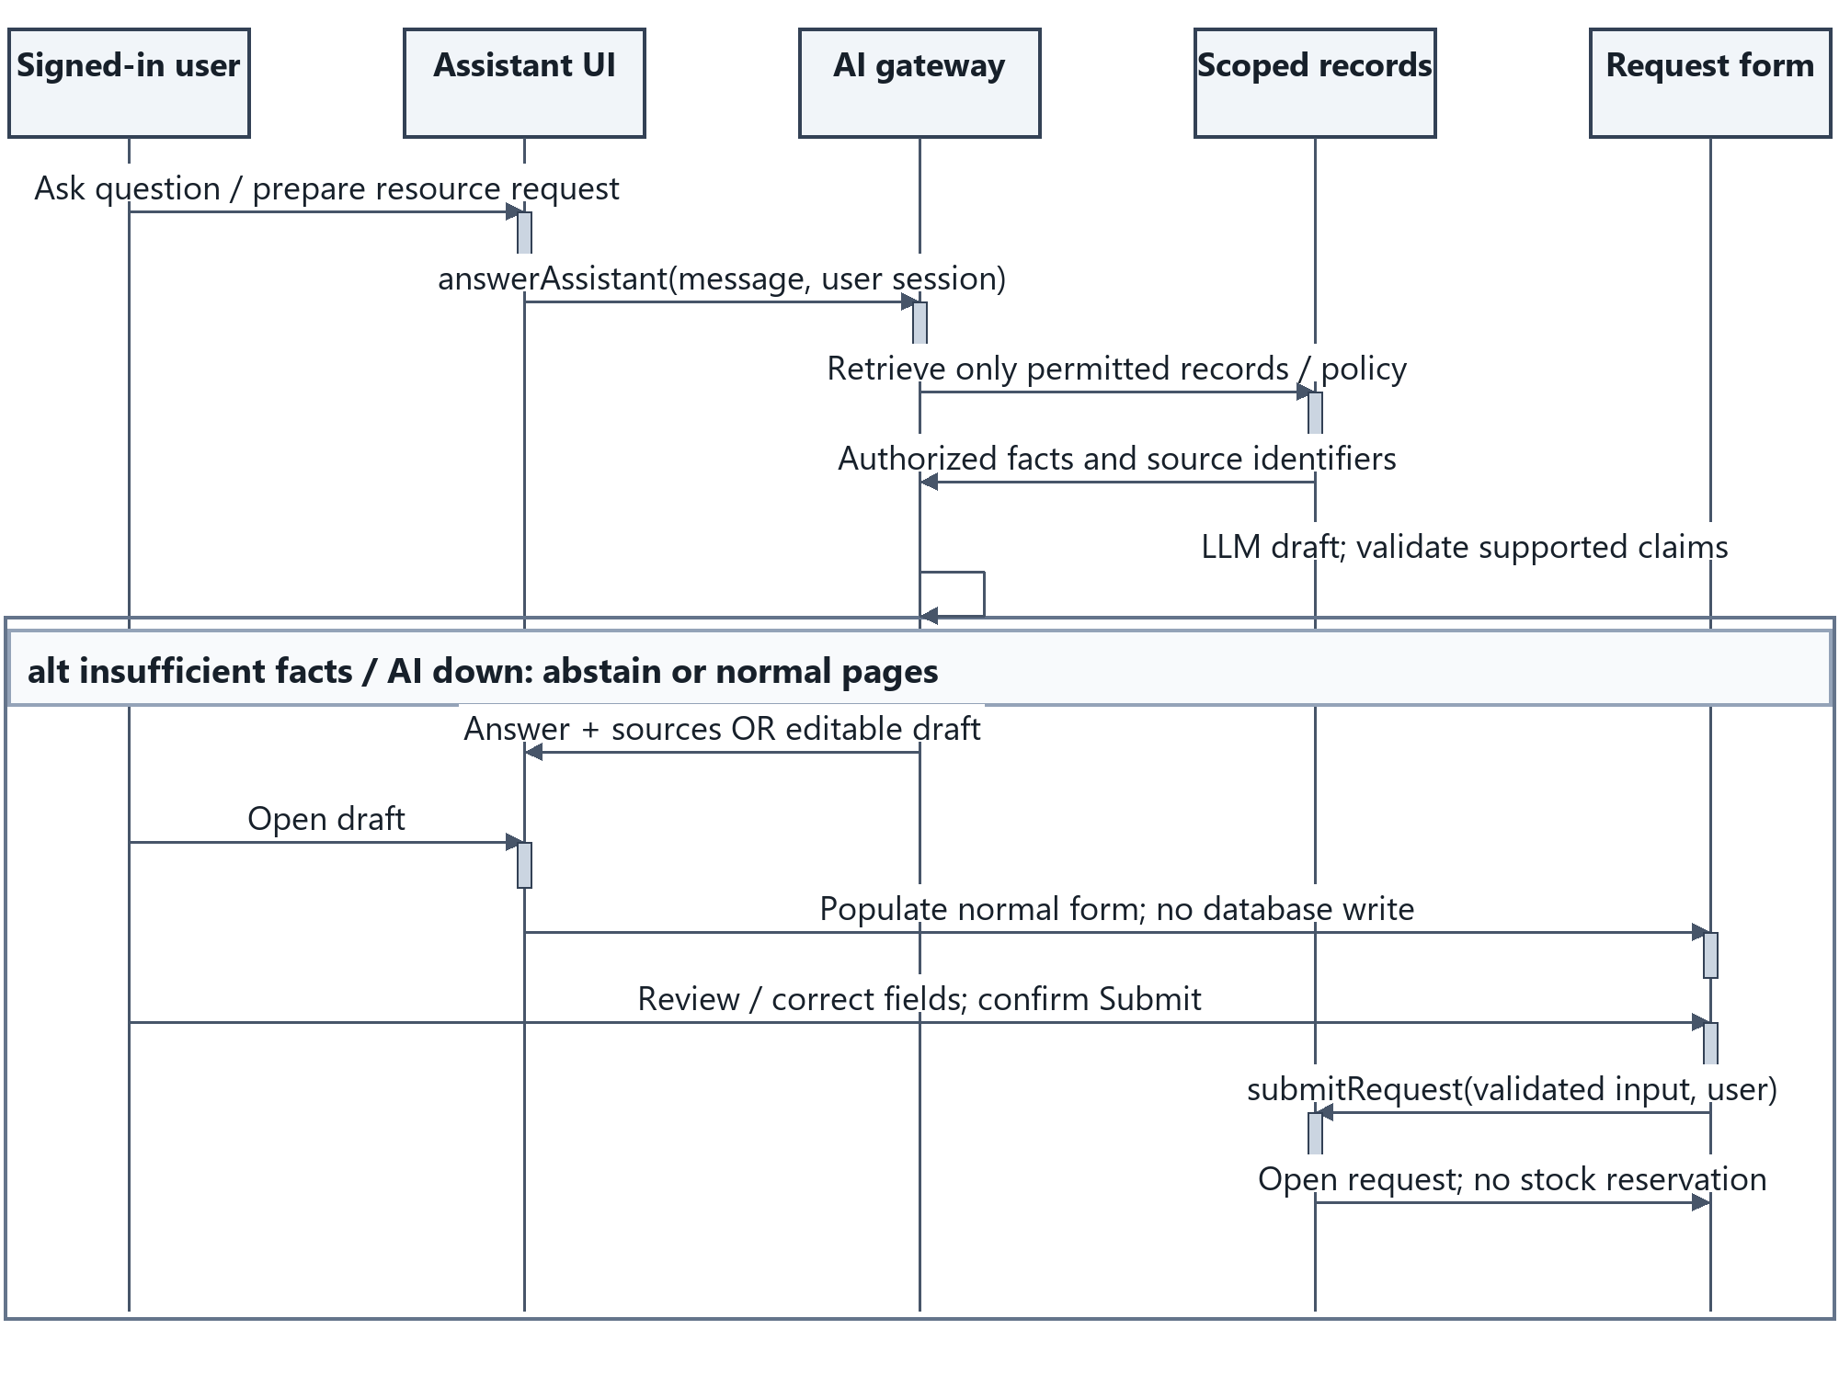
Figure 20 Scoped assistant response and normal request submission
UC-11/04. The assistant prepares an editable draft. Only the person’s standard form submission creates a request; approvals/reservations are never exposed as model actions. Factual answers carry permitted record references or an explicit lack-of-evidence response.
Solid messages: calls; dashed messages: replies; activation bars: executing participant. Alternative bands identify guarded branches; review the corresponding operation contracts in Section 11.

9.5 Exchange Activity
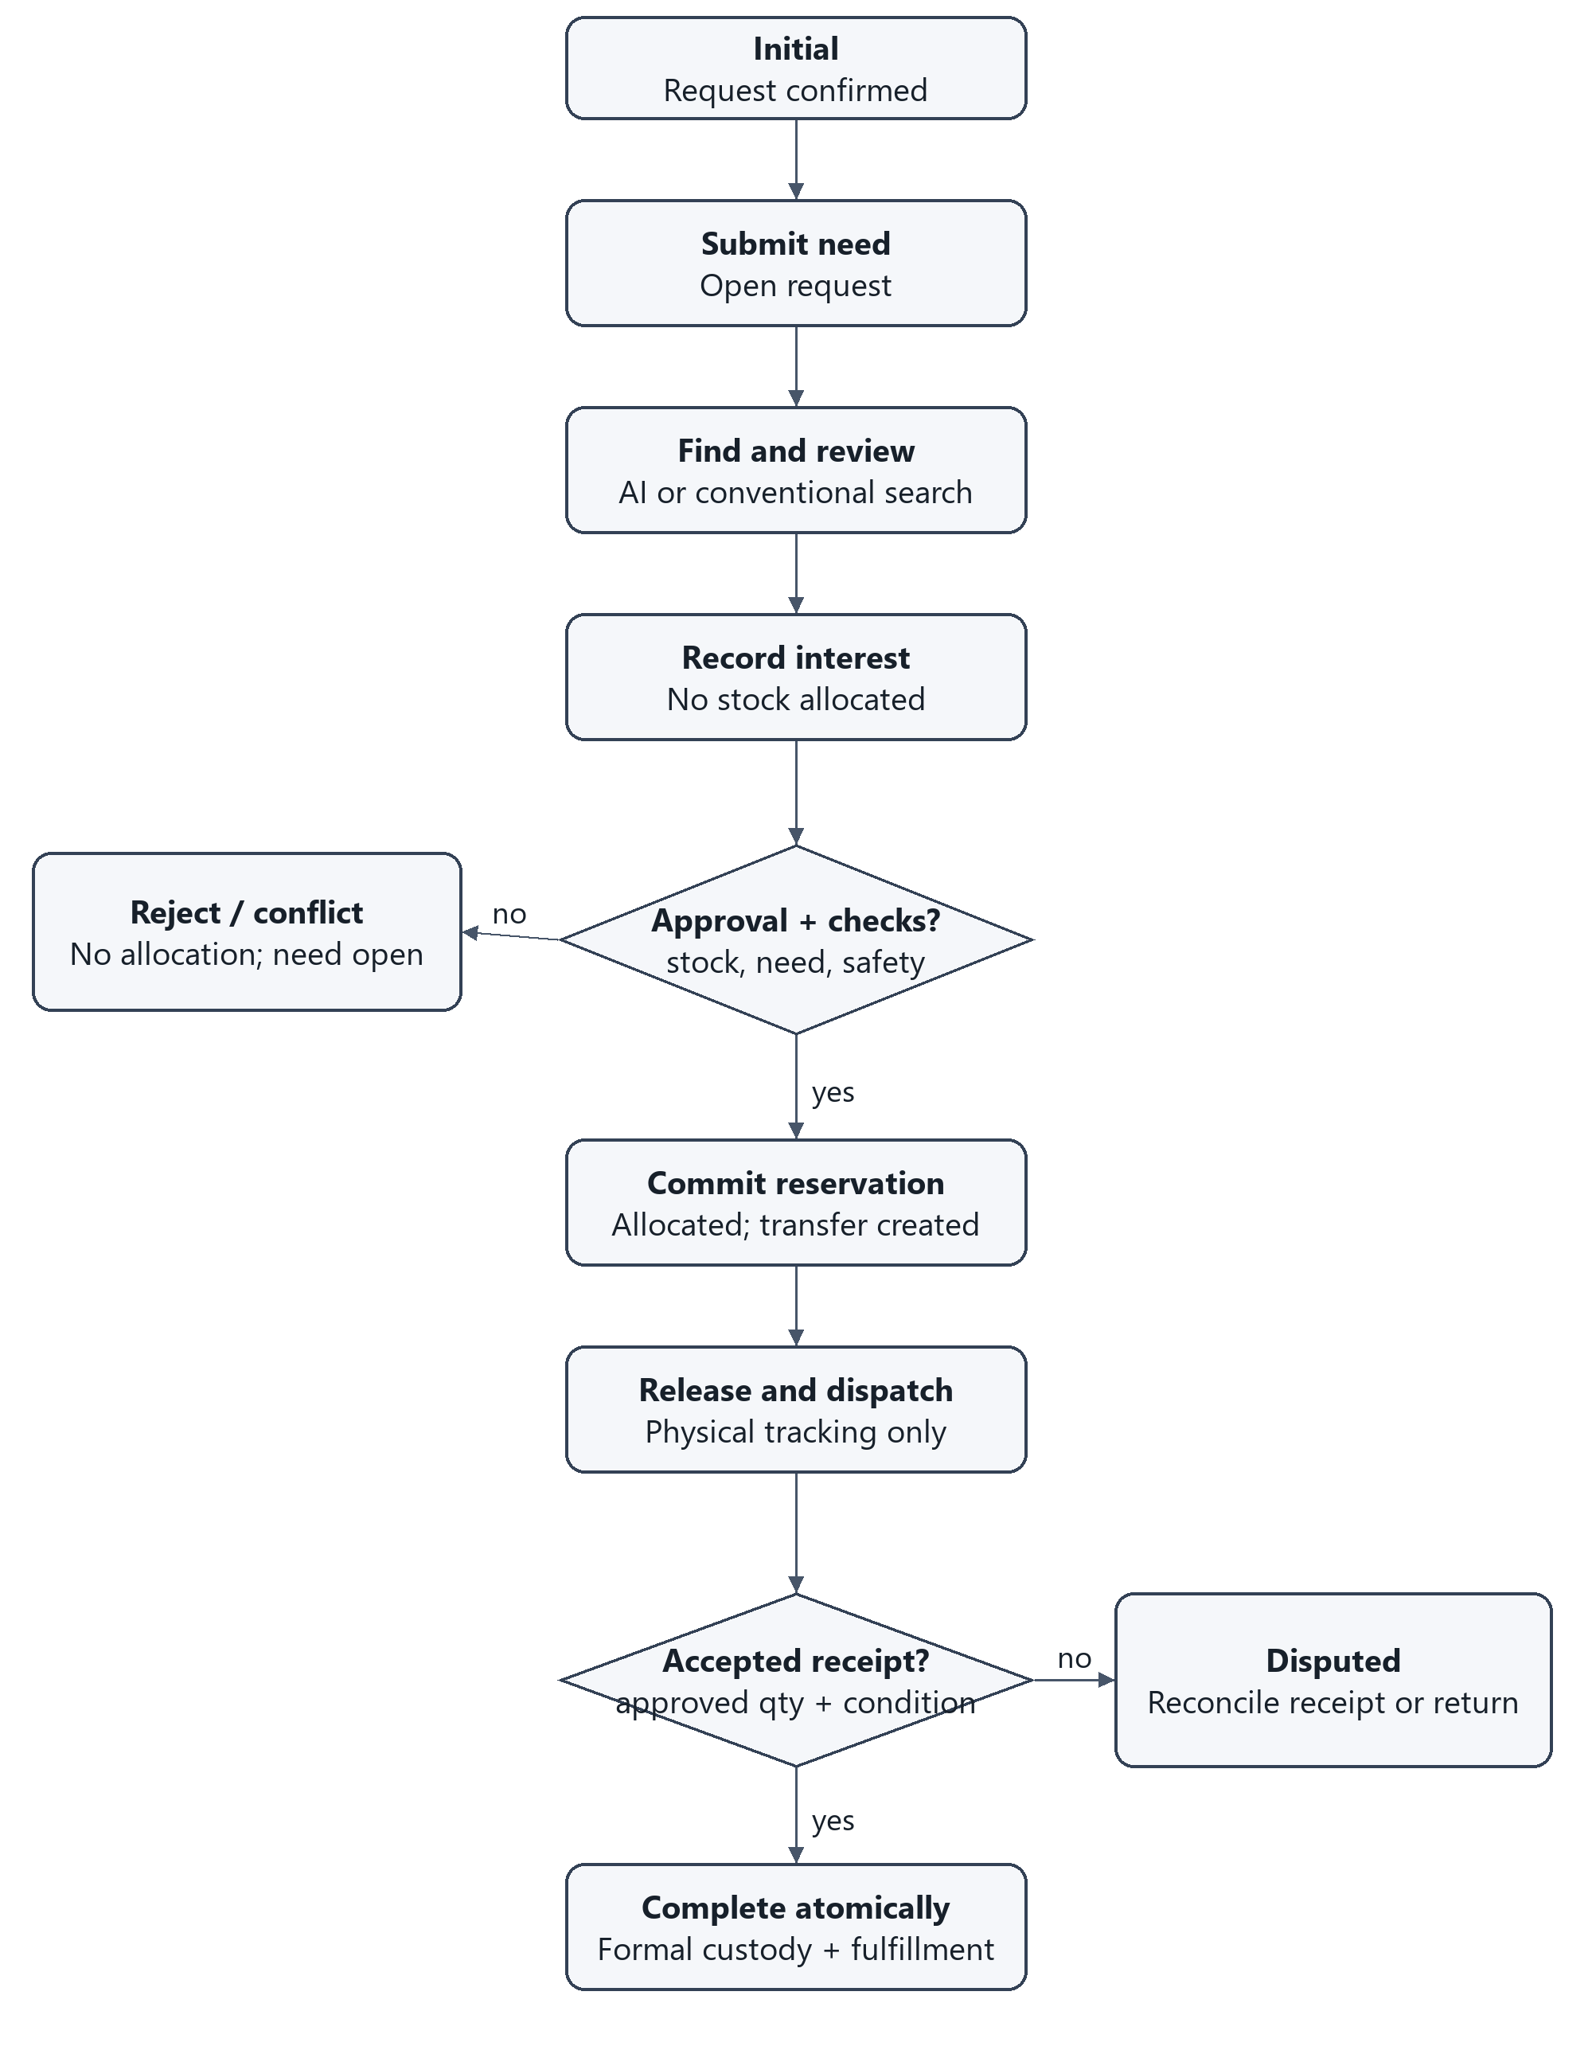
Figure 21 Exchange activity from request to accepted receipt
A rejected reservation keeps unmet need open. Before-dispatch cancellation releases allocation; after-dispatch cancellation cannot silently restore available stock. Disputes use the recorded reconciliation path. The flow ends in Completed only after receipt; the remaining demand of a partially fulfilled request stays active.

9.6 AI Recommendation Activity
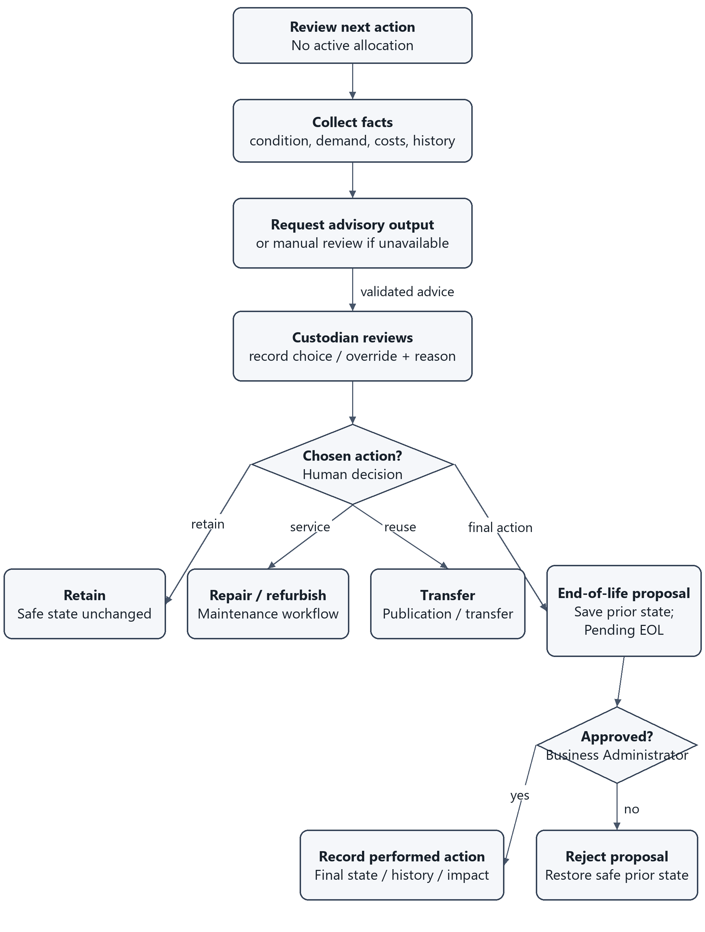
Figure 22 Sustainable action and human approval workflow
This is also the AI recommendation workflow diagram. Missing evidence or unavailable AI gives a reasoned manual-review path. Retain, repair and transfer end this review by entering their own workflow; none falls through to disposal. EOL approval and physical completion are separate events. An EOL rejection never certifies an unsafe item as usable.

9.7 Asset State Model
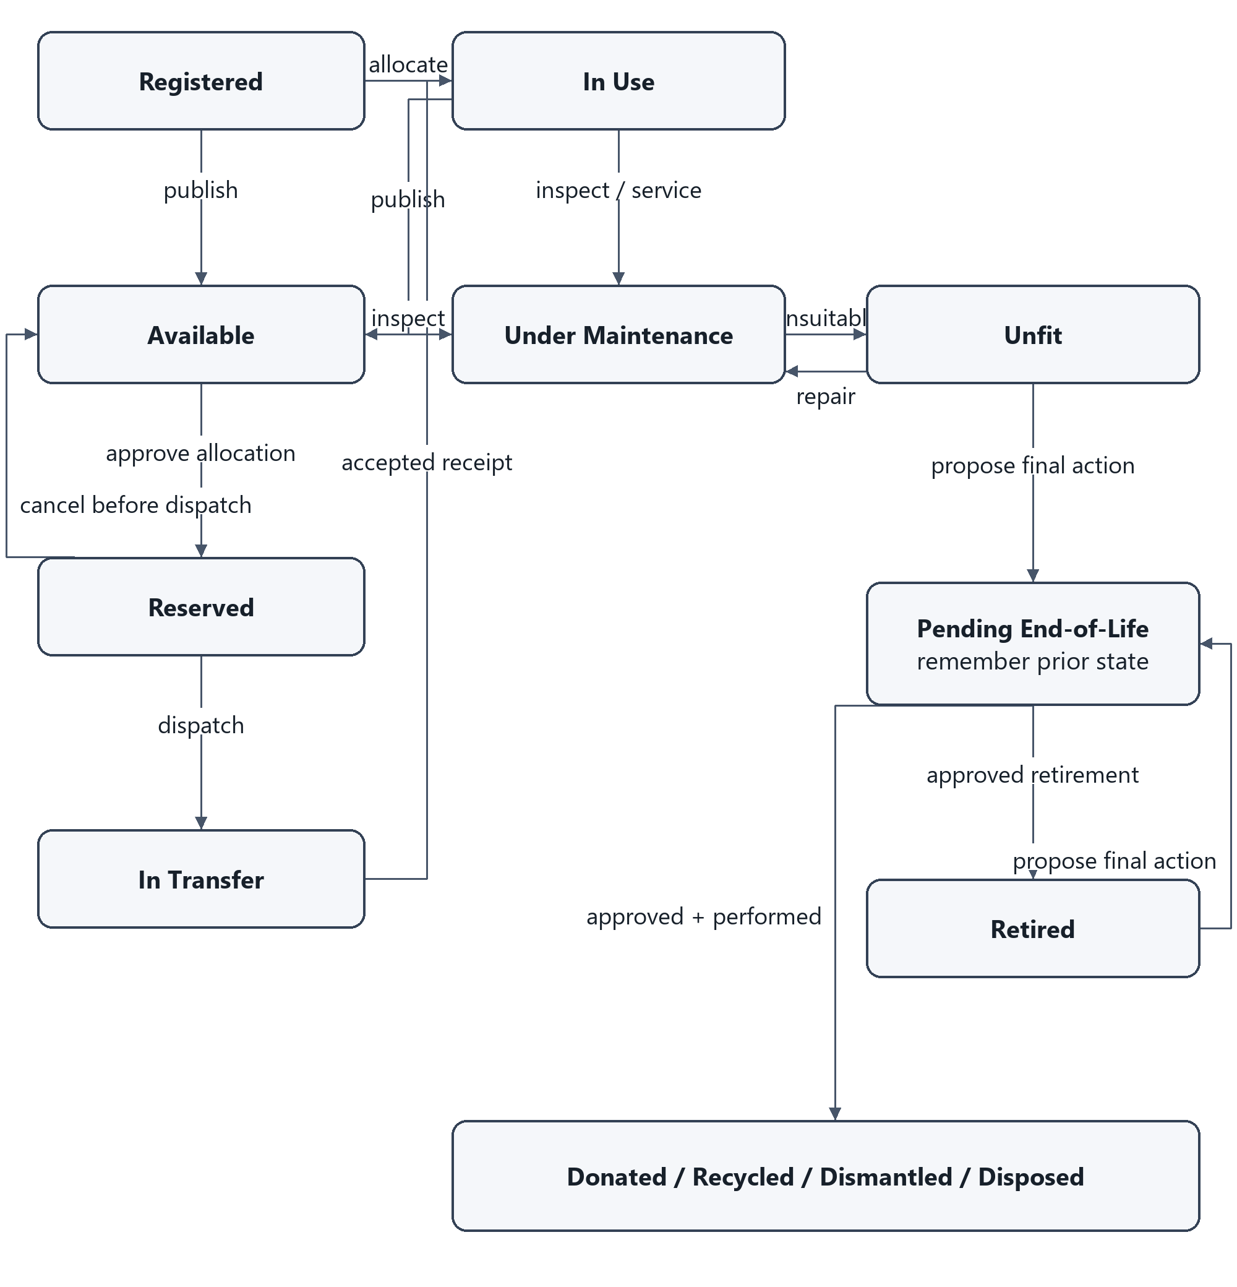
Figure 23 Asset or homogeneous portion state transitions
Additional guarded transitions from the SRS: In Use may become Unfit or Pending End-of-Life; Available/Reserved may become Under Maintenance or Unfit after a condition failure. A reserved condition failure releases/reconciles allocation and restores unmet need. Safe maintenance restoration returns to the prior In Use/Available context without overriding another active allocation.
Pending End-of-Life rejection restores its recorded prior In Use, Unfit or Retired state. In Transfer return requires supplier receipt/condition: restore Available/In Use only if suitable, otherwise Unfit/Under Maintenance. Final outcomes retain history. Each arrow applies to a portion, not every unit in a batch.

9.8 Request and Maintenance States
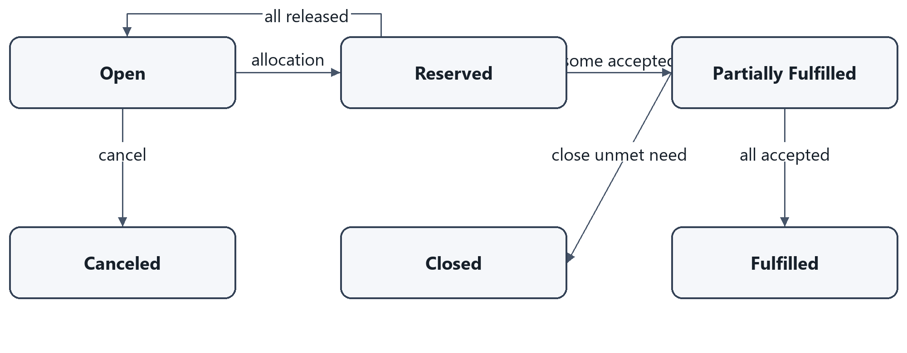
Figure 24 Request states
Reserved and Partially Fulfilled permit further eligible reservations while unallocated outstanding need remains. Full acceptance of all requested units gives Fulfilled; explicit closure of unmet need gives Closed. Cancel only after allocations/movement are reconciled. Returned units are not accepted fulfillment.
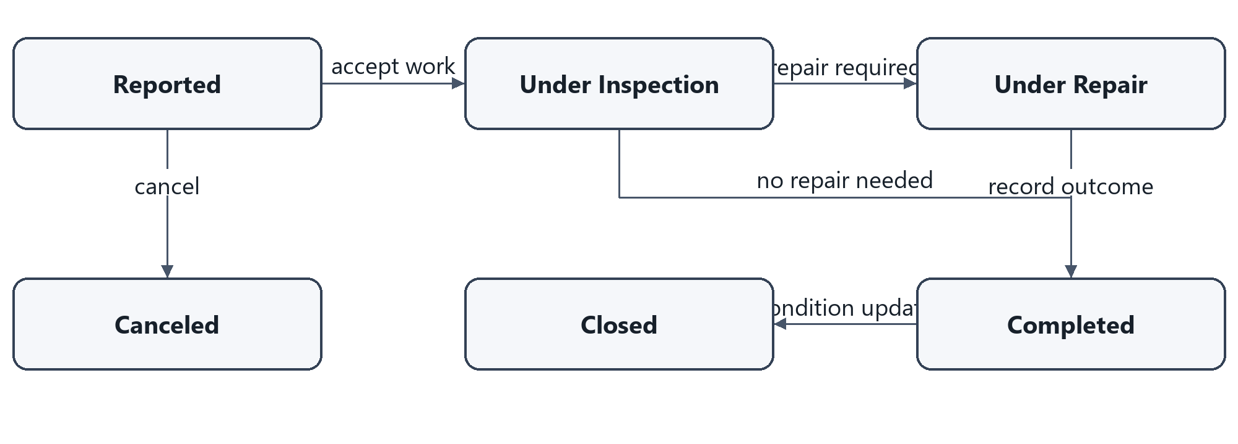
Figure 25 Maintenance work states
No-fault inspection may complete without repair. Completed work records its assessed outcome; only an authorized condition update closes the work and restores safe availability. Canceling a work order does not clear an unsafe assessment. Closed/Canceled retain history.

9.9 Transfer and Approval States
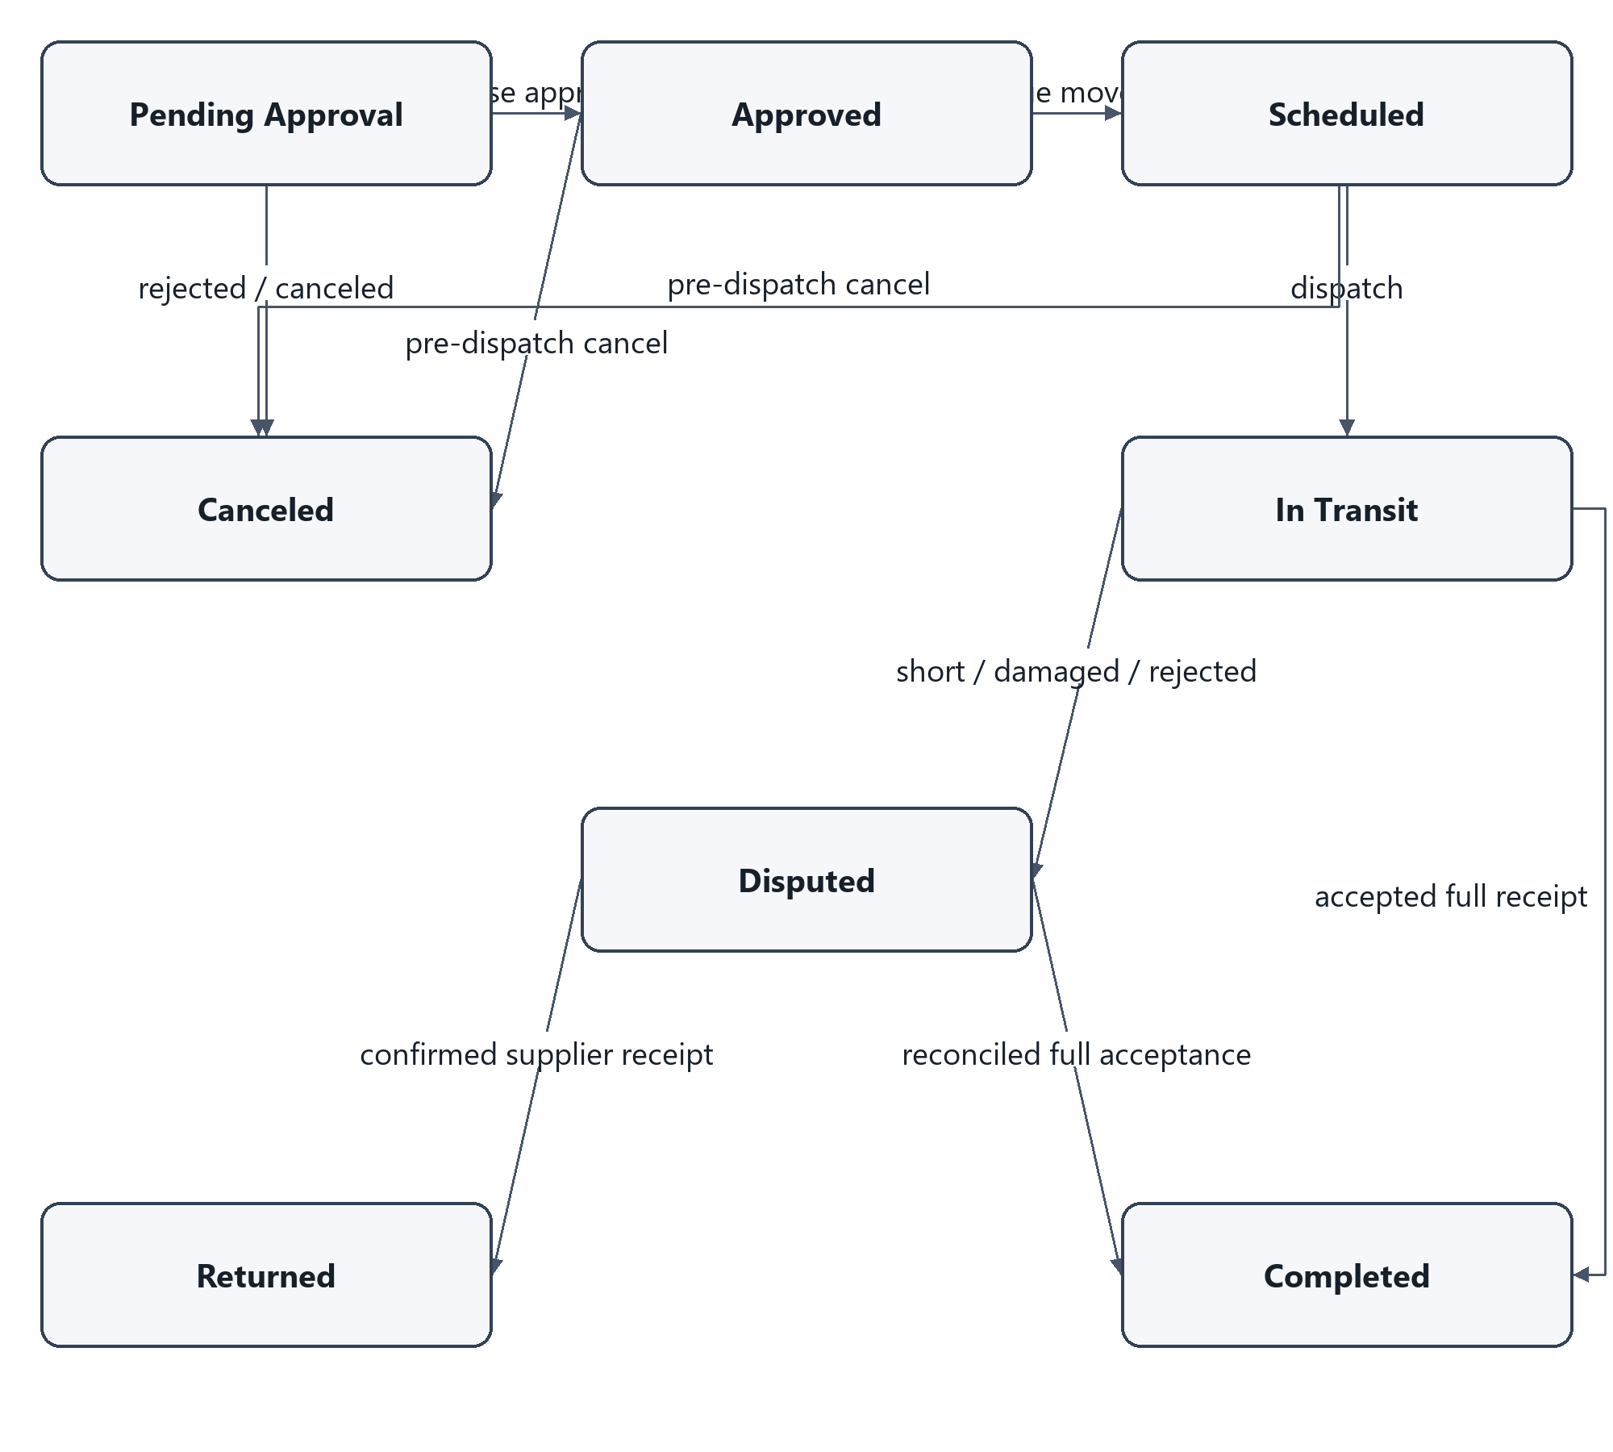
Figure 26 Transfer states and approval guards
Pending Approval is the transfer-release decision after confirmed reservation. A reservation approval and release approval are separate retained decision types, even when a permitted Should refinement combines their user interaction. Rejection/cancellation before dispatch releases allocation atomically. No path from In Transit directly to Canceled restores stock.
Disputed remains open and unavailable. Accepted reconciled full receipt completes transfer, formal assignment and request fulfillment together. Supplier-confirmed return releases allocation and restores remaining need; stock condition controls whether it becomes Available/In Use or remains unsafe. Terminal transfer states retain history.

10 Database Design
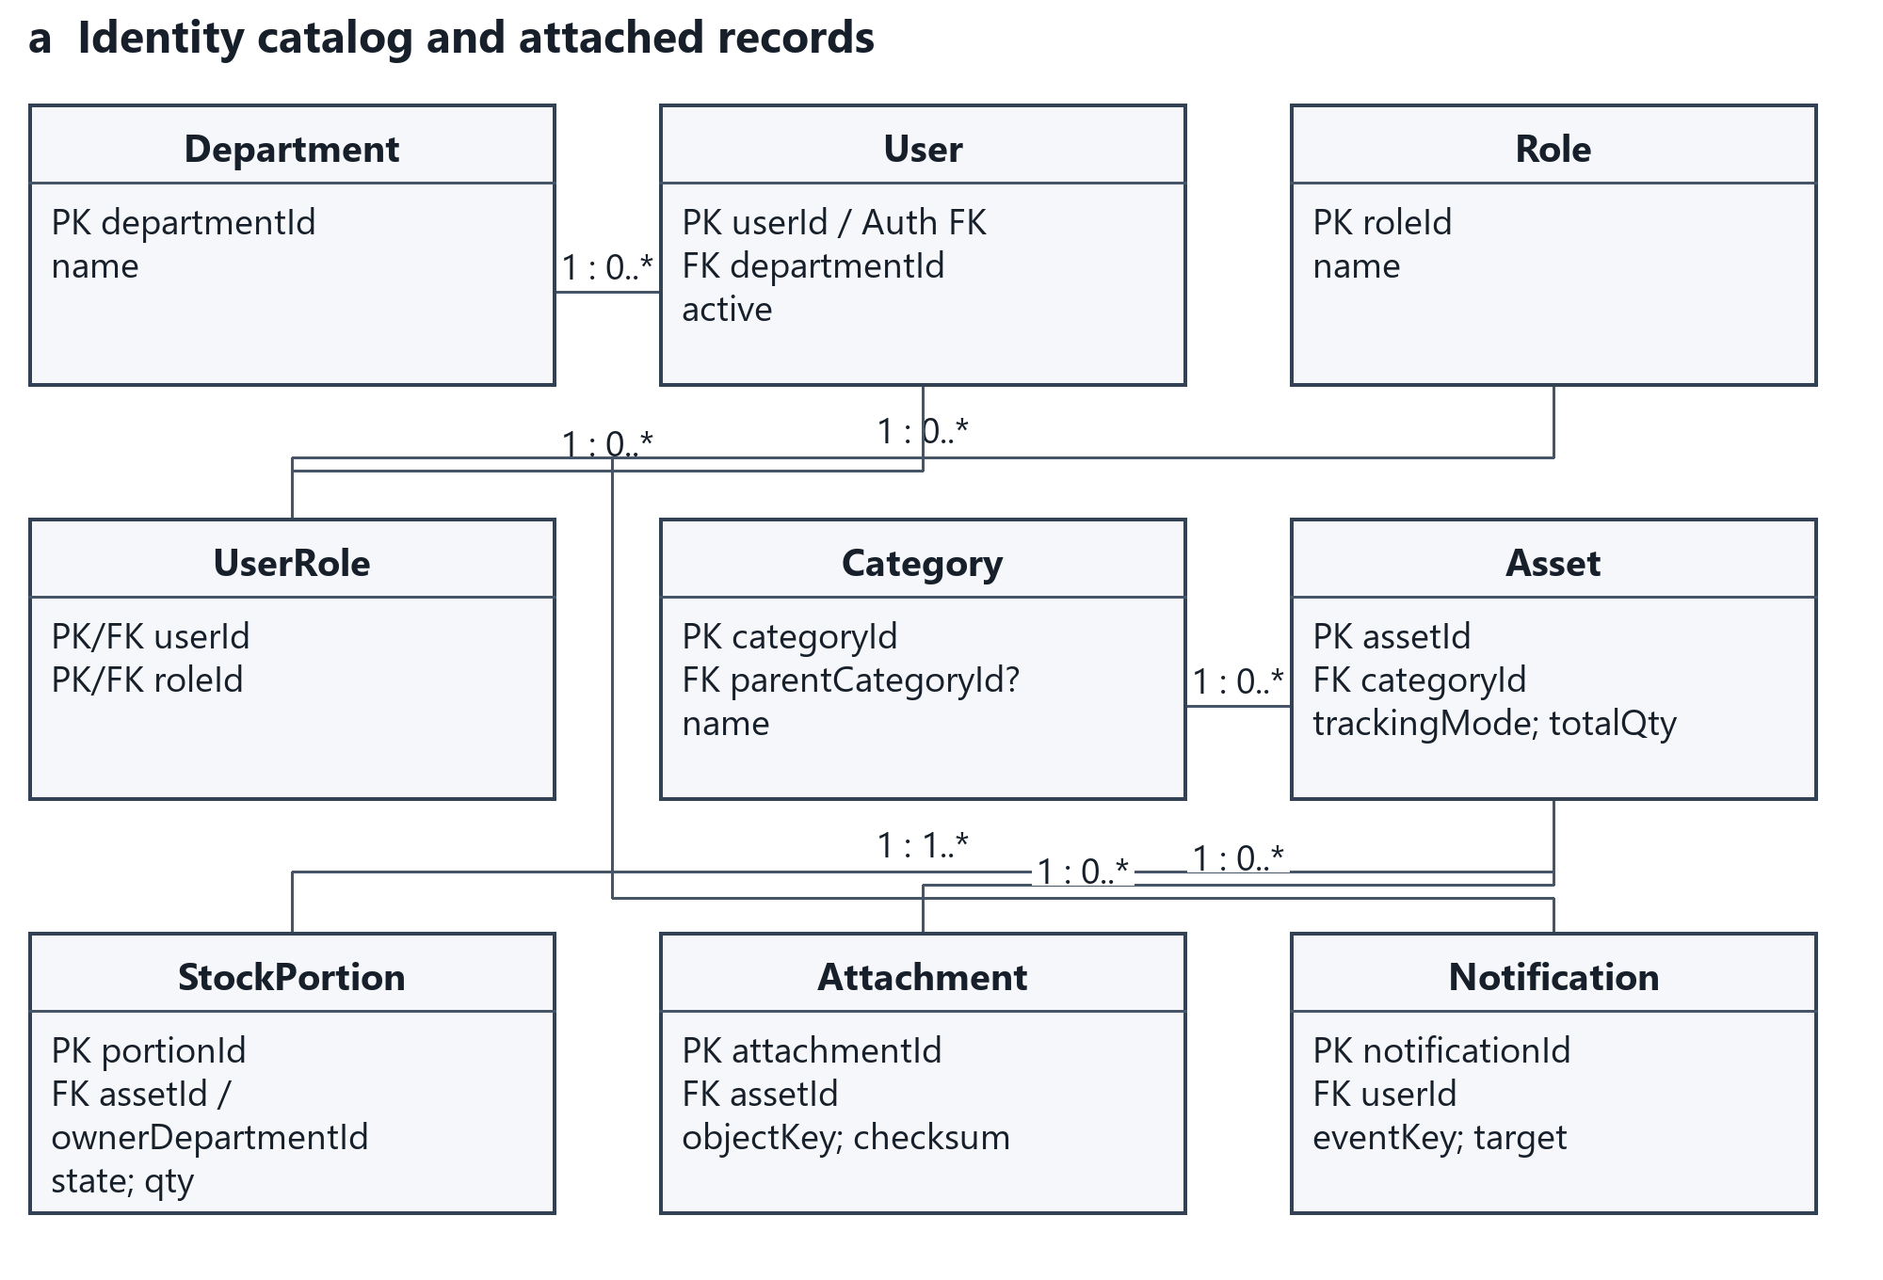
Figure 27 Core entities and relationship multiplicities

10.1.1 Exchange Entity Relationships
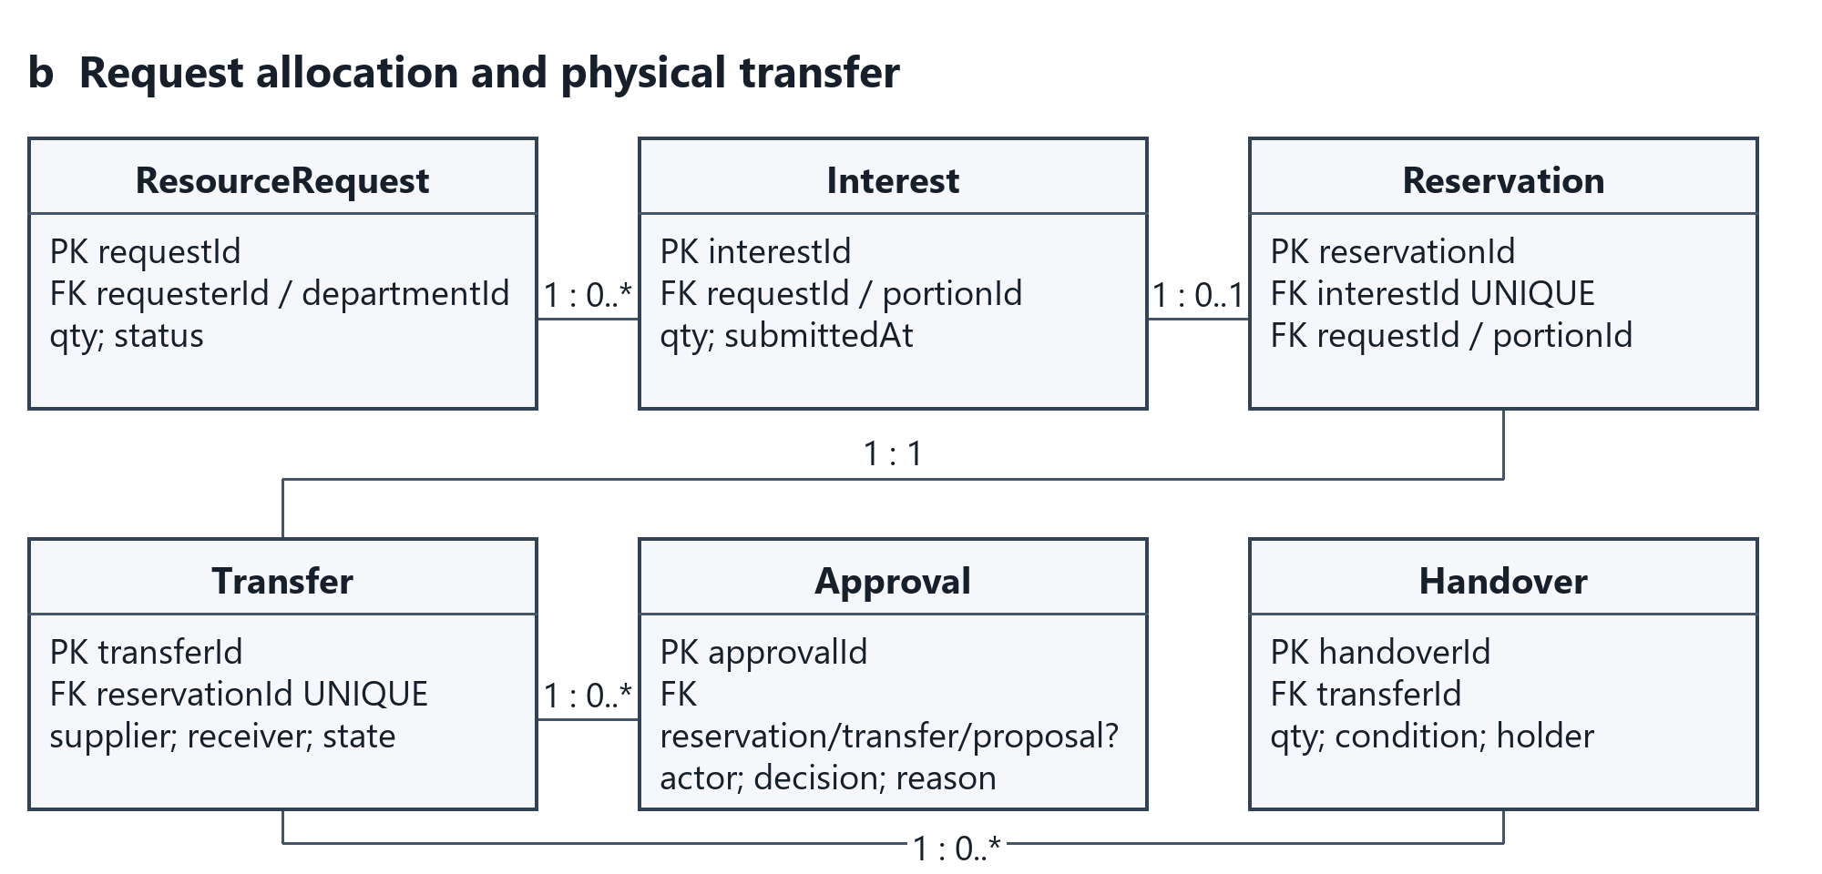
Figure 27b Exchange relationships
This and Figure 28 are views of one relational model, not separate databases. Full keys and constraints are listed in the dictionary. A reservation has at most one transfer through a unique foreign key; Role/UserRole implements many role assignments. Shared role labels do not grant a common report scope. Each request belongs to one requester and department.

10.2 Supporting Entity Relationships
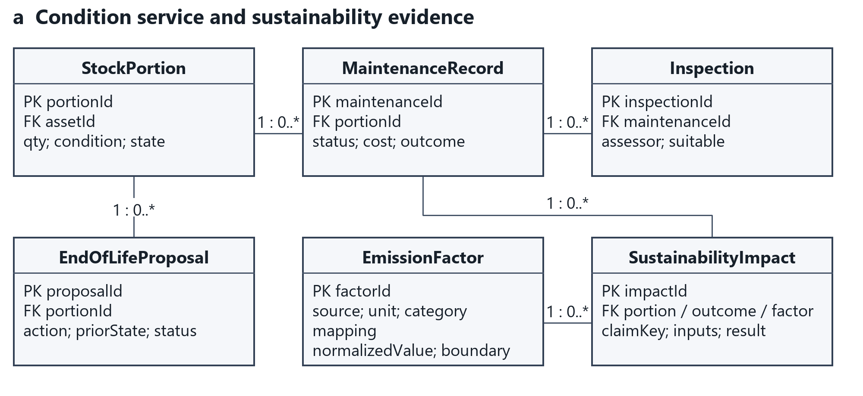
Figure 28 Maintenance AI sustainability and audit entity view

10.2.1 Model Review and Audit Entities
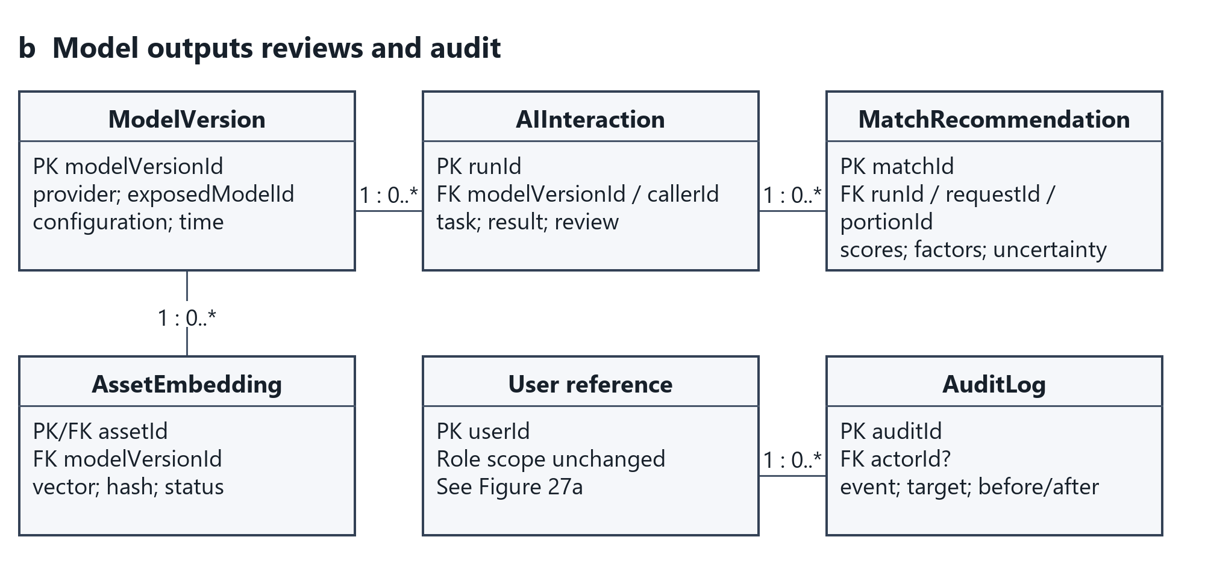
Figure 28b Model review and audit entities
Cross-view links: Attachment, StockPortion, MaintenanceRecord and EndOfLifeProposal refer to Asset/portion; AIInteraction identifies its caller and optional request/portion; MatchRecommendation links one request and portion. SustainabilityImpact keeps a qualifying source outcome and factor snapshot. Notification targets are resolved through authorized application access, not exposed as unrestricted URLs.

10.3 Core Data Dictionary
Entity / keys | Principal fields | Meaning and constraint
Department | departmentId PK; name | Organizational scope; no deletion while referenced.
User | userId PK/Auth FK; departmentId FK; name; active | One current department; assigned roles are separate.
Role / UserRole | roleId PK; name / (userId FK, roleId FK) PK | Nine human role classes; many assignments per user.
Category | categoryId PK; parentCategoryId FK?; name | Parent links subcategory; no artificial asset subclasses required.
Asset | assetId PK; categoryId FK; metadata; trackingMode; totalQty; purchaseDate; unitValue | Shared identity/specifications. Quantity ownership/state live on leaf portions.
StockPortion | portionId PK; assetId FK; parentPortionId FK?; qty; active; state; condition; ownerDepartmentId FK; custodianId FK; assignedLocation; holderId FK?; physicalLocation; priorState | Active leaf portions sum to asset total. Individual tracking has quantity one.
ResourceRequest | requestId PK; requesterId FK; departmentId FK; categoryId FK; requestedQty; status; specifications; condition; urgency; requiredDate; destination; purchaseBasis | Accepted/allocated/outstanding are computed from reconciled records, not editable totals.
Interest | interestId PK; requestId FK; portionId FK; qty; submittedAt; status | Selection only. Submission order supports fairness; no stock allocation.
Reservation | reservationId PK; interestId FK UNIQUE; requestId FK; portionId FK; qty; status | One approved allocation; transaction checks both stock and demand.
Transfer | transferId PK; reservationId FK UNIQUE; supplierDepartmentId FK; receiverDepartmentId FK; approvedQty; state; version; handlingCost | One tracked asset/portion per transfer. No multi-asset transfer engine.
Approval | approvalId PK; reservationId FK?; transferId FK?; proposalId FK?; actorId FK; decisionType; decision; reason; time | Exactly one target FK is present. Distinct approval types remain separate records.
Handover | handoverId PK; transferId FK; recordedBy FK; type; qty; condition; accepted; holderId FK?; location; time | Dispatch, receiver observation and confirmed supplier return are retained separately.

Portion and allocation invariants
Only active leaf portions count toward stock. Splitting replaces one active leaf with children whose quantities sum to the parent; closed parents remain for lineage and deduplication. Each accepted transfer can assign its quantity to a new receiver-owned leaf while the remaining supplier quantity retains its state. Reserve/dispatch/return affects only the allocated portion. Individual assets have quantity one.

10.4 Supporting Data Dictionary
Entity / keys | Principal fields | Meaning and constraint
Attachment | attachmentId PK; assetId FK; objectKey; mimeType; name; checksum | Private object storage; download permission follows the asset.
MaintenanceRecord | maintenanceId PK; portionId FK; reporterId FK; status; serviceType; priorState; cost; outcome | Work status does not itself establish safe condition.
Inspection | inspectionId PK; maintenanceId FK; assessorId FK; findings; suitable; evidence; assessedAt | Explicit condition assessment permits return to service.
EndOfLifeProposal | proposalId PK; portionId FK; priorState; action; justification; status; performedBy FK?; completedAt? | No active allocation. Rejection restores prior state without clearing unsafe condition.
ModelVersion | modelVersionId PK; provider; exposedModelId; configVersion; observedAt; revisionLimitation | Keep provider-visible identifier; do not invent an exact model revision.
AIInteraction | runId PK; modelVersionId FK; callerId FK; task; requestId FK?; portionId FK?; status; result; uncertainty; review; reviewerId FK?; reason; latency; callCount; tokens; cost? | Task-scoped input references, validated output and human review; secrets excluded.
AssetEmbedding | assetId PK/FK; modelVersionId FK; contentHash; vector; status | Ready/pending/failed. Invalidate on relevant metadata/model changes.
MatchRecommendation | matchId PK; runId FK; requestId FK; portionId FK; compatibility; rank; factors; missing; review | One request and one portion per recommendation; no authorization authority.
EmissionFactor | factorId PK; categoryMapping; sourceURL; sourceVersion; originalValue; originalUnit; normalizedValue; boundary | Source and unit conversion are retained with calculation snapshots.
SustainabilityImpact | impactId PK; portionId FK; transferId FK?; maintenanceId FK?; proposalId FK?; claimKey; cohort; metric; qty; result?; unit; inputs; factorId FK?; methodVersion | Unique benefit claim per physical unit/outcome/cohort; retain unavailable results and reasons.
Notification | notificationId PK; userId FK; eventKey; targetType; targetId; requiredAction; readAt? | Unique (userId,eventKey); linked-record access is checked again.
AuditLog | auditId PK; actorId FK?; event; targetType; targetId; time; before; after; correlationId | Append-only to ordinary roles. Record service identity for technical events.
All foreign keys refer to retained records. Approval has exactly one non-null reservation/transfer/proposal target. Active reservation quantities cannot exceed portion stock or request outstanding demand. Category/method/model identifiers are controlled data. Costs use fixed-decimal values and an explicit currency; quantities/mass and dates retain their units/time basis.

11 Interface Contracts
Protected operations receive the authenticated caller, target record, expected version and operation key where retry could duplicate a mutation. Return a typed outcome and current record/version; never trust a role/department supplied only by the browser. Error categories are Unauthorized, Forbidden, Validation, Conflict, NotFound and AIUnavailable. No partial mutation survives a failed transaction.
Operation / caller | Input and preconditions | Committed output / failure
saveAsset / publishAsset  Representative | Metadata, files, portion quantity/condition; caller owns department scope. Publication requires complete required fields and no conflicting allocation. | Registered record, or Available eligible quantity; audit. Invalid fields retain entered input. Optional embedding follows save.
submitRequest  Requester / Rep | Category, purpose, specs, qty>0, condition, urgency, date, destination; user confirms form, including assistant draft. | Open request; no interest/reservation. Validation returns field errors without losing input.
recordInterest  Requester / Rep | Active request, selected portion and positive quantity; permission and current listing rechecked. | Linked Interest; no stock or demand allocation. Closed/fulfilled/canceled requests reject new interest.
approveReservation  Supplying Rep | Interest ID, approved quantity, expected version, operation key; no self-approval. Lock request and portion; check suitable available stock and outstanding need. | Reservation, allocated portion, Pending Approval transfer, decision, audit/event all commit. Conflict or unsafe state rolls back everything.

Transaction and retry rule
Lock affected request and stock rows in a consistent key order. Recompute accepted fulfillment and active allocations from authoritative records, then check the new quantity against both limits. Keep a unique operation key per caller/operation; replay returns the previous committed result. Never perform AI/network calls while the stock transaction holds locks.
FR-ASSET-001 to 008; FR-REQUEST-001 to 008; CI-001; NFR-QUAL-003; BR-003/005/006.

11.2 Movement Maintenance and Reporting Contracts
Operation / caller | Required input / guard | Result
approveRelease / recordDispatch  Supplying Rep / Facilities | Transfer ID/version; separate authorized release, suitable condition, approved quantity; assigned facilities records actual holder/location. | Approved -> Scheduled -> In Transit. Dispatch does not change formal departmental custody.
acceptReceipt  Receiving Rep | Approved quantity fully observed and accepted; condition suitable, authority and transfer state rechecked; same operation key on retry. | Complete; formal assignment, fulfillment, stock, history, costs and notice event update atomically. Short/damaged receipt becomes Disputed instead.
confirmReturn  Supplying Rep | Disputed transfer; physical returned quantity reconciled; supplier confirms receipt and assessed condition. | Returned; allocation released, unmet need restored, supplying portion state selected from recorded condition/prior context. Unsafe stock unavailable.
recordMaintenanceOutcome  Maintenance / authorized Custodian | Work/inspection IDs; findings, assessed suitability, actions/cost, prior context; preserve/reconcile affected allocations. | Retained service evidence; safe condition update or Unfit. Missing findings block closure; cancellation does not certify safety.
propose / decide / completeEndOfLife  Custodian / BA / assigned staff | No active allocation; prior state, reason/action; authorized approval before recorded completion. | Retention/service/transfer route separately. Rejection restores recorded state; approved performed final action changes state/history.
generateReport / summarizeReport  Scoped report reader | Permitted department/category/period; fixed inputs/factors/cohort; AI receives only computed permitted snapshot. | Deterministic report first. Missing data -> unavailable; zero denominator -> N/A; unsupported AI numbers withhold draft.
FR-TRANSFER-001 to 008; FR-MAINT-001 to 006; FR-AI-SUST-004; FR-REPORT-001 to 009; SUS-001 to 007; BR-007/008/010.

11.3 AI Interface Contracts
The gateway authenticates the caller, obtains permitted facts, invokes the configured provider and validates the result. The shared result contains task/run ID, status, exposed model/configuration, source record references, advisory payload, uncertainty/missing fields and elapsed time. Only task-required fields/files are sent; no service key is part of the client contract.
Interface | Advisory payload and validation
classifyAsset | category/subcategory from allowed taxonomy, tags, standardized description, materials, missing fields, evidence references; reject malformed/unknown enum output.
embedAndMatch | vector with known model/dimension/content hash; candidates with portion/request IDs and constraint evidence. Stale/incompatible vectors cannot be silently compared.
rankCandidates | compatibility/rank scores, factors, blocked/needs-review flags and readable reasons; results come from the declared calculation, not a fabricated model score.
adviseAction | allowed action, feasible alternatives, supporting facts, costs/benefits, assumptions and uncertainty. Missing essential facts -> Needs review; no execution command.
answerAssistant / summarizeReport | permitted-source answer or editable draft; report snapshot references and numeric evidence. No unrestricted record lookup, approval tool or model-generated transaction.

Model monitoring records
AIInteraction retains provider-visible model ID, configuration/prompt/scoring version, task, input references/hash, result status, latency, call count, usage and estimated cost when a known rate exists. Retain acceptance/correction/rejection/override and reason. Operational reports show failure rate, latency distribution, review outcomes and counts per task. This is a small log/report design, not a separate monitoring platform.
Report validation compares all numeric claims to the computed snapshot; a failed check withholds the AI draft and keeps the fixed report. Confidence is a labeled uncertainty signal; unsupported self-assessments are never described as calibrated probabilities.

12 AI and Sustainability Design

12.1 Eligibility and transparent scoring
First enforce current publication/availability, ordinary-use safety, mandatory category/specification/condition constraints, authority and remaining need. Confirmed incompatibility is excluded. Missing mandatory evidence is Needs review and blocks reservation until resolved. Semantic similarity never overrides these checks.
For eligible candidates, define S = semantic signal in [0,1] from clamp(cosine,0,1); C = acceptable-condition fit; Q = min(available quantity / unallocated need,1); L = 1 for same building, 0.5 for same campus, 0 for different/unknown location. C = 1 if matching preferred condition, 0.5 if suitable but below preference and allowed; unknown mandatory condition remains blocked.
Compatibility = 100 x (0.65S + 0.15C + 0.10Q + 0.10L). These coefficients are prototype assumptions, versioned and checked on fixed labeled cases; they are not learned accuracy claims.
Rank = 100 x (0.60F + 0.15T + 0.10K + 0.10W + 0.05E), where F = compatibility/100; T = 1 for supported delivery by required date, 0 for unavailable/unknown timing; K = clamp(1 - (transfer + relevant repair cost)/replacement value,0,1); W = supported diverted fraction in [0,1]; E = clamp(estimated avoided manufacturing emissions / declared reference emissions for the same category,0,1). Missing optional cost/benefit factors contribute 0 with a warning; weights are not silently redistributed.
Urgency guides review across competing requests, with submission order as the default. A departure for urgency/suitability/timing requires a recorded human reason (BR-005); it is not automatic preferential allocation. Required-date feasibility is checked before release. Display each contributing factor and missing input. Rank below 60 is labeled Weak match; any mandatory uncertainty takes precedence over that threshold.
Worked factor set | Result
F=0.80; T=1; K=0.50; W=1; E=0.40 | Rank = 100 x (0.48+0.15+0.05+0.10+0.02) = 80.
Same factors, missing carbon evidence | E=0; rank=78; carbon estimate unavailable; explicit warning.
Mandatory HDMI incompatibility | Excluded regardless of any calculated score.
TBD-004 prototype decision; FR-AI-MATCH-001 to 011; AI-REQ-004/007/008; Decision 02-ai-integration.

12.2 Sustainability Methods
Metric | Method and boundary
Avoided purchases / gross value | Count only accepted reused units with a declared otherwise-purchase scenario. Gross value = qualifying units x replacement unit value. No purchase basis -> no avoided-purchase claim.
Waste diversion | Declare one disposal-risk cohort, period and unit. Rate = diverted / (diverted + disposed) x 100 for completed outcomes. Pending excluded; count a physical quantity once even if repaired then transferred.
Financial savings | Net = gross avoided-purchase value - relevant repair - allocated handling/transport costs. Shared costs allocated explicitly once. Negative net savings are valid.
Reuse / repair | Separate completed transfer events from accepted reused units, and repair events from units restored. Reuse rate = distinct accepted reused cohort units / distinct eligible cohort units x 100. Repair is not reuse until accepted transfer.
Life extension | Additional service months = max(expected post-action remaining service months - baseline remaining service months, 0). Inputs are human-reviewed forecasts with a date/basis; latest non-overlapping forecast per physical quantity prevents summing repeat claims.
Carbon / unknown inputs | Use only a documented category mapping and source factor. Retain mass, source version, unit conversion and boundary. Unsupported category or missing essential input -> unavailable. Zero rate denominator -> N/A.

EPA WARM v16 factor basis
Use source-reduction raw-material/manufacturing factors from the December 2023 Electronics chapter [R7]: desktop CPUs 20.86, portable electronic devices 29.83 and flat-panel displays 24.19 metric tonnes CO2e per US short ton. Source table values are negative reductions; the estimate below uses their positive avoided-emission magnitude. Desktop CPU excludes its display/peripherals. Map a monitor to flat-panel display; do not assign these factors to furniture, laboratory equipment or unsupported mixed assets.
kg CO2e per kg = source magnitude x 1000 / 907.18474. Gross avoided manufacturing = eligible otherwise-purchased mass in kg x normalized factor. Subtract documented incremental repair/transfer emissions when known; otherwise label the result a gross estimate with those emissions excluded. This is a limited avoided-manufacturing scenario, not the full WARM disposal-pathway comparison or measured campus savings. US category-average data are not UAE-specific product footprints.
SUS-001 to 007; TBD-002/003; EPA WARM v16 Electronics, Exhibit 1-7 [R7].

12.3 Independently Worked Examples
Case | Inputs | Expected result
Partial fulfillment | Request 10; accepted transfer 3; active reservation 2. | Unallocated outstanding = 10-3-2=5. Further reservation up to 5 only.
Batch conservation | 10 available; reserve 3; cancel before dispatch. | 7 Available + 3 Reserved, then 10 Available. Parent/child leaf quantities remain 10.
Financial savings | 3 units x AED 600; relevant repair AED 100; handling AED 100. | Gross AED 1,800; net AED 1,600. One shared AED 100 handling cost is allocated once.
Negative savings | 1 unit x AED 100; repair AED 120; handling AED 30. | Net = -AED 50; show negative result.
Waste diversion | Same cohort/period: 8 diverted units, 2 disposed, 3 pending. | 80%; pending 3 separately. A repaired-then-reused unit counts once.
Reuse units / events | Two completed transfers containing 3 and 2 distinct units; 10 eligible cohort units. | 2 transfer events; 5 reused units; reuse rate 50%.
Carbon illustration | 3 eligible monitors; 5 kg each; source 24.19; documented incremental emissions 10 kg CO2e. | Gross = 15 x 24.19 x 1000 / 907.18474 = 399.97 kg CO2e (2 dp); scenario net = 389.97. Mass and 10 kg are synthetic assumptions.
Forecast extension | Baseline 6 remaining months; post-repair forecast 18; same portion/action. | Estimated additional life 12 months. A later overlapping forecast replaces rather than adds the claim.
Missing / zero / return | Missing mass or mapping; no completed outcomes; dispatched units returned. | Carbon unavailable; zero-denominator rates N/A; returned units are not accepted reuse/fulfillment.
Every result stores its scope, period/cohort, physical quantity, supporting outcome, method/configuration, input values and source. Distinct unit/portion lineage is used to deduplicate benefits; database row counts are not physical quantities. The examples demonstrate arithmetic and workflow design using synthetic data.

12.4 Evaluation and Model Monitoring
Use a fixed, independently labeled synthetic case set before evaluating the model. Compare semantic matching with keyword/category search on exactly the same requests and listings. Record model/configuration, results and limitations; do not invent an accuracy target or claim production performance.
Evaluation area | Fixed design cases and evidence
Matching baseline | Synonym match (display/monitor), exact keyword, mandatory connector mismatch, unsafe asset, insufficient/partial quantity, unknown condition, missing cost/carbon, new match for outstanding need, closed request, stale embedding. Report suitable results in top 3 and unsuitable suggestions.
Classification | Clear title + image; conflicting title/document; unsupported category; missing metadata; invalid JSON; unavailable provider. Check suggestions against supplied metadata and retain acceptance/correction/rejection.
Sustainable actions | Repairable item; usable surplus; no demand; unsafe item; missing costs; active allocation; rejected EOL proposal. Verify feasible alternatives and human authority.
Assistant / reporting | Own request status; forbidden department/finance query; missing policy; draft request with missing fields; attempted approval; AI report with wrong/unsupported number. Check evidence, abstention and normal form flow.
Fairness / resources | Equivalent requests from different departments should not differ solely because of department identity. Retain human reasons for justified urgency exceptions. Log calls/latency/cost estimate where a valid rate exists.

Planned technical checks
Measure conventional filtered search at five sessions against the declared approximately 5,000-asset/500-listing dataset and the SRS p95 2-second requirement. Separately measure each AI task’s elapsed time, errors and fallback; 15/30-second limits are provisional. Confirm that AI-disabled registration, search, request, approval, maintenance and fixed reports still work. Measure backup restore only in an isolated environment during implementation.
Evaluation records retain case ID, predeclared expected outcome, inputs, model/configuration, baseline results, AI results, reviewer judgment and uncertainty. Human evaluation must actually occur before recording a reviewer verdict. This design submission does not report implementation/model test passes.

13 Traceability and Design Checks
The SRS v1.2 remains unchanged. Every requirement ID is mapped below; related IDs are grouped only where they share the same design evidence. Section references refer to this report. Full generated ID membership is supplied in sources/traceability.json.
SRS requirement IDs | Design evidence / use cases
UI-001 to UI-002 | 7, 9.1-4
SI-001 to SI-002 | 3-4, 8.4, 10-11
CI-001 to CI-002 | 6, 8.4, 11
FR-USER-001 to FR-USER-005 | 3, 6, 8, 10; UC-01
FR-ASSET-001 to FR-ASSET-008 | 1-3, 7, 9.1, 10-11; UC-02/03
FR-SEARCH-001 to FR-SEARCH-004 | 2, 4, 7.3, 10, 12.4; UC-05
FR-REQUEST-001 to FR-REQUEST-008 | 2.2, 7.2/3, 9.2/8, 10-11; UC-04/07
FR-TRANSFER-001 to FR-TRANSFER-008 | 5-7, 9.3/9, 10-11; UC-08
FR-MAINT-001 to FR-MAINT-006 | 5-7, 9.6-8, 10-11; UC-09/10
FR-AI-CLASS-001 to FR-AI-CLASS-004 | 4, 7.1, 9.1, 11.3, 12.4; UC-02
FR-AI-MATCH-001 to FR-AI-MATCH-011 | 2.2, 4, 7.3, 9.2, 11-12; UC-06/07
FR-AI-SUST-001 to FR-AI-SUST-004 | 4-5, 7.5, 9.6/7, 11-12; UC-10
FR-ASSIST-001 to FR-ASSIST-005 | 4, 6, 7.8, 9.4, 11.3; UC-11
FR-REPORT-001 to FR-REPORT-009 | 3-7, 10-12; UC-12
NFR-PERF-001 to NFR-PERF-003 | 4, 12.4; provisional AI timing
NFR-SAFE-001 to NFR-SAFE-002 | 5, 9, 11; unsafe / unauthorized cases
NFR-SEC-001 to NFR-SEC-004 | 6, 10-11; allowed / denied requests
NFR-PRIV-001 to NFR-PRIV-002 | 4, 6, 11.3; minimized task inputs
NFR-QUAL-001 to NFR-QUAL-006 | 3, 6-7, 11-12; reliability / recovery
NFR-AI-001 | 4, 7, 11.3, 12; evidence / override
AI-REQ-001 to AI-REQ-008 | 4-7, 9, 11-12; all five AI capabilities
SUS-001 to SUS-007 | 10.4, 11.2, 12.2/3; worked calculations
DD-001 to DD-002 | 6.2, 10-12; reproducible data / setup
BR-001 to 011 map to Sections 5, 6, 9 and 11. AD-001 to 006 remain assumptions in the SRS and are reflected in scope/fallback/source limitations. TBD-001 to 006 are tracked on the next page. All twelve use cases appear in Figure 13, with detailed sequences for the riskier interactions.

13.2 Decision Status and Design Verification
SRS item | Status in this design
TBD-001 Technology approval | Stack selected with justification. Instructor language approval is still pending; 100/100 on feasibility is not claimed as explicit approval.
TBD-002 Emission factors | Prototype source/mapping/conversion fixed in Section 12.2; unsupported categories remain unavailable. No institution-specific factor claim.
TBD-003 Life extension | Forecast-difference method selected in Section 12.2; human-reviewed assumptions retained.
TBD-004 Matching / uncertainty | Gates, factor weights, explanations and weak-score label selected in Section 12.1; calibration/effectiveness not claimed.
TBD-005 AI timing | Provisional 15/30-second timeout policy; measured targets pending technical checks.
TBD-006 Delegation / retention | Prototype matrix, no self-approval and assessment-period retention selected. Institutional delegation/retention remains external policy confirmation.

Design verification evidence
The companion design-check script verifies context/Level 1 boundary equality, Level 2 interface membership, schema references, requirement-ID coverage, score arithmetic, cohort/quantity examples and required artifact counts. These are checks of this specification and its examples, not tests of an implemented application.
Walkthrough reasoning: two approvals for the last unit serialize on the same stock row; only one can commit. A request for ten with three accepted and two actively allocated has five unallocated units. A disputed transfer retains its allocation; a confirmed return releases it without adding fulfillment. Rejected EOL restores recorded Unfit, and no cancellation clears a safety assessment. Direct/assistant access is filtered using the same permissions before any data reaches AI.
During implementation, execute the corresponding concurrency, authorization, interrupted-operation and restore tests. The document does not claim live database execution, instructor approval, teammate review or measured model performance.

References AI Use and Team Review
[R1] Group 6 Phase 3 SRS v1.2, supplied repository baseline; Phase 1 v1.0 and Phase 2 v1.1, Fall 2026.
[R2] COSC 336 Project Description, Project-September2026.pdf, Phase 4/5 requirements, physical PDF page 8.
[R3] Phase_4_Architecture_Design_fall26_Blackboard.pptx, slides 3-4 and 23-24; Phase_4_5_2.pptx, UML and ER notation. Supplied course material.
[R4] Supabase, Database Functions: https://supabase.com/docs/guides/database/functions (accessed 25 October 2026).
[R5] Supabase, Row Level Security: https://supabase.com/docs/guides/database/postgres/row-level-security (accessed 25 October 2026).
[R6] Supabase, Database Backups: https://supabase.com/docs/guides/platform/backups (accessed 25 October 2026).
[R7] US EPA, WARM v16 Electronics, December 2023, Exhibit 1-7: https://www.epa.gov/system/files/documents/2023-12/warm_electronics_v16_dec.pdf (accessed 25 October 2026).
[R8] Google, Gemini API Structured Outputs: https://ai.google.dev/gemini-api/docs/structured-output (accessed 25 October 2026).
[R9] Django, Django at a Glance: https://docs.djangoproject.com/en/stable/intro/overview/ (accessed 25 October 2026).

AI-use statement
OpenAI Codex assisted with requirements comparison, architecture/design drafting, editable diagrams and mockups, calculation examples, document generation and automated consistency checks. The generated specification was checked against the supplied course files and SRS. Diagram and mockup images were inspected, and the Word package was checked structurally. AI assistance does not establish institutional approval or measured implementation performance. Team members remain responsible for understanding and reviewing the work before submission.

Proposed individual review and repository responsibilities
Member | Proposed responsibility
Abi Ali | Architecture/DFDs, deployment and security/recovery.
Ahmed | ER model, dictionary, classes and business contracts.
Abdulrahman | Sequences, activities, states and approval consistency.
Muhammad Awais | Mockups, AI contracts, scoring, calculations/evaluation.
These are proposed assignments, not a claim of completed individual work. Each member should review/explain their part and create their own meaningful commits. Deadline discrepancy: architecture slides say week of 26 October; brief says week of 1 November. Confirm the lab deadline; do not treat either date as a new institutional decision.

