Phase 2: Feasibility Study

for

Intelligent, AI-Powered Circular Campus Resource Exchange and Asset Life Cycle Management System

Version 1.1
Prepared by Group 6
Abi Ali Murtaza Ghadiyali — 100066653
Ahmed Mohamed Moustafa Ghandour — 100066431
Abdulrahman Feras Junaid — 100066011
Muhammad Awais Afzal Mirza — 100066617
COSC 336: Introduction to Software Engineering
Lab Instructors: Basima Kurungadan and Natnael Takele
Course Professor: Dr. Jamal Bentahar
Fall 2026
26th September 2026

Table of Contents
1. Project Scope and Objectives 1
1.1 Purpose of the Study 1
1.2 Project Scope 1
1.3 Assessment Objectives and Reference Scenario 1
2. Stakeholders and Operational Feasibility 2
2.1 Stakeholder Needs and Responsibilities 2
2.2 Workflow Adoption and Organizational Readiness 3
3. Market Need and Existing Alternatives 4
3.1 Need and Demand 4
3.2 Existing Approaches and Alternatives 4
3.3 Proposed Added Value and How It Will Be Assessed 5
4. Technical, Data, and AI Feasibility 6
4.1 Technical Alternatives and Proposed Approach 6
4.2 Data Availability and Quality 7
4.3 AI Capability and Integration 8
4.4 Skills, Resources, and Validation Needs 8
5. Financial and Economic Feasibility 9
5.1 Cost Basis and Estimates 9
Hosting and AI costs 9
Development and maintenance costs 9
5.2 Benefits, ROI, and Sensitivity 10
6. Legal, Ethical, Privacy, and Policy Feasibility 12
6.1 Legal, Licensing, and Institutional Constraints 12
6.2 Privacy, Security, and Responsible AI 12
7. Risk Assessment and Contingencies 12
8. Project Schedule and Delivery Feasibility 13
9. Recommendation and Action Plan 14

Revision history
Name | Date | Reason For Changes | Version
Group 6 | 20th September 2026 | Initial feasibility report. | 1.0
Group 6 | 26th September 2026 | Revised following feedback: clarified assumptions and responsibilities, expanded alternatives analysis, improved cost and risk presentation, and simplified ROI explanation. | 1.1

1. Project Scope and Objectives

1.1 Purpose of the Study
This feasibility study assesses whether Group 6 can develop the proposed AI-powered campus resource-exchange and asset life-cycle management prototype within the semester. It builds on the scope and initial requirements established in the Phase 1 report.
The study examines technical and data requirements, operational adoption, costs and expected benefits, legal and ethical constraints, risks, and delivery resources. It compares practical alternatives and identifies the conditions needed to proceed. Conclusions about the semester prototype are distinguished from those about a future university deployment, which would require further operational evidence and institutional approval.

1.2 Project Scope
The proposed system will support internal resource exchange and asset life-cycle management in universities. Its scope includes asset registration and publication, departmental requests, search, reservations, approvals, transfers, maintenance, repair, refurbishment, and end-of-life records. AI-assisted functions will support classification, semantic matching, sustainable-action recommendations, conversational assistance, and reporting.
The semester deliverable is a working prototype using synthetic data. It will maintain its own records without requiring integration with KU or other institutional systems. Physical collection, storage, inspection, and repair remain staff responsibilities; the software will coordinate these activities and record their outcomes. Complete procurement, accounting, transport, and warehouse-management systems are outside scope.
Feasibility depends on access to suitable development tools, hosting, data storage, AI inference, and sufficient team time. This study will assess those dependencies and compare implementation options. The prototype will demonstrate the proposed workflows rather than replace an existing university system.

1.3 Assessment Objectives and Reference Scenario
The study assesses whether the required system can be delivered within the available time and resources, whether its workflows are practical, and whether expected benefits justify its costs. The following scenario provides a consistent basis for comparing options. Its figures are planning assumptions, not measured university data.

Assumption | Value | Basis
Participating units | 20 academic departments and service units | An initial university scenario, rather than every department or asset on campus.
Authorized users | 200 | Eight users per unit, plus 40 shared-service users across administration, maintenance, procurement, finance, sustainability, and IT.
Active usage | 40 daily users, 5 concurrent sessions | Assumes 20% daily participation and intermittent use. Five sessions matches the initial Phase 1 performance condition.
Asset catalog | 5,000 records, 500 available listings | An overall average of 250 records per unit, with 10% available for reuse. Actual quantities and categories vary by unit.
Monthly record changes | 200 | Approximately ten new or substantially updated records per unit.
Monthly exchanges | 100 requests, 40 completed transfers | Approximately five requests and two completed transfers per unit. These are workload estimates, not guaranteed outcomes.
Monthly AI activity | 1,600 searches, 400 assistant turns | Forty daily users over 20 working days, averaging two searches and half an assistant turn per active-user day.
Uploaded files | Approximately 12 GB | Two 1 MB photographs per record, plus one 2 MB document for 20% of records. Database storage, indexes, logs, and backups are additional.

Selected test requests will have known expected outcomes, including suitable matches, incompatible items, missing information, and unavailable quantities. The wider catalog will support performance testing. Section 4.2 explains the data checks, while Section 5 uses the workload to estimate costs and benefits. Lower and higher-usage cases will examine how sensitive the conclusions are to these assumptions.

The synthetic catalog will represent departments already using the system, with appropriate equipment, varied conditions, and linked requests, transfers, and maintenance records. Individually tracked assets and interchangeable batches will be represented separately; record count is not the same as physical-item count.

2. Stakeholders and Operational Feasibility

2.1 Stakeholder Needs and Responsibilities
The proposed arrangement separates university oversight, departmental decisions, and routine system use. These are suggested responsibilities for the prototype; an institution would confirm its own delegations before deployment.
Role | Main use of the system | Responsibility and authority
Business administrator / process owner | Review activity, exceptions, and end-of-life requests. | Oversee the reuse process, resolve escalated issues, and authorize end-of-life actions within delegated authority.
Department representative / asset custodian | Register assets, maintain listings, and review incoming requests. | Maintain accurate records and approve outgoing reservations and transfers. An authorized receiving representative confirms receipt.
Requester | Search, submit needs, review matches, and track requests. | Provide requirements and report changes. Requester access alone does not permit release approval.
Maintenance and facilities personnel | Record inspections, repairs, collection arrangements, and handovers. | Update service outcomes and condition; carry out assigned physical work. Physical handling does not itself grant disposal authority.
Procurement, finance, and sustainability personnel | Review unmet needs, costs, asset values, and impact reports. | Support purchasing, financial review, and sustainability monitoring within their assigned permissions.
System administrator | Manage accounts, roles, access, and technical operation. | Apply authorized access assignments and support the system. Technical privileges do not automatically grant business approval authority.
Routine exchanges should follow a short path:
requester submits → supplying representative approves → staff arrange handover → receiving representative confirms receipt.
Exceptions go to the designated process owner rather than requiring every role to approve every transaction.

2.2 Workflow Adoption and Organizational Readiness
Workflow adoption depends on making reuse convenient for both requesting and supplying departments. Existing information should carry forward between steps, while each screen shows the current status, responsible person, and next action. Clear procedures for collection and receipt are as important as easy-to-use forms.
The proposed introduction to the new system would include:
- Short role-specific guides for listing assets, requesting resources, approving transfers, and confirming receipt.
- A practical demonstration following one item from publication to handover, with brief in-app instructions available afterward.
- A limited departmental pilot before wider rollout, with a named support contact and a simple way to report difficulties.
The process owner would coordinate onboarding, while departmental representatives keep availability and condition records current. Physical handling still requires staff and storage capacity.

The pilot should record task completion, help requests, outdated listings, and continued participation from both sides. These findings would guide improvements to the interface, instructions, and workflow before expansion.

3. Market Need and Existing Alternatives

3.1 Need and Demand
Universities need ways to identify usable resources before purchasing replacements and to coordinate their transfer between departments. Existing services confirm that this problem is already being addressed: Cambridge provides WARPit for internal reuse, while KU guidance retrieved through KUBee describes equipment discovery, asset records, and approved transfer procedures.

The opportunity is therefore not simply to introduce an asset catalog. Staff must be able to find suitable items, trust their availability and condition, and complete the required handover without excessive effort. A new application is worthwhile only if it improves that process enough to justify its development and continued use.

The proposed prototype will test whether semantic matching finds suitable resources missed by keyword search, whether AI-assisted listing reduces data entry effort, and whether a connected workflow reduces repeated entry and follow up. These are potential benefits to evaluate, not improvements already demonstrated. Existing products and their overlapping capabilities are considered below.

Sources: University of Cambridge, “Waste and circular economy”; KU guidance retrieved through KUBee, citing Khazna Procedures, KUConnect Links, and policies KUP 6500, KUP 6510, and KUP 6600.

3.2 Existing Approaches and Alternatives
Several existing products address resource reuse and overlap with the proposed system.
Solution | Relevant capabilities described by the provider
WARPit | Resource listings, search filters, claims and approvals, and reporting on purchase savings, waste, and carbon emissions.
Rheaply | Internal reuse, configurable approvals, asset history, AI-assisted listing, and financial and environmental reporting.
Reyooz | Asset inventory, AI product recognition, reuse and repair services, and financial, carbon, and social-impact reports.
Sources: WARPit product tour; Rheaply Internal Reuse, Inventory Management, and AI Suggestions documentation; Reyooz Asset Management; Software Finder—Rheaply, updated 12 March 2026.

For a university, improving existing systems or adopting an available product may reduce custom development work. Building the prototype remains the course requirement, but a future institutional rollout must justify its cost through demonstrated benefits or a better fit with university procedures.

The reviewed material does not establish how Rheaply handles our exact requirements for semantic request matching, mandatory suitability checks, repair work orders, or AI-generated report narratives. These are questions for a product demonstration or technical assessment, rather than confirmed missing features.

Indicative pricing: Software Finder estimates Rheaply's enterprise subscription at $25,000 per year or more, while identifying its pricing as custom. This is a third-party estimate, not a confirmed vendor minimum and so actual charges and included services would need clarification through a quote.
Rheaply also provides AI-assisted data entry. Its documentation describes suggestions for asset information, including weight and replacement cost, which users can review, edit, and accept. Some suggested values are estimates, so their reliability still depends on review and the information supplied. This reinforces the need to evaluate our own AI-assisted entry rather than present it as a unique feature.
Rheaply is particularly close to the proposed application. Its inventory tools support records across teams and locations, custom fields, CSV imports, QR-based updates, activity history, and report exports. Its internal marketplace supports sharing resources through permissions and approval workflows. These capabilities overlap with our catalog, exchange process, and life-cycle visibility.

3.3 Proposed Added Value and How It Will Be Assessed
These tests compare approaches within the prototype, they do not establish superiority over commercial products that have not been trialled. Additional useful matches and easier participation could enable more reuse, but the financial benefit depends on completed exchanges that genuinely replace purchases. Section 5 therefore treats purchase avoidance as an assumption to test, not a guaranteed result of adding AI.
The prototype will focus on three improvements:
- Making exchanges easier to complete: Carrying information from the request through approval, handover, and reporting can reduce repeated entry and follow-up. Using task walkthroughs to count steps and repeated fields, record completion time, and check report totals against completed activity.
- Reducing listing effort: Image and document assistance can suggest asset details instead of requiring every field to be entered manually. Compare completion time, missing information, and corrections for the same items using manual and assisted entry. Faster entry is valuable only if the resulting records remain reliable.
- Finding more suitable resources: Semantic matching can connect different descriptions of the same need, for example “display” and “monitor”, while checking specifications, condition, quantity, and availability. Compare it with keyword and category search on the same catalog, counting requests with a suitable item among the first three results and recording unsuitable suggestions. AI-assistance could increase reuse matches, hence justifying it’s added cost to develop if proven by our tests.

4. Technical, Data, and AI Feasibility

4.1 Technical Alternatives and Proposed Approach
Three approaches were considered: a managed backend with a browser-based frontend; a Cloudflare-native application using Workers, D1, Vectorize, and R2; and a conventional Django application with PostgreSQL. Each provides a credible development path but distributes implementation and maintenance work differently.
The proposed stack is:
- Frontend: React with TypeScript and Vite, hosted through Cloudflare Workers Static Assets.
- Backend services: Supabase authentication, file storage, and server-side functions.
- Database and semantic retrieval: PostgreSQL with pgvector, keeping asset records and their searchable vectors in the same database.
This arrangement supplies the main backend facilities without requiring the team to operate a separate application server. The alternatives offer different advantages:
- Cloudflare-native: lower published service fees, but more coordination between authentication, relational records, and a separate vector index.
- Django with PostgreSQL: integrated backend facilities and a conventional Python environment, but still requires application hosting and purpose-built user screens.
The first approach is preferred because it lets the team concentrate on project-specific workflows. Database policies and transactional operations must enforce authorization and prevent competing reservations from allocating the same stock. Server-side functions will handle AI credentials and external calls; the browser will not receive secret keys. The proposed workload provides a starting point for sizing, while actual response times and resource limits must be checked during implementation.
The workload and storage assumptions supporting this approach are set out in Section 1.3, with service usage and costs in Section 5.1. The added-value checks in Section 3.3 will assess whether AI assistance improves the conventional workflow.
Sources: Supabase row-level security and database functions; pgvector; Cloudflare Workers Static Assets and D1; Django administration.
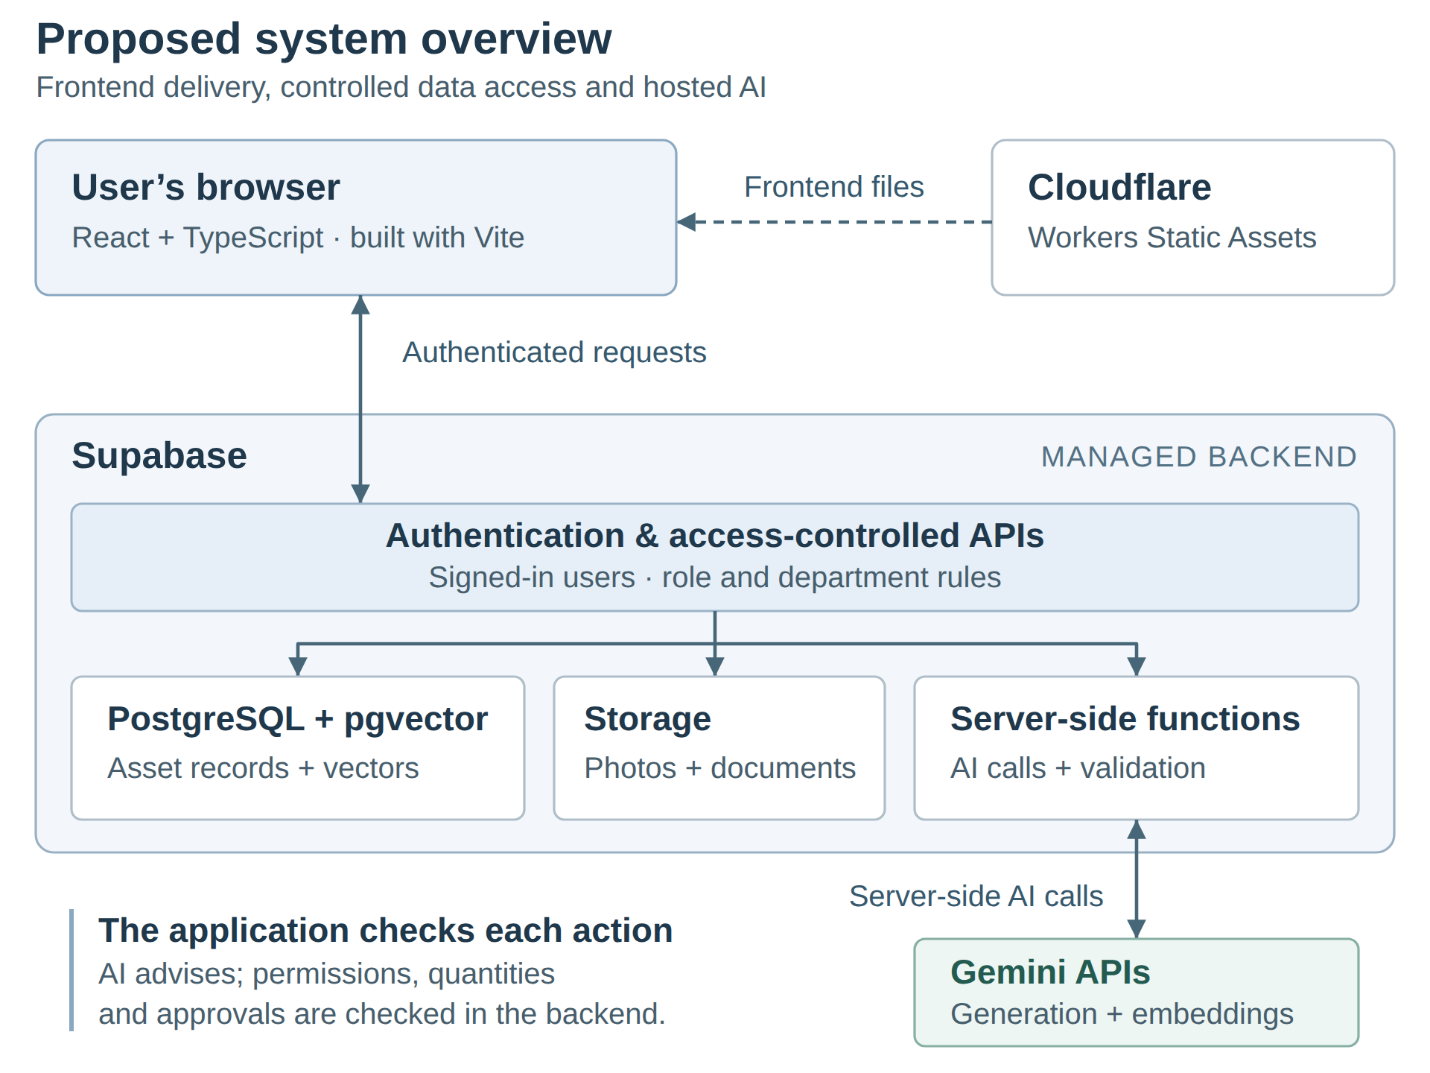
Figure 1. Proposed system overview

4.2 Data Availability and Quality
No university database will be supplied, so the prototype will use a synthetic catalog representing participating departments already using the system. This makes data preparation achievable without depending on institutional access, but the records must be consistent enough to support meaningful tests.
The dataset will include:
- Department-relevant inventory: individually tracked equipment and suitable quantity-based records, with varied specifications, conditions, locations, and availability.
- Connected operational records: users, requests, reservations, transfers, and maintenance history linked to the relevant assets.
- Representative photographs and documents: selected examples for testing uploads and AI classification, rather than manufacturing the full estimated storage volume.
Specific test requests will have expected outcomes defined before evaluation, including suitable matches, incompatible alternatives, missing information, insufficient quantities, and no-match cases. These requests will be tested against the shared catalog, with some held back while matching behaviour is refined. Additional generated records will support larger-volume performance tests.
Validation will check required fields, valid relationships, quantities, and consistent workflow states. A reproducible starting dataset will allow tests to be repeated after records are added or modified. Real personal or confidential information is unnecessary for these tests. Synthetic data can demonstrate functionality and expose defects, but cannot establish matching accuracy or adoption across actual universities.

4.3 AI Capability and Integration
The proposed approach uses Google’s Gemini API rather than training or hosting models ourselves. Two models serve different purposes:
- Gemini 3.5 Flash-Lite: processes text, images, and PDFs to suggest asset details, answer questions, recommend actions, and produce report summaries. It can return information in a defined format for the application to check.
- Gemini Embedding 2: converts asset descriptions and search requests into numerical representations of their meaning, called embeddings. These are stored in PostgreSQL and searched using pgvector to find potentially relevant items.
Cloudflare Workers AI is a credible alternative, offering image-capable models, embeddings, and document conversion. Gemini is preferred because its documented PDF handling and formatted responses provide a simpler starting point for the required features. Actual usefulness must still be tested with the project’s sample data.
AI requests will pass through server-side functions that protect API keys and restrict access to information the user is allowed to see. The application will check required fields, suitability, available quantities, and permissions before acting on model output. Financial totals will be calculated by ordinary code and supplied to the model for explanation.
Users will review suggested asset details and prepared requests before saving them. If AI assistance fails, conventional search, forms, and approval workflows will remain available. Testing will compare AI-assisted matching with ordinary search and check whether generated answers and reports agree with the underlying records.
Sources: Google Gemini 3.5 Flash-Lite capabilities and embeddings; Cloudflare Workers AI model capabilities, document conversion, and JSON Mode.

4.4 Skills, Resources, and Validation Needs
The project requires skills in frontend development, SQL, access control, API integration, testing, and deployment. The work also includes database design, AI-service configuration, and documentation of the system’s setup and operation.
Development can use team computers, GitHub, and the proposed hosted services. A dedicated GPU is not required because model processing will take place through external APIs. Internet access, service accounts, usage limits, and an agreed spending allowance will need to be arranged.
Before building all features, a small working example should confirm that:
- Users can access only the records and actions permitted by their roles.
- Two competing requests cannot reserve the same remaining item.
- The AI services can process representative text, images, and documents and return usable results.
- Search meets the provisional Phase 1 performance target under the declared test conditions.
- Both database records and uploaded files can be backed up and restored.
These checks target the main uncertainties early. Failed checks would lead to changes in the implementation approach before the team builds further features around it.

5. Financial and Economic Feasibility

5.1 Cost Basis and Estimates
Costs use the reference scenario in Section 1.3: 200 authorized users, 5,000 asset records, approximately 12 GB of uploaded files, and the stated monthly request and AI activity. Prices are expressed in US dollars and were checked in September 2026. Service prices are published figures and usage, work hours, labour values are planning assumptions.

Hosting and AI costs
The frontend will use Cloudflare Workers Static Assets, which provides free storage and delivery of directly served frontend files under its published terms. Static files have a 25 MiB per-file limit. Requests that execute Worker code are subject to separate request and processing limits; no such backend execution is included in the $0 frontend estimate.
Uploaded asset photographs and documents will be stored in Supabase, not treated as free frontend files. Supabase Pro starts at $25 per month and includes 100 GB of file storage, covering the estimated 12 GB. Its included user allowance also exceeds the assumed 200 accounts, although response times and processing capacity still require testing.
The AI estimate assumes the following monthly use:
- 400 assistant turns, including help preparing requests.
- 100 asset classifications, representing half of the 200 new or substantially updated records.
- 100 sustainable-action recommendations, an additional planning assumption.
- 21 report summaries: one per participating unit and one university-wide summary.
- 1,600 search-query embeddings and embeddings for 200 updated asset records.
Assumed request lengths, including a 10% allowance for retries and variation, total approximately 1.95 million generation-input tokens, 0.30 million output tokens, and 0.16 million embedding tokens. Tokens are the units providers use to measure model input and output. At the selected Gemini models’ published rates, this gives approximately $1.38 per month. A $5 AI allowance is used because actual conversation lengths and image/document processing have not yet been measured.

Development and maintenance costs
The table separates one-time development from recurring operation and support. First-year totals include the one-time cost and twelve months of recurring costs.

Cost item and calculation | One-time | Monthly | First year
Planning and design: 60 hours × $25 | $1,500 | — | $1,500
Core application: 160 hours × $25 | $4,000 | — | $4,000
AI integration: 80 hours × $25 | $2,000 | — | $2,000
Testing, deployment, documentation: 100 hours × $25 | $2,500 | — | $2,500
Maintenance: 8 hours/month × $25 | — | $200 | $2,400
Cloudflare static frontend | — | $0 | $0
Supabase Pro | — | $25 | $300
Gemini usage allowance | — | $5 | $60
Additional service-usage allowance | — | $5 | $60
System subtotal | $10,000 | $235 | $12,820
Transfer handling and minor repair: 40/month × $25 | — | $1,000 | $12,000
Total including transfer costs | $10,000 | $1,235 | $24,820
Optional development reserve: 20% × $10,000 | $2,000 | — | $2,000
Total with development reserve | $12,000 | $1,235 | $26,820

Development and maintenance values represent estimated labour, not agreed fees or supplier quotations. Transfer costs are included in the university financial scenario because reuse still requires physical handling. The development reserve covers possible additional effort and is separate from the monthly service-usage allowance.
For the student prototype, existing computers and internet access are assumed. Excluding the valuation of student labour and institutional transfer activity, three months of the $35 service budget would require approximately $105. Taxes, new hardware, institutional integrations, formal security assessments, and stronger backup arrangements remain excluded.
Sources: Cloudflare Workers Static Assets billing; Supabase pricing; Google Gemini API pricing. Workload, token usage, effort, and labour values are study assumptions.

5.2 Benefits, ROI, and Sensitivity
The benefit comes from avoiding purchases that would otherwise occur. The model assumes 40 transfers per month for twelve months. In the base case, we take that 20 of those transfers each month replace a $150 purchase each; the other 20 receive no purchase savings. Handling and minor repair are charged at $25 for every transfer, whether or not it avoids a purchase.
The first-year calculation is:
Item | Calculation | Annual amount
Purchases avoided | 20 per month × 12 months × $150 | $36,000 saved
System development, services, and maintenance | From Section 5.1 | $12,820 cost
Handling and minor repair | 40 transfers × 12 months × $25 | $12,000 cost
Total cost | $12,820 + $12,000 | $24,820
Net benefit | $36,000 − $24,820 | $11,180
ROI is the net benefit divided by total cost:
$$\text{First-year ROI}=\frac{11,180}{24,820}×100\%≈45\%$$
Thus, 50% of transfers avoiding purchases produces approximately 45% ROI. The first percentage describes our usage assumption; the second measures the financial return. The estimated net benefit is avoided expenditure after costs, not revenue from selling the software.
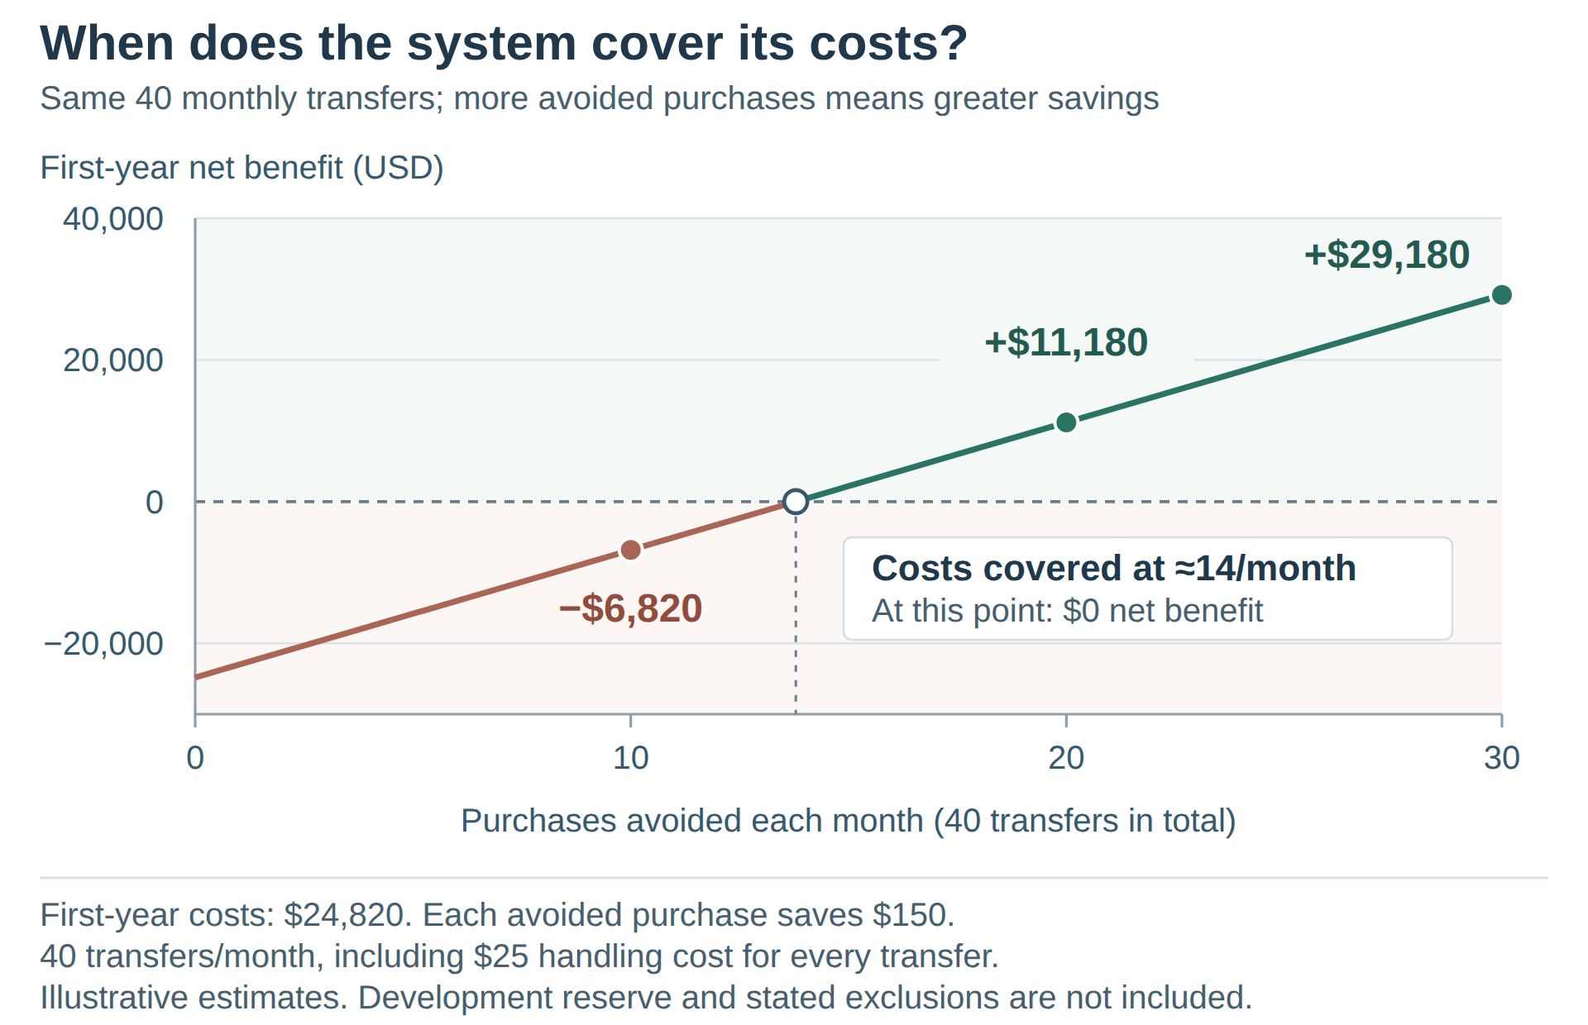
Figure 2. First-year net benefit by purchases avoided per month.
Figure 2 keeps total transfers fixed at 40 per month. Avoiding 10, 20, or 30 purchases per month produces first-year net benefits of −$6,820, +$11,180, and +$29,180, respectively, with ROI values of −27.5%, 45.0%, and 117.6%. Costs are covered at about 14 avoided purchases per month; at the exact break-even point, net benefit and ROI are both zero.
Including the $2,000 development reserve raises base case costs to $26,820 and reduces ROI to approximately 34%. The chart excludes this reserve. All figures are illustrative: slower adoption, lower replacement values, or higher costs would reduce the benefit. Only additional purchase avoidance is credited, while handling is charged for every transfer.

6. Legal, Ethical, Privacy, and Policy Feasibility

6.1 Legal, Licensing, and Institutional Constraints
The prototype will use synthetic records and test accounts. Sample photographs and documents must be team-created or used with permission. This reduces dependence on institutional data, but does not remove the need to follow software licences and service terms.
Each selected dependency must be checked for its licence obligations. For example, React’s MIT licence requires its copyright and permission notices to be retained. Hosted services such as Supabase, Cloudflare, and Gemini have separate terms governing account use, data processing, and service limits.
A future university deployment would require review of the applicable data-protection rules, including requirements for sending personal information to external providers. The UAE Government identifies Federal Decree-Law No. 45 of 2021 as part of the country’s data-protection framework; its application would need to be checked for the institution and data involved.
Asset ownership, transfer approvals, donation, and disposal remain subject to university policies and delegated authority. The software can enforce agreed permissions and record decisions, but cannot grant authority that users do not hold.
Sources: UAE Government, “Data protection laws”; React MIT licence; applicable hosted-service terms.

6.2 Privacy, Security, and Responsible AI
Only information needed for the task should be sent to an AI service. Real personal or confidential data should not be used without institutional approval and appropriate processing arrangements. Gemini’s terms distinguish unpaid usage, which may be used to improve products, from paid usage, which is not used for that purpose but may still involve limited logging.
The access controls and human-review steps in Section 4 remain essential. Testing should check whether recommendations favour particular departments without a justified reason and whether missing information produces misleading answers. Users must be able to correct suggestions, and important decisions must remain traceable to an authorized person.
Source: Google Gemini API Additional Terms of Service.

7. Risk Assessment and Contingencies
Risks are ordered by the attention they require during prototype development. Likelihood reflects how readily each issue could arise; impact reflects its consequences for delivery or operation. Where ratings are equal, dependencies and the timing of consequences determine the order. These are initial judgments, not measured probabilities.

Priority and risk | Likelihood / impact | Response and fallback
1. Schedule and integration delays | High / High | - Build an end-to-end exchange early; review progress weekly and reserve integration time.  - If delayed, redistribute tasks and postpone optional refinements. Required scope changes need instructor agreement.
2. Unauthorized access or inconsistent records | Medium / High | - Test permissions, competing reservations, and restoration of records and files before expanding functionality.  - Block release of affected features until errors are corrected.
3. Incorrect AI results or service limits | Medium / High | - Test representative cases, validate responses, and monitor usage.  - Keep conventional workflows available during failures; reassess the model or provider if necessary.
4. Costs exceeding benefits | Medium / High | - Compare actual effort and usage with estimates at each milestone.  - Reassess expansion if purchase avoidance is lower, or handling and support costs are higher, than assumed.
5. Low participation or outdated listings | Medium / High for deployment | - Keep updates simple, assign record ownership, and trial the workflow with participating departments.  - Limit rollout if records cannot be maintained.
Schedule risk comes first because delays affect every deliverable. Access and record correctness precede AI improvements because all workflows depend on them. Participation has a lower immediate priority for a synthetic-data prototype, but becomes a leading risk before institutional deployment.
Each task's owner and reviewer will track related risks. Weekly reviews should identify unresolved issues, decide the next response, and revise priorities where necessary.

8. Project Schedule and Delivery Feasibility
Phase 2 is due on 28 September 2026 following a one-week extension. Later milestones retain the dates in the lab slides and remain provisional until any changes are confirmed.
Lab week, 2026 | Deliverable and main work
28 September | Feasibility study and initial technical checks
5 October | Detailed requirements, permissions, test cases, and data definitions
26 October | Architecture and detailed design, informed by early integration trials
16 November | Working application with the required major features
23 November | Testing documentation, final report, presentation, and demonstration
Asset records and access controls must support the exchange workflow before AI is connected. Reporting depends on reliable records and agreed calculations. Technical trials should begin early, with testing and documentation continuing throughout development.
The total development estimate remains 400 hours, with a 20% effort reserve. At each milestone, the team should review completed work and distribute the remaining hours across the confirmed schedule. The shorter interval before Phase 3 makes early requirements preparation important.
Delivery depends on confirming task ownership and availability, reviewing progress weekly, and integrating work regularly. The final week is reserved for corrections and demonstration preparation. Forecast delays should trigger task redistribution and a review of priorities.

9. Recommendation and Action Plan
The study recommends proceeding with the semester prototype, subject to the checks in Section 4 and confirmation of team time and service spending. The proposed managed services provide a credible technical approach, synthetic data removes the need for institutional database access, and estimated prototype service costs are modest.
A university deployment requires a separate decision. The financial scenario shows potential savings, but lower purchase avoidance produces a negative first-year return. Actual adoption, handling arrangements, data permissions, and support costs must therefore be assessed before wider use.
Before commissioning a wider deployment, the university should compare the demonstrated benefits and full operating costs with improving existing systems or adopting an established product such as Rheaply.
The next steps are to:
- Confirm task ownership and weekly availability.
- Test access controls, competing reservations, AI inputs, and backup recovery in a small working example.
- Refine requirements specifications and data definitions using those results, then develop the architecture and detailed design.
- Review progress, spending, and major risks at each milestone.

Sources
This report draws on the project brief, feasibility lab & lecture slides, finalized Phase 1 report, and the sources identified in the relevant sections. Provider documentation and pricing were checked in September 2026.

