1. Setengah Piramida \*

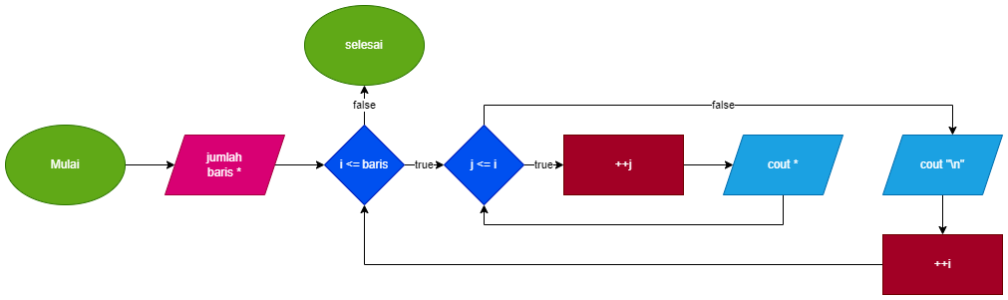

Baris: 5

1. i = 1
2. i <= baris (true)
3. j = 1
4. j <= i (true)
5. ++j
6. cout << \*
7. j = 2
8. j <= i (false)
9. cout<<”\n”
10. ++i
11. i = 2
12. i <= baris (true)
13. j = 1
14. j <= i (true)
15. ++j
16. cout << \*
17. j = 2
18. j <= i (true)
19. ++j
20. cout << \*
21. j = 3
22. j <= i (false)
23. cout<<”\n”
24. ++i
25. i = 3
26. i <= baris (true)
27. j = 1
28. j <= i (true)
29. ++j
30. cout << \*
31. j = 2
32. j <= i (true)
33. ++j
34. cout << \*
35. j =3
36. j <= i (true)
37. ++j
38. cout << \*
39. j = 4
40. j <= i (false)
41. cout<<”\n”
42. ++i
43. i = 4
44. i <= baris (true)
45. j = 1
46. j <= i (true)
47. ++j
48. cout << \*
49. j = 2
50. j <= i (true)
51. ++j
52. cout << \*
53. j = 3
54. j <= i (true)
55. ++j
56. cout << \*
57. j = 4
58. j <= i (true)
59. ++j
60. cout << \*
61. j = 5
62. j <= i (false)
63. cout<<”\n”
64. ++i
65. i = 5
66. i <= baris (true)
67. j = 1
68. j <= i (true)
69. ++j
70. cout << \*
71. j = 2
72. j <= i (true)
73. ++j
74. cout << \*
75. j = 3
76. j <= i (true)
77. ++j
78. cout << \*
79. j = 4
80. j <= i (true)
81. ++j
82. cout << \*
83. j = 5
84. j <= i (true)
85. ++j
86. cout << \*
87. j = 6
88. j <= i (false)
89. cout<<”\n”
90. ++i
91. i = 6
92. i <= baris (false)
93. selesai
94. Setengah Piramida Bilangan

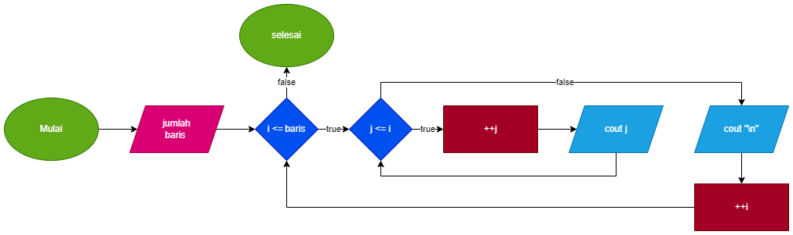

Baris: 5

1. i = 1
2. i <= baris (true)
3. j = 1
4. j <= i (true)
5. ++j
6. cout << j
7. j = 2
8. j <= i (false)
9. cout<<”\n”
10. ++i
11. i = 2
12. i <= baris (true)
13. j = 1
14. j <= i (true)
15. ++j
16. cout << j
17. j = 2
18. j <= i (true)
19. ++j
20. cout << j
21. j = 3
22. j <= i (false)
23. cout<<”\n”
24. ++i
25. i = 3
26. i <= baris (true)
27. j = 1
28. j <= i (true)
29. ++j
30. cout << j
31. j = 2
32. j <= i (true)
33. ++j
34. cout << j
35. j =3
36. j <= i (true)
37. ++j
38. cout << j
39. j = 4
40. j <= i (false)
41. cout<<”\n”
42. ++i
43. i = 4
44. i <= baris (true)
45. j = 1
46. j <= i (true)
47. ++j
48. cout << j
49. j = 2
50. j <= i (true)
51. ++j
52. cout << j
53. j = 3
54. j <= i (true)
55. ++j
56. cout << j
57. j = 4
58. j <= i (true)
59. ++j
60. cout << j
61. j = 5
62. j <= i (false)
63. cout<<”\n”
64. ++i
65. i = 5
66. i <= baris (true)
67. j = 1
68. j <= i (true)
69. ++j
70. cout << j
71. j = 2
72. j <= i (true)
73. ++j
74. cout << j
75. j = 3
76. j <= i (true)
77. ++j
78. cout << j
79. j = 4
80. j <= i (true)
81. ++j
82. cout << j
83. j = 5
84. j <= i (true)
85. ++j
86. cout << j
87. j = 6
88. j <= i (false)
89. cout<<”\n”
90. ++i
91. i = 6
92. i <= baris (false)
93. selesai
94. Setengah Piramida Abjad

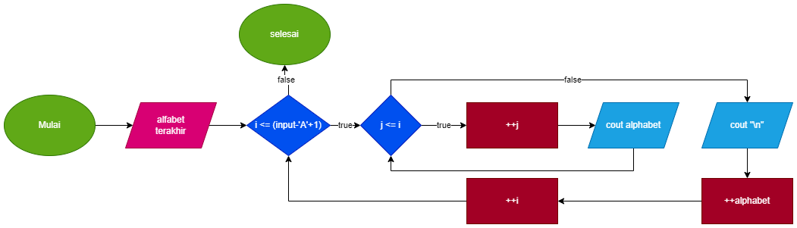

Baris: 3 (alphabet = A) (input = C)

1. 1<=('C'-'A'+1) (true)
2. j=1
3. j<=1 (true)
4. cout<<alphabet ""(A)
5. ++j; j=2
6. j<1 (false)
7. ++alphabet
8. cout<<endl
9. ++i; i=2
10. i=2
11. 2<=('C'-'A'+1) (true)
12. j = 1
13. j<=2 (true)
14. cout<<alphabet<<” “; (B)
15. ++j; j=2
16. cout<<alphabet<<” “; (B)
17. ++j; j=3
18. j<=2 (false)
19. ++alphabet
20. cout<<endl
21. ++I; j=3
22. i=3
23. 2<=('C'-'A'+1) (true)
24. j = 1
25. j<=3 (true)
26. cout<<alphabet<<” “; (C)
27. ++j; j=2
28. cout<<alphabet<<” “; (C)
29. ++j; j=3
30. cout<<alphabet<<” “; (C)
31. j<=3 (false)
32. ++alphabet
33. cout<<endl
34. ++I; j=4
35. selesai
36. Setengah piramida terbalik dari \*

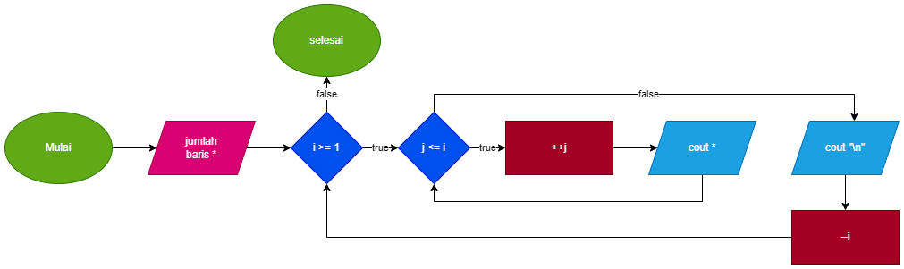

Baris: 3

1. i = 4
2. i >= 1 (true)
3. j = 1
4. j <= i (true)
5. ++j
6. cout << j
7. j = 2
8. j <= i (true)
9. ++j
10. cout << j
11. j =3
12. j <= i (true)
13. ++j
14. cout << j
15. j = 4
16. j <= i (true)
17. ++j
18. cout << j
19. j = 5
20. j <= i (true)
21. ++j
22. cout << j
23. j = 6
24. j <= i (false)
25. cout<<”\n”
26. --i
27. i = 4
28. i >= 1 (true)
29. j = 1
30. j <= i (true)
31. ++j
32. cout << j
33. j = 2
34. j <= i (true)
35. ++j
36. cout << j
37. j =3
38. j <= i (true)
39. ++j
40. cout << j
41. j = 4
42. j <= i (true)
43. ++j
44. cout << j
45. j = 5
46. j <= i (false)
47. cout<<”\n”
48. --i
49. i = 3
50. i >= 1 (true)
51. j = 1
52. j <= i (true)
53. ++j
54. cout << j
55. j = 2
56. j <= i (true)
57. ++j
58. cout << j
59. j =3
60. j <= i (true)
61. ++j
62. cout << j
63. j = 4
64. j <= i (false)
65. cout<<”\n”
66. --i
67. i = 2
68. i >= 1 (true)
69. j = 1
70. j <= i (true)
71. ++j
72. cout << j
73. j = 2
74. j <= i (true)
75. ++j
76. cout << j
77. j =3
78. j <= i (false)
79. cout<<”\n”
80. --i
81. i = 2
82. i >= 1 (true)
83. j = 1
84. j <= i (true)
85. ++j
86. cout << j
87. j = 2
88. j <= i (false)
89. cout<<”\n”
90. --i
91. Angka setengah piramid terbalik

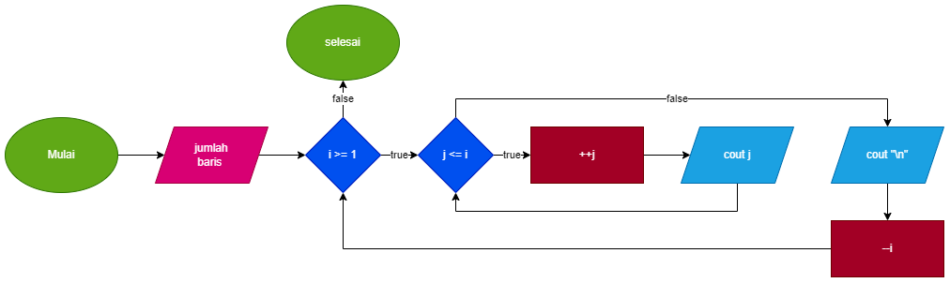

Baris: 3

1. i = 4
2. i >= 1 (true)
3. j = 1
4. j <= i (true)
5. ++j
6. cout << j
7. j = 2
8. j <= i (true)
9. ++j
10. cout << j
11. j =3
12. j <= i (true)
13. ++j
14. cout << j
15. j = 4
16. j <= i (true)
17. ++j
18. cout << j
19. j = 5
20. j <= i (true)
21. ++j
22. cout << j
23. j = 6
24. j <= i (false)
25. cout<<”\n”
26. --i
27. i = 4
28. i >= 1 (true)
29. j = 1
30. j <= i (true)
31. ++j
32. cout << j
33. j = 2
34. j <= i (true)
35. ++j
36. cout << j
37. j =3
38. j <= i (true)
39. ++j
40. cout << j
41. j = 4
42. j <= i (true)
43. ++j
44. cout << j
45. j = 5
46. j <= i (false)
47. cout<<”\n”
48. --i
49. i = 3
50. i >= 1 (true)
51. j = 1
52. j <= i (true)
53. ++j
54. cout << j
55. j = 2
56. j <= i (true)
57. ++j
58. cout << j
59. j =3
60. j <= i (true)
61. ++j
62. cout << j
63. j = 4
64. j <= i (false)
65. cout<<”\n”
66. --i
67. i = 2
68. i >= 1 (true)
69. j = 1
70. j <= i (true)
71. ++j
72. cout << j
73. j = 2
74. j <= i (true)
75. ++j
76. cout << j
77. j =3
78. j <= i (false)
79. cout<<”\n”
80. --i
81. i = 2
82. i >= 1 (true)
83. j = 1
84. j <= i (true)
85. ++j
86. cout << j
87. j = 2
88. j <= i (false)
89. cout<<”\n”
90. --i
91. selesai
92. Piramida Penuh \*

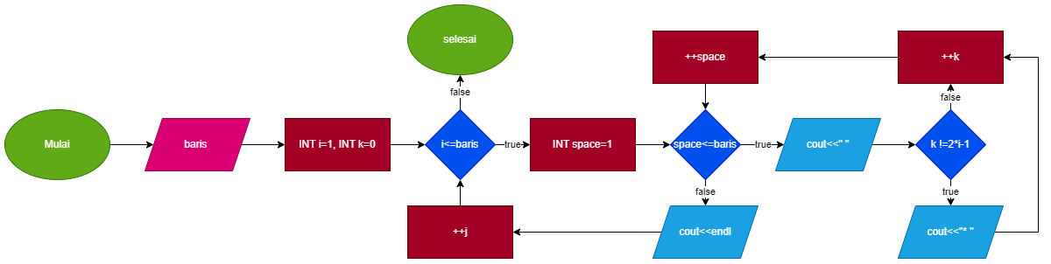

Baris: 2

1. i=1, k=0
2. i<=baris (true)
3. space=1
4. space<baris-1 (true)
5. cout<<” “;
6. k != 2\*i-1
7. 0 != 2\*1-1 (true)
8. cout<<”\*”;
9. ==k; k=1
10. ++space
11. space=2
12. space<baris-1 (true)
13. cout<<” “;
14. k != 2\*i-1
15. 1 != 2\*1-1 (true)
16. cout<<”\*”;
17. ++k; k=2
18. ++space
19. space=3
20. space<=baris-I (false)
21. cout<<endl;
22. ++i
23. i=2
24. i<=baris (true)
25. space=1
26. space<=baris-1 (false)
27. cout<<endl;
28. ++i; i=3
29. i<=baris (false)
30. selesai
31. Piramida Bilangan Penuh

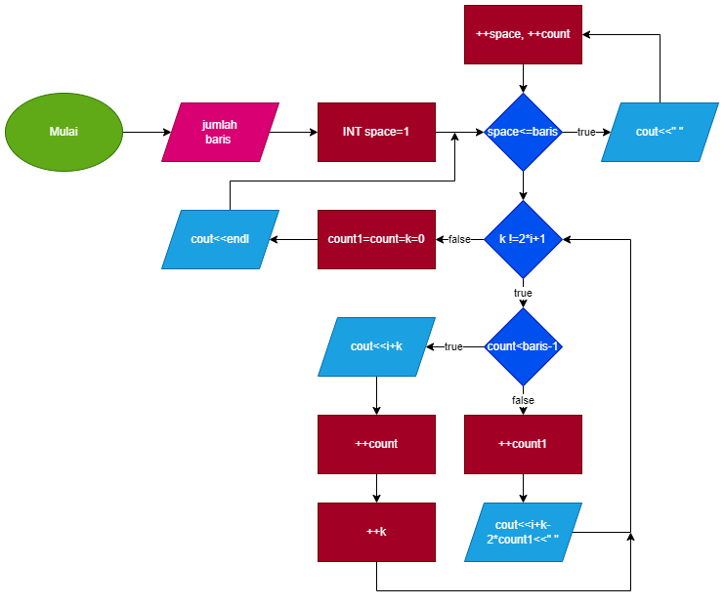

Baris: 2

1. i=1
2. i<=baris (true)
3. space=1
4. space<=baris-i (true)
5. cout<<” “;
6. ++space; space=2
7. ++count; count=1
8. space<=baris-1 (false)
9. k != 2\*i+1
10. 0 != 2\*1+1 (true)
11. count<=baris-1 (true)
12. cout<<i+k
13. ++count, count=1
14. ++k; k=1
15. k != 2\*i+1
16. 1 != 2\*1+1 (true)
17. count<=baris-1 (true)
18. cout<<i+k
19. ++count, count=2
20. ++k; k=2
21. k != 2\*i+1
22. 2 != 2\*1+1 (true)
23. count<=baris-1 (false)
24. ++count1; count1=1
25. cout<<i+k-2\*count1<<” “;
26. ++k; k=3
27. k != 2\*i+1
28. 3 != 2\*1+! (false)
29. count1=count=k=0
30. cout<<endl;
31. ++i; i=2
32. i=2
33. i<=baris (true)
34. space=1
35. space<=baris-i (false)
36. k != 2\*i+1 (true)
37. count<=baris-1 (true)
38. cout<<i+k
39. ++count; count=1
40. ++k; k=1
41. k != 2\*i+1 (true)
42. count<=baris-1 (true)
43. cout<<i+k
44. ++count; count=2
45. ++k; k=2
46. k != 2\*i+1 (true)
47. count<=baris-1 (false)
48. ++count1; count1=1
49. cout<<i+k-2\*count1<<” “;
50. ++k; k=3
51. k != 2\*i+1 (true)
52. ++k; k=4
53. k != 2\*i+1 (true)
54. ++k; k=5
55. k != 2\*i+1 (false)
56. count1=count=k=0
57. cout<<endl;
58. ++I; i=3
59. i<=baris (false)
60. selesai
61. Piramida penuh terbalik dari \*

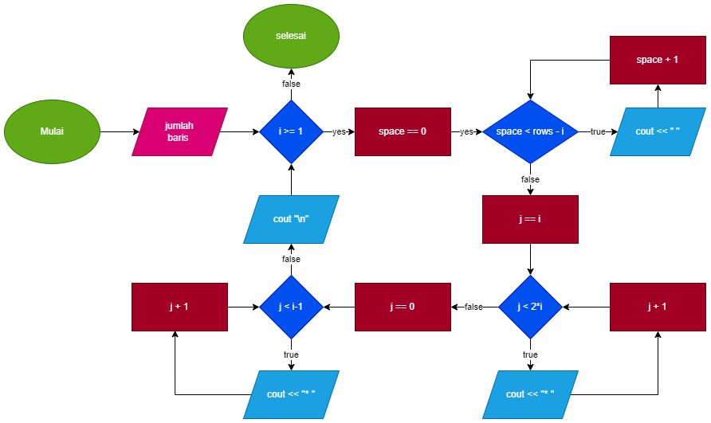

Baris: 2

1. i=2
2. i>=1 (true)
3. space=0
4. space<baris-i (false)
5. j=i
6. j=2
7. j < 2\*i+1 (true)
8. cout<<”\* “;
9. ++j; j=3
10. j < 2\*i+1 (true)
11. cout<<”\* “;
12. ++j; j=4
13. cout<<”\* “;
14. ++j; j=5
15. j < 2\*i+1 (false)
16. j=0
17. j < i-1 (true)
18. cout<<”\* “;
19. ++j; j=1
20. j < i-1 (false)
21. --i
22. i=1
23. i >= 1 (true)
24. space=0
25. space<baris-i (true)
26. cout<<” “;
27. ++space; space=1
28. space<baris-i (false)
29. j=i
30. j=1
31. j<=2\*i+1 (true)
32. cout<<”\* “;
33. ++j; j=2
34. j<=2\*i+1 (true)
35. cout<<”\* “;
36. ++j; j=3
37. j<=2\*i+1 (true)
38. cout<<”\* “;
39. ++j; j=4
40. j<=2\*i+1 (false)
41. j=0
42. j<i-1 (false)
43. --i;
44. i=0
45. i>=1 (false)
46. selesai
47. Segitiga Pascal

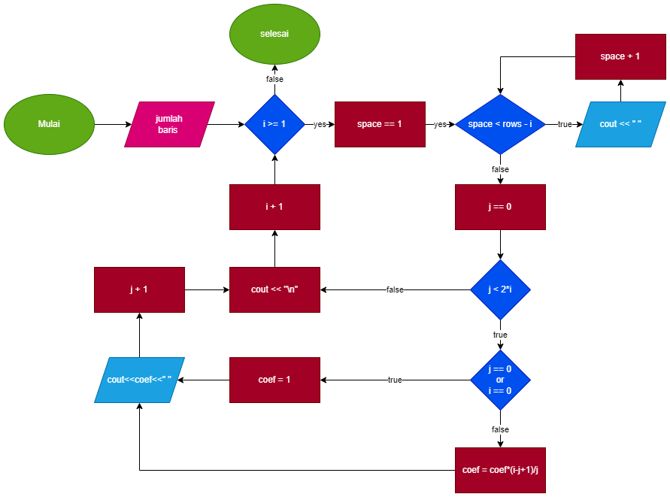

Baris: 2

1. coef=1, i=0
2. i<baris (true)
3. space=1
4. space<=rows-i (true)
5. cout<<" ";
6. space++; space=2
7. space<=baris-i (true)
8. cout<<” “;
9. space++; space=3
10. space<=rows-i (false)
11. j=0
12. j<=i (true)
13. j==0 (true)
14. coef=1
15. cout<<coef<<" " (1)
16. j++; j=1
17. j<=i (false)
18. cout<<endl;
19. i++; i=1
20. i<rows (true)
21. space=1
22. space<=baris-i (true)
23. cout<<" ";
24. space++; space=2
25. space<=baris-i (false)
26. j=0
27. j<=i (true)
28. j==0 (true)
29. coef=1
30. cout<<coef<<" "; (1)
31. j++; j=1
32. j==0 or i==0 (false)
33. coef=coef(i-j+1)
34. coef=1(0+1)=1
35. cout<<coef<<" "; (1)
36. j++; j=2
37. j<=i (false)
38. cout<<endl;
39. ++i;
40. i=3
41. i<rows (false)
42. selesai
43. Segitiga Floyd

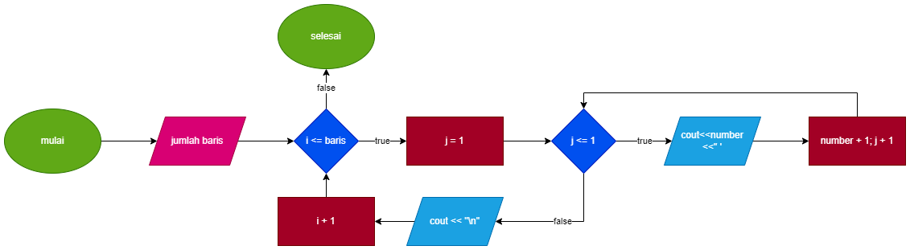

Baris: 3

1. number=1, 1=1
2. i<=baris (true)
3. j=1
4. j<=i (true)
5. cout<<number<<" "; (1)
6. ++number; number=2
7. ++j; j=2
8. j<=i (false)
9. cout<<endl;
10. i++
11. i=2
12. i<=baris (true)
13. j=1
14. j<=i (true)
15. cout<<number<<" "; (2)
16. ++number; number=3
17. ++j; j=2
18. j<=i (true)
19. cout<<number<<" "; (3)
20. ++number; number=4
21. ++j; j=3
22. j<=i (false)
23. cout<<endl;
24. i++;
25. i=3
26. i<=baris (true)
27. j=1
28. j<=i (true)
29. cout<<number<<" "; (4)
30. ++number; number=5
31. j<=i (true)
32. ++j; j=2
33. cout<<number<<" "; (5)
34. ++number; number=6
35. ++j; j=3
36. j<=i (true)
37. cout<<number<<" "; (6)
38. ++number; number=7
39. ++j; j=4 j<=i (false)
40. cout<<endl;
41. i++;
42. i=4
43. i<=rows (false)
44. selesai